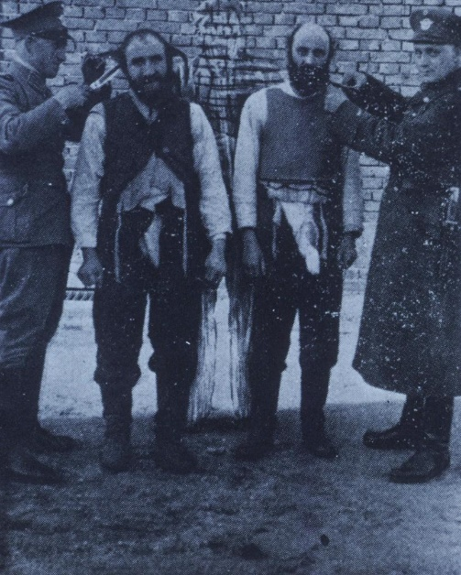
The Holocaust
German Soldiers Cut Beards and Side Curls of Orthodox Jews. JSTOR. Accessed 27 Dec. 2023. Available at: https://jstor.org/stable/community.13878833.
An Introduction to the Holocaust.

The Holocaust took place during World War Two, primarily between 1941 and 1945. It was a systematic genocide orchestrated by Adolf Hitler and the Nazi regime in Germany. The roots of the Holocaust can be traced back to the rise of the Nazi Party in the early 1930s. The Holocaust stands as a stark reminder of the depths of human cruelty and the devasting consequences of prejudice and hatred. During World War II, the Nazi regime orchestrated the systematic persecution and extermination of millions of innocent people, primarily targeting the Jewish population. This research project will delve into the causes, atrocities, and profound impact of the Holocaust, seeking to understand the magnitude of this dark chapter in history.
Under Hitler’s leadership, the Nazis promoted a racist ideology that deemed certain groups, particularly Jews, as inferior and a threat to the German ‘master race.’ This ideology, known as antisemitism, fuelled the persecution of Jews and other targeted groups.
According to Anheier in 1933, when Hitler became Chancellor of Germany, the Nazis implemented discriminatory policies against Jews, including the Nuremberg Laws, which stripped them of their rights and citizenship. Over time, these policies escalated, leading to the establishment of ghettos, forced labour camps, and ultimately, extermination camps.
The implementation of the Final Solution marked the most devastating phase of the Holocaust. It aimed to systematically exterminate Jews and other groups deemed undesirable by the Nazis. Mass deportations, gas chambers, and mass shootings were employed to carry out these atrocities. Lang States ‘millions of innocent people, including six million Jews, were murdered during the Holocaust.’ The Holocaust stands as one of the darkest chapters in human history, highlighting the depths of human cruelty and consequences of unchecked hatred discrimination.
Gerstenfeld sheds light on some interesting research on extermination camps, such as Auschwitz-Birkenau, Sobador, and Treblinka, where mass killings took place. Victims were transported to these camps in overcrowded trains, often enduring inhumane conditions and deprivation. Upon arrival, they were subjected to a selection process, where those deemed unfit for forced labour were sent directly to the gas chambers. The bodies were disposed of in crematoriums or mass graves.
Adolf-Eichmann was a high-ranking Nazi official who played a significant role in the implementation of the Holocaust. He was responsible for organising the deportation of Jews from various European countries to concentration camps and extermination centres. Eichmann was known for his efficiency in coordinating the logistics of mass deportations. He oversaw the transportation, registration, and forced labour of millions of Jews, ultimately leading to their persecution and death.
According to, The Purdue University Press, The Impact of the Holocaust is immeasurable. It resulted in the loss of millions of lives, the destruction of families and communities, and the perpetration of unspeakable acts of violence and cruelty. It serves as a stark reminder of the consequences of hatred prejudice, and discrimination. The Holocaust not only resulted in the loss of countless lives, but it also has profound effects on survivors and their descendants. Many survivors faced immense challenges in rebuilding their lives and communities after the war. The trauma and loss experienced by survivors left lasting scars, both physically and emotionally.
Klein, Jill G., et al states there was many individuals that survived the Holocaust, one of those individuals was Freddie Knoller, he was born in 1921. Freddie joined the French Resistance in 1943 and was then later arrested and taken to Auschwitz. Luckily Freddie wasn’t Jewish so that bought him time. Freddie managed to take the identity badge of a deceased French political prisoner to keep his identity to survive.
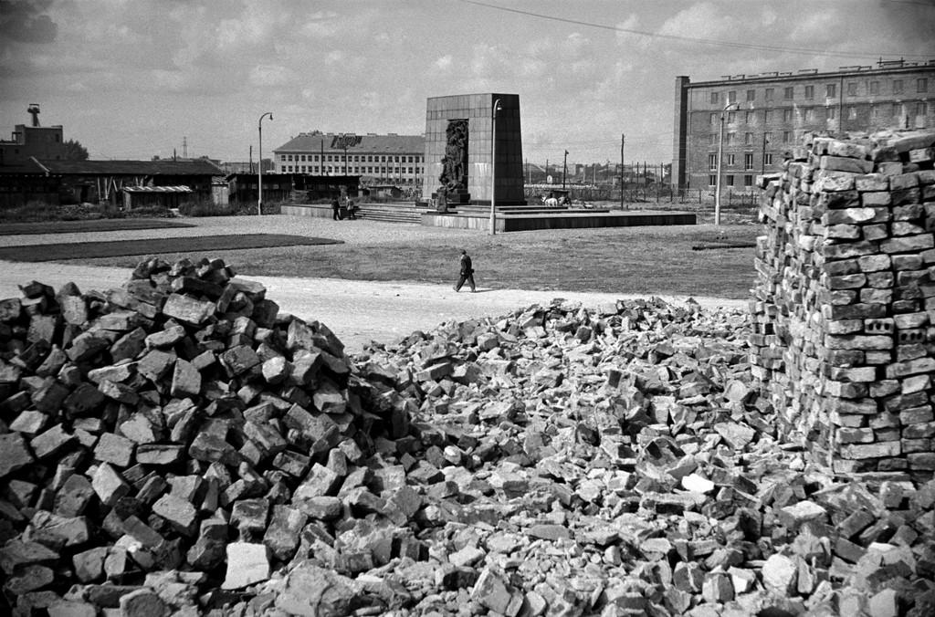
Lessing, Erich. ‘POLAND. 1956. Warsaw. The Ghetto-Monument, erected on the Ruins of the Former Ghetto, Remains the Jewish Armed Resistance against the Nazis during the Holocaust. Initiated by Mordechai ANIELEWICZ the Uprising Started from the End of April to July 1943.’JSTOR. Accessed 27 Dec. 2023. Available at: https://jstor.org/stable/community.9842757.
Heinrich Himmler, the head of ss (Schutzstaffel) played a central role in implementing and overseeing the Holocaust. Himmler was responsible for establishment and operation of the concentration camps, as well as coordination of mass shootings and deportations. His role in the Holocaust was instrumental in carrying out Hitlers genocidal policies. Reinhard Heydrich, a high-ranking SS officer, was another key figure in the implementation of the Holocaust. Heydrich chaired the Wannsee Conference in 1942, where plans for the Final solution were discussed and formalized. The conference marked a turning point in the systematic extermination of Jews.
During the Holocaust there was many acts of bravery. Some individuals became rescuers. Resistance during the Holocaust took many forms, ranging from organised uprisings in ghettos and concentration camps to individuals acts of defiance. These acts aimed to disrupt Nazi operations, provide aid to those targeted, and preserve human dignity. The Warsaw Ghetto Uprising in 1943, led by Jewish fighters, remains one of the most notable acts of resistance during this time. Rescuers were individuals who risked their lives to save Jews and other targeted groups. They provided shelter, forged documents, and helped people escape from persecution. Notable examples include Oskar Schindler, a German industrialist who saved over a thousand Jews by employing them in factories, and Raoul Wallenberg, a Swedish diplomat who issued protective passports and established safe houses in Budapest, Hungary. (Crowe, ‘Encyclopaedia Judaica’, 2007, p. 136).
Buckser discusses the role of Grundtvigian Nationalism in the rescue of the Danish Jews. In 1943, when the Nazis planned to deport Danish Jews to concentration camps, the Danish people rallied together to evacuate them to neutral Sweden. With the help of fishermen, citizens, and underground networks, around 7,200 Jews were successfully transported to safety. There were instances of individuals hiding Jews in their homes, known as Righteous Among the Nations. These brave individuals risked their own lives of their families to provide shelter and protection. Their acts of compassion and bravery saved countless lives and serve as a testament to the power of human kindness.
Raoul Wallenberg, a Swedish diplomat stationed in Budapest, Hungry during World War Two, issued protective passports and provided safe houses for thousands of Jews, saving them from deportation to concentration camps. His courageous actions helped an estimated 20,000 Jews escape persecution. Another individual Irena Sendler, a Polish social worker opened a network to smuggle Jewish children out of the Warsaw Ghetto, placing them in homes, converts, and orphanages. She saved approximately 2,500 children and kept records of their identities to reunite them with their families after the war.
Jan Karski, a courier for the Polish Underground, played a crucial role in alerting the world to the atrocities of the Holocaust. He infiltrated the Warsaw Ghetto and a transit camp, witnessing the horrific conditions firsthand. Karski risked his life to deliver detailed reports to Allied leaders, urging them to take action against genocide. Additionally, the Bielski brothers, Tuvia, Asael, and Zus, led a Jewish partisan group in the forests of Belarus. They provided shelter, food, and protection to hundreds of Jews who had escaped from ghettos and camps.
As Allied Forces advanced and liberated concentration camps, they encountered the devastating aftermath of the Holocaust. The true scale of the atrocities became apparent as survivors were found in horrific conditions, and the world began to grasp the extent of the genocide. Efforts were made to provide immediate medical care, food, shelter to the survivors. Displaced Persons (DP) camps were established to offer temporary refuge for those who had been liberated. These camps provided necessities and support to help saviours rebuild their lives. The Allied forces were determined to hold the perpetrators accountable for their crime. The Nuremburg Trials, which took place from 1945 to 1946, were held to prosecute key Nazi leaders for their involvement in the Holocaust and other war crimes. This marked a significant step towards justice and the law establishment of international criminal law.

Michalcyzk states in the aftermath of the Holocaust, the Nuremberg Trials took place to hold Nazi officials accountable for their crimes. These trails aimed to bring justice and shed light on the systematic persecution and genocide that had taken place. (John J. Michalcyzk, ‘Film in the End of the Holocaust: Allied Documentaries, Nuremberg and the Liberation of the Concentration Camps’ (London, England: Bloomsbury Academic, 2016), 45. Many perpetrators were convicted and sentenced for their roles in the Holocaust. The end of World War Two also marked the beginning of a long process of healing, remembrance, and education. Holocaust survivors shared their stories, ensuring that the horrors they endured would not be forgotten. Memorials, museums, and educational programs were established worldwide to honour the victims and educate future generations about the Holocaust.
In conclusion, the Holocaust was a tragic and horrifying event that must never be forgotten. It serves as a stark reminder of the consequences of prejudice, discrimination, and unchecked power. The systematic persecution and extermination of millions of innocent people during this dark period in history should serve as a solemn reminder of the importance of human rights, tolerance, and compassion. By remembering the Holocaust, we honour the victims and survivors and strive to ensure that such atrocities are never repeated. Let us stand together to promote understanding, empathy, and a world free from hatred and injustice.

Bibliography
‘German Soldiers Cut Beards and Side Curls of Orthodox Jews.’ JSTOR. Accessed 27 Dec. 2023. Available at: https://jstor.org/stable/community.13878833.
Anheier, Helmut K. ‘Studying the Nazi Party: 'Clean Models' Versus 'Dirty Hands’. ‘American Journal of Sociology’ 103, no. 1 (1997): 199-209. JSTOR. Accessed December 26, 2023. https://doi.org/10.1086/231177.
Bauer, Yehuda. ‘What Was the Holocaust?’ In Rethinking the Holocaust, 1-13. New Haven: Yale University Press, 2001. JSTOR. Accessed December 26, 2023. http://www.jstor.org/stable/j.ctt32bpxv.5.
Ben Aharan, Eldad. ‘The Holocaust and the 'Final Solution' of the European Jews.’ ‘In How Do We Remember the Armenian Genocide and the Holocaust?’ ‘A Global View of an Integrated Memory of Perpetrators, Victims and Third-Party Countries’, Peace Research Institute Frankfurt, 2020, pp. 3-6. JSTOR. Accessed December 26, 2023. http://www.jstor.org/stable/resrep28484.5.
Buckser, Andrew. 'Rescue and Cultural Context During the Holocaust: Grundtvigian Nationalism and the Rescue of the Danish Jews'. ‘Shofar’ (West Lafayette, Ind.) 19.2 (2001): 1-25
Caldwell, David. ‘Reflections on the Holocaust.’ Rocky Mountain Review 64, no. 1 (2010): 11-16. JSTOR. Accessed December 26, 2023. http://www.jstor.org/stable/25677052.
Connelly, John. ‘Nazis and Slavs: From Racial Theory to Racist Practice.’ Central European History 32, no. 1 (1999): 1-33. JSTOR. Accessed December 26, 2023. [Link: http://www.jstor.org/stable/4546842]
Crowe, David. ‘Schindler, Oskar°.’ In ‘Encyclopaedia Judaica’, edited by Michael Berenbaum and Fred Skolnik, 2nd ed., vol. 18, Macmillan Reference USA, 2007, p. 136. Gale eBooks. Accessed December 26, 2023. link.gale.com/apps/doc/CX2587517703/GVRL?u=walamp&sid=bookmark-GVRL&xid=da6c349a.
Gerstenfeld, Manfred. ‘The Multiple Distortions of Holocaust Memory.’ ‘Jewish Political Studies Review’ 19, no. 3/4 (2007): 35-55. JSTOR. Accessed December 26, 2023. http://www.jstor.org/stable/25834750.
Hinton, Alex, ‘Why Did the Nazis Kill?’ Anthropology, Genocide and the Goldhagen Controversy’. Anthropology Today 14, no. 5 (1998): 9-15, JSTOR, https://doi.org/10.2307/2783388.
Kaplan, Nadav, and Barry Schwartz. ‘Raoul Wallenberg in Israel Recovered Memory and Mediocre Commemoration’. Holocaust Studies 29.1 (2023): 116–40.
Kemp, Adam and British Broadcasting Corporation (Producers). Death Camp Treblinka: Survivor Stories. Video/DVD. BBC Worldwide, 2012. Accessed December 26, 2023. https://video.alexanderstreet.com/watch/death-camp-treblinka-survivor-stories.
Klein, Jill G., et al. ‘Identity-Based Motivations and Anticipated Reckoning: Contributions to Gift-Giving Theory from an Identity-Stripping Context.’ ‘Journal of Consumer Psychology’ 25, no. 3 (2015): 431-48. JSTOR. Accessed December 27, 2023. https://www.jstor.org/stable/26618082.
Lang, Berel. ‘Six Questions on (or about) Holocaust Denial.’ ‘History and Theory’ 49, no. 2 (2010): 157-68. JSTOR. Accessed December 26, 2023. http://www.jstor.org/stable/40864439.
Lessing, Erich. ‘POLAND. 1956. Warsaw. The Ghetto-Monument, erected on the Ruins of the Former Ghetto, Remains the Jewish Armed Resistance against the Nazis during the Holocaust. Initiated by Mordechai ANIELEWICZ the Uprising Started from the End of April to July 1943.’ JSTOR. Accessed 27 Dec. 2023. Available at: https://jstor.org/stable/community.9842757.
Michalcyzk, John J. ‘Filming the End of the Holocaust: Allied Documentaries, Nuremberg and the Liberation of the Concentration Camps’. 1st edn. London, England: Bloomsbury Academic, 2016
Skorczewski, Dawn, and Dan Stone. ‘I Was a Tape Recorder. I Was a Mailing Box’: Jan Karski’s Interviews’. The Journal of Holocaust Research 34.4 (2020): 350–69.
Steigmann-Gall, Richard. ‘Rethinking Nazism and Religion: How Anti-Christian Were the ‘Pagans’?” ‘Central European History’ 36, no. 1 (2003): 75–105. JSTOR. Accessed December 27, 2023. http://www.jstor.org/stable/4547272.
The Impact of the Holocaust in America: The Jewish Role in American Life (Purdue University Press, 2008)

United States Holocaust Memorial Museum, ‘Holocaust Encyclopaedia; How Did the Holocaust End?', Accessed 27th December 2023.Introduction to the Holocaust: What was the Holocaust? | Holocaust Encyclopaedia (ushmm.org)

Alex Hinton, ‘Why Did the Nazis Kill?’ Anthropology, Genocide and the Goldhagen Controversy,’ ‘Anthropology Today’ 14, no. 5 (1998): 9-15, JSTOR, https://doi.org/10.2307/2783388.
Yehuda Bauer, ‘What Was the Holocaust?’ In Rethinking the Holocaust (New Haven: Yale University Press, 2001), 1-13, JSTOR, http://www.jstor.org/stable/j.ctt32bpxv.5.
John Connelly, ‘Nazis and Slavs: From Racial Theory to Racist Practice,’ ‘Central European History’ 32, no. 1 (1999): 1-33, JSTOR, http://www.jstor.org/stable/4546842.
Helmut K. Anheier, ‘Studying the Nazi Party: 'Clean Models' Versus 'Dirty Hands', ‘American Journal of Sociology’ 103, no. 1 (1997): 199-209, JSTOR, https://doi.org/10.1086/231177.
Eldad Ben Aharan, ‘The Holocaust and the 'Final Solution' of the European Jews,’ in ‘How Do We Remember the Armenian Genocide and the Holocaust?’ ‘A Global View of an Integrated Memory of Perpetrators, Victims and Third-Party Countries’, Peace Research Institute Frankfurt, 2020, pp. 3-6, JSTOR, http://www.jstor.org/stable/resrep28484.5.
Berel Lang, ‘Six Questions on (or about) Holocaust Denial,’ ‘History and Theory’ 49, no. 2 (2010): 157-68, JSTOR, http://www.jstor.org/stable/40864439.
Manfred Gerstenfeld, ‘The Multiple Distortions of Holocaust Memory,’ ‘Jewish Political Studies Review’ 19, no. 3/4 (2007): 35-55, JSTOR, http://www.jstor.org/stable/25834750.
Adam Kemp and British Broadcasting Corporation (Producers), Death Camp Treblinka: Survivor Stories, video/DVD (BBC Worldwide, 2012), accessed December 26, 2023, https://video.alexanderstreet.com/watch/death-camp-treblinka-survivor-stories.
‘The Impact of the Holocaust in America’: ‘The Jewish Role in American Life’ (published by Purdue University Press, 2008).
Klein, Jill G., et al., ‘Identity-Based Motivations and Anticipated Reckoning: Contributions to Gift-Giving Theory from an Identity-Stripping Context,’ ‘Journal of Consumer Psychology’ 25, no. 3 (2015): 431-48, JSTOR, https://www.jstor.org/stable/26618082.
Richard Steigmann-Gall, ‘Rethinking Nazism and Religion: How Anti-Christian Were the ‘Pagans’?’ ‘Central European History’ 36, no. 1 (2003): 75–105, JSTOR, http://www.jstor.org/stable/4547272.
Milan Hauner, ‘Terrorism and Heroism: The Assassination of Reinhard Heydrich,’ ‘World Policy Journal’ 24.2 (2007): 85–89
David Crowe, ‘Schindler, Oskar°,’ in ‘Encyclopaedia Judaica’, ed. Michael Berenbaum and Fred Skolnik, 2nd ed., vol. 18 (Macmillan Reference USA, 2007), p. 136, Gale eBooks, link.gale.com/apps/doc/CX2587517703/GVRL?u=walamp&sid=bookmark-GVRL&xid=da6c349a.
Andrew Buckser, 'Rescue and Cultural Context During the Holocaust: Grundtvigian Nationalism and the Rescue of the Danish Jews', ‘Shofar’ (West Lafayette, Ind.), 19.2 (2001): 1-25.
Kaplan, Nadav, and Barry Schwartz, ‘Raoul Wallenberg in Israel Recovered Memory and Mediocre Commemoration’, Holocaust Studies, 29.1 (2023), 116–40.
Skorczewski, Dawn, and Dan Stone, ‘I Was a Tape Recorder. I Was a Mailing Box.’: Jan Karski’s Interviews’, The Journal of Holocaust Research, 34.4 (2020), 350–69.
United States Holocaust Memorial Museum, ‘Holocaust Encyclopaedia; What was the Holocaust?', Accessed 27th December 2023. Introduction to the Holocaust: What was the Holocaust? | Holocaust Encyclopaedia (ushmm.org)
John J. Michalcyzk, ‘Filming the End of the Holocaust: Allied Documentaries, Nuremberg and the Liberation of the Concentration Camps’, 1st edn (London, England: Bloomsbury Academic, 2016).

