Task 1 Written summary.
Study skills are a vital skill in our daily lives especially when it comes to education and employment, these skills are very transferrable and useful. There are many various factors that can assist you in studying effectively. It is useful to know what skills you currently have now and then learning how to build on them to further develop yourself. It is important to fully understand what it takes to be an independent learner as this comes at a cost but free of charge, time.
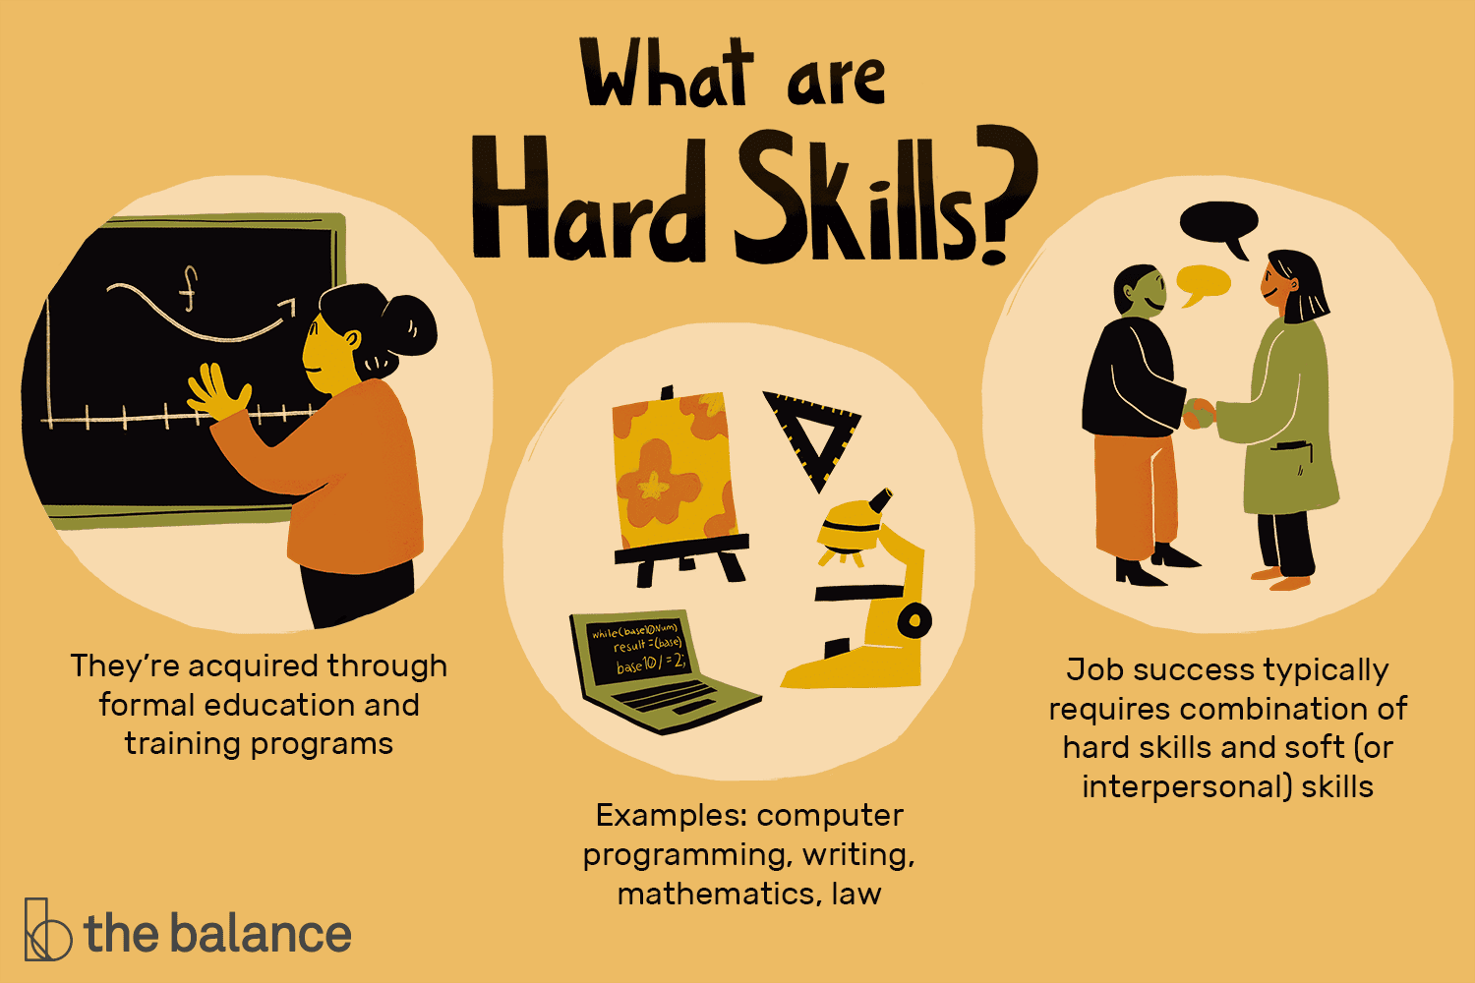
This then progresses onto employment, which relies on your ability to be independent, collaborative and forward thinking. The two are linked as when studying you to need to be an independent learner and organise your day effectively to study and maximise the outcome. This skill is also used in employment as most jobs look for organisation skills as an essential requirement.
When studying you may have a lot of assignments with tight deadlines. This helps students to manage their time management due to a large workload. This is also the case in the world of employment. “Research outside education suggests that good time management helps reduce the job stress that accompanies the pressures of needing to accomplish more than can be done in the time available.” [2]
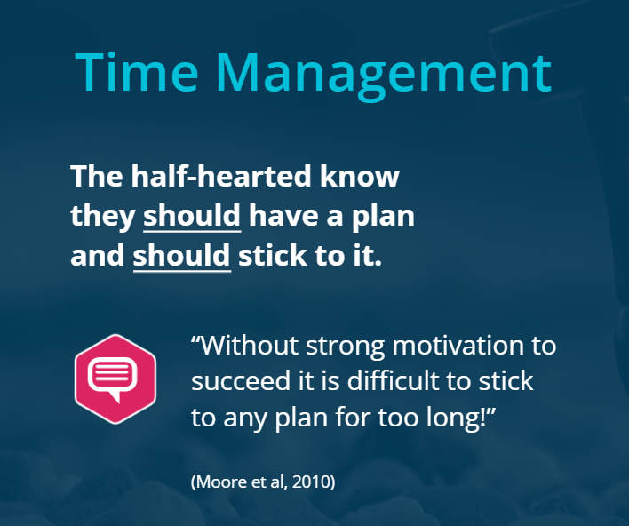
The skills that student learn from university are transferrable skills to employment that businesses need, including collaborative teamwork and development. These skills are obtained by completing projects and presentation in group work. [4]
[3]
[1]

[

