Abigail Louise Crimlis

1902008
Networking and cybersecurity essentials

ACCA4024

- Introduction
- Risks analysis
  - How a network function’s
  - Prominent threats in cybersecurity
    - Malware and viruses
    - DDOS attacks
    - User error
    - Phishing and Vishing
- Proposed techniques for mitigating attacks
  - Mitigating DDOS attacks
  - Mitigating Malware and viruses
  - Securing the cloud
  - Mitigating Phishing attacks
  - Securing personal devices
- Design and Implementation
  - Current flaws in polices
  - Protocol suites
  - Packet sniffing
  - Implementation (see annexure)
- Conclusion

- Introduction
Technology is growing at an exponential rate, with the technology growth comes increased vulnerabilities and threats towards our cyber infrastructure threatening our work and personal life. Making sure your company is aware of how attacks may manifester, what to look for and how to prevent them are paramount for any 21st century business.

2. Risk Analysis
2.1 Basics of a network
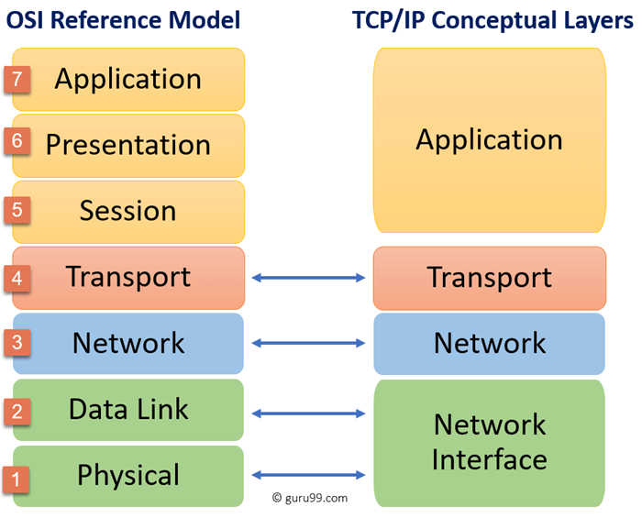
A network can be defined as a set of common communication protocols that interconnect with one another, they share resources and functionality between various devices. Data is transformed into bits that are sent through the network media to reach its destination.
A reference model is a domain-specific framework that exists to ensure clear communication between devices, an example of this is the OSI model which describes the functions and requirements needed for accessibility between different devices and software.
The TCP/IP protocol suites work within the OSI model and controls the transport layer of the OSI model.

2.2 Threats and attacks
The inability to centrally manage and update personal devices poses a growing threat to organisations that allow unmonitored devices on the network, any compromised personal device can act as an entry point into the network and therefore be used by attackers to intercept, malform or disrupt data.
2.2.1 Malwares and viruses
Malware is a malicious software that is often disguised as a legitimate app / program. They can cause harm in numerous way’s; the attackers can use this access point created by the malware to retrieve credentials from employees that will then allow them access to the corporate login system. [1]
Malware and virus attacks on mobile devices has increased in popularity since the ‘BYOD’ movement started gaining tractions within businesses; according to Verizon’s 2019 DBIR [3] 51% of identified hackers admitted to targeting mobile devices instead of using a conventional PC approach to gain access into the corporate systems.
For a network to be classed as ‘secure’ it must meet the requirements of the C.I.A triad; Confidentiality, Integrity and Accessibility.
DDos Attacks
Malware attacks are famously known for DDoS attacks(Distributed denial of service), Mirai (IoT botnet) became known in 2016, the sophisticated replicating worm virus was distributed using malware that infected any device, from home security cameras to routers and mobile devices, once the worm has sufficiently created enough ‘bot devices’, estimated around 600,000 within one month; the instigator started their attack, targeting large public figures and corporations to disrupt services and cause mass panic, the attack ‘took down the internet’ that same year by attacking a DNS service provider DYN, this caused a disruption in converting domain names to IP addresses, the effected sites ‘amazon, google, Facebook, Netflix’ among others was catastrophic to the users who were unable to gain access to the services for hours, some services required a complete reboot losing data in the process. [2]
DDos attacks make the target in accessible by overloading the network with requests or ‘pings’
User error
According to a 2014 study survey undertaken by IBM[4] 95% of security breaches are due to human error, the most commonly reported breaches are due to loss of personal devices, misconfigured systems, susceptibility to Phishing attacks and variants thereof and the use of default username / passwords or common passwords . Common passwords are stored in a lookup table that attackers can couple with a VM machine hosted through the cloud, using the lookup table and what is known as a brute-force attack, a hacker can find usernames and passwords combinations in a matter of minutes.
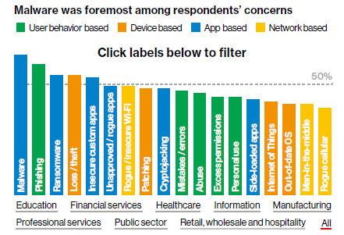
[1] Src : Verizon DBIR 2018 report PG9
Phishing and Vishing
Phishing is the act of using social engineering techniques to emotionally manipulate the user to provide sensitive information such as bank details, user login credentials or anything else the attackers may need to receive personal or financial gain.
Spear Phishing attacks are the main method used to deploy viruses, malware, and ransomware (92%) into the corporate network, one successful attack costs a business on average $1.6 million USD[6]
Phishing is deployed via emails, the attack methods used vary but most commonly are:
Click only: An embedded link that takes a user to a copycat website, these websites are usually hiding cookie stealing algorithms that track the users unknowingly or installing downloads in the background.
Data entry: A link to a login box that prompts users for username and password combinations.
Double barrel: deploys a conversational technique to gain trust from the user before sending the malicious links or files.
Highly personalized: Advanced social engineering tactics using sourced information regarding the target. [5]

sophisticated phishing emails will even use corporation email addresses they have mined or pretend to be somebody the victim knows, as shown in the figure below.
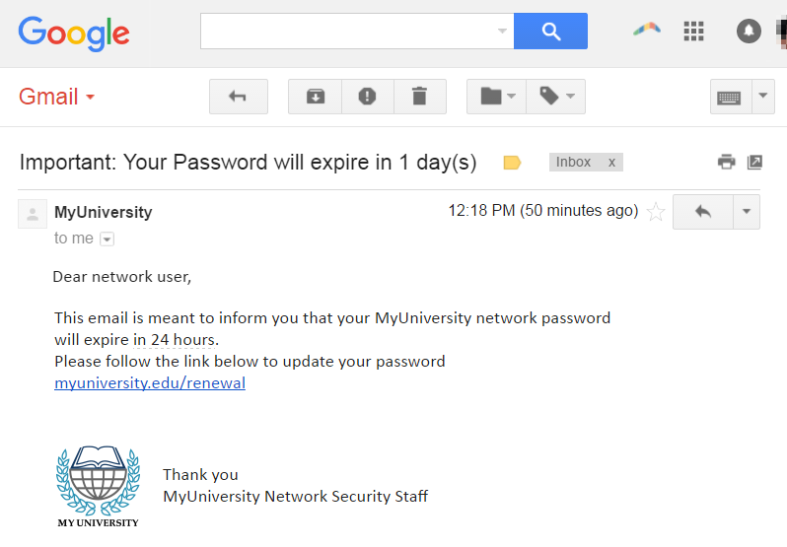
Src: Imperva @ https://www.imperva.com/learn/application-security/phishing-attack-scam/
Vishing and Smishing are other forms of Phishing that have been used more recently to attack mobile phones, they work the same as the original attack, on mobile phone recipient email addresses are usually hidden or shorten and links sent through text only shown a brief domain name making it harder to distinguish the attack.

2.2.2 Compromising the cloud
The ability to clone access to mobile devices and retrieve login details jeopardises the security of using cloud-based services. Personal devices are most susceptible to an attack when accessing a public network. MitM attackers will set up a device that captures users packet information (sniffers) whilst accessing the network point, the most common method is setting up a ‘rouge access point’ that acts and looks like a public network that has a better connection then other access point, this leaves the entire network open to unauthorized access via authorized devices.
Back door attacks are also common in this domain utilizing DDos

3. Possible techniques for mitigating attacks.
3.1 Mitigating DDOS attacks
SDN (software defined networking) is a relatively new solution to mitigating DDOS attacks. It implements software boundaries within the physical environment to redirect or cancel packet requests if certain conditions are met. The SDN acts on 3 layers: Application layer, control layer, infrastructure layer. Using North bound and South bound API protocols, these protocols allow for the communication of lower-level layers (Application layer) to higher level layers (control layer) and vice versa. The SDN software is implemented with the control level to manage packets and traffic as they are diverted to the network, the rules of the algorithm as source from Krishan.S el [7]
“ALGORITHM: Mitigation against DDoS Attack
Input: Packet-in Count (C), Bandwidth (B), Switches(S)
Output: Command to add/modify flow rule.
Step 1: Gather topology information by getting the number of switches and hosts connected to the network.
Step 2: Datapath ID (DPID) of the switch correspond to flow rule associated with the server.
Step 3: Find the DPID of the switches and decode it using the decode function.
Step 4: Find the attachment point of each of the hosts.
Step 5: Get the packet count, byte count, cookie value and Bandwidth value from the switches.
Step 6: If bits per second for source > 10000, such source may be an attacker, go to step 8.
Step 7: Else go to Step 1 and checks for an attack
Step 8: A new flow rule is written to block further request from that source.
Step 9: This new flow rule is added to switches with specific DPID.”

3.2 Mitigating Malware and viruses
Ensure users are correctly trained regarding how to spot potential malware carriers by providing employees with security education and awareness training. Ensure all data is backed up and the cloud service provider does not delete previous file versions once a new version is created, this will insure the integrity and availability of all data if an attack were to occur. [8]
Implement internet security gateways on the remote access points to ensure only validated traffic is allowed through the network.
Add a VPN into the network in which users will connect with a 2-factor authentication protocol. This will secure the data behind a DMZ network, allowing only users with the correct rights will be allowed access to the data.

3.3 Securing the cloud
SSH protocols can be implemented to securely encrypt a 2-way connection between a host and client device, SSH uses asymmetric keys to allow each user to access the content with their own private key, this mitigates the threat of man-in-the-middle attack and offers secure access onto the company network.
3.4 Mitigating Phishing attacks
To ensure data integrity it is important that all employees are behaviourally conditioned to decrease their susceptibility to attacks, specifically Phishing / Vishing and Smishing. A study undertaken by PhishMe showed that effective training can reduce the likelihood of an employee opening and acting on a phishing email by 97.14% [5].
3.4.1 Securing personal devices
Each employers device needs a secure login / password combination. to implement this, advise the employees on what makes a good password and show how easy it is for an attacker to gain access to poor / default passwords.
- Design and implementation
  - Current flaws in polices
- Allowing unmonitored personal devices to access private information through a third-party network
- Allowing potential unsecure devices on to the network
- Underdeveloped staff training
- Inappropriate network topology
  - Protocol suites needed to secure
SMTP & POP3: Securing, storing, and deleting emails that are sent through the network.
SSH: Shell Secure protocol allows for encrypted communications through the network when accessed from a remote device.
2-Factor authentication when accessing the cloud services, this will prevent user accounts that have been compromised gaining access to the server.
Deploy UDP suite, although less secure it would be necessary in this case as it allows video streaming at a faster rate, without interruption.

  - Packet sniffing
Packet sniffing is a form of attack that uses hardware and or computer software to analyse and capture packets that are travelling through the network. Attackers can use this packet information to see MAC addresses, IP addresses, file types and protocols in place on the network.
Many different types of software’s and devices can be used for this purpose.
-BetterCap: A device that captures HTTP, HTTPS and TCP traffic.
-EtterCap: A software that can be used to implement all types of attacks, it allows for live sniffing among other features.
-Wireshark: the most popular packet analyser.
-Dsnif: A software which main focus is to crack passwords travelling through the network.
-EtherApe: Linux operating system that adds a more graphical approach to analysing data.
Below are a few of the types of packets that can been intercepted using sniffer technology.
ARP: A protocol that is used to map IP addresses and link them with the correct MAC address for the device. A term named ARP spoofing is when an attacker who has implemented a sniffing device onto the network intercepts the ARP packet and sends back the information of their own device, therefor manipulating the ARP table and gaining access to the local network.
STTP: Hackers can seek packets that are attached to this protocol, they can gain access to emails that have been sent across the device and also send phishing emails once they have infiltrated the ARP table.
FTP: File transfer protocol, this can be used to intercept incoming and outgoing files on the network.
HTTP: Attackers can browse web traffic running through the network
They can see pretty much everything that happens on the network, they can capture telnet passwords to gain access to the router terminal. DHCP assignments to each device, Router configurations and instant messages that take place within the network.
Mitigating Sniffing attacks
There are software’s available that will mitigate the effects sniffers have on the network. Anti-sniffing software works by sending crafted ethernet frames to the devices on the network, devices that are in ‘promiscuous mode’ will illicit a response, authorised devices on the network will not.
Implementing a VPN into the network will also help with this by diverting traffic anonymously through the network.
[9]

  - Implementation
See Annexure for sniffing attack demonstration.

- Conclusion
95% of recorded security breaches are due to errors, this can be minimized by ensuring staff are behaviourally conditioned to deal with noticing security threats.
Ensure correct protocols are used to encrypt and channel data when at rest, use and transit.
Implement DMZ network topology to implement Role-based-access and protect data behind a firewall.
VPN and Anti-sniffing software can assist with mitigating packet sniffing attacks.
REFERENCES

[1] National cyber security centre: “Mitigating malware and ransomware attacks”, Published: 13/02/2020, available online: https://www.ncsc.gov.uk/guidance/mitigating-malware-and-ransomware-attacks accessed: 14 /12/2020
[2] Elie Bursztein https://blog.cloudflare.com/inside-mirai-the-infamous-iot-botnet-a-retrospective-analysis/
[3] Verizon https://enterprise.verizon.com/content/dam/resources/reports/msi-2019-report.pdf
[4] IBM – “IBM Security Services 2014 Cyber Security Intelligence Index” available online: https://i.crn.com/sites/default/files/ckfinderimages/userfiles/images/crn/custom/IBMSecurityServices2014.PDF accessed online: 23/12/2020
[5] PhishMe: “Enterprise Phishing Susceptibility Report”, available online: https://qhf0l1i8l8u25b2354fr8h39-wpengine.netdna-ssl.com/wp-content/uploads/2017/10/PhishMe_EnterprisePhishingSusceptibilityReport_2015_Final.pdf accessed: 23/12/2020
[6] https://www.keepnetlabs.com/phishing-statistics-you-need-to-know-to-protect-your-organization/
[7] S. Krishnan and J. J. E. Oliver, "Mitigating DDoS Attacks in Software Defined Networks," 2019 3rd International Conference on Trends in Electronics and Informatics (ICOEI), Tirunelveli, India, 2019, pp. 960-963, doi: 10.1109/ICOEI.2019.8862589. Available online: https://ieeexplore.ieee.org/abstract/document/8862589?casa_token=3uKu9pQIgfYAAAAA:CNkazNrUxj4dBw5S2N0EsUZSlPRrIJ9mnOBLA-DVsZVPSsF80WduzjTkRbfNZ3TPdW-It8J2aCp_lg accessed: 28/12/2020
[8] National Cyber security centre: “Mitigating malware and ransomware attacks” published: 12/2/2019, available online: https://www.ncsc.gov.uk/guidance/mitigating-malware-and-ransomware-attacks#preventmalwaredelivery accessed: 1/1/2021
[9] SANS Institute: “Global information Assurance certification paper”, Published: GIAC directory of certified professionals, available online: https://www.giac.org/paper/gsec/274/sniffer-detection-tools-countermeasures/100856 accessed: 6/01/2021

