

Programme Name: Master of Business Administration
Name and Code of the Module: International Marketing: Principles and Practices LCMB7026
Title: International Marketing: Principles and Practices- BMW(Germany and the USA)
Lecturer’s Name: Tushara Balendran
Name:- Meet Piyushkumar Ahir
Student ID:- 2436049
Submission Date: 19 DECEMBER, 2025

Table of Contents
1.Introduction:- 3
2.Brand overview:- 3
3.Comparison of the socio-cultural context of Country A (Germany) and Country B (USA):- 5
PESTLE:- 5
Cultural analysis based on the Hofstede model (6 dimensions):- 7
Similarities and dissimilarities of the PESTEL:- 11
4.Comparison of Brand’s STP strategies in Germany and the USA:- 11
similarities and differences of STP:- 14
5.Comparison of Marketing Mix Strategies in Germany and USA:- 16
6.Evaluation of the performance of marketing strategies:- 24
7.Evaluation of ethical issues:- 27
Overall ethical judgement:- 28
8.Recommendation & Conclusion:- 29
Reference List:- 31
Appendices:- 40
Appendix 1: PESTLE of Germany and the USA 40
Appendix 2: STP 41
Appendix 3: Implications of the theory towards market segmentation 42
Appendix 4: Ethical issues in the treatment of local employees 42
Appendix 5: Stores of BMW in Germany and the USA 43

1.Introduction:-
An effective market system is built on how well the company addresses customer needs. The marketing mix is a tool that highlights the key marketing features to build a stable, long-lasting market segment within the targeted market. In this report, BMW is considered as the main company and the analysis is developed based on that. The chosen two countries are Germany and the USA. An evaluation of their marketing practices in these two countries is effective for determining how they change based on the targeted market.
Rationale for selecting the company:-
BMW is selected because it is a globally recognised premium automobile manufacturer with strong brand equity and a broader international presence (BMW Group, 2025). Its operations in Germany and the USA provide a strong basis for the development of comparative analysis. Its long-established operations in both Germany (its home market) and the USA (one of its largest international markets) make it especially valuable for comparative investigation. Therefore, BMW across these two contexts is crucial to understand how multinational brands are involved in balancing global standardisation with local responsiveness.

2.Brand overview:-
BMW is a public limited company in the automobile industry. Camillo Castiglioni and Franz Josef Popp were the founders of the brand (BMW, 2025). The headquarter is in Munich, Germany, but the brand has expanded its marketing range worldwide. According to the recent report, the company produced 2,661,922 cars in 2023 and generated revenue of €155.50 billion (BMW Group Report, 2025). 154,950 employees are now working here. The motto of the company is to create a platform where they can explore the newest technological trends. The key brands included are BMW, MINI and Rolls-Royce (BMW, 2025). The product range includes a variety of Premium cars, motor-cycles and bicycles, and for its quality and company reputation, the brand has occupied a significant share of the global automotive market.
At the global scale, BMW competes with Mercedes-Benz, Audi, Lexus, Tesla, and Porsche, especially in the premium and electric vehicle segments. The company is recognised as a traditional international firm over a born-global company, as it widely expanded over decades. Germany serves as the home country, while the USA is considered as a host country. BMW entered across the US market through leading export and later foreign direct investment (FDI) through the establishment of manufacturing plants (Bmwgroup, 2025). The prime reasons for internationalisation include reaching high-income consumer bases, diversification of revenue streams, and reduction of production risks along with strengthening brand presence. BMW’s international expansion directly reflects alignment of principles of the Uppsala model, as the company first entered psychically and geographically close markets before entering in the international market like the USA through integration of a gradual learning-based approach to manage risks and development of market knowledge.

Figure 1: Logo of BMW
(Source: BMW, 2025)

3.Comparison of the socio-cultural context of Country A (Germany) and Country B (USA):-

PESTLE:-
In order to compare the socio-cultural context of two countries, PESTLE analysis can be the appropriate one. In this regard, the following section develops a comparative PESTLE analysis of Germany and the USA, with an impact analysis on the BMW business. (Refer to Appendix 1)
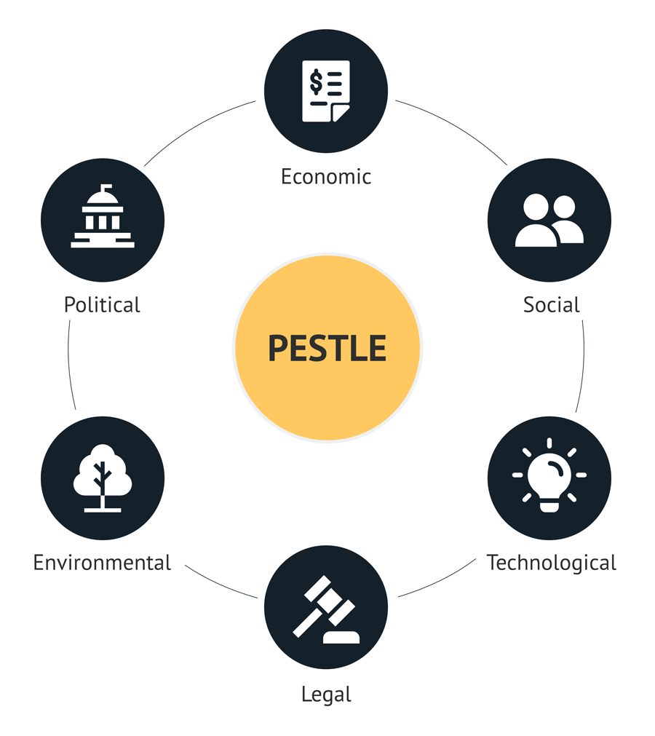
Figure 2: PESTLE
(Source: Heubel, 2024)
Political:-
It is seen that a stable parliamentary democracy is present in Germany and a leading EU policymaker. In the USA, The Federal presidential system is present and the major global military system has a direct impact on the country’s political system (Council on Foreign Relations, 2025). In Germany, Geopolitical reliance on EU energy policy may help a company to manage a sustainable base, while in the USA, major global military and diplomatic influence may hinder the process.
Favourable and Unfavourable:-
The political environment in both the countries is favourable as it will allow BMW to conduct business smoothy. However, geopolitical scenario is unfavourable for BMW as USA has major control in the global market than Germany.
Economic:-
It is seen that Germany's GDP was $4.66T in 2024 and the rate of unemployment was 4% (Destatis, 2025). The GDP rate in the USA is $30T in 2024-25 (Refer to Appendix 1), and the unemployment rate is 4.3%. It is seen that the unemployment rate is ~4.0% in Germany, but it is 4.3% in the USA (Tradingeconomics, 2025). The inflation rate is 2.4% in Germany (Destatis, 2025), but in the USA, it is higher, that is 2.9% (Spglobal, 2025).
Favourable and Unfavourable :-
GDP of both countries is favourable to BMW as it will support it to manage and increase their production. However, the inflation rate is unfavourable as it can directly have effect on the overall production and shipment of the products.
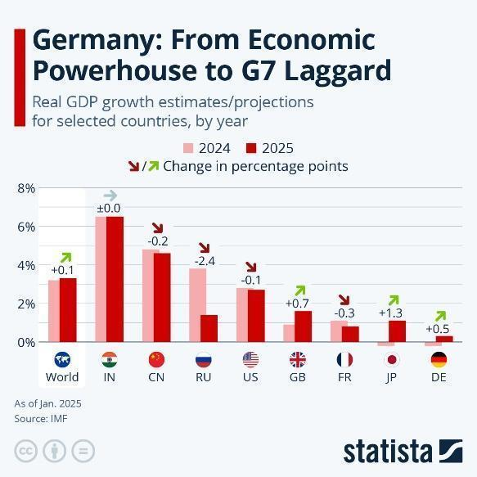
Figure 3: GDP in Germany
(Source: Richter, 2025)
Social:-
The population of Germany is 83,920,340 as of October 2025 and the literacy rate is approximately 100% (Burton, 2025). The population is 347,862,080 in the US as of October 2025, which is far higher than Germany's (Worldometer, 2025). The rate of literacy is nearly 100 per cent percent in Germany and in the USA, the rate of literacy is 99% for individuals over 15 (World Population Review, 2025).

Favourable and Unfavourable:-
The increasing population is favourable as it will allow BMW to reach more customers and increase sales. However, the aging population is unfavourable as it would restrict or reduce demand for high-end or performance centric vehicles.
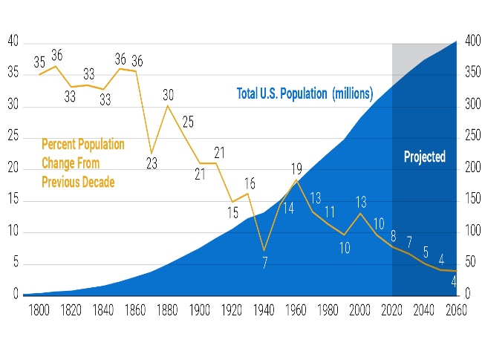
Figure 4: Population growth in the USA
(Source: Pollard et al. 2020)

Cultural analysis based on the Hofstede model (6 dimensions):-
The Hofstede Cultural Dimension Model comprises six areas that lead to comparisons in the context of assessing national cultures, taking into account consumer behaviour, management expectations and marketing communication strategies (Jan et al. 2024). (Refer to Appendix 2)
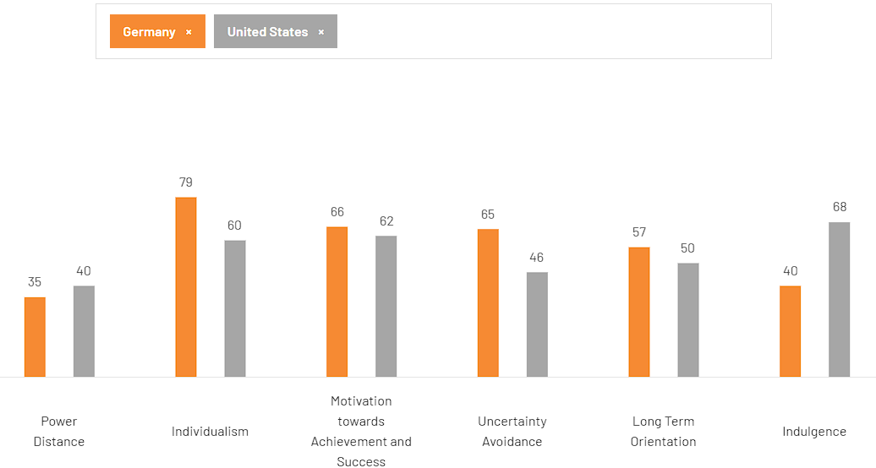
Figure 6: Hofstede Cultural Dimensions comparison between Germany and the United States
(Source: Theculturefactor, 2025)
With respect to the power distance dimension, Germany scores 35, while the United States scores 40. Societies value equality, decentralised structure and participatory decision-making. In both countries, BMW faces critical conditions to shape marketing strategies emphasising autonomy, user control and transparency in managing performance (Businessmodelanalyst, 2025). However, Germany's low score in power distance reflects greater customer expectation, prior precision, engineering logic and availability of product information in comparison to the USA, where consumers are slightly receptive to dealing with authoritative branding messages. Before the context of individualism, Germany scores 79, which is significantly higher than the USA (60), which reinforces a strong cultural impact on personal responsibility, privacy and self-reliance (Theculturefactor, 2025). BMW directly aligns its 'Sheer Driving Pleasure' perspective with a value orientation that positively appeals to personal achievement and technical mastery (BMW, 2025). In contrast to this, the USA scores moderately lower in individualism as its culture greatly emphasises community-driven consumption patterns with respect to priority to collectivism.
In the context of motivation towards achieving success, Germany scores 66, while the USA scores slightly lower at 62, suggesting similarities between the two countries as they are success-oriented (Theculturefactor, 2025). However, Germany suggested a slightly higher score in the context of quality, value of craftsmanship and dealing with professional achievement. Through this, BMW gains utmost benefits to achieve engineering excellence (Bmwgroup, 2025). Apart from this, significant cultural differences are determined in the context of uncertainty avoidance, as Germany scores 65 and the USA scores 46 (Theculturefactor, 2025). In this regard, Germany prefers clarity, ensuring detailed information and long-term reliability. In the USA, consumers accepted a higher degree of ambiguity, which directed BMW to deal with lifestyle-driven approaches (Manjula, 2025). Prior to long-term orientation, Germany scores 57 and the USA scores 50, which reflects a broader level of forward-planning behaviour (Theculturefactor, 2025). Moreover, indulgence shows that Germany ranks 40, while the USA ranks 68. However, the USA's strong influence reflects consumer willingness to make pleasure-driven purchases, while Germans exhibit more restrained habits.
Similarity and differences of the Hofstede’s Model:-
With respect to cultural perspectives, both Germany and the USA offer favourable conditions for BMW, each with its own strengths. Germany's strong long-term orientation, high uncertainty avoidance and emphasis on achievement ensure support for BMW's premium-quality product development (Jaroenwanit, 2025). At the same time, lower consumer indulgence in Germany enabled greater spending on premium-quality products. In contrast, high indulgence and a culture of individualism create favourable conditions to some extent before aligning lifestyle-driven strategies. However, the USA's low-uncertainty focus suggests that BMW consumers are less influenced by engineering superiority.
Advantages and disadvantages of the Hofstede’s Model:-
The application of Hofstede model is advantageous to BMW as it will help to understand cross-cultural environment, thereby, will allow to effectively assess differences in consumer preferences (Ikhsan et al. 2024). In addition, the model is effective to support the company in adapting market campaigns and customer service to local cultural values.
The model significantly emphasises on national culture due to which internal culture of the organisation would vary substantially from the national averages (Nemirovsky, 2025). Also, the model would not be completely effective in predicting specific choices of customers or response to products offered by BMW.
Technological:-
Germany has a proud history of research and innovation. Along with this, with a global market share of around 14%, it is also a leading nation in developing green products and services (Appunn, 2021). It was reported that the German government has set aside around 3 billion Euros for the research and development of artificial intelligence, to be spent through 2025. In the USA, the growth prospects of technology are also developing. For example, in 2025, it is recorded that the tech spending is projected to grow by 6.1% 2025 (Deloitte Insights, 2025).

Favourable and Unfavourable:-
The investment in R&D is favourable for BMW as it will allow it to design and develop new vehicles to meet the changing needs of the customers. However, high-tech competition and R&D cost are unfavourable as it impacts the production and operational value of the organisation.
Legal:-
The German legal system is robust and stringent labour protections and data/privacy regulations (GDPR) increase compliance costs for firms. In the USA, the involvement of the Disabilities Act (ADA), the Civil Rights Act of 1964 (Equal Employment Opportunity Commission, 2025), as well as the Family and Medical Leave Act (FMLA) is helpful for BMW.
Favourable and Unfavourable:-
Consumer protection laws are favourable in both countries as it supports in building consumer trust. On the other hand, meeting strict emissions standards can be unfavourable to BMW as the company would experience high compliance costs for meeting sustainability targets and benchmark.
Environmental:-
In Germany, emissions are falling and renewables exceeded 50% of electricity generation in 2023 (Ember-energy, 2025). It is identified that customers in this country value sustainability, which is important for companies to align their business activities to sustainability practices and eco-conscious culture. In the USA, per-capita emissions are higher than in Germany's, and the electricity mix is fossil-heavy in some places. In this country as well, eco-friendly vehicles are significantly demanded as it helps in reducing harmful gas emissions and protect the nature.
Favourable and Unfavourable:-
The favourable aspect is increasing demand for eco-friendly automobiles as it will allow BMW to more manufacture eco-friendly vehicles. However, varying emissions and environmental standards are imposed by different regions, which can be unfavourable to compliance efforts of BMW.
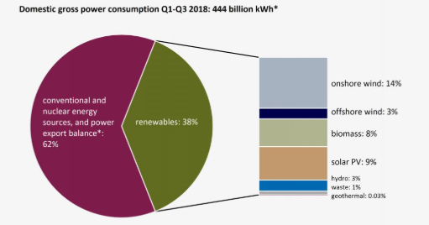
Figure 5: Use of renewables in Germany
(Source: Amelang and Wettengel, 2018)

Similarities and dissimilarities of the PESTEL:-
It can be highlighted that conducting business in a stable business environment is easier for BMW due to having a peaceful political environment and supportive regulatory policies. Further, increasing GDP rate in a particular country is beneficial for the organisation to operate and increase the production rate. Also, increasing population in both countries can help to capture larger customer base.
In context to dissimilarities, it can be pointed out that countries have distinct emission standards due to which it can be a challenge to comply the organisation’s sustainable practices with the respective government’s rules and regulations. Further, the use of renewable sources is different in countries, which can increase the cost of operation of the companies like BMW.

4.Comparison of Brand’s STP strategies in Germany and the USA:-
Maintaining a stable market base in a country, it is needed to understand the key demands of the customers. While determining the key demands of the customers, the features of the targeted customers are noted. In the following part of the discussion, the STP of BMW, based on its business in Germany and the USA, is explained.
Segmentation:-
It also segments its market, prioritising premium style, high income level and engineering preference. On the other hand, BMW prioritises income, lifestyle aspiration, vehicle size preference, performance appeal, and status-driven motives. (Refer to Appendix 3)
Demographic | Germany: BMW segmented its consumer base into 30-55-year-olds in Germany (Repositori, 2025).  USA: BMW segments its customers in the USA who are between 18-29 years (Bashir, 2025).
Behavioural | Germany: Consumers who show high brand loyalty, preference to technologically advanced safety features, and consistent demand for fuel-efficient and hybrid models. German buyers also engaged in prioritising long-term reliability and after-sales service excellence (Frankenberg, 2024).  USA: Behavioural segmentation also focuses on customers who are focused on performance-oriented driving, premium comfort along with customisation options.
Psychographic | Germany: BMW is strongly appealing to consumers prioritising performance-conscious lifestyle, valuing precision, craftsmanship, innovation, and environmental responsibility (Frankenberg, 2024).  USA: Psychographic profile directly emphasises status-driven, aspirational, and lifestyle-enhancing motives.
Geographic | Germany: BMW targets urban regions such as Munich, Berlin, Hamburg, and Frankfurt.  USA: BMW focuses on states with large luxury markets, particularly California, New York, Florida, and Texas.
Table 1: Market segmentation
(Source: Self-developed)
Targeting:-
A concentrated targeting strategy was applied to focus on high-income professionals, environmentally conscious drivers, and technology-focused customers. It is indicating a differentiated targeting in the country. They are appealing to German preferences for engineering excellence and sustainability (Lema et al. 2025). Additionally, in Germany, a differentiated strategy also leads to a narrower and technology-oriented approach as they tailor their products to highly knowledgeable and engineering-focused consumers. In this regard, variations in products strongly emphasise precision, efficiency and the desired levels of scalability (Iranshahi et al. 2025).
They are fundamentally promoting through an emotionally appealing approach, including high-convenience packages, customisation options and enhanced luxury products, which are more prominent than in Germany. In the US also a differentiated targeting strategy focuses on luxury-seeking professionals, families who prefer large vehicles and performance-focused customers (Hoenig, 2025). BMW appeals to American preference for comfort, space and power. A major advantage of this is associated with enhanced consumer reach and higher satisfaction of the consumer base. However, disadvantages for both the market are coined with higher cost involvement for advertisement generation.
With respect to the high indulgence score of the USA, alignment of emotional and social status-related messaging leads to encouragement to retain new buyers. Therefore, a concentrated strategy is not fruitful for BMW due to the existence of a wider product portfolio.
Positioning:-
In Germany, BMW positioned its brand as a precision-engineered, sustainable, and innovative luxury brand. It is notable that German customers are highly prioritising reliability and detailed product specifications.
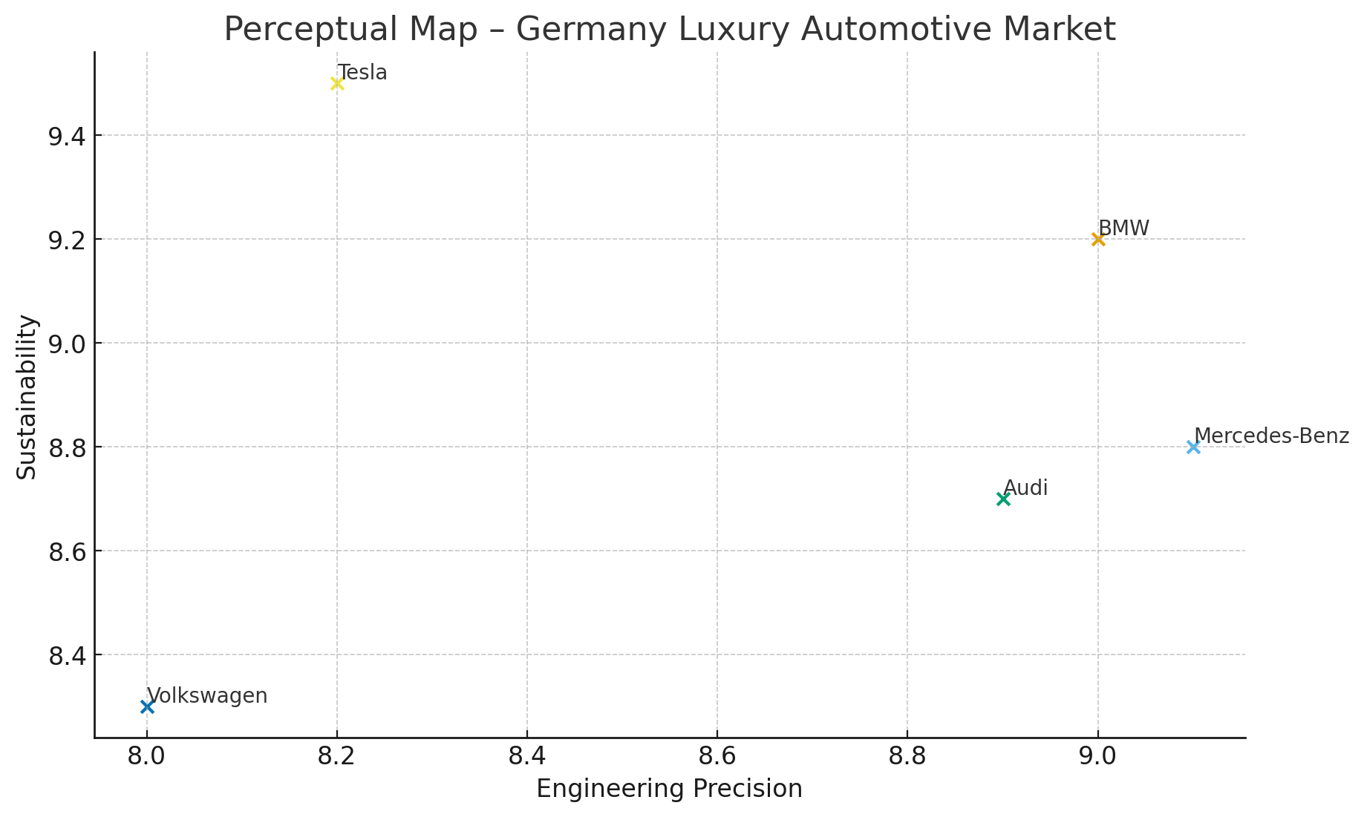
Figure 7: Perceptual Map of BMW in Germany
In USA, BMW also positioned its brand as a luxury performance and lifestyle-driven brand. In this regard, BMW leads in model differentiation through advanced engineering and top-tier safety systems (BMW Group, 2025). Therefore, a strong presence of domestic competitors underscores the need to refine target market segmentation.
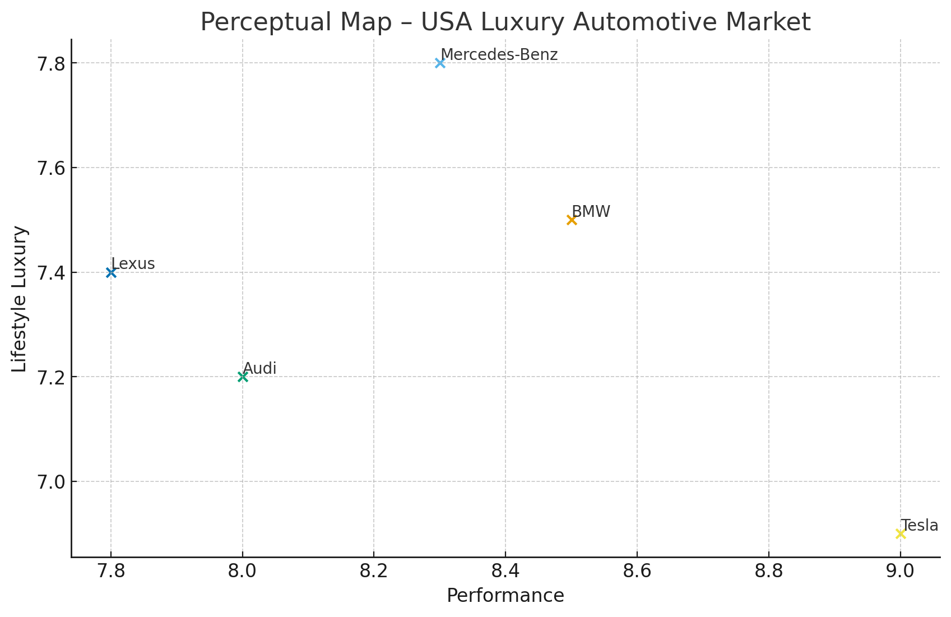
Figure 8: Perceptual Map of BMW in Germany
BMW's positioning in Germany and the USA signifies premium engineering and a luxury brand identity, reflecting consistency in global branding (BMW Group, 2025). It also reinforced through the adoption of multiple premium customer segments, aligning value, quality, brand prestige and performance. However, in Germany, segmentation is more focused on technical expectations and sustainability concerns.

similarities and differences of STP:-
In both Germany and the USA, BMW adopted a differentiated targeting strategy as they were concerned with established differences in local market dynamics. The application of a differentiated strategy allows BMW to serve multiple customer groups with specific product lines. This approach aligns with BMW's multi-segment brand structure and a premium-grade market orientation (Sushmith, 2024). In the USA, BMW has implemented differentiation strategies at a broader level, prioritising lifestyle-driven approaches. BMW centralises urban luxury users, SUV-oriented families, performance-driven buyers and young professionals (Shirsath, 2025). While, an undifferentiated strategy would also undermine the brand value and identity (Pfeifer et al. 2025).
A differentiated triaging strategy would have a significant impact on strategic and cultural alignment to drive values from both of these markets. The key similarity between the German and US markets has been identified in the context of differentiated segmentation and targeting strategies. On the other hand, positioning is also aligned with engineering excellence and the values of precision and durability. While Germans value high uncertainty avoidance, it reflects a preference for a rational, specification-focused marketing strategy. In contrast, in the USA, segmentation is broader and more lifestyle-oriented (Saxena, 2021). Therefore, the STP framework remains structurally similar across both BMW markets. With respect to its segmentation, targeting, and positioning strategies, BMW consistently follows its strategic measures and aligns with cultural expectations, which broadly impact its approach to lifestyle-driven markets. Moreover, consumer motivations in both countries reflect a value placed on people, empowering BMW to signify its position by prioritising the scale of its operations.

5.Comparison of Marketing Mix Strategies in Germany and USA:-
It is needless to mention that every company must have a particular specific marketing mix strategy and based on the different market ranges, those strategies can also be different. For example, the marketing mix of BMW can differ in the USA compared to Germany. The marketing mix of BMW in Germany and the USA is as mentioned below-
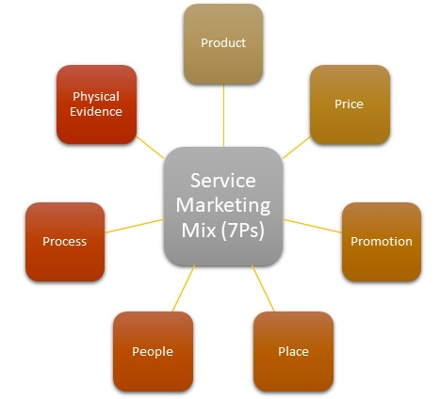
Figure 9: 7 P’s
(Source: Self-created)
- Product
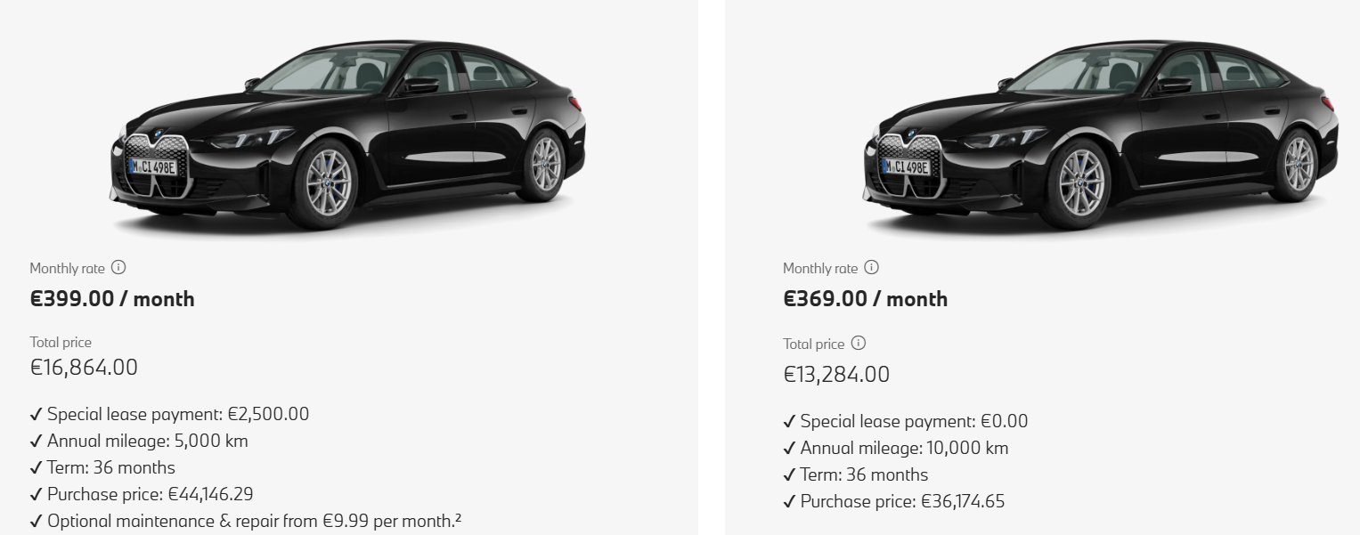
Figure 10: i4 BMW Model, Germany
(Source: BMW.de, 2025)
Product Width
In Germany, BMW offers a wide portfolio including the 1, 3, 5, and 7 Series, along with X and I models. It is noted that German consumers prioritise build quality and driving experience, aligning with BMW's "Sheer Driving Pleasure" philosophy. BMW's main product base centres on premium automotive engineering, innovation and performance (BMW Group Report, 2025). The German market also has strong demand for the X series including X1, X3, X5 reflecting the country’s emphasis on innovation and sustainability.
Product Depth
The depth of the product line is considered in the multiple trims, engine variations, and performance editions such as M3, M5, which align with German consumers’ preference for engineering precision and superior driving dynamics (Bmwgroup, 2025). In this regard, in Germany the company can attain success through a standardisation strategy. It is to be further pointed out that different branding strategies are adopted by BMW in Germany such as strongly focus on eco-friendly mobility and align with EU regulation and environmental consciousness. Also, it values German traditions and integrate culture to attract customers.
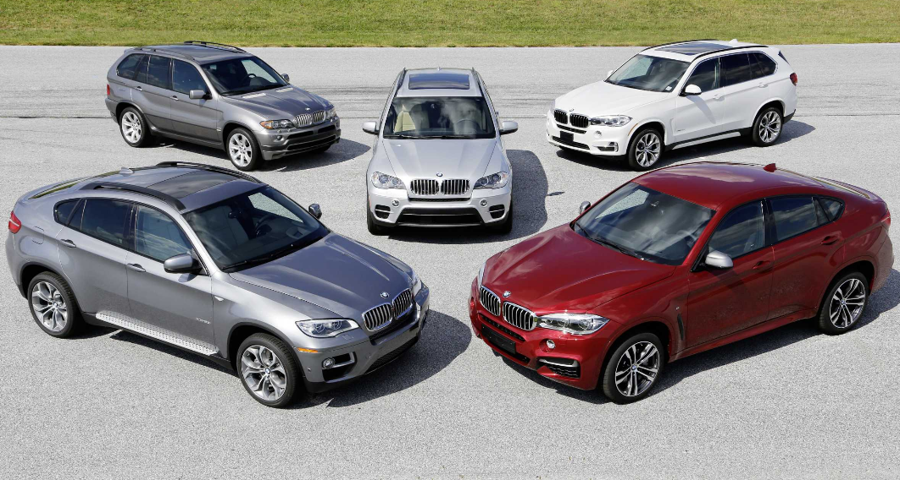
Figure 11: BMW X Models, USA
(Source: BMW Group, 2025)
Product Depth
In the USA, the main emphasis is given to the luxury and comfort of cars. Thus, it leads to promoting larger SUVs such as the X5, X7, and M-series (BMW Group Report, 2025). However, based on differing market needs, product diversification is seen.

Product Width
Considering width of products in the US, it is found that BMW has range of product lines such as Sedans, Coupes & Convertibles, SAVs/SUVs, performance models, EVs and roadsters. Further, depth of products of BMW includes X-series SUV, 3 Series Sedan, EV (i4, i7, iX) and M variants performance models. On the other hand, BMW’s branding strategies in the US include focus on lifestyle and prestige, experiential marketing like sponsoring cultural events, sports and luxury lifestyle campaigns.
- Price
The company mainly follows a premium pricing strategy in both markets. In Germany, pricing is positioned within the upper tier of the premium segment and it competes effectively with Audi and Mercedes-Benz. A value-based model is followed to set the pricing strategy (BMW Group Report, 2025). The BMW 3 Series starts around €45,000–€55,000, while the BMW 5 Series ranges from €60,000–€75,000, and the 7 Series exceeds €120,000 depending on the model and trim (Stratstone, 2025). In the USA, pricing is set based on higher disposable income, but it is also developed to compete with strong American and Asian luxury brands. The BMW X5 typically ranges from $65,000–$85,000, while the larger X7 starts around $80,000–$100,000 (Stratstone, 2025). Despite the premium category, BMW offers strategic discounts, lease deals, and financing plans to attract customers in a highly competitive market dominated by both American luxury SUVs to draw customers' attention, strategic discounts, dealer incentives as well as effective financing packages are applied that enhance affordability while maintaining exclusivity.
- Place
In the USA, the brand operates a network of around 350 dealerships, supported by a broader network of regional hubs. From the Spartanburg manufacturing facility, the company exports over 60% of its production. It also focuses on omnichannel retailing, enabling customers to order vehicles online through BMW's digital showroom while maintaining in-person consultation (BMW Group Report, 2025). Further, direct channels of distribution of BMW in the USA includes online store, company-owned dealership, BMW connected app and financial services whereas indirect channels are used-car agencies, independent dealerships, retail partnerships and 3rd party leasing firms.
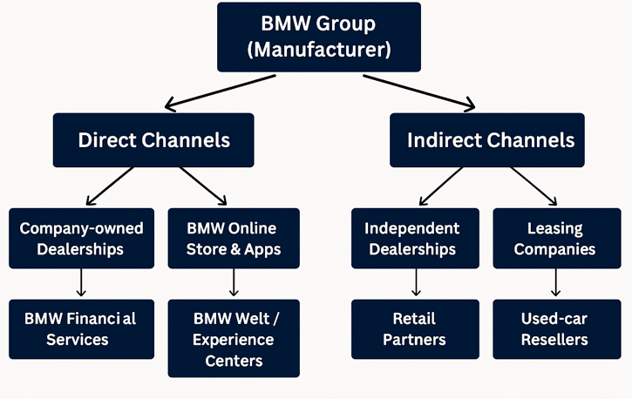
Figure 12: BMW Distribution Channels, USA
(Source: Self Developed)
In Germany, this MNC has a strong distribution network, which helps them develop customer engagement. In Germany, the company operates a dealer network with more than 500 authorised dealerships and service centres (BMW Group, 2025). As Germany is the home country for BMW, thus, no need to select an entry strategy. The company follows Home-country production and direct distribution, along with a direct sales network and a strong supplier ecosystem in Germany. Direct channels include BMW’s own showrooms, corporate-owned outlets, and the official BMW Online Store, where customers can configure and purchase vehicles digitally. Indirect channels include 500 authorised dealerships and service centres, used-car resellers, independent franchise partners, and third-party mobility providers.
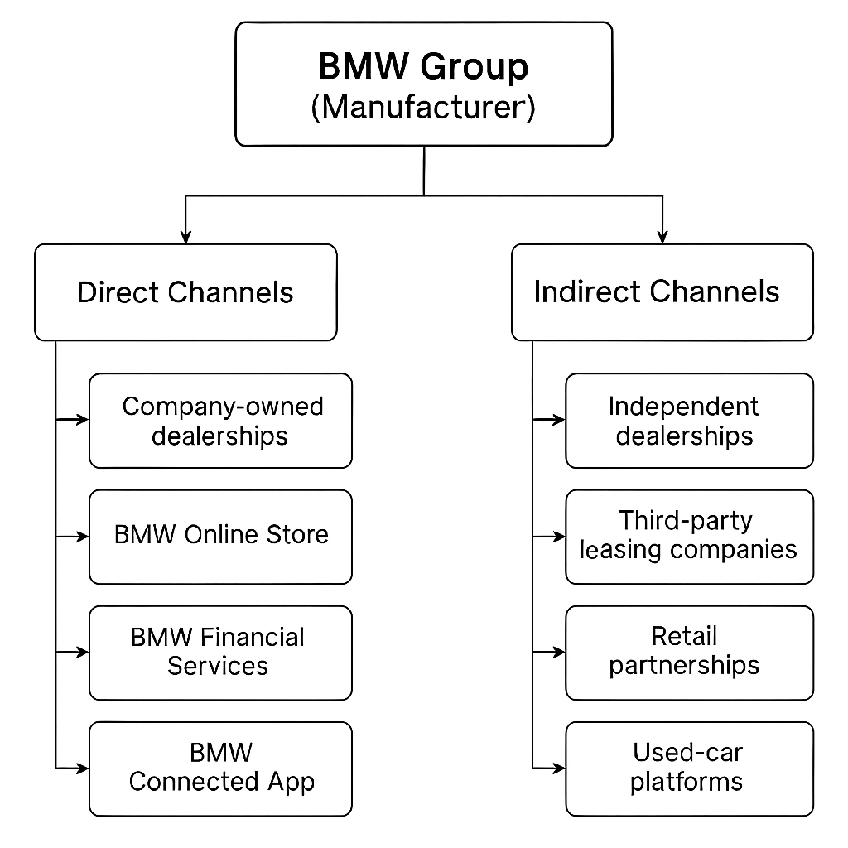
Figure 13: BMW Distribution Channels, Germany
(Source: Self Developed)
Market Entry Method:-
The USA is one of the prominent foreign markets of the company and the company has followed a Wholly-owned subsidiary (BMW of North America) and a Greenfield investment to enter (Bmwgroup, 2025). Major advantage of this strategy is linked with brand consistency, strategic expansion and control over operations (Morschett et al. 2025). However, the associated disadvantages are mainly linked with high setup costs along with local tax laws abroad.
- Promotion
The application of an effective promotional strategy helps brands gain customers' trust more easily and build a long-lasting business base (Kartomo, 2024). For example, in Germany, the company promotes engineering superiority, sustainability and heritage. Business campaigns highlight technological milestones such as electric mobility, autonomous features along with connectivity. It helps to resonate with the domestic audience's rational, quality-oriented mind-set. The campaign is developed to promote performance, luxury and aspirational success, supported by slogans like “The Ultimate Driving Machine.” Apart from this, influencer marketing methods help to uplift the company’s brand values.
- People
In Germany, staff training focuses on developing technical knowledge and product expertise and on meeting customers' needs across a broader market. It is evident that employees with an engineering background can easily resolve customer queries through data-driven consultations. Further, motivation strategies such job security and stability, work-life balance, recognition are used by BMW to encourage German staff for higher engagement and performance. In Germany, BMW has a strong workforce of 159,000 including manufacturing plants, research centres, and dealerships, with approximately (Bmwgroup, 2025) BMW's "Genius" program, a concierge-style assistance system, seems appropriate for providing on-demand product explanations and post-purchase support to address customers' broader needs.
In the USA, BMW employs around 11,000 workers across its Spartanburg plant, corporate offices, and 350 dealerships (Bmwgroup, 2025). Dealership staff are often seen to receive specialised soft-skills training to build emotional rapport and loyalty with the customers as well as other stakeholders such as suppliers. It is identified that targeted training is provided by BMW in the areas like customer services, sales and digital tools for enhancing dealership performance. Also, leadership development programs such as BMW FastTrack and BMW Service Technician Education Program help in the career growth of the staff. In addition, incentive-based compensation, flexible work options and innovative culture are provided by BMW to motivate employees.
- Process
The company's operational and service systems are prominently developed and digitised in both countries. In Germany, BMW uses Industry 4.0 manufacturing processes as well as introducing AI, robotics, and IoT within its domestic plants in Munich, Regensburg, and Leipzig (BMW, 2025). These appear helpful in managing green production. In context to customer complaint process, it can be pointed out that customers in Germany can contact BMW Dealer and further can reach out customer service by filling online form.
On the other hand, in the USA, the business process is focused on enhancing the customer experience and efficiency, supported by digital retail platforms. It becomes helpful for the customers to make online purchases. The after-sales service processes, including maintenance scheduling via the My BMW App, enhance convenience while considering U.S. consumers' time-sensitive expectations. On the other hand, customers in the US can dial 1-800-831-1117 to solve queries and also can email at customerrelations@bmwusa.com.
- Physical evidence
(Refer to Appendix 5)
In the USA, the physical evidence is based on modernity and comfort, integrating lounges, interactive configurators and delivery bays (BMW Group Report, 2025). It is evidenced that the company has 30 production sites worldwide and, in the USA, there are approximately 350 BMW passenger cars and Sports Activity Vehicle centres (BMW Group Report, 2025). The service centre keeps transparency in managing digital customers' interfaces. Thus, in short, it is stated that, from website to design, the brand relies on a global identity of premium innovation. Moreover, the tone of the website of BMW USA is consumer oriented along with emphasising innovation, prestige and affordability. On the other hand, staff uniforms in BMW USA include branded polo shirts with BMW logo and dark trousers.
In Germany, the brand's physical evidence lies in its heritage management. The BMW Welt and Museum in Munich serve as brand landmarks, presenting a considerable level of technological innovation throughout. Additionally, the use of brand-consistent design elements, such as blue-and-white colour schemes and digital displays, highlights luxury. BMW Germany website’s tone is more innovation and technical driven. Standardise uniforms are there in this country as well.
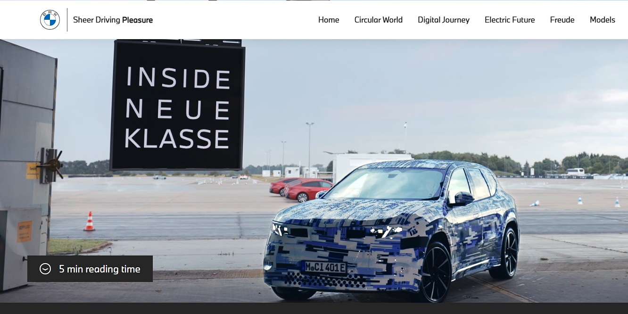
Figure 14: BMW’s website in Germany
(Source: Bmw, 2025)
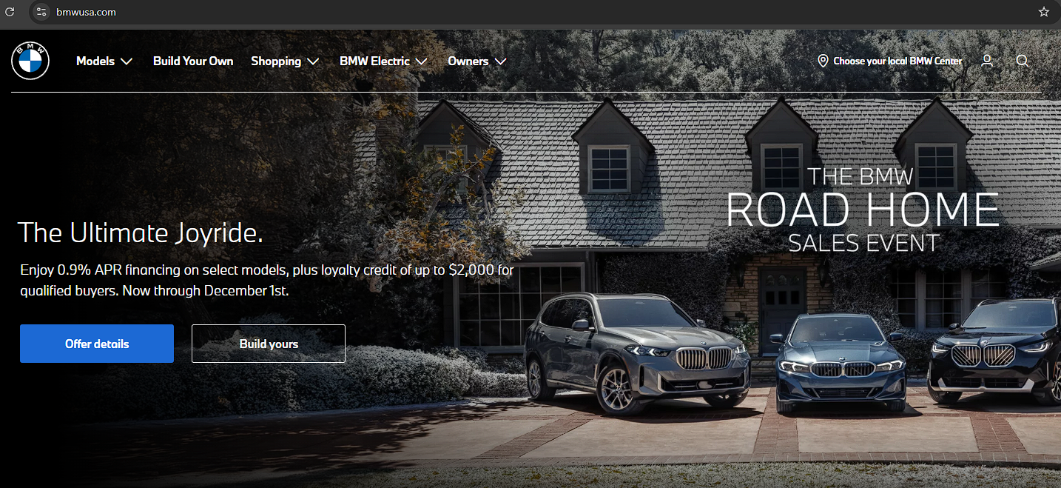
Figure 15: BMW’s website in USA
(Source: Bmwusa, 2025)
Similarities and Differences:-
BMW directly follows a premium, global brand strategy across Germany and the USA that influences innovation, luxury, and strong dealership networks. However, differences arose in the context of local preferences: Germany focuses on engineering precision, sustainability, and standardised premium sedans, whereas the USA prioritises larger SUVs, personalised service and emotional lifestyle marketing (Reddit.com, 2025). Pricing remains in the context of premium in both markets, but U.S. promotions strongly rely more on incentives, storytelling, and flexible financing to attract diverse consumer groups.

6.Evaluation of the performance of marketing strategies:-
Performance in Germany:-
BMW's marketing performance in Germany has shown strong traction across profits, sales and social media engagement, as well as customer sentiment. As of 2024, BMW recorded 224,721 vehicle sales, capturing an 8.3% share of Germany's passenger vehicle market (MarkLines, 2025). BMW also achieved strong BEV (battery-electric vehicle) uptake as it sold around 42,066 BEVs in Germany in 2024 (Bekker, 2025). With recognition as Best Selling Cars, production at BMW's German plants has reached a promising record of 1,087,067 vehicles, reflecting a 16% increase despite a slight dip in global demand. However, profitability remains under pressure, as net profit declined by around 37% in 2024 to €7.7 billion (Taylor and Gilchrist, 2025). On customer sentiment, BMW's reputation for engineering and quality remains strong in its home market.
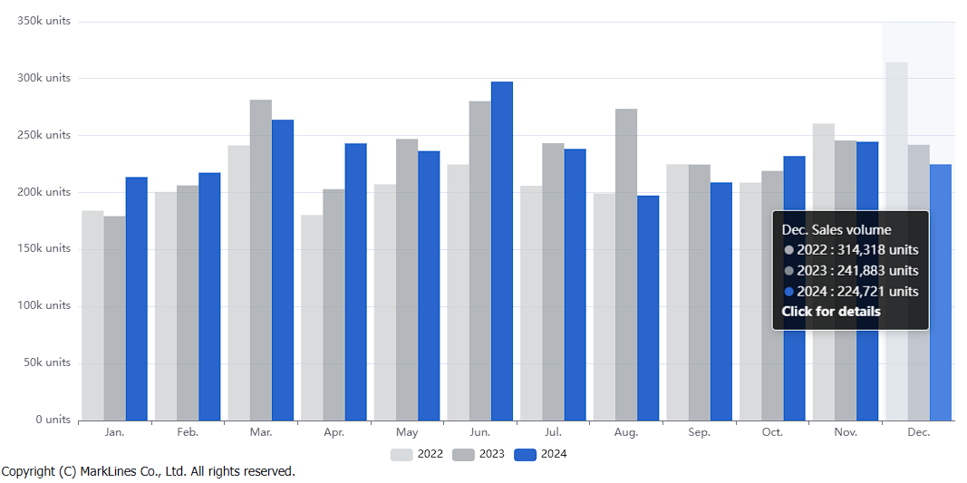
Figure 16: Sales of BMW in Germany
(Source: MarkLines, 2025)
Prior to social media management, BMW extensively relied on Instagram reels as its 78% posts in short-video formats (Mensenkampff, 2025). Therefore, German consumers engaged in demonstrating high responsiveness to BMW’s content in the context of showcasing engineering precision, sustainability initiatives, and model innovation. Moreover, customer reviews on BMW reflect a strong market position as they are the ‘BMW Lovers’. Also, any negative reviews are taken seriously by the organisation to ensure customer experience high quality and driving experience.
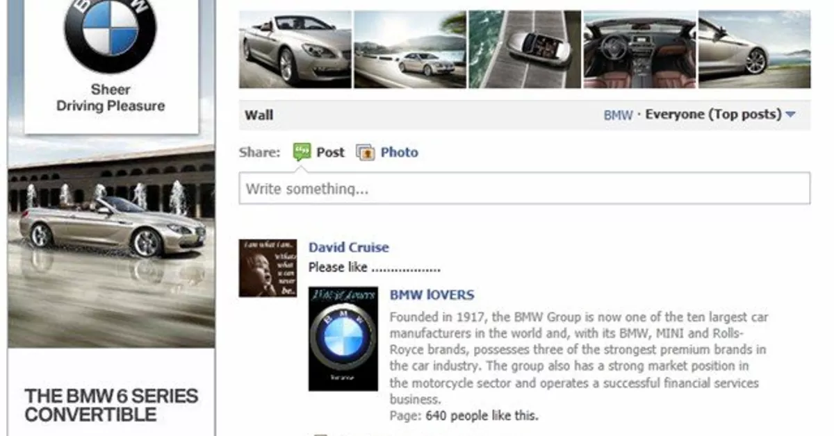
Figure 17: Customer Reviews
(Source: Tokic, 2025)
Performance in the USA:-
In the United States, BMW set a record in 2024, selling 371,346 vehicles, a 2.5% increase over 2023 (Boeriu, 2025). Most importantly, its electric vehicle (BEV) sales also increased to 50,981 BEVs in 2024, reflecting a 12.3% year-over-year increase and electrified models accounted for around 19% of total U.S. sales (BMW Group, 2025). Prioritising BMW buyers, record sales define the brand's marketing and distribution networks as performing strategically. Moreover, quarterly results increased momentum with strong performance levels through its passenger cars and light trucks. BMW brands' social media presence hosts 5.5 million fans, which directly contributes to a higher engagement rate index (BMW Group, 2025). In addition, it is to be pointed out that social media platforms such as Instagram, Facebook, TikTok and YouTube are used to engage customers. Visual storytelling is shared through different social media channels to create awareness about the brand. Customer reviews in the USA reveal strong appreciation for BMW’s driving dynamics, advanced comfort features, and prestige value.
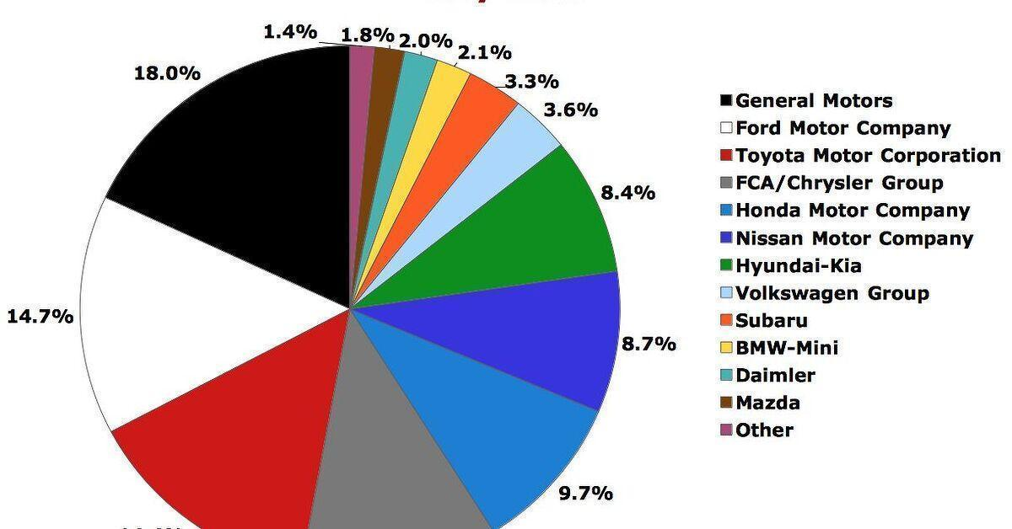
Figure 18: Market share of BMW in the USA
(Source: Cain, 2015)
Similarity and Differences:-
In both countries, BMW's marketing performance reflects both differences and similarities. In Germany, BMW sustained a strong engineering strategy that helped in the establishment of a strong position within the EV segment (Nytimes, 2025). However, the shrinkage of profits in the global market directly imposed cost pressure on BMW in the context of continuing operations in the German and US markets. Apart from this, the influence of electrification in the market has increased BMW's market share in the US and German markets, which subsequently reflects the ability to generate sales (BMW Group, 2025). In Germany, BMW strongly focuses on centralising its engineering excellence and on aspirational luxury, reflecting its promising role in EV innovation.
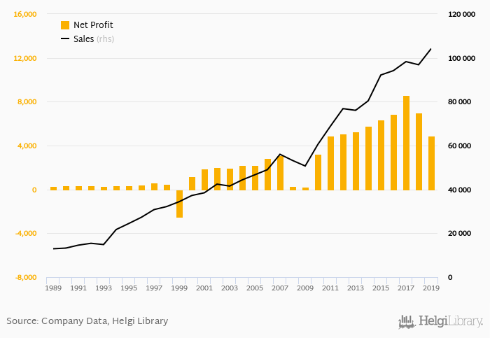
Figure 19: Profit and sales record of BMW
(Source: BMW Group, 2025)
It is seen that in both markets, the company manages its marketing base in such a manner that it can enhance the growth and stability in the industry. It is recorded that in Germany, the company is maintaining a solid market share of 8.3% with 224,721 vehicle sales in 2024. Thus, it can be interpreted that the developed engineering in automobiles and the following domestic heritage help BMW to maintain a stable market position. It is true that when a company becomes able to manage its marketing by focusing on the wider market demands, it can easily maintain a competitive base for a long time.
However, despite strong production output, profitability declined by 37%, suggesting cost pressures and market saturation in the home market. On the other hand, the USA sales volume highlights a more growth-driven market environment where BMW achieved record sales of 371,346 units in 2024. Additionally, the social media presence and the level of customer engagement are helping them to gain a more stable market share. Therefore, in short, the German market of BMW is based on maturity and strong brand loyalty, whereas the USA market is focused on growth potential and expanding EV demand. Apart from this, social media presence of BMW has reflected the value of strong presence while customer reviews also reflected diverse preference to the product inkling price related varieties and technology-based gestures.

7.Evaluation of ethical issues:-
Maintenance of marketing ethics is needed to support a company’s growth in a legitimate way. In this regard, the following are the marketing ethics practices managed by BMW in both countries.
Lack of Business Ethics: In Germany, lack of business ethics within the automotive sector have critically affected public trust and BMW is not out of such scrutiny. In this aspect, a strict regulatory environment places a higher degree of expectations on corporate transparency, responsible manufacturing and sustainability reporting. However, the cost for recall is high and it ensures full transparency, compensation and corrective measures for BMW to perform ethically.
Safety and product recall ethics: In 2024, BMW faced criticism after recalling 1.5 million vehicles following consumer concerns about a braking-system issue, which led to a sharp decline in its share price in Germany (The Guardian, 2024). At the same time, BMW addressed the recall with primary responsibility through scaling of issues, which raises ethical concerns. For a premium brand in Germany, alignment of customer safety is important to BMW.
Profitability vs Transparency: BMW's net profit disclosure shows a significant drop from 36–37% in 2024, driven by global demand reduction and cost overruns. It is true that financial downturns are common; how BMW interacts with its stakeholders and customers matters in dealing with market conditions in Germany. In the ethical context, a critical argument is driven by a lack of transparency in reporting, specifically regarding rising production costs and future model development.
Environmental sustainability issues: BMW's marketing greatly emphasises sustainability, as it achieved nearly 24.2% of its total sales in 2024, including electrified vehicles and 17.4% were fully electric (BMW Group, 2025). In this regard, ethical marketing leads focus on lower-emission vehicles, but it also raises risks of greenwashing. In Germany, where consumers are specifically tech-savvy and eco-conscious, misleading eco-claims could backfire as a result of damaging trust.
Lack of Labour and production priority: Global production strategy of BMW includes extensive use of German plants and its facility in Spartanburg, SC, which leads to mitigation of tariffs (Boeriu, 2025). On the other hand, economic and operational inefficiency also raises ethical concerns, empowering BMW to address labour practices, working conditions and fair wages across all locations. Any pivot to cost-cutting production must not compromise labour standards(Refer to Appendix 4).

Overall ethical judgement:-
Overall, BMW follows a structured approach to ethical marketing, while its practices signify diverse effectiveness. While they have a leading focus on promoting transparency, sustainability, and customer safety, ethical issues due to recalls, questions regarding financial disclosure and high potentiality in greenwashing that generates ethical tensions, particularly in the highly regulated and eco-conscious market in Germany (BMW Group, 2025). On the other hand, BMW’s global production strategy also raises significant concerns in the field of labour rights and consistency in managing working conditions (BMW Group, 2025). Regardless of these efforts to deal with responsible branding and alignment of stakeholder expectations shows gaps in managing communication clarity, ethical accountability.

8.Recommendation & Conclusion:-
Recommendations:-
USA:-
- In order to manage market risks in the USA, BMW needs to manage its competitive edge evolving premium electric vehicle (EV) market. The EV models are also available from Tesla and Mercedes-Benz; hence, the company needs to set competitive pricing with more affordable premium-entry models.
- Additionally, region-specific features such as extended-range batteries suited for long-distance American travel can also help them to gain customers’ trust. The selection of effective suppliers can help companies to gain stability in a new market range. Secondly, it can be suggested that BMW should deepen its collaboration with U.S. charging network providers to improve charging accessibility.
Germany:-
- Strategic partnerships with Electrify America, ChargePoint or regional utility firms can support BMW to set a value proposition for EV buyers. Apart from that, targeting and effective groups of customers such as millennial and Gen-Z consumers will help BMW to leverage an attracted and bouncing customer base in the competitive market.
- At the same time, BMW can emphasise on expanding digital retail channels and after-sales digitalisation to improve customer retention in an already mature market. Frequent adaptation and localisation strategies will surely help BMW to minimise market risks in the near future.

Conclusion:-
Thus, it can be concluded that this report has effectively discussed how the business of BMW can be managed in Germany as well as in the USA. Analysis of the external business environment through PESTLE and Hofstede cultural model has become beneficial to know what are the key external differences are that can impact the business process. It is mentioned that the economic environment in the USA is not particularly adverse but is tougher than in Germany. Apart from this, it can be noted that managing business in the USA is not an issue for attracting skilled individuals to BMW's automobile manufacturing operations. On the other hand, the market segmentation highlights that in both countries, the company needs to set the most promising customer base, so that it can be easier for the company to execute the marketing mix in a proper manner for long-term sustainability.

Reference List:-
Amelang, S. and Wettengel, J. (2018). Germany’s renewables share rises to 38 percent of power consumption, Clean Energy Wire. Available at: https://www.cleanenergywire.org/news/germanys-renewables-share-rises-38-percent-power-consumption (Accessed: 22 November 2025)
Appunn, K. (2021) Germany has high share in global market for Green Technologies – Report, Clean Energy Wire. Available at: https://www.cleanenergywire.org/news/germany-has-high-share-global-market-green-technologies-report (Accessed: 01 December 2025).
Bashir, U. (2025). People who primarily drive a BMW in the United States, by age, 2024. Statista. Available at: https://www.statista.com/statistics/227765/people-living-in-households-that-own-a-bmw-usa/?srsltid=AfmBOoo8x1lz4hpwADYgJe4STr_f9Colpvw1nya8BoSChWLeptYJXOvE (Accessed: 21 November 2025)
Bbmwgroup (2025) BMW Group reports strong growth in Europe and US, with significant increase in BEV sales worldwide, BMW Group PressClub. Available at: https://www.press.bmwgroup.com/global/article/detail/T0449504EN/bmw-group-reports-strong-growth-in-europe-and-us-with-significant-increase-in-bev-sales-worldwide?language=en (Accessed: 21 November 2025)
Bekker, H. (2025). Henk Bekker, Car Sales Statistics. Available at: https://www.best-selling-cars.com/germany/2024-full-year-germany-best-selling-electric-cars-by-brand-and-model/ (Accessed: 21 November 2025).
Bmw (2025). The history behind the BMW slogan ‘Sheer driving pleasure’, ‘Sheer Driving Pleasure’: BMW slogan history | BMW.com. Available at: https://www.bmw.com/en/automotive-life/the-history-of-the-bmw-slogan.html (Accessed: 21 November 2025).
BMW Group (2025) Dealerships in Germany: Locations in Germany: BMW Group Careers, Dealerships in Germany | Locations in Germany | BMW Group Careers. Available at: https://www.bmwgroup.jobs/de/en/location/dealerships-germany.html (Accessed: 05 December 2025)
BMW Group (2025). 15 years of BMW X models. Available at: https://www.press.bmwgroup.com/latin-america-caribbean/article/detail/T0195207EN/15-years-of-bmw-x-models?language=en [Accessed 4 December 2025].
BMW Group Report, 2025. Downloads: BMW Group Report 2024, Downloads | BMW Group Report 2024. Available at: https://www.bmwgroup.com/en/report/2024/downloads/index.html (Accessed: 27 October 2025)
BMW, 2025. The International BMW Website, BMW.com | The international BMW Website. Available at: https://www.bmw.com/en/index.html (Accessed: 27 October 2025)
BMW.de (2025). i4 THE BMW i4 GRAN COUPÉ. Available at: https://www.bmw.de/de/neufahrzeuge/bmw-i/i4/bmw-i4-gran-coupe.html#leasingbeispiel [Accessed 4 December 2025].
Bmwgroup (2025) B MW Group R EPORT 2021 on the way to an electric and digitalised mobility, bmwgroup.com. Available at: https://www.bmwgroup.com/content/dam/grpw/websites/bmwgroup_com/ir/downloads/en/2022/hv/E1.2.pdf (Accessed: 01 December 2025).
Bmwgroup (2025) BMW Group – Our Employees, BMW Group – Our employees. Available at: https://www.bmwgroup.com/en/sustainability/employees.html (Accessed: 01 December 2025).
Bmwgroup (2025) BMW of North America Reports Q4 2024 U.S. sales results, sets new benchmarks for annual sales and Bev Sales., BMW Group PressClub. Available at: https://www.press.bmwgroup.com/usa/article/detail/T0447290EN_US/bmw-of-north-america-reports-q4-2024-u-s-sales-results-sets-new-benchmarks-for-annual-sales-and-bev-sales?language (Accessed: 21 November 2025).
Bmwgroup (2025).BMW Group maintains Bev Growth Path in challenging market situation in 2024, BMW Group PressClub. Available at: https://www.press.bmwgroup.com/global/article/detail/T0447427EN/bmw-group-maintains-bev-growth-path-in-challenging-market-situation-in-2024?language=en (Accessed: 21 November 2025).
Bmwgroup (2025).Transformation and responsibility: BMW Group steps up Technological Change for Sustainable Future, BMW Group PressClub. Available at: https://www.press.bmwgroup.com/global/article/detail/T0374213EN/transformation-and-responsibility:-bmw-group-steps-up-technological-change-for-sustainable-future?language=en (Accessed: 21 November 2025).
Bmwgroup (2025b) Media alert: BMW Group at the Enhanced Safety of Vehicles Conference, BMW Group PressClub. Available at: https://www.press.bmwgroup.com/usa/article/detail/T0112874EN_US/media-alert:-bmw-group-at-the-enhanced-safety-of-vehicles-conference?language=en_US (Accessed: 21 November 2025).
Bmwusa (2025) Explore local inventory., Luxury SUVs, Sedans, Coupes, Convertibles, and Crossovers | BMW USA. Available at: https://www.bmwusa.com/ (Accessed: 01 December 2025).
Boeriu, H. (2025). BMW breaks records: Over 371,000 vehicles sold in the U.S. in 2024, BMW BLOG. Available at: https://www.bmwblog.com/2025/01/03/bmw-us-sales-record-2024-electric-vehicle-milestone/ (Accessed: 21 November 2025).
Boeriu, H. (2025). Germany’s BMW plants hit record production despite sales dip, BMW BLOG. Available at: https://www.bmwblog.com/2025/02/27/bmw-2024-german-production-sales-trend/ (Accessed: 21 November 2025).
Burton, J. (2025) List of countries by literacy rate, WorldAtlas. Available at: https://www.worldatlas.com/articles/the-highest-literacy-rates-in-the-world.html (Accessed: 01 December 2025).
Businessmodelanalyst (2025) BMW Marketing Strategy (2025). Available at: https://businessmodelanalyst.com/bmw-marketing-strategy/ (Accessed: 21 November 2025).
Cain, T. (2015).Chart of the day: Automaker market share in America – july 2015, thetruthaboutcars.com. Available at: https://www.thetruthaboutcars.com/2015/08/chart-day-automaker-market-share-america-july-2015/ (Accessed: 22 November 2025)
Council on Foreign Relations (2025) U.S. foreign policy powers: Congress and the president, Council on Foreign Relations. Available at: https://www.cfr.org/backgrounder/us-foreign-policy-powers-congress-and-president (Accessed: 05 December 2025)
Deloitte Insights (2025).2025 technology industry outlook, Deloitte Insights. Available at: https://www.deloitte.com/us/en/insights/industry/technology/technology-media-telecom-outlooks/technology-industry-outlook.html (Accessed: 22 November 2025)
Destatis (2025) Inflation rate at +2.4% in September 2025, Federal Statistical Office. Available at: https://www.destatis.de/EN/Press/2025/10/PE25_374_611.html (Accessed: 01 December 2025).
Destatis, 2025. EU unemployment rate, EU unemployment rate - German Federal Statistical Office. Available at: https://www.destatis.de/Europa/EN/Topic/Population-Labour-Social-Issues/Labour-market/EULabourMarketCrisis.html (Accessed: 27 October 2025)
Ember-energy (2025) Germany, Ember. Available at: https://ember-energy.org/countries-and-regions/germany/ (Accessed: 01 December 2025).
Equal Employment Opportunity Commission (2025) Title VII of the Civil Rights Act of 1964, U.S. Equal Employment Opportunity Commission. Available at: https://www.eeoc.gov/statutes/title-vii-civil-rights-act-1964 (Accessed: 05 December 2025)
Federal office of Justice, 2025. Gesetze-im-internet. Available at: https://www.gesetze-im-internet.de/englisch_entgtranspg/englisch_entgtranspg.pdf (Accessed: 27 October 2025)
Frankenberg, A. (2024) Why patience is key for companies entering the German market, MMehr. Available at: https://mmehr.eu/en/why-patience-is-key-for-companies-entering-the-german-market/ (Accessed: 05 December 2025)
Heubel, M. (2024).Pestle analysis: The macro-environmental analysis explained, Consulterce. Available at: https://consulterce.com/pestle-analysis/ (Accessed: 22 November 2025)
Hoenig, H. (2025) Understanding market segmentation: A comprehensive guide, Investopedia. Available at: https://www.investopedia.com/terms/m/marketsegmentation.asp (Accessed: 29 November 2025).
Ikhsan, R.B., Fernando, Y., Gui, A. and Fernando, E. (2024). The power of online reviews: Exploring information asymmetry and its impact on green product purchasing behavior. International Journal of Consumer Studies, 48(3), p.e13050.https://onlinelibrary.wiley.com/doi/abs/10.1111/ijcs.13050
Iranshahi, K., Brun, J., Arnold, T., Sergi, T. and Müller, U.C., (2025). Digital twins: Recent advances and future directions in engineering fields. Intelligent Systems with Applications, 26, p.200516. https://www.sciencedirect.com/science/article/pii/S2667305325000420
Jan, J., Alshare, K.A. and Lane, P.L., (2024). Hofstede’s cultural dimensions in technology acceptance models: a meta-analysis. Universal Access in the Information Society, 23(2), pp.717-741.https://link.springer.com/article/10.1007/s10209-022-00930-7
Kartomo, T., 2024. The Role Of Discounts And Promotions In Enhancing Consumer Loyalty. Marketica: Jurnal Ilmiah Pemasaran, 1(4), pp.181-190. https://journals.sanusantara.com/index.php/marketica/article/download/189/148
Lema, R., Rabellotti, R. and Ambrogi, J. (2025). Seizing windows of opportunity in green global value chains: the role of industrial policies in middle-income countries. Journal of International Business Policy, pp.1-32.https://link.springer.com/article/10.1057/s42214-025-00219-5
Maier, L. and Baccarella, C.V. (2025). The psychological and behavioral consequences of customer empowerment in new product development: Situational framework, review, and research agenda. Journal of Product Innovation Management, 42(1), pp.220-252.https://onlinelibrary.wiley.com/doi/full/10.1111/jpim.12734
Manjula (2025) BMW’s strategy amid luxury automotive market challenges, Inspirepreneur Magazine. Available at: https://inspirepreneurmagazine.com/case-studies/bmw-group-steering-through-challenges-in-the-luxury-automotive-market/ (Accessed: 21 November 2025).
MarkLines (2025) Germany - new car sales in 2024 by OEM, model, Vehicle Type, MarkLines Automotive Industry Portal. Available at: https://www.marklines.com/en/statistics/flash_sales/automotive-sales-in-germany-by-month-2024 (Accessed: 21 November 2025).
Mensenkampff, S. von (2025) BMW, Mercedes, Audi: Who is leading the German automotive industry on social media?, visibrain.com. Available at: https://www.visibrain.com/blog/german-automotive-industry-on-social-media (Accessed: 29 November 2025).
Morschett, D., Schramm-Klein, H., Zentes, J. and Bader, B. (2025). Wholly-Owned Subsidiaries. In Strategic International Management: Text and Cases (pp. 447-466). Cham: Springer Nature Switzerland.
Nemirovsky, D. (2025). BMW Marketing Strategy (updated 2025): Digital, Global & EV Leadership: Brand Vision, Brand Vision Insights. Available at: https://www.brandvm.com/post/bmws-marketing (Accessed: 21 November 2025).
Pfeifer, L.M., Schreiner, T.F. and Sattler, H., (2025). The role of consumer-based brand equity on the prolongation of trademarks. Journal of Brand Management, 32(2), pp.94-108.https://link.springer.com/article/10.1057/s41262-024-00370-z
Pollard, K., Jacobsen, L. and Mather, M. (2020).The U.S. population is growing at the slowest rate since the 1930s, PRB. Available at: https://www.prb.org/resources/u-s-population-growing-at-slowest-rate-since-the-1930s/ (Accessed: 22 November 2025)
Reddit.com (2025) R/cars on reddit: Why are German cars known for their engineering excellence?, reddit.com. Available at: https://www.reddit.com/r/cars/comments/fmvnwr/why_are_german_cars_known_for_their_engineering/ (Accessed: 01 December 2025).
Repositori (2025) Uji, repositori.uji.es. Available at: https://repositori.uji.es/server/api/core/bitstreams/f7a28481-0f96-40fa-9c6f-69dd72ab96a6/content (Accessed: 21 November 2025).
Richter, F. (2025).Infographic: Germany: From economic powerhouse to G7 laggard, Statista Daily Data. Available at: https://www.statista.com/chart/33347/gdp-growth-projections-for-selected-countries/?srsltid=AfmBOoprd43dzbgdHNUAsQwGLYKLxd3cp5lPpHt-7uMyV7kkQc8z6_Fr (Accessed: 22 November 2025)
Saxena, D. (2021). BMW market segmentation and targeting success story, Super Heuristics. Available at: https://www.superheuristics.com/segmentation-targeting-bmw/ (Accessed: 21 November 2025).
Shirsath, P. (2025). How BMW used market research to enhance luxury vehicle features and meet consumer demands, Cognitive Market Research. Available at: https://www.cognitivemarketresearch.com/blog/how-bmw-used-market-research-to-enhance-luxury-vehicle-features-and-meet-consumer-demands (Accessed: 21 November 2025).
Spglobal (2025) US consumer price inflation rose to 2.9% in August, with survey data hinting at more price rises to come, IHS Markit. Available at: https://www.spglobal.com/marketintelligence/en/mi/research-analysis/us-consumer-price-inflation-rose-to-2.9-in-august-with-survey-data-hinting-at-more-price-rises-to-come-sep25.html (Accessed: 01 December 2025).
Stratstone (2025) BMW 5 Series VS BMW 7 Series: Which Is Right For You?, Stratstone. Available at: https://www.stratstone.com/blog/bmw-5-series-vs-bmw-7-series/?srsltid=AfmBOopZiodeKD5T3U_GwXfxP_ZUA8pt7Vt3_P2aCzhkLMjYT0aMzNlK (Accessed: 05 December 2025)
Sushmith (2024) BMW’s Luxury Marketing Strategy: Innovation & Branding, Sprintzeal.com. Available at: https://www.sprintzeal.com/blog/bmw-marketing-strategy (Accessed: 21 November 2025).
Taylor, C. and Gilchrist, K. (2025) BMW posts 37% drop in annual net profit, warns of ‘subdued’ Chinese demand, CNBC. Available at: https://www.cnbc.com/2025/03/14/bmw-bmw-full-year-results-2024.html#:~:text=BMW%20’s%20net%20profits%20slumped,LSEG%20forecast%2C%20according%20to%20Reuters. (Accessed: 21 November 2025).
The New York Times (2025). BMW is a surprise winner in Electric Vehicles (published 2024), nytimes.com. Available at: https://www.nytimes.com/2024/03/09/business/bmw-electric-vehicles.html (Accessed: 21 November 2025).
Theguardian (2024) BMW shares fall to four-year low as recall of 1.5m cars announced, The Guardian. Available at: https://www.theguardian.com/business/article/2024/sep/10/bmw-shares-fall-recall-braking-fault (Accessed: 21 November 2025).
Tokic, A. (2025) BMW dealership wins case over employee fired for negative Facebook comments, Autoguide.com. Available at: https://www.autoguide.com/auto-news/2011/10/bmw-dealership-wins-case-over-employee-fired-for-negative-facebook-comments.html (Accessed: 29 November 2025).
Tradingeconomics (2025) Germany unemployment rate. Available at: https://tradingeconomics.com/germany/unemployment-rate (Accessed: 01 December 2025).
World Population Review (2025) Literacy rate by country 2025, World Population Review. Available at: https://worldpopulationreview.com/country-rankings/literacy-rate-by-country (Accessed: 05 December 2025)
Worldometer (2025) United States population (2025), Worldometer. Available at: https://www.worldometers.info/world-population/us-population/ (Accessed: 01 December 2025).

Appendices:-

Appendix 1: PESTLE of Germany and the USA
Factors | Germany | USA
Political | - Stable parliamentary democracy  - EU policymaking and strong regulatory standards  - Geopolitical reliance on EU energy policy | - Federal presidential system; significant state-level policy divergence  - Major global military and diplomatic influence.
Economic | - GDP ≈ $4.66T (2024)  - GDP per capita ≈ $55,800  - Unemployment ~4.0%  - Inflation ~2.4% | - GDP ≈ $30T (2024–25)  - GDP per capita ≈ $89,600  - Unemployment ~4.3%  - CPI annual ~2.9%
Social | - The population range in Germany is 83,920,340  - The rate of literacy is nearly 100 per cent percent  - Roughly 2.8 million millionaires in Germany | - In the USA, the population range is 347,862,080 as of October 2025  - The rate of literacy is 99% for individuals over 15  - The top 1% of the population owns 43% of the wealth distribution
Technological | - Germany has a proud history of research and innovation  - It is also a leading nation in developing green products and services  - The German government has set aside around 3 billion Euros for research and development of AI | - Tech spending projected to grow by 6.1% in 2025  - broader market forecasted to grow at a Compound Annual Growth Rate (CAGR) of 7.99% between 2025 and 2032
Legal | - Robust rule of law  - Stringent labour protections and data/privacy rules (GDPR) that increase compliance costs for firms. | - Common-law federal system  - Lighter national data restrictions than the EU
Environmental | - Rapid coal phase-out progress  - Emissions falling and renewables exceeded 50% electricity generation in 2023, reporting | - Historically, the highest cumulative emitter  - Per-capita emissions are higher than in Germany  - Renewables growing, but electricity mix still fossil-heavy in places

Appendix 2: STP
Factors | Germany | USA
Segmentation | - upper-middle to high-income professionals  - Ages 30–60  - Performance-oriented, eco-conscious buyers  - Brand loyalty  - Preference for engineering precision  The market favours compact executive cars, hybrids, and EVs due to urban lifestyles and environmental awareness. | - Affluent individuals aged 30–65, emphasising lifestyle, status, and comfort  - Luxury seekers  - Tech enthusiasts  - Families desiring SUVs  - Seeking prestige and reliability in mobility.
Targeting | - Uses differentiated targeting, appealing to business executives, professionals, and sustainability-conscious customers through diverse model lines (3 Series, i4, iX). | - Applies premium niche targeting, focusing on luxury-performance and SUV segments
Positioning | - Positioned as a symbol of German precision, innovation, and efficiency, offering “Sheer Driving Pleasure” with sustainability leadership | - Positioned as “The Ultimate Driving Machine”, representing luxury, performance, and prestige tailored to the American lifestyle

Appendix 3: Implications of the theory towards market segmentation
Market segmentation theory provides a meaningful understanding of BMW consumers, directing a structured approach to heterogeneous markets in both Germany and the USA. Segmentation model that factorises using demographic, psychographic, behavioural and geographic guides to help BMW identify consumer demand and preferences with respect to premium mobility needs. In Germany, demographic and psychographic segmentation plays a significant role, as consumers extensively prioritise engineering precision, environmental consciousness, and long-term value. This perspective aligns with the cultural traits of high uncertainty avoidance and high-quality orientation, which broadly indicate the value of segmentation as they centralise value in reliability, safety and technological excellence. On the other hand, in the USA, the application of segmentation theory highlights the potential of behavioural and lifestyle-based segmentation given the country's high indulgence, strong individualism and preference for performance-driven products. BMW's segmentation strategies must integrate consumer motivations, cultural expectations, and socio-economic factors unique to each market to ensure accuracy and competitiveness.

Appendix 4: Ethical issues in the treatment of local employees
The strong influence of uncertainty avoidance in Germany creates a critical ethical issue for local employees, affecting their expectations regarding job security, transparency in communication and the development of structured working environments. The influence of co-determination demands from German local employees is ethically included in organisational decision-making processes, which directly raises concerns in the context of automation or operational changes. In the USA, power distance is low and individualism is high, employees expect equitable treatment and value-based rewards and reflect opportunities for professional growth. On the other hand, prior to the ethical challenges that arise when global companies are engaged in the context of adoption of inconsistent policies throughout the regions that reflect disparities in wages, safety standards, or career progression opportunities. Moreover, American workplaces face issues related to diversity and inclusion, as well as the influence of unethical practices, such as biased recruitment, unequal pay or limited support for minority groups.

Appendix 5: Stores of BMW in Germany and the USA
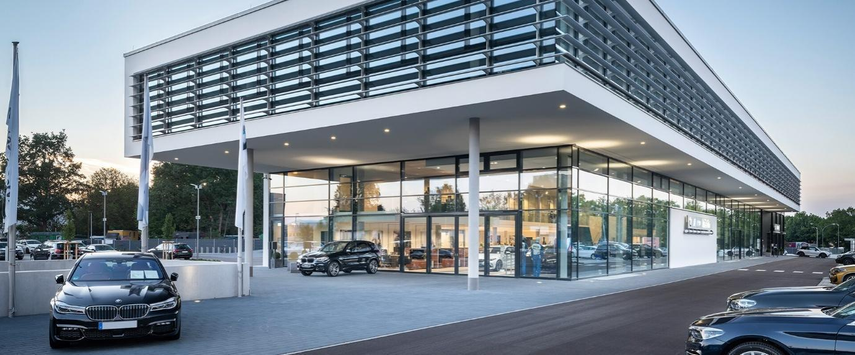
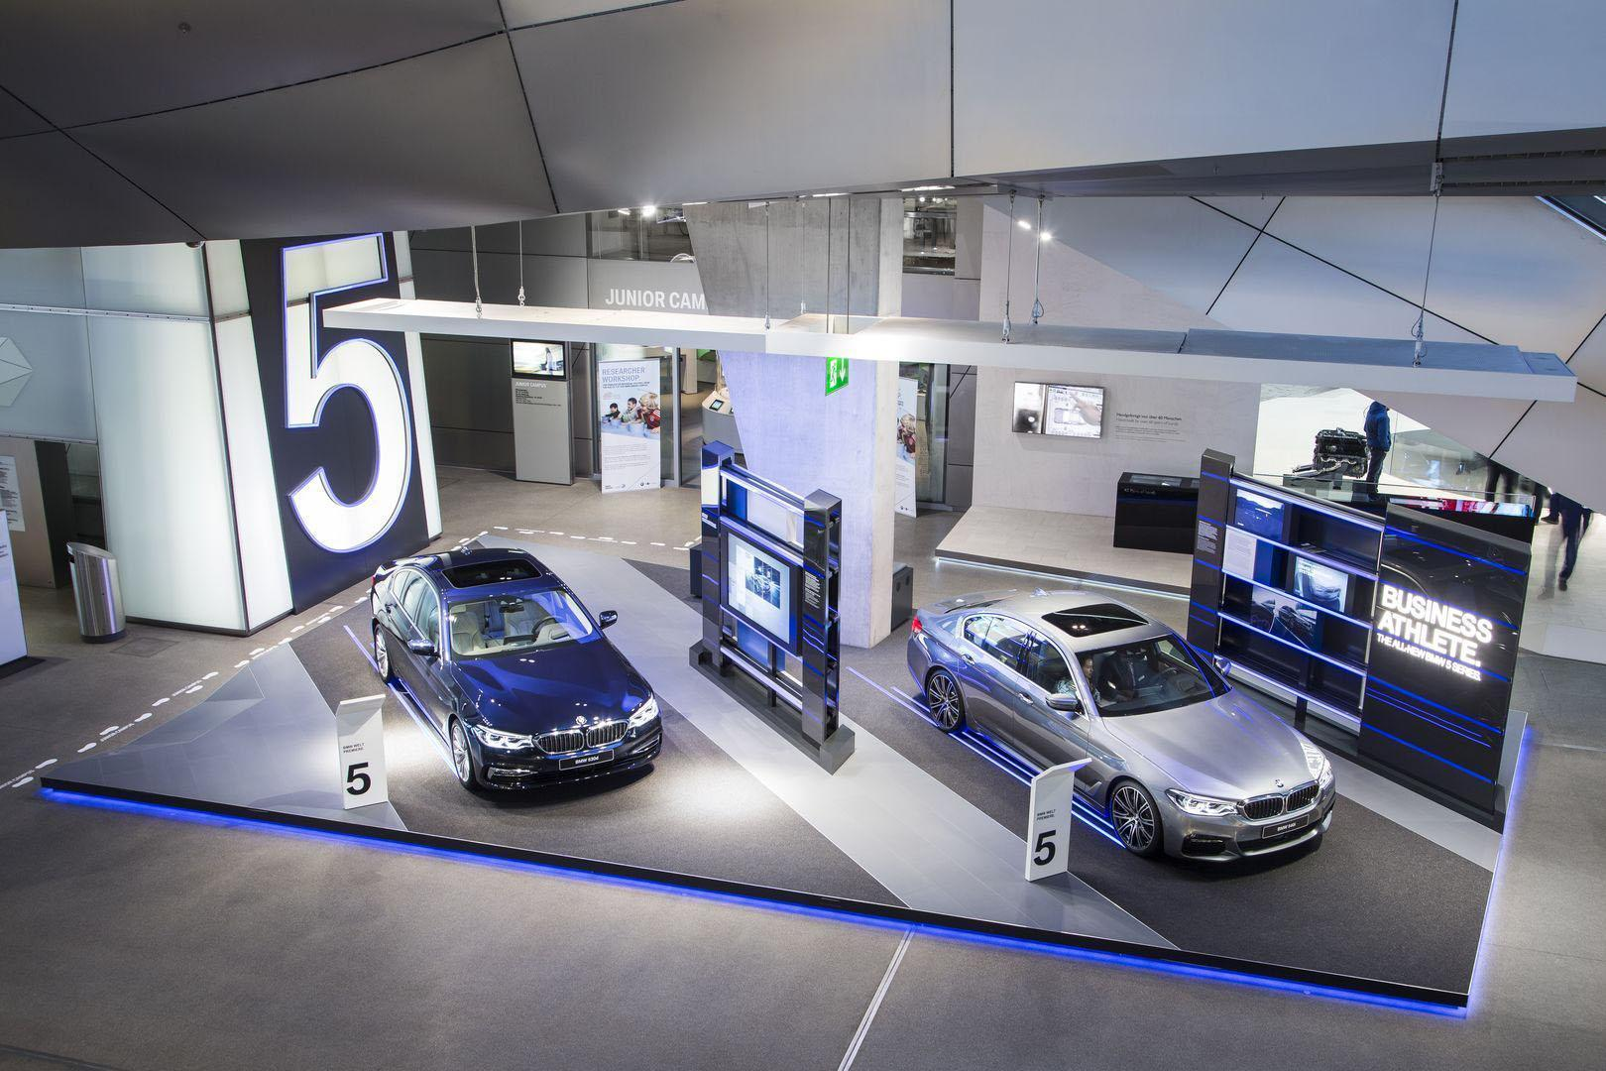
Figure 20: Store of BMW in Germany
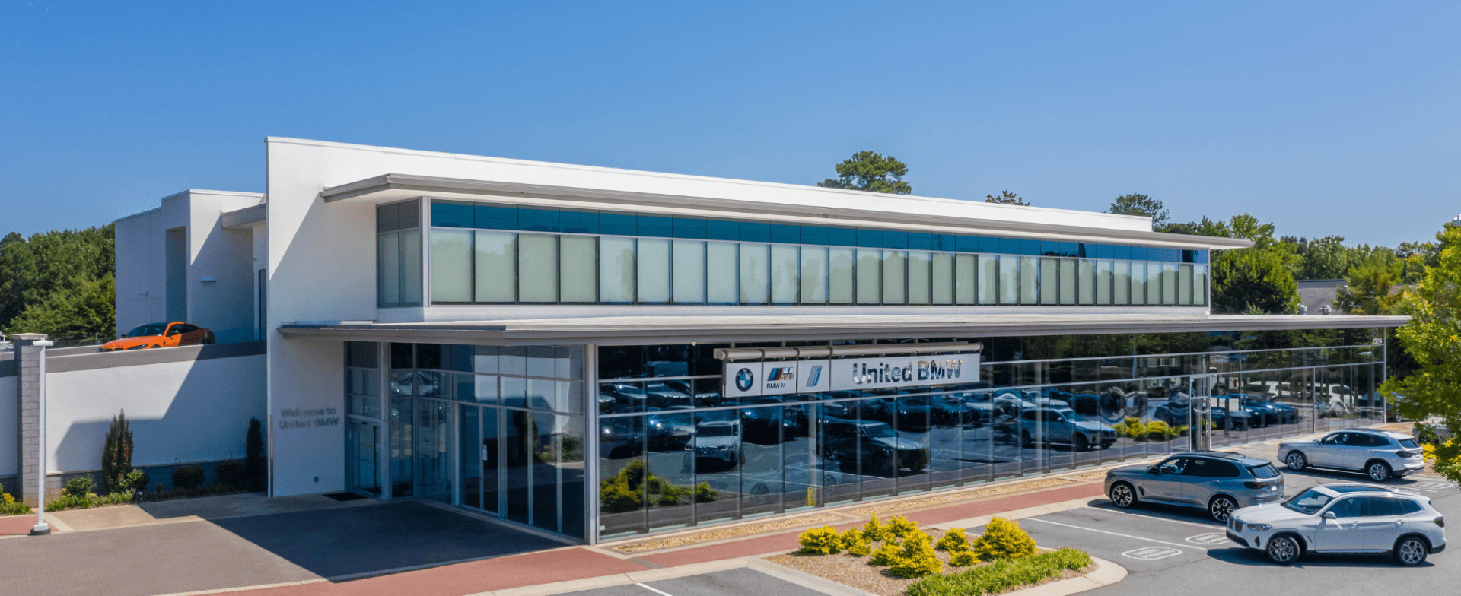
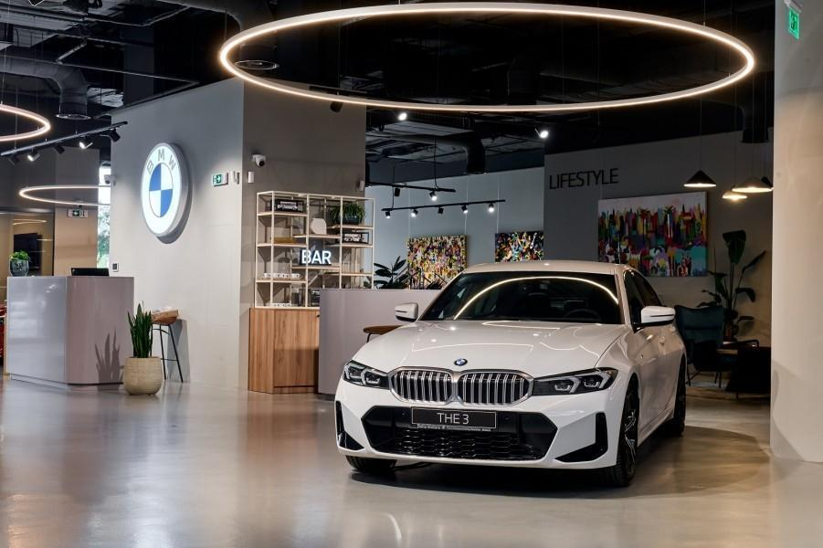
Figure 21: Stores of BMW in the USA

