
ACCA7022
Advance Statistical programming
Reflective Summary: Exploring Air Quality with R
SHAIDHUL HASAN
Student ID.2442113

1. Introduction
For this project, I acted like a data detective. I used a computer program called R to look at a big pile of numbers about the air we breathe. I wanted to see if things like heat, humidity, or the time of year change how much pollution is in the sky. To do this, I had to clean the data, draw pictures (visualisations), and do some math tests to see if my guesses were right. This process helped me understand that data is not just numbers; it is a way to see how the world works.

2. Visualisations: Turning Numbers into Pictures
For this analysis, I used the ggplot2 library to create four different types of charts. Each one was chosen to make the invisible air around us easier to understand.

2.1 Time Trends
I used a line plot to show how CO and NO2 change over days and weeks. Line plots are perfect for this because they show the "ups and downs" of pollution clearly. I noticed that while NO2 (the blue line) stays quite high, CO (the pink line) is much lower and more stable.
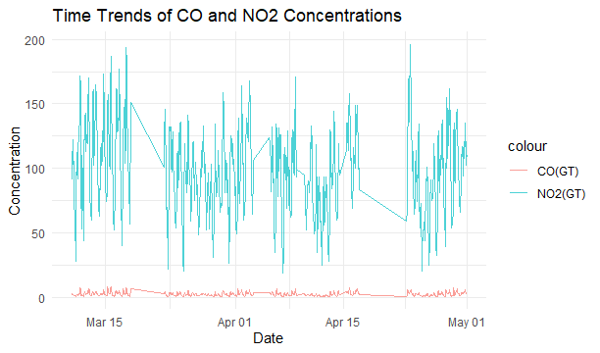
Figure 1: This line plot shows the levels of CO and NO2 over several weeks. The blue line (NO2) is much busier than the pink line (CO).

2.2 Weather Relationships
I wanted to see if heat makes pollution worse. I used a scatterplot with a red trend line. It clearly shows that as the Temperature goes up, Benzene levels tend to rise too. This helped me see a positive correlation that wasn't obvious in the raw data.
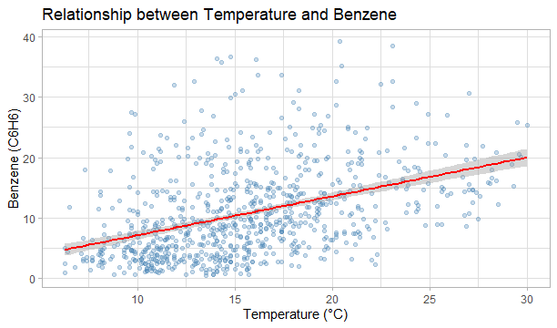
Figure 2: This scatterplot shows that as the Temperature goes up, the Benzene goes up too. The red line makes this very easy to see.
2.3 Pollutant Connections (Correlation Matrix)
I created a Correlation Matrix to see which pollutants "travel together." The dark blue color and the number 0.97 show that CO and Benzene are almost always found together. This is a big clue that they probably come from the same source, like car exhaust.

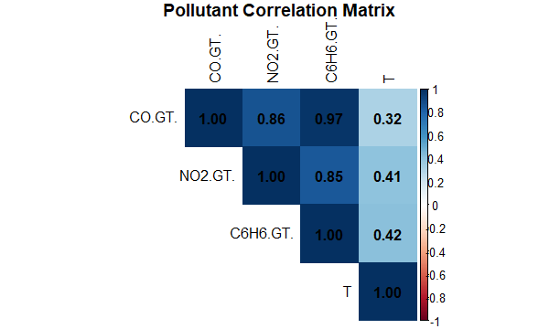
Figure 3: This heatmap shows that CO and Benzene are very strongly linked.

2.4 The "Seasons" Boxes (Boxplot)
Finally, I made a boxplot to compare the air in different seasons.
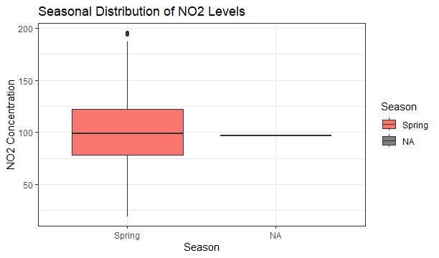
Figure 4: This boxplot shows the NO2 levels for Spring. The thick line in the middle is the average, and the dots at the top are "outliers"—times when the air was extra dirty.

3. Challenges and Things I Learned
The biggest "mountain" I had to climb was just opening the file! The data came from Europe, so it used semicolons (;) instead of commas to separate the numbers. If I didn't fix this in my code, R got very confused. Another big challenge was "ghost data." The machines that measure air quality sometimes break and record a -200. I learned that I couldn't just leave those in, or my averages would be totally wrong! I had to tell R to treat -200 as "Nothing" (NA).
I also learned that math isn't just one-size-fits-all. When I did my Hypothesis Test for Humidity, I chose the Wilcoxon test instead of a T-test. I learned that air quality data is "wonky" and doesn't follow a perfect bell curve (which we call "normal distribution"). The Wilcoxon test is a better "referee" for this kind of data because it doesn't mind if the data is a bit messy.
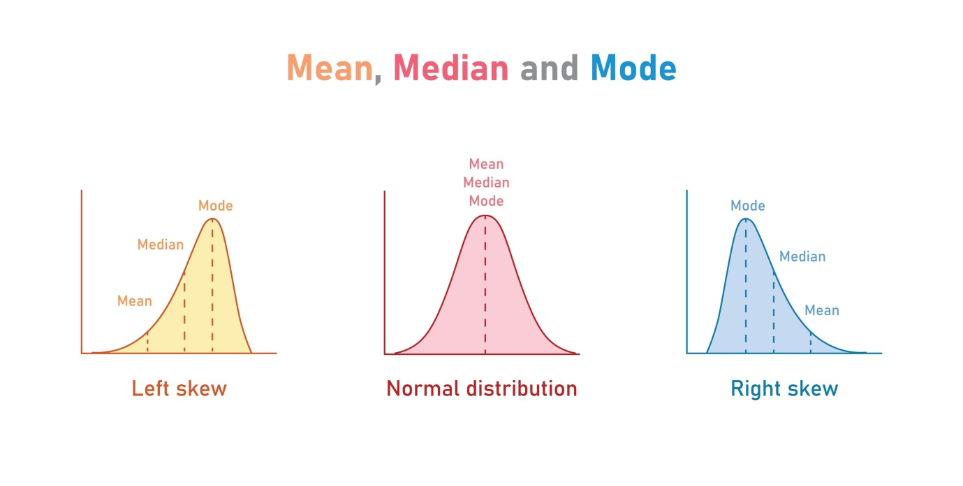

4. Improvements for Future Work
If I could do this again, I would want to look at a whole year of data. In my boxplot (Figure 4), you can see some "NA" spots because my data slice was mostly from the Springtime. Having Winter and Summer data would help me see if the air gets cleaner when people turn off their heaters.
I would also like to use a "Tukey Test" after my ANOVA. My ANOVA test said, "Hey! The seasons are different!" but it didn't tell me exactly which seasons were the most different. A Tukey test would be like a magnifying glass to find the exact answer. I would also try to make my graphs interactive using plotly so people could zoom in on specific days.

AI Disclosure
I used Gemini to understand the task on assignment brief also I used it to organize my R code logic and also for doing research . I wrote the code and report myself to make sure it followed the assignment rules for the ACCA7022 module.

