Connor Daniel
1909665@uwtsd.student.ac.uk

Electronic systems design
Assignment 2

Table of Contents
Task 1 3
Portable weather measurement systems 3
Current weather measurement systems 3
Task 2 4
Microcontroller selection 4
Task 3 5
Enclosure and design 5
Enclosure box 5
Wheels 5
Pole for mounting external sensors 6
Bracket to panel mount pole 6
Inspection window 6
Panel vent 7
Switch 7
LED 8
Non-volatile memory 8
Parameters 8
Increments for parameters. 9
Memory calculation 10
SD card 10
USB 11
Sensor selection 12
Temperature and Humidity 12
Wind speed and direction 12
Airborne particle count 13
Sunlight brightness 14
UV level 14
GPS 15
VOC levels 16
Voltage regulator 16
Connector specification 17
Sunlight Brightness 17
Wind speed and direction sensor 17
Connecting from enclosure to PCB 18
Battery selection 18
Current draw 18
Battery comparison 19
Task 4 20
PCB 20
Before copper pour 20
After copper pour 21
PCB price 22
Task 5 22
Structure diagram 22
Task 6 22
Build cost 22
Task 7 23
Task 8 24
Schematic diagram 24
Full schematic 24
Voltage regulation 24
Pull up resistors 25
LED 25
SD card 26
PM sensor 26
USB 27
VOC sensor & sunlight brightness sensor 27
Wind speed and direction 28
Temperature and humidity sensor 29
UV sensor 30
Software flow chart 30
Mode selection 30
Data upload mode 31
Data acquisition mode 32
Bibliography 36

Task 1

Portable weather measurement systems
A portable weather measurement system will measure record and transmit data that has been collected from its surroundings. The weather measurement systems typically measure the following parameters:
- Temperature
- Wind Speed
- Wind Direction
- Precipitation
- Humidity
- Solar Radiation
- Atmospheric Pressure
- Visibility. [1]

This measurement system will typically use various sensors to collect the data needed. For example, the temperature could be measured using a thermometer and a hygrometer could be used to measure the humidity. To measure the wind speed and direction an anemometer and a wind vane could be used. [2]

Current weather measurement systems

 | 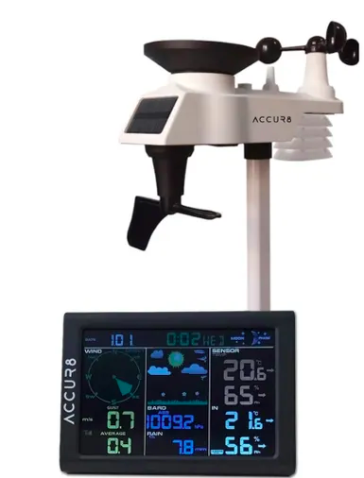 | 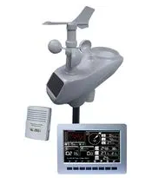 | 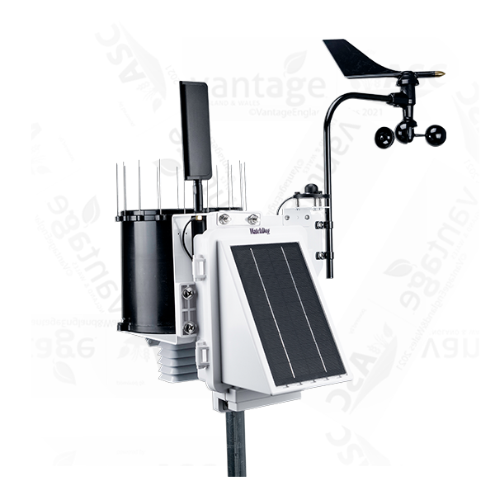
Supplier | [3] Weather shop | [4] CPC Farnell | [5] Vantage
Model | Accur8 | W–8681-PRO | Watchdog 3250
Temperature range | -40 to 60 °C | -30 to 65 °C | -40 to 125 °C
Humidity range | 1 to 99% | 1 to 99% | 0 to 100%
Wind speed range | 0 to 112 mph | 0 to 100 mph | 0 to 200 mph
Rainfall range | 0 to 9999 mm | 0 to 9999 mm | 0.245 mm resolution
Barometric pressure range | 300 to 1100 hPa | 300 to 1100 hPa
Battery life |  |  | 14 days without solar power
Data capacity |  |  | 312 days at 15-minute intervals (30,000 records)
Price | £109.99 | £262.80 | £2,125.00
Other features | - Weather forecast  - Wind direction  - Wi-Fi and phone compatibility  - Calendar and time functions  - Programmable alarms  - Dew point  - Memory records | - Lux meter – 0 to 400 lux  - Wind direction  - Time display  - Dew point  - Wi-Fi connection  - MicroSD memory card slot | - Solar radiation measurement – 0 to 1500 W/m^2  - Operating temperature range - -30 to 65°C  - Wi-Fi and phone compatibility  - One available sensor port  - Wind direction – 0 to 359°

Task 2

Microcontroller selection
For the microcontroller the PIC18F27J53 will be used.
 | 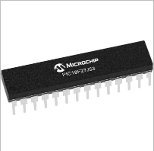
Supplier | [28] Farnell
Microchip | PIC18F27J53
Pin count | 28
Supply voltage | 3.3 V
Program memory | 128 (Kbytes)
Data memory | 3.8 (Kbytes)
ADC input | 10
Max ADC resolution | 12
UART | 2
SPI | 2
I2C | 2
Number of USB modules | 1
Price | £4.52

This microcontroller was chosen as it has 28 pins and has a good program memory of 128 KB. The microcontroller also has 2 ports for UART, SPI and I2C meaning it will give a range of options when picking sensors. The low cost of £4.53 was also a factor when selecting this microchip. These factors should fit the specifications set out for the weather station.

Task 3

Enclosure and design

Enclosure box
The enclosure box below has been chosen as it’s dimensions will fit the battery and PCB board inside. The enclosure is also IP66 rated meaning that it will be suitable for a variety of different weather conditions.
 | 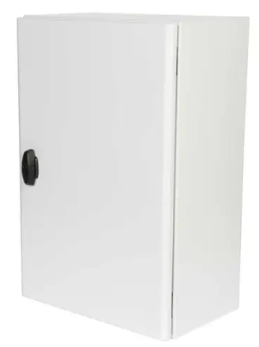
Supplier | [29] CEF
Model | Schneider Sarel
Dimensions | 600mm x 400mm x 250mm
IP rating | IP 66
Weight | 11.644 kg
Price | £127.20

Wheels
The wheels below have been chosen in order to improve the portability of the weather station, there will be a wheel on each corner of the box.
 | 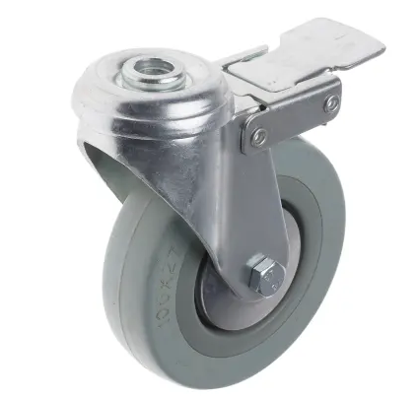
Supplier | [30] RS
Model | RS PRO Braked Swivel Castor Wheel
Load capacity | 70 kg
Wheel diameter | 100mm
Wheel width | 27 mm
Price | £15.13

Pole for mounting external sensors
The conduit below has been selected to mount the external sensors due to its lightweight and low cost.
 | 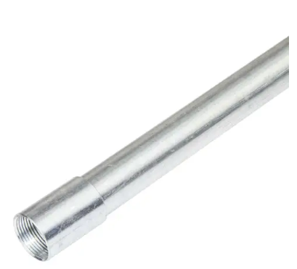
Supplier | [31] CEF
Model | Metal Pre-Galvanised Steel Conduit
Pole diameter | 25mm
weight | 0.688 kg
Price | £16.92

Bracket to panel mount pole
This bracket will be mounted to the side of the panel and has been chosen as it is a good diameter to hold the pole in place.
 | 
Supplier | [32] CPC
Model | Pressed Caravan Facia Bracket with Clamp
Diameter | 1 inch (25.4mm)
Price | £3.00

Inspection window
The inspection window below will be used to allow sunlight to the UV sensor. It has been chosen as it is IP67 rated.
 | 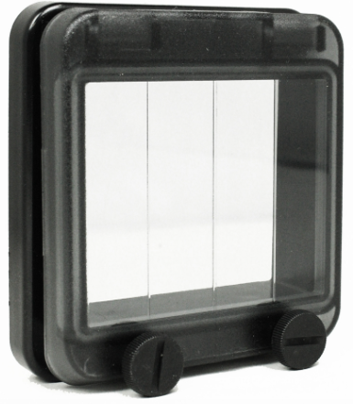
Supplier | [33] Essential supplies
Model | INSPECTION WINDOW 4 MODULE
IP rating | IP 67
Price | £14.21

Panel vent
This is the panel vent that will be used to allow airflow into the enclosure for the sensors that require it.
 | 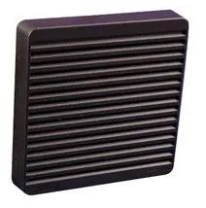
Supplier | [34] Farnell
Model | HAMMOND XPFA120BK
IP rating | IP 54
Price | £23.72

Switch
 | 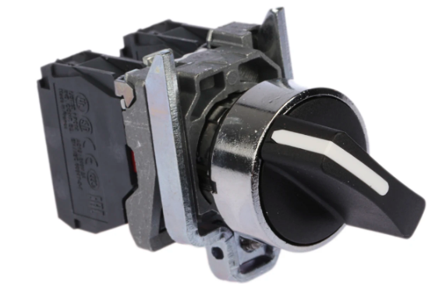
Supplier | [52] RS
Model | Schneider Electric Knob Selector Switch
IP rating | IP67
Price | £29.17

LED
 | 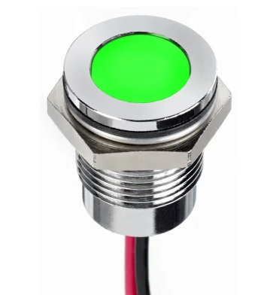
Supplier | [49] RS
Optimum voltage | 3.2 V
Current rating | 20 mA
IP rating | IP 67
Price | £16.12

Non-volatile memory

Parameters
To work out how much memory is needed, first a suitable range and frequency of sample rate must be worked out for each parameter. This can then be used to calculate the number of bytes that will be used over the 14-day period.

Temperature and humidity
For the temperature and humidity, a sensor that can measure a wide range is desirable so the weather station can be set up in a variety of different environments. From completing research into temperatures that have been recorded, source [20] states that the highest temperature recorded was 58°C and the lowest was -88°C. Due to this an appropriate range for the application of the weather station being built is -40 to 60°C. The humidity should range from 0 to 100% relative humidity.

Wind speed and direction
The highest wind speed ever recorded according to source [35] is 253 mph however, due to the structural design of the weather station and the application an acceptable range would be between 0 and 120 MPH. The wind direction should cover a full 360°.

Airborne particle count
According to source [36] the particles size PM2.5 and PM10 are the ranges typically measured. These measure between 2.5 µm and 10 µm respectively therefore, a good range that the sensor will need to be able to detect particles would be 1 µm to 10 µm in order to detect all particles. Source [36] also states the average concentration of PM2.5 in Delhi is 130.1 µg/m3 therefore, a suitable concentration range for the airborne particle count would be 0 to 500 µg/m3.

Sunlight brightness
Source [37] states that typical lux levels range from less than 0.01 at night and up to 100,000 with direct sunlight. As these are typical values a suitable range to gather a good range of readings would be 0 to 120,000 lux.

UV levels
For UV levels it will have to gather readings from the entire ultraviolet spectrum. According to source [38] this ranges between 100 and 400 nm. UVC being between 100 and 280 nm, UVB being between 280 and 315 nm and UVC being between 315 and 400 nm.

GPS
The GPS will always remain on.

VOC levels
The VOC levels will be measured on a scale of 0 to 1000 ppm

Parameter | Measurement range
Temperature | -40 to 60°C
Humidity | 0 to 100%
Wind speed | 0 to 120 mph
Wind direction | 0 to 360°
Airborne particle count | 0 to 500 µg/m3
Sunlight brightness | 0 to 120,000 lux
UV levels | 100 to 400 nm
GPS position | N/A
VOC levels | 0 to 1000 ppm

Increments for parameters.
Parameter | Increment | Number of possible Values | Number of bits | Bytes needed | Sampling rate
Temperature | 1°C | 100 | 7 | 1 | 1 minute
Humidity | 1% | 100 | 7 | 1 | 1 minute
Wind speed | 1 mph | 120 | 7 | 1 | 10 seconds
Wind direction | 1° | 360 | 9 | 2 | 10 seconds
Airborne particle count | 1 µg/m3 | 500 | 9 | 2 | 1 minute
Sunlight brightness | 100 lux | 1200 | 11 | 4 | 1 minute
UV levels | 1 nm | 300 | 9 | 2 | 1 minute
GPS position | N/A | N/A | 9600 | 14 | 5 minutes
VOC levels | 10 ppm | 100 | 7 | 1 | 1 minute

Memory calculation

Sensors sampling at 1 minute.
$$11 bytes a minute$$
$$11 x 60=660 bytes per hour$$
$$660 x 24=15,840 bytes per day$$
$$15,840 x 14=221,760 bytes over a 14 day period$$
$$221,760 bytes= 0.22176 MB$$

Wind speed and direction
$$3 bytes every 10 seconds$$
$$3 x 6=18 bytes per minute$$
$$18 x 60=1080 bytes per hour$$
$$1080 x 24=25,920 bytes per day$$
$$25,920 x 14=362,880 bytes over a 14 day period$$
$$362,880 bytes= 0.36288 MB$$

GPS
$$14 bytes every 5 minutes$$
$$14 x 12=168 bytes per hour$$
$$168 x 24=4,032 bytes per day$$
$$4,032 x 14=56,448 bytes over a 14 day period$$
$$56,448 bytes= 0.056448 MB$$

Total memory needed.
$$0.22176+0.36288+0.056448=0.641088 MB$$
$$0.641088 mB needed over the 14 day period.$$

SD card
 | 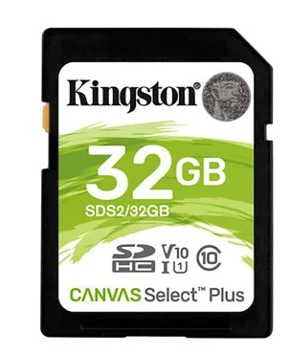
Supplier | [39] RS
Model | Kingston
Capacity | 32 GB
Temperature range | -25 to 85°C
Voltage | 3.3 V
Dimensions | 24mm x 32mm x 2.1mm
Price | £10.99
To mount the SD card to the PCB the 8-way connector shown below will be used.

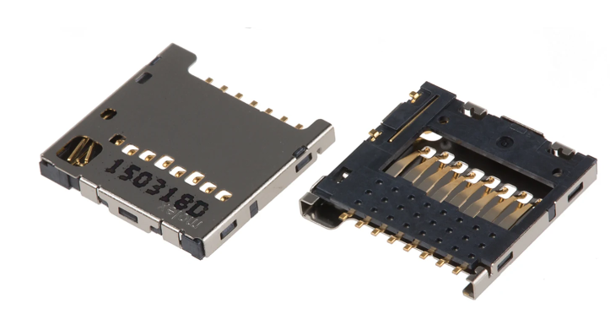

This has been chosen as it has a low cost of £2.166 and it has an operating temperature of 25 to 85°C. [40]

USB

 | 
Supplier | [41] RS
Model | Kingston
Capacity | 32 GB
Temperature range | 0 to 65°C
Dimensions | 39mm x 12.6mm x 4.9mm
Price | £12.36

To connect the USB to the PCB the connector below will be used. [42]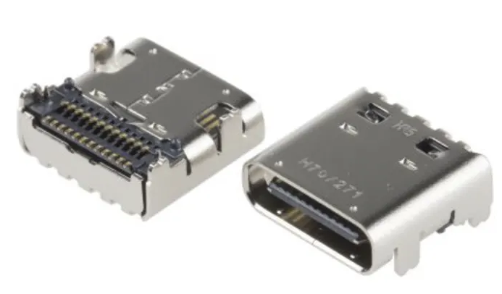

Sensor selection

Temperature and Humidity
 | 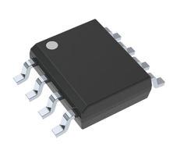 | 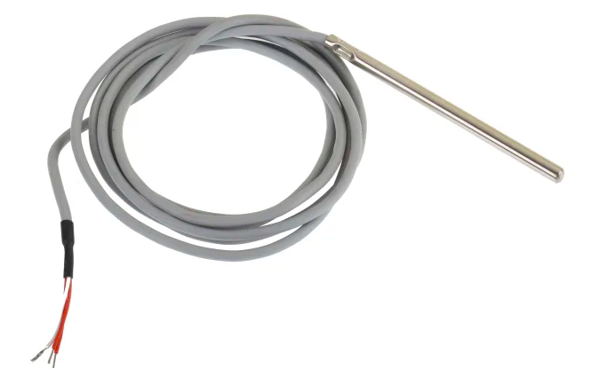 | 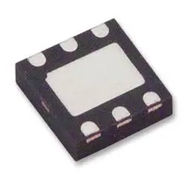
Supplier | [6] Digikey | [7] RS | [8] Farnell
Model | LM75BIM-5+ | PT100 RTD sensor | TE connectivity HTU21D
Sensor Type | Digital | PT100 (open collector) | Digital
Output type | I^2C |  | I^2C
Temperature measurement range | -55 to 125 °C | -50 to 250 °C | -40 to 125 °C
Humidity range |  |  | 0 to 100% rh
Supply voltage | 3.3V to 5V |  | 3.6V
Operating supply current | 250μA |  | 500μA
Price | £2.55 | £33.73 | £6.852
IP rating |  | IP 68 | IP 67

For the temperature and humidity sensor the TE connectivity HTU21D has been chosen. This is due to it having a good temperature range compared with the other sensors I have found and compared to my research with source [20]. It also measures the humidity which the other sensors I have selected do not. This will reduce the number of connections required as I will not need a separate sensor for the humidity. It is also reasonably priced at £6.852 which will help the cost of the weather station with the more expensive components.

Wind speed and direction

 | 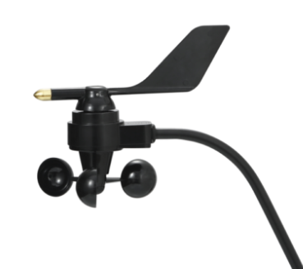 | 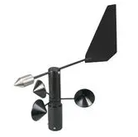 | 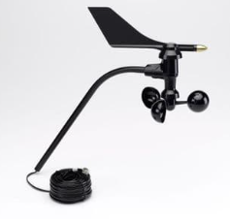
Supplier | [9] QUARK-ELEC | [10] Farnell | [11] Prodata weather systems
Manufacturer | QK-AS06 | Omega | Davis
Sensor type | Anemometer | Open collector anemometer | Anemometer (RJ-11 connector)
Supply voltage | 10 to 15 VDC | 12 Vac or dc
Measuring range | 0 to 55 m/s (123 mph) | 0 TO 100 MPH | 1 TO 200 MPH
Wind direction operating range | 0 to 359° | 0 to 360° | 0 to 360°
Operating temperature | -35 to 65°C | -20 to 50°C | -40 to 65°C
IP rating | IP 66
Power consumption | 27mA
Output |  | Dual 4 – 20mA
Price | £250.68 | £1058.00 | £225.00
The QK-AS06 will be used to measure both the wind speed and direction. This is because it has a low power consumption of 27mA and is also IP66 rated whilst having good measurement ranges in wind speed and direction.

Airborne particle count

 | 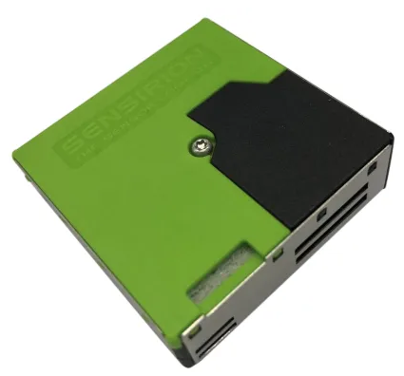 |  | 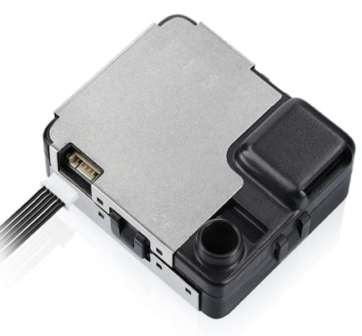
Supplier | [12] RS | [13] Farnell | [14] RS
Manufacturer | Seinsirion | Honeywell | Tera
Sensor type | PM sensor | PM sensor | PM sensor
Supply voltage | 4.5 to 5.5V | 5V | 5V
Operating current |  | 50mA
Operating temperature | -10 to 60°C | -20 to 60°C | -20 to 70°C
Mass concentration range | 0 to 1000 µg/m3 | 0 to 1000 µg/m3 | 0 to 1000 µg/m3
Particle size detection range | 0.3 to 10µm | 0.3 to 10µm | 0.3 to 10µm
Output type | I2C, UART | I2C, UART | UART/Modbus(RS485)
Price | £47.92 | £31.09 | £93.16

For my airborne particle count the Honeywell Particle matter sensor will be used. This is due to it having a good operating temperature and is the cheaper of the two sensors that are I2C compatible.

Sunlight brightness
 | 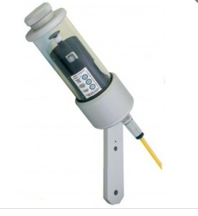 | 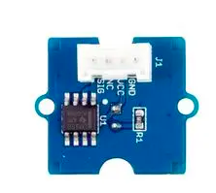 | 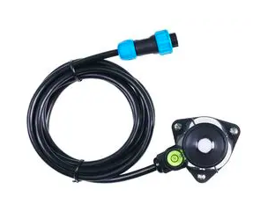
Supplier | [15] Omni instruments | [16] Farnell | [27] Farnell
Model | CSD3 sunshine sensor | SEEED STUDIO photoresistor light sensor | SEEED STUDIO 314990740
Spectral range | 400 to 1100 nm | Max 540 nm
Measurement range |  |  | 0 to 200,000 LUX
Operating temperature | -40 to 70°C |  | -40 to 85°C
Power supply | 12 Vdc | 3 to 5V | 3.9 to 30 VDC
Signal | Analog(1mV/Wm²) | Analog | Analog
Operating current |  | 0.5 to 3 mA | 7 mA at 24VDC
IP rating |  |  | IP 66
Price | £2166.00 | £3.31 | £67.10
To measure sunlight brightness the SEEED STUDIO 314990740 will be used as it has a good measurement range and is IP 66 rated. It also has a good operating temperature meaning it will be suitable for any conditions that it may need to operate in.

UV level
 | 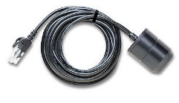 | 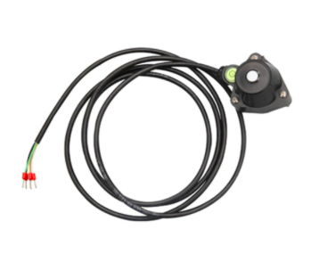 | 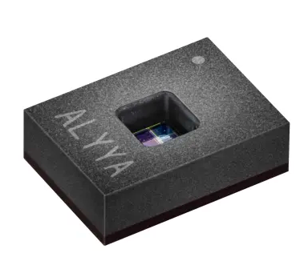
Supplier | [17] MSL | [18] Fruugo | [19] RS
Sensor type | Pyranometer | Pyranometer | UV Light sensor
Power supply |  | 12 to 30V | 3.3 V
Current consumption |  |  | 1.42 mA
Standby current |  |  | 970 µA
Measurement parameters | 0 to 1280 W/m2 | 0 to 2000 W/m2
Spectral range | 300 to 1100 nm | 400 to 1100 nm | UVA, UVB, UVC
Operating temperature | -40 to 75°C | -40 to 85°C | -40 to 85°C
IP Rating |  | IP 66
Output |  | Analog 4 to 20mA | I2C
Price | £368.40 | £139.00 | £9.84
To measure the UV levels the UV light sensor from RS will be used due to it being the cheapest option.

GPS
 | 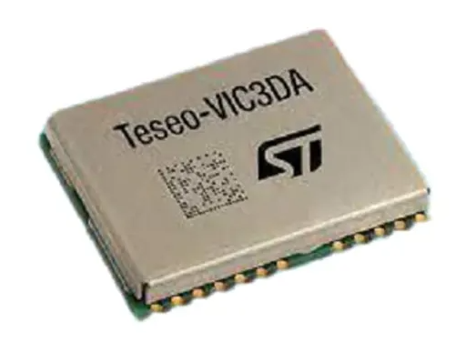 | 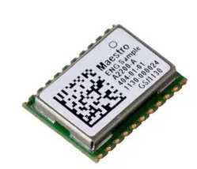 | 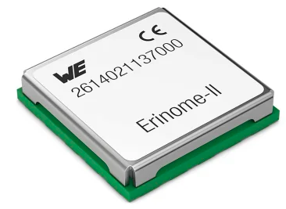
Supplier | [21] RS | [22] Farnell | [23] RS
Model | TESEO-VIC3DA | LANTRONIX A2200A | Wurth Elektronik 2614021137000
Supply voltage | 3.3V | 3 to 3.6V | 1.8 V
Operating temperature | -40 to 85°C | -40 to 85°C | -40 to 85°C
Standby current | 17 µA | 25 µA | 30 µA
Current consumption | 48.8 mA | 52 mA | 55 mA
Bus interfaces | I2C, UART | I2C, UART, SPI | I2C, UART
Position accuracy | 1.5 m
Price | £20.41 | £14.24 | £26.318
For GPS the TESEO-VIC3DA has been selected as the operating temperature and supply voltage are suitable for the application it will be used for. However, when compared to the other GPS Modules it has a lower standby current and current consumption which will help lower the battery size needed considering this will be monitored over a 14-day period.

VOC levels
 | 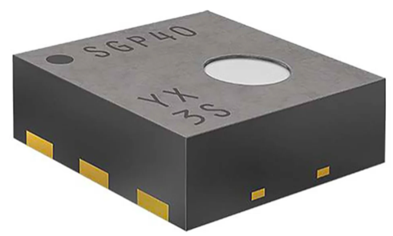 | 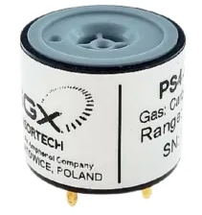 | 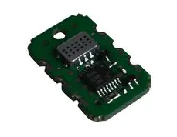
Supplier | [24] RS | [25] RS | [26] Farnell
Model | Sensirion SGP40-D-R4 | SGX PS4 | AMPHENOL ADVANCED SENSORS MICS-VZ-89TE
Supply voltage | 3.3 V | 0 V (solid polymer electrolyte) | 3.3 VDC
Operating temperature | -10 to 50°C | -40 to 50°C | 0 to 50°C
Operating current/ power | 2.6 mA | 0 A (+/- 100 nA) | 125 mW
Measurement range | 0 to 1000 ppm | 0 to 1000 ppm | 400 to 2000 ppm
Price | £6.89 | £88.32 | £19.85

For the VOC level sensor, the Sensirion SGP40-D-R4 will be used as it has an ideal measurement range and is the only sensor from the three above that is I2C compatible. It is also the cheapest of the three types of sensors I have researched.

Voltage regulator
Due to the majority of the sensors having a supply voltage of 3.3 V and having a 12 V battery a voltage regulator is required. The voltage regulator below has been chosen as it has a max input voltage of 15 V and an output voltage of 3.3 V therefore it is ideal for the specifications of this weather station.
 | 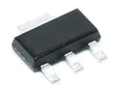
Supplier | [43] Mouser
Model | LM1117MPX-3.3
Input voltage | 15 V (max)
Output voltage | 3.3 V
Operating temperature | -40 to 125°C
Price | £0.86

Connector specification

Sunlight Brightness
To connect the sensor to the enclosure the Male and Female connectors will be used. These connectors have been chosen as they are IP 67 rated and have a good operating temperature range. This allows the weather station to be placed in a variety of different weather conditions.
 | 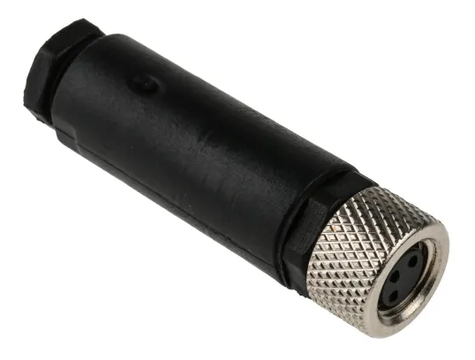 | 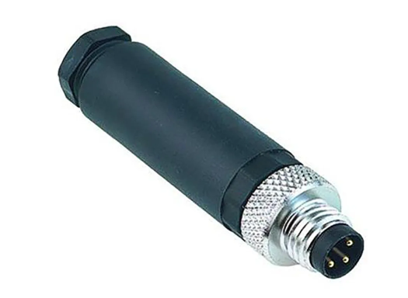
Supplier | RS
Type | [44] 3 Contact Female circular connector | [45] 3 Contact Male circular connector
IP rating | IP 67
Operating temperature | -25 to 75°C
Current rating | 3A
Voltage rating | 30 V
Price | £22.24 | £19.81

Wind speed and direction sensor
To connect the sensor this RS232 Female socket will be used as it has a good operating temperature range and is IP 67 rated. This means it is suitable for the weather conditions it may be placed in and will not have an impact of the integrity of the enclosure.
 | 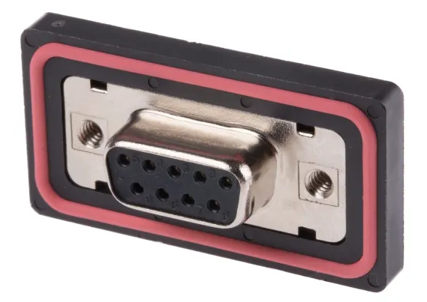
Supplier | [46] RS
Type | Female 9-way panel mount connector socket
IP rating | IP 67
Operating temperature | -40 to 105°C
Price | £26.00

Connecting from enclosure to PCB
To connect from the enclosure to the PCB board the Molex kk connector and crimp will be used as they are cheap and have a good operating temperature.

 | 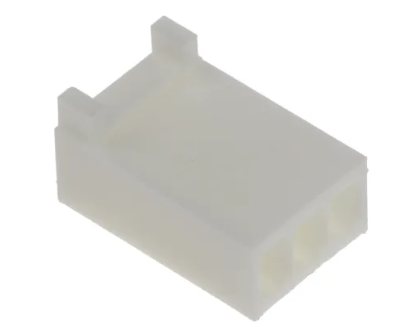 | 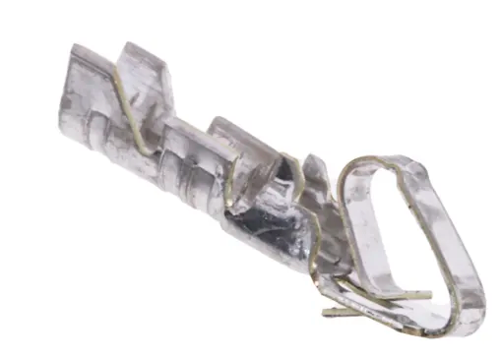
Supplier | RS
Type | [47] Molex kk Female connector housing | [48] Molex kk crimp contact
Operating temperature | -40 to 105°C | -40 to 80°C
Price | £0.27 | £0.134

Battery selection

Current draw
To work out the size of the battery needed, the total current draw over a 14-day period must be calculated for the sensors chosen.

Parameter | Current draw from sensor
Temperature and humidity | 500 μA
Wind speed and wind direction | 27 mA
Airborne particle count | 50 mA
Sunlight brightness | 7 mA
UV level | 1.42 mA
GPS | 48.8 mA
VOC level | 2.6 mA
TOTAL CURRENT DRAW | 137.32 mA

$$137.32 mA X 24=3295.65 mA$$
$$3295.65 mA=3.3 A$$
$$3.3 A x 14=46.2 A$$
$$Total AH needed by battery over the 14 day period=46.2 AH$$

Battery comparison
 | 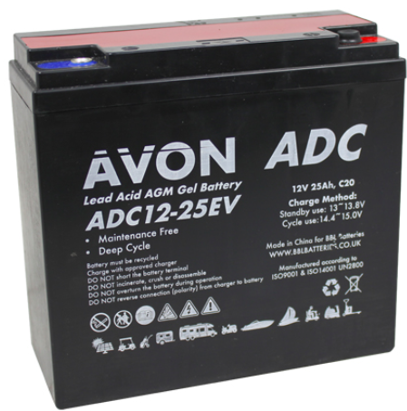 | 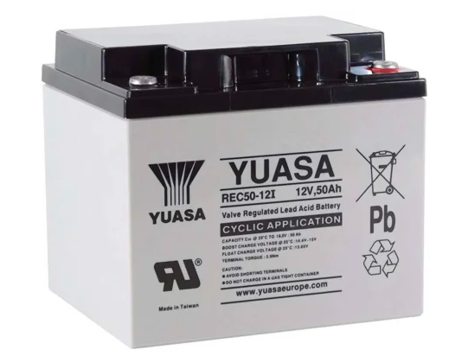
Supplier | [50] BBL Batteries | [51] RS
Model | Avon Deep Cycle AGM GEL | Yuasa 12V M5 Sealed Lead Acid Battery
Voltage | 12 V | 12 V
Number of AH | 50 AH | 50 AH
Connected in | Parallel | Single unit
Total weight | 12 kg | 15.3 kg
Total dimensions | 360 x 154 x 340 mm | 197 x 165 x 175 mm
Total cost | £95.96 | £291.64

For the battery the Yuasa 12V M5 Sealed Lead Acid Battery will be used giving 50 AH which is more than is needed to meet the 46.2 AH calculated previously. Although this is the heavier and more expensive option, this battery will reduce the cost and weight of the enclosure due to its smaller dimensions, which will help increase the portability of the weather station.

Task 4

PCB

Before copper pour
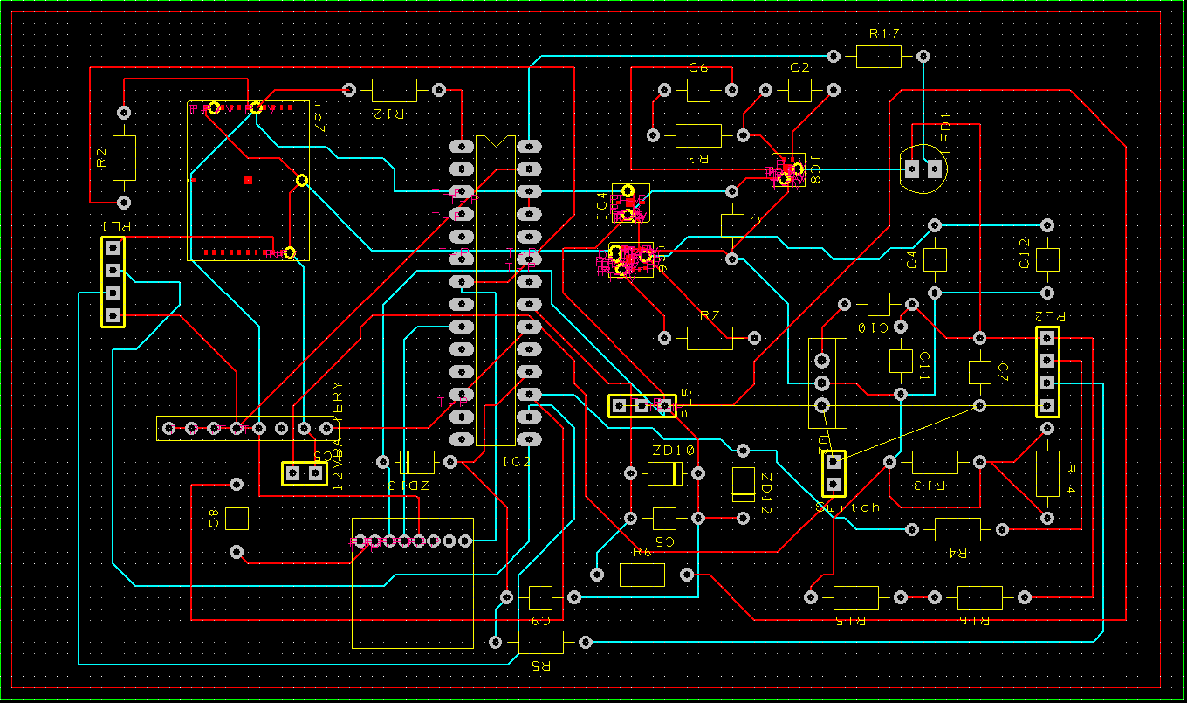

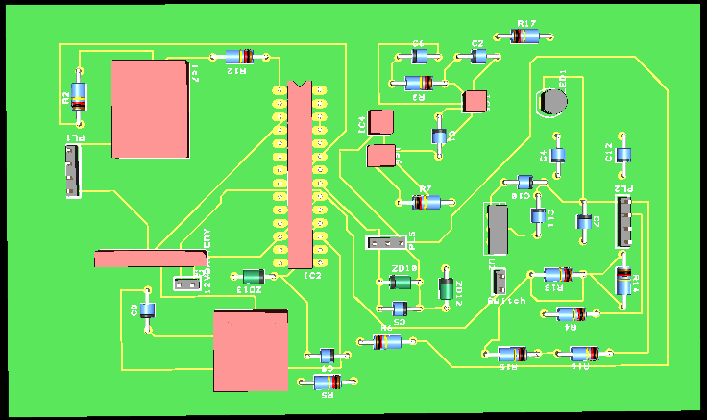

After copper pour
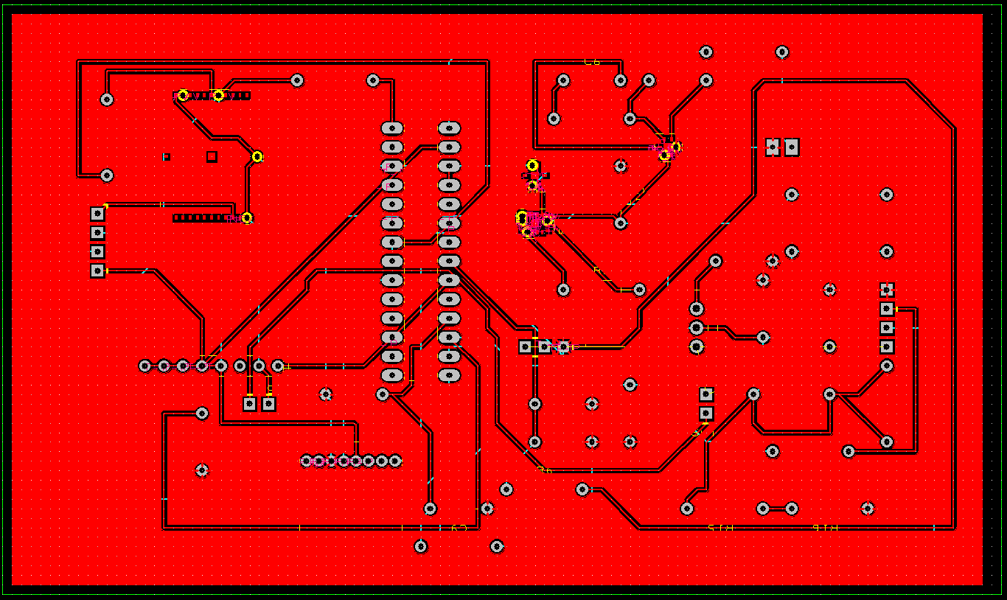

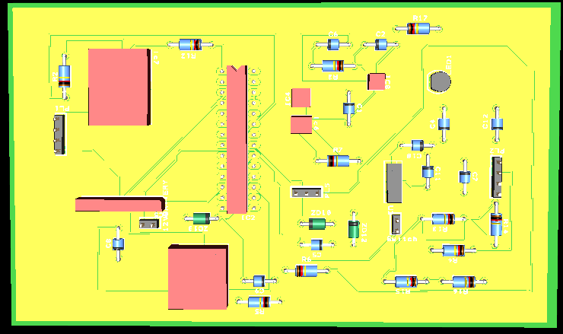

PCB price
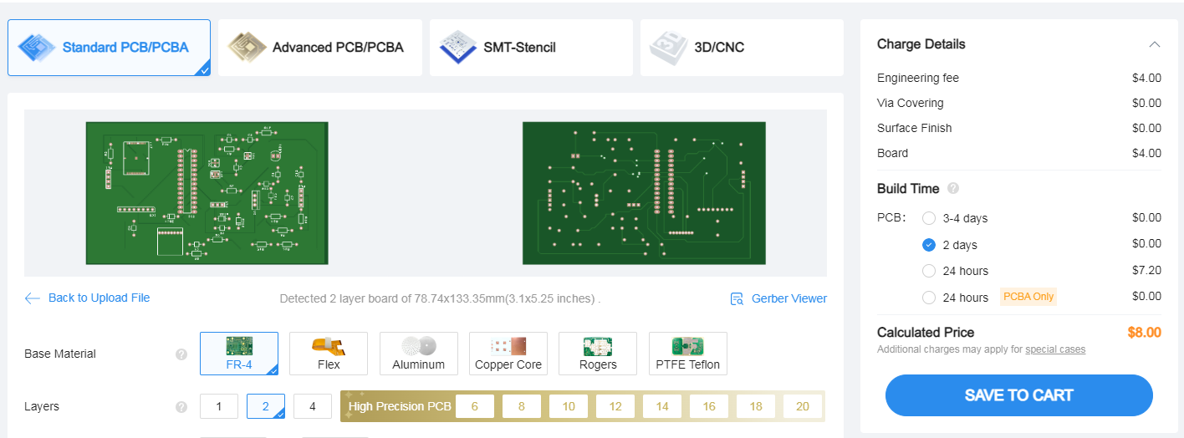

Task 5

Structure diagram
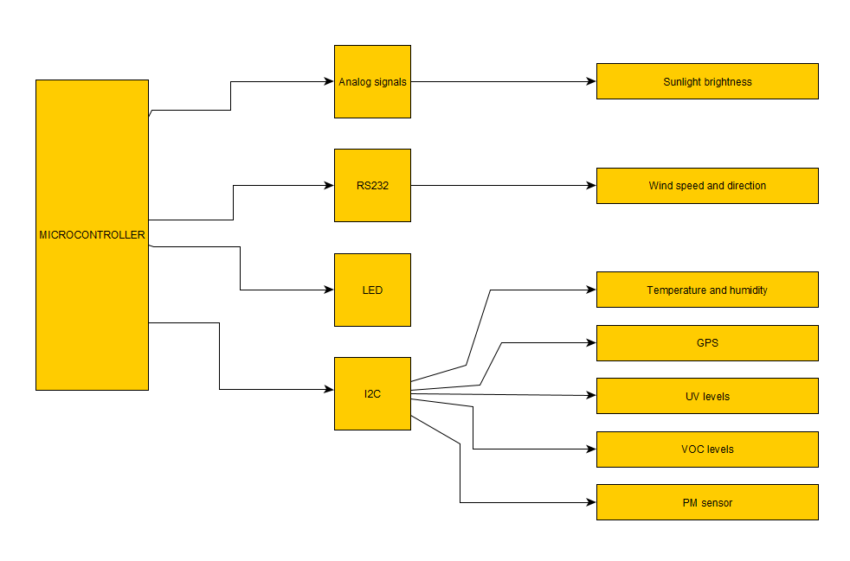

Task 6

Build cost
Component | Cost
TE connectivity HTU21D | £6.58
QK-AS06 | £250.68
Honeywell PM sensor | £31.09
SEEED STUDIO 314990740 | £67.10
UV Light sensor | £9.84
TESEO-VIC3DA | £20.41
Sensirion SGP40-D-R4 | £6.89
Avon Deep Cycle AGM GEL | £95.96
PIC18F27J53 | £4.52
Schneider Sarel | £127.20
RS PRO Braked Swivel Castor Wheel x4 | £60.52
Metal Pre-Galvanised Steel Conduit | £16.92
Pressed Caravan Facia Bracket with Clamp | £3.00
INSPECTION WINDOW 4 MODULE | £14.21
HAMMOND XPFA120BK | £23.72
Schneider Electric Knob Selector Switch | £29.17
Kingston SD card | £10.99
SD card connector | £2.166
USB | £12.36
USB connector | £2.47
LM1117MPX-3.3 | £0.86
3 Contact Female circular connector | £22.24
3 Contact Male circular connector | £19.81
9-way socket | £26.00
Molex kk Female connector housing | £0.27
Molex kk crimp | £0.402
LED | £16.12
PCB | £6.88 ($8)
Total cost | £888.38

Task 7
To improve on the weather station for the next iteration a solar system would be incorporated, this would extend the battery life of the current system. Solar panels would be used to generate electricity through sunlight and recharge the battery. This would be an improvement on the current design as it would allow for a smaller battery therefore reducing cost and increasing the portability of the design.
The second improvement that could be made to the current weather station would be to program the sensors to enter sleep mode when not taking readings. This would substantially lower the total current draw again allowing for a smaller battery therefore reducing cost and improving the portability of the weather station.
The third improvement that could be made to improve the weather station would to be to change the airborne particle sensor to an external sensor. This is due to the airborne particle sensor requiring airflow, which as it is currently directly connected to the PCB compromises the IP rating of the enclosure.

Task 8

Schematic diagram

Full schematic
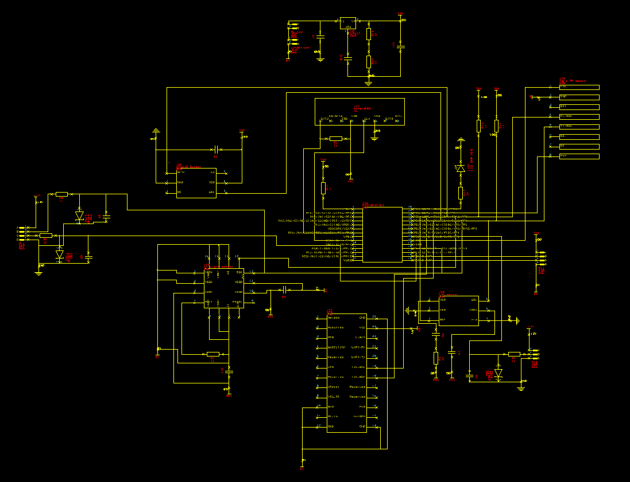

Voltage regulation
The circuit below shows the voltage regulation circuit. The circuit shows how the 12 V supply from the battery to the switch and gets taken down to the 3.3v supply for the microcontroller and the sensors that have a supply voltage of 3.3v. The value of capacitor C7 is 10µF. The value of the resistor R15 is 121Ω and the value of R16 is 1k. Capacitor C11 has a value of 100µF. Capacitor C10 has been put in place to improve ripple rejection.

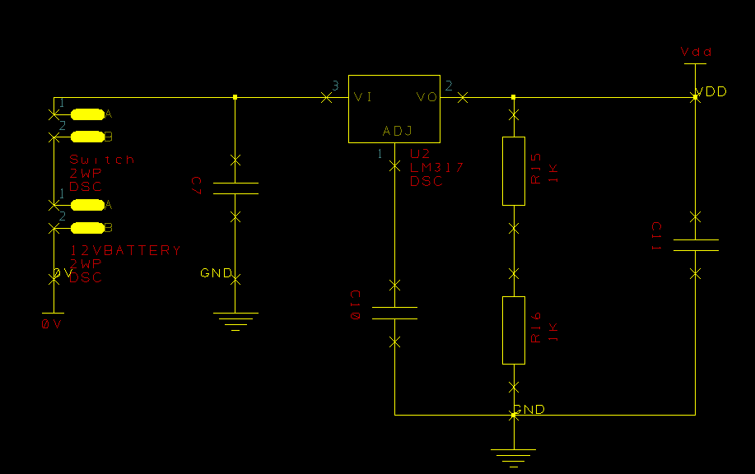

Pull up resistors
These pull up resistors have been put in place on the SDA and SCL lines of the I2C circuits. The resistors have been put in place to keep the lines high when data is not being transferred.
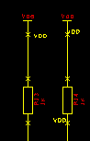

LED
The circuitry below shows the LED that is connected to the microcontroller as it must be programmed to flash every 10 seconds. The resistor has been put in place to limit the current going to the LED.
$$Value of resistor R17$$
$$R17=\frac{Vsupply-VLED}{ILED}$$
$$R17= \frac{3.3v-3.2v}{0.02A}$$
$$R17=\frac{0.1v}{0.02A}$$
$$R17=5Ω$$
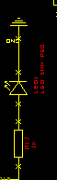

SD card
The circuit below shows how the SD card is connected. A shown VBS is connected to ground and VDD is connected to VDD for the power supply to for the SD card. There is also a resistor between the Data and VDD line as shown in the data sheet for the SD card, the purpose of this resistor is for noise reduction and signal integrity. The clock line and the data line from the SD card go to the required pins of the microcontroller.
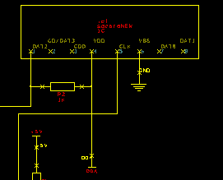

PM sensor
The circuit below shows how the particle matter sensor is connected. The VDD line goes to the VDD line of the microcontroller and the ground line from the sensor is connected to ground. The SCL line is connected to the SCL pin of the microcontroller and the SDA line from the sensor goes to the SDA pin on the microcontroller. The PWM line from the sensor goes to pin 28 of the microcontroller which the data sheet specifies is suitable for PWM input/output.
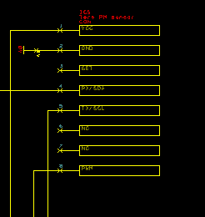

USB
The USB connecter is connected to ground and VDD. Pins 2 and 3 are connected to the D+ and D- pins of the microcontroller respectively.
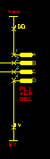

VOC sensor & sunlight brightness sensor
The VOC sensor has been wired-up as the data sheet specified, with VDD from the sensor having a 1μF capacitor and a 4.7 Ohm resistor in pace before connecting it to VDD. The VSS and n/a lines from the sensor are connected directly to ground. The VDDH line also has a 1μF capacitor which is then connected to VDD. The SCL and SDA lines from the sensor go to their pins on the microcontroller, with the pull up resistor required from the data sheet already in place on both lines.

The sunlight brightness sensor is a 3-pin connector with a 12v being fed straight of the battery. Pin 2 from the connector is the analog out from the sensor and is connected to the pin 21 on the microcontroller which is suitable for analog input. The third pin is connected to ground. The circuit for the sunlight brightness sensor also has over voltage protection in the form of a Zener diode and a low pass filter which includes a resistor and capacitor. As the microcontroller has a supply voltage of 3.3 V the Zener diode will have a voltage of 3.4 V to ensure proper over voltage protection.

$$Calculating the resistor and capacitor value of the low pass filter$$
$$Frequency \left(Hz\right)=\frac{sample rate}{Time (s)}$$
$$Frequency= \frac{1}{60 s}$$
$$Frequency=0.0167 Hz$$
$$Cutoff frequency=\frac{0.0167}{2}$$
$$Cutoff frequency=0.00835 Hz$$
$$Fc=\frac{1}{2πRC}$$
$$C=\frac{1}{2πx0.00835x9.1x{10}^{3}}$$
$$C5=2.1 mF$$
$$R6=9.1kΩ$$

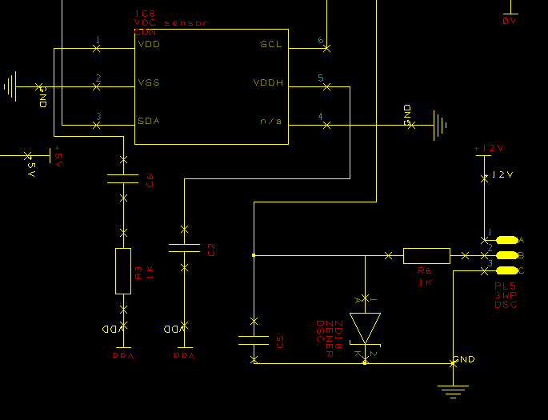

Wind speed and direction
The wind speed and direction sensor are connected by rs232 straight from the 12v batteries for a supply. Pins 2 and 3 are connected to the receive (RX) and transmit (TX) lines respectively. Both these lines have low pass filters and a Zener diode for over voltage protection. The Zener diode will be 3.4 V as the microcontroller has a supply voltage of 3.3 V.
$$Calculating the resistor and capacitor value of the low pass filter$$
$$Frequency \left(Hz\right)=\frac{sample rate}{Time (s)}$$
$$Frequency= \frac{1}{10 s}$$
$$Frequency=0.1 Hz$$
$$Cutoff frequency=\frac{0.1}{2}$$
$$Cutoff frequency=0.05 Hz$$
$$Fc=\frac{1}{2πRC}$$
$$C=\frac{1}{2πx0.05x10x{10}^{3}}$$
$$C8 \& C9=0.16F$$
$$R4 \& R5=10kΩ$$

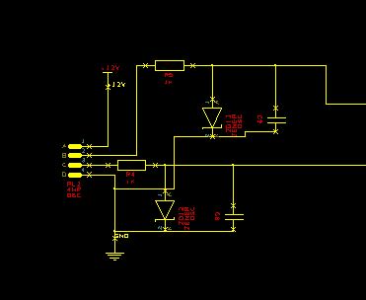

Temperature and humidity sensor
The temperature and humidity sensor has been wired up as the data sheet suggested, with the VDD and ground pins from the sensor going to VDD and ground respectively. These lines have a capacitor between them rated at 100 nF. The SCL and SDA lines got to the SCL and SDA lines on the microcontroller with the pull up resistors needed already in place.
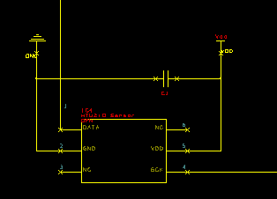

UV sensor
The UV sensor has been connected as specified by the data sheet with the VSSD and VDDD pins from the sensor connected to VDD with a capacitor rated at 100 nF. The VDDA pin is connected to VDD with a 100 nF capacitor and the REXT pin has a 3.3 MΩ resistor connected to it before it is connected to the VDD line. All the VSSA are connected to ground.
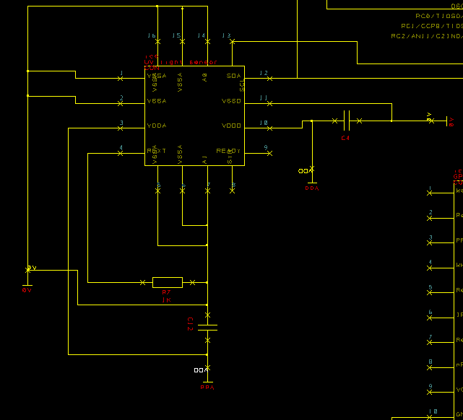

Software flow chart

Mode selection
This shows the first part of the software where the system decides if it is acquiring or uploading data. The first step is to initialize the hardware and check if the USB is connected, if the USB is connected it the program will enter data upload mode. This is where the data will be uploaded from the SD card to the USB. The program will check and test the software before setting the time and calling the data upload program. Once the data upload the program is complete it will end the program. If the USB is not connected it will enter data acquisition mode where data from the sensors is being collected and stored on to the SD card. The program will call each program individually and check that it has successfully been called. When the data acquisition is complete the program will end.
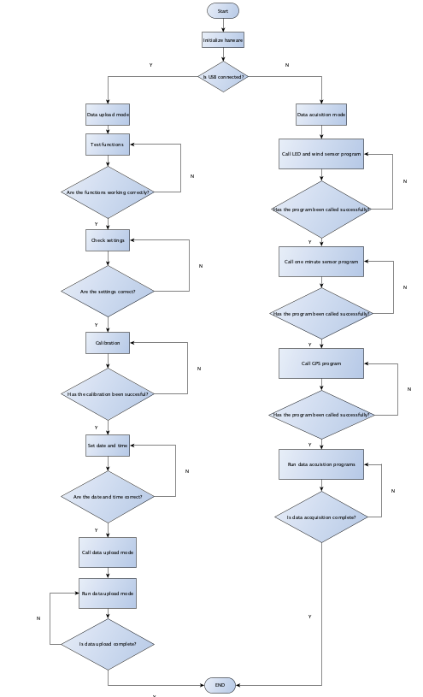

Data upload mode
The flow chart below shows how the program will red data from the SD card and write it to the USB. The first step is to check the host is ready then read a byte from the SD card, if the byte was read correctly, it will write it to the USB. If the read or write are not correct it will re-read or rewrite the byte. Once a byte has been written the program will check if all the data has been transferred if it has it will clear the SD card of its data and end the program. If all the data has not been transferred the program will continue to read and write bytes.
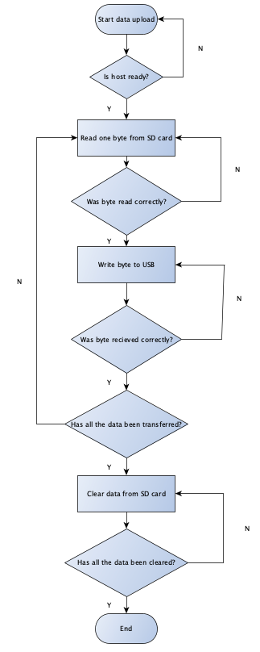

Data acquisition mode

LED and wind sensor
The flow chart below shows how the system will flash the LED and read the wind sensor. The first step is to initialize the system and start the timer, when the timer is equal to 10 seconds it will flash the LED and read the wind sensor. If the data is correct for wind speed and direction data is correct, then it will store the value in the data memory. If the data is incorrect, it will re-read the sensor. If the data memory is not full it will re-start the timer and continue to acquire readings, if the data memory is full, it will end the program.
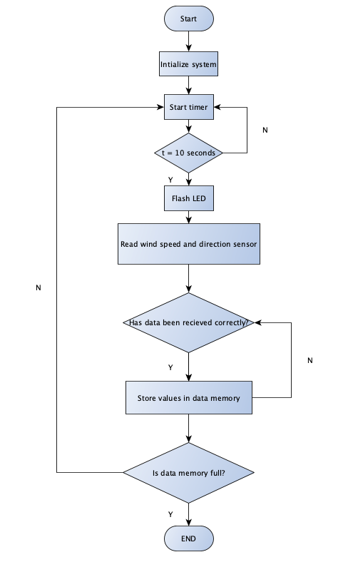

Sensors reading at one minute.
The flow chart below shows how the system will read the sensors that have a sample rate of 1 minute. The first step is to initialize the system and start the timer, when the timer is equal to one minute it will read the sensors. If the data is correct the system will store the data in the data memory. If the data is not correct it will re-read the sensors, then store the correct values in the data memory. If the data memory is full the program will end, if not it will restart the timer and take more readings.
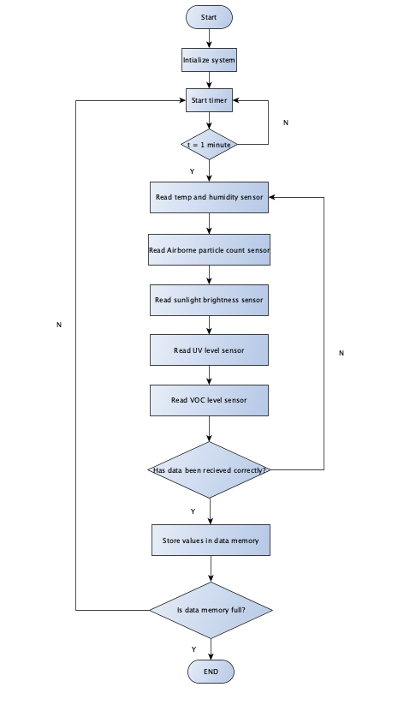

GPS
The flow chart below shows how the system will collect data from the GPS sensor. The first step is to initialize the system and start the timer. When the timer is equal to 5 minutes the system will read the GPS sensor and if the data is correct, it will store the data in the data memory. If the data is incorrect, then then the system will re-read the sensor and store the correct data in the data memory. If the data memory is full then the program will end, if there is still space on the data memory it will restart the timer and collect more readings from the sensor.
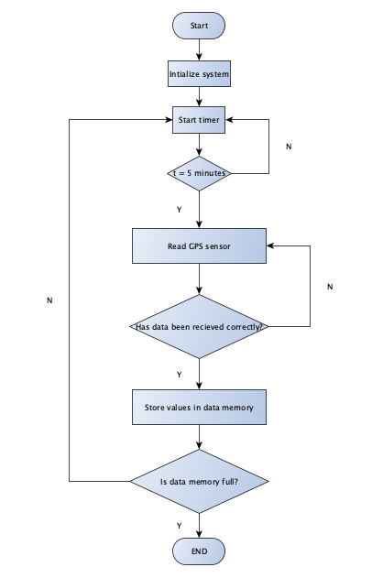

Bibliography
[1] “Automated Weather Stations (AWS) - earth networks,” Earth Networks -, https://www.earthnetworks.com/resources/weather-facts/automated-weather-stations/ (accessed Jan. 3, 2024).
[2] H. Abdullah, “What is a home weather station and how do they work? Wireless Weather Stations,” Medium, https://medium.com/@hashimabdullah/what-is-a-home-weather-station-and-how-do-they-work-wireless-weather-stations-2e4ceaa633de (accessed Jan. 3, 2024).
[3] “Accur8 DWS5100 5-in-1 solar-powered WIFI weather station with weather alerts - connects to Wunderground.com & Mobile app,” Weather Shop UK, https://www.weathershop.co.uk/5-in-1-wifi-weather-station-accur8-5100?dfw_tracker=123558-DWS5100&gad_source=1&gclid=CjwKCAiAqNSsBhAvEiwAn_tmxWnZHPTpsDBiMX7SlguMvZCQwTAIxar5jIsuvmNrIymX_mcQu-CDEhoCJJIQAvD_BwE (accessed Jan. 3, 2024).
[4] “Professional Wireless Weather Station with WIFI - W-8681-PRO,” CPC, https://cpc.farnell.com/watson/w-8681-pro/weather-station-with-wi-fi/dp/IN07090?mckv=sczBKHPrp_dc%7Cpcrid%7C491098866161%7Ckword%7C%7Cmatch%7C%7Cplid%7C%7Cslid%7C%7Cproduct%7CIN07090%7Cpgrid%7C100371161198%7Cptaid%7Cpla-1123245835146%7C&CMP=KNC-GUK-CPC-SHOPPING-9262013734-100371161198-IN07090&s_kwcid=AL%215616%213%21491098866161%21%21%21network%7D%211123245835146%21&gclid=CjwKCAiAqNSsBhAvEiwAn_tmxbohZaTYrec8lSQsXAMdOqn6xT60MYpCJmXHzzG_IF3p0QM354sxnRoCJtYQAvD_BwE (accessed Jan. 3, 2024).
[5] “Watchdog 3250 wireless et weather station,” Vantage E & W, https://vantage-ag.uk/product/watchdog-3250-wireless-et-weather-station/ (accessed Jan. 3, 2024).
[6] LM35 precision centigrade temperature sensors datasheet (rev. H), https://www.ti.com/lit/ds/symlink/lm35.pdf (accessed Jan. 3, 2024).
[7] “RS pro pt100 RTD sensor, 6mm DIA, 100mm long, 3 wire, probe, class A +200°C Max,” RS, https://uk.rs-online.com/web/p/rtd-sensors/3730372?gb=s (accessed Jan. 3, 2024).
[8] “HTU21D - temperature and humidity sensor, 0 to 100% rh, -40°C to 125°C, I2C, digital, dfn-6, 1.8 to 3.6 V,” Farnell, https://uk.farnell.com/sensor-solutions-te-connectivity/htu21d/humidity-temp-sensor-digital-dfn/dp/2393536?st=digital+temperature+and+humidity+sensor (accessed Jan. 3, 2024).
[9] “QK-AS06 wind sensor with NMEA 0183 output,” Quark, https://www.quark-elec.com/product/as06-wind-sensor/?currency=GBP&gclid=Cj0KCQiAy9msBhD0ARIsANbk0A9PMECoxcDFz13Jmryeq4uqWw95z2WoeCw8QGIqls1te3_78za-aU8aAgI2EALw_wcB (accessed Jan. 4, 2024).
[10] “WMS-23 - anemometer, 0m/H to 100m/h, -40 °C, 40 °C, 114 mm,” Farnell, https://uk.farnell.com/omega/wms-23/air-velocity-114-h-x216-w-mm/dp/3870587 (accessed Jan. 3, 2024).
[11] “Davis anemometer 6410,” Prodata Weather Systems, https://shop.weatherstations.co.uk/davis-anemometer-6410-157-p.asp?gad_source=1&gclid=Cj0KCQiAyeWrBhDDARIsAGP1mWSGz7WhhgO96e0cH9hPKVAvwhGUDfSjsYAN0jzVHrmIKxyIzga-eQAaAqgFEALw_wcB (accessed Jan. 3, 2024).
[12] “Sensirion SPS30, air quality sensor for air quality monitors,” RS, https://uk.rs-online.com/web/p/environmental-sensor-ics/1862540?cm_mmc=UK-PLA-DS3A-_-google-_-CSS_UK_EN_PMAX_Catch%2BAll-_--_- (accessed Jan. 3, 2024).
[13] “IH-PMC-002 - intelligent particulate matter sensor, Air, I2C/UART/PWM, 5V, air-in-out-opposite-sides, IPM series,” Farnell, https://uk.farnell.com/honeywell/ih-pmc-002/particle-sensor-air-i2c-uart-pwm/dp/4198290?st=pm+sensor (accessed Jan. 3, 2024).
[14] “Tera sensor next-PM, particle matter / dust air quality sensor,” RS, https://uk.rs-online.com/web/p/environmental-sensor-ics/1953770?gb=s (accessed Jan. 3, 2024).
[15] “CSD3 Sunshine Duration Sensor,” Omni Instruments, https://www.omniinstruments.co.uk/csd3-sunshine-duration-sensor.html (accessed Jan. 4, 2024).
[16] “101020173 - light sensor, 3 V to 5 V, Arduino & Raspberry Pi Board,” Farnell, https://uk.farnell.com/seeed-studio/101020173/light-sensor-arduino-raspberry/dp/4007696?gad_source=1&gclid=CjwKCAiA98WrBhAYEiwA2WvhOqx59rFbLG1wrunh3Er5pSX7UgJTlh2yql_S9bA3QlKkHlJYpLgaHhoCZC0QAvD_BwE&CMP=KNC-GUK-GEN-SHOPPING-PMAX-SLOBS-Test1596&gross_price=true (accessed Jan. 4, 2024).
[17] “Lib-M003 Silicon Pyranometer sensor with 3M Cable,” S, https://www.measurementsystems.co.uk/data-logging/battery_operated_data_loggers/Cables_and_Sensors/S-LIB-M003_Silicon_Pyranometer_sensor_with_3m_cable?gclid=CjwKCAiA98WrBhAYEiwA2WvhOpjLWtOdmO-Lu3PBV6dw8t2EbmxkuMYQrzdjrxMVm5AxSoGgqDaKIhoCU6cQAvD_BwE (accessed Jan. 4, 2024).
[18] “Pyr20 solar radiation/pyranometer sensor(4-20ma),” Fruugo, https://www.fruugo.co.uk/pyr20-solar-radiationpyranometer-sensor4-20ma/p-225170048-480640475?language=en&ac=croud&asc=pmax&gad_source=1&gclid=CjwKCAiA98WrBhAYEiwA2WvhOqXol7q1RFJ1oksfp96QFBRb9BulDbtxhPjzuh3IZBDtpARGCQGFShoCBWkQAvD_BwE (accessed Jan. 4, 2024).
[19] “AS7331-AQFM AMS Osram, UV light sensor, I2C 16-pin Olga16,” RS, https://uk.rs-online.com/web/p/colour-light-sensor-ics/2724082P?cm_mmc=UK-PLA-DS3A-_-google-_-CSS_UK_EN_PMAX_Catch+All-_--_-2724082P&gad_source=1&gclid=Cj0KCQiAy9msBhD0ARIsANbk0A_d4vp1YtxxPVKW0smLr3ScdoH4XJ1xGV3RAexRsrXWNjp8H72EhlgaApVHEALw_wcB&gclsrc=aw.ds&matchtype= (accessed Jan. 4, 2024).
[20] “Ask an astronomer,” Cool Cosmos, https://coolcosmos.ipac.caltech.edu/ask/63-What-are-the-highest-and-lowest-temperatures-on-Earth-#:~:text=The%20highest%20temperature%20ever%20recorded,at%20Vostok%20Station%20in%20Antarctica. (accessed Jan. 4, 2024).
[21] “STMicroelectronics Teseo-VIC3DA GPS module,” RS, https://uk.rs-online.com/web/p/gnss-gps-modules/2348907P?gb=s (accessed Jan. 4, 2024).
[22] “A2200A - GPS receiver module, 48-channel, 1.575 GHz, 3 V to 3.6 V,” Farnell, https://uk.farnell.com/lantronix/a2200a/gps-receiver-module-1-575ghz-3/dp/3677174?gad_source=1&gclid=CjwKCAiAg9urBhB_EiwAgw88mTXNGgN-E-z96rH_AVWI7tGd4_ip23CeAS8svnGn2pfjp7SWepy2BRoCGWMQAvD_BwE&CMP=KNC-GUK-GEN-SHOPPING-PMAX-Medium_ROAS-Test1596&gross_price=true (accessed Jan. 4, 2024).
[23] “Wurth Elektronik 2614021137000 GPS module,” RS, https://uk.rs-online.com/web/p/gnss-gps-modules/2060015 (accessed Jan. 4, 2024).

[24] “Sensirion SGP40-D-R4, voc air quality sensor for VOC monitors,” RS, https://uk.rs-online.com/web/p/environmental-sensor-ics/2047512P?cm_mmc=UK-PLA-DS3A-_-google-_-CSS_UK_EN_PMAX_Catch+All-_--_-2047512P&gad_source=1&gclid=CjwKCAiApuCrBhAuEiwA8VJ6JiRc7Fn3N79wnhhZqbtVM_PH3rkF_AMs5to3jPLOf32gpjtgACAM3xoCb0oQAvD_BwE&gclsrc=aw.ds&matchtype= (accessed Jan. 4, 2024).
[25] “Organic Vapour Gas Sensor IC for VOC monitors,” RS, https://uk.rs-online.com/web/p/environmental-sensor-ics/2541585?cm_mmc=UK-PLA-DS3A-_-google-_-CSS_UK_EN_PMAX_Catch%2BAll-_--_-2541585&matchtype=&&gad_source=1&gclid=CjwKCAiApuCrBhAuEiwA8VJ6JnHxX9N_Qvky9G6yLUPBA4RpgituSIHQEBZJ2pd2mTkV69ufScwathoCkGYQAvD_BwE&gclsrc=aw.ds (accessed Jan. 4, 2024).
[26] “Mics-vz-89te - gas detection sensor, carbon dioxide, volatile organic compound, VOC 0-1000 ppb, CO2 400-2000 ppm,” Farnell, https://uk.farnell.com/amphenol-advanced-sensors/mics-vz-89te/gas-sensor-2000ppm-3-3v/dp/2845662?st=voc+sensor (accessed Jan. 4, 2024).
[27] “314990740 - ambient light photo sensor, 3.9 to 30 VDC, voltage, -40°C to 85°C,” Farnell, https://uk.farnell.com/seeed-studio/314990740/par-sensor-40-deg-to-85-deg/dp/4060409?gad_source=1&gclid=Cj0KCQiAy9msBhD0ARIsANbk0A_3clmZQmpqMsXPCxin7f7EQR9HGDSnImZo2xBDGG9eQTvIEp_w5xoaAnvsEALw_wcB&CMP=KNC-GUK-GEN-SHOPPING-PMAX-Medium_ROAS-Test1596&gross_price=true (accessed Jan. 4, 2024).
[28] “PIC18F27J53-I/so - 8 bit MCU, Flash, PIC18 family PIC18F j5x series microcontrollers, PIC18, 48 MHz, 128 KB, 28 pins,” Farnell, https://uk.farnell.com/microchip/pic18f27j53-i-so/mcu-8bit-pic18-48mhz-soic-28/dp/1814995 (accessed Jan. 12, 2024).
[29] Schneider Sarel 600mm x 400mm x 250mm steel enclosure IP66 - CEF, https://www.cef.co.uk/catalogue/products/1867512-600mmx400mmx250mm-sheet-steel-enclosure-ip66 (accessed Jan. 12, 2024).
[30] “RS Pro braked swivel castor wheel, 80kg capacity, 100mm wheel,” RS, https://uk.rs-online.com/web/p/castor-wheels/8286353 (accessed Jan. 12, 2024).
[31] 25 mm metal pre galvanised steel conduit (3m length) - CEF, https://www.cef.co.uk/catalogue/products/1360369-25mm-pre-galvanised-steel-conduit-3m-length (accessed Jan. 12, 2024).
[32] “Pressed Caravan Facia Bracket with Clamp - AE4085HD,” CPC, https://cpc.farnell.com/sac/ae4085hd/pressed-caravan-bracket-inc-clamp/dp/AP02295?mckv=sOCvyzrt2_dc%7Cpcrid%7C224680055011%7Ckword%7C%7Cmatch%7C%7Cplid%7C%7Cslid%7C%7Cproduct%7CAP02295%7Cpgrid%7C51011277550%7Cptaid%7Cpla-577922734295%7C&CMP=KNC-GUK-CPC-SHOPPING-945736535-51011277550-AP02295&s_kwcid=AL%215616%213%21224680055011%21%21%21network%7D%21577922734295%21&gclid=CjwKCAiA44OtBhAOEiwAj4gpOfG6mH0WMFT11t3qHpthynuiJRRmZ3_qKrQJ-MbIA0rypngh1IMJNhoCiIcQAvD_BwE (accessed Jan. 12, 2024).
[33] “Inspection window 4 module IP67,” Welcome to Essential Supplies! Bespoke Lighting - Power Distro - Custom Event Designs, https://www.essentialsupplies.co.uk/inspection-window-4-module-ip67.html (accessed Jan. 12, 2024).
[34] “XPFA120BK - Vent, ABS, black, 120 mm square fans, 150 mm, 150 mm,” Farnell, https://uk.farnell.com/hammond/xpfa120bk/filter-fan-grill-abs-black/dp/2912666 (accessed Jan. 12, 2024).
[35] P. Trambley, “Professor Paul thursday- the strongest winds ever recorded,” weatherology°, https://weatherology.com/trending/articles/Professor-Paul-Strongest-Winds-Recorded.html (accessed Jan. 12, 2024).
[36] "Airborne particle matter" , https://www.ncbi.nlm.nih.gov/pmc/articles/PMC7536032/ (accessed Jan. 12, 2024).
[37] “Read our ultimate guide to lux vs lumens vs Watts for lighting installations: Warehouse & Factory Lighting,” Green Business Light, https://greenbusinesslight.com/resources/lighting-lux-lumens-watts/ (accessed Jan. 12, 2024).
[38] “Radiation: Ultraviolet (UV) radiation,” World Health Organization, https://www.who.int/news-room/questions-and-answers/item/radiation-ultraviolet-(uv)#:~:text=The%20UV%20region%20covers%20the,(100%2D280%20nm). (accessed Jan. 12, 2024).
[39] “Kingston 32 GB SD SD Card, class 10, UHS,” I, https://uk.rs-online.com/web/p/sd-cards/1958335?gb=s (accessed Jan. 12, 2024).
[40] “Molex, 104031 8 way push/pull micro SD memory card connector with push in termination,” RS, https://uk.rs-online.com/web/p/memory-card-connectors/8967560?gb=s (accessed Jan. 12, 2024).
[41] “Kingston Kyson 32 GB USB 3.2 USB Flash Drive,” RS, https://uk.rs-online.com/web/p/usb-sticks/2436456?gb=a (accessed Jan. 12, 2024).
[42] “Hirose straight, PCB mount, socket type C 3.1 USB connector,” RS, https://uk.rs-online.com/web/p/usb-connectors/1739953?gb=s (accessed Jan. 12, 2024).
[43] LM1117MPX-3.3/NOPB Texas Instruments | Mouser - Mouser Electronics, https://www.mouser.com/ProductDetail/Texas-Instruments/LM1117MPX-3.3-NOPB?qs=X1J7HmVL2ZHRbBIxXi4utg%3D%3D (accessed Jan. 12, 2024).
[44] “RS Pro Circular Connector, 3 contacts, cable mount, M8 connector, socket, female, IP67,” RS, https://uk.rs-online.com/web/p/industrial-circular-connectors/1863084?gb=a (accessed Jan. 12, 2024).
[45] “RS Pro Circular Connector, 3 contacts, cable mount, M8 connector, Plug, male, IP67,” RS, https://uk.rs-online.com/web/p/industrial-circular-connectors/1863081 (accessed Jan. 12, 2024).
[46] “RS Pro 9 Way Panel mount D-sub connector socket,” RS, https://uk.rs-online.com/web/p/d-sub-connectors/1223035?gb=s (accessed Jan. 12, 2024).
[47] “Molex, KK 254 female connector housing, 2.54mm pitch, 3 way, 1 row,” RS, https://uk.rs-online.com/web/p/wire-housings-plugs/6795375?gb=s (accessed Jan. 12, 2024).
[48] “Molex KK 4809 crimp terminal contact, female, 0.05mm2 to 0.35mm2, 30AWG to 22AWG, Tin Plating,” RS, https://uk.rs-online.com/web/p/crimp-contacts/0467598 (accessed Jan. 12, 2024).
[49] RS Pro Hyper Green Panel mount indicator, 1,8 → 3,3V DC, 8mm mounting ..., https://uk.rs-online.com/web/p/panel-mount-indicators/2208967 (accessed Jan. 12, 2024).
[50] “Avon deep cycle AGM gel 12V 25AH,” BBL Batteries, https://www.bblbatteries.co.uk/product/avon-deep-cycle-agm-gel-12v-25ah/ (accessed Jan. 12, 2024).
[51] “Yuasa 12V M5 sealed lead acid battery, 50ah,” RS, https://uk.rs-online.com/web/p/lead-acid-batteries/8720096?gb=s (accessed Jan. 12, 2024).
[52] “Schneider Electric Knob Selector Switch - (SPDT) 22mm cutout diameter 2 positions,” RS, https://uk.rs-online.com/web/p/selector-switches/3308688?gb=s (accessed Jan. 12, 2024).

