Student Name: Hussain Ahmed
Student Id: 1815238
Programme: Master of Business Administration
Module Name: Marketing Management
Module Code: LCMB7001
Lecturer Name: Efua Adams
Assignment Title: Essay (Assessment 1)
Master of Business Administration

Table of Content

Overview /Introduction……………………………………………………………………...…P3-4

Concepts and Importance of Marketing……………………………………………………….P4

The internal, macro-, and micro- environment of the organisation……….……………..P4

Target Markets…………………………………………………………………………………..P5-7

Selection of Media………………………………………………………………………………P7-8

Measurable Success……………………………………………………………………………P8-9

Task 2: Provide a managerial implication on the organisation’s marketing strategy…………………………………………………………………………………………P9-11

Task 3: Based on the managerial implications drawn in Task 2, provide recommendations as to how the organisation’s marketing strategy could be improved……………………………………………………………………………………….P11-13

References………………………………………………………...………………………………P14

Overview /Introduction
Here is the overview of The Midlands Greek Cypriot Association
The original committee was made up of friends and included Stathis Efstathiou (Chairman), Michael Sotiris, Xenis Elia, Nicolas Nicolaou, George Papageorgiou, and Panayiotis Elia. The group first came together as a football team in the middle of the 1970s that went by the name of GR and competed in the Coronation League from a base in Handsworth.
The committee officially changed its name to a Friendly Society in 1980, giving them among other significant advantages the legal ability to hold real estate in the name of their trustees. They started by renting a tiny structure on Station Road in Erdington as they looked for a location for the social activities of their neighbourhood. More room was required as the Greek Cypriot population quickly outgrew the centre due to its ever-growing size.
Greek Cypriots from the local community acquired The Magnet Centre from the GEC in May 1984 with the help of grants from the old West Midlands County Council and Inner-City Partnership programme.
It offers many sports facilities including football, cricket, bowls, tennis, and hockey are now possible thanks to Birmingham City Council's 1985 purchase of the adjacent 13.5 acres of Magnet recreation fields from the GEC. Additionally, the purchase provided plenty of room for unorganised play and conservation among Erdington's Greek Cypriot and local population. Magnet Sports and Social Club, through which the original football team—now known as Kypros FC—is actively participating, is in charge of managing the fields.
The Friendly Society was transformed into an Industrial and Provident Society under the FSA in 2006. This change in status allowed it to become a limited liability association, protecting the trustees, and to issue shares based on the principle of "one share, one vote" upon membership. The Association, a separate legal body, now owns the Magnet Centre in its whole. The Midlands Greek and Cypriot Association was granted exempt charitable status by HMRC in 2008, allowing it to claim gift assistance on the significant contributions that it needs to continue operating in the second city of the UK.
Acting as a Marketing Consultant on behalf of this organisation, “Christos Cypriot Greek Restaurant” which is located within the “Midlands Greek & Cypriot Association”. The task was to identify all marketing activities of the organisation and write up a full report on the marketing activities, which are in place currently and how it can be improved on for future and continuous success for the organisation. Also find out the organisation’s goals or objectives (mission/vision), and touch on some other aspects to recommend how it can improve it marketing strategies.
Christos and his family owns and operate The Midlands Greek Cypriot community centre, and operating the restaurant within, which is located in Erdington , Birmingham. Christos spent the majority of his professional life in the restaurant business, he spent about 15 years as the head chef, manager, and musician of a Greek restaurant in Tamworth.
In addition to the restaurant, the centre has access to a Greek Church, a coffee shop, a games room, and a Greek school. If you enjoy mingling with the locals, this is the place to go. They cater primarily to locals and tourists.
Concepts and Importance of Marketing
The benefit of marketing for your company is that it engages consumers and helps them decide whether to purchase your goods or services. A marketing strategy, which should be included in your business plan, also aids in generating and maintaining demand, relevance, reputation, and competition. It may therefore be a little challenging to manage and run a successful business in today's world without understanding the importance of marketing, given the important role that marketing plays in making your firm a tremendous success. We must first comprehend what marketing is in order to comprehend the necessity of marketing for your organisation and why it is necessary (Jaiswal, 2022).
The internal, macro-, and micro-environment of the organisation
The Christos Restaurant has a mission to serve quality food, mainly Greek food in the community and to be one of the best Greek Restaurants in the midlands. Their target audience is the Greek community as they have created this cultural relationship in the community. Other than advertising the restaurant on social media they rely on the olden style of advertising which is, ‘word of mouth’ and they believe this is the best way for cost reduction. In order to lower the overall cost of operating a firm, cost reduction is the process of locating and removing needless expenses. It is a crucial component of corporate management since it helps organisations maintain their competitiveness, boost earnings, and enhance overall effectiveness (Importance of cost reduction in business 2022).
As a result of the changes environmentally, i.e., increase in price of raw material, increase in energy prices, increasing national minimum living wages, the business has been affected, especially during the Pandemic (COVID 19), when there was many restriction and bands with what a business can and can not do. In this instance a Brand recognition would have played a vital role where a company can overcome this.
Target Markets
The Christos restaurant is targeting its customers via emails, Facebook, Instagram and word of mouth. Their customers are in a age group of 18 to 34 years of age, mainly the local and the Greek community. The other group of customers they attract are the congregator whom attend the Church on the Sunday service, in this aspects it seems to be working for Christos for Sundays trading.
Christos can use the Marketing mix tool set to implement its marketing strategy. The marketing mix, also known as the 4Ps and 7Ps of marketing, refers to a series of measures that a business use to sell its brand. The foundation of marketing strategy is it. The 7Ps are made up of the 4Ps plus Processes, People, and Physical Place, whereas the 4Ps are Product, Pricing, Place, and Promotion (Belyh, The elements of product mix 2022).

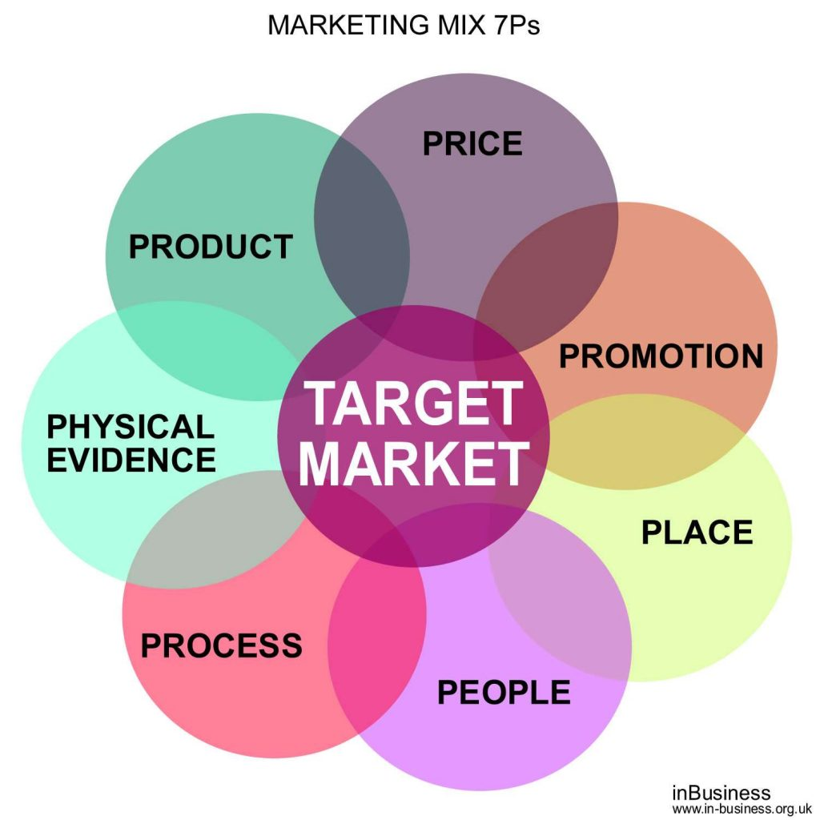
(Belyh, 12 Global Marketing Strategies & Examples of innovative companies 2022).
Products
This refers to what the company produces (whether it is a product, service, or a combination of both) and is designed to meet the customer's primary need. The challenge is to develop the appropriate 'bundle of benefits' to meet this need. So, what happens when customer needs shift, competitors outperform, or new opportunities emerge? To improve the offering, we must add to the 'bundle of benefits,' create new versions of existing products, or launch entirely new products. Think beyond the product itself when improving the product offering - value can be added and differentiation achieved through guarantees, warranties, after-sales or online support, a user-friendly app, or digital content such as a video that helps the user get the most out of the product (Alpha, 7Ps of marketing mix: Explained well with examples 2022).
Price
This is the only revenue-generating component of the marketing mix; all other marketing activities are expenses. As a result, it is critical to get the price right in order to not only cover costs but also generate profit! Before we set prices, we must first gather information on what customers are willing to pay and gain an understanding of the market demand for that product/service. Because price is a strong indicator of market positioning against competitors (low prices=value brand), prices must be set with competitors in mind as well (Barrington, Understanding the 7PS of the marketing mix 2020).
Promotion
The mainstream definition of the word 'Promotion' also applies here. The essence of promotion is found in the activities that a marketer performs in order to properly showcase the product in the market. Technically, promotional activities entail multi-channel, multi-level marketing communications. In a summary, these practises are the communications that businesses engage in, such as advertising, direct calling, using social media channels, and print media. There are numerous examples of how promotional activities have distinguished a product from its competitors in the industry (Alpha, 7Ps of marketing mix: Explained well with examples 2022).
Place
The term "place" refers to the location and the means by which your clients will purchase your good or service. This could happen, for instance, through your website or in a specific shop or shops. When thinking about "location," you need to make two decisions: how to get the products there and how to get them to the customer. According to research, delivery of online-purchased goods is crucial to total client satisfaction and should be incorporated into your overall strategy (The 7 PS of Marketing Mix 2011-2023).
People
All of the people involved in the creation, distribution, and sale of your company's product are also necessary. Generally, marketing mixes for services (intangible offerings) are centred on the people presenting the product. The employees in your store, including delivery personnel and sales executives, leave a lasting impression on customers. Hotels such as Taj, Hyatt, and JW Marriott are well-known for the people who work there to serve the customers. Because of the people they employ, these brands have established themselves and built loyal customer bases (Barrington, Understanding the 7PS of the marketing mix 2020).
Process
Many businesses strive to provide a seamless, effective, and customer-friendly trip, but this cannot be done without the proper processes in place. We may think about what procedures need to be in place to guarantee the consumer has a great experience by understanding the steps of the customer journey, from making an online inquiry to requesting information and making a purchase. How long will it take for a consumer to get a response after making an inquiry? How long does it take to schedule a meeting with the sales staff before the meeting really occurs? What takes place once they place an order? How can we ensure that reviews are generated after a purchase? How can we use technology to make our processes more efficient? All of these considerations contribute to a positive customer experience (Barrington, Understanding the 7PS of the marketing mix 2020).
Physical Evidence
Tangible proof gives clear indications of the calibre of the experience being offered by a business. When a customer is expected to pay for a service in advance of receiving it or when they have never purchased from the company before, it can be especially helpful. Physical evidence for a restaurant could take the shape of the setting, staff attire, menus, and online reviews to show what kind of experience might be anticipated. For an agency, the website itself is a great source of tangible proof, including client testimonials, case studies, and contracts that outline the kinds of services clients may anticipate receiving (Barrington, Understanding the 7PS of the marketing mix 2020).
Selection of Media
Christo’s Restaurant are using social media site to advertise their business. They are using Face Book, Twitter, Instagram and their own Webpage, where most information are held and shared, including the events, opening hours, menus, any special offers and all other facilities they provide, i.e. Banqueting Suite up to 270 People, sports facilities, a Greek School and the Church. This information is very useful for the community to have access to as they need to be aware of all.
The strength of social media is remarkable since it allows you to reach a huge audience quickly after placing an advertisement, which lowers your costs and helps your adverts reach your target audience (Henderson, The importance of social media marketing 2021).
Measurable Success
The evidence shows that, the Christos Restaurant do not trade on two days in a week (Tuesdays and Thursdays), they have a capacity of 102 seatings, which means they can serve up to 102 customers at same time in the restaurant. Also, they have a separate Banqueting Room which can hold up to 270 people at a time and it is available to the community with prior booking. They offer separate menus for different days at the Restaurant and Café they promote their customers to take advantage of their pre-booking facility on certain days to avoid disappointment, for using this reservation or pre-booking service it requires a payment of £10.00 per person in advance.
By carrying out this SWOT analysis it helped to identify or measure Christos Restaurant’ internal affairs.
SWOT Analysis
Strengths
- Christos is Michelin Star chef.
- 102 seating capacity is available at the Restaurant.
- It offers a separate Banqueting Room with up to 270 seating capacity.
- It has its own car parking facility which is free for all customer to use.
- Christos has direct ownership of the property.
- Competitive pricing on the menu.
- Top quality food served.
Weaknesses
- Christos seems to be multitasking, i.e., cheffing, marketing, taking booking for reservations,
- Not selling Halal food at the Restaurant.
- Restaurant is not open every day.
- Menu is not specified, i.e. there is no selections to specified if the dish is Vegan, vegetarian, non – vegetarian, etc.
Opportunities
- Christos has 15 years of previous experience as Manager, Musician and working as a Head Chef, therefore he can train his staffs to his needs.
- Christos is a Michelin star Chef, which is a phenomenon achievement or qualification for any Chefs.
- Scope to introduce Halal food in their menu.
- Scope to introduce Vegan and Vegetarian food in their menu.
- May modernise the building to attract more customers.
Threat
- Competitor may take advantage as Christos restaurant is close every Tuesdays and Thursdays
- Charging the £10.00 per person when making Reservations to dine in certain days.
- Lack of finance
- New entrant
- Location can be an environmental factor as competition may be high.
- Cost of food may increase relating to economic factors, i.e. raw materials, transportation
Task 2: Provide a managerial implication on the organisation’s marketing strategy
An internalisation technique known as "global marketing" entails a corporation designing or altering its goods to meet the needs of a diverse customer base. In other words, it entails modifying a product to concentrate on the requirements of potential customers in various markets.
The business develops a comprehensive strategy for the planning, production, placement, and promotion aspects of its 4Ps of product marketing.
Knowing your audience is the key to successful global marketing, just like it is for everything else in marketing. You must understand who needs your product, in what form they need it, and how to promote it to them most successfully while upholding the principles that define your brand.
You will need to do new market research as part of your global marketing strategy to determine which nations will have the most success potential for your product. After then, you can adapt your brand to the new market, however it's not always required to do so.
One thing to keep in mind, though, is that global marketing does not include developing a standard procedure and then applying it on a global scale.
Though brands occasionally use different names in different territories for a variety of reasons, some aspects of your brand, such as your name and logo, will be standardised, while others, such as your messaging, packaging, PR, advertising, and preferred channels, might not be as effective for your global marketing strategy and will need to be changed.
For instance, while Facebook marketing might be very successful for you in the US, it might be less successful in Japan, where Twitter is more well-known than Facebook, or it might not be successful at all in China, where it has almost no presence (Belyh, 2022).
It is very important to do marketing or have a marketing strategy in place for an organisation to make consumers aware of the services or products you are offering, which helps the consumers with their buying decisions. As this marketing plan is very important and helps create a business plan to run your business successfully, without a marketing plan a business can come into difficulties, suffer and eventually will not be as successful and profitable as it should be (Jaiswal, 2022). Therefore, this will be the first suggestion will be for Christos to have this in place.
Also Cost reduction is significant in business for several reasons, including:
- Enhanced competitiveness: Businesses confront fierce competition from both domestic and foreign opponents in today's global market. Companies can offer competitive prices to their clients and maintain their competitiveness in their sector by lowering costs.
- Improved earnings: By raising margins, cutting expenses enables enterprises to boost profits. Small firms that have limited resources and must optimise their revenues to survive and expand may find this to be of particular importance.
- Improved efficiency: Companies can streamline their processes and become more efficient by cutting superfluous costs. This may result in higher production, which might then translate into higher earnings and a more resilient company.
- Increased flexibility: Cutting expenses allows businesses to invest more freely in other aspects of their operations, such as marketing, research and development, or personnel training and development.
There are numerous ways for firms to cut expenses, such as:
- Better price negotiations with suppliers: Businesses can lower their cost of items sold by negotiating better prices with suppliers.
- Operational streamlining: By streamlining operations, organisations can spend less time and money on tasks that are not necessary, which will result in cost savings.
- Employing energy-efficient procedures: Energy-efficient procedures can assist firms in lowering their energy expenditures and carbon impact.
- Using technology: Businesses can automate some operations and use less manual labour by using technology, which results in cost savings.
Cost cutting is a significant component of business management because it aids in a company's ability to grow earnings, stay competitive, and operate more effectively. Businesses can improve their financial performance and their chances of long-term success by putting cost-cutting initiatives into practise (Importance of cost reduction in business 2022).

Task 3: Based on the managerial implications drawn in Task 2, provide recommendations as to how the organisation’s marketing strategy could be improved.
Following a Marketing strategy is very important to for any organisation to find out the organisations gap in the market, by planning this, the organisation can find any missing gaps in the marketing plan and fulfil them to perform effectively and efficiently. This is one the Model which can be used to analyse the “Service Quality in an organisation”.
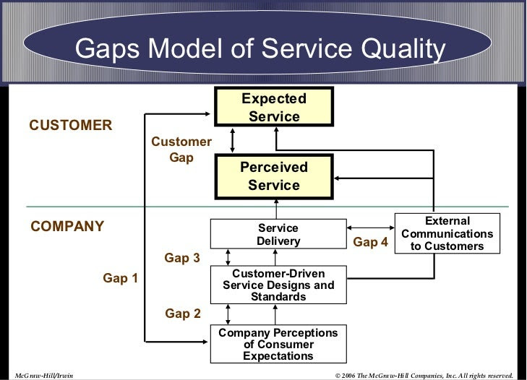
As a marketing consultant the shortcoming of Christos restaurant it has been identified that there are missing gaps in their marketing strategy (as explained below)
What the customer expects | Knowledge Gap | What management thinks the customer expects
Management’s understanding of customer needs | Policy Gap | Service delivery policies and employee standards
Experience specification | Delivery Gap | Actual results
Delivery of the customer experience | Communication Gap | What was communicated to the customer
Customer expectations | Customer Gap | Customer perception of the experience
Further Recommendations
After carrying out a SWOT analysis, I was able to identify, that if Christos were to use his strength being an award-winning Michelin star chef and improves the service quality that would be beneficial for attracting high-end customers, and if this is done then the menu price can be increased accordingly, as quality always pays for itself. Secondly, the opening hours will need to be looked at, if the restaurant is close for two days in a week, then it is obvious the customers will go else where to dine in, and that might result in losing the customer as the competitors will take advantage.
The restaurant is in need of modernising its interior to create an ambiance. Also, the takeaway delivery service is advisable to be available everyday as people after Covid-19 pandemic are now used to having their food delivered to their home or workplace. To conclude my final recommendation for Christos to implement the Marketing Strategies by using different Marketing Frameworks “Service Blueprint” as well as previously mentioned in my research.

References
Jaiswal, S. (2022) What is the importance of marketing for business?: Emeritus India, Emeritus. Available at: https://emeritus.org/in/learn/what-is-the-importance-of-marketing-for-business/#:~:text=The%20importance%20of%20marketing%20for%20your%20business%20is%20that%20it,%2C%20reputation%2C%20competition%2C%20etc. (Accessed: February 24, 2023).
Belyh, A. (2022) 12 Global Marketing Strategies & Examples of innovative companies, FounderJar. Available at: https://www.founderjar.com/global-marketing-strategies/ (Accessed: February 27, 2023).
Importance of cost reduction in business (no date) Importance of cost reduction in business. Cost Management in the Banking Industry. 2022-11-02. Available at: http://complianceportal.american.edu/importance-of-cost-reduction-in-business.php (Accessed: March 1, 2023).
Henderson, G. (2021) The importance of social media marketing, The Importance Of Social Media Marketing. DigitalMarketing.org. Available at: https://www.digitalmarketing.org/blog/the-importance-of-social-media-marketing (Accessed: March 2, 2023).
Belyh, A. (2022) The elements of product mix, FounderJar. Available at: https://www.founderjar.com/elements-of-product-mix/ (Accessed: March 2, 2023).
Barrington, R. (2020) Understanding the 7PS of the marketing mix, Oxford College of Marketing Blog. Available at: https://blog.oxfordcollegeofmarketing.com/2020/10/08/understanding-the-7ps-of-the-marketing-mix/ (Accessed: March 3, 2023).
Alpha (2022) 7Ps of marketing mix: Explained well with examples, CaseReads. Available at: https://casereads.com/7ps-of-marketing-mix-explained-well-with-examples/ (Accessed: March 3, 2023).
2011-2023, (c) C.skillsyouneed.com (no date) The 7 PS of Marketing Mix, SkillsYouNeed. Available at: https://www.skillsyouneed.com/lead/7-marketing-ps.html (Accessed: March 3, 2023).

