
Student Name | Saima Ijaz
Student ID | 2237202
Module Details | Digital Transformation in Health and Care Professions  (BMHP6026_BIRM)
Module Lecturer | Martin Svejda
Assignment Details | Component 1: Written Report

Contents Page No.

Introduction 3
Workforce Impact analysis 4
- Changes in Job Roles 6
- Competency and Training Requirements 7
- Benefits vs. Challenges 7
Service delivery 8
- Changes in Workflows, Communication, and Efficiency 8
- Short-Term Challenges 9
- UK-Based Case Studies 9
Recommendations 10
Conclusion 11
References 12

Investigate a digital innovation (technology/device) that has been successfully implemented within Health and Social Care within the last 10 years.
Introduction
Technology plays a vital and crucial role in health and social care to improve patient’s outcomes, easy access to patient’s medical records, reduce medical errors and reduction in care cost.
Blood glucose monitoring sensors introduced on NHS Drug Tariff in 2017 but access for type 1 diabetes patients was only committed by the NHS Long Term Plan in 2019 and finally rolled out by 2022 (Crabtree et al., 2018). A continuous glucose monitor (CGM) is a device for those people who have diabetes which allow the patients to check glucose level in the blood at any time without painful finger pricks. CGM is made up of a sensor which can be attached to the upper arm or tummy, it senses that how much glucose is in the interstitial fluid under the skin. A compatible device like a smart phone shows result as patient scan the sensor (NHS, 2024).
With the help of CGM device, patients can keep a closer eye on their blood glucose levels stability, better management of hypo and hyper episodes, pain relief and reduction in further complications of diabetes. As well as health professionals can check real time data of glucose level, take decisions on time to reduce the risk of complications and hospital admissions (National Institute of Health, 2023).
However, report will identify changes in and competencies of job roles due to this digital innovation in health care. As well as, report will examine that how this technology affect patient’s perception and experiences of care.
Furthermore, report will explain that how this innovation change service regarding workflows, efficiency and communication. Report will provide deep insight about the impact of innovation on community level and will address accessibility improvements in rural areas as well as family involvement in patient’s care. Conclusion and recommendations will be added at the end.
Workforce Impact Analysis
CGM device changed workforce dynamics in healthcare. This device is benefiting for working diabetic population such as: better health outcomes, improving concentration and overall job performance. The use of continuous glucose monitoring (CGM) has totally transformed diabetes management on daily basis for patients as well as reshaped the responsibilities, competencies, and training needs of healthcare professionals. According to Diabetes UK (2024), there are 5.8 million people living in UK with diabetes, 4.6 million diagnosed with diabetes although 1.3 million people living with diabetes but not diagnosed yet. The numbers of people for 2023-24 are up by 185,034 from 2022-23. Around 8% of people diagnosed with diabetes type 1 whilst 90% with type 2.
People from India, Pakistan, Bangladesh, Chinese, Black African and Caribbean ethnicities have been found 4 times more likely to type 1 or type 2 diabetes than white people (Statista.com, 2025).
Ethnic Groups have type 1 or type 2 diabetes.
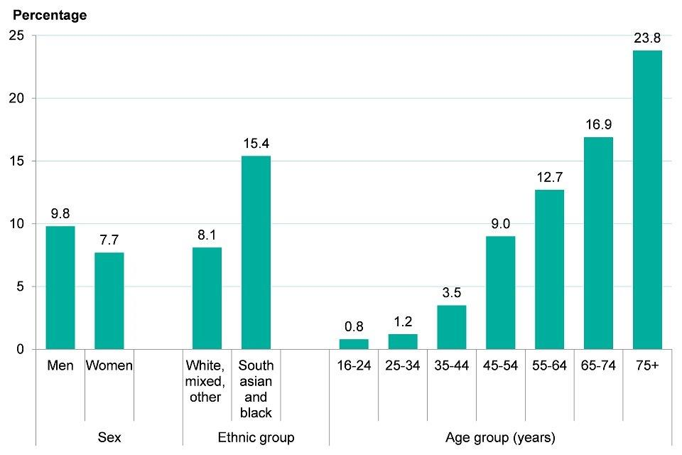
Figure 1: Percentage of ethnic groups has diabetes. (Diabetes UK, 2023)

How it looks and works
A CGM system continuously measures glucose levels in the interstitial fluid through a sensor, providing a real time data rather than finger prick tests.
According to National Institute for Health and Care Excellence (NICE) (2023), 28,453 people are using FreeStyle Libre device in England however, 250,000 people living with diabetes type 1 in country. Roughly one in ten people with type 1 diabetes are using FreeStyle Libre device currently. As per 2024, 7 million people are using FreeStyle Libre technology across more than 60 countries.
Over 200,000 diabetes patients are using non-invasive glucose monitoring devices (CGMs) which allow them to check blood glucose levels at home more easily and regularly (NHS, 2022)

(FreeStyle Libre, 2023)

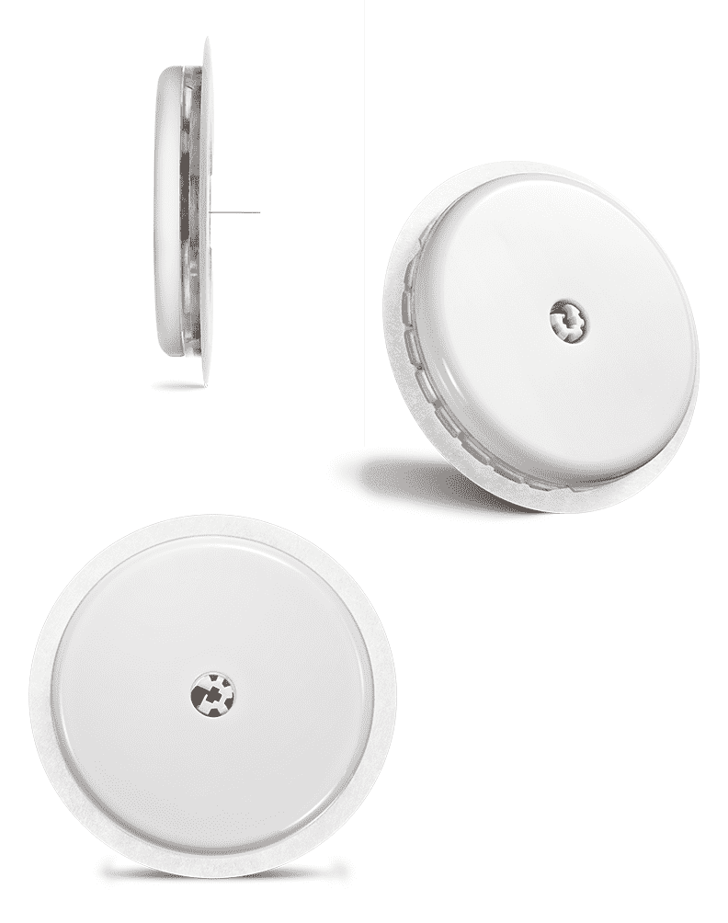
(FreeStyle Libre, 2023)

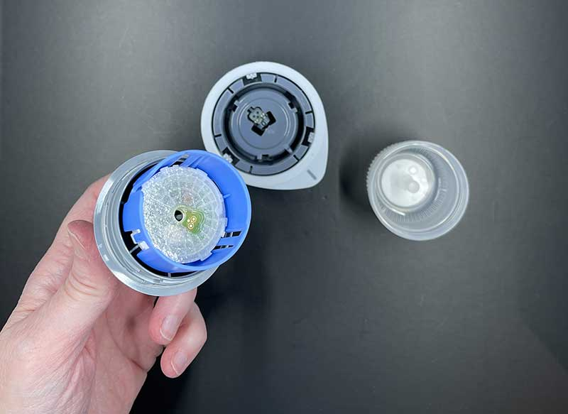

(The Gadgeteer, 2020)
The above figures are showing that which things are including in the kit made by Abbot and how it looks like. On youtube, there are los of videos which describe the way that how to use device.
In this part of the report will examine that how CGM device changed job roles of healthcare professionals as well as how daily life of patients changed after using this, what type of competencies and training required for workforce training and what benefits and challenges faced by the workforce.

Changes in Job Roles
The introduction of CGM in diabetes industry has changed traditional way to handle the job responsibilities within diabetic care particularly. Healthcare providers and diabetes educators (specialist nurses) are now work in a different way to attend the patients such as, routine glucose testing, data analysis and patient education based on continuous readings (Ni et al., 2024). The roles of nurses, diabetic educators and specialist nurses involve in interpreting complex data, advising on hypers/hypos and managing alerts generated by CGM device. They are spending time on to teach device placement, troubleshooting connectivity and checking and managing their readings rather than finger pricking testing. According to Gavin and Bailey (2023), the rapid adoption of CGM improved accuracy and as per patient’s demand new positions such as “remote monitoring specialists” and “digital health coaches” emerged. For healthcare staff, CGM device changed the focus from manual glucose checks to turn a high level analytical and consultative work. This transformation demands updated and IT related job descriptions (Morris-Murray & Frazzitta, 2024). NHS must invest a good amount to set up on IT specialists, infrastructure and collaboration between clinicians, and educators to support effective CGM device deployment.

Competency and Training Requirements
Healthcare requires new IT skills and advance technological knowledge to interpret and understand data received by CGM devices. Candidates should be eligible to understand interpreting “time-in-range” graphs, routine data reviews, change of medication and how to integrate digital tools into clinical workflows (Morris-Murray & Frazzitta, 2024). NHS must start targeted and structured certification training programmes for already appointed medical trained nurses, pharmacists and educators to set up of device, understand the received data, to manage continuous datasets, asynchronous review capacity as well as use of telehealth systems effectively. Kwon and Moon (2025) highlighted that digital fluency, analytical thinking, and patient communication are now essential competencies in healthcare sector. This revolutionary innovation requires healthcare organisations to adopt a continuous professional development programme which should be align with new emerging technologies and based on patient-centred care.

Benefits vs. Challenges

According to Kwon and Moon, (2025), Patients who are using CGM device experience a visible reduction in glycated haemoglobin (HbA1c) level, (range between 0.25% - 3.0%). As a result, risks and complications in diabetic patients reduce such as hypoglycaemia as well as this device improves patient satisfaction and quality of life. CGM devices enhance workforce efficiency and productivity by helping and managing their blood glucose level through CGM devices rather than spending time in manual checking. Interdisciplinary collaboration can be seen like Nurses, specialist diabetic nurses, data engineers and IT specialists working together and share patient’s medical records/data according to Data protection Act 2018 and UK General Data Protection Regulations (UK GDPR) which make ease for them in decision making about the better health outcomes for the patient. Skill diversity, data management capabilities and digital literacy may be increased in patients.
However, the implementation of CGM devices brought benefits for the NHS as well as it brought challenges for the healthcare providers and users. Device costs, reviewing and monitoring data, analysing data, and data overload can be a burden for patients and health providers (Gavin & Bailey, 2023). To overcome on these issues, NHS has to pay a heavy amount to handle them in proper way. There is an eligibility criteria for diabetic patients to attain CGM device free from NHS if they are not eligible, they should pay from their own pocket which is difficult for patients (Diabetes UK, 2025). Additionally, limited access to resources, low-income and minority populations are less likely to benefit from CGM technology (Agarwal et al., 2022). Gaps in data often occur when users experience unstable glucose levels, which limit clinical effectiveness. Addressing these barriers, targeted policies, improved device affordability, and comprehensive user education is required. Due to a great decrease in routine glucose monitoring, a range of jobs are at risk. Real time alerts may increase stress in patients as well.

Service Delivery
Continuous glucose monitoring (CGM) device reshaped diabetes care. It shifted regular clinic visits, manual glucometer checks by painful finger pricking into continuous real time readings, data review and targeted interventions. CGM devices are providing proactive, continuous and remote monitoring as well as telehealth integration. These devices shift the care model and provide a complete game changer experience to both healthcare providers and service users.

Changes in Workflows, Communication, and Efficiency

In primary care and special settings, CGM devices enables healthcare professionals including nurses, specialist diabetes nurses, educators, and pharmacists to share their tasks, integrate digital date received by sensors to healthcare records as well as analyse data and prepare reports based on real time readings of diabetes (American Diabetes Association, 2025). CGM devices has clinically proved in tests to reduce HBA1c level in diabetes management in primary care settings, which minimise urgent and emergency calls to handle hypo/hyperglycaemia situations (Norman et al., 2025).
Communication patterns also change because CGM devices are connected with healthcare professional’s digital tools and cloud dashboards. In this way, healthcare professionals from interdisciplinary teams enable to access the real time readings and reduce the visits to GPs and hospitals. During the pandemic and after, virtual CGM devices provide an easy and feasible access to patients, they minimise the in person contacts which saved their lives and others. Professionals used and had access to device platforms and share analytical graphs with patients, improving shared decision-making and self-management literacy (Underwood et al., 2021). Direct access to patient’s blood glucose readings reduced ambiguity in conversation as well as increased the chances of saving lives on time to include proper medicines in patient’s medical chart (American Diabetes Association, 2025).
Efficiency depends on quick and accurate information, and then healthcare professionals reduced emergencies and hospitalisation due to early intervention. CGM data automatically gathered time to time in patient’s electronic health records (EHR), not a member of staff manually changed this data, no risks of forgery and duplicate documentation left. In this way, healthcare personals save their time and produced better outcomes (Aleppo et al., 2023). Patients felt empowerment and ease to receiving proper and appropriate treatments.

Short-Term Challenges
First barrier was cost, both direct and indirect cost to train staff and continuous analysing reviewing data. Cost varies in every country. However, multiple analyses found that CGM technology cost-effective than self-monitoring as well as better long-term control (Isitt et al., 2022). People with type 2 diabetes and not using insulin are not eligible to take CGM device from NHS but if patient’s medical chart based on tablets and patient is taking insulin twice in a day are eligible for a CGM device from NHS. Some patients are still restricting to get this which is prolonging inequities and administrative burden (Martens et al., 2021).
Technology Integration with current EHR system was emerged another challenge. NHS and other interdisciplinary organisations must be compatible with each other. To avoid disruption in workflow, start intensive training programmes, integrate EHR data with CGM technology, avoid gaps between them, to remove obstacles (Vimalananda et al., 2025).
UK-Based Case Studies

Association of British Clinical Diabetologists (ABCD) (2020), audit collected real-world data from over 10,000 freestyle Libra users from 101 NHS hospitals in UK. Through this study, they examine effects on glycaemic control (HBA1c), hypoglycaemic awareness, time in hypoglycaemia, diabetes stress and utilisation of healthcare resources.

In another study, 92 adults aged 18 years old with type 1 diabetes from Eastern Chestshire region participate. Researcher found that after 3 months use of Libre HBA1c reduced to 83.0 mmol to 72.3 mmol and further reduced in next 6 months. Age and gender did not correlate with any change in HBA1c (The University of Manchester 2020).

Quality in Care (2020) developed a study during Covid-19 pandemic when NHS Trust uses to implement Libre or similar flash device on 350 patients to reduce staff exposure as well as staff burden. Device users found it extremely useful, 94% reported about staff exposure reduction, 87% preferred it on finger pricking, 68% felt great control on diabetes and 79% reported about increased in confidence.

Manchester Biomedical Research Centre (NIHR) (2024), conducted a study from Blackpool Teaching Hospital’s 127 patients who participated to check the affects of Libre after 1 year use. They reported 46% reduction in hypoglycaemic episodes as well as they check the work flow and efficiency after using this device.

Recommendations

NHS should be targeted high need group first whether they belong to any area or ethnic group.

Provide a mandatory education for users and gave them awareness of CGM device’s importance for their diabetes management.

Some patients with type 2 treated with insulin but some local government found them costly. In this way NHS make them cost effective for those patients.

CGM should be adopted broadly for people with insulin-treated diabetes including Type 2, pregnant women with Type 1, and those have hypoglycaemia episodes or who require carer support.

Ensure paring device with existing NHS EHR system and adopt strict safety criteria.

Conclusion
CGM devices has been widely implemented across UK health and social care during last ten years and emerged as revolutionary innovation in the field of diabetes management. As well as they played a vital role in improving glycaemic control (HBA1c). This device rollout must be paired with training, equity measures, and robust training programmes. Over the last decade CGM has moved to mainstream diabetes care in many parts of health and social care sector. The technology is clinically valuable and can be cost-effective, but its success depends on accompanying education, safe procurement, data integration and equity-focused implementation. CGM represents a high-value digital innovation that improves outcomes and quality of life for people who are treated by insulin.

References
Association of British Clinical Diabetologists (ABCD) (2020) Diabetes Care Publishes ABCD Freestyle Libre Audit Outcomes. Available at: https://www.abcd.care/announcement/diabetes-care-publishes-abcd-freestyle-libre-aduit-outcomes (Accessed: 25th October 2025).
Agarwal, S., Schechter, C., Gonzalez, J., & Long, J. A. (2022). The use of diabetes technology to address inequity in diabetes care. Diabetes Technology & Therapeutics, 24(8), 580–587. Available at: https://doi.org/10.1089/dia.2021.0515 (Accessed: 20th October 2025).
Aleppo, G., Chmiel, R., Zurn, A., Bandoske, R., Creamer, P., Neubauer, N., Wong, J., Andrade, S. B., & Hauptman, A. (2025). Integration of continuous glucose monitoring data into an electronic health record system: Single-center implementation. Journal of Diabetes Science and Technology, 19(2), 426–430. https://doi.org/10.1177/19322968231196168 (Accessed: 20th October 2025).
American Diabetes Association (ADA). (2025). Standards of medical care in diabetes — 2025. Diabetes Care, 48(Suppl. 1). https://doi.org/10.2337/dc25-S001 (Accessed: 22nd October 2025).
American Diabetes Association. (2025). Summary of revisions: Standards of medical care in diabetes — 2025. Diabetes Care, 48(Suppl. 1). https://doi.org/10.2337/dc25-Srev (Accessed: 22nd October 2025).
Bender, C., & colleagues. (2025). The history, evolution and future of continuous glucose monitoring. [MDPI Diabetes Overview Journal], 6(3), 17. https://doi.org/10.3390/diabetes6030017 (Accessed: 20th October 2025).
Crabtree, SJ. T., Sathyapalan, T., and Wimot, G.E., (2018) ‘FreeStyle Libre: available on the NHS?’ The British Journal of diabetes. Available at: https://www.doi.org/10.15277/bjd.2018.168. (Accessed: 18th September 2025).
Diabetes UK (2024) How many people in the UK have diabetes? Available at: https://www.diabetes.org.uk/about-as/about-the-charity/our-strategy/statistics (Accessed: 22nd October 2025).
Diabetes UK (2023) Available at: https://www.assets.publishing.service.gov.uk/government/uploads/system/uploads/image_data/file/78624/HpfE_Chapt3_fig10.jpg (Accessed: 22nd October 2025).
Diabetes UK (2025) Can I get continuous glucose monitoring on the NHS? Available at: https://www.diabetes.org.uk/about-diabetes/looking-after-diabetes/technology/continuous-glucose-monitors/can-i-get-cgm-on-the-nhs (Accessed: 23rd October 2025).
Espinoza, J. C., Xu, N. Y., & Shah, N. (2021). The need for data standards and implementation policies to integrate CGM data into the electronic health record. Journal of Diabetes Science and Technology, 15(5), 905–912. https://doi.org/10.1177/19322968211058148 (Accessed: 20th October 2025).
FreeStyle Libre (2023) The FreeStyle Libre 2 System.
Available at: https://www.freestyle.abbott/uk-en/products/freestyle-libre-2.html
(Accessed: 23rd October 2025).
FreeStyle Libre (2023) FreeStyle Libre Sensors. Available at: https://www.freestyle.abbott/ae-en/product/freestyle-libre-sensor.html (Accessed: 23rd October 2025).
Gavin III, J. R., & Bailey, C. J. (2023). Continuous glucose monitoring impact and implications of real-world evidence: Past, present, and future. Diabetes Technology & Therapeutics. Available at: https://doi.org/10.1089/dia.2023.0057 (Accessed: 20th October 2025).
Isitt, J. J., et al. (2022). Cost-effectiveness of real-time continuous glucose monitoring versus self-monitoring of blood glucose in adults with type 1 and type 2 diabetes: A systematic review. Diabetes Therapy, 13(3), 719–734. https://doi.org/10.1007/s13300-022-01209-9 (Accessed: 22nd October 2025).
Kwon, S. Y., & Moon, J. S. (2025). Advances in continuous glucose monitoring: Clinical applications. Endocrinology and Metabolism (Seoul), 40(2), 161–173. Available at: https://doi.org/10.3803/EnM.2025.2370 (Accessed: 20th October 2025).
Manchester Biomedical Research Centre (NIHR) (2024) Diabetes technology associated with reduced hospital admissions and improved blood sugar control for Blackpool patients. Available at: https://www.manchesterbrc.nihr.ac.uk/news-and-events/diabetes-technology-associated-with-reduced-hospital-admissions-and-improved-blood-sugar-control-for-blackpool-patients/?utm_source=chatgpt.com (Accessed: 25th October 2025).
Martens, T., et al. (2021). Effect of continuous glucose monitoring on glycemic control in patients with type 2 diabetes treated with basal insulin: The MOBILE randomized clinical trial. JAMA, 325(22), 2262–2272. https://doi.org/10.1001/jama.2021.7444 (Accessed: 22nd October 2025).
Morris-Murray, M., &Frazzitta, M. (2024). Using continuous glucose monitoring to measure and improve quality metrics: Updates on the Healthcare Effectiveness Data and Information Set 2024 Glucose Management Indicator measure. Journal of Managed Care & Specialty Pharmacy, 30(10-B Suppl), S30–S39. Available at: https://doi.org/10.18553/jmcp.2024.30.10-b.s30 (Accessed: 20th October 2025).
National Institute of Care Excellence (2023) Continuous Glucose Monitoring. Available at: https://www.niddk.nih.gov/health-information/diabetes/overview/managing-diabetes/continuous-glucose-monitoring (Accessed: 18th September 2025).
National Institute of Care Excellence (2023) NICE recommends life changing technology is rolled out to people with type 1 diabetes. Available at: https://www.nice.org.uk/newa/articles/nice-recommeds-life-changing-technology-is-rolled-out-to-people-with-type-1-diabetes (Accessed: 22nd October 2025).
NHS (2024) Continuous glucose monitoring and hybrid closed loop for diabetes. Available at: https://www.nhs.uk/tests-and-treatments/cgm-and-hcl-for-diabetes/ (Accessed: 18th September 2025).
NHS (2022) Rapid NHS rollout sees 200,000 diabetes patients get life changing devices. Available at: https://www.england.nhs.uk/2022/12/rapid-nhs-rollout-sees-200000-diabetes-patients-get-lifechanging-devices/ (Accessed: 22nd October 2025).
Ni, K., Johnston, A. R., Poll, J. B., Hays, E. M., & Jones, C. W. (2024). Continuous glucose monitor: Reclaiming type 2 diabetes self-care. Journal of Diabetes Science and Technology, 18(3), 501–512. Available at: https://pmc.ncbi.nlm.nih.gov/articles/PMC11223994/ (Accessed: 20th October 2025).
Norman, G., et al. (2025). Continuous glucose monitoring in primary care: Real-world effectiveness and clinical integration. Primary Care Diabetes, 19(1), 15–23. https://doi.org/10.1016/j.pcd.2024.07.003 (Accessed: 22nd October 2025).
Quality in Care Diabetes (2025) Diabetes Digital Monitoring: Building Back Better to Support Nursing Teams, Reduce Healthcare Inequalities & Empower Patients. available at:
https://qualityincare.org/?s=Diabetes+Digital+Monitoring%3A+Building+Back+Better+to+Support+Nursing+Teams%2C+Reduce+Healthcare+Inequalities+%26+Empower+Patients&asp _active=1&p_asid=1&p_asp_data=1&filters_initial=1&filters_changed=0&qtranslate_lang=0&current_page_id=21210 (Accessed: 25th October 2025).
Statista.com (2025) Share of patient receiving care processes and treatment for diabetes in England in 2023/24, by type.
Available at: https://www.statista.com/statistics/386758/patients-receiving-the-care-processes-for-diabetes-by-in-england/ (Accessed: 22nd October 2025).

The Gadgeteer (2020) Abbott FreeStyle Libre 14-day flash glucose monitoring sensor review – No more finger sticks! Available at:
https://www.the-gadgeteer.com/2020/12/08/abbott-freestyle-libre-14-day-flash-glucose-monitoring-sensor-review-no-more-finger-sticks/ (Accessed: 23rd October 2025).

The University of Manchester (2020) The FreeStyle Libre flash glucose monitoring system: how it has improved glycaemic control for people with type 1 diabetes in Eastern Cheshire, UK. Available at:
https://research.manchester.ac.uk/en/searchAll/index/?search=The+FreeStyle+Libre+flash+glucose+monitoring+system%3A+how+it+has+improved+glycaemic+control+for+people+with+type+1+diabetes+in+Eastern+Cheshire%2C+UK&pageSize=25&showAdvanced=false&allConcepts=true&inferConcepts=true&searchBy=PartOfNameOrTitle (Accessed: 25th October 2025).
Underwood, P., Hibben, J., Gibson, J., & DiNardo, M. (2022). Virtual visits and the use of continuous glucose monitoring for diabetes care in the era of COVID-19. Journal of the American Association of Nurse Practitioners, 34(3), 586–596. https://doi.org/10.1097/JXX.0000000000000659 (Accessed: 20th October 2025).
Vimalananda, V. G., et al. (2025). Implementing continuous glucose monitoring in primary care: Barriers and facilitators to adoption. BMJ Open Diabetes Research & Care, 13(2), e004856. https://doi.org/10.1136/bmjdrc-2025-004856 (Accessed: 22nd October 2025).
Vrany, E. A., et al. (2023). Continuous glucose monitors and virtual care in high-risk populations: Addressing disparities and leveraging CGM in telehealth. Frontiers in Endocrinology, 14, Article 1083145. https://doi.org/10.3389/fendo.2023.1083145 (Accessed: 20th October 2025).

