LEADERSHIP AND MANAGEMENT, THEORY AND PRACTICE
Assessment 1
Module lecturer:Anita Nan
Student name:Georgiana Stan
Student number :1915942

Table of Contents
Introduction 3
Overview of Tesco 3
Illustration of model and theories of management and leadership 3
Developing previous models and theories for the leader of Tesco, that reflect the evaluation of the effective impact of leadership at Tesco 6
Contemporary leadership and management development issues 7
Self-reflection 8
Conclusion 9
Reference List 10
Appendix 12
Appendix 1: PDP Plan 12

Introduction
Management and leadership are the most crucial part of the organization and these two crucial areas of the organization shape the entire business and help to achieve the ultimate goal of the company. Positive management and leadership roles help to develop the work experience of employees. Moreover, it also assists to develop positive work culture in the organization which enhances employee satisfaction rate remarkably. In case of this study, it is going to analyze the crucial theory and model related to management and leadership. It also showcases the impact of effective theories and models on Tesco and its business growth. This area of the study has also portrayed the issues related to leadership and management and also enlightened the reflection.

Overview of Tesco
Tesco is one of the most popular multinational retail company that located in the UK. The employee number of Tesco reached 354,744 in 2022. The revenue rate of Tesco reached over 56 billion British pounds in the 2021/22 financial year (statista.com, 2022). The sales rate of the company increases even during the time of the pandemic. This company develops an effective management team and adopts a most significant leadership style in their organization which helps to improve the internal and external organizational culture. On the other hand, Tesco has also implemented AI technology in their company which helps to enhance the productivity rate of the company.

Illustration of model and theories of management and leadership
Theories and models play the most effective role in an organization and this area of the study is going to showcase the crucial theory and model of management and leadership. The following area of this section portrays this effective information.
Kurt Lewin's change management model
This is one of the most effective management models that help to implement change inside the organization. Behavioral elements among employees can also be measured through this model. In the following area, the figure of the model has been developed.
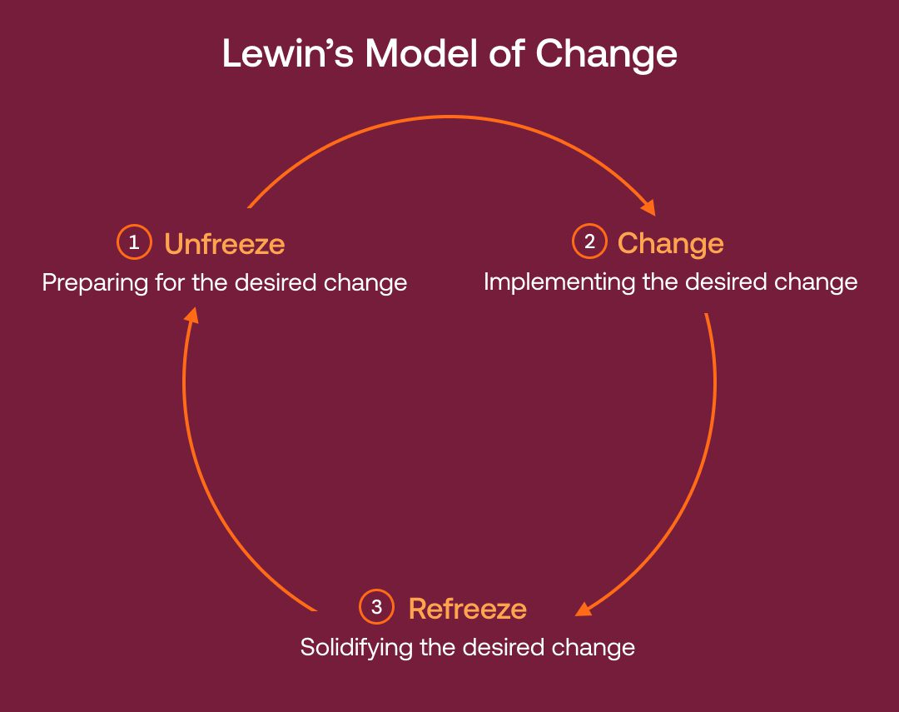
Figure 1: Lewin’s change management model
(Source: Hussain et al. 2018)
The above figure has portrayed three areas of this model which are “unfreeze”, “change” and “refreeze”. In the unfreeze stage the organization first observes the current situation of the company and examines the entire organization in an appropriate way (Hussain et al. 2018). In the next “change” stage the organization implemented changes and employees of the organization started to adopt new behaviors and thinking to recent changes. The last stage of this model is “refreeze” and in this stage, the management team starts to eliminate and identify barriers and develop a feedback system.
Bureaucratic management theory
Max Weber developed bureaucratic management theory (BMT) and the main focus of this organization is to create effective structure in the significant hierarchy. This effective theory help in establishing procedures and standards in the organization. As per the view of Abun et al. (2021), it has been stated that BMT help to develop skillful employees in the company and it also assists to maintain equality inside the organization.
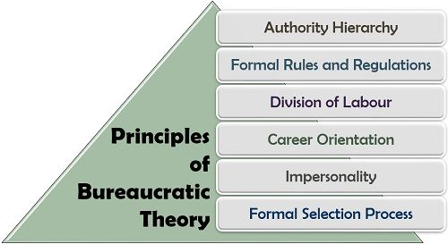
Figure 2: Bureaucratic management theory
(Source: Abun, 2021)
The above figure has highlighted the most effective principle of the BMT and it has been found that the development of this theory helps to bring formal regulations and rules which help to improve the internal organizational culture significantly.
Team-oriented leadership model
This effective leadership model develops a collaborative team in the organization and makes the environment more collaborative. these effective models help to enhance individual employees' strengths and make them more potential which helps to develop the entire team effectively and motivated. As per the view of Chang, Ma, and Lin (2022), it has been stated that the team-oriented leadership model is one of the most motivational and implied focus models that helps to enhance the value of employees in the organization which enhance the employed retention rate in the company. the development of clear communication through this model help to eliminate the communication gap and conflict rate in the company which motivates employees positively and helps to create positive organizational culture effectively.
Trait theory of leadership
The trait theory of leadership portrayed that inborn characteristics and qualities make a paper a leader and those qualities can be physical factors personality factors and it also can be intelligence factors. According to Wyatt and Silvester (2018), trade theory enlightened that the leaders trade at the key to a company's success and identified someone with the right traits to help to improve the organization's performance. On the other hand, another disadvantage of this theory is it neglects all the followers and provides major preference to the leader, and sometimes that brings negative challenges to the company.
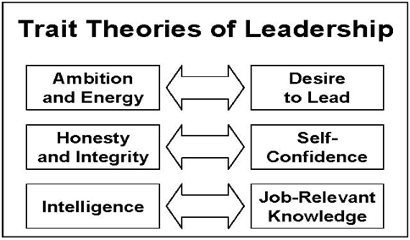
Figure 3: Trait theory of leadership
(Source: Wyatt and Silvester, 2018)
the above figure has mentioned all the crucial trades that a leader should have and the straight can influenza leader to become the most significant part of the organization which influences organization growth and business performance of the entire company.

Developing previous models and theories for the leader of Tesco, that reflect the evaluation of the effective impact of leadership at Tesco
Tesco is expanding its business throughout the entire world. The development of an effective theory and model in Tesco help the company to enhance its sales rate and create a positive position in the global market. As per the view of Meng and Berger (2019), it has been identified that implementation of the effective management and leadership theory in the organization can help to enhance the organizational culture and productivity rate of the company. Supporting this statement, it can be stated that the implementation of Lewin's change management model in Tesco, helps to welcome new changes in the company without facing any challenges in the organization. Every organization should prefer employee priorities in the organization because that portrays the employee value in the company significantly. Organizational structure is the most important part of the organization and the development of an effective organizational structure enhances the employee and leader relationship inside the organization. According to Augustin and Liaw (2020), it has been found that a proper hierarchy structure speeds up productivity and also makes operation clarity. In this scenario, to improve the operation area of Tesco, the development of Bureaucratic management theory can enhance the job security in the organization which motivated employees and enhances work performance of them effectively. On the other hand, this effective theory encourages specialization which improves the performance of individuals and welcomes innovation and creativity in Tesco.
Communication issue is one of the major drawbacks of the company and it can be stated that miss communication among employees can enhance internal conflicts which affect the organizational culture negatively (Banaeianjahromi and Smolander, 2019). most importantly increasing team performance issues in Tesco can affect the company's growth and create a major barrier to developing future opportunities for the company. in this scenario development of a team-oriented leadership, the model can develop the team performance of the company and that can welcome future opportunities and the chances of future growth for Tesco. Analyzing the leadership performance in Tesco's development of trade theory is highly important full stop development of this theory in Tesco helps to understand employees and other management team the quality of a leader and how the leader can make the company more productive. most significantly the development of trade theory helped Tesco's leader to understand which features that leaders should develop and that helps to develop the leadership quality of the leader and that grade significant impact on the organizational growth.

Contemporary leadership and management development issues
Multiple issues have been identified in leadership and management development: artificial intelligence, changing rates accelerating, the war of talent, constant learning becoming necessary, and many more. Companies are recruiting talented and skillful employees to make the organization's development and that is done by the competitors as well and that becomes a challenge for the company to make a success and that is increasing war of talent among the organization and employees (Rosenbach, 2018). The changing rate in development and acceptance of technology in the organization creates a huge pressure on the employees and the employees need to adapt to those changes quickly and involve themselves in the constant planning process for the organizational development. The leaders are facing massive challenges regarding these employees to manage the change along with the employee's demands.
Leaders and managers in multinational corporations are also facing challenges with the engagement of artificial intelligence in operation functions and activities. According to them, it is affecting the skills, techniques, and experience used for the projects and also resisting the development of the employees in the organization. According to the sources, leaders also face challenges such as leading a team, managing stakeholders, inspiring the employees, guiding the changes, and many more and that also affects the growth of the leaders and their skills (Schedlitzki and Edwards, 2021). Some of the contemporary issues are creating permanent challenges to the organization such as improper guidance to the changes of the organization and the rejection of the adoption of technology and AI in the process. The leaders and managers are also facing temporary challenges such as gaining trust from the team members and that is becoming a major conflict in the future stages. Due to the increasing competitiveness in the market, the organizations are rejecting higher potential and talented employees and that is affecting the leaders and managers regarding the outcome of the quality and performance in the organization (Figueroa et al. 2019. The mentioned contemporary issues his also affecting the management of the organization due to the sudden changes and adaptation best challenges faced by the leaders and manager and it affect the quality and performance of the organization overall. Companies such as Tesco, Unilever, Zara, Amazon, and many more are facing multiple challenges of similar type. Challenges such as transforming the business operations with maintaining strong performance and outcomes are difficult for the companies to handle and that creates massive pressure on the leader and manager (Whysall et al. 2019). Along with that constant delivery of quality products and services to the audiences with the changing demand and requirements in the market also creates a huge pressure on the manager and leaders and that requires the adaptation of Technology, AI, Change management, and many more.

Self-reflection
Leadership is a vital role in developing the operation quality and performance of the organization. Leadership helps in leading the teams and employees in the organization to fulfil the requirement and achieve the goals. According to my opinion, I have developed multiple skills and techniques while leading a team and that increases my self-confidence and boosts my self-esteem during the project. Problem-solving and decision making skills are also developed when working as a leader in an organization and that helps to fight in difficult situations and mitigate the conflicts among the employees. I have faced time management skills that have been affected the quality of the projects and I am trying to improve my time management skills by making short-term goals in the project. I always made smart decisions with the changes in the organization and that helps me to adapt to different kinds of situations whether it is complex or simple. According to me, I have the ability to manage the workload and pressure and that has helped me to increase my existing skills such as determination, vision, clarity, adaptation, and many more. The leadership process also helps me to develop my interpersonal skills and communication skills by interacting with the team members to achieve the goals and targets of the project.

Conclusion
This research can be concluded as the significance of leadership and Management in organizations like Tesco is very effective. The discussion on the contemporary management and leadership development issues is done which helps to identify my own experience in the organization for my own development. The theories and models of management and leadership are discussed in the study to highlight the importance of an organization like Tesco in the situation. PDP plan would be made to develop my personal and professional skills to become an efficient, productive, and higher-quality employee for the organization.

Reference List
Abun, D., 2021. Bureaucratic and humanistic management styles and organizational citizenship behavior: A study of divine word college of Laoag. Available at SSRN 3954140.
Abun, D., Calamaan, S.M.T., Magallanes, T., Encarnacion, M.J. and Sallong, M., 2021. Bureaucratic management style and workplace well-being of the Divine Word Colleges. International Journal of Research in Business and Social Science, 10(3), pp.477-489.
Augustin, J.L.P.M. and Liaw, S.Y., 2020. Exploring the relationship between perceived big data advantages and online consumers’ behavior: An extended hierarchy of effects model. International Business Research, 13(6), pp.73-85.
Banaeianjahromi, N. and Smolander, K., 2019. Lack of communication and collaboration in enterprise architecture development. Information Systems Frontiers, 21(4), pp.877-908.
Chang, P.C., Ma, G. and Lin, Y.Y., 2022. Inclusive Leadership and Employee Proactive Behavior: A Cross-Level Moderated Mediation Model. Psychology Research and Behavior Management, 15, p.1797.
Figueroa, C.A., Harrison, R., Chauhan, A. and Meyer, L., 2019. Priorities and challenges for health leadership and workforce management globally: a rapid review. BMC health services research, 19(1), pp.1-11.
Hussain, S.T., Lei, S., Akram, T., Haider, M.J., Hussain, S.H. and Ali, M., 2018. Kurt Lewin's change model: A critical review of the role of leadership and employee involvement in organizational change. Journal of Innovation & Knowledge, 3(3), pp.123-127.
Meng, J. and Berger, B.K., 2019. The impact of organizational culture and leadership performance on PR professionals’ job satisfaction: Testing the joint mediating effects of engagement and trust. Public Relations Review, 45(1), pp.64-75.
Rosenbach, W.E., 2018. Contemporary issues in leadership. Routledge.
Schedlitzki, D. and Edwards, G., 2021. Studying leadership: Traditional and critical approaches. Sage.
Statista.com (2022), Annual revenue of Tesco Group in the United Kingdom (UK) and the Republic of Ireland from the financial year 2015 to 2022, Available at: https://www.statista.com/statistics/490931/tesco-group-finance-revenue-united-kingdom-uk/#:~:text=In%20its%202021%2F2022%20financial,to%20the%20prior%20financial%20year [Accessed on: 25/07/2022]
Whysall, Z., Owtram, M. and Brittain, S., 2019. The new talent management challenges of Industry 4.0. Journal of management development.
Wyatt, M. and Silvester, J., 2018. Do voters get it right? A test of the ascription-actuality trait theory of leadership with political elites. The Leadership Quarterly, 29(5), pp.609-621.

Appendix

Appendix 1: PDP Plan
Specific | How to improve | Time Frame
To develop the time management skills | Time management skills can be developing by dividing the task into short term goals. Also giving time limitation in every task can help in this situation. | 1-2 months
To improve my quality of performance | Quality of the performance can be improved by revising the task and projects multiple times. Working with quality employees can help to improve my performance for the company. | 1 month
(Source: Self-Created)

