

Personal Reflection

Student Name: Magdalena Urbanska

Student ID: 2245520

Module: Human Resource Management

Module Code: LCMB7000

Lecturer’s Name: Dr. Mohamed Asim

Submitted on: 24.08.2023

This presentation is going to focus on ‘Developing an Effective Talent Acquisition Strategy in a Globalised World’.

The presentation will start by:
- introducing the concept of talent acquisition and
- talking about understanding, application and significance of talent acquisition.

Marks and Spencer has been chosen as a case study, which is going to be introduced as well.

After that, the following topics will be discussed in the presentation:
- the significance of acquiring top talent for Marks and Spencer and
- the contribution of talent acquisition to the organisational success of Marks and Spencer.

The final point of focus in the presentation are going to be the similarities and differences between talent acquisition and recruitment.

In the presentation, to support the findings, there is going to be a reference to a selection of 5 sources, 5 of which are going to be cited as well. There will be a reference to statistics about Marks and Spencer as a company as well as extensive personal experience as a Marks and Spencer’s customer will be applied.
The sources studied to prepare the presentation consist of professional human resource management books, academic articles from databases such as ResearchGate and human resource management blogs, including the LinkedIn blog.
The main key words have been established in the search, both on line and off line, such as: talent acquisition and recruitment, and have been linked with Marks and Spencer. The sources are most recent and not older than 5 years to assure the correctness and relevance of findings.
All the sources have been accessed within 1-2 weeks prior to the presentation deadline and the on line ones as recently as few days prior to the deadline, including today, to assure the correctness and relevance of findings.
To begin with, what is talent acquisition in a globalised world?
As we can read below, according to Muiz
‘(...) talent acquisition is a unique profession and this job can be performed by skilful person who has the skills in sourcing tactics, candidate assessment, compliance, hiring standards, employment branding and corporate hiring initiatives that makes talent acquisition process different than the traditional recruitment process.’ (Muiz, 2020, p.3)
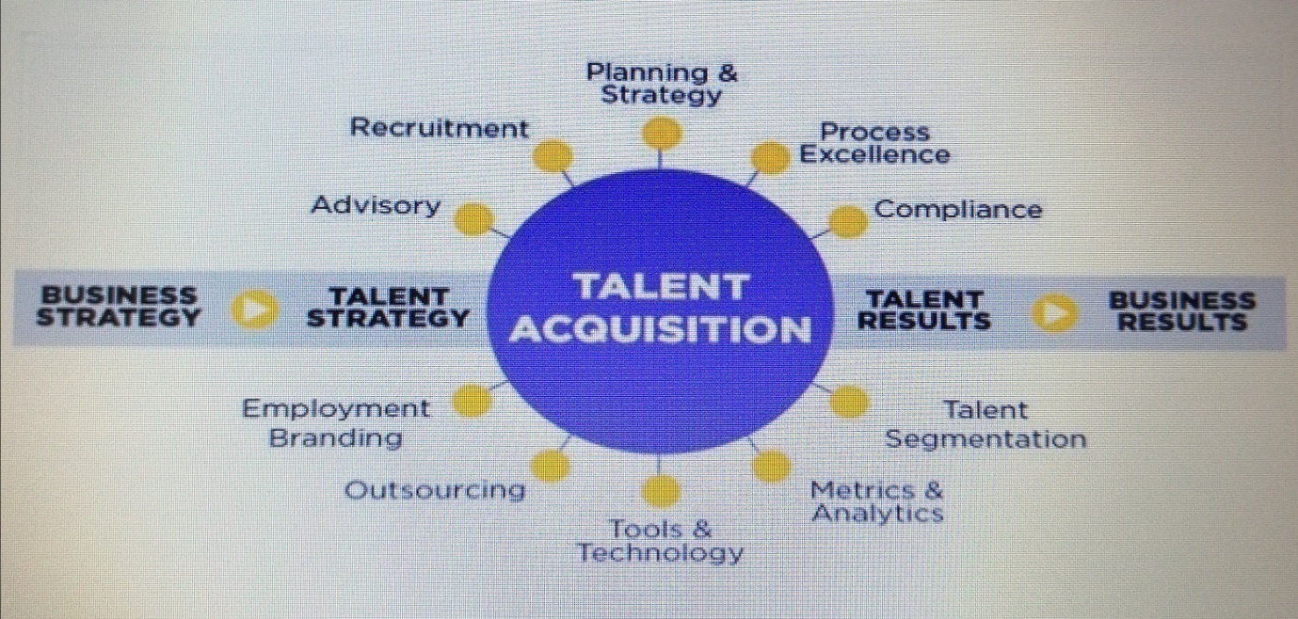
(Muiz, 2020, p.4)
Or, according to Andy Bass, simply: ‘Ability to attract the right talent’. Bass asks us some questions to consider: ‘Are we particularly attractive to the type of candidates we need? Are we a club that they want to get into?’ Top companies definitely ‘have distinctive cultures that attract exactly the talent they need.’ (Bass, 2021, p.65)
Now the significance of acquiring top talent in a competitive business environment is going to be discussed.
Why is it so important to acquire the highest calibre of candidates out there?
Most qualified candidates help drive business and raise revenue for top stakeholders.
Which leads to making more investments in the company and employees.
Which results in becoming a leading player on the market, both domestic and global, beating the competitors, generating even more money and investing in newest technologies and research.
Which leads to obtaining power on a global arena.
A spiral up effect.

How does talent acquisition work in practice?

As previously mentioned, Marks and Spencer has been chosen as a case study of talent acquisition in the UK which is going to be talked about in more detail now.
Why M&S?
Because it is one of the biggest UK’s multinational retailers. It specialises in selling clothes, homeware, beauty, food and grocery products. It is also listed on the London Stock Exchange (LSE) in the UK's FTSE 100 Index.
M&S is definitely an example of a success story.
But, why is it so successful?
- Founded in 1884 by Michael Marks and Thomas Spencer in Leeds. It has survived two world wars, mastered the art of entrepreneurship, customer service and offers highest quality products.
- Strong brand attracts best talent.
- Niche and tailored roles inside the company.
- Succession planning – promoting from within the company.
- Investment in employees.
All the above points lead to elaborating on:
- the significance of acquiring top talent for Marks and Spencer and
- the contribution of talent acquisition to the organisational success of Marks and Spencer.
‘Marks & Spencer is set to create 3,400 jobs by opening ‘bigger and better’ stores across the UK’. (Webber, 2023) As Ashleigh Webber mentions in his article in Personnel Today - the professional human resource management blog – published on 16th January 2023, so very recently, ‘a five year store rotation programme with a £480m investment’ will attract more high skilled employees. (Webber, 2023)
Stores are relocating to newer and larger sites with younger population. The plan is to create more jobs.
In January 2023, M&S also launched a flexible working programme for retail managers - a four-day week, a nine-day fortnight or combining the two. This initiative created a better work – life balance and was hugely successful.
Another big incentive to attract best employees who then provide the best results.

The final point of focus and discussion of the presentation will be the similarities and differences between talent acquisition and recruitment.

‘Recruitment (...) is an activity that results from one of two causes: firstly, a vacancy in an existing base of supply that occurs when the incumbent leaves a role either through turnover or internal mobility; secondly, a new demand that results in the creation of a new role’. (Gibson, 2021, p.113)
‘Job recruiting addresses a company’s short-term headcount needs. Talent acquisition (...) is an overall business and HR strategy that factors in an organization’s long-term goals, and acknowledges that people (or talent) can play a huge role in a company’s future successes.’ (Lybrand, 2018)
Talent acquisition:

Process:
Sourcing and attracting talent
Whom?
Executive level and leadership positions, and requiring specialised training
Who?
HR/ head hunters
How?
Employee referrals
Talent pools
Employer branding
Interviewing
Background checks/ obtaining references
Onboarding
Hiring

Long term strategy, On going strategy

Long term process

Recruitment:

Process:
Sourcing and lead generation of suitable candidates
Whom?
Entry to mid level positions
Who?
HR/ recruiters
How?
Job opening announcement
Internal or external hire - using a third party
Interviewing
Background checks/ obtaining references
Onboarding
Hiring - filling in a role immediately or as soon as possible

Short term strategy
Short term process
The presentation has aimed to introduce the concept of talent acquisition. The significance of acquiring top talent in a competitive business environment has been discussed with a main focus on the talent acquisition in the UK and a case study of Marks and Spencer. The contribution of talent acquisition to the organisational success of Marks and Spencer has been elaborated on. The final point discussed in the presentation have been the similarities and differences between talent acquisition and recruitment.

References

Bass, A. (2021) Start with What Works. 1st ed. Harlow: Pearson Education Limited.
Gibson, A. (2021) Agile Workforce Planning: How to Align People with Organizational Strategy for Improved Performance. 1st ed. London: Kogan Books Limited.
Lybrand, S. A. (2018) 'What is Talent Acquisition?', LinkedIn Talent Blog, 21 March. Available at https://www.linkedin.com/business/talent/blog/talent-acquisition/what-is-talent-acquisition (Accessed: 24 August 2023).
Muiz, A. (2020) ‘Talent Acquisition’, ResearchGate, pp. 1-21. Available at: https://www.researchgate.net/publication/342720039 (Accessed: 24 August 2023).
Webber, A. (2023) 'M&S store expansion to create 3,400 jobs', Personnel Today, 16 January. Available at https://www.personneltoday.com/hr/marks-and-spencer-m-s-job-creation/ (Accessed: 24 August 2023).

