

BSc Level 5 in Health and Social Care
Introduction to Physiology
(BMHP5003_LON.)
Term 2

Assignment 2 Report.
Date: 25 /8 /2021

Normal and abnormal elements of physiology:
A lifestyle of a Cardiovascular Patient.

Elizabeth Owusu
Student Number: 1917244
Module: Introduction to Physiology
Code: BMHP_5003_LON.
Lecturer: Eleni Koutsogeorgou.

1

Table of Contents. Page
Introduction…………………………………………………………………………….…………………2

2. Case Study………………….…………………………………………………….……………………2

3. Health assessment……………………………………………………………….………………….3
3.1. Risk Factors…………………………………………………………………………………………3
3.2. Psychological- depression and emotional unstableness………………………….…………...4
3.3. Essential tips to reduce pressure………………………………………………………………….4

4. Lifestyle……………………………………………………………………………………………….5

5. Findings………………………………………………………………………………………………5

6. Normal and abnormal physiology……………………………………………………………….6- 7
6.1. Health Promotion……………………………………………………………………………….7- 8
Recommendation……………………………………………………………………………………….8

Conclusion…………………………………………………………………………………………….8

References…………………………………………………………………………………………. A- B
Appendences………………………………………………………………………………………C- F

2
Introduction.
Cardiovascular disease continues to be a primary source of morbidity and mortality in the Western world and the world, despite several advances in acute and chronic care. There are health risks associated with certain lifestyle choices. (Bonnet, 2005). It is the world’s biggest cause of death. (Xue Feng- Hu, 2019).
This report is to analyse the risk factors of patient A’s, lifestyle, and the help and advice she can have, in terms of prevention, intervention, measures, activities, and dietary requirements. The study also assesses the physical, physiological, and biological aspect of cardiovascular disease, the risk factors of patient ‘A.’, in relation to heart attack.

Case Study.
The Case of Patient A. Health Profile.
Patient A might be at risk for a heart attack, a stroke, or Diabetes. Due to the amount of alcohol, she consumes on regular basis (3-6 units each day), and the sort of food she eats daily. Lack of exercise and family history of health problems, the father suffered a heart attack at the age of 68, and his sister had cholesterol problems. Patient A has a blood pressure of 180/ 95, which is higher than the normal blood pressure of 120/80. Patient A, also smoke 10-19 cigarette a day.
Patient A is 165 centimetres tall and weighs 86 kilograms, is 48 years of age. Patient A can be classified as obese according to the NHS BMI calculation, as her BMI is 31.6. Her BMI which is calculated by comparing her height and weight, should be between 18.5- 25, with anything above 30 being a risk factor. Patient A should strive to lose 5% of her body weight.

Health status.
Patient A
Weight | Height | Age | Sex | Ethnic group | Activeness | Genetics
86kg | 165 cents | 48 | Female | Middle Eastern | Inactive | Evidence active

Patient A appears to be obese according to the NHS BMI calculator. Her weight should be between 18.5 and 25, because of her height being 165cm. Anything over 30 in weight in her situation is considered a danger sign. She should weigh between 50.4 and 68.1 kilograms.

3
Health assessment.
According to the NHS heart calculator, patient A’s heart age is around 65 on average; yet someone like Patient A, can live to be 74 without having a heart attack or stroke. Patient A ‘s heart age could be 58 if she quits smoking and she could live to be 78 without having a heart attack. Her heart age could be around 54 and she could live to be 83 if she can lower her blood pressure to a healthy level of 119. (PHE, 2021).
Patient A’s heart age may be 61 and she could live to be 78 without having a heart attack or stroke if she loses weight and lower her BMI to 23.44, instead of 31.
Her heart age in relation to cholesterol could be 5, and she could live to be 80 without experiencing a heart attack, but her cholesterol level is not known, she can see her GP for checking. Patient A needs to examine her cholesterol levels. If she can lower them to 4.5 and 1.4, she should expect to live to be 85 years old with a heart age of 58.

Risk Factors.
Patient A has a 3.7% chance of suffering a heart attack or stroke in the following ten years. Her heart age could be as high as 62 if she has Cholesterol, but it could be as low as 50 if she is in good health. (PHE, 2021).
Weight and blood pressure: Patient A’s heart age 65, has a 9.2% chance of living to be 74 in the next ten years if she has cholesterol; if she does have cholesterol, her heart age may be as high as 72, but if it is healthy, it could be as low as 58. Cholesterol puts you at a 6.4% chance of having a heart attack in the next ten years, while weight puts you at 5.2% chance of having a heart attack or stroke in the following ten years. (NHS, 2021).
BMI weight of 31.6 put you in greater risk of serious health conditions including heart diseases, atherosclerosis, and stroke and asthma. Metabolic syndrome—A combination of diabetes, obesity, and several types of cancer. The risk of having gallstones- reduce fertility, osteoarthritis, sleep apnoea and Liver disease.
Her ethnicity puts her at risk of health problems if her BMI is 25 or higher. Losing and maintaining 5% of the body weight has health benefits, such as lowering blood pressure, and lowering her risk of type two diabetes. Patient A, according to NHS BMI calculator analysis, should work towards a healthier weight overtime and should go and see a GP. (NHS, 2019).
At least twice a week, Patient A, should engage in physical activities such as toning, and activities that target main muscle groups, such as legs, back, abdomen, chest, shoulders, and arms. Patient A should engage in at least 150 minutes of moderate level activity or 75 minutes of high intensity activities and reduce the time she spent being inactive.

4
Psychological- Depression, and emotional unstableness
Patient A appears to be socially inactive according to the health assessment, she has not much engagement in any social life, but enjoys drinking alcohol, this may or can have some emotional disorder or even mental unstableness.
.
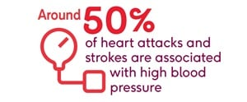
Heart Attack. (NHS, 2021).
Blood pressure, often known as hypertension, is a condition in which blood pressure is persistently elevated, causing the heart to work harder to pump blood around your body. Ignoring high blood pleasure, can progress to heart and circulation problems, such as heart attack, or stroke. Even though, the arteries are flexible, blood pressure can cause them to lose their flexibility and become stiff and restricted. (NHS, 2021). Drinking too much alcohol, smoking, being overweight or obese, not getting enough exercise, and eating too much salt and oily foods can increase the risk of having a heart attack. According to NHS, kidney illness, diabetes, and various drugs, such as oral contraceptives and other over-the=counter and herbal medicines, are also an increasing risk factors of getting heart attack. (NHS, 2021).

Essential tips to reduce blood pressure.
1 | 2 | 3 | 4 | 5 | 6
Regular physical activity | Keeping a healthy weight | Eating a healthy balance diet | Cutting down salt | Reduce alcohol intake | Consult your GP

Patient A can avoid smoking and can contact British Heart Foundation. According to the NHS health check, eating a nutritious and exercising regularly can help lower cholesterol levels in the blood.
Avoid high-saturated fat foods like meat pies, sausages, and fatty cuts of meat, as well as butter, ghee, and lard, cream, hard cheese, cakes and biscuit, and anything containing coconut or palm oil. (PHE, 2021). Oily fishlike mackerel and salmon, which are high in unsaturated fat, are good choices. Almonds and cashews, for instance. Sunflower and pumpkinseeds are examples of seeds that can be healthy. Avocados, rapeseed of vegetable oil, sunflower, olive corn, or walnut oils are all good.
Reducing fat in your diet can help lower your risk of heart disease. Consider grilling, steaming, poaching, boiling, and microwaving instead of roasting and frying.
Physical activities: See appendences.
5
Lifestyle.
Cardiovascular system function is maintained by lifestyle decisions. Exercising and maintaining a healthy weight can help to lower your risk of heart disease. Smoking should be avoided because it harms your compounds and causes heart problems.
Alcohol is linked to variety of diseases, including heart disease, cancer, and liver illness, as well as harm from accidents, aggression, and self -harm. Alcohol is involved in 12to 15% of A&E visits, and alcohol is a casual component in about 1.1 million hospital admission each year, diagnosis. (NHS, 2021).
Social and emotional factors.
Patients with cardiovascular disease encounter a variety of physical symptoms, such as fatigue, dyspnoea, or chest discomfort, which have a negative impact on their emotional and social well-being, resulting in a considerable reduction in their quality of life. (HO Abu, 2018)
Patient with coronary heart disease, social support, unstable angina, and stroke may be major predictors of depression, as well as the influence of mental health and improvement on depression, health and quality of life can be achieved. (Su., et al., 2018)

Findings.
According to the widely referenced Global Burden of Disease (GBD) study, environmental pollution is directly responsible for roughly 9.0 million deaths with 4.2 million deaths due to ambient air pollution and 2.9 million deaths due to household air pollution. (Rajagopalan, 2018).
Reduced physical activity can have a negative impact on ones’ mental health, manifesting as unpleasant feelings such as melancholy, anger, annoyance, and aggravation. Physical inactivity was linked to 24% increased risk of coronary artery disease. (Lippi G, 2020).
Dietary variables are the most important of the four CVD behaviour factors, accounting for most of the CVD mortality in population. Western Europe has a male-to-female mortality rate percent of 47 percent and 38 percent, respectively, Diet, alcohol consumption, excessive cholesterol, and smoking are all factors that might affect one’s health. (Wilkins, 2017).
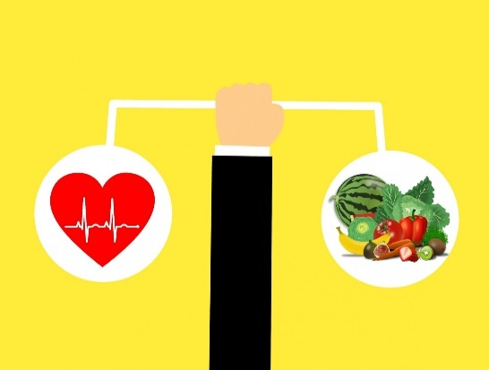
This Photo CC BY-NC-ND
Healthy+Lifestyle.jpg (996×523) (bp.blogspot.com).
6
Normal and Abnormal physiology.
The study of how a live organism or physiological portion functions is referred to as physiology. Medical physiology is the problems and disorders. Individuals and care providers are affected by changes in physiological condition.
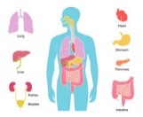

Heart attack.
Psychosocial stressors have been linked to an increased risk of coronary artery disease. Depression, chronic work stress, a lack of control, and financial stress all increase the risk of heart disease. (Hagstrom, 2018).
The Cardiovascular system.
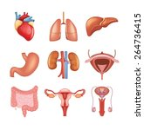
The cardiovascular system

The double pump system
Systematic
Pulmonary

Systemic transport oxygenated blood throughout the body for use and returns deoxygenated blood to the heart
The pulmonary system transports
Deoxygenated, before returning to the heart.

The cardiovascular system aids in maintaining homeostatic balance by providing oxygen and glucose to the central nervous system, the brain, and the spinal cord on a continuous basis, without oxygen for even one minute, brain cells begin to die. The process of homeostasis is when the body is in a state of equilibrium.

7
There are three parts to the cardiovascular system, the heart, blood arteries, and blood are all parts of the human body. Plasma, red blood cells, white blood cells, and platelets are the four basic components of the blood, which serve a variety of activities, including carrying oxygen and nutrients to the lungs and tissues.
When the circulatory system fails, blood flow stops, and muscles are deprived of the oxygen and nutrients they require. Blood provides oxygen and glucose to the cells, allowing them to convert food into energy for survival. If the cells do not receive blood, they will die, killing the organism.
Coronary artery disease occurs when the arteries construct and contract, preventing oxygen and nutrients from reaching the heart. High blood pressure, often known as hypertension, narrows the arteries and makes it difficult for blood to flow through the veins. Another disorder is stroke, which occurs when the arteries that supply the brain with blood and oxygen get blocked, causing the brain to die. The risk of vascular dementia is further increased by stroke and heart disease.
According to Zhou (1999), an abnormal rise in fat is caused by an imbalance in energy intake and expenditure. White adipose tissue and brown adipose tissue are the two basic forms of fat, in humans. WAT is the most widespread energy storage tissue.(Yang, 2021). A range of HDACs has been implicated in audiogenic differentiation in studies.

.

Health promotion.
Public Health England’s goal by 2029 is the hypertension treatment program to treat 80% of people diagnosed with hypertension according to NICE standards. (Norberg, 2021).
Nurse- led intervention have been shown to reduce cardiovascular risk estimates (Marco, 2014). Changes in behaviour have been shown to be both and effective. Patients with coronary artery disease and heart failure have been shown benefits from interventions such as education, behavioural counselling, and support. Attempting to excuse lifestyle changes, on the other hand, is tough and time consuming. (Marco, 2014).

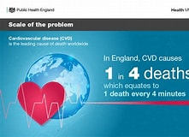
The national Public Health England has provided an overview of data on heart disease, stroke, diabetes, and renal disease, as well as other cardiovascular and cardiovascular -related illness. They are designed to assist commissioners and health professionals in assessing the impact of cardiovascular disease, making decisions, and improving patients’ outcomes. (PHE, 2020).
HYP, percentage of patients aged 79 years who have hypertension
8
measured within the last 12 months in the GP’s hypertension register is 140/ 90 or less and the percentage of patients. GPS hypertension measured within the last 12 months is 150/ 90mmhg or less. (PHE, 2020). (Wilkins, 2017). European statistic report.

Recommendation.
Maintaining a healthy weight and eating a nutritious diet with a 500-calorie reduction in daily intake. Limiting your time spent sedentary and staying physically active. Weight gain may be influenced by environment, family history, and genetics. Metabolism, referring to the process by which the body converts food and oxygen into energy, as well as habit or behaviour. (DHH, 2020).
Alcohol counselling is available for all care and parental care visits, so Patient A. can benefit from that. Cancer screening is available for people aged 50 to 75. The liver is known as the ‘’energy factory’’ of the human body. It transforms glucose to glycogen and store it, and then coverts glycogen back to glucose as needed. It processes nutrients in the body and clear out toxins and waste, an individual cannot live without a liver and drinking alcohol harms the liver. Prevention programs are available (Kähkönen, et al., 2019).
WHO suggested physical activity reduces risk. Risk levels linked to a 17 percent lower risk of cardiovascular events, Relative risk? 0.83 which is 95%, confidence intervals: 0.77, which is 89% and 23 % lower risk of cardiovascular mortality. (Lippi G, 2020).
As a result, in both clinical management and future clinical studies, secondary prevention of CHD should focus on psychological concerns. (Hagstrom, 2018). Regardless of context, lifestyle counselling should be incorporated into clinical nursing practice. New research should be conducted to see how much risk reduction affects end points like myocardial infarction and death. (Marco Aurelio Lumertz., 2014). Healthy Diet.

Nutrition requirement: See appendences.
Physical Activities: (NHS, 2019). See appendences for table.

.
Conclusion.
Heart disease, stroke, diabetes, kidney disease, and some types of dementia are among the diseases that the NHS health check program attempts to avoid. Everyone between the age s of 40 and 74 who has not been diagnosed with one of these risks will be encouraged to undergo a check-up once a year to assess their risk of heart disease, stroke, renal disease, or diabetes, and will be given support and advice to help reduce or manage that risk. (NHS, 2021).
.
A
References.
Bonnet, F. K. I. J.-. L. T. P. a. N. ,. F. B., 2005. Anxiety and depression are associated with unhealthy lifestyle in patients at risk of cardiovascular disease. Atherosclerosis, February, 178(2), pp. 339-344.
DHH, U., 2020. NIH. [Online]
Available at: https://www.nhlbi.nih.gov/health/educational/lose_wt/index.htm
[Accessed 15 August 2021].
Hagstrom, E. F. N., 2018. Psychosocial stress and major cardiovascular events in patients with stable coronary heart disease. Journal of Internal Medicine, January, 283(1), pp. 83-92.
HO Abu, C. U. E. D. J. A. E. S.-B. R. J. G. &. C. I. K., 2018. Association of religiosity and spirituality with quality of life in patients with cardiovascular disease. 11 June, 27(6), pp. 2277-2297.
Kähkönen, .. O. P. R. et al., 2019. Adherence to Treatment of Female Patients With Coronary Heart Disease After a Percutaneous Coronary Intervention. The Journal of Cardiovascular Nursing, 9 October.34(5).
Lippi G, H. B. S.-G. F., 2020. Physical inactivity and cardiovascular disease at the time of coronavirus disease 2019 (COVID-19). European Journal of Preventive Cardiology., 9 April , 27(9), pp. 906-908.
Marco, A. L. S. C. P. E. R. R., 2014. Lifestyle interventions reduce cardiovascular risk in patients with coronary artery disease: A randomized clinical trial. European Journal of Cardiovascular Nursing, 1 0ctober, 13(5), pp. 436-443.
NHS, 2019. Physical activities for adults and older adults. Guidance and support, September.
NHS, 2021. NHS Health Check, London: NHS.
NHS, 2021. Population Intervention Triangle:, London: PHE.
Norberg, 2021. Guide to the cardiovascular disease (CVD) prevention programme supporting data packs. Cardiovascular disease prevention programme supporting data packs, June.pp. 7-9.
PHE, 2020. Cardiovascular disease profiles: May 2020 update. [Online]
Available at: https://www.gov.uk/government/statistics/cardiovascular-disease-profiles-may-2020-upda
[Accessed 24 July 2021].
PHE, 2020. Publi Health England. [Online]
Available at: https://fingertips.phe.org.uk/documents/NCVIN_Hypertension_Prevalence_and_Management_Oct20.xlsx
[Accessed 24 July 2021].
PHE, 2021. NHS Health Check. [Online]
Available at: https://www.nhs.uk/conditions/nhs-health-check/check-your-heart-age-tool/
[Accessed 20 August 2021].
Rajagopalan, S. S. G. A.-K. M. R. D. B. M., 2018. Air Pollution and Cardiovascular Disease. Journal of American College of Cardiology, 28 October, 72(17), p. 2054–2070.
Su., S.-F. P. M. R., Chang, M.-Y. M. R. & He, C.-P. M. R., 2018. Social Support, Unstable Angina, and Stroke as Predictors of Depression in Patients With Coronary Heart Disease. The Journal of Cardiovascular Nursing, 3 4, 33(2), pp. 179-186.
Wilkins, E. L. W. K. W. P. B. J. L. R. L.-F. R. B. M. R. N. T., 2017. European Cardiovascular Disease Statistics, Brussels: European Heart Network,.
Xue Feng- Hu, K. S. T.-A. K., 2019. Prevalence of heart attack and stroke and associated risk factors among Inuitin Canada.. International Journal of Hygiene andEnvironmental Health, March, 222(2), pp. 319-326.
Yang, H. e. a., 2021. The role of HDAC11 in obesity‐related metabolic disorder. Journal of Cellular Physiology, 236(8), pp. 5582-5591.

Appendix C

Lifestyle questionnaire.
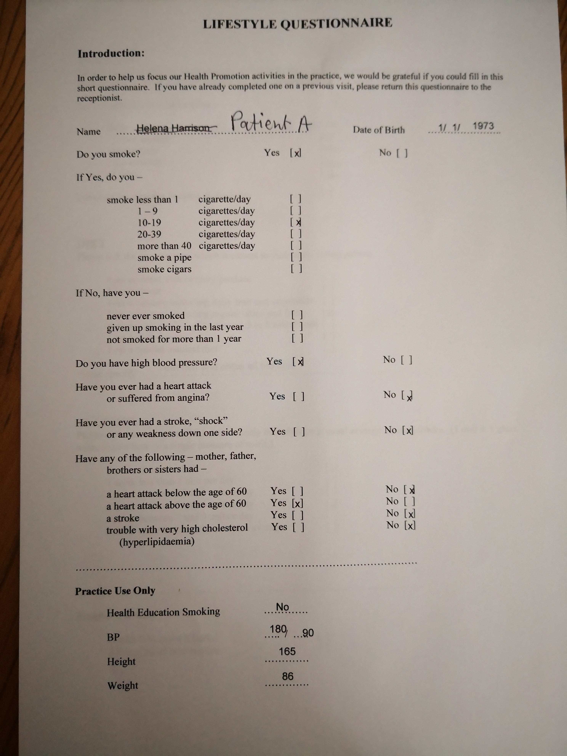

D

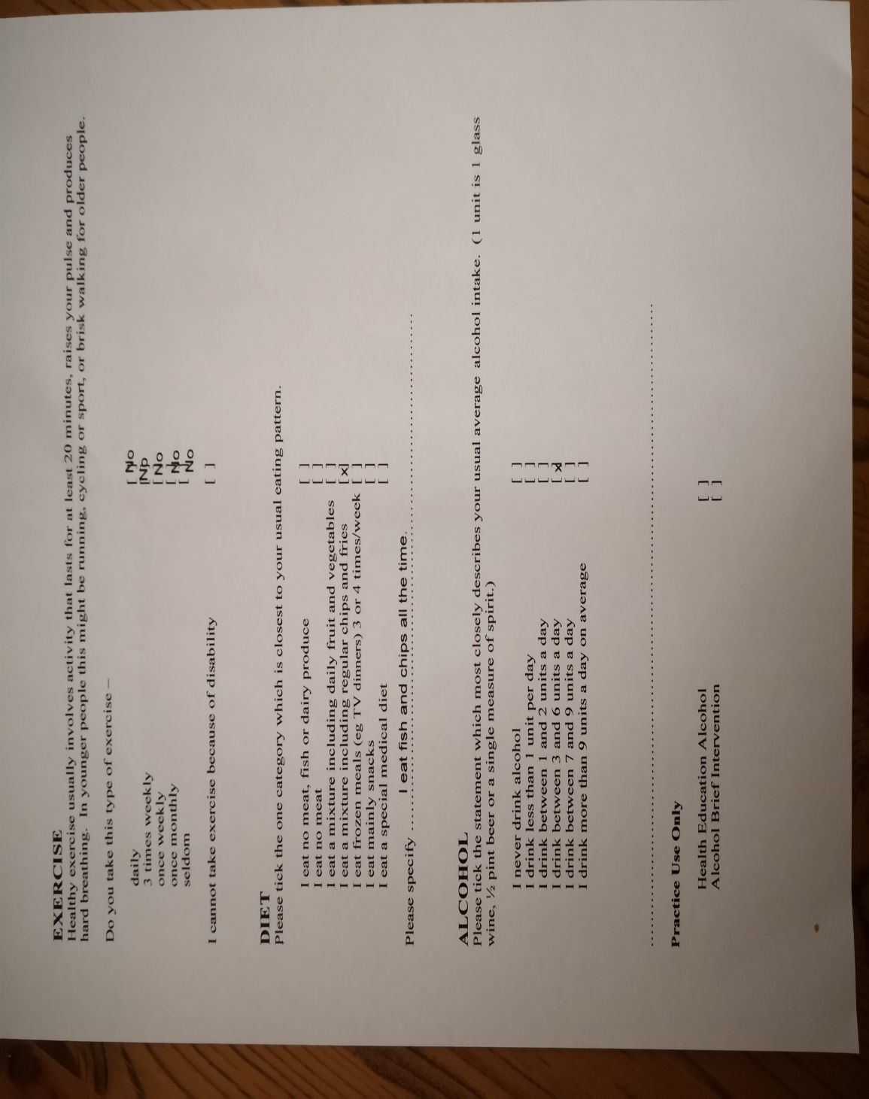

E
Physical activities.
Physical activity guidelines for adult 19-64 (NHS, 2019)

Moderate Intensive Activities | Vigorous Activities | Muscle strengthening Activities.
Brisk working | Jogging or running | Yoga
Water aerobics | Swimming fast | Pilates
Riding a bike | Riding a bike fast or on a hill | Tai chi
Dancing | Walking up the stairs | Working with resistance bands
Double tennis | Sports, like football, ruby, netball, and hockey | Push ups and Sit ups
Pushing a lawn mower | Skipping rope | Heavy gardening
Hiking | Aerobic and gymnastics | Wheeling a wheelchair
Rader bladding Martial arts Lifting and carrying children.

.

.

