Luke Savin
Student Number - 1810328
Study Skills - OME

Abstract

This report identifies the major skills that are needed for higher education. It states that for a student to be successful in their studies they need to schedule their time and to study independently. It is an advantage for the student to have prior know in academic writing beforehand. They are also required to be able work well in teams.

The report writer took several personality tests. They found that their strengths include working well in a team, hardworking and ambitious. The areas that they need to improve is that they don’t speak up enough and can come across as reserved.

After a year, one the most transferable the writer of the report has learnt is report writing. As this will be used in most subjects and their day to day job. Other skills that have been learnt this year include how to deliver information in a presentation.

After doing research the report writer decided to back up their work by using the 3-2-1 rule. The documents will be stored on their home computer, whilst having a backup on a USB drive. The writer will also back up their work using a cloud base service.

Finally, the writer of the report felt that the group presentation was a success. The team worked well together, everyone knew what they had to do, and everyone contributed to the presentation.

Table of Contents
Abstract 0
Introduction 3
Skill Evaluation 3
Higher Education skills 3
Self-Evaluation 4
SWOT Analysis 5
Strengths 5
Weaknesses 5
Opportunities 6
Threats 6
Application 6
Study Skills 6
Backing up 6
Group Presentation 7
Conclusion 8
References 9
Appendix 10
Appendix A 10
Appendix B 11
Appendix C 14
Appendix D 15

Introduction

Going into higher education is a big part of a person’s life. Whether its them working towards a degree to help them get their dream job or advancing them in their current career. From the new people they will meet and work with to the new and exciting experiences they will encounter along the way, it’s a big change in a person’s life.

There is a bigger expectation on the students in higher education and some aren’t prepared for it, but this report highlights some of the important skills for success at university. It also covers the current skills of the report writer, along with a plan to improve and enhance the skills that they are missing. The report goes on to what they have already learnt at university and how it will be applied to their future studies and subjects. It goes on to say how the author is planning to back their work up to prevent loss of their work. It finally it covers an evaluation of a group presentation that was preformed earlier in the year about the essential study skills that are needed.

Skill Evaluation

Higher Education skills

For a student to be successful and to get the most out of their time at university it is important for them to come with the correct set of skills to study and have the correct frame of mind to further their education and knowledge.

One of the most important skills a student can bring to high education is being able to study independently and be self-motivated. According to J.K. Schurr ‘Good studiers are active learners, not passive recipients of facts and details’ [1]. She also states that for a student to be successful they are able to have ‘(a) overview before reading; (b) look for important information and pay greater attention to it (which often requires jumping forward or backward to process information); (c) relate important points to one another; (d) activate and use prior knowledge; (e) change strategies when understanding is not good; and (f) monitor understanding and take action to correct or “fix up” inaccuracies in comprehension.’ [2]. Rather than just being taught in lectures, a successful student will go out and expand on what they were taught. Taking reliable notes during the lecture is significant when it comes to revision or extra reading, as it can usually be a jumping off point to do research into the topics that were covered. With this the student can engage with the subject and have a better understanding of it.

For this type of studying, the students should be able to plan their time and working to a schedule. This is important when an assignment is set. To be able to hand the work in on time, they need to be able to plan out how long to work on each assignment and research the topics set in the assignment. It is also vital when it is exam period, for them to plan their revision. Coming up with a revision schedule will help them cover all the topics in each subject.

Before starting Higher Education, it’s a good if the student has an idea of how to write a reports or essays as these are the two main types of academic writing. To write reports, it’s important to be able to interpret data from an experiment to help support a theory. The data and result can be used to create graphs to solve problems and draw conclusions. Where a report heavily relies on results from an experiment, essays on the other hand are more about the writer’s own opinion. The student who is writing the essays need to structure it in a coherent way to strengthen their argument. To help support their views, they must back up their opinion with supporting material to help persuade the readers. This involves the student being able to find reliable references from sources from different medias such as journal, books or websites.

Being able to work with other is an essential skill that a student can bring to higher education. When a group presentation or assignment is given, they need to be able to help and contribute to the group. Being able to listen to other people sound like a simple skill to have but it’s vital when it comes to working in a team. Listening to the ideas and opinion of other team member can lead to a better way of working or different ideas that can be contributed. When working in a team they should be prepared to give and accept criticisms and not take it personally. Being able to accept criticism from other member of group could help and improve the student’s way of thinking. Likewise, the student shouldn’t be afraid to give criticism and stand up for what they think is right.

Self-Evaluation

To get a better understanding of the report writers’ strengths and weaknesses and help improve their way of studying, they completed a SWOT assessment. This stands for Strength, Weakness, Opportunities and Threats. The assessments are often used in companies and organisation to analyse and identify what is going well and area where they can improve. They can also be used for personal use to ‘explore your strengths and weaknesses and try to discover the professional opportunities that exist for you. Your personal obstacles, issues that might hinder your progress’ [3]. These can help think things through and identify openings that might have been missed and help develop a plan.

To help recognise the strengths and weaknesses of the report writer, they undertook several personality tests. The first was taken from the VIA Institute on Character which is based on the Big Five Personality traits which are Openness, Conscientiousness, Extraversion, Agreeableness and Neuroticism. This assessment tests on 24-character traits and says that ‘Every individual possesses all 24-character strengths in different degrees, giving each person a unique character profile’ [4]. After completing the test, the top 3 traits for the report writer were Kindness, Humour and Fairness, whereas at the bottom of the list it stated Perspective, Bravery and Spirituality traits.

The second personality assessment is done on 16 Personalities. This is also based on the Big Five Personality traits but also uses the format from the Myers-Briggs. The Myers-Briggs Type indicator is based on the Carl Jung theory ‘what appears to be random behavior is actually the result of differences in the way people prefer to use their mental capacities’ [5]. Jung theory states that their 16-personality typology which the tests builds on. From the results the report writer most identifies as a ‘Mediator’ who are described as ‘true idealists, always looking for the hint of good in even the worst of people and events, searching for ways to make things better. While they may be perceived as calm, reserved, or even shy, Mediators have an inner flame and passion that can truly shine.’ [6]. It goes on to say that this personality type strengths include ‘Idealistic’, ‘Dedicated and Hard-Working’ and ‘Open-Minded and Flexible’, whilst the weaknesses of a ‘Mediator’ include ‘Impractical’, ‘Take Things Personally’ and ‘Difficult to Get to Know’.

The final test the report writer decided to do was an Interpersonal Skills by SkillsYouNeed.com who help develop ‘the skills needed to help improve people's lives, both professionally and personally’ [7]. Interpersonal Skills tests ‘are centred around communication, such as listening, questioning and understanding body language. They also include the skills and attributes associated with emotional intelligence, or being able to understand and manage your own and others’ emotions’ [8] . This is one of the main areas the report write feels they need to improve on. Upon completing the assessment, the results were;
Listening Skills – 69%
Emotional Intelligence – 38%
Verbal Communication – 45%
Communicating in Groups – 39%
For the full of the personality tests see Appendices.

SWOT Analysis

After looking at the result from the personality tests, a few common strengths and weaknesses appeared about the report author. From this they can work out what they need to work on or obstacles that might get in the way of them achieving success.

Strengths
One of the authors major strength is being able to work in a team or group environment. They can listen to other people’s opinions and are open to new ways of working. The writer of the report also found that they are hard-working and focused with the task at hand. According to the results of the assessments they can often be ambitious and have a strong determination to succeed.

Weaknesses
From the assessments it shows that the writer is reserved. This might make it difficult for other people to get to know the author. Even though they can work in a team, they may not speak up and express their own ideas or deal with confrontations. This maybe be because they find it difficult expressing themselves or put their own thoughts into words. From the assessment the writer of the report may take criticism personally and take it to heart.

Opportunities
By being in higher education the author has many opportunities ahead of themselves. Not only will they be getting a degree at the end, they will also learn new skills and be able to improve on the skills they already have. With a degree it will also open new job opportunities or career paths in the future.

Threats
There are several threats that stand in the way of the report writers’ success, the first of which is themselves. If they remain being quiet, they may not ask for help when they need it most. This can lead them to become disheartened and stop putting in the effort they have done so far. They may also fall behind due to person life. With thing such as moving to a new house or getting married, they must try and find time to put aside for university work.

Application

Study Skills

In the Study Skill module, the report writer learnt many things over the year such as set up Microsoft Word into a format that make it easier when writing report or essays. Also finding valid sources to back up a piece of work or arguments.

This year the report writer also learnt about the different types of Academic Writing. Essay are written with the writer’s opinion and is laid out in paragraphs which flows from one point to the next. Whereas reports are presenting data or information in an unbiased way. It is divided into section with headings and sub-headings. Report writing is an important skill, being able to present data and information in a way that is coherent and understandable is something that can be transferred and used in other subjects or at the workplace.

When writing reports, it’s important to reference other people's work, as it gives support to the writer’s argument and give a source for the data that is being used. It is important to know where the influence of the work can from as well as avoid plagiarism allegations. When looking for references to support the argument the writer needs it to be taken from a reliable source. They should come from a trusted source such as a journal rather than a blog found on the internet.

A skill that was taught this year in Study Skill was how to deliver presentations. This is a vital skill that can be applied at university and in the workplace. Being able to deliver and communicate a message across to an audience is one that takes practice. The information that is being presented must be captivating for the audience so that it is taken in.

Backing up

It is vital for students to back up their work and should always have a plan to recover it. The loss in work could result in redoing the assignment or even missed deadlines. In the commercial and business world, they are required to back up data in case of it being corrupted or lost. Many companies use the 3-2-1 rule when it comes to backing up and storing their data. The 3-2-1 rule means ‘having at least 3 total copies of your data, 2 of which are local but on different mediums (read: devices), and at least 1 copy offsite’ [9]. This is an efficient way of back up work and the student in this report had decided to use this method.

The first copy where the documents are going to be stored on, is their home computer where most of their work is completed. For added safety to the work, the report writer has also installed a RAID on their hard drives. RAID stands for Redundant Array of Independent Disks. This is where there are two or more hard drives but works as one hard drives. There are several levels of RAID, but the author has decided to have level 5. This level stores the data across the three hard drives but also stores parity data that can be used to backup and retrieve data in the event of a hard drive failing.

Having a second storage device that is local to have quick access to the backups should anything happen to the first computer. To do this the report writer has purchase a USB stick. These are also very useful for transferring files from one computer to the other or being able to access them whilst on the move.

Hard drives are known to get corrupted and damage or in the event of a fire where both storage devices are damage it is important to have the reporter’s documents at a ‘off site’ location. The author had decided for their offsite location they will be using a cloud-based system. The user can upload their documents to a server that is being maintained by another company. They can upload their work at home and still able to access it whilst at university.

Group Presentation

For part of this module the report writer was asked to produce a group presentation on what was being learnt and covered in the Study Skills lecture. The presentation included the topics academic writing and the differences between reports and essays, what is plagiarism and how to avoid it, referencing quotes and the different styles of referencing and finally finding accurate and reliable sources that are appropriate for the work.

Originally the group consisted of George Goddard (GG), Max Smith (MS), Vincent Wren (VW) and the report writer. They met up to discussed how to gather the information for the presentation and how it was going to be arranged. It was deliberated that the information could be accumulated in 1 of 2 ways. Either each pick a subject for the presentation or do the whole presentation each and combine then with the best parts. The latter was decided, and VW volunteered to put the presentations together after everyone sent theirs to him. After putting the presentation together, VW unfortunately left university.

The academic writing slide were presented by the report write and covered the difference between report and essay writing. The main difference between the two is the layout. Essays are set out in paragraphs with one idea flowing to the next, whilst giving the authors own argument and opinion. Whereas a report is laid out in headings and subheadings and uses an unbiased account of an investigation or experiment, which is written in 3rd person and past tense.

MS presented the slides with the Plagiarism. In the presentation, Plagiarism was described as ‘presenting someone else’s work or ideas as your own, with or without their consent, by incorporating it into your work without full acknowledgement’ [10]. Plagiarism can happen directly on purpose or indirectly by accident, so it is always best for the writer to use his own words. MS also presented the different types and styles of referencing these included examples such as Harvard and Chicago but the one that is used at UWTSD is IEEE.

GG presented how Turnitin and other plagiarism detection services worked. He pointed out the differences between them and the ones that should be avoided. He also done the conclusion of the presentation and the recommendation.

Too enhance on the way the presentation was put together Office 365 could have been used. With this it would allow the group to work on the same document at the same time rather then having to clear a schedule to meet face to face. The report writer feels that if there was more time, then they would have written the slides they were presenting in their own words. They also feel they should have used more notes or cue cards to help with the presentation.

Overall though the author feels that the group worked well together as each member knew what they had to do. Having to each produce the presentation and then selecting the best parts worked well. They were able to get information that someone else in the group might have missed.

Conclusion

When starting higher education for the first time it can be daunting. If a student prepares beforehand and have the right skills, such as being able to schedule their time to study independently, they will find themselves succeeding and getting the grades they want. Also coming to university with prior knowledge of essay and report writing will make it far less intimidating when it comes to having assignments set. A big part of higher education and university is meeting and working with new people. Being able to work with others, involves understanding and listening to other’s ideas as well as contributing to the group.

After completing several personality tests, the report writer has a much better idea about their strengths and weaknesses. The strengths include working well in a team, hard working and being ambitious. Whereas areas that need improving is that they are reserved and don’t speak up enough. These issues shouldn’t be a problem for the writer, if they stayed focused and work on them, then they will be able to get the results they were expecting and hope for.

After a year, one the most transferable the writer of the report has learnt is report writing. As this will be used in most subjects and their day to day job. Other skills that have been learnt this year include how to deliver information in a presentation in a way that is interesting and engaging with the audience.

The report writer understands the importance of backing up their documents and after doing research they have decided to use the 3-2-1 rule. The documents will originally be stored on their computer and have backups on a USB drive whilst also using a cloud base service.

For the presentation the writer of the report thought that the team worked well together. Everyone contributed to the presentation and knew what they had to do. Next time though they would have used more notes rather then reading off the screen.

References

[1] | J. K. Schurr, "Contributions of Study Skills to Academic Competence," Contributions of Study Skills to Academic Competence, vol. 31, no. 3, p. 353, 2002.
[2] | J. K. Schurr, "Contributions of Study Skills to Academic Competence," Contributions of Study Skills to Academic Competence, vol. 31, no. 3, p. 352, 2002.
[3] | 123test, "What is a Strengths and Weakness Analysis? - Analyze Yourself | 123test," [Online]. Available: https://www.123test.com/strengths-weaknesses-analysis/. [Accessed 16 04 2019].
[4] | VIA Institute on Character, "Learn Your 24 Character Strengths: Free VIA Character Survey," [Online]. Available: https://www.viacharacter.org/www/Character-Strengths. [Accessed 16 04 2019].
[5] | The Myers & Briggs Foundation, "Myersbriggs.org," [Online]. Available: https://www.myersbriggs.org/my-mbti-personality-type/mbti-basics/c-g-jungs-theory.htm. [Accessed 16 04 2019].
[6] | 16Personalities, "Introduction | Mediator Personality (INFP-A / INFP-T) | 16Personalities," [Online]. Available: https://www.16personalities.com/infp-personality. [Accessed 16 04 2019].
[7] | Skillsyouneed.com, "About Skills You Need - Helping you Develop Life Skills," [Online]. Available: https://www.skillsyouneed.com/about.html. [Accessed 16 04 2019].
[8] | Skillsyouneed.com, "Interpersonal Skills | SkillsYouNeed," [Online]. Available: https://www.skillsyouneed.com/interpersonal-skills.html. [Accessed 16 04 2019].
[9] | Y. Pusin, “The 3-2-1 Backup Strategy,” [Online]. Available: https://www.backblaze.com/blog/the-3-2-1-backup-strategy/. [Accessed 10 04 2019].
[10] | University of Oxford, "Plagiarism," University of Oxford, [Online]. Available: https://www.ox.ac.uk/students/academic/guidance/skills/plagiarism?wssl=1. [Accessed 16 04 2019].

Appendix

Appendix A

Results from the personality test by VIA Institute on Character
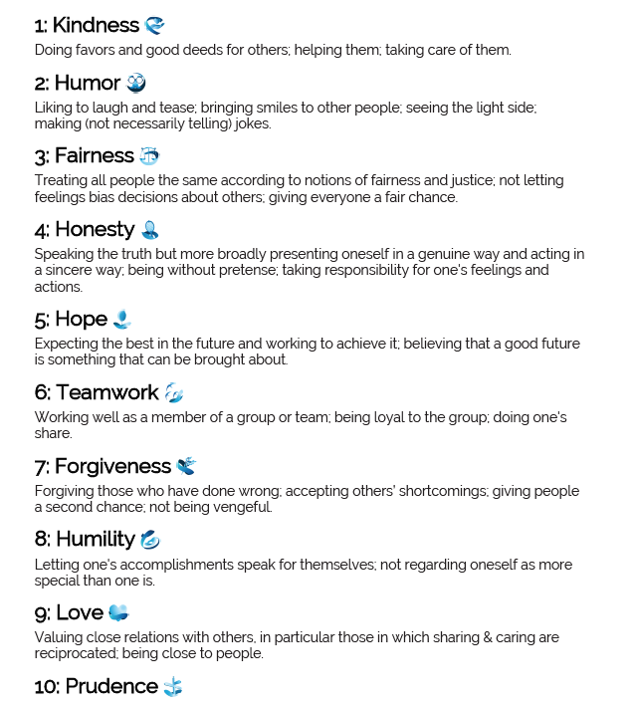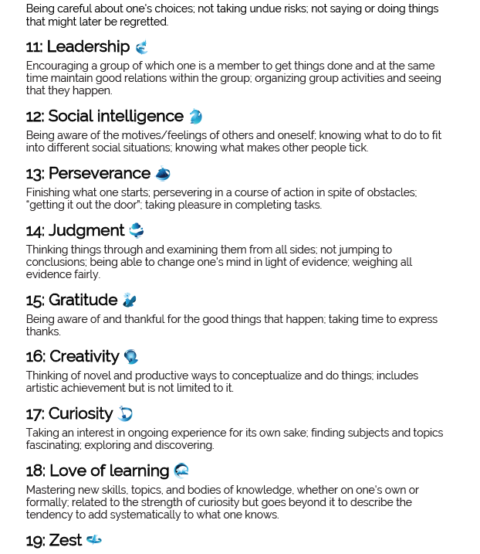

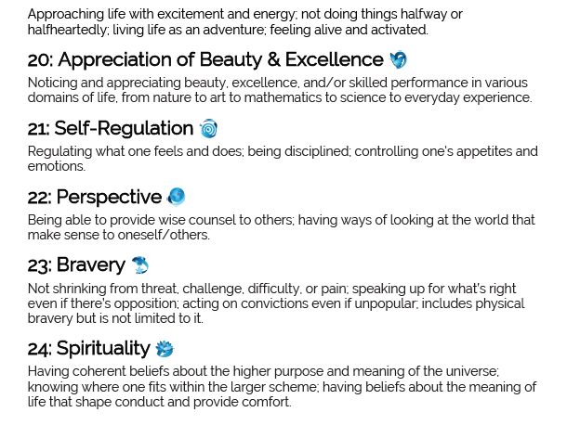

Appendix B

Results from the personality test by 16 personalities.
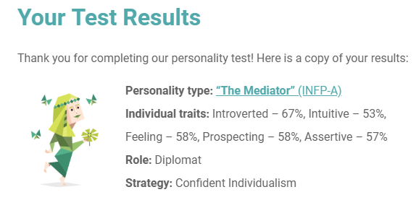

Strengths
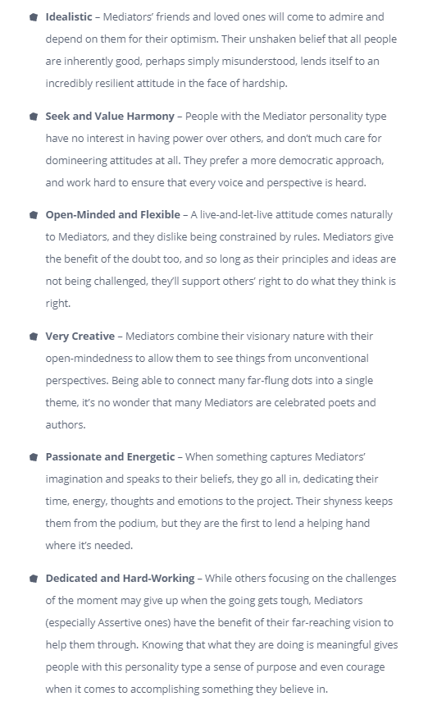

Weaknesses
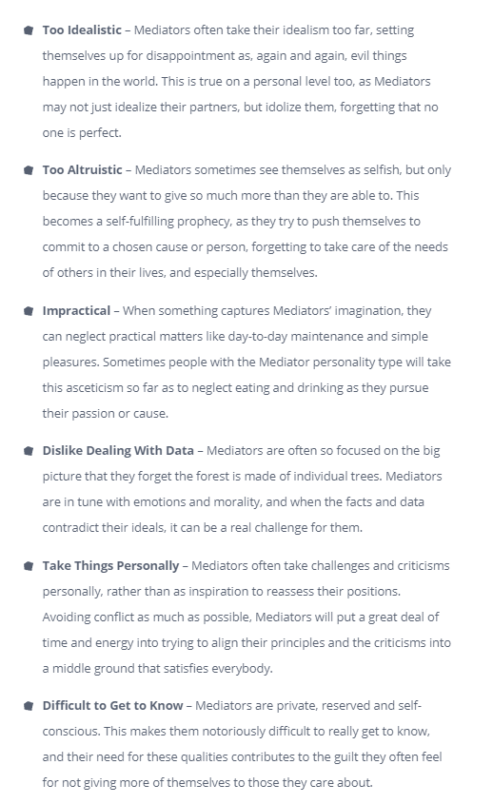

Appendix C

Results from the personality test by Skillyouneed.com.
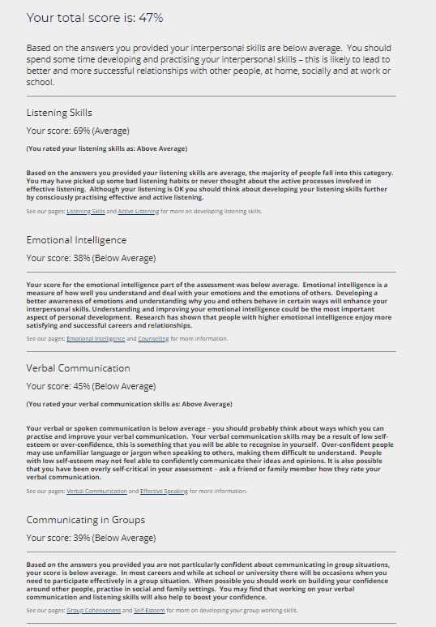

Appendix D



