NAME: Aayush Patel
STUDENT NUMBER:2132835
LECTURER: TUSHARA BALENDRAN
COURSE: MBA in gernal management
Module Code- LCMB7001
Module Name- Marketing Management-Assessment 2
Assignment Title- Market analysis of Volkswagen

Table of contents

Introduction 3
Company background (Volkswagen) 3
Environmental marketing analysis for Volkswagen 4
SWOT analysis of Volkswagen 4
PESTLE analysis of Volkswagen 6
Key drivers for business growth 10
Competitive market analysis of Volkswagen 11
Porter’s five forces 13
The marketing strategy of Volkswagen 14
Integrated marketing communication for Volkswagen 14
STP analysis 15
Marketing Mix 15
Recommendations for the future 15
Conclusion 17

Introduction
This business report is done based on the company Volkswagen for their future growth. It consists of the background of the company, external and internal factors that affect the company, key drivers for the growth of the company and a recommendation for its future growth.

Company background (Volkswagen)
Volkswagen is a leading automobile manufacturing company and one of the leading car makers all over Europe. The development, production and sale of light commercial vehicles, trucks and buses are what their commercial vehicle business is primarily made of. The Volkswagen Group; also provides various financial services including dealer financing and customer financing, leasing, banking and some other insurance activities (Bai, 2021). Volkswagen Group has a total of 122 production plants in 20 countries in Europe and 11 countries in America, Asia and Africa. The company has around 6.5 lakhs of employees who produce vehicles for the company along with working in vehicle-related services or other fields of the business. This group sells its products in around 153 countries.
Vision and mission
The vision of the Volkswagen group is 'Shaping mobility - for generations to come. This group follows their unique strategy, TOGETHER 2025+ to make sure that all the challenges of today and tomorrow are answered. Making mobility sustainable for today and tomorrow is the goal of this company. The company promises that they are making clean, quiet, safe and smart automobiles through their electric drive, digital networking and autonomous driving.
Brands and product
The Volkswagen group has a total of twelve brands in seven countries in Europe such as Volkswagen passenger cars, SKODA, SEAT, Audi, Bentley, Bugatti, Lamborghini, Porsche, Ducati, Scania, MAN and Volkswagen commercial vehicles (Kuivalainen, 2018). Every brand of this company has its characteristics in the market and operates independently.

Environmental marketing analysis for Volkswagen
Microenvironment

SWOT analysis of Volkswagen
Strength  Volkswagen has high financial conditions, Effective management, brand recognition, among consumers globally and the brands of this company are also famous individually (Benzaghta et al., 2021). | Weakness  Due to the Emission scandal in the year 2015, the reputation of this company significantly decreased among its consumers and was also penalised to pay over 30 billion euros in different countries. The marketing strategy of Volkswagen outside Europe is poor.
Opportunity  The number of eco-conscious customers and the autonomous market is also in demand and it increases more in the next few years (Chen and Zhong, 2022). | Threat  For climate change and increase in pollution levels, all the governments are strengthening their laws and regulations related to the environment.
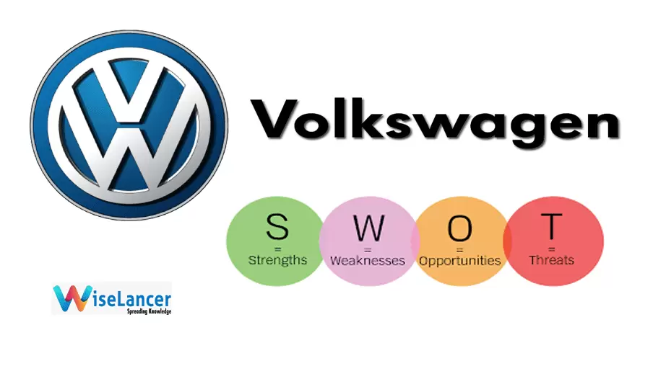
Fig: SWOT Analysis
Source: (Benzaghta et al., 2021)
Macro environment

PESTLE analysis of Volkswagen
Factors | Analysis
Political | - The United States and the United Kingdom are the major markets for Volkswagen but there is some uncertainty about the future trade regulations between Germany and those countries. It can be an unfavourable condition for the company as they are largely dependent on imports and exports.  Justification: A risk remains for the Volkswagen company for their export business as they have a large consumer base in the US (Bai, 2019). The future trade regulations can affect the company because Volkswagen has huge customer bases in other countries too. So this regulation can make obstacles for exporting their products.
Economical | - The willingness of consumers to spend is increasing all over the world. This consumer spending is an important factor for automobile brands in low market conditions. This is also effective in high market conditions as it makes the consumers go for a more expensive model along with some extras which is a positive sign for Volkswagen.  Justification: This factor is a favourable condition for Volkswagen as it can increase their sales of the expensive models.
Social | - Some of the Volkswagen brands such as Lamborghini, Audi, Porsche, Bugatti and Volkswagen itself are very popular among the consumers but some brands are less popular among the consumers such as Seat and Skoda so this can affect the overall reputation of the company in the global market.  - The luxurious and innovative competitors in the market such as Tesla or BMW make it difficult for Volkswagen in terms of recognition as some of their models are nearly similar.  Justification: The less popular brands of Volkswagen can indicate the downside of the company which makes it an unfavourable condition for them. The competitors with the high segment models are also quite popular in the market thus creating an unfavourable condition for the company as the number of high end customers is already few while also divided among the different companies resulting in a low sale of the expensive models.
Technological | - Due to technology changes, the trend of autonomous vehicles keeps rising. But to develop an autonomous vehicle both hardware and software challenges are involved which requires heavy funding also (Jacinto, 2021). But the Volkswagen group is not much affected by it for their strong financial standing which makes it easier for them to invest in research and development and fulfil the needs of their consumers.  Justification: Due to the strong financial condition of Volkswagen the technology changes does not affect much to the company but the companies with low financial condition can get affected by it which makes it a favourable condition for the company. The increasing demand of the green technologies forces the automotive companies to implement those but Volkswgen was already into this such as electric cars under tye brand Audi and Porsche which makes it a favourable condition for the condition.
Environmental | - The development of green technologies is also an environmental factor. For decades automobiles are those of the major sources of pollution but shortly, it is going to change completely so Volkswagen group should stay with the trend to avoid the negative impacts by adapting to the future needs of the consumers.  Justification: This factor is favourable for Volkswagen as they are already adapting the changes by making electric cars according to the demands of the consumers.
Legal | - Volkswagen has been facing difficulties since 2015 in the manufacturing of their engines which repeatedly failed the emission test. The emissions produced by the engines were low while testing but upon regular use, the engines produced more emission levels than the allowed level. This is negatively affecting their brand image because these emissions are negative factors for the environment.  Justification: The repeated failure of the emission tests have a huge negative impact on their consumer base and make it an unfavourable condition for the company.
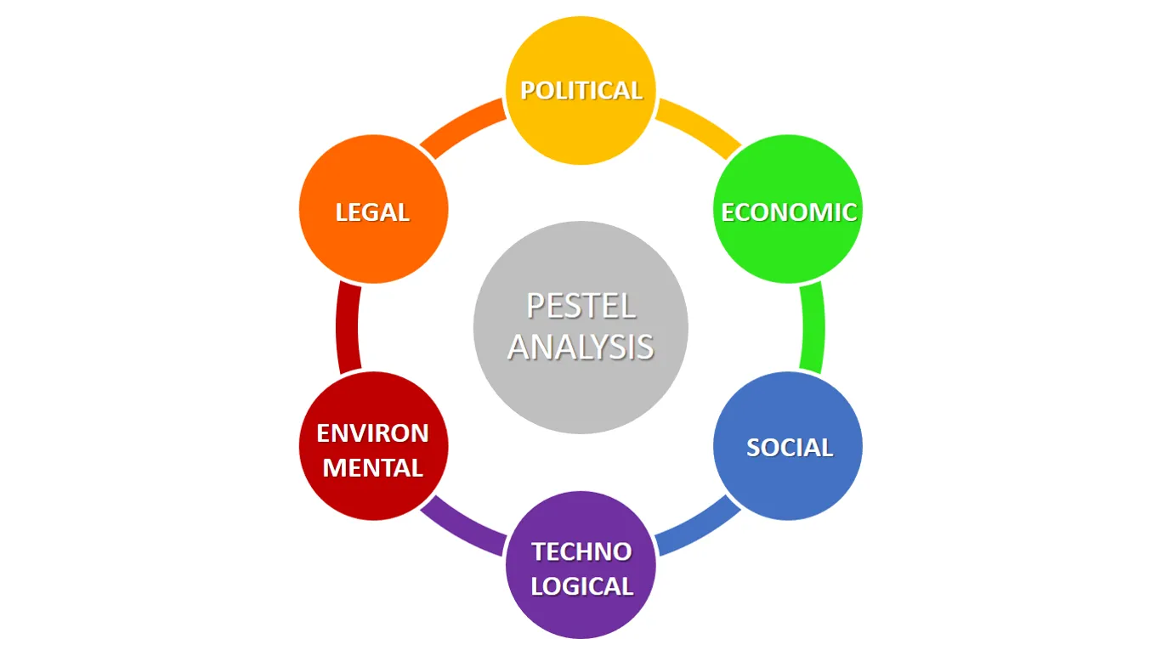
Fig: PESTLE Analysis
Source: (Kubiczek and Hadasik, 2021)

Key drivers for business growth
Seven key drivers help to protect the growth plans. These drivers help the company to think differently about their operational activities and successfully implement the strategies for long-term growth.
The customer
Meeting the needs of the customers gives Volkswagen a competitive advantage that helps the company to build loyalty which is very essential for the long-term sustainable growth of the company.
People
Volkswagen has over 6.5 lakhs of employees who consistently work for the growth of this company (Valentini and Kruckeberg, 2018). The strong leadership of this company creates an innovative environment which helps the employees to innovate new things to drive the business forward.
Technology
Technology has several positive impacts on all industries. Due to the strong financial condition of Volkswagen, they invest a sufficient amount in the innovations of new technologies which creates many opportunities that help in the long run of this business.
Operations
A clear approach to aligning the operations according to the strategies helps businesses to achieve success easily (Shu, 2022). Effective leaders drive a culture of innovation and improvements which helps the company to stay ahead of its competitors in the market.
Finance
Funds are an essential element for a business to grow. The financial condition of Volkswagen is very strong. The growth strategy helps businesses to select the most appropriate financial approach at every stage.
Transactions
Successful partnerships and strategic acquisitions are needed to enhance the growth and profitability of a business. Leading companies like Volkswagen are generally quick to grasp the transactional value in the market of recent times. Doing the right deal with the right person is everything for the overall growth of a business.
Risk
Identifying and managing the risk factors in a business is a major reason for achieving success. Volkswagen should manage its risks more effectively so as not to repeat the 2015 incident in the future which may create more difficulties and affect its reputation badly in the market.

Competitive market analysis of Volkswagen
Competitive analysis helps companies to learn more about their competitors. Identifying the potential competitors is the main thing in this segment (Merwitz, 2020). Then the businesses should find out what different offers and strategies the rival companies are applying. The tactics of sales, price of the products and shipping costs all should be measured thoroughly to effectively target the customers.

Porter’s five forces
The threat of new entrants (low)
The threats of new entrants in the automobile industry are low because the barriers in the market are very high which makes it very difficult to enter the market. Heavy investment in the infrastructure is required including manufacturing, marketing, supply chain and distribution (Khurram, Hassan and Khurram, 2020).
Bargaining power of suppliers (low)
The bargaining power of suppliers of the Volkswagen group is low because this company has various suppliers in many countries so they can switch anytime to new suppliers. Volkswagen has a strong financial condition and also has a supply chain and distribution system all over the world.
Bargaining powers of buyers (high)
In the modern world, the bargaining power of the customers is beginning to rise at a noticeable rate because there are many heavy players in the market such as Tesla and BMW so the customers have a wide variety of options (Yang, 2022). Nowadays the customers are judging the products in every aspect from quality to safety to environmental impacts to fuel efficiency.
Industry rivalry (high)
The rivalry among the competitors in the automobile industry is also very high because the number of automobile companies is huge and most of them provide products that have many similarities in terms of quality and efficiency (Hemanth, 2020). This is why most of the brands along with Volkswagen invest a huge amount in the marketing and research and development sector to find or create innovative strategies to stay ahead of the other competitors.
Advantages of the Porter’s five force model
The Porter's five forces model helps a business to identify the competition in the market. It also provides information about the strengths and threats of a company in the market. By displaying the power of the customers and suppliers in the market this model helps the businesses in their expansion process. That is why this model is chosen to evaluate potential competitive business situational analysis tools for the company, Volkswagen.
Disadvantages of the Porter’s five force model
This model only focuses on the power of the customers and the suppliers but the other factors such as technological factors are not considered in this model. This model is not effective for the businesses who operate within more than one industry, it is only limited for companies in a single industry.
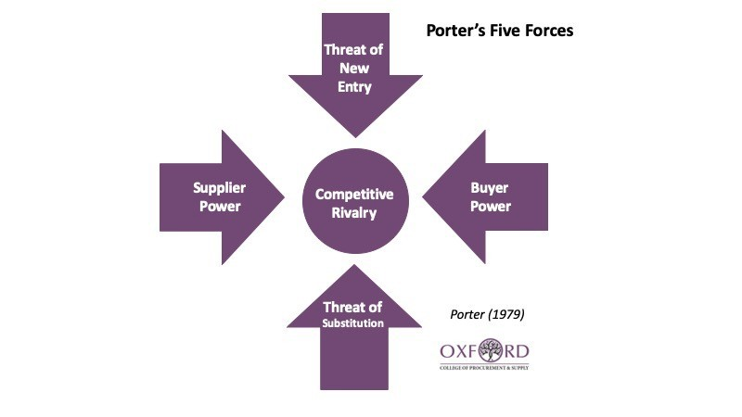
Fig: Porter’s five forces
Source: (Khurram, Hassan and Khurram, 2020)

The marketing strategy of Volkswagen
The marketing strategy refers to the overall game plan of a business for racing the target customers and then turning them effectively into the consumers of their products. The value proposition, brand messaging, and demographic data of the customers along with other things are included in the whole marketing strategy.

Integrated marketing communication for Volkswagen

STP analysis
Segmentation
Different types of cars are produced by Volkswagen for the different needs of the consumers. Each segmented model is for targeting a specific group of customers (Gaultier and Marcello, 2021). They produce small cars like golf, polo and the famous beetle along with expensive cars also like lamborghini, bugatti and bentley. The demographic segmentation includes the consumer of age ranges from 18 to 50 years. The Men are the prime target customers for this company with middle and upper class status. The geographic segmentation includes the developed cities where most of the citizens belong to the middle and upper class.
Targeting
For targeting the consumer bases Volkswagen did not go for a single segment strategy rather adopted the multi segment strategy. Consumers within the age of 18 to 50 are the most targeted customers of Volkswagen though a wide range of different models can be affordable and efficient for ant customers and corporate activities. The high end customers are also targeted by this company with expensive models such as lamborghini or bugatti.
Positioning
Volkswagen produces their cars in many different countries such as Brazil, China, India, Germany, Slovakia, North America, Hungary, Japan, Russia and many more (Kubiczek and Hadasik, 2021). All the models are positioned in every state according to the demand such as states with bad road condition are ideal for the SUVs and smaller cars for the cities with high population.
The Volkswagen company deploys modern technologies and innovations to maintain the quality of their product and to satisfy their customers. This company is known as the ‘people's car’ for their mass production of low priced car segments such as the famous Beetle.

Marketing Mix
Product
Volkswagen has different types of models for the various needs of the customers. More than 70 different models with 12 different brands are included in the portfolio of Volkswagen. The VW Golf model is one of the best selling cars of this company (Nikbin et al., 2021). Volkswagen polo is very popular in Malaysia. Convertibles, hatchbacks. Coupe, sedan, sports, and SUV are the different types of models of Volkswagen. This company aims to increase the share of all electric cars by 70 per cent in Europe and by 50 percent in the US and asian countries within the year 2030. As a part of this they have implemented a new brand design which reflects their quality of products, attention to detail, value and durability of the product. In 2021 this new brand design was already implemented across India with a mission to create 360 degree customer experience.
Price
For the different needs of the consumers the cars of Volkswagen range from affordable to expensive ones. The company aims to target every segment of the market. They set the prices of the luxurious ones a little bit more to keep it premium for the high end customers. This refers to the psychological pricing strategy as a perception is given to the customers of getting quality based products for justifying their high prices.
Place
Volkswagen targeted the prime locations for manufacturing and distribution of their cars for providing a time delivery service to the consumers (Cibrian Bravo, 2021). 20 European countries with 11 other countries across the globe are covered by the company and China and Europe are the leading markets for the company.
Promotion
Each car is promoted by Volkswagen individually as they invest in 360 advertising. The digital medium is mainly used by the company for promoting which includes their websites and the other social platforms. The features and specifications are included in the advertising for effectively connecting with the customers. Integrated market communication plays a major role in the automobile industry. Volkswagen uses different kinds of integrated marketing communication tools to communicate with the customers. They start with the basic methods of direct marketing such as sending brochures to the customers through e-mails and some multimedia files in the form of DVDs are also sent to the old loyal and targeted customers by the company (Chodakowska, 2018). The ads are placed on various websites and blogs that take the customers directly to the main website of Volkswagens which shows various ranges and information about the products. The customers can also find the financing deals and their nearest dealership on the website. In the modern digital world, TV commercials are still one of the effective methods for integrated marketing so Volkswagen invests a sufficient amount of money in TV commercials all over the world (Stanislavscaia, 2021).

Recommendations for the future
Volkswagen was accused of an emission scandal in 2015. Because of this, their sales decrease temporarily which greatly affects the sustainability of their business and also affects their reputation in the market. So Volkiswagoin should be careful about this in the future for sustainable growth of the company (Mačaitytė and Virbašiūtė, 2018). In terms of marketing strategy they do well in European countries but outside Europe, they have many flaws so they should plan new marketing strategies for the rest of the countries to increase their overall sales and revenue. The competition in the market is also increasing at a rapid rate so they must invest more in their research and development department to make new innovative findings to stay one step ahead of their competitors in the market. From decision making to the growth of the business, guided by the Ansoff Matrix. This offers four strategic choices such as market penetration, market development, product development and diversification. By using the market development strategy Volkswagen can introduce their existing products in new types of markets. This can be done by investing more in the research and development department for identifying new markets and new customer segments. Exploring new distribution channels can also help the company to reach new customer segments in the market.

Conclusion
So it can be concluded that despite being a leading brand in the automobile industry they still have to innovate new things regularly to maintain its strong position in the market. They must also have to understand that choosing the wrong path may help to gain benefits but it may create several difficulties in the long run for the business. After all, slow steady growth is much better than fast-paced risky growth.

References
Bai, X., 2019. Research on the Strategy of Chinese Automobile Enterprises Entering Overseas Markets.
Bai, Y., 2021, March. Analysis of Overseas Management Strategy of the Volkswagen Group. In 6th International Conference on Financial Innovation and Economic Development (ICFIED 2021) (pp. 229-234). Atlantis Press.
Benzaghta, M.A., Elwalda, A., Mousa, M.M., Erkan, I. and Rahman, M., 2021. SWOT analysis applications: An integrative literature review. Journal of Global Business Insights, 6(1), pp.55-73.
Benzaghta, M.A., Elwalda, A., Mousa, M.M., Erkan, I. and Rahman, M., 2021. SWOT analysis applications: An integrative literature review. Journal of Global Business Insights, 6(1), pp.55-73.
Chen, F., 2022, July. Analysis of Key Factors for Tesla’s Success. In 2022 2nd International Conference on Enterprise Management and Economic Development (ICEMED 2022) (pp. 758-763). Atlantis Press.
Chen, J. and Zhong, M., 2022, April. Research on Volkswagen’s Development Strategy During Covid-19. In 2022 7th International Conference on Social Sciences and Economic Development (ICSSED 2022) (pp. 705-710). Atlantis Press.
Chodakowska, A., 2018. The mobility revolution in the automobile industry. Electric cars and battery management.
Cibrian Bravo, S.K., 2021. Marketing mix of used electric vehicles in Ontario, Canada (Master's thesis, University of Waterloo).
Friesendorf, C. and Uedelhoven, L., 2021. Macro-Environment of Mobility. In Mobility in Germany (pp. 11-17). Springer, Cham.
Gaultier, C. and Marcello, K., 2021. VOLKSWAGEN GROUP SUPPLY CHAIN ANALYSIS IN EUROPE. African Journal of Emerging Issues, 3(8), pp.1-10.
Hemanth, G., 2020. An Organization Study Report On Bajaj Auto Limited.
Jacinto, P.M.M., 2021. Paradigm shift in the automotive market: how will premium brands deal with the innumerous challenges they will face? Current strategy overview (Doctoral dissertation).
Jacinto, P.M.M., 2021. Paradigm shift in the automotive market: how will premium brands deal with the innumerous challenges they will face? Current strategy overview (Doctoral dissertation).
Khurram, A., Hassan, S. and Khurram, S., 2020. Revisiting Porter five forces model: Influence of non-governmental organizations on competitive rivalry in various economic sectors. Pakistan Social Sciences Review, 4(1), pp.1-15.
Kubiczek, J. and Hadasik, B., 2021. Segmentation of Passenger Electric Cars Market in Poland. World Electric Vehicle Journal, 12(1), p.23.
Kuivalainen, O., 2018. Critical Analysis of Automobile Sector & Specific Case Study of Volkswagen Group (VWG)’s Offshoring and Outsourcing decisions in India.
Mačaitytė, I. and Virbašiūtė, G., 2018. Volkswagen emission scandal and corporate social responsibility–a case study.
Merwitz, O.C., 2020. Analysis of the current after sales market for Volkswagen Commercial Vehicles and future trends in Finland.
Nikbin, D., Iranmanesh, M., Ghobakhloo, M. and Foroughi, B., 2021. Marketing mix strategies during and after COVID-19 pandemic and recession: a systematic review. Asia-Pacific Journal of Business Administration.
Shu, J., 2022, April. Analysing on External Environment and Industrial Competition of High-tech Companies. In 2022 7th International Conference on Social Sciences and Economic Development (ICSSED 2022) (pp. 76-80). Atlantis Press.
Stanislavscaia, N., 2021. The strategic diagnostic of the automotive industry enterprises [Articol].
Valentini, C. and Kruckeberg, D., 2018. “Walking the environmental responsibility talk” in the automobile industry: An ethics case study of the Volkswagen environmental scandal. Corporate Communications: An International Journal.
Yang, X., 2022, July. Research on Tesla’s Market—Based on Porter’s Five Forces and Ratio Analysis Model. In 2022 2nd International Conference on Enterprise Management and Economic Development (ICEMED 2022) (pp. 773-777). Atlantis Press.

