

APPENDIX GA36c

LEVEL 6 ASSESSMENT SPECIFICATION

Student name: | Keiran Lewis | Student ID number: | 119965
Programme: | BSc Applied Computing
Module: | Big Data
Module code: |  | Contribution to Overall Module Assessment (%): | 50%
Lecturer: | John Williams | Internal Verifier: | Jeanette Adams
Assignment Title: | Big Data Report | Word count (or equivalent): | 3000
Submission deadline: | 19/04/2019 | Return date of provisional marks & written feedback: | 26/04/2019
Submission method: | All written assessments, where practical and possible, must be submitted via Turnitin unless otherwise instructed by the Lecturer. (Please DO NOT put this assessment specification into Turnitin or it will match many similarities with other students’ submissions.)  Alternative submission method (if applicable):  Late submission of the assessment will result in a late penalty mark. Penalties for late submission: Up to one week late, maximum mark of 40%. Over one week late, 0%. Only the Extenuating Circumstances Panel may approve a change to submission dates.
Academic honesty / referencing: | Academic honesty is required. In the main body of your submission you must give credit to authors on whose research and ideas your work is based. Append to your submission a reference list that indicates the books, articles, etc. that you have used, cited or quoted in order to complete this assessment.

Module Learning Outcomes
(from module syllabus)
1. Critically discuss the concepts behind, sources of and problems related to Big Data
2. Design, build and professionally document a small data warehouse suitable for use with Big Data
3. Perform data analysis and reporting on complex data within a Big-Data data warehouse
4. Demonstrate a creative use of appropriate data mining and data visualisation techniques within a Big Data context.

TASK DESCRIPTION

Design and produce professional-standard reports based upon the Skewen News Big-Data data warehouse using appropriate tools and techniques. Select and apply appropriate data mining processes to Big Data within a given problem domain and produce effective visualisations of the results.
Skewen News, are a local news provider. News articles are posted on the company's news feed. Their USP is that they have a local bias, and concentrate mainly on local interest stories whilst still reporting on some major national and international stories. The data provided is an indicative sample of the type of data collected by Skewen news.
Using this data you should do the following:
- Design and develop an appropriate data warehouse structure to store the data provided.
- You should justify all of your design decisions.
- Upload the data into your data warehouse, documenting the ETL process in a professional manner.

The reports should be appropriately referenced and should include the appropriate tables of contents, tables of figures and tables of tables. Any figures should have titles and identification labels. The document should also be spellchecked and grammar-checked.
Design, develop and critically evaluate reports that can be run to retrieve and display the
Following data:
- All stories on a user-defined topic
- All stories within a user-defined geographical area
- A timeline showing the development of a complex story over a period of at least a week
- Stories that are related to a user-defined story by location, content or other features.’

The report should be submitted via Turnitin.

GUIDANCE FOR Students IN THE COMPLETION OF TASKS

NOTE: The guidance offered below is linked to the five generic assessment criteria overleaf.

- Engagement with Literature Skills
Your work must be informed and supported by scholarly material that is relevant to and focused on the task(s) set; you should make use of scholarly reviews and primary sources, where appropriate (for example, refereed research articles and/or original materials appropriate to the discipline). You should provide evidence that you have accessed a wide range of sources, which may be academic, governmental and industrial; these sources may include academic journal articles, textbooks, current news articles, organisational documents, and websites. You should consider the credibility of your sources; academic journals are normally highly credible sources while websites require careful consideration/selection and should be used sparingly. Any sources you use should be current and up-to-date, mostly published within the last five years or so, though seminal/important works in the field may be older. You must provide evidence of your research/own reading throughout your work, using a suitable referencing system, including in-text citations in the main body of your work and a reference list at the end of your work.

Guidance specific to this assessment:

- Knowledge and Understanding Skills
At level 6, you should be able to demonstrate coherent and detailed knowledge and a systematic understanding of the subject area, at least some of which is informed by the latest research and/or advanced scholarship within the discipline. You should be aware of the uncertainty, ambiguity and limits of knowledge. Your work must demonstrate the growing extent of your knowledge and systematic understanding of concepts and underlying principles associated with the subject area. Knowledge relates to the facts, information and skills you have acquired through your learning. You demonstrate your understanding by interpreting the meaning of the facts and information (knowledge). This means that you need to select and include in your work the concepts, techniques, models, theories, etc. appropriate to the task(s) set. You should be able to explain the theories, concepts, etc. meaningfully to show your understanding. Your mark/grade will also depend upon the extent to which you demonstrate your knowledge and understanding; ideally each should be complete and detailed, with comprehensive coverage.

Guidance specific to this assessment:

You will need to demonstrate detailed knowledge and understanding of the design and development strategies employed when building a data warehouse.

- Cognitive and Intellectual Skills
You should be able to: critically evaluate evidence, arguments, assumptions, abstract concepts and data some of which are at the forefront of a discipline (and that may be incomplete) to devise and sustain arguments, to make judgements and/or solve problems; describe and comment upon particular aspects of current research, or equivalent advanced scholarship, in the discipline Your work must contain evidence of logical, analytical thinking, evaluation and synthesis. For example, to examine and break information down into parts, make inferences, compile, compare and contrast information. This means not just describing what! But also justifying: Why? How? When? Who? Where? At what cost? At all times, you must provide justification for your arguments and judgements. Evidence that you have reflected upon the ideas of others within the subject area is crucial to you providing a reasoned and informed debate within your work. Furthermore, you should provide evidence that you are able to make sound judgements and convincing arguments using data and concepts. Sound, valid conclusions are necessary and must be derived from the content of your work. Where relevant, alternative solutions and recommendations may be proposed.

Guidance specific to this assessment:

- Practical Skills
At level 6, you should be able to apply the methods and techniques that you have learned to review, consolidate, extend and apply your knowledge and understanding, and to initiate and carry out projects. You will deploy accurately established techniques of analysis and enquiry relevant to the discipline, and apply them in complex and unpredictable contexts, to devise and sustain arguments and/or to solve problems. You should be able to frame appropriate questions to achieve a solution - or identify a range of solutions. You should be able to demonstrate how the subject-related concepts and ideas relate to real world situations and/or a particular context. How do they work in practice? You will deploy models, methods, techniques, and/or theories, in that context or circumstances, to assess current situations, perhaps to formulate plans or solutions to solve problems, or to create artefacts, some of which may be innovative and creative. This is likely to involve, for instance, the use of real world artefacts, examples and cases, the application of a model within an organisation and/or benchmarking one theory or organisation against others based on stated criteria. You should show awareness of the limitations of concepts and theories when applied in particular contexts.

Guidance specific to this assessment:
You should build your data warehouse using an appropriate large database platform such as Oracle. You will need to demonstrate advanced DDL and DML skills in order to effect the ETL process. You will deploy complex SQL queries to extract data to generate reports, data mining analysis and visualisation techniques.

- Transferable Skills for Life and Professional Practice
Your work must provide evidence of the qualities and transferable skills necessary for graduate-level employment requiring the exercise of initiative and personal responsibility and decision-making in complex and unpredictable circumstances. This includes demonstrating: the learning ability for professional development to advance existing skills and acquire new competences of a professional nature that will enable you to assume significant responsibility within organisations; that you can initiate and complete tasks and procedures, whether individually and/or collaboratively; that you can use appropriate media to effectively communicate information, arguments and analysis in a variety of forms to specialist and non-specialist audiences; fluency of expression; clarity and effectiveness in presentation and organisation. Work should be coherent and well-structured in presentation and organisation.

Guidance specific to this assessment:

Student FEEDBACK FORM

This section details the extent to which the assessment criteria are demonstrated by you, which in turn determines your mark. The marks available for each category of skill are shown. Lecturers will use the space provided to comment on the achievement of the task(s), including those areas in which you have performed well and areas that would benefit from development/improvement.

Generic Assessment Criteria | Marks available | Marks  awarded
1. Engagement with Literature Skills  . | 0
2. Knowledge and Understanding Skills | 10 | 7
Knowledge is reasonably extensive coherent and detailed. Exhibits very good understanding of the breadth and depth of established views, and the work is, at least in part, well-informed by current research and scholarship.
3. Cognitive and Intellectual Skills | 20 | 13
Sound critical thinking, analysis, synthesis and evaluation demonstrating critical thinking. Ability to devise and sustain persuasive arguments, and to review the reliability, validity and significance of evidence to make mostly appropriate and valid judgements.

4. Practical Application Skills | 60 | 42
An advanced application of a range of methods, materials, tools and techniques. The context of the application is well considered, and insightful. Can identify complex problems and propose excellent solutions. Innovation and creativity evident.
5. Transferable Skills for Life and Professional Practice | 10 | 7
Can communicate professionally confidently and consistently in a suitable format.
Work is coherent, very fluent and is presented professionally. Demonstrates excellent graduate employment skills and an appetite for further development

Assessment Mark (Assessment marks are subject to ratification at the Exam Board. These comments and marks are to give feedback on module work and are for guidance only until they are confirmed. ) | Late Submission Penalties (tick if appropriate) |  | 69%
 | Up to 1 week late (40% Max) |  | 69%
 | Over 1 week late (0%) |  | 69%

Big Data Report
Big Data
Keiran Lewis

Contents
Data Warehousing of Skewen News 12
Determine Business Objectives 12
ERD Reports System 12
Conceptual Data Model 15
Data Warehouse Structure 15
ETL (Extract, Transform & Load) – Data Transition Process 21
Dimensional Table: DimDay 21
Dimensional Table: DimMonth 21
Dimensional Table: DimYear 21
Dimensional Table: Concatenating Dates 22
Dimensional Table: DimTopic 22
Dimensional Table: DimTitle 22
Dimensional Table: DimStory 23
Dimensional Table: DimLocation 23
Dimensional Table: DimTime 23
Dimensional Table: DimReport 24
Querying Data through Fact Table Utilisation 24

Data Warehousing of Skewen News
Skewen News, are a local news provider. News articles are posted on the company's news feed. Their USP is that they have a local bias, and concentrate mainly on local interest stories whilst still reporting on some major national and international stories. The data provided is an indicative sample of the type of data collected by Skewen news.
I have been approached by Skewen News, who is a local news provider who covers both local and national news. Data has been scraped from their website in order to store all of the relative and irrelevant data and stored in an MS Access file where the initial data warehouse design will be create for the large amount of data to extract and analyse appropriately. This documentation will show the ETL (Extract, Transform and Load) process of how the scraped data had been manipulated in order to create a fully functional and efficient data warehouse.

Determine Business Objectives
Skewen News have large amounts of data on various topics from local, national and international news. The current ERD (Entity Relationship Diagram) that is used to store all of their reports is not very affective when trying to extract and query any meaningful data, upon extracting the raw data from the website, the structure of the table with their respective tables. The overall outcome that we are striving to achieve with this particular data warehousing is to collect:
- Collect, store and report large amounts of data optimally
- Make use of previous data that was too large to be processed
- Perform data analytics on large amounts and complex data.

ERD Reports System
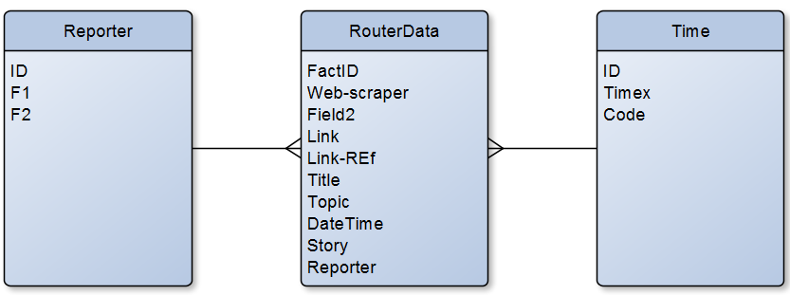

Data Definition
Application Name  Data Source Name  Primary Key |  | News  Reporter  ID#
Connection | Details |  |  |  | Comments
Database Location  Database Platform  Dataset  SQL  Access Method | J:\BSc Applied Computing\Big Data\News  Reporter  Select * from Reporter  Select |  |  |  | The reporter table holds all of the reporters ID and their names.
File Name | Type |  | Size | Format |  | Description | Validation | Key
ID# | AutoNumber |  | Integer | # |  | Primary Key | Must be Unique | P
F1 | Short Text |  | 255 | @
F2 | Short Text |  | 255 | @

Data Definition
Application Name  Data Source Name  Primary Key |  | News  Time  ID#
Connection | Details |  |  |  | Comments
Database Location  Database Platform  Dataset  SQL  Access Method | J:\BSc Applied Computing\Big Data\News  Time  Select * from Time  Select |  |  |  | The time table holds all of the various times at which the report was uploaded with their respective IDs.
File Name | Type |  | Size | Format |  | Description | Validation | Key
ID# | AutoNumber |  | Integer | # |  | Primary Key | Must be Unique | P
Timex | Date/Time |  | Long Integer
Code | Short Text |  | 255

Data Definition
Application Name  Data Source Name  Primary Key |  | News  RouterData  FactID#
Connection | Details |  |  |  | Comments
Database Location  Database Platform  Dataset  SQL  Access Method | J:\BSc Applied Computing\Big Data\News  RouterData  Select * from RouterData  Select |  |  |  | The Router data is the main table which contains all of the data and metadata regarding information on certain news topics.
File Name | Type |  | Size | Format |  | Description | Validation | Key
FactID# | AutoNumber |  | Integer | # |  | Primary Key | Must be Unique | P
Web-Scraper | Short Text |  | 255 | @
Field2 | Short Text |  | 255 | @
Link | Short Text |  | 255 | @
Link-REf | Short Text |  | 255 | @
Title | Short Text |  | 255 | @
Topic | Short Text |  | 255 | @
DateTime | Short Text |  | 255 | @
Story | Long Text |  |  | @
Reporter | Short Text |  | 255 | @

Conceptual Data Model
Once all of the collected data had been extracted from Skewen News webpages listing all of the various news stories and identifying all of the various dimensions, in order to create a the conceptual data model show below we must first identify all of the various relevant pieces of data that can be separated into their respective dimensions when the data was initially collected from Skewen News, this collected data will separate the various columns from the original router data into the appropriate dimensional tables.
The conceptual data model that has been carefully designed below to ensure that large amounts of data can be stored and populated into the various tables that will be required in order to perform data analysis and query the data in the future. All of the dimensional tables have been linked alongside their respective temporary tables which act as a connection between the fact table, which will hold all of the small integer values of data that can be converted to more meaningful data that is stored on in each dimensional table.

Data Warehouse Structure

Fact Table: NewsFact(FactID#, Title#, Topic#, DateTime#, Story#, Reporter#)

Dimension Table: DimDay(DayID#, Dy)
Dimension Table: DimMonth(MnthID#, Mnth)
Dimension Table: DimYear(YrID#, Yr)
Dimension Table: DimTopic(TopicID#, Topic)
Dimension Table: DimTime(TimeID#, Time)
Dimension Table: DimReport(ReportID# F2)
Dimension Table: DimLocation(LocationID#, Location)
Dimension Table: DimStory(StoryID#, Story)
Dimension Table: DimTitle(TitleID#, Title)

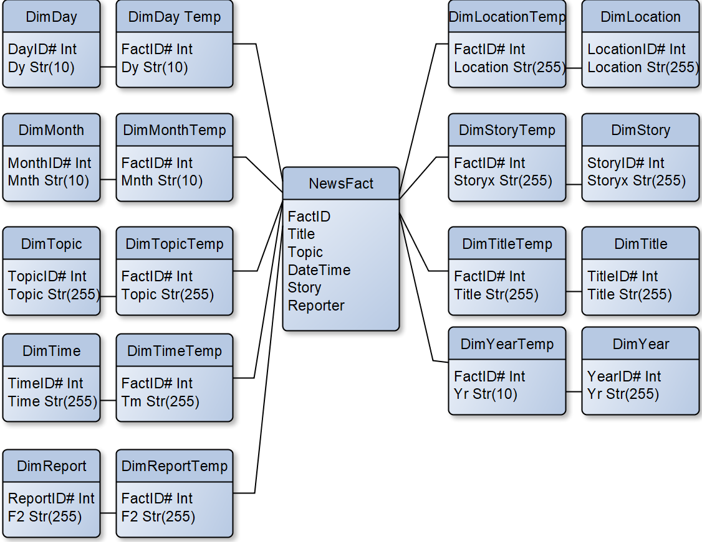

Data Definition
Application Name  Data Source Name  Primary Key |  | News  DimDay  DayID#
Connection | Details |  |  |  | Comments
Database Location  Database Platform  Dataset  SQL  Access Method | http://4500:1001:7376210469666/apex  Oracle  DimDay  Select * from DimDay  Select |  |  |  | Dimension table for storing all the days where reports had been uploaded to Skewen’s website.
File Name | Type |  | Size | Format |  | Description | Validation | Key
DayID | Number |  | Integer | # |  | Primary Key | Must be Unique | P
Dy | Text |  | 255

Data Definition
Application Name  Data Source Name  Primary Key |  | News  DimMonth  MnthID#
Connection | Details |  |  |  | Comments
Database Location  Database Platform  Dataset  SQL  Access Method | http://4500:1001:7376210469666/apex  Oracle  DimMonth  Select * from DimMonth  Select |  |  |  | Dimension table for storing all the months where reports that had been uploaded to Skewen’s website.
File Name | Type |  | Size | Format |  | Description | Validation | Key
MnthID | Number |  | Integer | # |  | Primary Key | Must be Unique | P
Mnth | Text |  | 255

Data Definition
Application Name  Data Source Name  Primary Key |  | News  DimYear  YearID#
Connection | Details |  |  |  | Comments
Database Location  Database Platform  Dataset  SQL  Access Method | http://4500:1001:7376210469666/apex  Oracle  DimYear  Select * from DimYear  Select |  |  |  | Dimension table for storing all the years where reports that had been uploaded to Skewen’s website.
File Name | Type |  | Size | Format |  | Description | Validation | Key
YearID | Number |  | Integer | # |  | Primary Key | Must be Unique | P
Yr | Text |  | 255

Data Definition
Application Name  Data Source Name  Primary Key |  | News  DimTopic  TopicID#
Connection | Details |  |  |  | Comments
Database Location  Database Platform  Dataset  SQL  Access Method | http://4500:1001:7376210469666/apex  Oracle  DimTopic  Select * from DimTopic  Select |  |  |  | Dimension table for storing all the topics of news reports that had been uploaded to Skewen’s website.
File Name | Type |  | Size | Format |  | Description | Validation | Key
TopicID | Number |  | Integer | # |  | Primary Key | Must be Unique | P
Topic | Text |  | 255

Data Definition
Application Name  Data Source Name  Primary Key |  | News  DimTime  TimeID#
Connection | Details |  |  |  | Comments
Database Location  Database Platform  Dataset  SQL  Access Method | http://4500:1001:7376210469666/apex  Oracle  DimTime  Select * from DimTime  Select |  |  |  | Dimension table for storing all the times where reports that had been uploaded to Skewen’s website.
File Name | Type |  | Size | Format |  | Description | Validation | Key
TimeID | Number |  | Integer | # |  | Primary Key | Must be Unique | P
Time | Text |  | 255

Data Definition
Application Name  Data Source Name  Primary Key |  | News  DimReport  ReportID#
Connection | Details |  |  |  | Comments
Database Location  Database Platform  Dataset  SQL  Access Method | http://4500:1001:7376210469666/apex  Oracle  DimReport  Select * from DimReport  Select |  |  |  | Dimension table for storing all news reporters that upload onto Skewen’s website.
File Name | Type |  | Size | Format |  | Description | Validation | Key
ReportD | Number |  | Integer | # |  | Primary Key | Must be Unique | P
F2 | Text |  | 255

Data Definition
Application Name  Data Source Name  Primary Key |  | News  DimLocation  LocationID#
Connection | Details |  |  |  | Comments
Database Location  Database Platform  Dataset  SQL  Access Method | http://4500:1001:7376210469666/apex  Oracle  DimLocation  Select * from DimLocation  Select |  |  |  | Dimension table for storing all the locations of news reports that had been uploaded to Skewen’s website.
File Name | Type |  | Size | Format |  | Description | Validation | Key
LocationID | Number |  | Integer | # |  | Primary Key | Must be Unique | P
Location | Text |  | 255

Data Definition
Application Name  Data Source Name  Primary Key |  | News  DimStory  StoryID#
Connection | Details |  |  |  | Comments
Database Location  Database Platform  Dataset  SQL  Access Method | http://4500:1001:7376210469666/apex  Oracle  DimStory  Select * from DimStory  Select |  |  |  | Dimension table for storing all the stories of news reports that had been uploaded to Skewen’s website.
File Name | Type |  | Size | Format |  | Description | Validation | Key
StoryID | Number |  | Integer | # |  | Primary Key | Must be Unique | P
Story | Text |  | 255

Data Definition
Application Name  Data Source Name  Primary Key |  | News  DimTitle  TitleID#
Connection | Details |  |  |  | Comments
Database Location  Database Platform  Dataset  SQL  Access Method | http://4500:1001:7376210469666/apex  Oracle  DimTitle  Select * from DimTopic  Select |  |  |  | Dimension table for storing all the titles on news reports that had been uploaded to Skewen’s website.
File Name | Type |  | Size | Format |  | Description | Validation | Key
TitleID | Number |  | Integer | # |  | Primary Key | Must be Unique | P
Title | Text |  | 255

ETL (Extract, Transform & Load) – Data Transition Process
In order to get the proposed data warehouse, the initial scraped datasets need to be properly cut into the various tables that were designed above, in order to do this we need through the extract, transform and load data transition process which is:
- Extract – Remove the relevant data through the use of queries that separate the data appropriately
- Transform – Sanitize the data to ensure that all data collected is both relevant and usable for future analysis
- Load – Define the newly formed table to ensure that it has an appropriate relationship with the rest of the data warehouse for future analysis.

Dimensional Table: DimDay
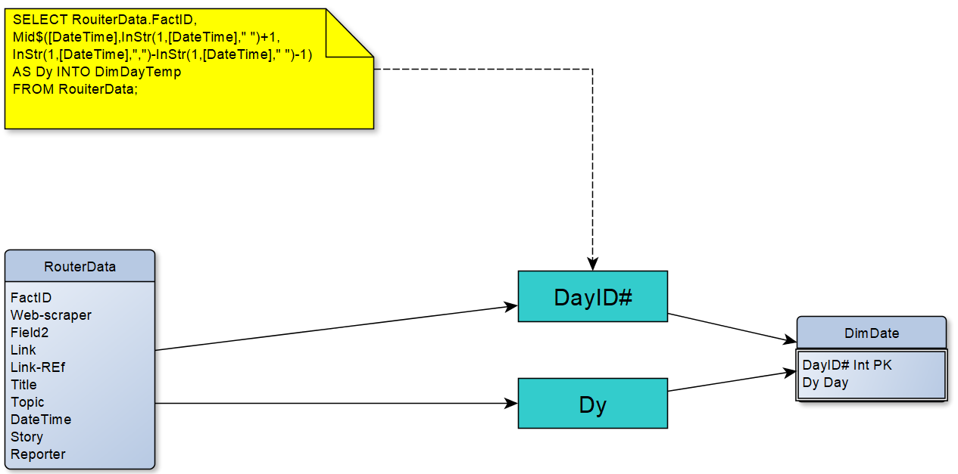
The day dimension table was extracted from the web-scraped data. DayID# and Dy are selected from the web-scraped data. All of the days selected are valid.

Dimensional Table: DimMonth
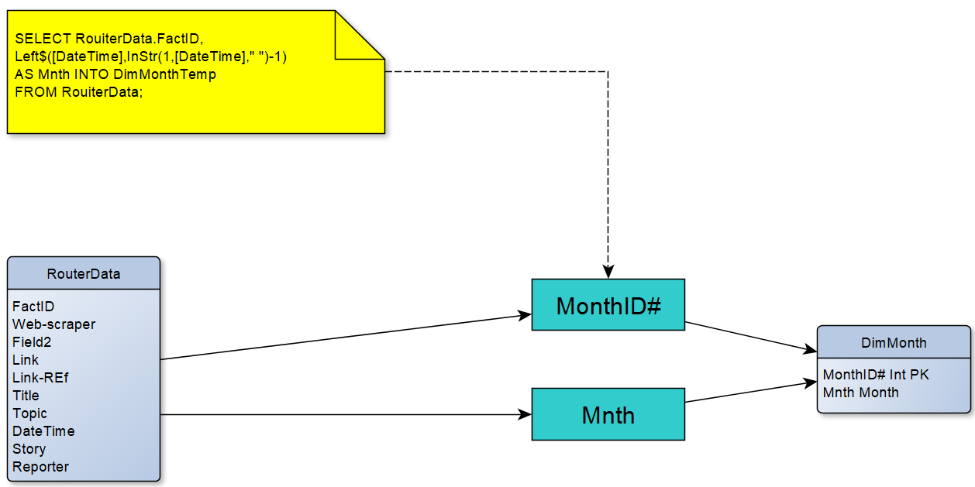
The month dimension table was extracted from the web-scraped data. MonthID# and Mnth are selected from the web-scraped data. All of the months selected are valid.

Dimensional Table: DimYear
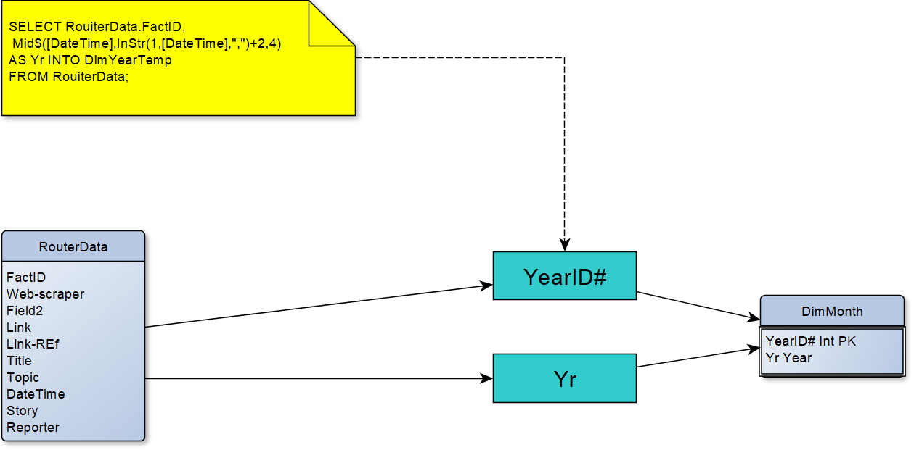
The year dimension table was extracted from the web-scraped data. YearID# and Yr are selected from the web-scraped data. All of the years selected are valid.

Dimensional Table: Concatenating Dates
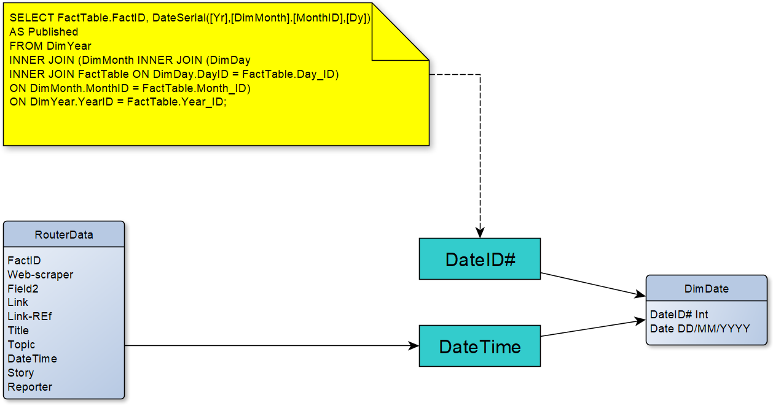

Once all of the dates had been extracted into their own dimensional tables, to further improve the performance and search time in the data warehouse, it was made possible to search by full dates straight away rather than query the dates into another query when searching for specific reports for example which was initially the plan.

Dimensional Table: DimTopic
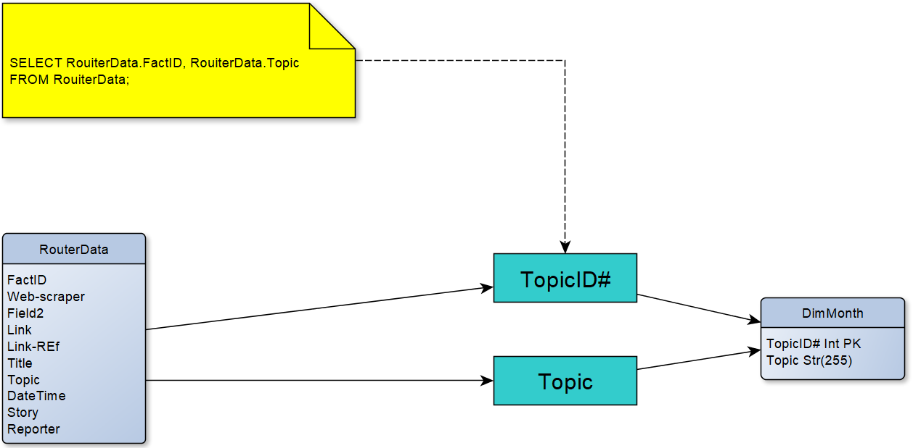
The topic dimension table was extracted from the web-scraped data. TopicID# and Topic are selected from the web-scraped data. All of the topics selected are valid.

Dimensional Table: DimTitle
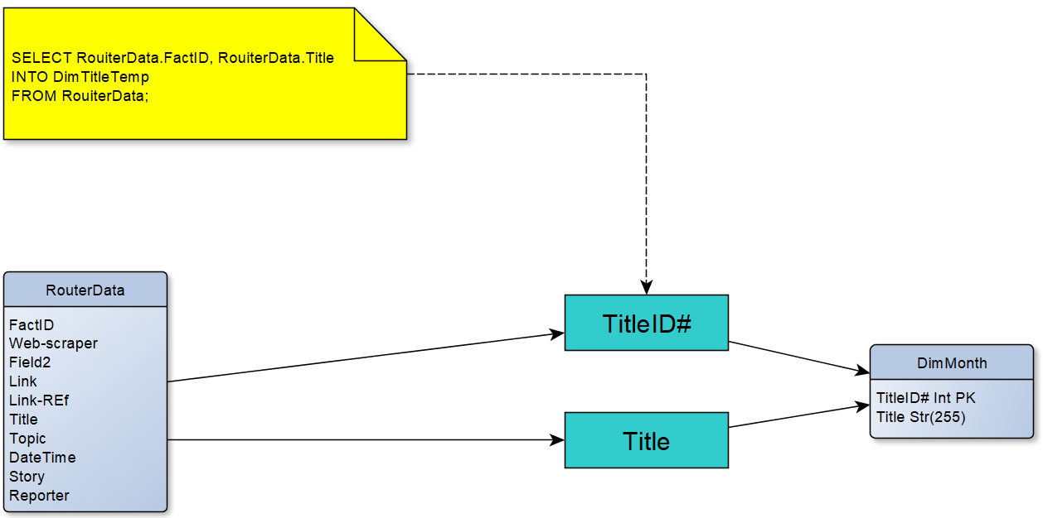
The title dimension table was extracted from the web-scraped data. TitleID# and Title are selected from the web-scraped data. All of the titles selected are valid.

Dimensional Table: DimStory
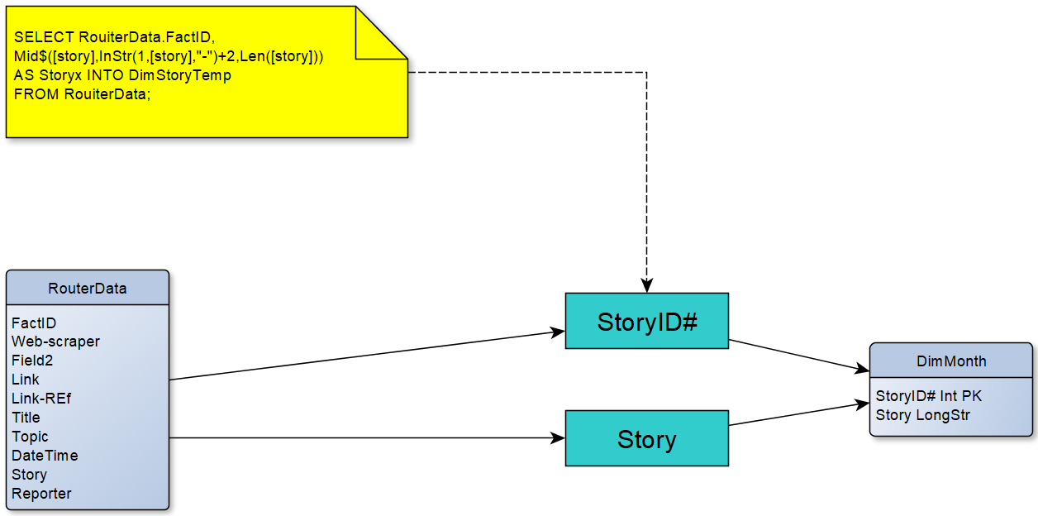
The story dimension table was extracted from the web-scraped data. StoryID# and Story are selected from the web-scraped data. All of the stories selected are valid.

Dimensional Table: DimLocation
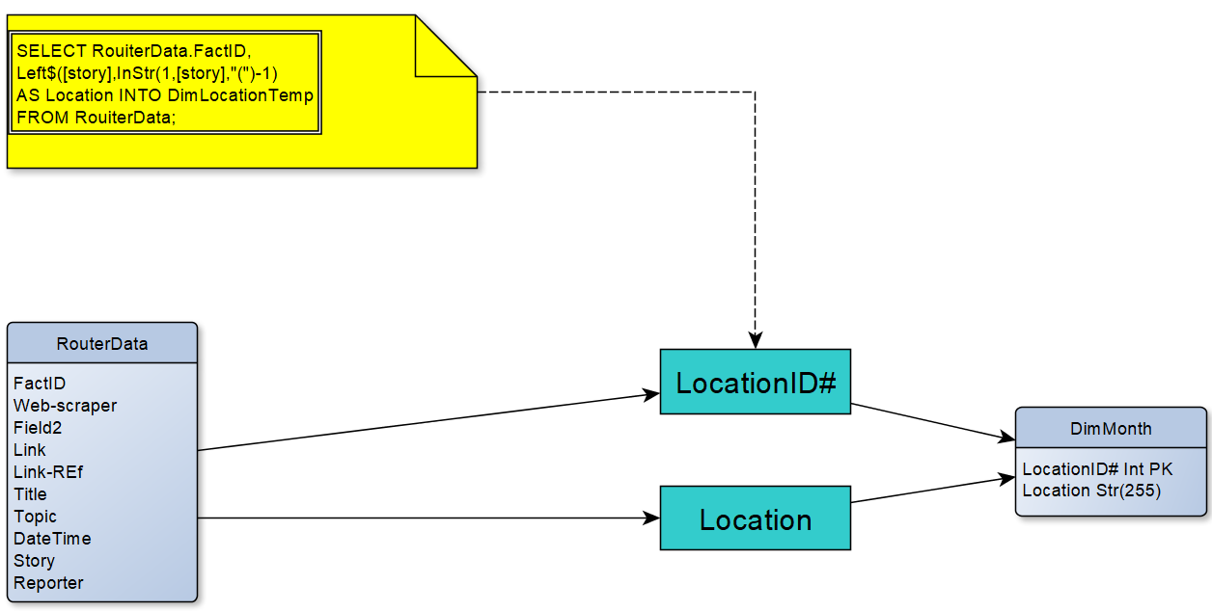
The location dimension table was extracted from the web-scraped data. LocationID# and Location are selected from the web-scraped data. All of the stories selected are valid.

Dimensional Table: DimTime
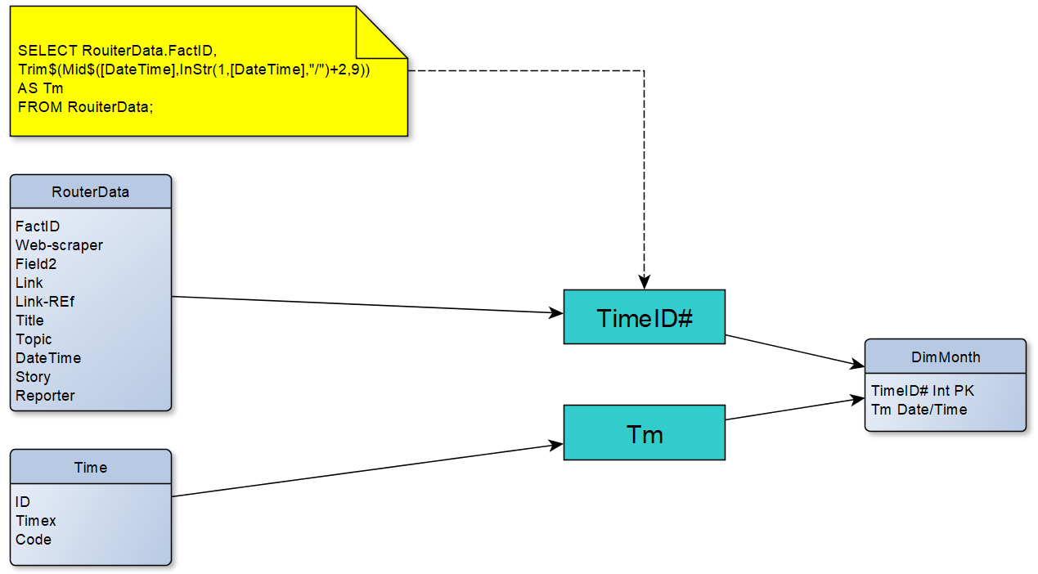
The time dimension table was extracted from the web-scraped data as well as the time table. TimeID# was selected from the web-scraped data, while Tm was selected from the Time table. All of the times selected are valid.

Dimensional Table: DimReport
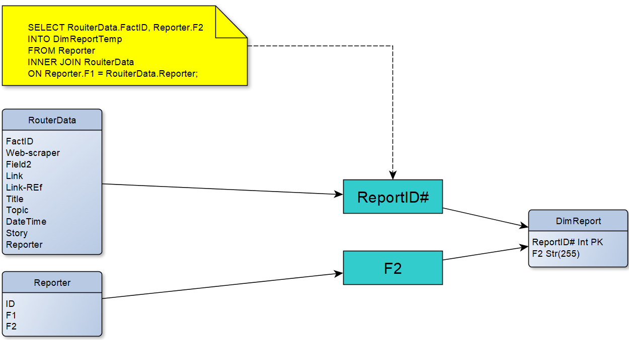
The report dimension table was extracted from the web-scraped data as well as the reporter table. ReportID# was selected from the web-scraped data, while F2 (reporters name) was selected from the Reporter table. All of the reporters selected are valid.

Querying Data through Fact Table Utilisation
Once all of the dimension tables have been created and all of the steps of ETL have been completed to suit the initial data warehouse designs, queries can be run against that data that has been implemented into the data warehouse, a simple query that actually ensures a more stable database is being able to show in the example below is to ensure that every reporter that is listed in the database has all of the appropriate fields of data, and that there is no blank space within the records. This form of data sanitisation ensures that any future queries that could potentially bring back data that is no technically there will prevent the data warehouse from running into any potential issues.
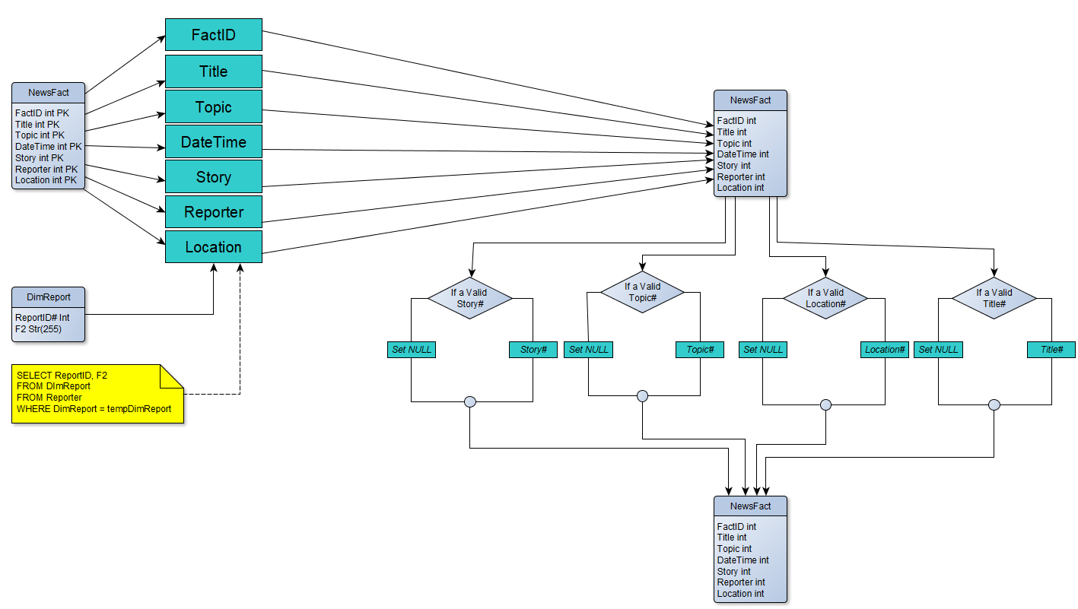

Skewen News Queries & Data Analysis
Some simple initial queries that were requested by Skewen News were discussed as:
- All stories on a user-defined topic
- All stories within a user-defined geographical area
- A timeline showing the development of a complex story over a period of at least a week
- Stories that are related to a user-defined story by location, content or other features.

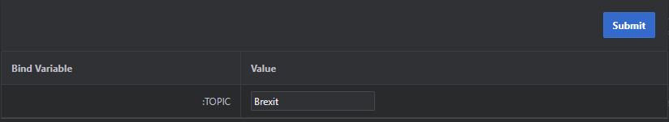
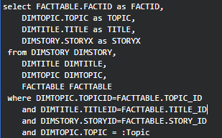
Taking the user-defined topics query as an example. This query along with the rest allows for employees at Skewen News to be able to grab data from a specific topic using the program Oracle Application Express which will prompt the user to enter a particular topic/location and once submitted will return all relevant pieces of data to the user immediately.
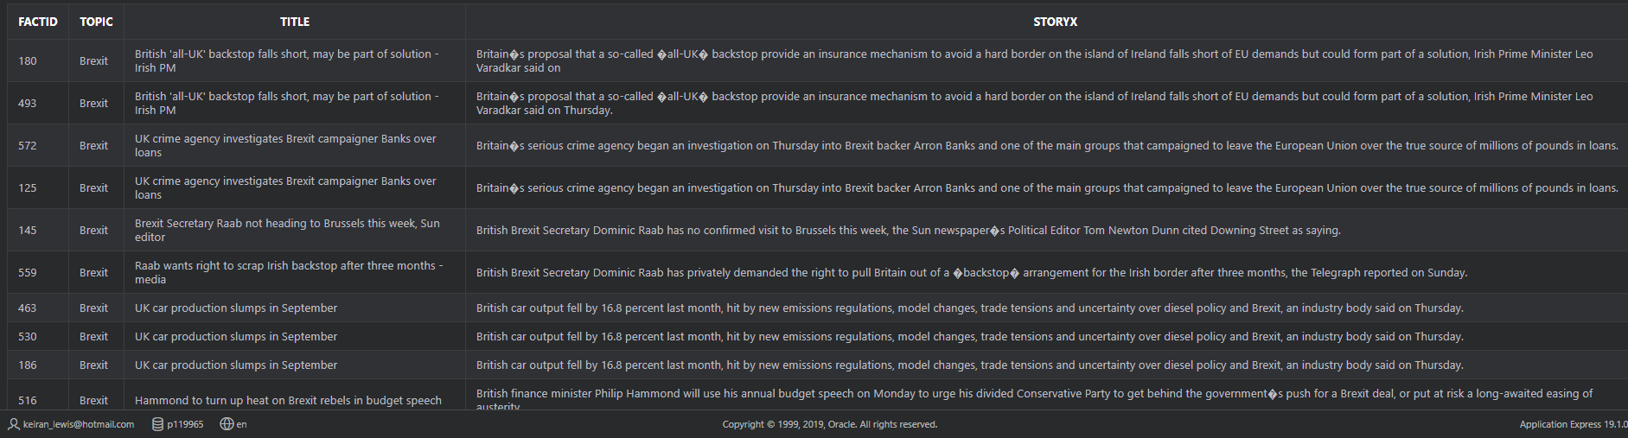

The SQL above shows that the upon searching for the news topic ‘Brexit’ in the user interface, all stories that have been stored under the topic ‘Brexit’ will now appear for the user to be interact and read from it.
From the data that is returned when using the same query above, Skewen News has the ability to further analyse their data into more meaningful reports, the example below shows the number of reports on a specific topic which in this case is Brexit and how often they show report on that particular within a certain timeframe. From the analysis it is clear to see that reports on Brexit are primarily reported on from central European nations and both the data and visual analysis reflect that.
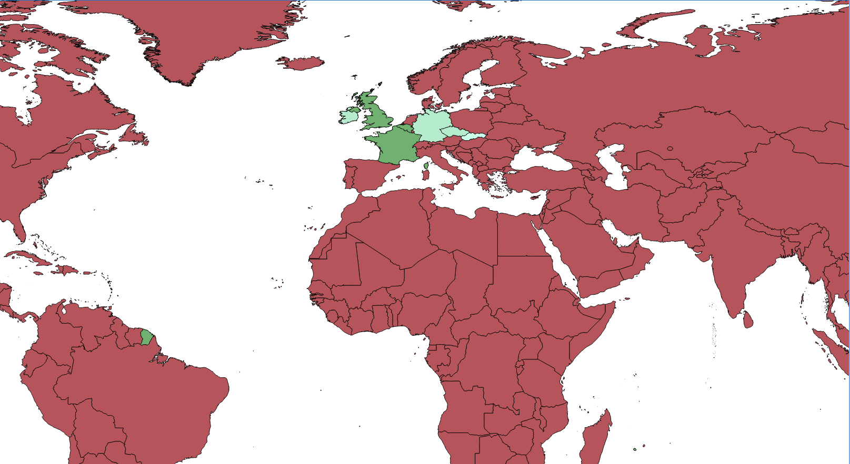
This form of query building and data analysis similar to OLAP cubes which allow for large amounts of data to be queried and fed into program like mapping the data whilst dealing with thousands of records being queried all at once and multiple times due to the structure of the data warehouse.

