Running Head: [Business Plan]

Business Plan

Student Name: Iftikhar Uddin

Student ID:2027581

Module Code:BMSW4006

[Institution Name]

Table of Contents
1.0 “Executive Summary” 1
1.1. “Business Objectives” 1
1.2. “Mission Statement” 1
2.0 “Company Description” 2
3.0 “Production and Services” 3
3.1. “Future Proposed Services” 4
4.0 “Market Analysis” 4
4.1 “Market Trends” 5
4.2. “Market Growth” 6
4.3. “Market Positioning” 6
4.4. “Market Strategy and Implementation” 6
4.4.1. “Pricing Strategy” 7
4.4.2. “Milestones” 8
5.0 “Organisation and Management” 8
5.1.1 “Management Team and Gaps” 8
6.0 “Financial Plan” 8
References 1

“Executive Summary”
The Traditional Home-style Restaurant (THR) will be a competitively priced “86-seat restaurant with family-style food and service at reasonable prices”. It has a wide variety of dishes on the menu that include roasted chicken and pot roast; steak and pork chop; a traditional hamburger; and large salads and many more. We will provide a wide range of options, including a children's menu with smaller portions and lighter cuisine. A new restaurant in Edinburgh's West Land will be owned and operated by us, THE FRIENDS. It is expected that the first year will generate £1,825,000 in annual revenue. The total start-up expenditures are estimated at £1,469,625 and the yearly profit is estimated at £505,375. The royal family will provide £30,000 and the owners will contribute the rest of the $150,000 needed to get the business up and running. "The consumer is almost always accurate" is the concept we aim to start our firm with.

1.1. “Business Objectives”
- “To be the premier home-style restaurant in West Land of Edinburgh”
- “To provide quality meals at reasonable prices with exemplary service”
- “Achieve Cover ratios of 1.00X at each lunch and dinner serving”
- “We attempt to offer the great values to our clients by keeping their requirements at first place and to provide maximum customer satisfaction”
- “Our goal is to maximize our output by the usage of minimum assets”
- “To generate greater revenues at a greater pace and to achieve breakeven in the initial year of business”

1.2. “Mission Statement”
“Our Mission is to provide a unique and relaxing dining experience – similar to dining at home. We will strive to achieve this goal by: 1) by providing menu items incorporating quality ingredients at reasonable prices, and 2) we will be mindful of the well-being of our customers and staff– treating each and everyone with dignity and respect – just like we would at our own home!”

“Company Description”
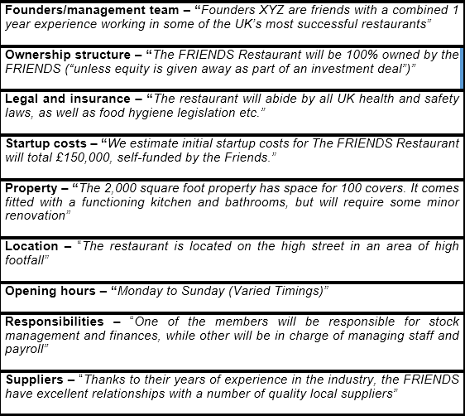

The "Traditional Home-Style Restaurant will be" located in Edinburgh West Land, a part of the Edinburgh Metropolitan Borough in the United Kingdom. All FRIENDS members will own and operate the eatery. Pot roast and mashed potatoes, as well as cheeseburger melts and vanilla ice cream, will be on the menu at the new eatery. We will rely on friends and family members to step in as needed until we are fully operational and profitable due to the regular turnover of workers in startup eateries. The state of Edinburgh will recognise THR as a communal property state. The restaurant's start-up costs are expected to be in the region of £150,000. To get the project done, the Friends will use the services of outside contractors. The first launch costs will be covered by the owners to the tune of £120,000. Marketable securities and Liquid assets, the majority of which come from the owner's catering business, make up the bulk of our financial resources.
Located in Edinburgh West Land, the "Traditional Home-Style Restaurant" will serve traditional British fare. As a collective, our members will be the only owners and operators of the eatery. Chuck roast and mashed potatoes, as well as hamburger melts and vanilla ice cream, will be on the menu at the new eatery. We will rely on friends and family members to pitch in as needed until our business is up and running and successful, due to the constant turnover of workers in startup eateries. All persons will be responsible for running THR: collectively called THE FRIENDS.
The restaurant will remain open for “7 days a week with hours” as follows:


“Production and Services”

- THR will be open seven days a week for dinner and lunch will require a variety of shifts. It will be feasible to change hourly labour levels in response to sales volume so that labour costs may be kept under control at all times. In order to meet demand during peak business hours, it is essential to have adequate storage space, proper labelling, and rotation systems in place.
- There will be replenishing and preparation during off-peak hours. One member of the team will be responsible for procuring, receiving, and maintaining an appropriate supply of materials to meet production needs.
- Perishables will be ordered many times a week in order to keep them fresh. A more limited set of similar food and supply orders will be placed on a less frequent basis, according to the availability of storage space and a predetermined schedule.
- Operations checklists are used by other members to guarantee that each work shift is well-prepared and that operational standards are followed before, during and after shifts are performed. There is a great deal of flexibility in the restaurant's layout to accommodate changing customer traffic and peak meal times.
- An assistant manager will ask guests where they wish to sit when they arrive. We will take drink orders and offer complimentary buns to everybody who comes in. The grill area's requisition printer immediately prints the customer's order after it has been taken.
- To maintain track of orders, the grill cook would utilise “the printed ticket” for keeping track of food, and then lay the meal under the heating lamps until it is done.
- At least one chef and a max of four cooks were considered while designing the kitchen preparation line. This design allows line workers to adjust their schedules based on the volume of business.
- During shift changes, everyone will be responsible for cleaning, preparing and restocking.
- All money will be paid at the end of each shift. The closing shift will include a list of tasks that must be completed to guarantee that the restaurant is ready for business on the next day.

3.1. “Future Proposed Services”
Future catering offerings from THR include family reunions, wedding receptions, and other events that demand for a "home-style" meal. This might quickly become a major contributor to the company's overall revenue. We want to have a sales agent in place by the end of the second year, who will be able to advertise their products straight for daily delivery or catering.

“Market Analysis”

- “The Industry”–Edinburgh’s restaurant industry has had its highest closure rate in decades, as well as a high incidence of turnover of staff, in the past two years. Chain restaurants and upscale places have been particularly badly affected, as consumers want for more real independents such as THR Restaurant.
- “The target Market” - Affluent young professionals and families with £40,000 as an annual income make up the bulk of the 260,000-strong local population, making up "the target market."
- “Competitors” - Three direct competitors exist within a radius of five-mile, including:

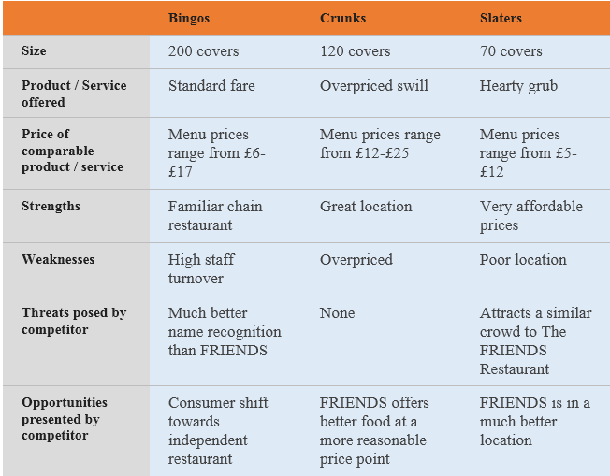
The “FRIENDS Restaurant” will establish itself as West Edinburgh's premier mid-range family restaurant. Our plan will encompass both “traditional” and “digital marketing” tactics. To begin, we will:
- “Develop relationships with local businesses by offering lunchtime deals”
- “Implement a loyalty scheme”
- “Encourage repeat visits through our email database”

4.1 “Market Trends”
In accordance with the “National Restaurant Association”, the major restaurant trends are:
- sustainability as “a culinary theme”,
- locally grown produce,
- nutritious dishes for kids,
- farm brand ingredients,
- locally sourced meats and seafood,
- hyper-local items, (“networked locally grown – like a Craigslist for restaurants”)
- gluten-free allergy conscious items,
- sustainable seafood,
- children’s nutrition as a “culinary theme” and
- back to basics cuisine.

4.2. “Market Growth”
After Covid-19, when all industries including retail one faced a significant challenge, online food services were there to combat the loss. In November 2021, consumer spending on services in the UK climbed by 2.1%, a sign of rising restaurant sales. In the week ending January 16, 2022, the average retail price of diesel and regular gas in the United Kingdom increased by 15.1% and 11.3%, respectively, compared to the same week last year. In the third quarter of 2021, US tourists spent 8.1 percent more on food services and drinking establishments than they did in the third quarter of 2020. During the first phase of my investigation.

4.3. “Market Positioning”
For the most part, diners believe that home-cooked meals are more healthful and better prepared than restaurant fare. THR's goal is to become the top home-style restaurant by serving only the freshest, most organic ingredients in all of our dishes. Additionally, our FRIENDS will be providing home-cooked meals that are in keeping with the current trend toward healthy eating and will feature menu options that appeal to these demographics. When it comes to traditional home-style dining, THR will be the region's best bet.

4.4. “Market Strategy and Implementation”
A combination of regular and seasonal menu items will be offered in order to save money and stay on top of food industry trends.Likewise, we at THR strive to be the finest place to work in the industry. Our restaurant, THR, expects to employ both full- and part-time workers, allowing for a wide range of career options for our employees. Maintaining records accurately, including “daily examination of the Prime Cost Report”, and “using Cost Accounting Systems to minimise inventory shortages”, will allow us to offer competitive remuneration to our staff. To keep our employees motivated, we will conduct periodic reviews and provide them with rewards and other incentives. Additional training on food safety standards and worker safety will be provided to our employees.
THR will also stay on top of the latest marketing trends in the business. We will have a Facebook page as well as utilise other social media platforms (“such as Twitter”), in addition to a website with our menu, map, and directions. Yelp and Group On will be our partners. “Loyalty and birthday clubs” have been shown to increase income by as much as 15%, according to recent studies.
THR's success will need more than just great meals and friendly service. In order to improve customer traffic, we'll devise a marketing plan. In order to better serve our clients, we at THR will keep up with the most recent market trends and use a proactive approach rather than a reactive one in our marketing. These goals will be achieved using the following methods:
- Database: The first step in our marketing effort will be to target current customers. Our big opening will be announced through email. A fishbowl in the foyer will be used to gather business cards and have a drawing once a week or once a month.
- A Birthday/Loyalty Program. If you join THR's Birthday Club, you'll get a free hamburger, chicken sandwich or wrap on your birthday every year! The National Restaurant Association has conducted research that found that this simple strategy might increase sales by up to 15% by encouraging customers to return.
- For this reason, we want to be actively involved in the community by supporting and donating to local non-profits and sports teams while also building partnerships with local companies as a quick and easy lunch alternative. A marketing effort in the future will see us contacting local companies in the market area, bringing samples, and encouraging them to dine at our restaurant.

4.4.1. “Pricing Strategy”

Cost accounting is essential at THR, where a menu item's initial cost is determined by the profitability of several meals. It is important to us that we maximise our favourable financing conditions with suppliers while also including seasonal dishes prepared with fresh local ingredients into our menu. “The Prime Cost Report”, which puts emphasis on the controllable expenditures of Cost of Labour and Goods Sold, will also be closely monitored. As a new company, we may save money by hiring family members to work for little or no compensation.

4.4.2. “Milestones”
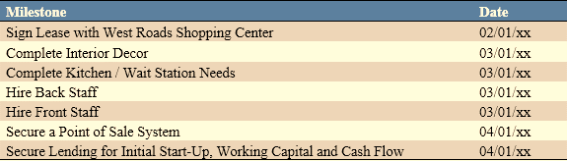

“Organisation and Management”
THR expects to hire 19 more employees. FRIENDS will make their own selections for each candidate. As a result of our effective interviewing methods, the restaurant now employs only the most capable people in each job. A predetermined set of job-specific criteria will be used to score and assess each applicant. Background checks will be performed on chosen candidates for certain positions. The majority of new hiring will come through referrals.

“Management Team and Gaps”

All partners are skilled at a quick-service foodservice operation and together constitute the restaurant's management team. In the beginning, we'll focus on fixing some of the most serious management problems. Soon, we hope to have a sales director, an executive chef and an operations director on our team. The Wrights are considering acquiring a “POS (point of sale)” system that improves communications between the wait staff and kitchen in order to improve inventory management, cost accounting and payroll,. The kitchen printer receives orders online and promptly processes them. It is also possible to keep track of the most popular menu items using restaurant point-of-sale systems. A time clock function built in to the point of sale system can save money in the bookkeeping department since it doubles as the POS system's time clock function. Profits and losses statements and sales tax can also be handled by a POS system in addition to daily activities.

“Financial Plan”
Startup costs – The Friends will initiate the business with the estimated startup cost of £150,000. £30,000 will be grant by the Royal Family, on the celebration of Queen’s 60th coronation anniversary. The remaining cost i.e. 120,000 will be invested equally by all the partners.

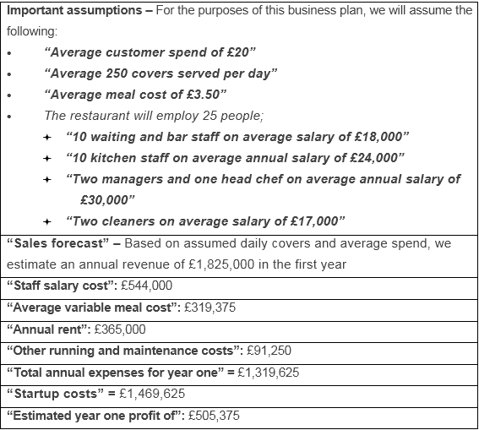

References
Fullen, S.L., 2005. Opening a Restaurant Or Other Food Business Starter Kit: How to Prepare a Restaurant Business Plan & Feasibility Study: with Companion CD-ROM. Atlantic Publishing Company.
Mason, C. and Stark, M., 2004. What do investors look for in a business plan? A comparison of the investment criteria of bankers, venture capitalists and business angels. International small business journal, 22(3), pp.227-248.
Pinson, L., 2008. Anatomy of a Business Plan: A Step-by-step Guide to Building the Business and Securing Your Company's Future. Aka associates.
Shiyo, A. and Keter, N., 2012. Business plan for a restaurant.

