

Assignment title: Coursework essay

Programme: BA BUSINESS MANAGEMENT
Module name: PROJECT MANAGEMENT
Module code: LCBB5005
Student name: ALEXANDRA CREANGA
Student ID: 2113195

Table of Contents
Contents
Introduction 2
Discussion 2
Critical analysis of project management 2
Tools and techniques used in the management 4
Stakeholder management 6
Evaluating the risk factors of the Project 8
Recommendations and Conclusion 9
Recommendations 9
Conclusion 10
Reference list 11

Introduction
This essay is going to evaluate the Hinkley Point C project of assessment 1. This project of the nuclear power plant in Somerset, UK is focused on creating low-carbon electricity and this project is going to create 25,000 opportunities for employment. This nuclear power plant is currently under construction in Somerset. This plant is expected to be operational by 2025 and will generate enough electricity to power 6 billion homes. The Hinkley Point C nuclear power reactor is a pressurised water reactor. These PWRs are the most common type of nuclear power plant in the world. The project is intended to be approached by a team of experts with experience in nuclear power plant assessment. The team will use a variety of methods to gather relevant information. The intended approach of the assessment is fairly and objective. All the relevant information will be considered and recommendations will be based on the best available evidence. Transparency about the findings will be maintained and it will be ensured that they are accessible to the public. The findings of the assessment will be used by the government of the UK to decide whether they can proceed with this project or not. This part of the essay will identify whether this will be a successful project or it will result in failure for the future energy sector of the UK and what factors will be responsible for the results will be discussed in this study. The lessons that are learned will be highlighted and useful recommendations will be provided to carry out a similar project in the future.

Discussion

Critical analysis of project management
The significance of project management is vital for integrating the team efforts for meeting client objectives and nuclear project deadlines. The focal pointers are determined by the project manager as per the “organisational hierarchy for decentralising the designated duties”. Nuclear power projects are complex in nature therefore specialised skills are necessary in every operational phase as per the project management structure. The project manager is responsible for coordinating the central tasks of the Hinkley Nuclear Power plant. This team includes a project procurement manager, field construction manager, project engineer, cost supervisor, construction coordinator and startup engineer. The project management of the nuclear power plant is dependent on monitoring the project performance such that the focal objectives are met within the stipulated deadline (Santos and de Carvalho, 2022). The project manager of Hinkley Nuclear Power Plant here acts as an interface or the direct communication link between the corporation and the client. The project manager oversees that the objectives are met within budget and is on schedule and is acceptable to both the corporation and the client. The prerogative of modern project management helps in shaping the efforts put in by each employee as per the project life cycle. Specific standard computer programs and techniques are incorporated for maximising total capability as per the available human resources. This type of project management technique helps in influencing consistency and reduces the possibility of error. The success of the project is dependent on the effective management system followed by the organisation to strengthen its business structure.
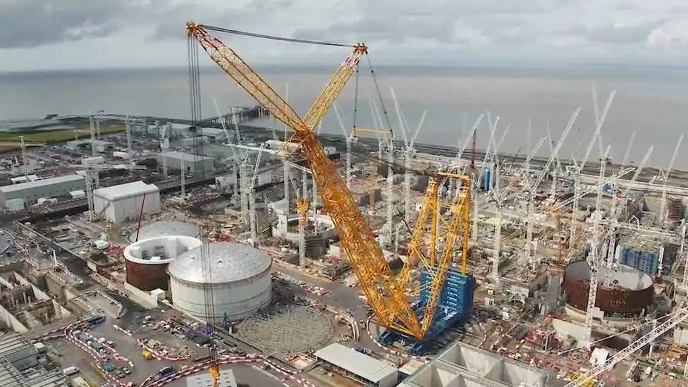
Figure: Hinkley Point C Project Management
(Source: Blackridgeresearch, 2023)
In order to ensure success in the project the preliminary development at the first level of the nuclear power project. It is necessary in defining the “functional responsibilities, estimated cost, procedures, and scope of services”. The effective proposal plan was amended by the management of the Hinkley Nuclear Power Plant which provides a rough estimate of the number of equipment used and the location. An effective proposal plan helps in meeting the client’s requirements as per request. The preliminary system flow diagram of the site facility, plant arrangement, quantity takeoff and site condition data are considered (Martinsuo and Ahola, 2022). The project plan also comprises three elements such as scope, cost and schedule. The Hinkley Project C of the organisation focuses on the building of two nuclear reactors with the service of providing zero-carbon electricity in the UK. The practice of Field Manhour Control is used by the project managers of Hinkley Nuclear Power Plant to track the performance of each team member. As a result, the performance of the workers is kept on track. The software provides a performance report which contradicts the planned performance versus the real-time performance of project members. It has been witnessed that the future perspective of the project ensures nature-friendly execution of electricity reducing the rate of pollution by 45% based on environmental norms (Edfenergy, 2023). The deviation in plans also allows the higher authority to take corrective action before adverse situations such as exceeding budget and manhour overruns. The organisation has funded more than $12.5 billion in the execution of the project by the year 2030 (Edfenergy, 2023). The project is working on providing proper visibility and ensuring proper communication within the premises to ensure project growth and success in the long term.

Tools and techniques used in the management
Monitoring of the project
The practice of the Engineer Control System helps in guiding the team members of Hinkley Nuclear Power Plant with engineering information, specification and drawing status. The system program helps in updating the construction schedules of the power plant and identifying the design constraints. The detailed engineering activities are further enhanced by the Quantity Tracking System which helps in indicating status and estimating the number of materials and equipment for the plant project. The commodities are installed based on the control system and job reporting. Permanent plant equipment is identified from drawings and designed via procurement before startup, testing, installation and acceptance. Concrete-related materials such as valves, electrical equipment such as instrumentation, and mechanical equipment such as pipe hangers are ordered in bulk quantities for the nuclear power plant project (Ghorbani, 2023). It has been witnessed that the future perspective of the project ensures nature-friendly execution of electricity reducing the rate of pollution by 25% based on environmental norms by the year 2024 (Edfenergy, 2023). The project is monitored by the board of directors to generate timely execution of the project with effective constructive formulation.
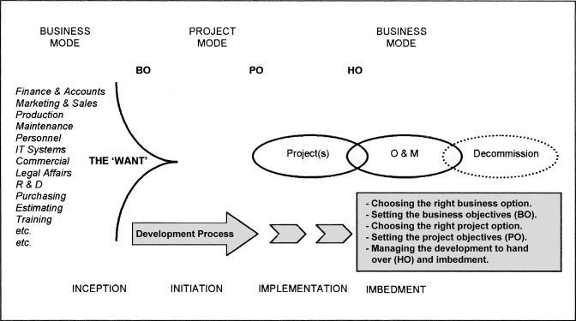
Figure: Steps for monitoring the project
(Source: Sciencedirect, 2023)
Strategic planning
The use of strategic planning helps in effective project execution with timely deployment in association with skilled labours. The status of the Hinkley Nuclear Power Plant is communicated to the client via financial analysis and management reports. The report provides detailed performance progress, work quality and schedule along with a production summary and progress photographs. The application Field Manhour Control is used by the project managers of Hinkley Nuclear Power Plant to track the performance of each team member. The software provides a performance report which contradicts the planned performance versus the real-time performance of project members (Lock, 2020). This type of strategic planning help in providing proper visibility and warns the management about project deviation. It also plans and allows the higher authority to take corrective action before adverse situations such as exceeding budget and manhour overruns. The strategic plan and effective management technique help in serving the requirements of the project to a large extent.
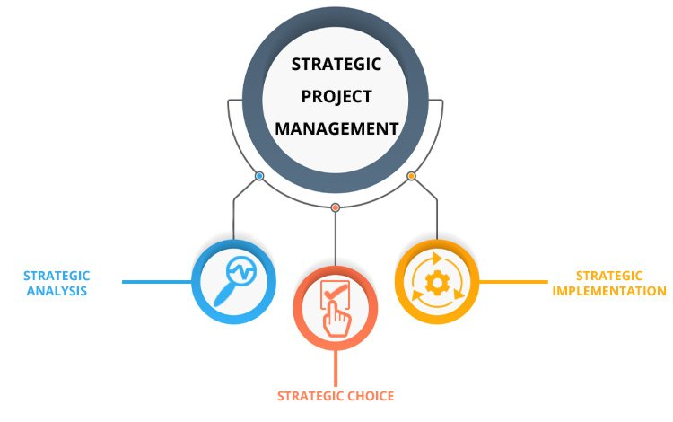
Figure: Strategic Project Management
(Source: Prince2, 2023)

Stakeholder management
This project of Hinkley Point C is a major project in the UK and as a result, it has a wide range of stakeholders.
Government stakeholders: These include the UK government, the French government and the local government in Somerset. As understood from assessment 1 these stakeholders are interested in the project for a variety of reasons, including the development of the economy, security of energy and protection of the environment.
Industry stakeholders: These Include the industry of nuclear, the construction industry and the supply chain (Camilleri, 2020). These stakeholders are interested in the economic opportunity this project will create.
Project management team: This team of the project is responsible for looking over all the activities such as planning, execution and delivery of the project (Rogers, 2019). As understood this team is led by EDF energy and includes representatives from the government of the French and the UK government as well as the local government in somerset. They are divided into different categories to carry out individual tasks to complete the project on time. The delivery team of the project is responsible for the overall delivery of the product and they are responsible for budgeting, scheduling and planning. On the other hand, the stakeholders who are responsible for managing the project are the engineering team who are responsible for the design and the construction team are responsible for the construction of the nuclear power plant. At the same time, the environmental team of the project is responsible to ensure that this project causes no negative impact on the environment.
Community stakeholders: These are the residents, businesses and environmental groups (Lumpkin and Bacq, 2019). Therefore, these stakeholders are interested in this project for its potential impact on their lives, their businesses and the environment.
It is analysed that the management of the stakeholders effectively is important for the success of the project. Therefore, this includes identifying their interests, assessing their level of impact and finding out their importance. At the same time, this also includes engaging them in the project and managing their expectations. As per (Lehtinen et al. 2019) business and management research has focused increasing attention on external stakeholders' engagement in business activities in different contexts including innovation management. Therefore it is understood that effective management of the stakeholder is essential for the success of a large project of Hinkley. This will also have a significant impact on the community and environment. Effective management of the stakeholders is important for Hinkley care as this will be vital for the project to overcome any challenges that may arise. At the same time, any risks to the project will be mitigated and feedback about the success of the project will be useful for making any adjustments if required.
It is understood that the project team has conducted extensive stakeholder analysis to identify the different groups of stakeholders who have got interest in the project and this has helped them to understand the different needs and concerns of these stakeholders (Pedrini and Ferri, 2019). The project team has engaged with the team of stakeholders in a meaningful way and this has helped the project team to build trust among the stakeholders of the project (Pererva et al. 2021). Therefore, one thing is understood from the stakeholder management is that by managing effectively the stakeholders of the project the project team can increase the chances of success of the project.

Evaluating the risk factors of the Project
The evaluation of the risk is concerned with many different aspects based on both qualitative and quantitative risk assessment approaches. The understanding of the risks perceived with the project and its benefits is also regarded as a very useful strategy in determining the success of the project (Mac Donald et al. 2020). The different factors associated with the criteria of risk assessment can be stated as hazards, unwanted consequences, problematic scenarios, events, effectiveness and likelihood. The dysfunction of any of these factors can affect the project's growth to a large extent. The risk of the projects can be analysed in the case of the Hinkley Point C project of the Nuclear Power Plant taking into consideration the following consequences such as:
- Identify the likelihood of the risk or the frequency of risk occurrence.
- Estimating the potential impact of the occurrence of the risk in association with cost reduction assessment.
- Determining the path to manage the risk taking place effectively with the help of accurate decisions.
- The lack of communication and technological disruption also affects the risk-taking ability of the project in the long term.
The frequency of risk occurrence can be in different ways like it can be delayed or sometimes the government found some of the points are missed by the company in constructing the project. And also any type of accident can occur during the construction of the project. The potential impact of the risk occurring can be assessed in terms of its severity and its impact on cost. For example a risk with a high likelihood and high severity and its impact on cost. A risk with low likelihood and low severity would have a minimum impact on cost.
The path to managing the risk efficiently is accurate in the decision about the decision. This involves implementing control measures such as training, equipment and production (Daniel and Daniel, 2019.). It can also involve monitoring the activity of employees and their actions during work.
The lack of communication can cause misunderstandings between stakeholders. This can increase the chance of still as the different stakeholders have a different position in the project and lack of communication can be the risk or any type of accident occurrence. These things can also lead to costly and delayed projects as the stakeholders do not have information about the activity of different stakeholders and their work.

Recommendations and Conclusion

Recommendations
Improve planning details: strategic planning for contractual projects like the “Hinkley Point C nuclear power plant” is necessary for managing the projects in a particular way. Well-thought-out constructional projects give a road map for increasing productivity and completing tasks on time and under budget. During planning, you identify project milestones and goals. Planning of “Hinkley Point C nuclear power plant” includes identifying the tools and labour required, organizing the work of subcontractors, obtaining the necessary building supplies, and reviewing the designs (Nguyen et al. 2022). A security strategy should be developed, communications should be planned, risk assessments should be done, and action plans should be made, among other things.
Monitoring and adjusting progress: Once the building starts, the objective is to make sure that as much as possible happens according to plan. The majority of the time, several minor issues rather than one major one cause projects to fail. Studying daily performance reports, budget and schedule controls, and risk management meticulously requires a high degree of attention to detail (Alzoubi, 2022). Finding any predicted problems or delays should be the first step in the “Hinkley Point C nuclear power plant”. The following level calls for investigative work. When a task or activity is taking longer than expected, it's imperative to figure out why. If output is poor, you might not have the appropriate personnel on staff. Lack of equipment on site or delayed material deliveries are further potential reasons for poor performance.
Effective collaboration and communication: Beyond completing everyone's tasks on schedule, effective project collaboration extends beyond that. To effectively complete the project, it is important to develop relationships with all stakeholders that are built on mutual respect and trust. For enhanced productivity in “Hinkley Point C nuclear power plant", combining and coordinating efforts is essential. Some of these goals are reachable with an effective communication strategy. Technology has significantly impacted communication and collaboration in recent years (Sbiti et al. 2021). The administration of construction projects will be easier by using smartphones and tablets for "building information modelling (BIM)" and “cloud-based project management software”, managing construction projects has been easier. Every communication regarding the construction project is based on the contract documents, which also contain the “requests for information (RFIs)”, change order forms, and status reports.

Conclusion
From the above discussion and information, the essay is about the critical analysis of project management with tools and techniques used in management. However, the results of the investigation have been transparently disclosed. The results of the assessment have been used by the UK Government to decide whether or not to go ahead with the project. This part of the essay will determine whether the project has succeeded or failed in the UK's future energy sector and what factors have influenced the outcome of this study. The study has highlighted the lessons learned and makes useful suggestions for the implementation of such projects in the future. The Hinkley Project Manager here serves as the interface or direct link between the company and its customers. Project managers ensure that objectives are acceptable to both the company and the client, within budget, and on time.

Reference list
Alzoubi, H.M., 2022. BIM as a tool to optimise and manage project risk management. International Journal of Mechanical Engineering, 7(1).
Blackridgeresearch.com. 2023. https://www.blackridgeresearch.com/project-profiles/hinkley-point-c-nuclear-power-station-the-largest-nuclear-project-in-united-kingdom [Accessed on 10/07/23]
Camilleri, M.A., 2020. European environment policy for the circular economy: Implications for business and industry stakeholders. Sustainable Development, 28(6), pp.1804-1812.
Daniel, E. and Daniel, P.A., 2019. Megaprojects as complex adaptive systems: The Hinkley point C case. International Journal of Project Management, 37(8), pp.1017-1033.
Edfenergy.com. 2023. https://www.edfenergy.com/energy/nuclear-new-build-projects/hinkley-point-c [Accessed on 10/07/23]
Ghorbani, A., 2023. A review of successful construction project managers’ competencies and leadership profile. Journal of Rehabilitation in Civil Engineering, 11(1), pp.76-95.
Lehtinen, J., Aaltonen, K. and Rajala, R., 2019. Stakeholder management in complex product systems: Practices and rationales for engagement and disengagement. Industrial marketing management, 79, pp.58-70.
Lock, D., 2020. Project management. Routledge.
Lumpkin, G.T. and Bacq, S., 2019. Civic wealth creation: A new view of stakeholder engagement and societal impact. Academy of Management Perspectives, 33(4), pp.383-404.
Mac Donald, K., Rezania, D. and Baker, R., 2020. A grounded theory examination of project managers' accountability. International Journal of Project Management, 38(1), pp.27-35.
Martinsuo, M. and Ahola, T., 2022. Multi-project management in inter-organizational contexts. International Journal of Project Management, 40(7), pp.813-826.
Nguyen, Q., Nguyen, D.H., Huynh, S.T., Dam, H.K. and Nguyen, B.T., 2022. TaDeR: A New Task Dependency Recommendation for Project Management Platform. arXiv preprint arXiv:2205.05976.
Pedrini, M. and Ferri, L.M., 2019. Stakeholder management: a systematic literature review. Corporate Governance: The International Journal of Business in Society, 19(1), pp.44-59.
Pererva, P.G., Kobielieva, T.O., Tkachov, M.M. and Diachenko, T.A., 2021. Management of relations with enterprise stakeholders based on value approach.
Prince2.com. 2023. https://www.prince2.com/uk/blog/strategic-project-management [Accessed on 10/07/23]
Rogers, T., 2019. Project success and project team individuals. European Project Management Journal, 9(1), pp.27-33.
Santos, P.D.O. and de Carvalho, M.M., 2022. Exploring the challenges and benefits for scaling agile project management to large projects: a review. Requirements engineering, pp.1-18.
Sbiti, M., Beddiar, K., Beladjine, D., Perrault, R. and Mazari, B., 2021. Toward BIM and LPS data integration for lean site project management: A state-of-the-art review and recommendations. Buildings, 11(5), p.196.
Sciencedirect.com. 2023. https://www.sciencedirect.com/science/article/abs/pii/S026378630200087X [Accessed on 10/07/23]

