University of Wales Trinity Saint Davis London
MD Kajol Miah
Student ID: 2417013
Module Code: LCLM5003
Project Management
Lecturer Name: Xavier Matieni

Table Contents

- Introduction

- Project Description

- Scope

- Work Breakdown Structure (WBS)

- Quad Chart

- Gantt Chart

- Stakeholders’ Involvement

- Allocation of Resources

- Risk Analysis

- Conclusions

- References

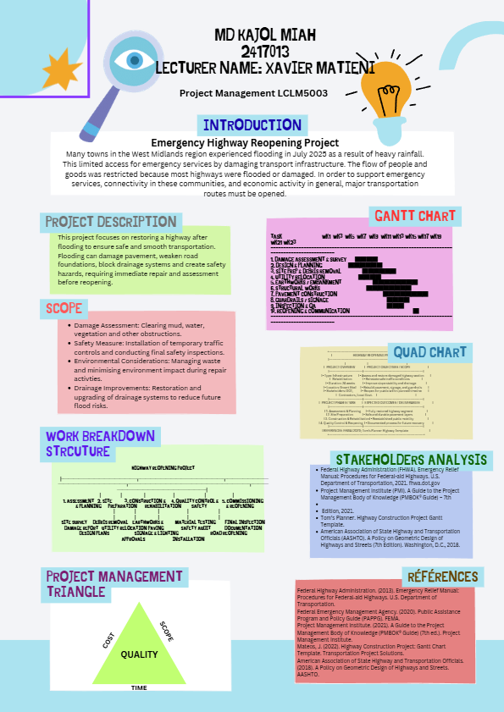
Reflection
The poster presentation about the Emergency Highway Reopening Project gave useful feedback from both the teacher and other students, pointing out both strengths and weaknesses. People thought the project idea was relevant, realistic, and clearly connected to the flooding in the West Midlands. People also liked the way the poster was laid out, with sections like scope, work breakdown structure (WBS), and Gantt chart. This showed that the person knew how to use important project management tools.
One of the main strengths that was found was how clear the project's goal was. It was thought that the goal of restoring highway connectivity to help emergency services and the economy get back on track was a good one that fit with what people needed in the real world. Also, the use of several project management tools, such as a Gantt chart, quad chart, and stakeholder analysis, showed that the person had a good basic understanding of how to plan a project.
But there were some areas that needed work. First, some parts didn't have as much detail as they could have because of the poster format. For instance, the scope section didn't have clear lines between what was part of the project and what wasn't. Based on this feedback, the final project plan will include a more detailed and organised definition of the scope to avoid confusion and scope creep.
Second, people thought the Gantt chart was too simple. It did show the order of tasks, but it didn't make it clear what tasks depended on each other, how long they would take, or what tasks were most important. In response, the final project plan will have a more detailed and realistic schedule that includes dependencies and timelines to help keep track of and control the project.
Another important point that was made was that stakeholder analysis needs to be more thorough. Even though important stakeholders like local governments and emergency services were named, their roles, interests, and levels of influence were not fully explained. The final submission will be better because it will include a more thorough analysis of stakeholders, including strategies for getting them involved.

The poster also said that risk analysis was missing or not fully developed. Because of the nature of the project, risks like more flooding, lack of resources, and safety hazards are very important. So, the final project management plan will include a full risk assessment with plans for how to deal with them.
Lastly, feedback said that there needed to be stronger connections to project management theory and academic sources. The final plan will deal with this by using relevant frameworks like the PMBOK approach and backing up arguments with academic sources.
In conclusion, the feedback has been very helpful and will make the final project management plan much better by adding more detail, critical thinking, and real-world use.

Introduction
As a result of the heavy rains in July 2025, floods occurred in the West Midlands, affecting local infrastructures. The highways, which form an important link for transport, suffered from the effects of the floods because of extensive damage and weakening structures. The importance of the highways for facilitating rescue efforts, business operations, and travel made the closure a serious problem both at the time and in the long run.

In order to solve this problem, the Emergency Highway Reopening Project has been conceived with the objective of reopening a damaged highway that will help in facilitating the delivery of emergency services and will provide benefits for the general population.

Project management concepts and practices have been used in the design of the project. Specifically, the use of project management theories found in various sources, such as the Project Management Body of Knowledge, are important tools that help guide the process of the project. The three constraints of time, cost, and quality (also known as the project management triangle) should be considered when dealing with projects.

As the disaster recovery projects tend to be time-sensitive, it is important for the project to be able to achieve results efficiently without compromising on safety and quality requirements. Hence, both speed and control are key aspects of this project.

Moreover, infrastructure recovery projects come with their own set of challenges that differentiate them from regular projects, mainly because of uncertainties, time pressures, and environmental conditions. In contrast to regular projects, which may have some flexibility regarding time frames, post-disaster projects must be completed promptly while maintaining high levels of safety and adherence to established standards. This adds another layer of difficulty to project management (Nicholas and Steyn, 2020).

Also, the execution of such projects greatly relies on cooperation among different parties, such as governmental agencies, emergency teams, and local communities. Mismanagement during coordination can cause inefficiencies, duplications, and wastage of resources. Hence, utilizing a proper project management strategy is vital for ensuring harmony between all the involved parties (Project Management Institute, 2021).

Project Description
Emergency Highway Reopening Project aims to assess and repair flood-damaged roads to reopen them. In this case, the road must be assessed for structural damage, repaired, and reopened to meet the set standards. Reconstruct damaged carriageway, embankments and drainage to standards that account for projected flood risk and climate change guidance. Maintani safe access for emergency and local traffic during works.
Engage key stakeholders (local councils, environment agency, emergency services, local businesses, residents) through scheduled consultations at each major project stage.

Project Phase 1
The first phase of the project will involve assessing the structural damages on the road surface, sub-base layers, and drainage system. It is important to carry out such an evaluation to identify the need for repairs and allocate the necessary resources.

Project Phase 2
Phase two involves repairing damaged areas using physical labour. Some tasks will include clearing mud, fallen trees, and other debris from the affected highway, reconstructing weak areas, and restoring drainage channels. Lack of adequate drainage facilities is a primary cause of flood-related damage to roads. Safety features must also be considered in the process of repair. For example, proper traffic control must be put in place during the repair to ensure worker and public safety. Upon completion of the repair work, thorough tests must be conducted before the highway is reopened to the public.

It is important to note that the project is extremely time-bound as failure to reopen the highway would have severe economic and social implications.
A factor to consider in this project is resilience. It is important that the main aim of reopening the highway is achieved; however, it will also be essential to ensure that any repair done minimizes the chances of future problems with the road. This could be through better drainage systems or strengthening the road as much as possible. In the case of flood prevention, it goes beyond the current scope of the project but incorporating some elements of resilience in the process will help to increase its sustainability (Environment Agency, 2023).

It is also critical for the project to be executed while considering various constraints like time, money, and quality. In relation to the project management triangle, increasing one constraint affects the other two (Kerzner, 2022). For instance, speeding up the project timeline will result in an increase in expenses due to extra manpower among other reasons.

Scope
It is vital for one to define the boundaries of their project so that everyone involved is on the same page regarding what the project should produce. This also prevents scope creep, which could result in delays and cost escalation.

In Scope
The project involves all those tasks required for the restoration of the highway into an operational state. They include:

- Assessment of damages caused
- Removal of any debris or flood water present at the site
- Reconstruction and repair work on road surfaces that are damaged
- Improvement of drainage systems
- Temporary traffic control measures
- Final inspection before opening the highway to traffic
- Detailed damage assessment and geotechnical surveys.
- Integration of improved flood pathways and sustainable drainage features where feasible.
- Traffic management, diversions and temporary access for emergency vehicles.
- Carriageway reconstruction, drainage upgrades and embankment stabilisation on flooded sections.
These tasks have a clear relationship with the objectives of the project.

Out of Scope
This project does not involve any task which is not relevant for the timely opening of the highway. Some of these are:

- The reconstruction of adjacent housing complexes and businesses
- The construction of any additional infrastructure or alternative routes
- The building of facilities for flood protection, such as a dam
- Long-term regional flood defence schemes outside the highway corridor.
- Private property reinstatement.

The restriction of the scope ensures that only relevant tasks are undertaken by the project team.

Scope Management
Scope management requires constant surveillance and control to ensure the project stays on track with its goals. All changes to the scope should go through a proper evaluation process to avoid unwanted enlargement.
Effective management of scope also includes the adoption of an effective change control procedure. Any change within the project scope should be assessed regarding its effect on project time, costs, and quality. In the absence of change control procedures, there would be scope creep, and the project will become subject to failure (Meredith, Mantel and Shafer, 2019).

Secondly, it is also important to document the scope of work for the sake of making sure that everyone involved understands project deliverables. Mismatched interests among stakeholders are quite typical of infrastructure projects.

Work Breakdown Structure

The project is broken down into work packages using the Work Breakdown Structure allowing it to easily be planned and controlled.
- Project Initiation
- Confirm funding and governance
- Appoint project team and key suppliers
- Kick-off meeting and stakeholder mapping
- Assessment Phase
- Visit site
- Assess damages
- Determine risks/hazards
- Planning Phase
- Schedule project
- Provide resources
- Estimate costs
- Construction Phase
- Procurement of contractions and materials
- Traffic management planning
- Environmental management plan
- Construction works
- Carriageway reconstruction
- Drainage and culvert upgrades
- Embankment stabilisation
- Road markings, barriers and signage
- Execution Phase
- Clear debris/puddles
- Patch road
- Restore drainage
- Monitoring and Control
- Monitor Progress
- Control quality
- Risk management
- Closure Phase
- Final inspection
- Gain approvals
- Reopen highway
The application of the Work Breakdown Structure further promotes accountability in the project team. The task can be assigned to particular people or groups of people, thus making it easy to assess their performance and note any delays in the process. This correlates with the responsibility assignment principle, which is crucial for efficient project management (Project Management Institute, 2021).

Nevertheless, one should keep in mind the disadvantages of using the Work Breakdown Structure. Though this tool works well in planning and structuring a project, it fails to demonstrate the dependencies and timeframes of individual tasks. This means that the Work Breakdown Structure should be accompanied by other tools like the Gantt chart (Nicholas and Steyn, 2020).

Quad Chart
This chart can be used in governance meetings to ensure stakeholders can quickly understand status and make decisions.

Objectives | Schedule
- Reopen flood-damaged highway safely  - Restore transport connectivity  - Support emergency services and economic recovery | - Total duration: 6–8 weeks  - Week 1: Assessment & planning  - Weeks 2–5: Repairs  - Week 6: Testing  - Weeks 7–8: Reopening
Costs | Risks
-Labour costs (engineers, workers)  - Materials (asphalt, concrete)  - Equipment and machinery  - Contingency budget (10–15%) | - Bad weather delays  - Material shortages  - Health & safety risks  - Budget overruns

Gantt Chart
Task | Week 1 | Week 2 | Week 3 | Week 4 | Week 5 | Week 6 | Week 7
Damage Assessment
Project Planning
Debris Removal
Road Repairs
Drainage Restoration
Quality Testing
Final Inspection
Reopening

Task dependencies are critical. For example, repair work cannot begin until the assessment phase is complete. The Gantt chart helps ensure that tasks are completed in the correct sequence and within the allocated time.

Stakeholders’ Involvement
The stakeholders will greatly influence the success of the project. Their effective engagement is important because it leads to cooperation and support.

Key Stakeholders:
- Local Government Authorities: Funding and Approvals
- Emergency Services: Reliant on the highway for their operation
- Construction Work Force: Execution of the Project
- Local Communities: Impacted by the road closure
- Environmental Organizations: Regulator Compliance
- Utility providers affected by road access constraints
- Contractors, consultants and suppliers
- Local businesses and residents

Analysis of Stakeholders
The stakeholders could be divided according to their level of interest and influence:
- Influential and Interested: Local government agencies
- Interested but Not Influential: Local communities
- Influential but not Interested: Regulating authorities

Strategies for Engagement
- Provide regular feedback
- Community consultation
- Work with emergency services

However, failure in managing stakeholders can cause huge risks in the project. For instance, a project may face resistance from local people for not engaging them effectively. Similarly, failure in coordinating with emergency services may disrupt operations in emergencies. Hence, stakeholder management involves more than communication; it also requires meeting their requirements and expectations (Bourne, 2015).

Moreover, the power of stakeholders can vary at different stages of the project. For example, local government officials may hold maximum power during planning activities, whereas construction teams gain maximum power during implementation activities.

Allocation of Resources

Optimum resource management is essential to ensure the successful completion of the project.
Human Resources
- Project manager, assistant PM
- Design team (highways, drainage, geotechnical)
- Civil engineers
- Construction staff: construction manager and site manager
- Health and Safety officer, environmental specialists

Material Resources
- Construction material like (aggregates, asphalt, drainage pipes, geotextiles)
- Mechanized equipment
- Plant and equipment (excavators, rollers, and pavers)
Financial Resources
- Funding from local government bodies
- Contingency funds for risk and inflation

Effective use of these resources will result in successful project delivery. Resource allocation will be monitored, and capacity will be adjusted if delays or additional work arises. Resource allocation should also be efficient and productive. Resource overallocation results in excessive expenditure, whereas resource under allocation might create a lag in production. The project manager must thus find the right balance to maximize efficiency in resource utilization (Kerzner, 2022).

The other factor that the project manager should consider is the availability of labour. There will be an increased demand for labour in post-disaster situations, causing a shortage. It is vital to plan and arrange supply contracts before such an occurrence.

Risk Analysis

Risk management plays a crucial role in infrastructure projects, particularly in post-disaster situations.
Risks Involved
- Weather problems: Could cause delays in construction
- Lack of materials: May interfere with the process
- Safety hazards: Possible injuries during the process
- Over-budgeting: Additional unforeseen costs for repairs
Risk Management Solutions
- Plan for contingencies
- Employ various suppliers
- Maintain high safety standards
- Control costs efficiently

In addition to assessing and controlling risks, one must also prioritize risks by considering their probability and potential impacts. Qualitative risk assessment may prove useful here, whereby risks are prioritized according to those that demand immediate action (Project Management Institute, 2021).

Furthermore, all risks cannot be eradicated, and some degree of uncertainty is always present. Thus, contingency planning becomes imperative in dealing with any unpredicted occurrences. For instance, creating contingency reserves and allowing buffer times can address any unplanned delays (Hillson, 2017).

Conclusion
Emergency Highway Reopening Project is one of the most important initiatives which is meant to help restore the damaged infrastructure because of flooding in the West Midlands area. In this case, the project is managed using proper project management approaches.

The use of project management techniques, such as work breakdown structure, stakeholders’ analysis and risk management, shows how theoretical knowledge can be used in practice. Not only do these techniques make projects more efficient, but they also enable organizations to cope with problems and challenges that might occur.

Even though the project is oriented towards short-term relief, there is recognition of the need for future projects to adopt flood prevention techniques, among other aspects of project management and sustainability.

From the above analysis, it is evident that proper project management is crucial in dealing with challenging situations encountered in real life. Project managers should apply project management knowledge, skills, and tools effectively to create solutions to problems.

References
- Project Management Institute (2021) A Guide to the Project Management Body of Knowledge (PMBOK Guide). 7th edn. Newtown Square, PA: PMI.

- Kerzner, H. (2022) Project Management: A Systems Approach to Planning, Scheduling, and Controlling. 13th edn. Hoboken: Wiley.

- Meredith, J.R., Mantel, S.J. and Shafer, S.M. (2019) Project Management: A Managerial Approach. 10th edn. Hoboken: Wiley.

- Nicholas, J.M. and Steyn, H. (2020) Project Management for Engineering, Business and Technology. 6th edn. London: Routledge.

- Bourne, L. (2015) Stakeholder Relationship Management. 2nd edn. Farnham: Gower.

- Eskerod, P. and Jepsen, A.L. (2016) Project Stakeholder Management. 2nd edn. London: Routledge.

- Hillson, D. (2017) The Risk Management Handbook. London: Kogan Page.

- Environment Agency (2023) Flood and Coastal Risk Management Report. Available at: https://www.gov.uk

