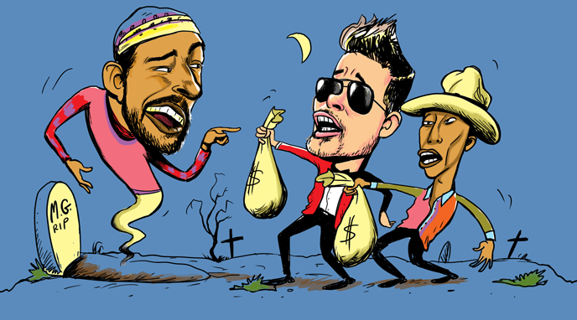

Blurred Lines of Copyright
In 2013, Robin Thicke and Pharrell Williams co-produced the run-away hit single “Blurred Lines,” earning them over $16 million in sales and streaming revenues. The music video has been viewed hundreds of millions of times on YouTube and Vevo, and has been parodied numerous times as well. Despite its popularity, the similarity of “Blurred Lines” to Marvin Gaye’s 1977 hit song “Got to Give It Up” sparked controversy. The family of artist Marvin Gaye was outraged; they believed Gaye’s work was stolen. Thicke filed a preemptive lawsuit to prevent the Gaye family from claiming any share of royalties. However, Thicke also stated in public interviews that he was influenced by Marvin Gaye and, specifically, “Got to Give It Up” when he co-composed “Blurred Lines” with Williams.
In response, the Gaye family sued Williams and Thicke. Contradictions were apparent in Thicke’s account. In an interview with GQ, he stated that he co-wrote “Blurred Lines.” But in court he claimed that he was too high in the studio, and that Williams had in fact composed the song, and he had lied earlier in order to get credit. Williams claimed that, although Gaye’s music had influenced him in his youth, he did not copy Gaye’s song in his composition.
In March 2015, the jury ruled in favor of the Gaye estate, stating that while Williams and Thicke did not directly copy “Got to Give It Up,” there was enough of a similar “feel” to warrant copyright infringement. Gaye’s heirs were awarded $7.4 million in damages, the largest amount ever granted in a music copyright case.
While many commentators agreed with this verdict, others were concerned that it could negatively affect song writing within an entire genre. Musicologist Robert Fink, for example, stated that this verdict had the potential to set a precedent for “fencing off our shared heritage of sounds, grooves, vibes, tunes, and feels.” Musicians, artists, and writers often note that previous works influence them in their creative process, and that there is very little that is completely original. Thicke and Williams did not see the musical influence of Gaye as copyright infringement, but rather as inspiration that spurred them to create a new, original single.

Discussion Questions
1. Do you think the Gaye family should own the rights to the “feel” of “Got to Give It Up” in addition to specific lyrics, melodies, harmony, etc.? Why or why not?
2. What distinctions can you identify among sampling, appropriating, and stealing components of a song?
3. This court case is one among many over the past decade that have placed limits on song-writing and musical composition. Do you think it is important to provide these legal protections for artists even if it means hindering artistic creativity and the new works that might come from musical influence? Explain your reasoning.
4. Should authors, musicians, and other artists acknowledge all of the influences on their work, regardless of the degree of influence? Why or why not?
5. If you purchase a song and then recognize that it is appropriating an earlier work, you are not legally obligated to stop listening, but are you obligated ethically? Explain your reasoning..

