Intercultural Competence Report

Student name: Andreea Cristina Mirica
Student ID number: 2211629
Foreign Languages and Cultural Awareness BMIH5003
Lecturer: Lisa Bassler
Word count (reflections): 1000 words (+ - 10%).

Executive Summary
The aim of this report is to analyse the cultural setting and structure of customer services. The selected country for the evaluation is Spain and the organisation is Diversity Hotel & Spa. The company is looking forward to introducing its hospitality services in Spain. Therefore, this report covers the relevant information about the cultural and customer beliefs in Spain. This will be helpful for the hotel to manage the services according to Spain. Moreover, it will be effective in managing a good market positioning by recognizing the customer needs and requirements.

Table of Contents
Executive Summary 2
Introduction 4
Cultural overview 4
Country analysis 5
Importance of cultural intelligence and Sensitivity for Hotel Industry 6
Conclusion 7
Recommendations 8
REFERENCES 9

Introduction

The capacity to recognise and understand one another's cultural obstacles is referred to as intercultural competences. The critical success of any multinational or multicultural activity depends on intercultural abilities. The essential elements of intercultural competencies are attitude, knowledge, skills, and both internal and external outcomes. (2020, Li). This report is based on the five-star Diversity Hotel & Spa in London, United Kingdom (Wang, Yang, and Chen, 2023). The general manager is scheduled to visit the recently opened hotel in Spain as part of the hotel chain's recent international expansion. This report will provide a study of Spain's country analysis and cultural overview.

Cultural overview
Cultural and customs overview
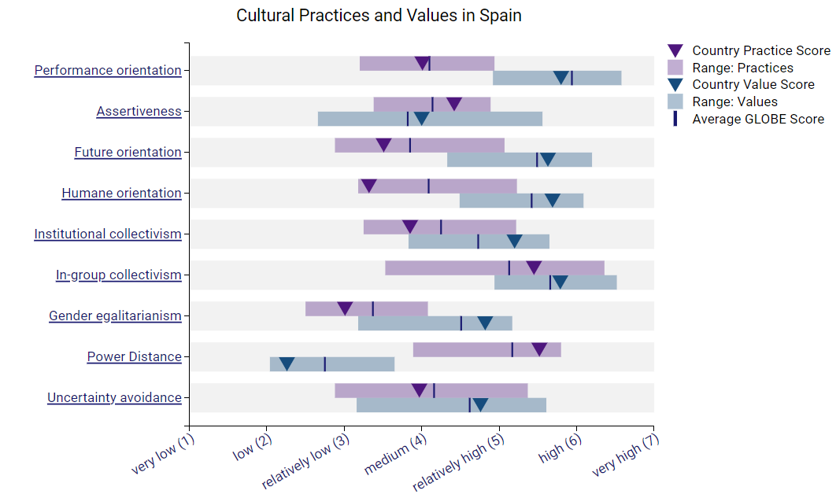
People in Spain have a friendly, lively culture and are vocal, devoted, and passionate. The country's western heritage has a strong influence on its culture. Spanish-speaking people love their surroundings and live life to the fullest. Furthermore, corporate cultures have a strong hierarchical structure. Business etiquette, business communication, and student placements are the hallmarks of Spanish business culture. In the globe, Spain has the most pubs and restaurants per capita. In Spain, around 95% of the population is Catholic, with the remaining 5% being Muslims (Gosling, 2023). When entering any particular location, people say hello to one another. When meeting someone, Spanish people make a lot of motions with their hands and faces. Compared to other cultures, maintaining eye contact is valued and kept. Furthermore, compared to other nations, Spanish lunch and dinnertimes are later. One of Spain's most well-known customs is siesta (Sevillano-Monje et al., 2023).

Country analysis
A national analysis is a diagnostic technique that gives general managers a way to comprehend the business environment in Spain by learning accurate cultural knowledge. The management of the company can use a pepper analysis of the nation to help them make decisions about their future commercial operations. The GLOBE Project is regarded as one of the best resources for giving managers accurate insights into foreign markets, such as Spain.
GLOBE project
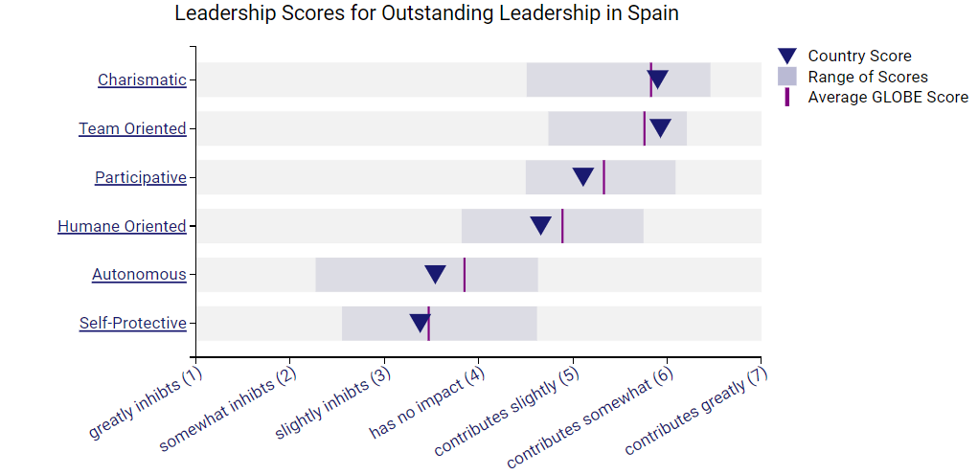
- The Global Leadership Organisational Behaviour Effectiveness Project gives managers a perspective that helps them function more effectively in a global setting. Two distinct dimensions—humane orientation and performance orientation—are identified in this paradigm. By using this model, the general managers of Diversity Hotel & Spa will be better able to understand Spanish culture.
- Humane orientation: This dimension indicates how much members value and promote being amiable, selfless, just, and giving to others. To ensure that the new business operations run successfully, the general manager of Diversity Hotel & Spa must be amiable, reasonable, and considerate in the direction of the associates and human capital of the new hotel in Spain (Bauer, 2020) (Arnold et.al., 2021). Offering monetary and non-monetary rewards can help managers get constructive feedback from staff members towards the company's objective.
- Performance orientation: This GLOBE project dimension shows how much recognition and encouragement are given to exceptional performance, high standards, and inventiveness. To encourage performance gains, it would be crucial for the general manager of Diversity Hotel & Spa to make investments in employee training and development. Providing the training that staff members need in areas such as housekeeping, financial accounting, kitchen, front desk, marketing, retailing, human resources, and the cuisine sector. Additionally, one of the most crucial aspects of operating in order to carry out activities in Spain would be to provide training and information about the customs and values of Spain (Jackson, 2014).

Importance of cultural intelligence and sensitivity for hotel industry
The Diversity Hotel & Spa would benefit from cultural sensitivity and intelligence as it promotes employee and customer comfort and increases guest satisfaction, retention, and repeat business (Klyukanov, 2020). The Diversity Hotel & Spa's human resources must embrace Spanish culture, values, and communication techniques (Deale, and Lee, 2021). Additionally, in order to add value for the staff, general managers must prioritise honouring their values and beliefs.

Conclusion
According to the analysis of the mentioned report, company managers must have a solid understanding of the cultures of the various nations in order to seize any expectations for future operations. Before entering the market, managers must conduct a thorough nation analysis with the aid of the GLOBE Project. Managers can learn about the two primary dimensions—human orientation and performance orientation—by utilising the GLOBE initiative. Many recommendations pertaining to the county analysis are included in the report's conclusion.

Recommendations

- The general manager must concentrate on carrying out their business operations in line with client demands.
- To conduct an accurate cultural analysis, the GLOBE project and its two primary dimensions—humane and performance orientation—must be utilised.
- In order to provide value for their consumers, businesses should train and develop their staff about the many departments inside the company as well as the values, beliefs, and interests of their clients (Leitão et al., 2022).
- For good success and growth in the new business climate, every new business should be employee- and customer-centered.

REFERENCES

Arnold, M., Jung, S., Fischer, H., Philippe, S., Radelet, V., Chevallier, P.C., Efstathiou, A., Boukas, N. and Sourouklis, C., 2021, September. Evaluation of user experiences in an immersive role play for cross-institutional and cross-national virtual collaborative learning in hospitality management. In International Conference on Interactive Collaborative Learning (pp. 602-613). Cham: Springer International Publishing.
Bauer, U., 2020. Intercultural competencies and cultural standards in international hospitality. In The Routledge Companion to International Hospitality Management (pp. 93-105). Routledge.
Deale, C.S. and Lee, S.H., 2021. An exploratory study of hospitality and tourism stakeholders’ perceptions of professional etiquette. Journal of Hospitality & Tourism Education, 33(1), pp.43-56.
GLOBE Project (2023) Results globe project, GLOBE Project. Available at: https://globeproject.com/results?page_id=country (Accessed: 12 November 2023).
Gosling, M., 2023. Enhancing Cultural Intelligence Through International Hospitality Internships. Journal of Hospitality & Tourism Education, pp.1-11.
Jackson, J. (2014) Introducing language and Intercultural Communication. London: Routledge.
Klyukanov, I., 2020. Principles of intercultural communication. Routledge.
Leitão, J.C.C. et al. (2022) [PDF] the effect of cultural orientations on country innovation ... Available at: https://www.semanticscholar.org/paper/The-Effect-of-Cultural-Orientations-on-Country-Escand%C3%B3n-Barbosa-Ram%C3%ADrez/078a895576468a5e1839e6c6f9bb65e0c11e1f7d (Accessed: 10 November 2023).
Sevillano-Monje, V., Martín-Gutiérrez, Á. and León-Sánchez, M., 2023. Comparative analysis of intercultural education from the perspective of management teams. The case of Spain and France. Croatian Journal of Education: Hrvatski časopis za odgoj i obrazovanje, 25(2), pp.701-735.
Wang, M.J., Yang, L.Z. and Chen, T.L., 2023. The effectiveness of ICT-enhanced learning on raising intercultural competencies and class interaction in a hospitality course. Interactive Learning Environments, 31(2), pp.994-1006.

