Student number:1600787 word count:1915
Choose either one building or one object and explain its significance and importance within Islamic art and archaeology? - Dome of the Rock
The Dome of the Rock, located in Jerusalem, stands out from the surrounding buildings in one of the oldest and most well-known cities in the world. The Dome of the Rock has undergone many significant changes and transference of ownership throughout its long history. Few buildings in the world hold equal significance to the Dome of the Rock, as it is an important site to the Jewish and Islamic people, and in earlier times, the Romans. It was constructed under the Umayyad period in 690-1 during the rule of Abd al-Malik 685-705 AD, seized and converted by crusaders, and then retaken by Muslims. The most radical change to the building since then is arguably the now golden-anodised dome put in place during the 16th century under the Ottoman, which draws the eyes of all who view the city
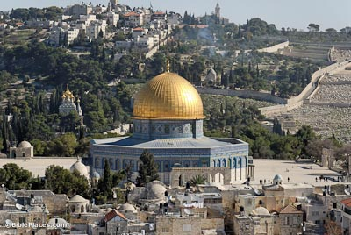 figure 1
The significance of the Dome of the Rock, is illustrated by its central location in the old centre of Jerusalem. The location of this building also holds significance as it is perhaps the third most important building in Islamic architecture behind Mecca and the Kaaba This building holds significance in Islam as it was the first building to incorporate elements of structural and decorative measures to such an extent, which can clearly be seen in the building’s decoration. In Islam it is thought that this was the site where the prophet ascended to heaven and is also why the dome is located there, as it signifies mount Moriah. It is due to this that the site is arguably the third most important in the Islamic world, not only for its’ religious significance but also for the designs and methods that have been incorporated into the history of this building.
The significance of the buildings that were constructed under the Umayyad dynasty and especially under the reign of Abd al-malik was that the Muslims introduced urbanisation into agricultural areas. This was done according to the creation treaties applied in places such as Syria and Palestine; this meant that Muslims were unable to settle cities, although abandoned property or state land fell outside of these treaties. This would also partly explain why the Dome of the Rock is situated in its current location. However, due to the religious significance and meaning behind the location of the Rock, this is unlikely to be the case, due to the building being located in the old section of Jerusalem.
Other possible reasons exist for why the Dome is located in Jerusalem include Ibn al-Zubayr a rival caliph during the second fitna, had made Mecca his base during the conflict with Abdul al-Malik and he wanted to convert Palestine into the new pilgrimage centre. Therefore this further added to the importance of the Dome’s location, creation and grandeur. As Muslim historian al-Muqaddasi wrote, the Dome was constructed specifically to rival those of Christian design. Another possible theory is that is the rock in the centre of the dome is where the prophet Mohammed ascended to heaven. Both reasons are plausible for the location of the Dome when viewed from historical and religious perspectives. However, the second reason is more plausible as the dome construction began in 690, as Ibn al-Zubayr is thought to have been killed around this time. However, texts which would provide evidence for the exact purpose of the Dome’s chosen location for construction remains unknown due to the first writings being Abbasid in origin and anti umayyad

The Dome has a great significance in terms of Islamic architecture. It is more than just a spectacular feat of design, but took it’s specific size and shape as it was originally build to cover the Qibla. However, the smaller domes of earlier mosques in other areas were made larger to encompass a greater area of the building themselves. The original Dome of the Rock smaller dome may have been positioned to cover the burial area of the founder’s body. Ultimately, the domes have been expanded to occupy a central position on the building. This change was made over time and now serves a greater function of helping to illuminate the imam and his central position in the mosque.it also illuminates the surrounding walls to highlight the scripture of the Mosque which will be further considered later in this essay.

The domes of Islam also hold a greater religious purpose than one might think. In Islam, domes represent the vault of heaven. In the dome of the Rock, the dome also symbolizes heaven but it is here combined with the cosmological tree, growing down and throughout the dome’s architecture to embrace all of the building. Below is an image depicting the tree taken from the interior of Dome of the Rock. The tree was decorated in this way to continue the symbolism communicating how Heaven mirrors the earth. Because of this decoration and the dome, it makes it significant to Islamic art and architecture as it is one of many examples throughout the Islamic world that depicts the principle of reversibility. It might not be the best example but to a non-Muslim, it is easier to show the visual conception of this concept by using Dome of the Rock as it helps to show the idea and notions behind the faith. The present dome is visually different in its form to its original predecessors as it replaced smaller and different versions of itself, it was the first of its kind to have a large dome that served to illuminate the mosque, the interior of the dome being covered with jewels taken from royalty.

Figure. 2
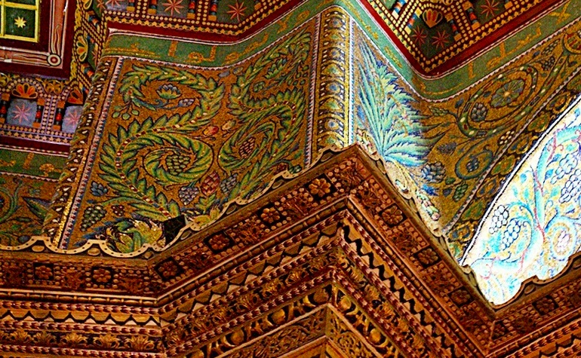Decoration and mosaic
As mentioned above the Dome has a vegetal design, representing the tree and paradise, but it is also decorated with jewels, which are not uniform in their appearance but sited and in a specific position in the dome. The jewels are primarily found around the inside of the mosque around “inner face of the octagonal colonnade” (Oleg 1954:47)
This is thought to have been done intentionally as it helps to better illuminate the mosque and to show the interior design more effectively. The jewels are significant because of their effective purpose. They are only used in one part of the mosque, therefore, the purpose they serve of illuminating is vital, especially as they are also not encased or covered in any way(REF). This means that they are not there primarily to be shown off as a power display to the Umayyads who built the dome but they have also been intricately woven into the mosaic of the building.

“it may rather be suggested that these actual crowns, bracelets, and other jewelled ornaments are meant to surround the holy place towards which they face” (Oleg 1973:55) These designs and purposed use of jewels is specific to Islam and therefore significant.
While in other religions stones are used to further add to a building’s grandeur, in this instance they are used to better illuminate and focus the attention of visitors to the site where Mohammed ascended to heaven on his night journey. This unique site is also thought to be where Abraham sacrificed his son to God, thus adding to the importance of Dome of the Rock, not only in Islam but also in Judaism. By using items from Byzantine and Persian empires in their religious building, the greatness of God is emphasised, showing that he is above all others and as this is perhaps the first creation of the Umayyad dynasty where the use of jewels serves a greater purpose than simply being decorative. It also sets the stage for how other Islamic buildings would be decorated later.

Inside the Dome of the Rock there are a number of inscriptions written throughout the building, it is very common in Islam that Arabic scripture is used as a decorative feature. However, in Dome of the Rock there are three surviving Umayyad inscriptions, one measuring at 240 meters, located above the inner arches of the octagonal arcade that are believed to be contemporary with the building. Interestingly, other inscriptions found at the Dome have also been tampered with by Al-ma’mun. This fact further shows the significance of Dome of the Rock, as it was tampered with by another Caliph in the 9th century, to claim or replace its ownership by replacing the name of Abd al-malik. Nevertheless, the main inscription located on the gate has a very unique scripture which seems to be a threat aimed at the other two major religions in Jerusalem, Christianity and Judaism. The scripture calls an invitation to the other faiths to submit and join, also showing the relative position of Jesus and the other significant Christians within Islam.

Oleg Graber wrote “moreover, it must be realised that even those quotations which later became commonplace were used here, if not for the first time, at a time when they had not become standard” (Graber 1973:61) Therefore, beyond the dome, other Islamic buildings around the world have inscriptions that were originally written here, further showing how far Islam has spread. This reflects the rule of the Umayyad dynasty who conquered vast swaths of North Africa and Spain. Thus, the inscriptions are significant to the development of Islamic architecture as it is perhaps the earliest example of this use of scripture around the building or in this size and scale. The Dome of the Rock was the first building created by the Umayyads to have such grandeur and intricate decoration, thus setting it apart from the previous mosques that were constructed. below is a picture showing the inscriptions found at dome of the rock
Figure. 3
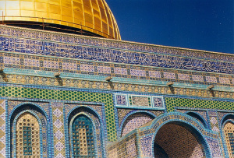

The architecture at Dome of the Rock, both by its creation and nature are significant. The presence of the dome before the changes under the Byzantines shows that it had early significance as does the addition of the gold plating, and the creation of a dome over the third most sacred site in Islam where the prophet ascended to heaven. The Dome rises, mirroring his ascent, and this combined with the jewels taken from the conquered regions in the Islamic conquests and the presence of royal insignia from the Byzantine and Persian kings all add to the splendour Used to illuminate the rock within the centre of the dome, the scripture is significant too as it is rare for this to appear in that manner elsewhere in the Islamic world so openly calling non-believers to pray and to submit to Islam. Moreover, it was at the Dome of the Rock that many of the inscriptions that would later be used far and wide originated here written on the structure. Few buildings compete with the Dome’s significance, it’s striking appearance being the present golden dome and the site contained within the dome being so unusual make the building exquisitely unique to the region.
While other mosques have domes and use inscriptions, none possess the same religious significance as those found at Dome of the Rock where the prophet ascended to heaven, and even less buildings in any religion have importance in the worlds three largest religions. Even if the dome was not capped in gold, contained jewels or the rare inscriptions, the site itself, with it’s unique history would remain.

Bibliography
Ernst j. gruber, James Dickie, Oleg grabar, Elenor sims, Ronald lewcock, Dalu Jones, Guy t. petherbridge ed George michell Architecture of the Islamic world Thames and Hudson London 1978
Graber, Oleg the formation of Islamic art: Yale university United states of America 1973
Grabar, Oleg. “The Umayyad Dome of the Rock in Jerusalem.” Ars Orientalis, vol. 3, 1959, pp. 33–62.
Figure 2
Islamic land marks https://www.islamiclandmarks.com/palestine-masjid-al-aqsa/interior-of-the-dome-of-the-rock 1.1.18
Figure 3
Keren Simon http://www.sacred-destinations.com/israel/jerusalem-dome-of-the-rock/photos/dome-of-the-rock-on-temple-mount-cc-kjs-flickr 1.1.18
Rabbat, Nasser. “The Meaning of the Umayyad Dome of the Rock.” Muqarnas, vol. 6, 1989, pp. 12–21. Rabbat, N. (1989). The Meaning of the Umayyad Dome of the Rock. Muqarnas, 6, 12-21
Figure 1
Zaighum Abbas Ranjha. Islamichistoryand travel.com 10.1.18

Michell1995:235
Michelle 1995:236
Michell1995:235
Graber 1954:38
Graber 1954:36
Rabbat 1989:13
Dickie et al1995:34
Dickie et al 1995:34
Dickie et al 1995:34
Dickie et al 1995:34
Zaighum Abbas Ranjha.
Oleg 1973:58
Oleg 1973:58
Oleg 1973:58
Rabbat 1989:12
keren Simon

