Professional development reflection

For my professional development I had to create a personal pitch. My pitch consisted of a portfolio of photos that showed different film locations in Pembrokeshire and film locations that I would chose to use for my adaption script.
At the start of the module I had to create a c.v and a covering letter this was a skill that I had learnt before but this time I can to make it suited towards the type of job that I wanted to go into after university this meant crating a creative cv demonstrating all my skills within the media industry and my skills with online recourses used inn everyday situations in the job I am aiming for I also had to demonstrate the different types of experience I had already had in the industry this was a bit of a set back as I haven't really had much experience just brief nits here and there . Due to this cv having to be tailored for the types of jobs in the industry I had to cut out a lot of my original cv just keeping relevant information that clients and employers will want to hear to compliment this we had to make a cover letter that went along side my c.v to aid it and to give employer the chance to see what makes you suited for the job before reading your c.v and to get a personal feel of the type of person you are this was quite hard to create as had to keep the information to a minimal and also bring across everything that would be an asset to the type of job I want to go for so even though I had already had a brief overview of this skill it was defiantly developed during the first part of the module

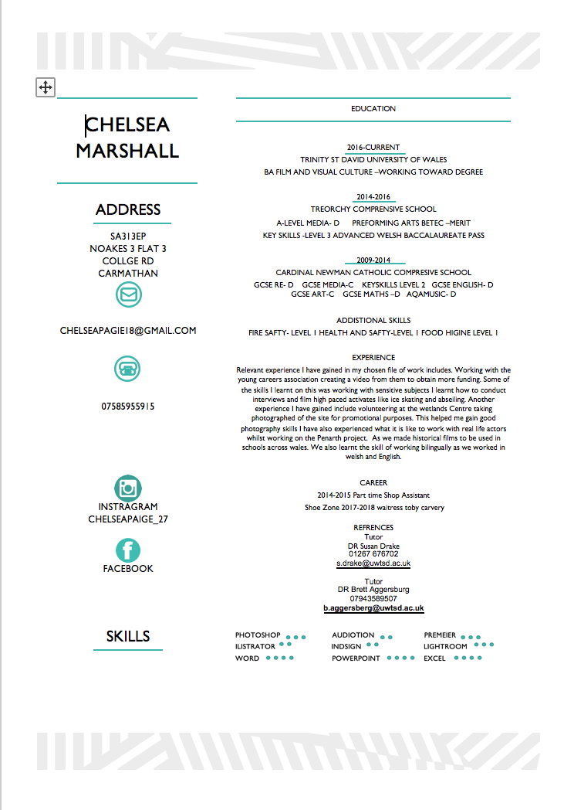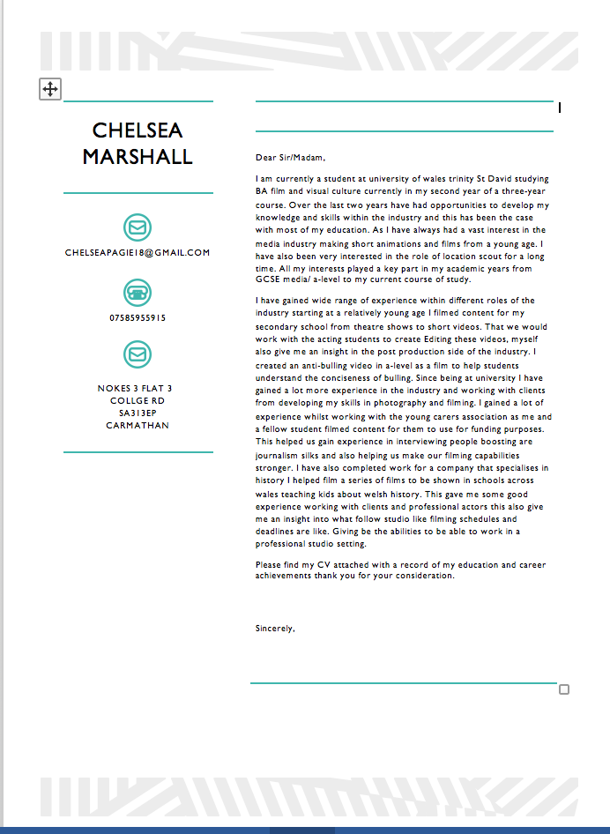

For the second half of the module I had to create a portfolio of photos that show case locations throughout Pembrokeshire at the beginning of this module I had to work closely to my lectures to create an idea that would be suitable for me to under take for my portfolio a few I dead I had to start with we taking photos of local historical places such as local monuments museums we discussed this idea and I was told that it was to similar to my live project module this set me back a bit as I had planed this idea out step my step but It meant that I had to create a different idea when discussing possible other ideas I decided how I have always wanted to work with locations and be a location scout so we came up with the idea of talking phots of locations that have been us for filming I first off suggested about the whole of wales as that gave my such a broad variety of options but this was before I know the amount of locations that have been used for filming in Pembrokeshire that’s when I decided to narrow it down just to this area this give mw the opportunity to pick and focus on a few different locations and the ability to make my photos the best I could as living so close to the areas allowed me to go back and forth to re take photos when needed I started out by researching all the diffident locations within Pembrokeshire looking at what and here things had been filmed I found numerus different locations within miles of each other such a fresh water west where harry potter was filmed, st marloes sands snow white and the huntsman was films at this location, porthgain harbour was used for a scene in their finest kidwelly castle which saw the 80s tv show robin hood and left its outside view to Monty pythons holy grail , fishguard bay was used in filming for Moby dick and milk under wood and Pembrokeshire castle was used in the 2017 film me before you.
I created a pan for myself to be able to take photographs of everything I planed to go out and take photos over the course of three weekends I quickly figured out that the location that I had chosen where hard to get to on public transport so I arranged with my parents to drive me a round so I planed out routes to the different places I got a AA road maps to the locations that I needed to go to

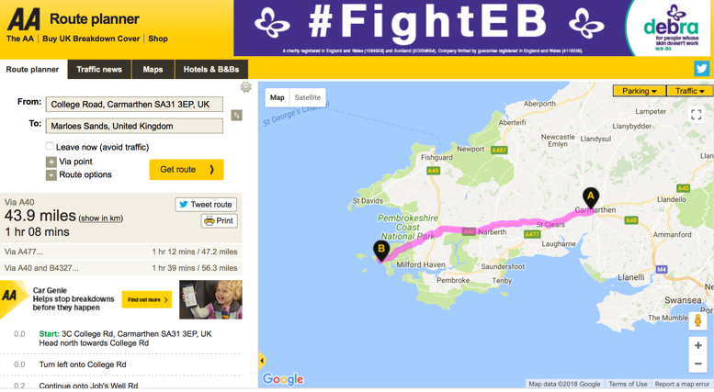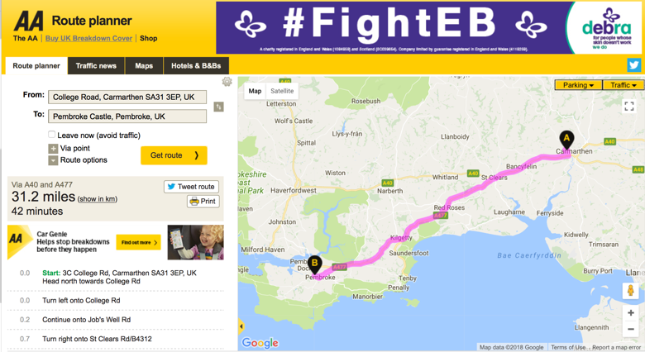
I created a schedule for myself of where I was going to go on each day I decide that on the 8th of April I planed to go to Pembroke castle kidwelly castle and Creswell quay and cresswell arms I spent the day thing photos of theses locations in the cresswell arms the guy who runs the pub had a room dedicated to the film their finest which did a lot of there filming there it was filmed with memorabilia of the film and he told me about they location scouts picked out the pub and the procedures they went through in choosing to use his pub this was a good InSite to how it works within the actual industry and what I would have to do if I got a job as a location scout if I want to use a location.

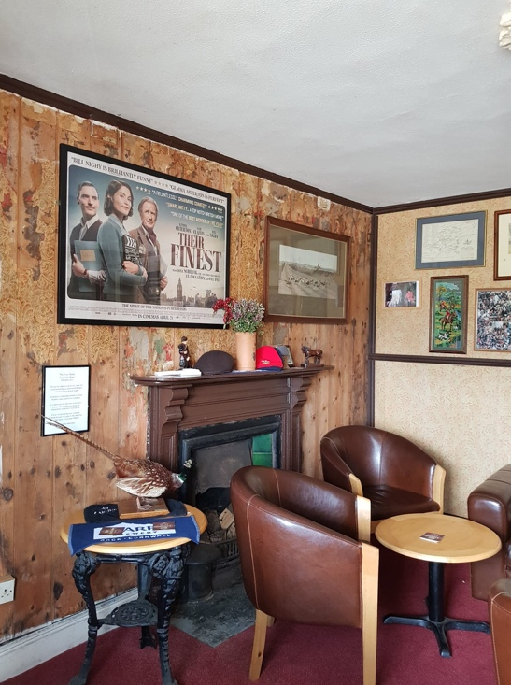
On the 15th I went to porthgain harbour where their finest was also filmed I also went to freshwater west where I actually ran into a location scout for a film company who was taking photos to show the producers of the film what the location looks like I asked him questions about what he actually has to do for his job and how he goes about looking for a location this give me
some skills for the future On my final day of taking photos the 22nd I went to marloes sands where snow white and the huntsman was filmed I took some great photos of the beach from loads of different angles this enhanced my photography skills (me taking photos on the cliff)

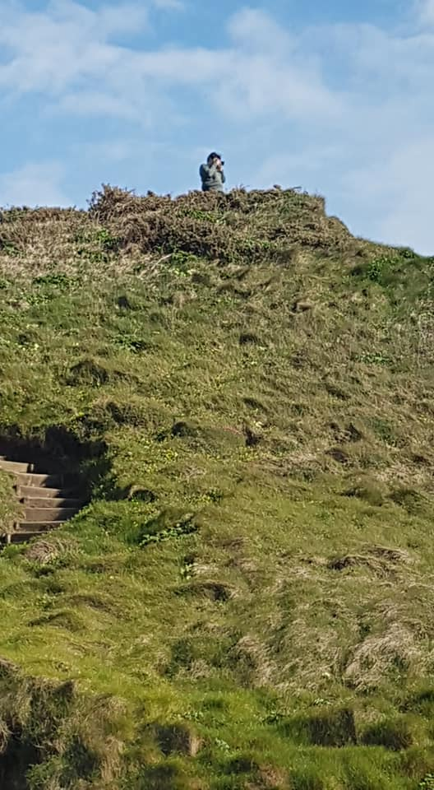
On the first of may I had to go back to marloes sands freshwater west and porthgain harbour to take a few more photos as my first lot went quite as good as I wanted then to be this give me an opportunity to get better photos for my portfolio
On the 3rd of my I went to a lecture meeting with matt where we decided that I would also be a good idea to show case some of my types of locations and to link this to my adaptation script as I could take photos of locations that would work for my script to show how I have developed in my work for my scripted I decide to select a few different diary entries from the book broke girl diaries and create a small sequence this book is about a girl that goes to university and how she got through not having any money and the funny things that happen to her through out the years I was at an advantage with this as I live on campus and was able to use my surroundings as they would be a perfect location for my film anyway On the first of may I had to go back to marloes sands freshwater west and porthgain harbour to take a few more photos as my first lot went quite as good as I wanted then to be this give me an opportunity to get better photos for my portfolio
On the 7th of may I edited my photos and put them in to a portfolio and worked on the presentation of them whilst eating I had to learn some new skills on Photoshop as there was one photo from kidwelly castle that I really wanted to use but there was 2 bars across the photo usually I would not include the photo but I saw this as an opportunity to create some new skills that I could use in a professional setting so I watched a few tutorials and learned how to use the clone tool to stich up the photo and make it match the back ground to get rid of the bars

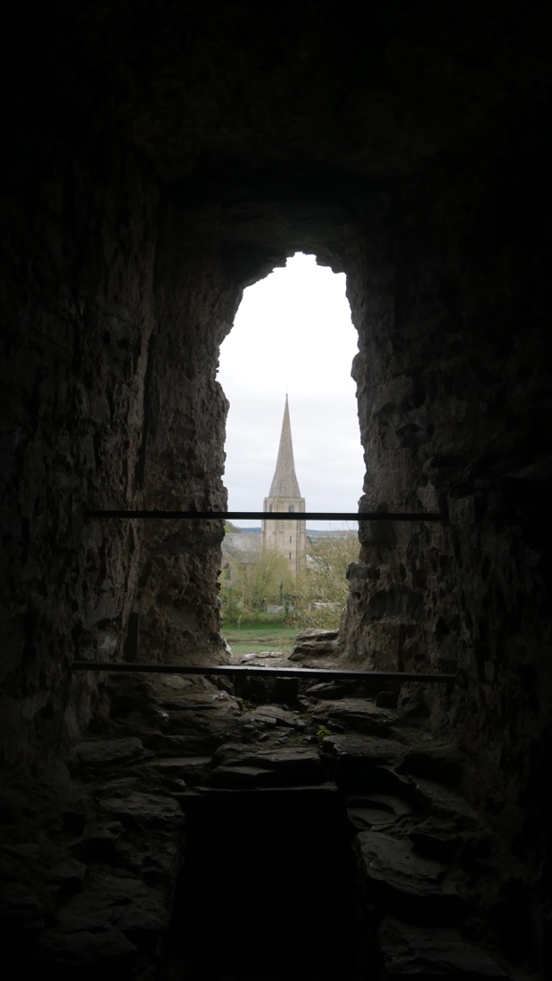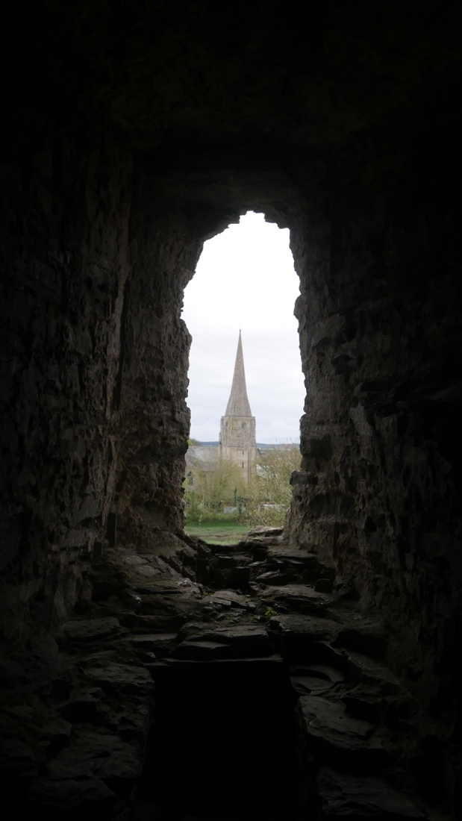

Through this module I have learnt a lot about how to create a portfolio of work to professional standards I have also learnt a lot about how a location scout works and what they have to do to achieve there job and briefly how they work I feel like I gained a lot of skills from new photography skills to new abilities in organisation, time management and team work and also better problem solving skills as a run into a few whilst creating my portfolio some where the fact the everything was so hard to get to without a car I solved that problem by planning days where someone could drive me to the places and another problem I had to face was lack of skills on photoshop so I had to solve that problem by learning how to remove the bars on my photos a few thongs that I would have improved on or would have liked to have done to improve my work would to look at more than one location for my last part of my portfolio that was due to time management as I did not have the time or money to get down to Cardiff over the last week.

