
Advanced Construction and Civil Engineering Technology
Urban Renewal



Jonathan Triggs
1807834

Contents
Part 1 3
Pile and Excavation 3
Site Layout 3
Secant Pile Wall 3
Basement Excavation 3
Excavation Process 4
Waterproofing Measures 5
Floor (-1) 5
Floors (-2 + -3 + -4) 6
Task 2 7
Steel Frame 7
Site Layout 7
Advantages of steel Frame 7
Typical Section 8
Logistics 8
Task 3 9
Cladding 9
Stone Cladding 9
Cladding Construction 9
Roof Covering 10
PVC Membrane 10
Example Section 10
References 11

Part 1

Pile and Excavation

Site Layout
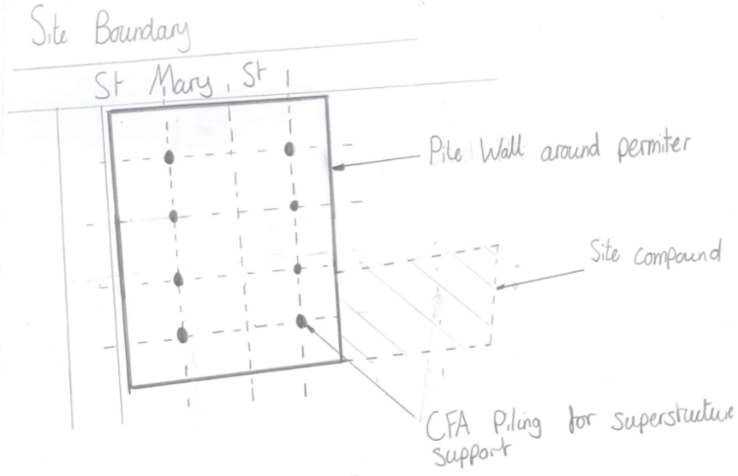
To maximize the space and for it to be an effective design the building can be built tight to the site boundary on St. Mary’s Street and the adjacent sheet. Therefore, then creating a rectangle building leaving a section behind the building for a site compound when construction is taking place this can then be used as an area to receive deliveries and for storage when the building is in use. To able to construct a 4-story basement within proximity to other buildings first a secant pile wall could be constructed along the perimeter of the building to enclose the basement excavation. However, any existing services running through the site must be diverted prior this. Once the secant pile wall has been constructed around the perimeter of the building the process of CFA (Continuous flight auger) Piling can be used to insert structurally sound piles inside of the perimeter with pile caps as a stable foundation and aid the superstructure works. As shown in figure 1:
Figure 1 Site Overview

Secant Pile Wall
A Secant Piled Wall is a retaining wall built prior to excavation for ground retention. The wall is built by alternating primary (female) and secondary (male) piles, with the secondary piles cutting into either side of the primary piles to form a continuous impervious structure. There is minimal vibration and noise, as well as the ability to fit complex site boundaries and maximize land use. Secant piling can also pass-through underground obstacles such as steel, heavily reinforced concrete, granite, and masonry while avoiding the risk of construction-induced settlements to neighboring structures. This makes it ideal for St, Mary’s Street with it being so tight to surround structures and busy streets.

Basement Excavation
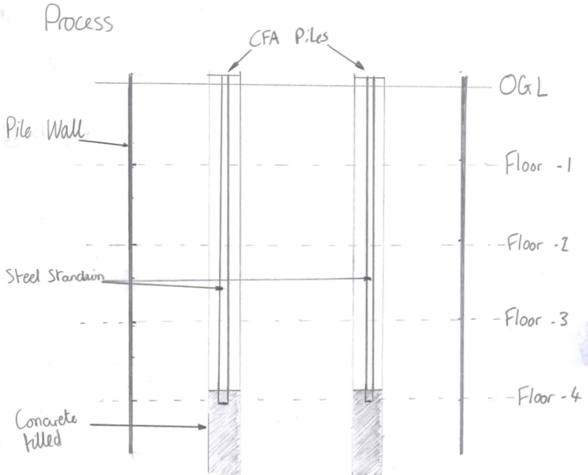
Once the secant pile wall and internal CFA piles are complete, excavation can begin on the basement. The use of sheet piles allows us to dig down within their perimeter as they hold back any material that could potentially fall if you were just to excavate without support. This is because the piles forming the secant pile wall are tight therefore leaving no gaps between. CFA pilling allows us to pump concrete through a central borehole while we are digging. The bottom of the bore hole can be filled with concrete just extruding the formation level to allow future works to be constructed off them. As well as this a steel station would be pushed through the bore hole and used as temporary vertical supports for the basement floors and the stanchions can then be concreted into the permanent structure once the dig is low enough. This is illustrated in figure 2.
Figure 2 Basement Excavation Section

Excavation Process
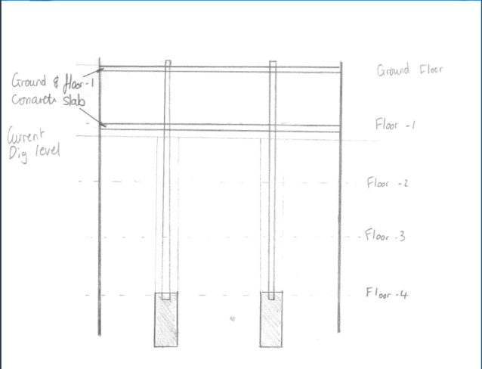
Once the piling work is finished excavation can begin. Excavation extents will be limited to the pile wall permitter. Firstly, the ground floor of the building can be constructed once the ground has been dug deep enough. Once the ground floor is constructed this supports the lateral forces on the pile wall making it safe to continue digging deeper. Then once the ground is dug down deep enough t floor -1 the safe process of building the floor can begin. This then again supports the pile wall lateral forces deeper down allowing us to keep working through the floors. This process can then be repeated until all the required floors are built. As shown in figure 3.

Figure 3 Excavation Process

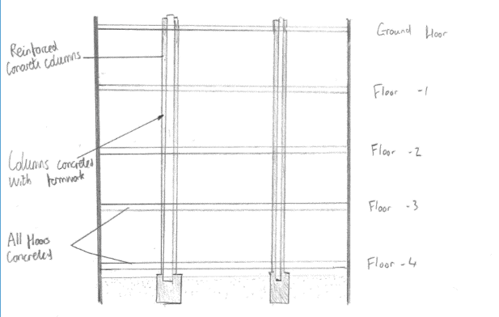
Once all the required floors are dug and their corresponding floors and walls have been constructed formwork can then be erected on the steel stanchions. Surround the steel stanchions with concrete then creates a permanent pile column support for the superstructure of the building.
Figure 4 Basement Remedials

Waterproofing Measures

Floor (-1)

Due to the first under ground floor being used as a gymnasium/spa this mans that it will need to meet the requirements of grade 3 according to BS 8102:2009. This means that no penetration or dampness is permitted within the floor. To conform with this standard a ‘Type A’ method from BS 8102:2009 can be used meaning using a tanking waterproof membrane to line the whole of the basement, allowing no water through. To do this a waterproof membrane is laid on stop of the concrete structural concrete floor and against the structural concrete wall that sits flush with the pile wall. These membranes are then overlapped to ensure no gaps and then a concrete floor can then be placed on top of the membrane keeping it in place. This can then also be done on the walls by constructing a blockwork wall to hold the membrane in place. The second layer of concrete floor and the blockwork wall should then be kept dry and away from the damp this then allows any finishes to be places on top them. This is illustrated in figure 5 below:
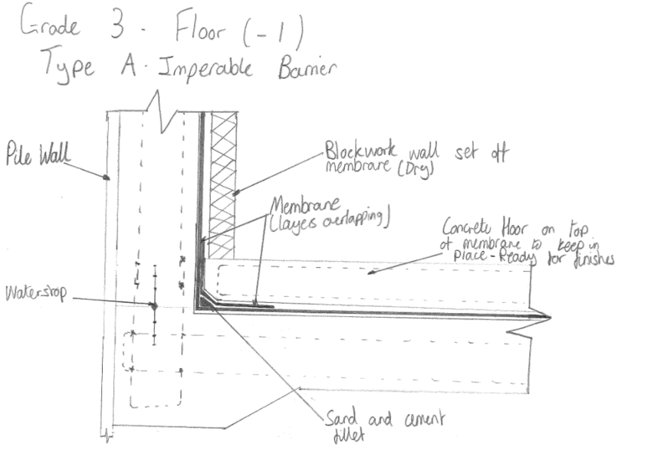

Figure 5 Grade 3 - Type A

Floors (-2 + -3 + -4)

As the three floors below the first underground floor being used as a car park this means that the waterproof grade, they need to conform to in line with BS 8102:2009 I grade 1. This means that some seepage and dampness is permitted. To conform to this grade a ‘type B’ method can be used in line with BS 8102:2009. Type B means the use of monolithic concrete to create a water-resistant member around the basement cavity. Firstly, a blinding layer is formed to allow a clean working surface for the concrete to be poured on. Then once the formwork is erected the steel reinforcement bar can be put in place. Ensuring that starter bars are left extruding from the pour to tie in with the wall sections. Aswell as the steel reinforcement a PVC water stop is inserted centrally along all the wall and floor joints to stop the water from travelling. Once all these steps have been complete the concrete can then be poured. If required extra additives can be used to make the concrete have a higher water resistance, this all depends on how damp the conditions are. This can be seen in figure 6 below:
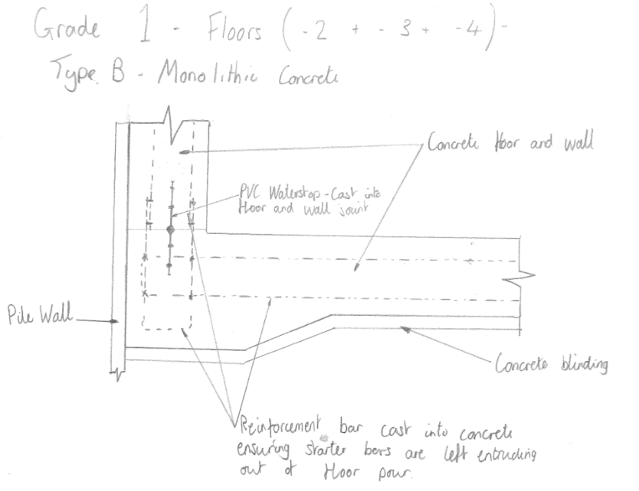

Figure 6 Grade 1 - Type B

Task 2

Steel Frame

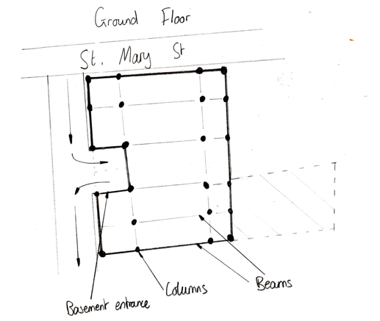
Site Layout
Figure 7 Steel Structure Overview
As shown in figure 7 steel frame would be an appropriate method for the construction of this building. This involves a series of columns and beams in a gid that suite the internal spaces of the proposed building. The columns can sit on the structurally sound pile caps and then can be pieced together floor by floor with beams and columns to create the structure.

Advantages of steel Frame
As steel has such high strength properties this allows a lot of versatility with the design of the building. Firstly, due to steel being strong this allows for longer lengths of spans across the building. Longer spans allow for larger internal spaces which allows the building to be versatile in its uses. As a result of this reduction in material use, material shipping costs, labor costs, and the design of foundations and other structural supports are reduced.
The steel is prefabricated, meaning that it is created off site in a to the site-specific needs. This means that it can be delivered when it is required, allowing for more room within the construction site as it won’t take up any storage space that could be used for other elements of the building. With it being created off site also allows for higher quality of work as it is made in a controlled environment. This also means there is no need for temporary formwork, which must be assembled and then dismantled, delaying construction and creating waste.
The erection of the steel frame is a quick method of building. This Is because the bulk of the structural elements are made so there is no curing time required for these elements. The steel just had to relate to bolt connects which takes little labor.
Using steel is also a sustainable method due to the steel being manufactured off site it can accurately fabricated meaning that waste is kept as little as possible. However even steel that has been fabricated can be reused for various other uses. Steel can also be recycled because it can be melted down and made into another shape for different uses. This applies to the waste in off-site fabrication but as well as this when the building comes to the end of its life cycle all the steel from the structure can be taken out and melted down for use in another project.

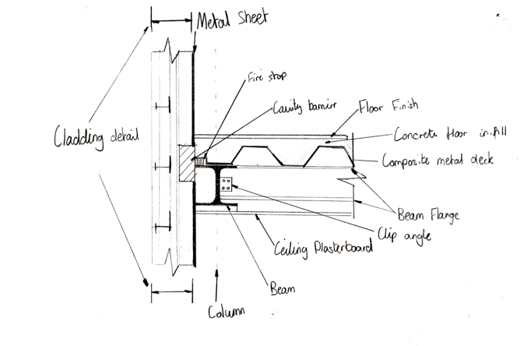
Typical Section
Figure 8 Typical Section
Figure 8 shows a typical section through a column and beam connection with the internal floor structure. Firstly, the cladding detail can be found in figure 9 in the following section. To join the beams and columns a clip angle can be used, which is a quick and effective method of joining steel as it doesn’t required skilled welders and is just a case of putting in place the prefabricated steel and connecting them up. Sitting on top of the beams is a composite steel sheet this supports the gap between the columns and beams. Using a composite steel sheet is an effective way of creating floors as there is no need for separate formwork as the steel sheet supports the concrete sitting on top of it and can reman there permanently. Once the concrete has cured the floor finishes can then be placed on top. The ceiling can then be plaster boarded for the floor underneath when ready.

Logistics
The steel itself will require a crane to lift each beam and column into place. A suitable crane would need to be specific that considers the surrounding infrastructure as well as the weight that is required to lift. This crane can be set up internally on the site offset from the building so that it can stay there during the whole project until all steel is in place.

Task 3

Cladding

Stone Cladding
The use of a stone cladding system is an aesthetically effective design that suites the surround buildings of St. Mary’s Street. Using stone sits to create an illusion of the entire building being made from stone works makes the structure look grand and suitably fits the surrounding area of one of Cardiff’s main streets. Also due to the restraints of the construction site with it being directly on the main street of Cardiff and there be little room to store materials. Using stone cladding along with prefabricated steel supports and purlins is an effective solution as it is an easy method sealing the outer envelope and required little storage space. This method of construction also has a minimal construction time.

Cladding Construction
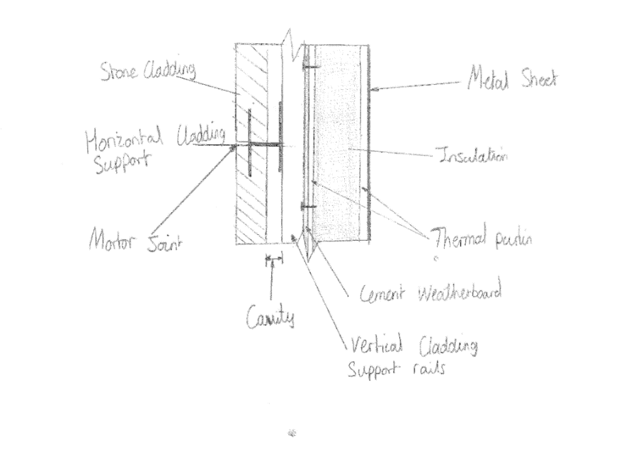
The stone cladding slits itself will fix into a series of metal support rails. These slits need to be appropriately spaced to allow for a motor joints which seals gaps and gives a realistic illusion. This involves horizontal supports that the slits fix onto at the top and bottom of each slit. The horizontal support rails then fix onto vertical rails. This ensures that there is a cavity between cladding and internal makeup of the wall. This contributes to keeping the internal envelope of the building sealed as there isn’t material for water to travel to. The vertical restraints are then placed onto cement weatherboard panels which further contribute to sealing the building. The prefabricated thermal purlins are then placed next to the cement weather boards. The thermal purlins are prefabricated with holes to reduce their thermal conductivity. These purlins are then filled with suitable thermal mineral wool insulation to contribute to the building’s thermal capacity. The vertical support rails are steel fixed the purlins which then also holds the cement weather board in place and holed the whole structure together. The steel purlins will be placed onto the structural columns of the building. The columns split the building up into manageable sections to construct.
Figure 9 Cladding Detail

Roof Covering

PVC Membrane

PVC is a popular roofing material due to its extreme durability. It's a long-lasting option because of its durability, which makes it cost-effective. PVC roofing must be sealed at the seams because it is rolled onto the roof. Unlike other roofs, which frequently use tape, adhesive, or caulk on the seams, this is accomplished using a heat welding method. These materials do not form permanent seams and may cause leaking roof seams to be watertight and permanent thanks to the welding process. With secure seams, you won't have to worry about roof leaks. Seams are frequently the source of damaging leaks on other types of flat roof materials. The watertight design is especially useful on flat or low-sloped roofs. Water tends to collect on these types of roofs. Pooling water is not an issue with a properly installed PVC roof membranes are resistant to tearing and punctures, which are common issues with flat roof materials.
Another advantage is that it is resistant to fire. This can keep your building from catching fire if something falls from the roof and ignites other materials. PVC is extremely difficult to ignite. If it does catch fire, it burns slowly, which can reduce building damage. PVC membrane roofing, unlike other flat roof options, requires little maintenance. The low maintenance requirements of a PVC roof also contribute to its cost-effectiveness. You don't need to hire a roofing company on a regular basis to address common commercial roofing issues. You also don't have to invest in additional materials to repair roof damage on a regular basis.

Example Section
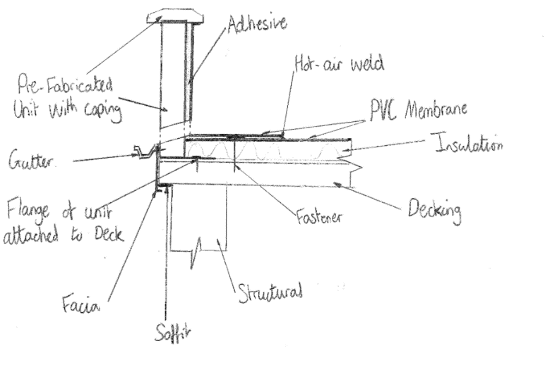
This section illustrates the PVC roof membrane and where it ties into the front of the building. The PVC membrane is stuck down with adhesive which then sits on top of the insulation layer. Every PVC membrane sheet overlaps which is then hot air welded together to ensure a water tight connection. A prefabricated parapet unit is to sit on the edge of the roof. This parapet is then attached to the decking with connections so that it is stable. The parapets have drainage holes situated along them this allows for any gathering water on top of the roof to run into a guttering system external to the building. This will then bring the storm water down to the ground and into the drainage systems.

Figure 10 Roof Section

References
There are no sources in the current document.

