Supporting Pupil Progress: a detailed analysis of one child’s holistic development, with justification for the next steps in learning. WC: 4616

The purpose of this essay is to give an analysis of one pupil’s learning over several areas of development and to show understanding of how to move their learning forward. This research has taken place in an English-medium primary school situated to the North-West of Swansea. It has approximately four hundred and fifty pupils with around twenty percent Free School Meals; this is above the Wales national average. The percentage of pupils on School Action or School Action Plus is well above the Wales average, however the percentage of pupils with English as an Additional Language is a lot lower than Wales or the local authority. The proportion of Ethnic Minority Status is less than ten percent.
There is a two-class entry for the reception year group and this particular class has twenty-eight pupils. The boy/girl split is almost even with just two more boys than girls.
The learner who is the focus of this research is five years old, one of the oldest in the class and lives with two parents and an older brother, who attends the local comprehensive school. He is exposed to lots of experiences by his parents, and mum does a lot of reading and other educational activities with him as well.

Data collection:
The qualitative methods (Mack et al., 2005) of collecting the relevant data have been used due to their suitability for collecting perspectives from young children, enabling children to have a voice and some autonomy over the research they are involved in.
The Mosaic Approach was devised, based on the Reggio Emilia concept of the child as a competent, capable, socially constructed individual with the right to be listened to (Clark, A. 2007; Edwards et al. 1998). It was first utilised in London with pre-school children by Clark and Moss (2011) when devising inclusive research tools in order to elicit the opinions of very young children. This approach also acknowledges that children have a unique perception of their own lives, utilising their natural tendency towards actively making meaning out of life, to build a picture alongside the viewpoints of adults. However, it has been argued that underlying power relationships are essentially still upheld despite the efforts to implement these participatory, child-led techniques, (Cooke and Kothari, 2001). It was important that this point was seriously considered when carrying out this research, to ensure that I as researcher did not lead the child to express views and opinions not of their own making. Nevertheless, the main advantage of this approach is the flexibility to use any number of data collection methods and triangulate results to achieve a full picture of the participants ideas while guarding against any bias and ensure factual validity and reliability (Bell, 2010). The mosaic approach can be tailor-made to the capabilities of the ‘subjects’ too. As such the methods I chose to employ for this research were photographs, separate pupil and teacher informal interviews and non-participant observation.
There are strengths and limitations to each of these although the use of all these data collection methods together help mitigate the limitations. Interviews can be long-winded, dry and difficult for young children to access in order to give their viewpoints and therefore I ensured that the interview focused on the pupil’s interests. Keeping the interviews as informal as possible helped keep the situation relaxed, comfortable and accessible to all parties with the hope of eliciting honest, open answers. Gaining the teacher’s viewpoint on the pupil’s learning is vital as she has a full overview from having educated him since September. She was able to provide information about where he started in his learning journey in Reception, and his progression since then and predict his outcomes for the end of the year.
The reason for using non-participant, as opposed to participant observation, was from a practical viewpoint, in that I was able to observe the pupil on several occasions as part of other activities we were doing; this could be seen as promoting the power relationship between teacher and pupil but on the other hand, because he was involved in a particular activity he was not so aware of being formally observed and so It was easier to get a view of what he would do naturally, (Greig et. al.,2013).
Ethics:
Throughout this research, consideration was given to the well-being of the pupil and their rights as a child as stated in the UNCRC (UNICEF, 2015), in Article 12 and 13; that the child has the right to have their opinion listened to and to express those opinions through any medium.
This study also abides by BERA (2018) guidelines to guarantee participant and school anonymity and confidentiality. Safeguarding, consent and assent procedures were adhered to prior to and throughout the research process. The school’s general consent form covers the observation and collection of data for individual pupils.

Pupil Analysis - analysis of five areas of learning:
I have used Nottingham’s, (2013) ASK model as an evaluation tool when analysing the pupil’s learning; using the three areas that Nottingham recognised as key to understanding how children learn to learn; namely Attitudes, Skills and Knowledge to determine where the pupil is at with their learning holistically. Each of these three areas are defined in more depth by Nottingham (2013), which aids in their use as an appraisal tool. Attitudes encompasses positive outlooks, manners, and mind-sets. A key one, which has arisen from this research is that of resilience and will be discussed further at a later point. This area goes along with Dweck’s (2015) notion of growth mindset; explicitly using all learning experiences, whether positive or negative to help the pupil to become better at what they can do and not hiding knowledge gaps from them. Indeed, Bates (2016), suggests that one should accept all mistakes and use them as a learning opportunity. Listening to the learners to understand what their barriers and perceived limitations are is key to scaffolding their learning experience (Hattie, 2012).
Skills are identified as the wider skills of communication, physical, intellectual and social acts rather than the proficiencies expected as part of the curriculum. Knowledge is concerned with all the facts and concepts the child has a grasp of and are able to interact with confidently. In Bloom’s taxonomy, (Bloom, 1956) knowledge is the foundation of his classification pyramid on which all other learning is acquired and constructed. Both new knowledge and prior knowledge.

Language, Literacy and Communication:
Attitudes: By triangulating the results from the pupil and teacher interviews along with my own observations it would appear that the pupil’s preferences of activities are colouring and reading. During our discussion, the pupil’s attitude to books, literacy and language was positive and focused as he spoke animatedly when referring to all the books he has and specific books he likes. He told me that he has ‘tons of books’ in the house. The reading scheme used in the school is Alphablocks, Bug Club and Pupil X is reading ‘The Van’ currently. He sounds out individual letters and blends them to make a word, and he is able to segment unusual words, such as ‘revs’ and ‘begins’ into parts too.
We looked at his own Toy Story book together too. When asked about who the characters are, he said, “I don’t know the names”, but he pointed at Woody and said, “he is the hero, he has genius plans.” He therefore has an understanding of the language he hears and an awareness of storylines. Pointing at another picture of Woody he said, “he has an evil looking face”. This appears to be indicative of his ability to identify different facial expressions. This was tested further using some emotion flashcards (Appendix B), this will be discussed later under Well-being and Emotional development.
Skills and Knowledge: His command of language is at a high level for his age, he is able to articulate his words clearly and make himself understood, without the need to repeat himself. His sentences are well-structured. This is indicative of someone who considers what they are saying beforehand. He understands how to structure his sentences, although his knowledge of the mechanics behind the grammar he is using may not be developed yet. However, contrary to this assertion, a study has shown that even toddlers understand the grammatical structure of sentences (Melina, 2011) and use this knowledge to make sense of spoken language. Bandura (1977, cited in Gray and MacBlain, 2012) asserts that meaningful learning comes from imitation of and identification with appropriate role-models; this could be an explanation for Pupil X’s advanced language skills as he is exposed to mostly adult-type conversations at home.
During literacy sessions, learning about phonics and practicing segmenting and blending words, it was documented that he was able to perform those skills and identify real and fake words as a result (Appendix E). His writing is phonically plausible, and he can construct his words with the knowledge he has of the sounds for the individual phonemes. The majority of his writing practice to date has been through shared and modelled writing (Appendices H and I).

Mathematical Development:
Attitudes and skills: When observing pupil X working in his focus group, he has a tendency to sit slumped in the chair; needing to be brought back to focus on the task at hand. This may have something to do with a lack of physical engagement in the activity; in Nottingham’s (2013) Thinking acronym E.D.U.C.E.R.E, where the initial ‘E’ stands for Engaged, physical engagement is defined as body language indicative of being interested in the activity. Mental acts of engagement where an individual is focusing and maintaining concentration links to the physical involvement; Pupil X may be demonstrating that he does not have the maturity to self-regulate this aspect of his learning. When interviewed he added numbers as another learning preference. However, the question was not an open-ended one (see Appendix A) and he may have picked up on the last thing said rather than the range of choices I tried to present to him. From experience I am aware many pupils struggle with sound discrimination, auditory memory and sequencing (DfES, 2007), for this reason it is important to take care when phrasing questions.
Knowledge: When Counting in twos by ordering ‘eyes’ on an alien face, he struggled a little to group them in pairs clearly. From having a slightly haphazard approach in the first session he progressed in the subsequent session the following day; this skill had improved as he used two horizontal parallel rows. Although he was very capable at counting verbally in twos beyond twenty his 1:2 correspondence counting – that of using one number per two items, needed some support to be successful in the first session but by the second session he had no problems with this skill. This indicates that Pupil X is a quick learner and that repetition is a necessary tool to enable that learning and consolidation of skills.
In his work book it is evident to see that he can form his written numbers and order numbers to twenty (appendices J(ii) and K).

Well-Being, Social, Emotional development:
Attitudes: Well-being is intrinsically linked with Emotional development, particularly in being aware of others needs as well as one’s own needs (WG, 2015). Pupil X has a small circle of friends; there are two other children he will play with if they are around, but he has one particular friend he likes to be with and appears to be a bit lost if he is not there. They do everything together, whether it is colouring, role playing, out in the playground or when the children are told to find a partner in P.E.
In an informal interview with the teacher she explained that Pupil X is treated as the baby of the family by his parents, causing him to be less emotionally mature for his age, than some of the other children in the class, evidenced by the fact he likes to be in charge, first in line, and have his own way, sulking and scowling if this does not happen. He needs validation by an adult at various times throughout the day. This points to a lack of a resilient mind-set, taking it personally when he has a knock back.
Skills and Knowledge: There are, according to academics, four key aspects of emotional intelligence or emotional literacy, (Macblain, 2014). Pupil X exhibits a grasp of three of these but needs some work on the fourth, which is, managing emotions. Despite this aspect of emotional immaturity, he is very aware of others’ needs and will often help another pupil with a task, both educationally and also emotionally. He has a caring side to him that enables him to reach out to others if they are upset; having the ability to sympathise with them. He has been observed helping another child put their coat on and also helping another pupil with their cutting out in the creative area. When checking his emotion awareness with flashcards Pupil X was able to identify the basic emotions of sad, happy, tired, but identified alternative negative emotions, such as frustrated and angry, as being sad and alternative positive emotions such as excitement as being happy. It may be that he doesn’t have the vocabulary to express what these emotions are or perhaps the photographs were too similar.

Physical Development:
Attitudes: Pupil X is confident and is aware of his body and what he can do physically. However, being taller than most of the children in class and one of the oldest he can have a tendency to dominate his peers in physical activity, often getting into their personal space in his excitement for the physical activity.
Skills and Knowledge: He is able to manoeuvre himself around his environment with coordination (WG, 2015), his spatial awareness and proprioceptive skills are well developed; he does not bump into things or people. From my observation in the playground at break times, he tends to stay in one area by the basketball hoop. He is able to control the ball with relative ease, throwing it up in the air and catching it the majority of the time and sometimes being able to get the ball through the hoop too, showing a command of his gross-motor skills. During Physical Education classes he is able to move around the gym and the outdoor area within his own space and can carry out instructions. In team games he is keen to be first in the line and has a desire to succeed (Nottingham 2013). He can perform several tasks in sequence when shown once, and can use the apparatus appropriately, such as in a relay race with hoops, balls and cups.
He is able to undress and dress himself with relative ease and gets his clothing on the right way out and shoes on the correct feet, though, typically of this stage of development and particularly in boys, he is not very organised when it comes to putting his clothes tidily after changing.

Knowledge and Understanding of the World:
Attitudes: Pupil X’s attitude to learning about and identifying areas within his environment was positive and enthusiastic. His enthusiastic attitude aids him in his learning as he is more motivated and willing to contribute to the session, than if his outlook was negative.
Skills: Pupil X was able to locate the different areas of the classroom and ably prioritised the photographs according to his preference on a plan of the two rooms that make up the reception classes (see Appendix O) showing that he is aware of his immediate environment. The plan elicited questions from Pupil X with regards to wanting clarification of various items, he knew what he wanted to find out and knew the questions to ask to achieve that. He is able to communicate his thoughts and ideas about his preferences regarding his environment.
Knowledge: As evidenced by his work, (appendix M (i) and N) his knowledge and understanding of ordering and sequencing, is being learned through science related topics that generate interest in the pupil. He shows he can sequence the cycle of a chick in the correct order, he also could place the planets in order of size and then in order from the sun once he had been given the information he needed. This shows that he can synthesise the knowledge he has, utilising it in different situations.

Next Steps:
Children should be involved in the process of identifying their current abilities and planning their next learning steps, encouraging them to take ownership of their learning (Kerry, (2015), however, teachers also carry out formative assessment as part of their everyday classroom practice and use this information to decide on the next steps for instruction and learning. If pupil voice is utilised alongside teacher observation and assessment, better goals can be set than had they not elicited this information, (Black and Wiliam, 2006). As such, the following next steps decisions have been taken from pupil observations; red, amber, green assessment ratings of the pupil in particular sessions; teacher assessments and support staff insights. As a teacher it is important for me to have overt high expectations of the pupil, to instil a can-do attitude. I have detailed the next steps for three areas in a different order to the analyses above as I consider that Well-being underpins an ideal learning environment.
Next Steps - Well-being, Emotional and Social Development – resilience: Having looked in more detail at Pupils X’s outcomes in this area, the key focus should be to build up his resilience. Being resilient means to be able to cope and deal with unexpected and stressful situations in an appropriate manner when they arise. This is an important skill to nurture and internalise, as many of those who have difficulty with developing resilience go on to suffer with mental health issues in adult life (Maynard, 2007). Working on resilience will enable him to be more successful across all areas of learning and development. To build resilience means to move the learning focus to how one learns rather than the content of what they are learning, developing coping strategies to enable a progression to success, (Claxton, 2017). Encouraging self-belief through acknowledging successes overtly (Bates, 2016), and building trust, autonomy and initiative (Bouillet, et al., 2014) will aid in developing his resilience; Being aware of their emotions and the impact these have on the way they see the world around them and the way they can use these emotions in positive ways to move learning forward is crucial. This in turn will develop perseverance, but they need to know what helps them to keep trying, what strategies work for them when reasoning things out and visualise where they want to be in terms of the learning situation, (Claxton, 2018). To understand how to develop this trait it is helpful to break down the term resilience into its explanatory parts of self-efficacy (self-belief), persistence and problem-solving capabilities (Blackwell, 2015). Bruner (1961) advocates discovery learning and problem solving as a way to build resilience. Providing different situations for the pupil to interact with, e.g. a Forest Schools approach, and meaningful, engaging tasks which allow the pupil autonomy and control of his environment and learning (Blackwell, 2015) will support this. Blackwell also reports that social or community connectedness builds resilience and that providing situations where pupils need to help one another are beneficial to building self-confidence, awareness of self and others; Pupil X has some grounding in this area already as he is aware of and willing to help others in various situations within the school experience. As part of his next steps this could be supported and extended by grouping him in some activities with pupils who are less able than he and extending his understanding of community and relationships with others. Another strategy that could be employed is Philosophy for Children (P4C). P4C engenders emotional awareness and thinking skills as well as improving attainment in literacy, speaking and listening and maths (Trickey and Topping, 2004).

Next Steps - Mathematical Development - Patterns of number:
To follow on from the need to foster resilience by helping the child build positive relationships, research suggests that there is a need to draw on the pupil’s connections with family and community when teaching mathematical concepts; understanding where the pupil’s knowledge comes from and what experiences they are building from (Turner at al. 2016). It has been found that the most successful mathematical teaching sessions have come from basing the learning around the interests and prior learning within their home community, such as using gardening or the measuring of the football pitch to develop mathematical concepts because of the relevance to the pupil’s hobbies and home life (Taylor, 2012).
Pupil X’s next steps will be looking more at patterns within numbers. This will be done through a familiar topic of the beach; he has experience of the beach already and will be given further familiarity through a class visit to a beach. Initially, relevant and engaging extension activities for counting in twos placed in the continuous provision areas to give opportunities to practice the skill will be beneficial to Pupil X. Then moving on to developing his understanding and knowledge of number bonds to ten through focused group tasks, in order to give him the tools to solve number problems, aiding his progress in mathematical development. For this, specific apparatus, such as dice, can be used both to encourage gross (large foam dice) and fine motor skills (small dice) and also addition of two numbers to equal ten. The number six on each dice would have two stars on as a points reward system to be added up at the end, to again consolidate his understanding of counting in twos. However, Pupil X would be more than capable of learning the skills to be able to manage number bonds to twelve. The pupil can reliably count beyond twenty in ones and twos and so his next step needs to stretch him. The pupil should be given opportunities to count up to thirty and fifty, and a specific focus on 1:1 and 1:2 correspondence (as this is a weakness in his mathematical skill set) will help him move forward at a pace that suits his capabilities. Providing opportunities to find patterns in number will aid Pupil X in his learning and internalisation of number (Haylock and Cockburn, 2008).

Next Steps – Language, Literacy and Communication - reading, phonics blending and segmenting and sentence structures: Just as it is beneficial for pupils to learn mathematical concepts through topics of interest and relevance, so it would benefit Pupil X to maintain the skills he already exhibits in language and literacy and extend those capabilities further through topics that interest him, so that he engages physically and mentally with his learning (Nottingham, 2013). Opportunities to read, through having language rich activities in the continuous and enhanced provision areas, relating to the current and previous topics, will be of benefit to him. Also, focused tasks addressing blending and segmenting of words through the use of phonics, then extending his understanding by using di-graphs and tri-graphs too, so that he can segment difficult or new words more successfully. Pupil X stated that he enjoys the tricky words, it is not certain whether this is to do with the challenge he perceives or to do with the song with a catchy tune that is played during snack time. Clarification of the reason for his interest here would be beneficial to aid in delivering experiences that particularly activate a desire for learning. Activities, such as sorting objects according to a set criterion and ‘pairs’ games and also identification of recorded everyday sounds will help to develop the pupil’s visual and auditory discrimination (Waugh et al. 2016). A Wales produced scheme called POPAT helps with the auditory discrimination of sounds. Encouraging him to look for patterns that will help him recognise and remember more words and will help him with his next step of constructing sentences is crucial too. Sentence building is an important area to focus on for Pupil X, so that he gains an understanding of sentence structures along with the use of capital letters and full stops. This will then enable him to express himself and his ideas through the written word, not just orally. A precursor to the skill of writing in sentences is to be able to form his letters accurately. As evidenced by his workbooks, his writing does not marry up with his capabilities in other areas. He needs more regular practice of writing; some research finds a link between spelling and handwriting, (Waugh et al. 2016). As handwriting develops in a fluent cursive style, there is a likelihood that spelling correctly will come more naturally, as digraphs and shorter tricky words can be learned as one fluid movement. Further to this, more use of scaffolding style teaching devices, such as modelled writing forms and shared writing will enable the pupil to grow within the zone of proximal development that Vygotsky believed is created when an individual is supported by a more knowledgeable other (Bates, 2016). Alongside these strategies it is crucial to provide opportunities to develop his fine-motor control through the use of scissors, drawing and colouring detailed pictures, and threading laces. This will aid him in better pencil control when writing as well as hand-eye coordination, which is beneficial for his physical development too when playing sports with bat and ball.
Questioning can be an effective teaching method for engaging pupils in their own learning, encouraging positive attitudes to learning, increasing their wider skills of communication, and internalising their knowledge of facts and ideas. Questioning can further pupils’ learning through forming collaborations, which are significant and concentrated, (Gershon, 2013).
Linking all new learning to the pupil’s prior knowledge and learning in a gradual process is, according to Ausubel (1978, cited in Bates, 2016), the way to elicit achievement.

Conclusion:
The effectiveness of the mosaic approach comes from its ability to address the imbalance of power between children and adults, although according to Clark, (2005) power is still prevalent, just reversed rather than equalised. However, some of the effectiveness of the approach was minimised due to the short space of time afforded to carry out the research around other tasks to be carried out.
The data collected is just a snapshot of what the pupil can do or is performing currently, children learn at such a rate, especially when taught through repetition, that if I were to gather more data in two weeks, I would most likely be re-evaluating my current analysis of some of his areas of development. However, this was the purpose of using an approach that affords the use of several methods of data collection as mentioned previously. The work that mum does with Pupil X outside of school has a big impact on his academic development and is invaluable to support the work that goes on in school; he has progressed over the course of the year from outcome three to four and is predicted to achieve outcome six by the end of the Foundation Phase.
The experience of carrying out this research has enabled me to reflect more deeply on how a child learns and also the benefits of certain teaching approaches. Furthermore, it has caused reflection on the effectiveness of my own actions as a student-teacher in the learning process of the pupil. I consider that as a result of this research I understand better the necessity for focus tasks and enhanced provision tasks to consolidate and generalise the pupil’s skills and therefore will utilise this as I move forward into the last few weeks of teaching practice and into my NQT year.

REFERENCES:
Bates, B. (2016), ‘Learning Theories Simplified’, Sage, London.
Bell, J. (2010), ‘Doing Your Research Project’, A guide for first-time researchers in education, health and social science, Open University Press, 5th ed., Maidenhead.

Black, P.J. and Wiliam, D. (2006), ‘Inside the black box: Raising standards through classroom assessment’, King's College School of Education, London.
Blackwell, S. (2015), ‘Impacts of Long-Term Forest School Programmes on Children’s Resilience, Confidence and Wellbeing’, https://getchildrenoutdoors.files.wordpress.com/2015/06/impacts-of-long-term-forest-schools-programmes-on-childrens-resilience-confidence-and-wellbeing.pdf accessed on 25.05.19
Bloom, B.S. (1956) ‘Taxonomy of educational objectives: The Classification of Educational Goals’, London: Longman Group Ltd

Bouillet, D., Tea, P.I., Miljević-Ridički, R. (2014), ‘Preschool teachers’ resilience and their readiness for building children's resilience’
Health Education; Bradford Vol. 114, Iss. 6, 435-450.
DOI:10.1108/HE-11-2013-0062 accessed on 26.05.19

British Educational Research Association [BERA] (2018) ‘Ethical Guidelines for Educational Research’, fourth edition, London, https://www.bera.ac.uk/researchers-resources/publications/ethicalguidelines-for-educational-research-2018 , accessed on 15.05.19

Bruner, J. S. (1961). The act of discovery. Harvard Educational Review, vol.31, pp 21-32.

Clark, A. (2005) ‘Ways of Seeing: Using the Mosaic Approach to Listen to Young Children’s Perspectives’, in Clark, A., Kjørholt and Moss, P. (eds.) Beyond Listening. Children’s perspectives on early childhood services. Bristol: Policy Press, pp. 29–49.

Clark, A. (2007), ‘A Hundred Ways of Listening- Gathering Children’s Perspectives of Their Early Childhood Environment’, Young Children, 62(3) pp. 76–81

Clark, A., and Moss, P. (2011). ‘Listening to young children: The mosaic approach’ (Second edition.). London: National Children’s Bureau.

Claxton, G. (2017), ‘Building Learning Power’, https://circleoflifetraining.com/wordpress/wp-content/uploads/2017/12/Building-Learning-Power-Guy-Claxton.pdf accessed on 24.05.19

Claxton, G. (2018), ‘Progression in Learning Habits’, https://www.buildinglearningpower.com/2018/05/progression-in-learning-habits/ accessed on 24.05.19

Cooke, B. and Kothari, U. (2001), ‘Participation: The New Tyranny?’, New York: Zed Books.

Department for Education and Skills (DfES), (2007), ‘Letters and Sounds - Principles and Practice of High-Quality Phonics’, Primary National Strategy, Crown Copyright.

Dweck, C. (2015), ‘Carol Dweck Revisits Growth Mindset’, Education Week, Vol. 35, Issue 05, Pages 20, 24
https://www.stem.org.uk/system/files/community-resources/2016/06/DweckEducationWeek.pdf accessed 29.05.19

Edwards, C.P., Gandini, L., Forman, G.E., (1998), ‘The Hundred Languages of Children: The Reggio Emilia Approach – Advanced Reflections’, 2nd ed., pp263-281, London, JAI Press.

Gershon, M. (2013). ‘How to use Questioning in the Classroom: The Complete Guide’ (The ‘How To...’ Great Classroom Teaching Series Book 5) Kindle ed.

Gray, C. and MacBlain, S. (2012), ‘Learning Theories in Childhood’, London, Sage Publications

Greig, A., Taylor, J., MacKay, T., (2013), ‘Doing Research with Children, A Practical guide’, 3rd Ed. London, Sage Publications LTD.

Hattie, J. (2012), ‘Visible Learning for Teachers’, London, Routledge.

Haylock, D. and Cockburn, A. (2008), ‘Understanding Mathematics for Young Children – A guide for Foundation Stage and Lower Primary Teachers’, London, Sage Publications LTD.
Kerry, T. (2015), ‘Cross-Curricular Teaching in the Primary School – planning and facilitating imaginative lessons’, 2nd Ed. London, Routledge.
Macblain, S. (2014), ‘How Children Learn’, London, Sage Publications LTD.
Mack, N., Woodsong, C., MacQueen, K.M., Guest, G. & Namey, E. (2005), ‘Qualitative Research Methods: A data Collector’s Field Guide’, North Carolina, USA, Family Health International (FHI).
Maynard, T. (2007), ‘Forest schools in Great Britain: an initial exploration’, Contemporary Issues In Early Childhood, vol.,8, no.4, p.330.
Melina, R. (2011), ‘Toddlers Understand Complex Grammar, Study Shows’, https://www.livescience.com/15709-toddlers-understand-complex-grammar.html accessed on 24.05.19

Nottingham, J. (2013) https://www.slideshare.net/jabulani4/develop-ask accessed on 25.05.19

POPAT http://www.popat.co.uk/4cac974e-e096-48f6-b6ae-7a014d92cc09.aspx

Taylor, E. V. (2012). ‘Supporting children’s mathematical understanding: Professional development focused on out-of-school practices’. Journal of Mathematics Teacher Education, 15(1), 271–291

Trickey, S. and Topping, K.J., (2004), ‘Philosophy for Children: A Systematic Review.’, Research Papers in Education, Ed. 19, vol 3, pp363-378

Turner, E., Foote, M., McDuffie, A.R., Bartell, T.G., Stoehr, K.J., Aguirre, J.M. and Drake, C. (2016), ‘Learning to Leverage Children’s Multiple Mathematical Knowledge Bases in Mathematics Instruction’, Journal of Urban Mathematics Education, July, Vol. 9, No. 1, pp. 48–78 ©JUME. http://education.gsu.edu/JUME

UNICEF. (2015). FACT SHEET: A summary of the rights under the Convention on the Rights of the Child. [online] Available at: http://www.unicef.org/crc/files/Rights_overview.pdf [Accessed 19 Mar. 2015].

Waugh, D., Warner, C. and Waugh, R., (2016), ‘Teaching Grammar, Punctuation and Spelling in Primary Schools’, 2nd Ed. London, Sage.

Welsh Government, (2015), ‘Curriculum for Wales – Foundation Phase Framework’, Department for Education and Skills, Cardiff, OGL

Appendix A:

Pupil informal interview:

Q: Why did you choose the reading area to photograph?
A: because you can read books and some of the books are joyful. ...I’ve got loads—tons of books at home.... Oh, and one thing about it - - it’s got a story mountain in it.
Q: What’s a story mountain?
A: you work up to the top to a problem and then come back down and it gets all happy again.
Q: Why did you choose the role play area?
A: because I love it
Q: What do you love about it?
A: It look so fun because you can go in the rocket.
Q: What do you like about Tedi Twt’s cwtch?
A: You can colour.
Q: What do you like about the dark tent?
A: I just love it because it’s dark so I can go to sleep. I’m learning to sleep on my own.
Q: Why did you choose the Interactive board and the Tricky Words?
A: Because you can learn and they are hard, you can paint on the board too.
Q: If you could choose an area to go to first which would you choose?
A: The dark tent.
Q: Is there anything in the dark tent?
A: no
Q: What do you think could be put in the dark tent to help you learn?
A: put colourings in it – a crayon box.
Q: What learning do you do in the writing garden?
A: Colouring.
Q: Do you prefer writing and reading or numberwork?
A: Numbers, because I’m nearly 6!

Further questions:
Q: If I was going to change an area in the classroom which one would you change and what would you want to change it to?
A: The reading corner, because it’s been there a long time. Dinosaur bones and fossils, digging, and what dinosaur bones belong in it.

Appendix B: Emotion flashcards example -
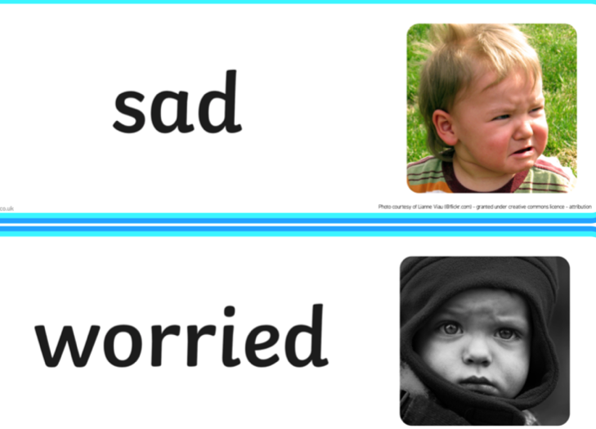

Appendix C:
- Tedi Twt’s cwtch
- Reading area
- The dark tent
- Role play area
- Interactive Board

Appendix D: MD

Appendix E: LLC –
t

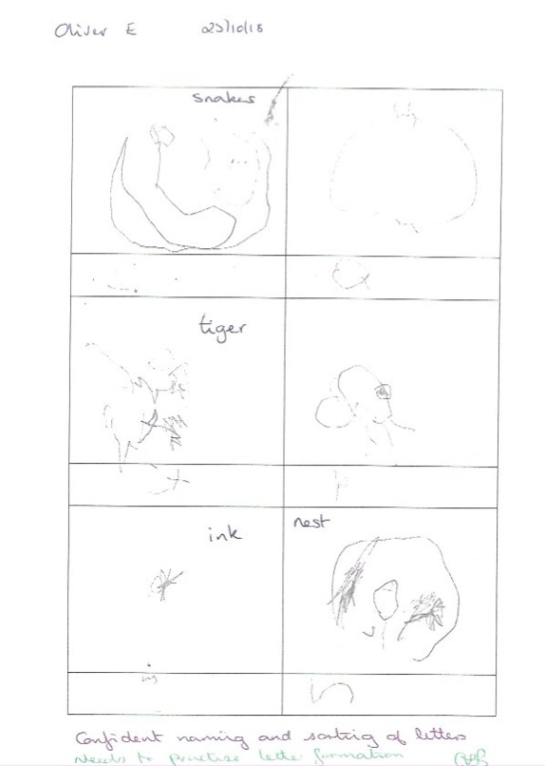
Appendix F: LLC Pupil Work
Appendix G: 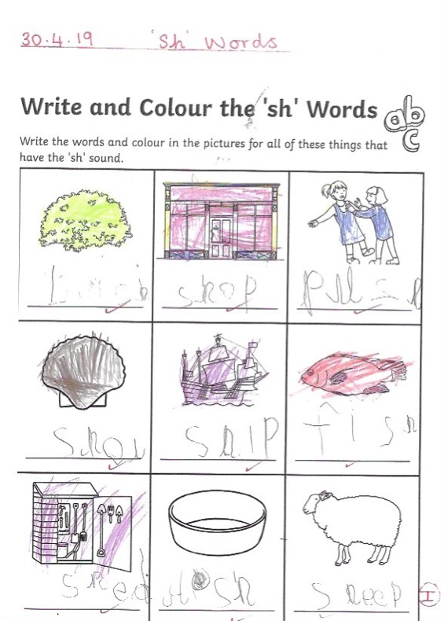

Appendix H:
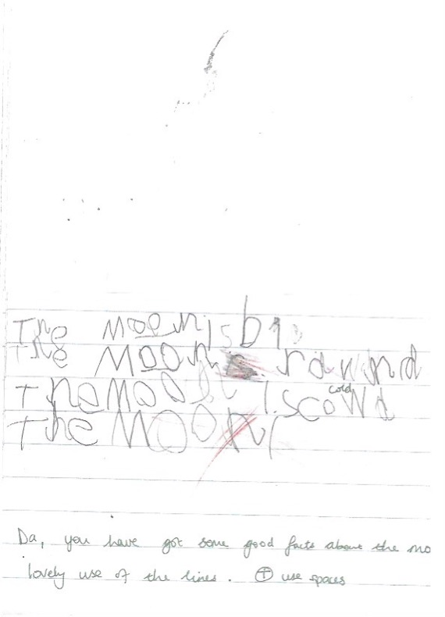
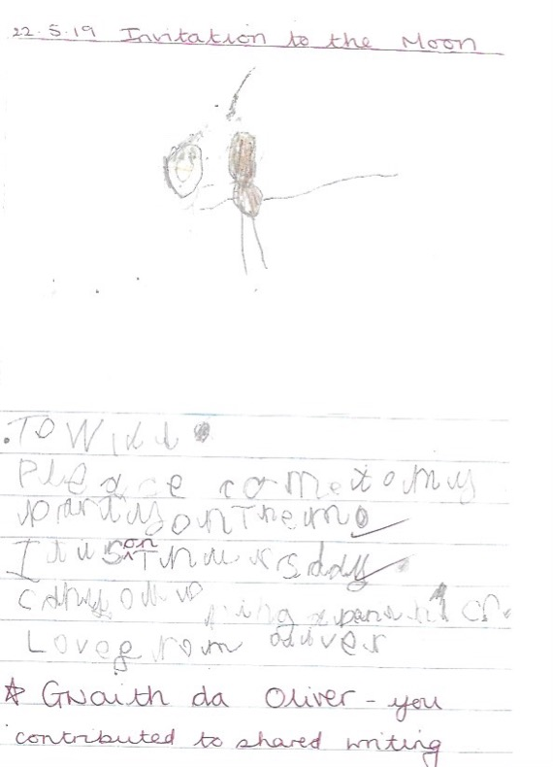
Appendix I:
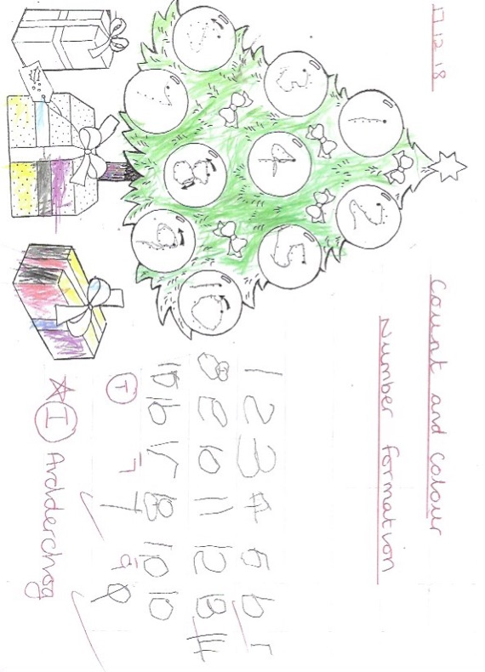
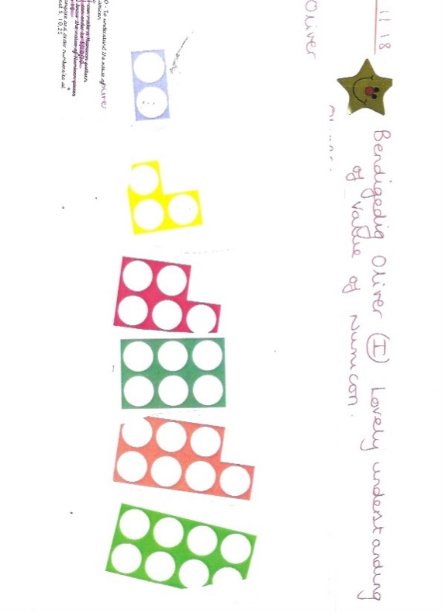
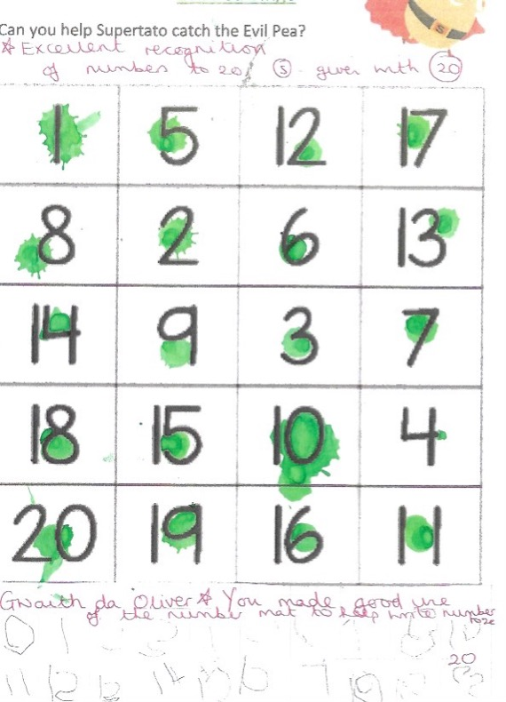
Appendix J (i) and (ii): MD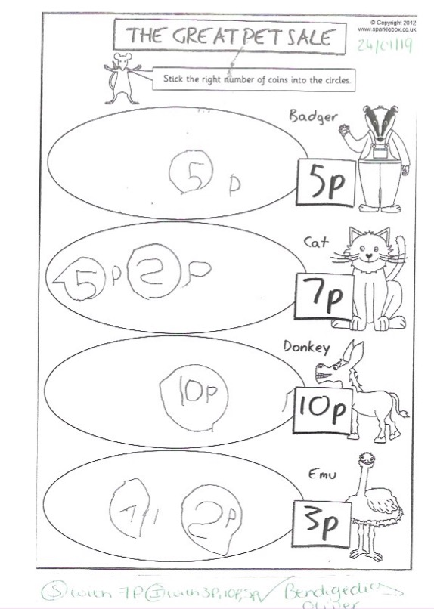
Appendix K:

Appendix L:

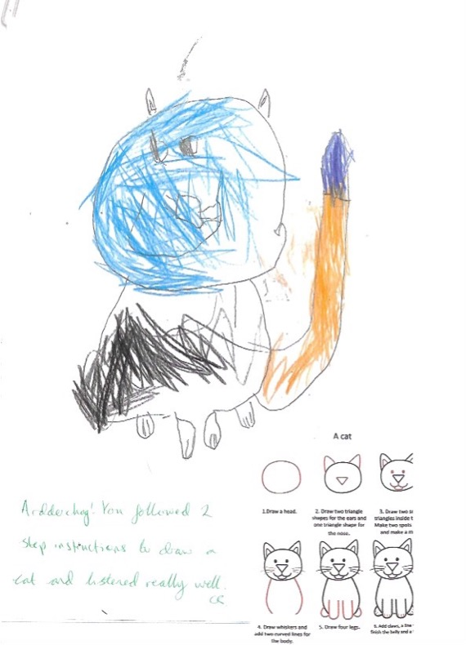
Appendix N: KUW

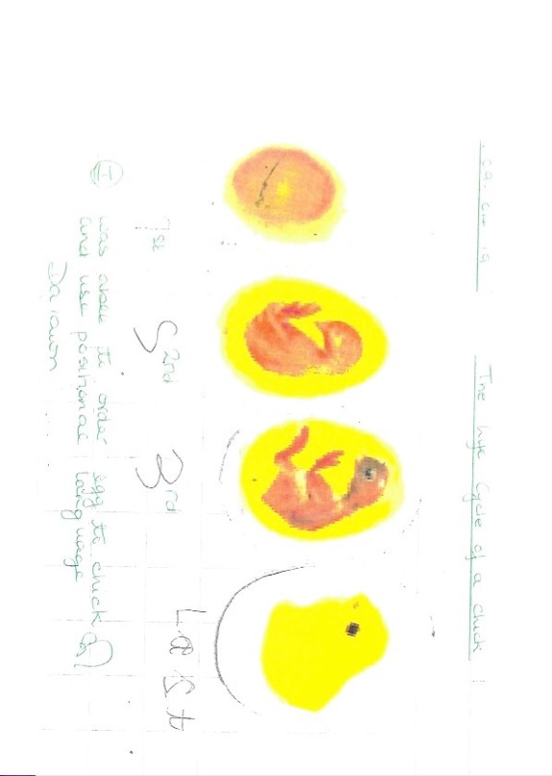
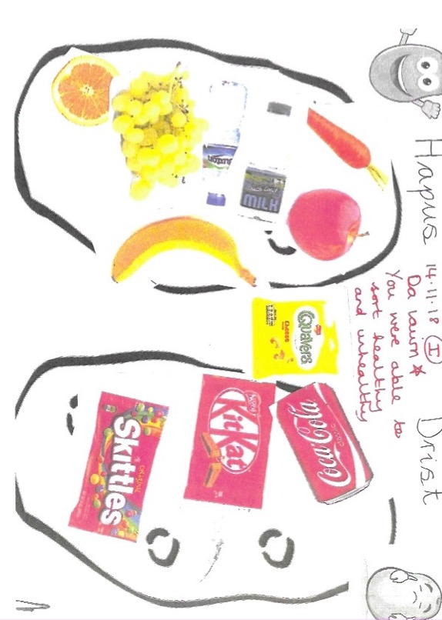
Appendix M (i) and (ii)
Appendix N
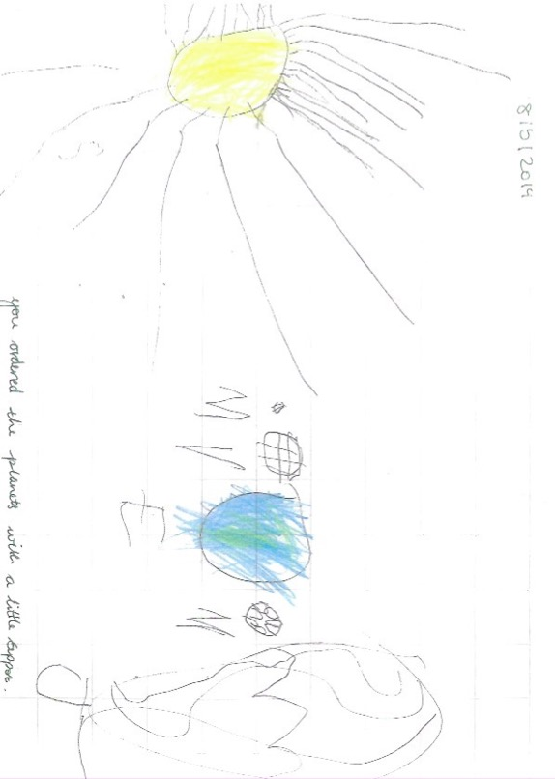

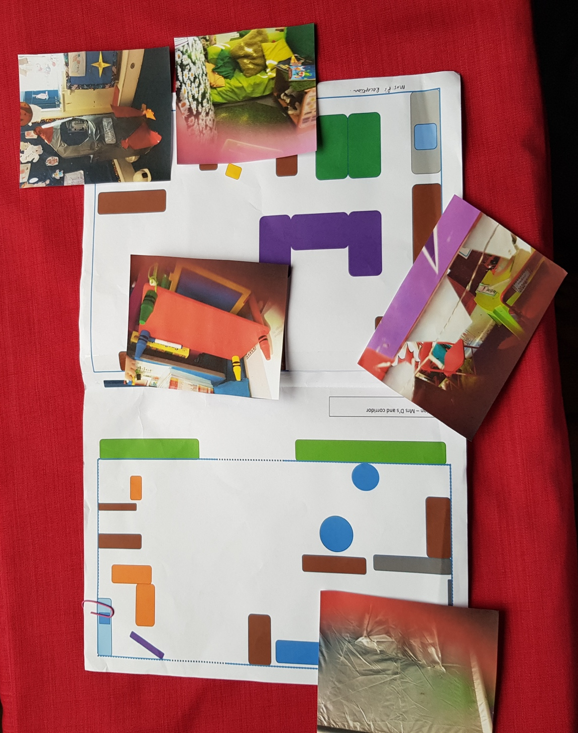
Appendix O: Classroom Map with Pupil X’s Choice of Favourite Areas

