BA INTERNATIONAL HOTEL MANAGEMENT
ASSESSMENT OF PRACTICAL TASKS
(MENU ENGINEERING)

Student Name: ANDREEA RALUCA SUCIU

Student ID number: 2206963

Food & Beverage Operations BMIH4002

Lecturer: Tristan Hawkins

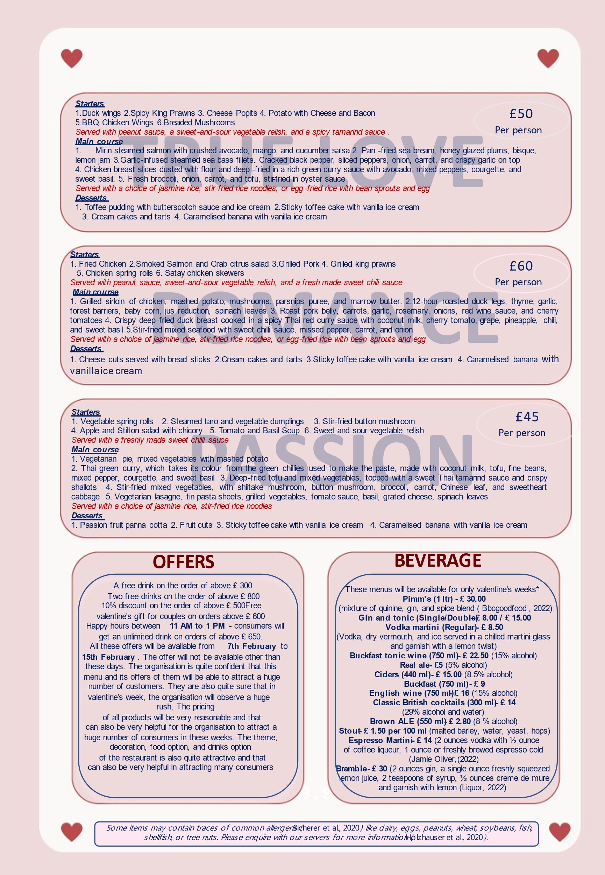
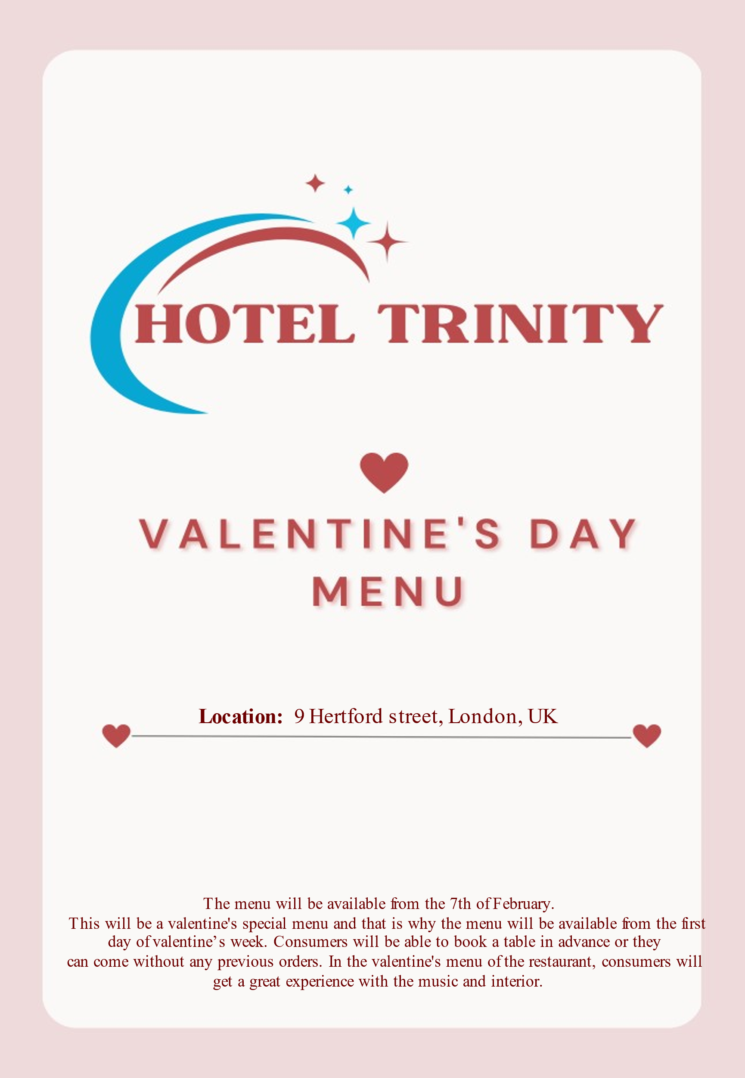

Location
9 Hertford street, London, UK
Availability
The menu will be available from the 7th of February. This will be a valentine's special menu and that is why the menu will be available from the first day of valentine’s week. Consumers will be able to book a table in advance or they can come without any previous orders. In the valentine's menu of the restaurant, consumers will get a great experience with the music and interior.
Offers
- A free drink on the order of above £ 300
- Two free drinks on the order of above £ 800
- 10% discount on the order of above £ 500
- Free valentine's gift for couples on orders above £ 600
- Happy hours between 11 AM to 1 PM - consumers will get an unlimited drink on orders of above £ 650.
All these offers will be available from 7th February to 15th February. The offer will not be available other than these days. The organisation is quite confident that this menu and its offers of them will be able to attract a huge number of customers. They are also quite sure that in the valentine’s week, the organisation will observe a huge rush. The pricing of all products will be very reasonable and that can also be very helpful for the organisation to attract a huge number of consumers in these weeks. The theme, decoration, food option, and drinks option of the restaurant is also quite attractive and that can also be very helpful in attracting many consumers.
Valentine’s Week Buffet Menu
True Love
£ 50 per person
- Duck wings
- Spicy King Prawns
- Cheese Popits
- Potato with Cheese and Bacon
- BBQ Chicken Wings
- Breaded Mushrooms
Served with a spicy tamarind sauce, a sweet-and-sour vegetable relish, and a peanut sauce.
Main course
- Mirin steamed salmon with crushed avocado, mango, and cucumber salsa
- Pan-fried sea bream, honey glazed plums, bisque, lemon jam
- Garlic-infused steamed sea bass fillets. Cracked black pepper, sliced peppers, onion, carrot, and crispy garlic on top.
- Chicken breast slices dusted with flour and deep-fried in a rich green curry sauce with avocado, mixed peppers, courgette, and sweet basil.
- Fresh broccoli, onion, carrot, and tofu, stir-fried in oyster sauce
Served with a choice of jasmine rice, stir-fried rice noodles, or egg-fried rice with bean sprouts and egg
Desserts
- Toffee pudding with butterscotch sauce and ice-cream
- Sticky toffee cake with vanilla ice cream
- Cream cakes and tarts
- Caramelised banana with vanilla ice cream
Romance
£60 per person
Starters
- Fried Chicken
- Smoked Salmon and Crab citrus salad
- Grilled Pork
- Grilled king prawns
- Chicken spring rolls
- Satay chicken skewers
Served with peanut sauce, sweet-and-sour vegetable relish, and a fresh made sweet chili sauce Main course
- Grilled sirloin of chicken, mashed potato, mushrooms, parsnips puree, and marrow butter
- 12-hour roasted duck legs, thyme, garlic, forest barriers, baby corn, jus reduction, spinach leaves
- Roast pork belly, carrots, garlic, rosemary, onions, red wine sauce, cherry tomatoes
- Crispy deep-fried duck breast cooked in a spicy Thai red curry sauce with coconut milk, cherry tomato, grape, pineapple, chilli, and sweet basil
- Stir-fried mixed seafood with sweet chilli sauce, missed pepper, carrot, and onion
Served with a choice of jasmine rice, stir-fried rice noodles, or egg-fried rice with bean sprouts and egg
Desserts
- Cheese cuts served with bread sticks
- Cream cakes and tarts
- Sticky toffee cake with vanilla ice cream
- Caramelised banana with vanilla ice cream
Passion
£45 per person
Starters
- Vegetable spring rolls
- Steamed taro and vegetable dumplings
- Stir-fried button mushroom
- Apple and Stilton salad with chicory
- Tomato and Basil Soup
- Sweet and sour vegetable relish
Served with a freshly made sweet chili sauce
Main course
- Vegetarian pie, mixed vegetables with mashed potato
- Thai green curry, which takes its colour from the green chilies used to make the paste, made with coconut milk, tofu, fine beans, mixed pepper, courgette, and sweet basil
- Deep-fried tofu and mixed vegetables, topped with a sweet Thai tamarind sauce and crispy shallots
- Stir-fried mixed vegetables, with shiitake mushroom, button mushroom, broccoli, carrot, Chinese leaf, and sweetheart cabbage
- Vegetarian lasagne, tin pasta sheets, grilled vegetables, tomato sauce, basil, grated cheese, spinach leaves
Served with a choice of jasmine rice, stir-fried rice noodles
Desserts
- Passion fruit panna cotta
- Fruit cuts
- Sticky toffee cake with vanilla ice cream
- Caramelised banana with vanilla ice cream
Some items may contain traces of common allergens (Sicherer et al., 2020) like dairy, eggs, peanuts, wheat, soybeans, fish, shellfish, or tree nuts. Please enquire with our servers for more information (Holzhauser et al., 2020).
Beverages
*These menus will be available for only valentine's weeks*
Pimm’s (1 ltr) - £ 30.00
(mixture of quinine, gin, and spice blend (Bbcgoodfood, 2022)
Gin and tonic (Single/Double) - £ 8.00 / £ 15.00
Vodka martini (Regular) - £ 8.50
(Vodka, dry vermouth, and ice served in a chilled martini glass and garnish with a lemon twist)
Buckfast tonic wine (750 ml) - £ 22.50
(15% alcohol)
Real ale- £ 5
(5% alcohol)
Ciders (440 ml)- £ 15.00
(8.5% alcohol)
Buckfast (750 ml)- £ 9
English wine (750 ml)- £ 16
(15% alcohol)
Classic British cocktails (300 ml)- £ 14
(29% alcohol and water)
Brown ALE (550 ml)- £ 2.80
(8 % alcohol)
Stout- £ 1.50 per 100 ml
(malted barley, water, yeast, hops)
Espresso Martini- £ 14
(2 ounces vodka with ½ ounce of coffee liqueur, 1 ounce or freshly brewed espresso cold (Jamieoliver, (2022)
Bramble- £ 30
(2 ounces gin, a single ounce freshly squeezed lemon juice, 2 teaspoons of syrup, ½ ounces creme de mure and garnish with lemon (Liquor, 2022)
References
Bbcgoodfood (2022) “Bramble recipe” Available at: https://www.bbcgoodfood.com/recipes/pimms [Accessed on: 6th February 2022]
Holzhauser, T., Johnson, P., Hindley, J. P., O'Connor, G., Chan, C. H., Costa, J., ... and Flanagan, S. D. (2020). Are current analytical methods suitable to verify VITAL® 2.0/3.0 allergen reference doses for EU allergens in foods?. Food and Chemical Toxicology, 145, 111709. Available at: https://www.sciencedirect.com/science/article/pii/S0278691520305998 [Accessed on: 6th February 2022]
Jamieoliver, (2022) ”Espresso martini recipe” Available at: https://www.jamieoliver.com/features/how-to-make-espresso-martini/ [Accessed on: 6th February 2022]
Liquor, (2022) “Bramble recipe” Available at: https://www.liquor.com/recipes/bramble/ [Accessed on: 6th February 2022]
Sicherer, S. H., Warren, C. M., Dant, C., Gupta, R. S., and Nadeau, K. C. (2020). Food allergy from infancy through adulthood. The Journal of Allergy and Clinical Immunology: In Practice, 8(6), 1854-1864. Available at: https://www.ncbi.nlm.nih.gov/pmc/articles/PMC7899184/ [Accessed on: 6th February 2022]

