Electronics 2

(ACDA6001)
  - For electronics
James T | 2322728 | Embedded Electronics | 23/06/2026

Contents
- Introduction – PG5
- Background research – PG5-7
  - Brauns multiplier – PG5
  - Wallace Tree multiplier – PG6
  - Dadda multiplier – PG6
  - Booth multiplier – PG6
  - Baugh Wooley multiplier – PG6
  - Vedic multiplier – PG7
- Brauns Multiplier – PG7-17
  - Design process – PG7
  - VHDL Code and design process – PG8
  - Vivado Brauns Implementation Schematics, delay diagrams, IO planning and device – PG9
  - Results – PG12
- Wallace Tree Multiplier – PG18-28
  - Design Process – PG18
  - VHDL Code and design process – PG20
  - Vivado Wallace tree Implementation schematics, delay diagrams, IO planning and device – PG20
  - Results – PG23
- Comparison – PG29-30
  - Results comparison – PG29
  - Recommendations for future improvements – PG29
- Conclusion – PG30
- Bibliography – PG31-33
- Appendices – PG34-45
  - Appendix A – Brauns VHDL Code – PG34
  - Appendix B – Constraints code for Brauns simulations – PG38
  - Appendix C – Wallace tree VHDL code – PG39
  - Appendix D – Constraints code for Wallace tree simulations – PG44

Figures
- Figure 1 – Flowchart of Braun multiplier
- Figure 2 – Multiplication table for 8x8 Brauns
- Figure 3 – Braun array containing adders and partial products
- Figure 4 – Brauns multiplier schematic
- Figure 5 – Brauns RTL design
- Figure 6 – Brauns Device
- Figure 7 – Brauns I/O planning
- Figure 8 – Brauns longest delay
- Figure 9 – Brauns implemented design power summary
- Figure 10 – Brauns synthesized design power summary
- Figure 11 – Brauns implemented design timing summary
- Figure 12 – Brauns synthesized design timing summary
- Figure 13 – Brauns utilization report
- Figure 14 – Brauns utilization summary
- Figure 15 – Brauns multiplier simulation result with inputs 01 and 01
- Figure 16 – Brauns multiplier simulation result with inputs 23 and 55
- Figure 17 – Brauns multiplier simulation results with inputs aa and bc
- Figure 18 – Brauns multiplier similation results with inputs ff and ff
- Figure 19 – Brauns multiplier real results with inputs 01 and 01
- Figure 20 – Brauns multiplier real results with inputs 23 and 55
- Figure 21 – Brauns multiplier real results with inputs aa and bc
- Figure 22 – Brauns multiplier real results with inputs ff and ff
- Figure 23 – Flowchart of Wallace tree multiplier
- Figure 24 – Multiplication table for 8x8 Wallace tree
- Figure 25 – Wallace tree containing adders and partial products
- Figure 26 – Dot diagram for 8x8 Wallace tree
- Figure 27 – Wallace tree multiplier schematic
- Figure 28 – Wallace tree RTL design
- Figure 29 – Wallace tree Device
- Figure 30 – Wallace tree I/O planning
- Figure 31 – Wallace tree longest delay
- Figure 32 – Wallace tree implemented design power summary
- Figure 33 – Wallace tree synthesized design power summary
- Figure 34 – Wallace tree implemented design timing summary
- Figure 35 – Wallace tree synthesized design timing summary
- Figure 36 – Wallace tree utilization report
- Figure 37 – Wallace tree utilization summary
- Figure 38 – Wallace tree multiplier simulation results with inputs 01 and 01
- Figure 39 - Wallace tree multiplier simulation results with inputs 23 and 55
- Figure 40 - Wallace tree multiplier simulation results with inputs aa and bc
- Figure 41 - Wallace tree multiplier simulation results with inputs ff and ff
- Figure 42 - Wallace tree multiplier real results with inputs 01 and 01
- Figure 43 - Wallace tree multiplier real results with inputs 23 and 55
- Figure 44 - Wallace tree multiplier real results with inputs aa and bc
- Figure 45 - Wallace tree multiplier real results with inputs ff and ff

Introduction
Multiplication is a core arithmetic operation in digital systems, typically implemented in combinational hardware by generating partial products and then summed using shift and add techniques. In FPGA design, multiplier architecture has a significant impact on speed, power consumption and silicon area. This report investigates and compares a range of common multiplier architectures, including the Braun array, Wallace tree, Booth, Baugh Wooley, Dadda and Vedic multipliers, highlighting their advantages, disadvantages and uses.
The report then moves onto a practical component, which focuses on the design, implementation and simulation of 8x8 Braun and Wallace tree multipliers in VHDL and synthesized in Vivado. Both architectures timing, power consumption and resource utilization are evaluated. The Braun is implemented as a basic array structure, while the Wallace tree uses a parallel reduction approach using carry-save adders to minimise propagation delay. This assignments aim is to assess whether the theoretical performance differences between the two multipliers can measured at the small 8x8 operand size.

Background research
Multiplication is a fundamental arithmetic operation within digital circuits and systems and can be implemented as a sequence of shift and add operations. In binary terms, the multiplication process involves generating partial products and is computed by multiplying each bit by the entire multiplicand, then shifting the resulting partial product one position left for each successive bit [1, 2]. For example, multiplying 15 (${1111}_{2}$) by 5 (${101}_{2}$) produces the partial products 1111, 00000, 111100. Summing these partial products using binary addition is ${1001011}_{2}$, or ${75}_{10}$.
Although binary multiplication is conceptually straight forward, implementing it efficiently in hardware and present several challenges. The performance of a multiplier directly affects the overall performance of digital circuits, particularly its power consumption, area utilization and operating speed. As a result, there are a range of multiplier techniques developed to optimize these parameters, each with their own advantages and disadvantages. The architectures discussed in this report include the Brauns, Booth, Wallace tree, Dadda, Vedic and Baugh Wooley multipliers.

Brauns multiplier
The Braun array multiplier is one of the earliest parallel multipliers for unsigned parallel multiplication, proposed in the 1960s [3, 4, 5]. It operates by making all the partial products simultaneously using an array of AND gates, before summing them using an array of half and full adders. The Braun multiplier computes all the partial products in parallel, resulting in them being fast but expensive in terms of power consumption and silicon area [6]. As the number of bits increases, the number of adders and AND gates required also increases, therefore is only best suited for 16-bit [7]. It is also slower than other parallel multipliers, such as Wallace and booths. Due to its simplicity, the Brauns multiplier is commonly implemented in FPGA and VLSI designs, educational hardware projects and arithmetic circuits which require prioritise ease of implementation and predictable layout are prioritised over operating speed. They are also used in DSP systems, although more advanced multipliers are typically preferred [8, 9, 10].

Wallace Tree multiplier
The Wallace tree multiplier was developed by Chris S. Wallace in 1964, where he introduced a new method of parallel addition of the partial product matrix by using a tree network of carry save adders. This reduces the propagation delay by minimising carry propagation during partial product reduction [5, 11]. Single carry bits are not propagated straight away but rather carry over to the next stage of the reduction. At the final stage of the process, a carry-look-ahead adder or carry-propagate adder is used to combine both rows, resulting in a final product. The advantage of this is its noticeably faster speed and less delay related to the critical path in digital circuits [1]. The Wallace tree architecture is beneficial where rapid data processing is a key requirement in high-performance computing application, and multipliers are longer than 16 bits [6, 1]. Examples of these include modern digital signal processing and graphics processing. However, the disadvantage of the Wallace tree architecture is that it uses a large chip area due to its complicated routing and longer wires [6].

Dadda multiplier
The Dadda multiplier was proposed in 1965 by Luigi Dadda to improve on the Wallace tree. Similar to the Wallace tree architecture, it generates all partial products simultaneously and reduces them using a tree of carry-save adders. The Dadda multiplier delays some of the reductions so that fewer adders are required and a slight improvement in speed. This reduction means the hardware area used and power consumption is lower, while maintaining comparable speeds to the Wallace architecture, even improving speeds at higher word sizes [12, 13, 14]. This architecture is used for high speed arithmetic, FPGAs and application specific integrated circuits, where performance and low power are a priority [15].

Booth multiplier
The Booth multiplier is an array architecture, invented in 1950 by Andrew D. Booth. The first version, Radix-2, was introduced to improve multiplication efficiency. In 1951, the modified Booth algorithm was created to further optimise this process. It does this by scanning multiple bits at a time, with three bits scanned in the Radix-4 (modified Booth) implementation. Radix-4 uses half the number of partial products compared to Radix-2. The Booth multiplier architecture is suitable for signed and unsigned numbers and is capable of faster multiplication, making it widely used for large multipliers. However, the booth has a higher power consumption and complexity compared to alternative multipliers. They are typically used in high performance multipliers. [5, 6, 11, 12, 16, 17].

Baugh Wooley multiplier
The Baugh Wooley is a parallel multiplication algorithm, proposed in 1973 by Baugh and Wooley [18]. This algorithm was introduced for signed number multiplication and is one of the most cost effective ways to handle the sign bits. It transforms negative partial products into something that can be summed using a regular array. This algorithm keeping the sign of partial products positive makes it easy to just add the partial products together and use a simple array of adders. This simplifies the hardware implementation, making it suitable for VLSI and ASIC design. While newer hybrid architectures offer higher performance, the Baugh Wooley is commonly used in microcontrollers, digital filters and DSP processors [4, 5, 19].

Vedic multiplier
The Vedic multiplier is based on the ancient Indian system of Vedic mathematics. Multiplication of numbers is performed in a single line using the Urdhva (Urdhva Tiryakbhyam) method, also known as a vertical and horizontal algorithm. The algorithm was compared to traditional multipliers in 2009, and was developed overtime to improve speed, power consumption and chip area. They managed to reduce the delay by 45%, increase speed 25% and reduce power consumption by 57%. Vedic multipliers have demonstrated these improvements in various papers, showing how important of a tool it is in technology growing fast, being used in image processing, DSP and real time signal processing [20, 21, 22, 23].
While these technologies show clear advancements in performance of multipliers, the Braun and Wallace Tree remain fundamental to the study of digital arithmetic. The Braun array provides a simple architecture for educational and VLSI purposes, while the Wallace introduces the tree based concept for partial product reduction. The remainder of the report will explore the design and simulation of 8x8 Braun and Wallace Tree multipliers in Vivado.

Brauns multiplier

Design process
The design of the Brauns multiplier began with producing a flowchart to show the sequence of operation performed by the Braun multiplier, which will be used to make the VHDL code. As shown in figure 1, the multiplier accepts two 8 bit binary inputs before generating all 64 partial products using AND gates. These partial products are arranged in the Braun array and summed using half and full adders, producing the final 16 bit product.
Figure 1 – Flowchart of Braun multiplier
Figure 2 – Multiplication table for 8x8 Brauns
A partial product table was produced to verify the multiplication process. The table in figure 2 shows the how each bit of the multiplicand is multiplied by each bit of the multiplier to generate the partial products, before being shifted. This was used to design the Braun array in figure 3. The adders combine the partial products while propagating carry bits through the array until the final 16 bit product. This design was then implemented in VHDL.
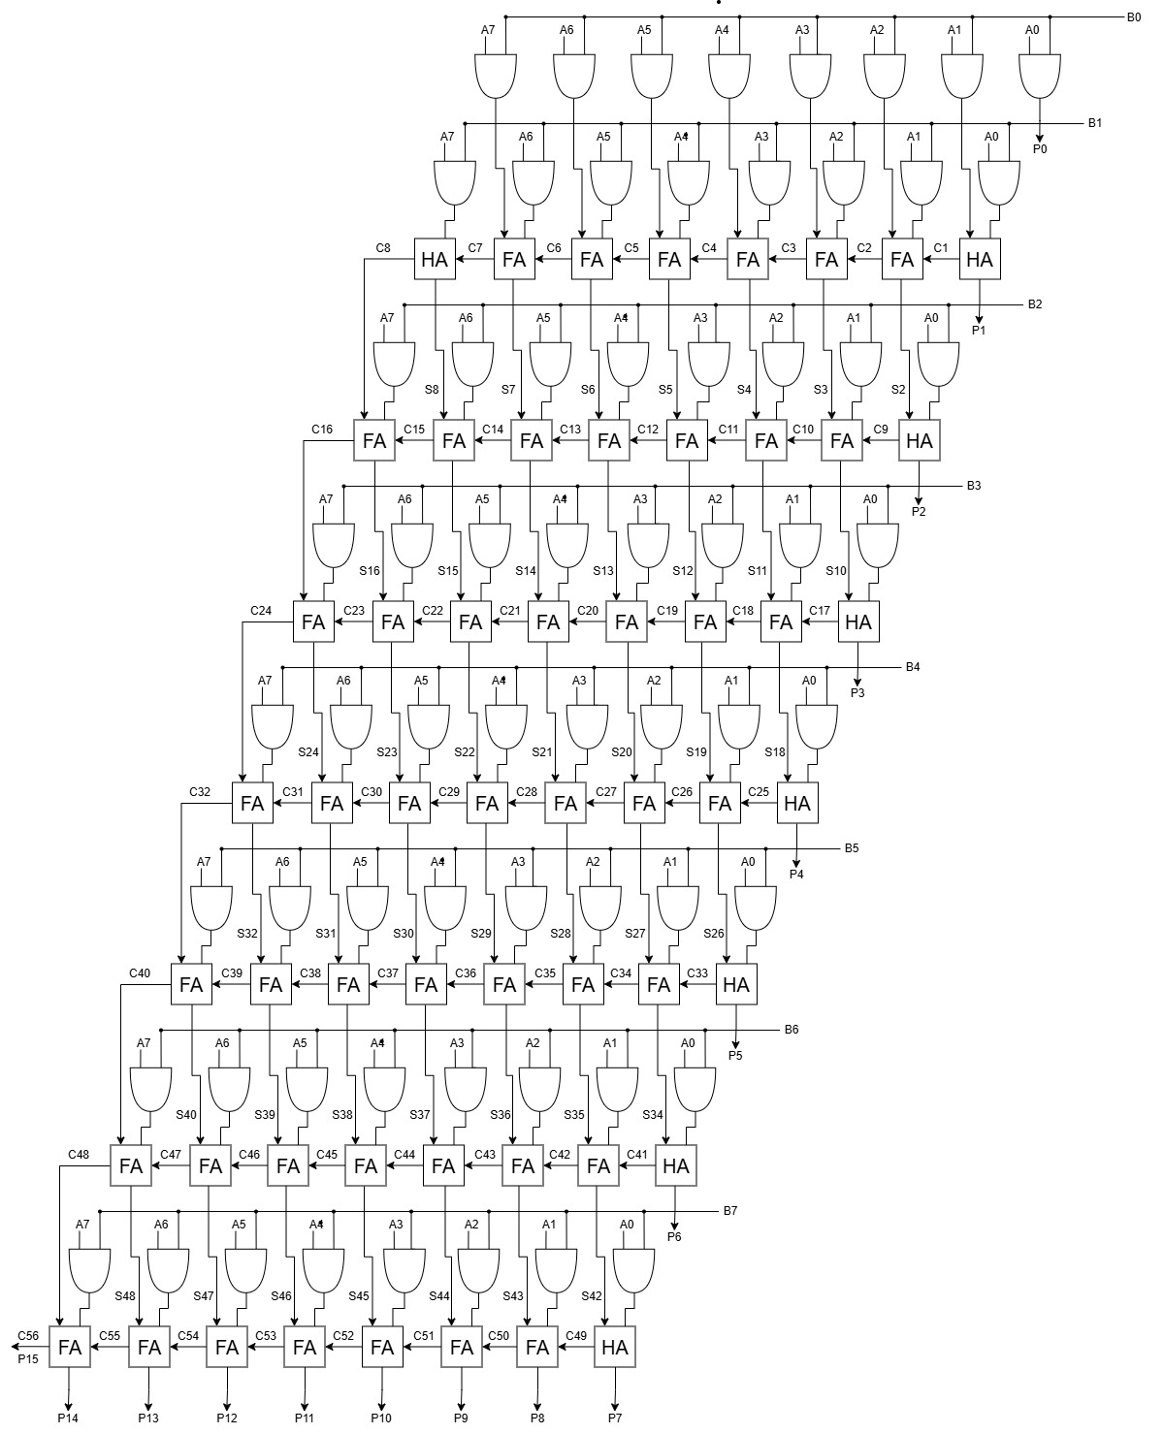
Figure 3 – Braun array containing adders and partial products
VHDL Code and design process
The VHDL code seen in Appendix A first defines the 8 bit inputs A and B, outputs P and other signals, representing the partial products, sums and carries produced throughout the multiplication process. The partial products are then generated by performing AND operations between every multiplicand and multiplier, producing a total of 64 partial products. Finally, all the outputs are produced using half and full adders, replicating the Braun architecture drawn in figure 3.
Appendix B shows the constraints code, containing a 0.25W power budget for the Brauns simulation, the clock and max delay. The max delay was calculated using the critical path shown in figure 8, which was worked out to be 41ns (1ns + 20*2ns). The clock must be set larger than that, so was set to 45ns.

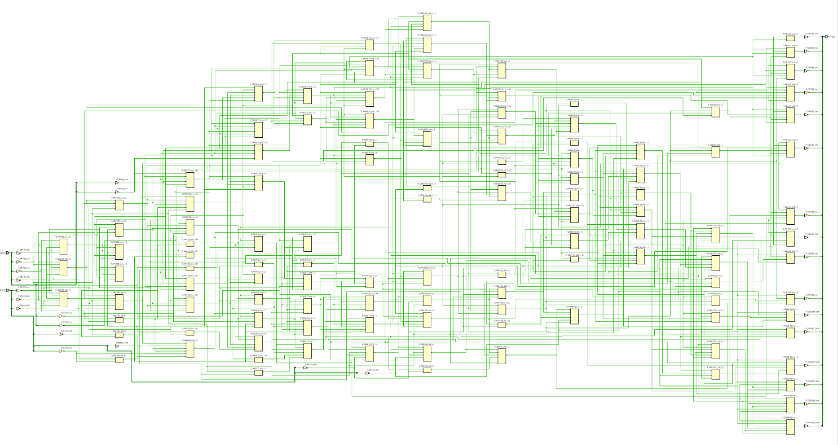
Vivado Brauns Implementation Schematics, delay diagrams, IO planning and device
Figure 4 – Brauns multiplier schematic
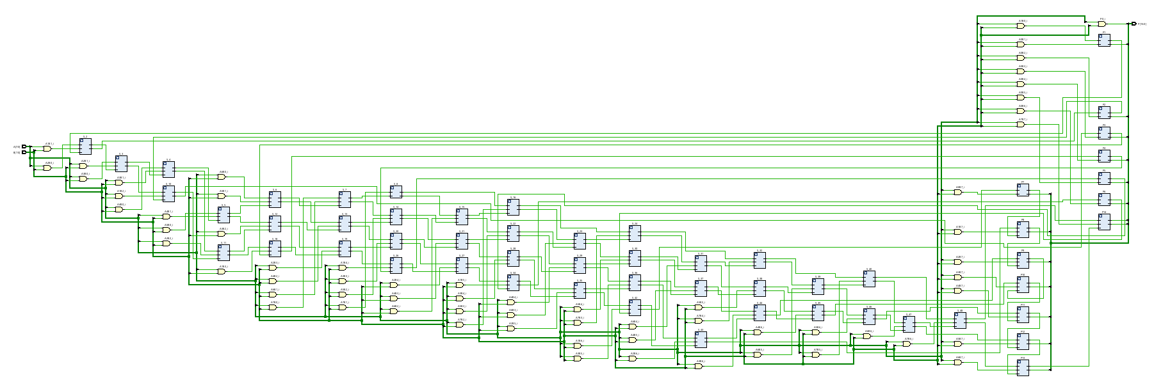
Figure 5 – Brauns RTL design

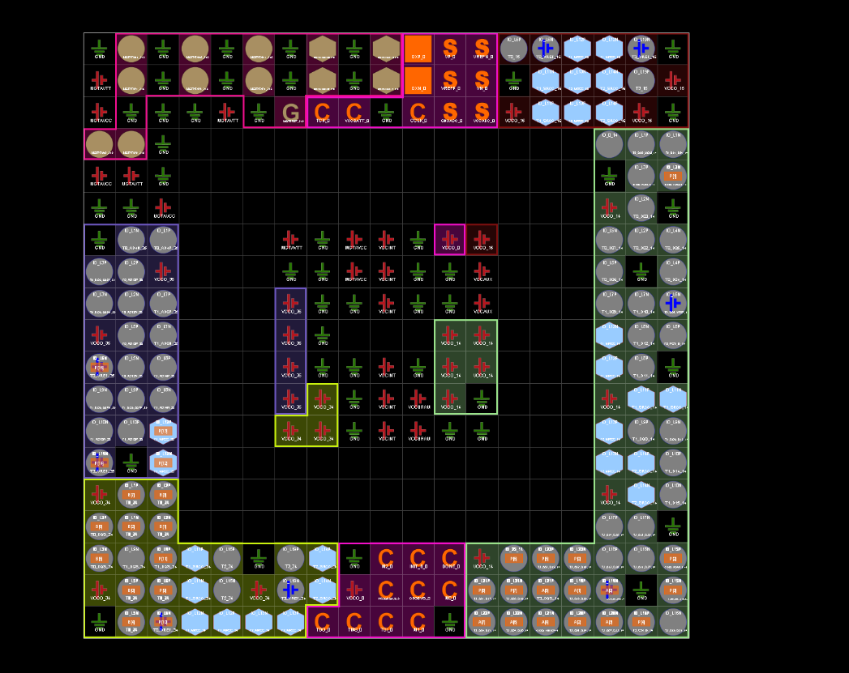
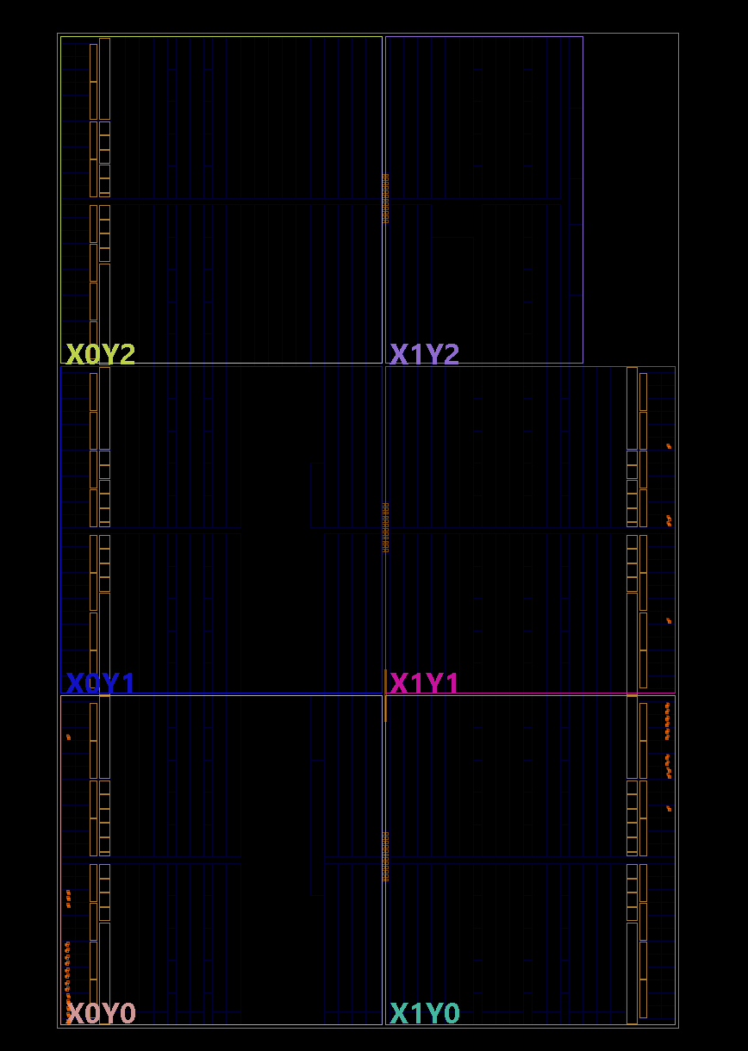
Figure 6 – Brauns Device
Figure 7 – Brauns I/O planning
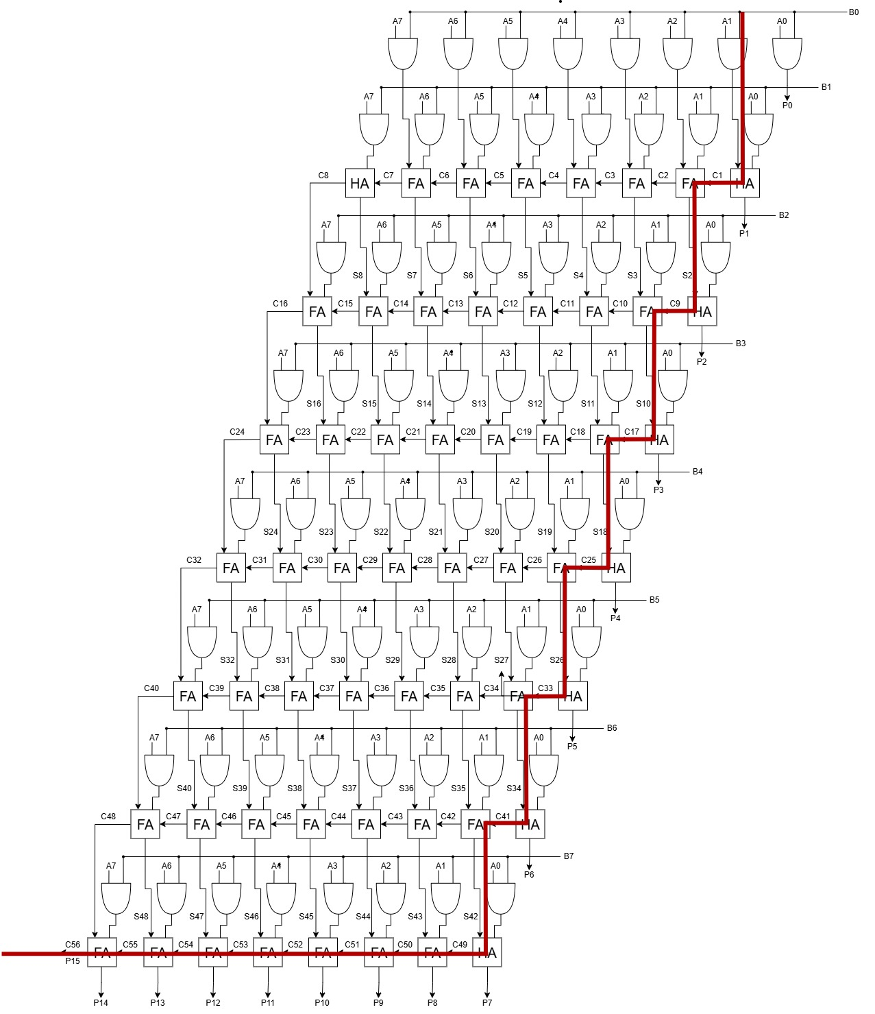
Figure 8 – Brauns longest delay

Results
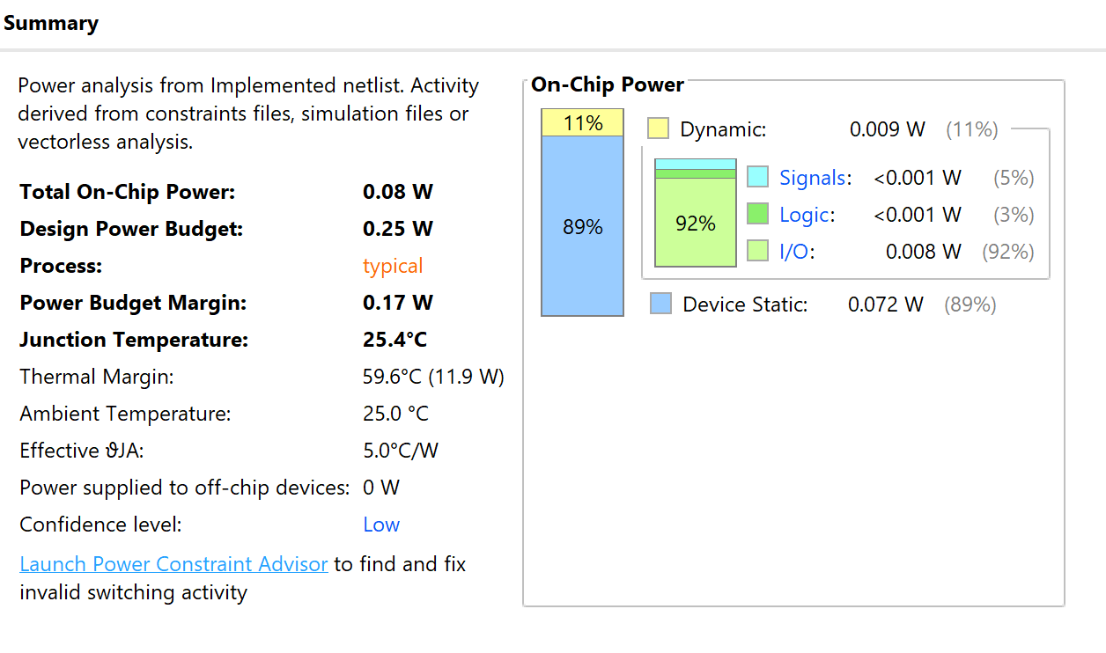
Below are the results of the Brauns power and timing summaries, simulation and real testing of the VHDL design using various 8 bit values and utilization.
Figure 9 – Brauns implemented design power summary
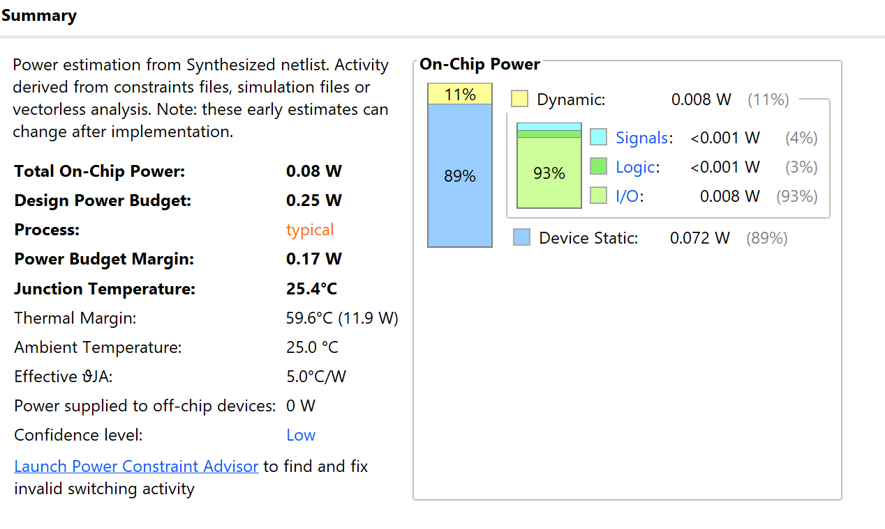
Figure 10 – Brauns synthesized design power summary
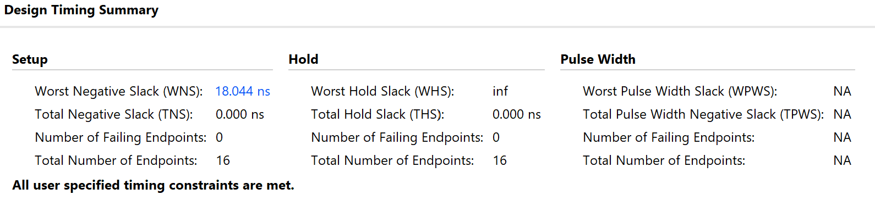
Figure 11 – Brauns implemented design timing summary
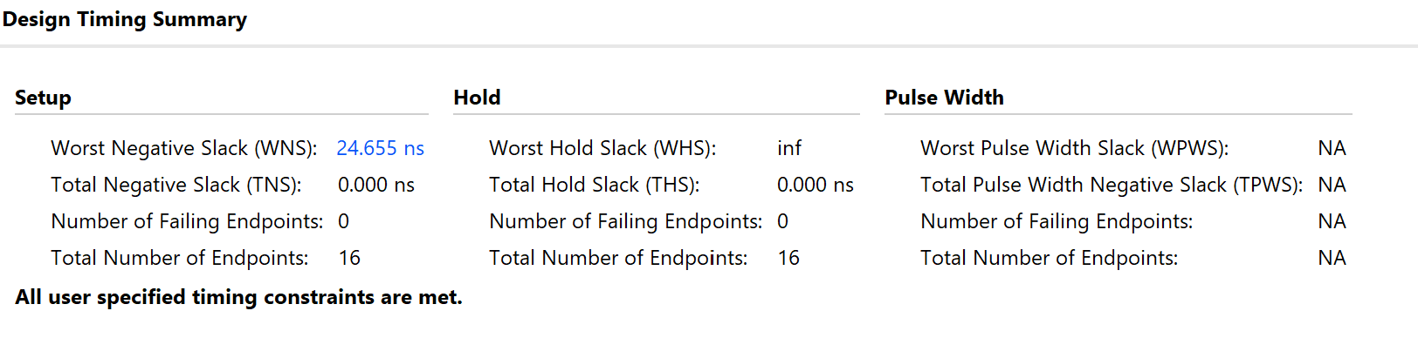
Figure 12 – Brauns synthesized design timing summary
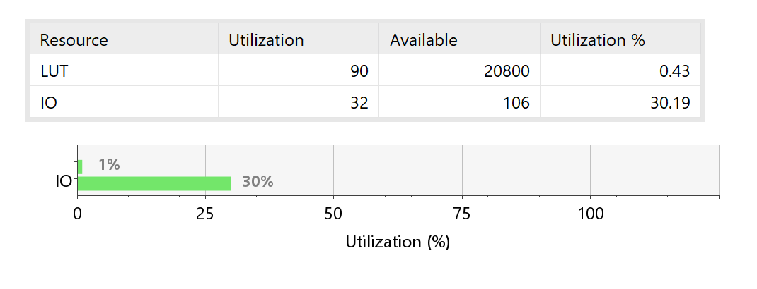
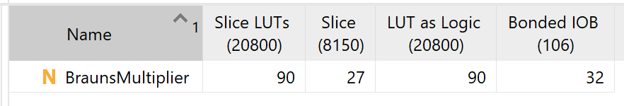
Figure 13 – Brauns utilization report
Figure 14 – Brauns utilization summary

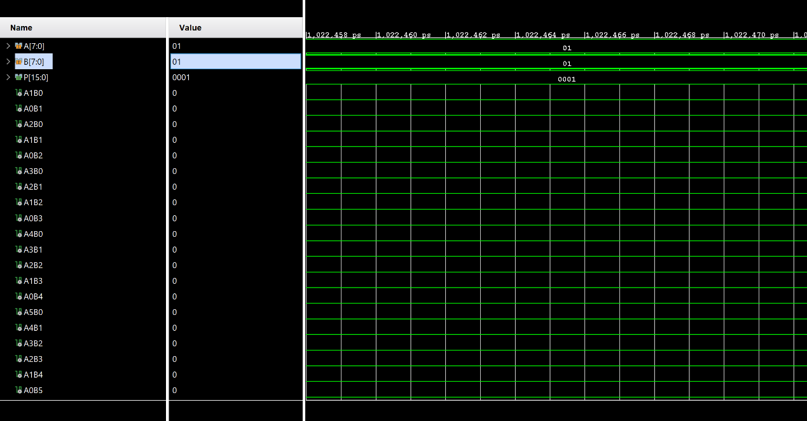
Figure 15 – Brauns multiplier simulation result with inputs 01 and 01
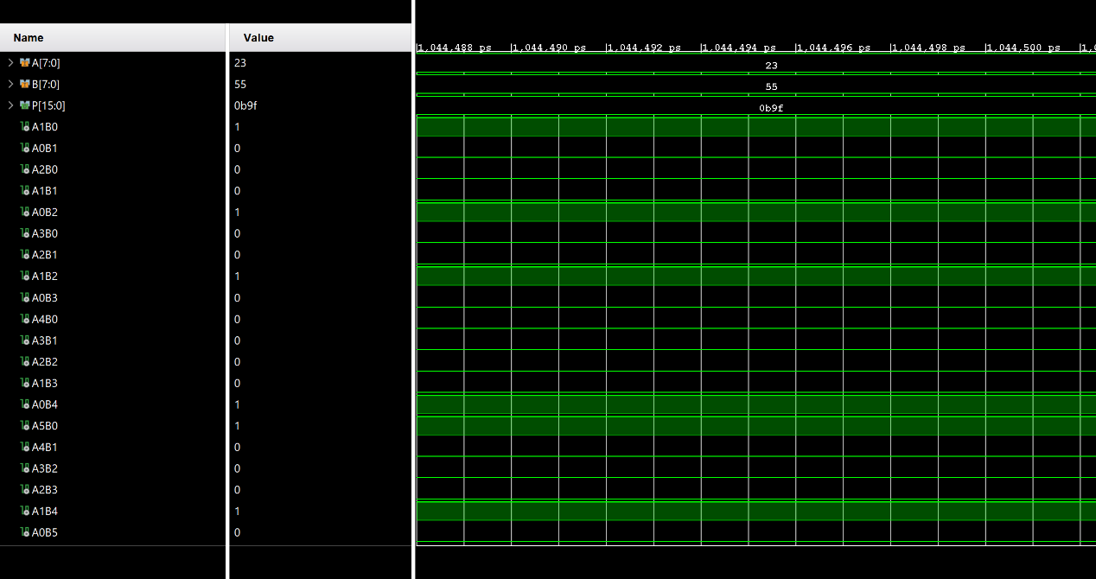
Figure 16 – Brauns multiplier simulation result with inputs 23 and 55

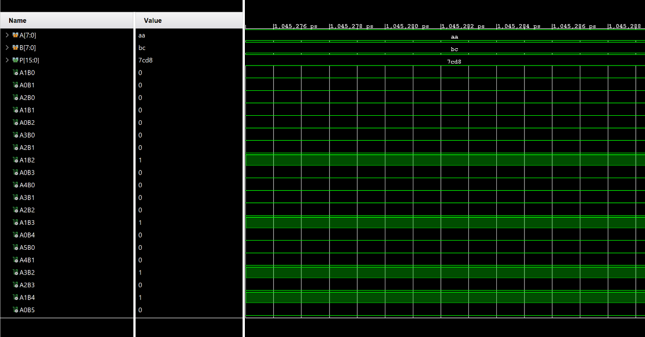
Figure 17 – Brauns multiplier simulation results with inputs aa and bc
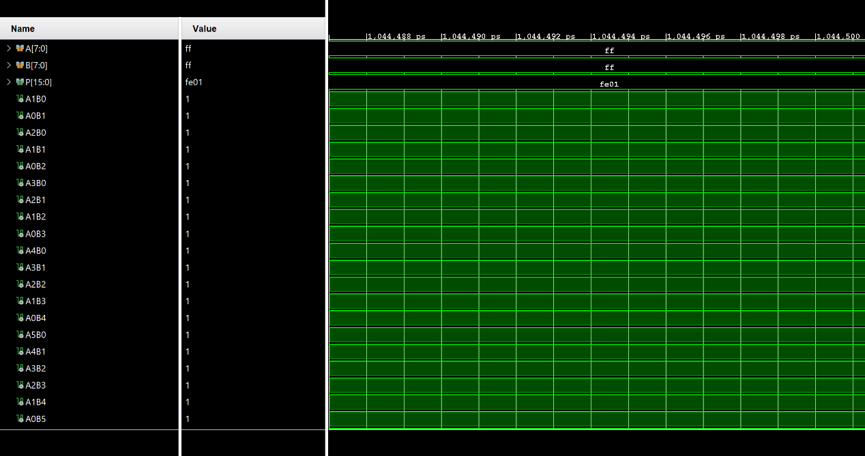
Figure 18 – Brauns multiplier similation results with inputs ff and ff

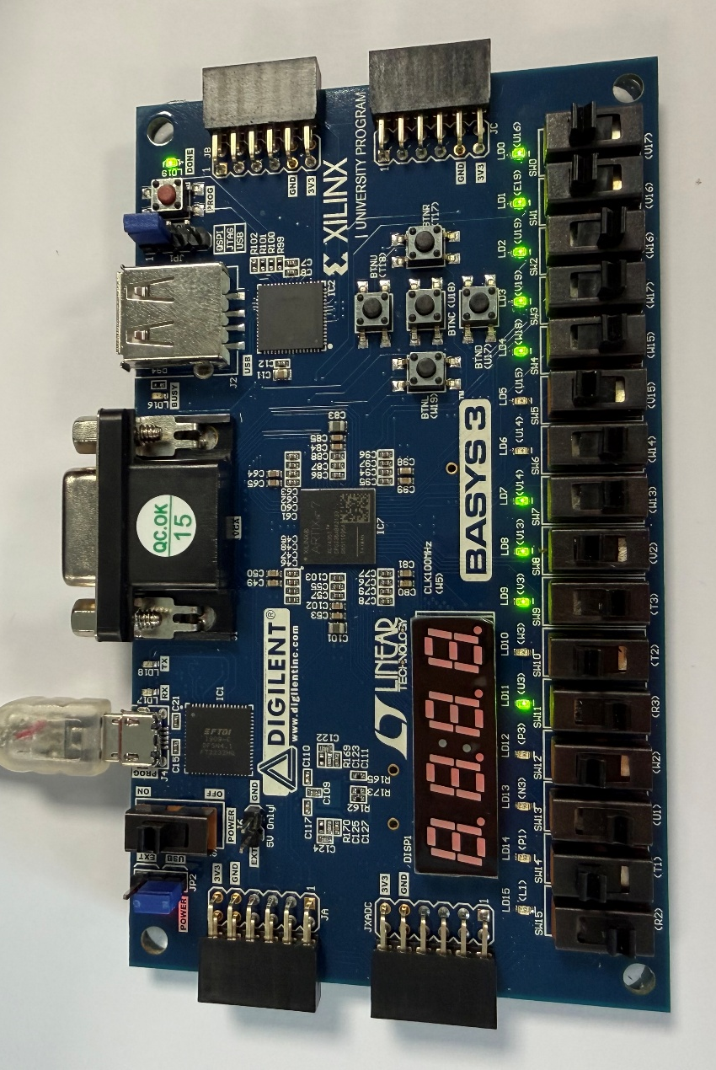
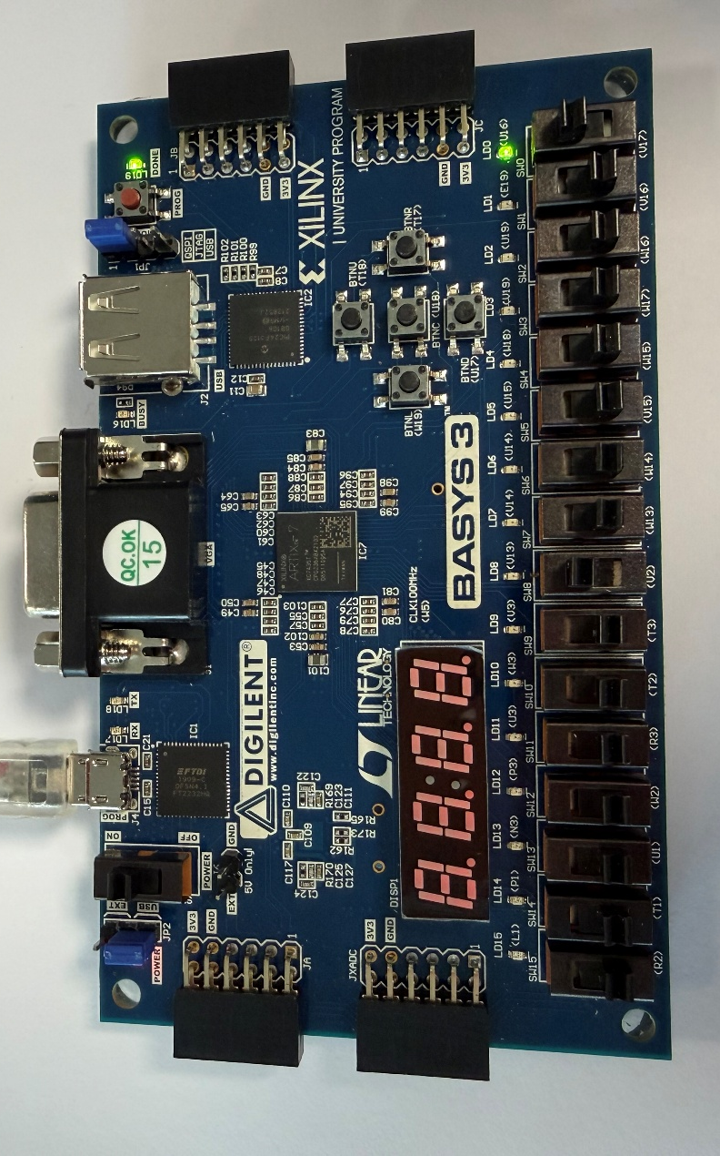
Figure 19 – Brauns multiplier real results with inputs 01 and 01
Figure 20 – Brauns multiplier real results with inputs 23 and 55

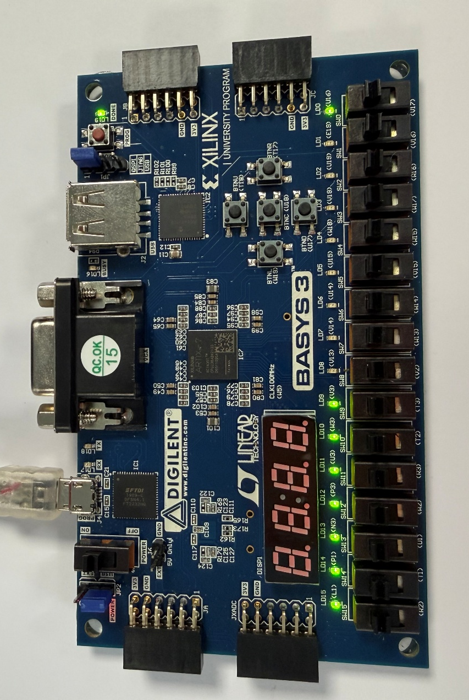
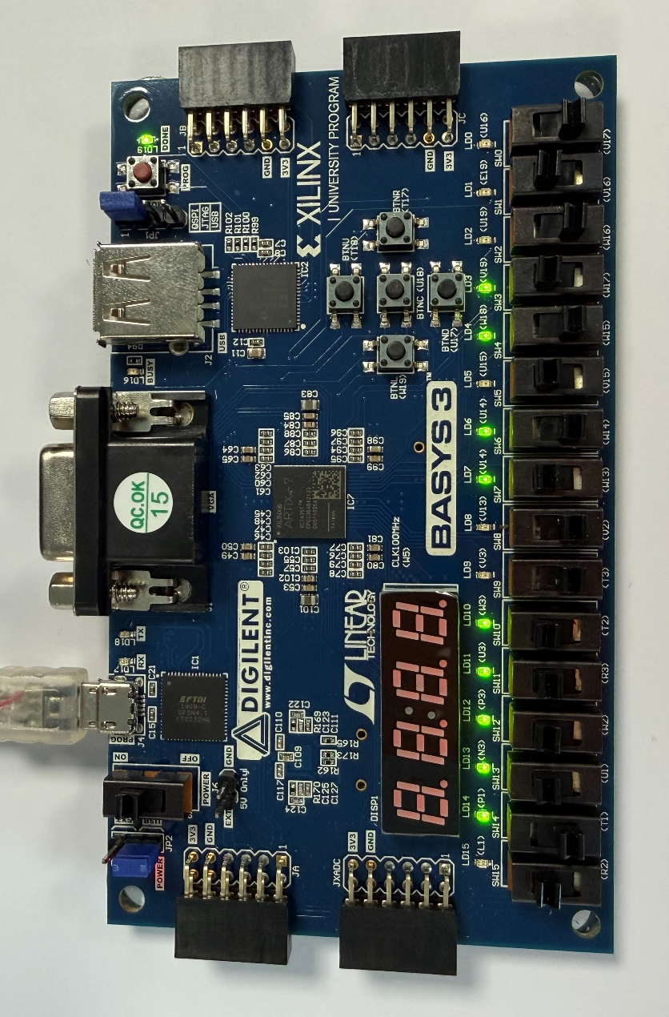
Figure 21 – Brauns multiplier real results with inputs aa and bc
Figure 22 – Brauns multiplier real results with inputs ff and ff

Wallace-tree multiplier

Design Process
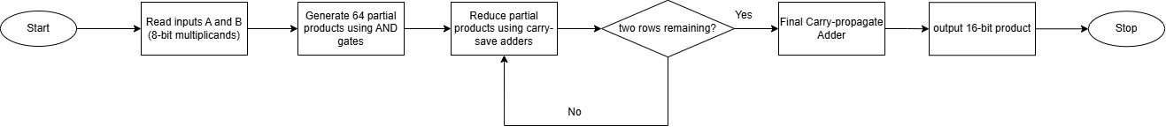
The Wallace multiplier design process started with a flowchart, shown in figure 23. The flowchart the main steps of the multiplication process. It begins with the generation of partial products before reducing them using carry save adders in a tree structure. When the reduction is complete, the remaining two rows are combined with carry propagate adders to produce the final product.
Figure 23 – Flowchart of Wallace tree multiplier
Figure 24 – Multiplication table for 8x8 Wallace tree
Similar to designing the Braun array, a partial product table, shown in figure 24, was created to aid the designing of the 8x8 Wallace tree in figure 25. The table shows the generation of partial products and reduction stages to get the 16 bit output. The Wallace tree designed in figure 25 shows the more complex connections compared to the Brauns array. These were used for creating the VHDL code in Vivado.

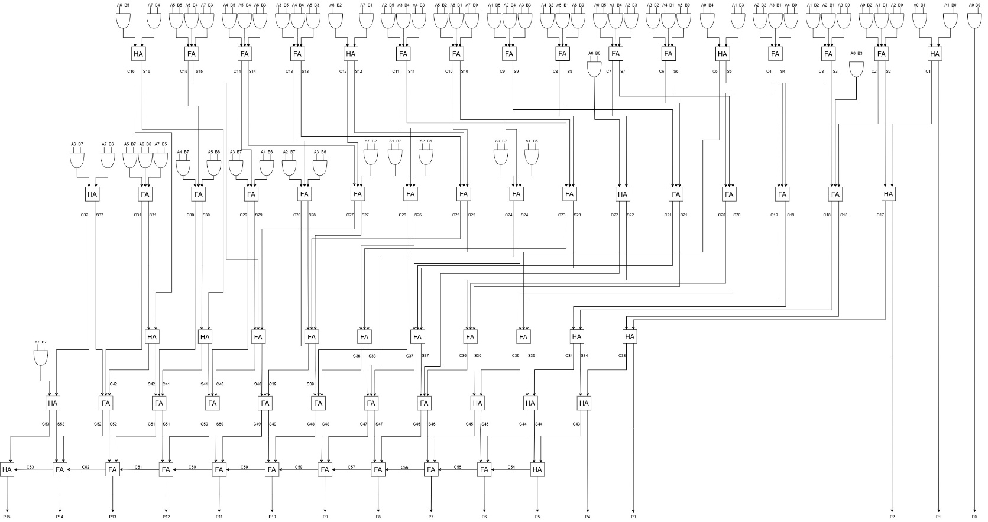
Figure 25 – Wallace tree containing adders and partial products
Figure 26 – Dot diagram for 8x8 Wallace tree [24]
The 8x8 Wallace tree dot diagram in figure 26 shows the reduction stages. Each dot represents a partial product, carry or sum bit. Green squares represent a half adder, and pink squares represent full adders. The final reduction stage also contains the carry bits to make up the final row of half or full adders.

VHDL Code and design process
The Wallace trees VHDL code can be seen in Appendix C. As with the Brauns, it first generates all 64 partial products using AND gates. The partial products are then grouped and reduced in multiple stages using half and full adders. Each stage lowers the number of bits in each column until only 2 rows remain and these final rows produce the 16 bit product output. This method shortens the critical path compared to the Braun array, resulting in faster multiplication. This can be seen in appendix D, which shows the constraint code for the Wallace tree. The code is similar to the Brauns array, but with a delay of 31ns (1ns + 15*2ns).
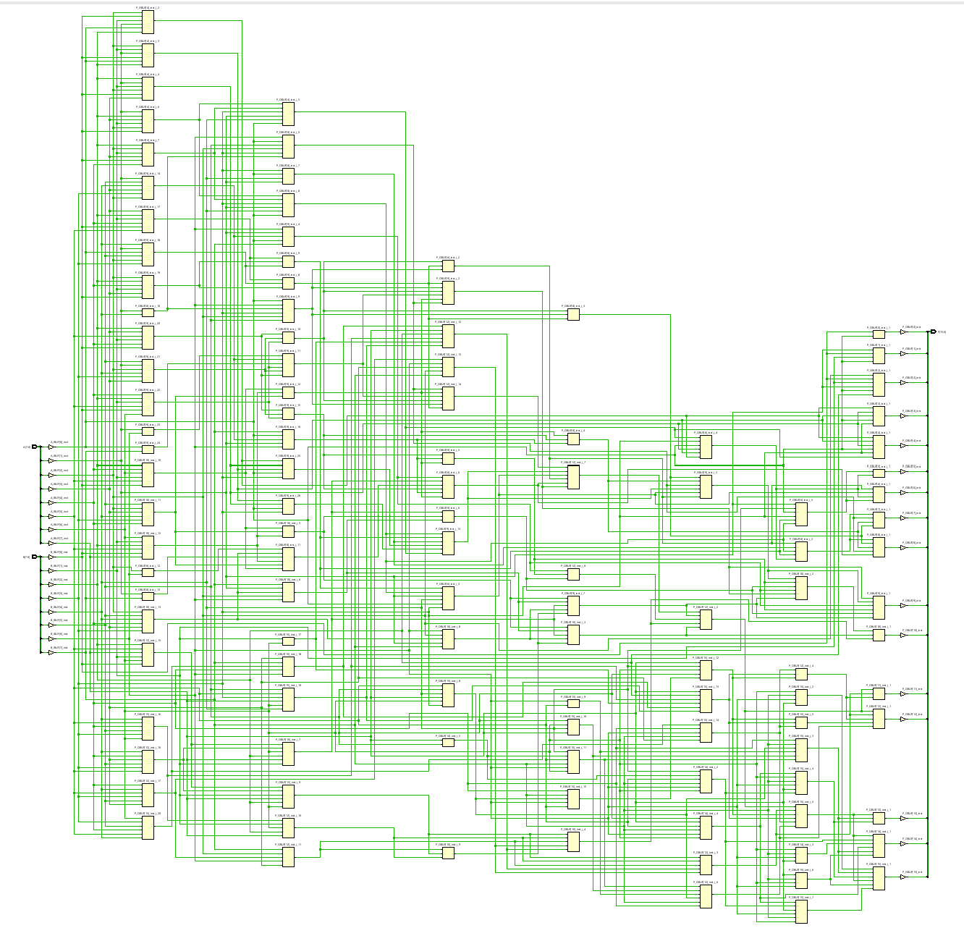
Vivado Wallace tree Implementation schematics, delay diagrams, IO planning and device
Figure 27 – Wallace tree multiplier schematic
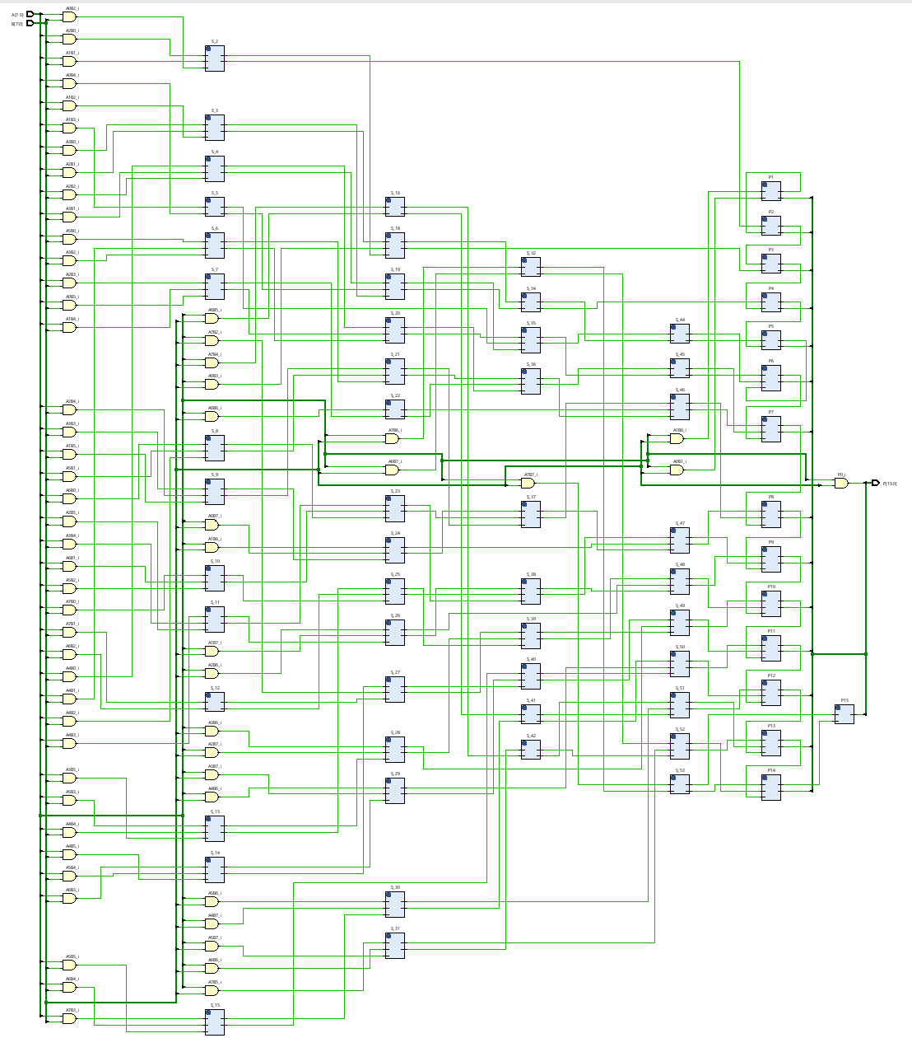
Figure 28 – Wallace tree RTL design
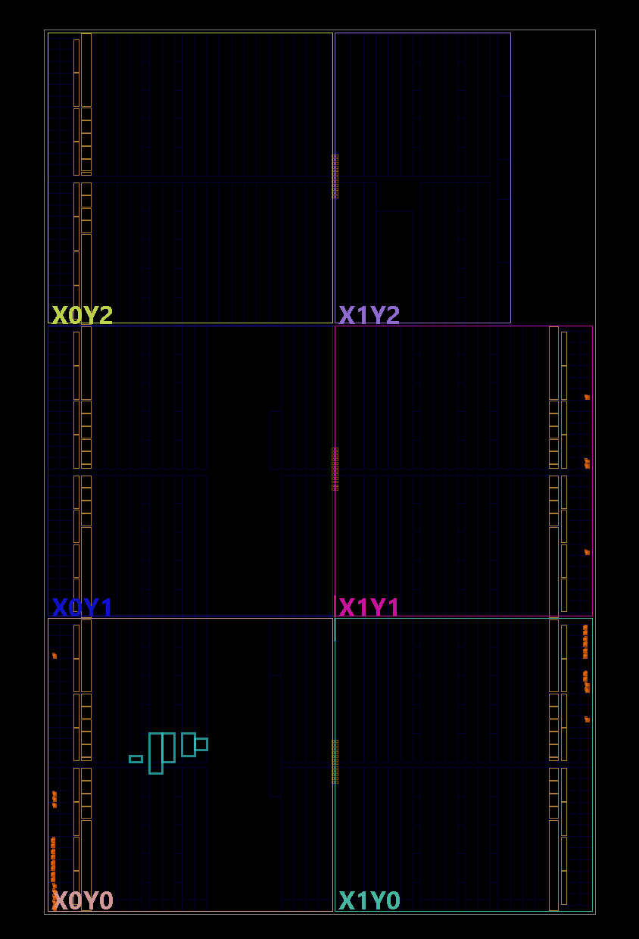
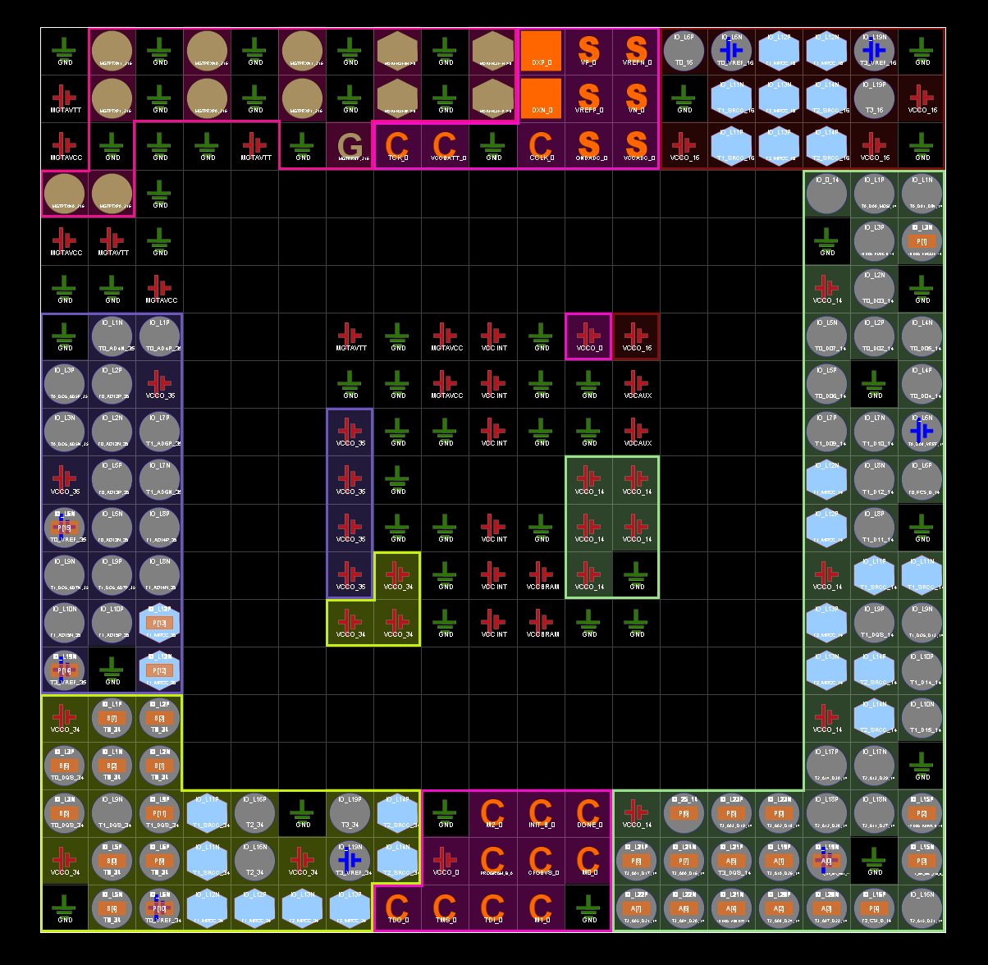
Figure 29 – Wallace tree Device
Figure 30 – Wallace tree I/O planning
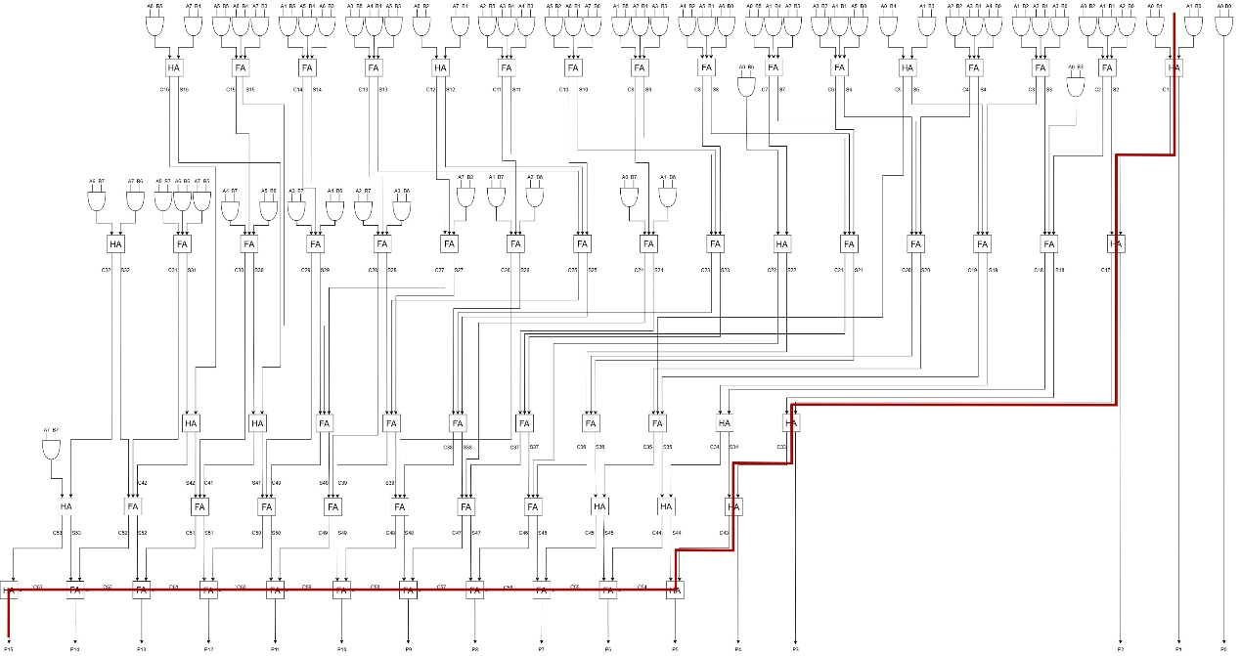
Figure 31 – Wallace tree longest delay

Results
The results of the Wallace tree timing and power summaries, simulation and real testing of the VHDL design using four different input combinations and utilization are below.
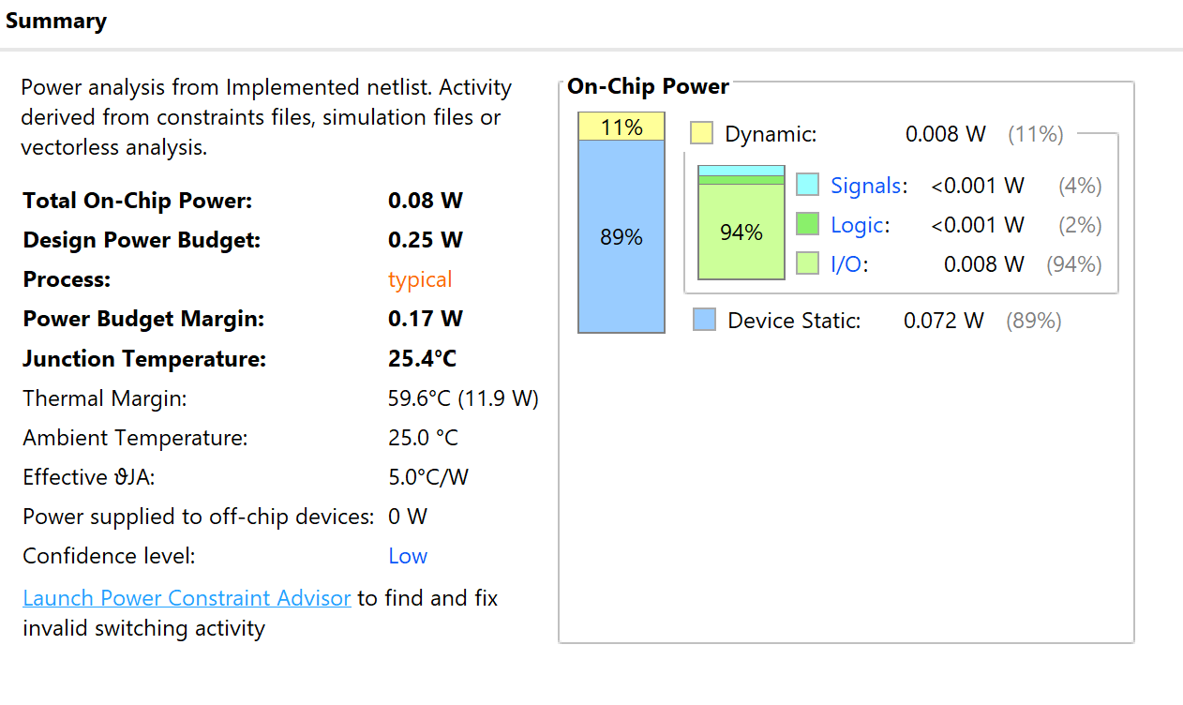
Figure 32 – Wallace tree implemented design power summary

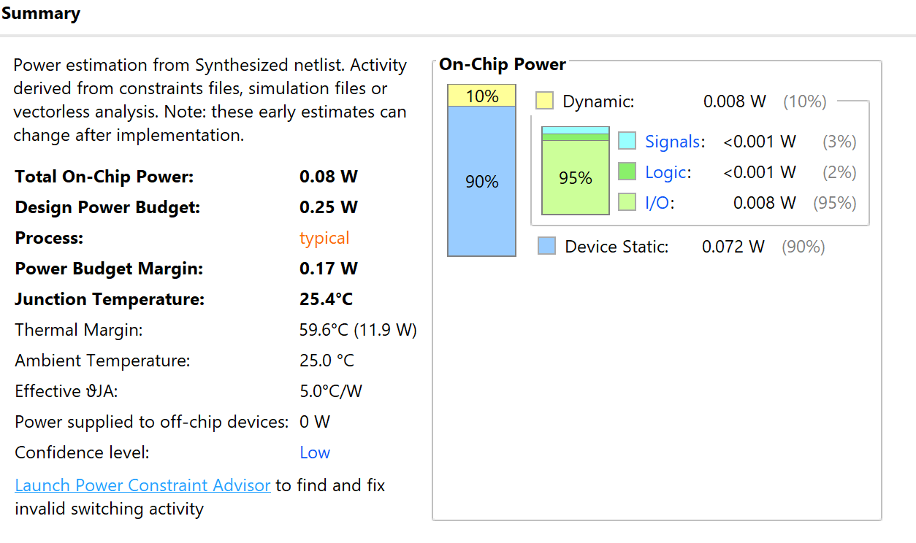
Figure 33 – Wallace tree synthesized design power summary
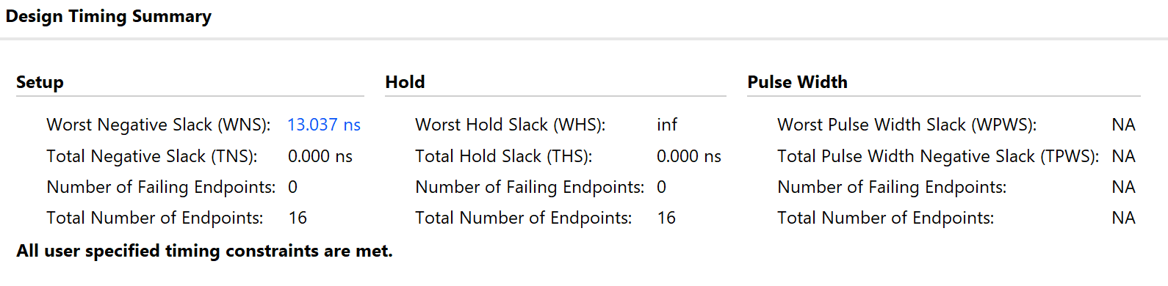
Figure 34 – Wallace tree implemented design timing summary
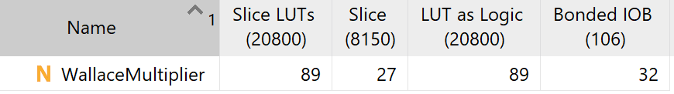
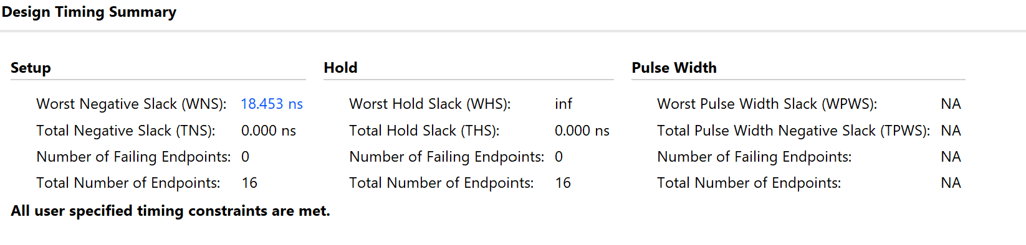
Figure 35 – Wallace tree synthesized design timing summary
Figure 36 – Wallace tree utilization report

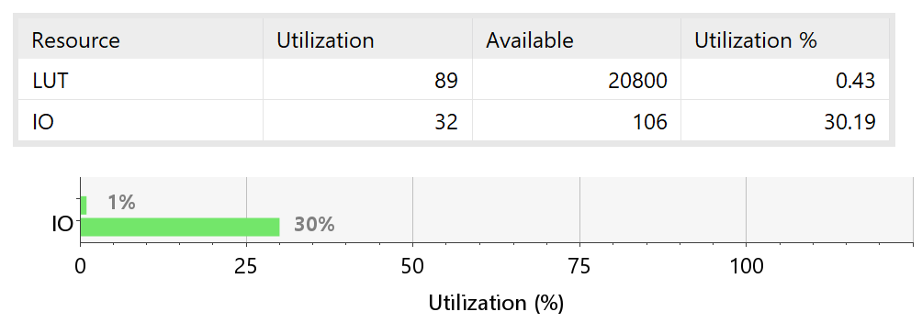
Figure 37 – Wallace tree utilization summary
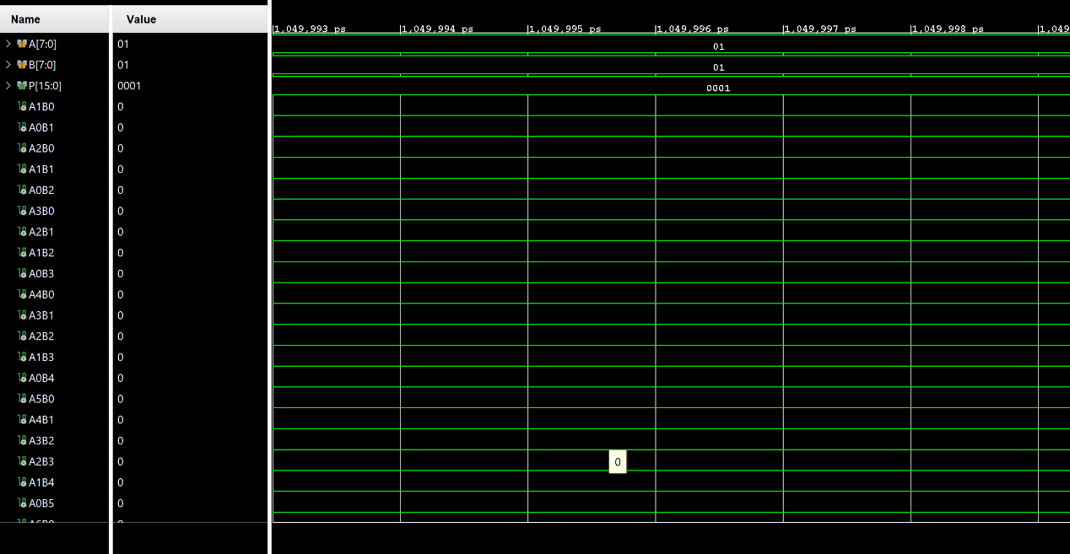
Figure 38 – Wallace tree multiplier simulation results with inputs 01 and 01
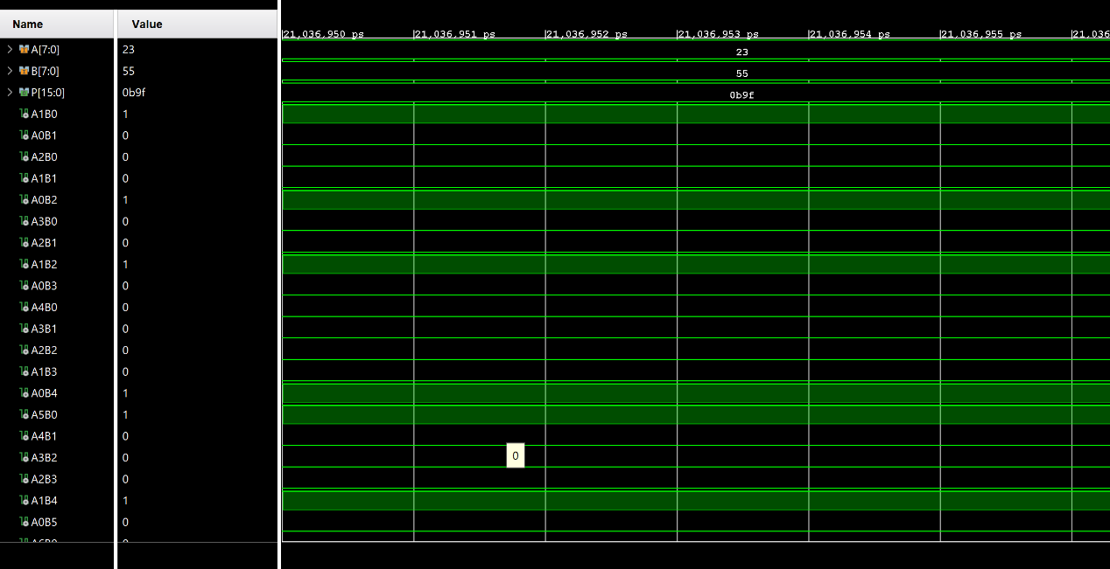
Figure 39 - Wallace tree multiplier simulation results with inputs 23 and 55

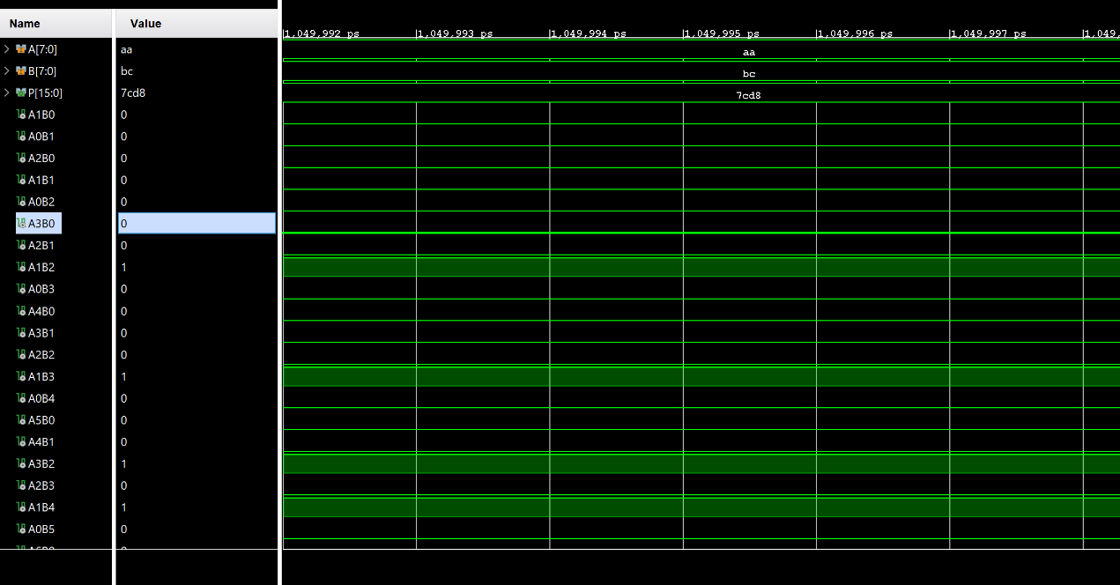
Figure 40 - Wallace tree multiplier simulation results with inputs aa and bc
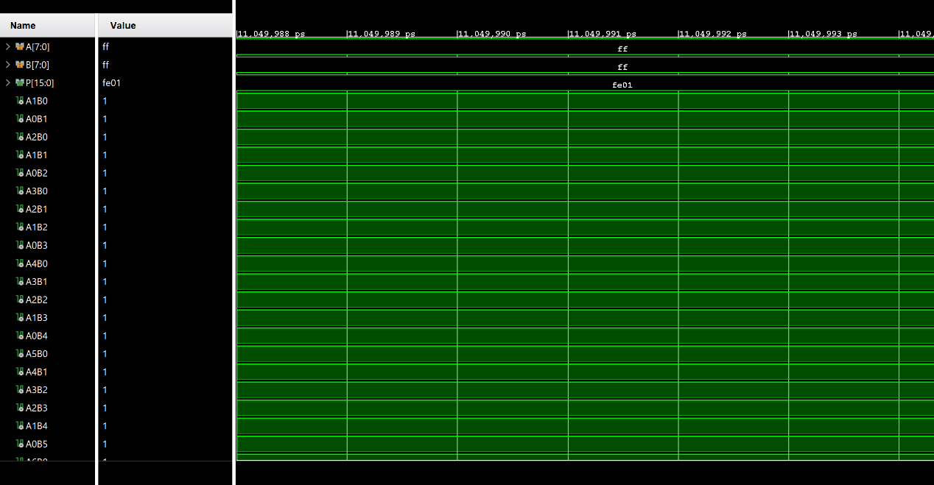
Figure 41 - Wallace tree multiplier simulation results with inputs ff and ff

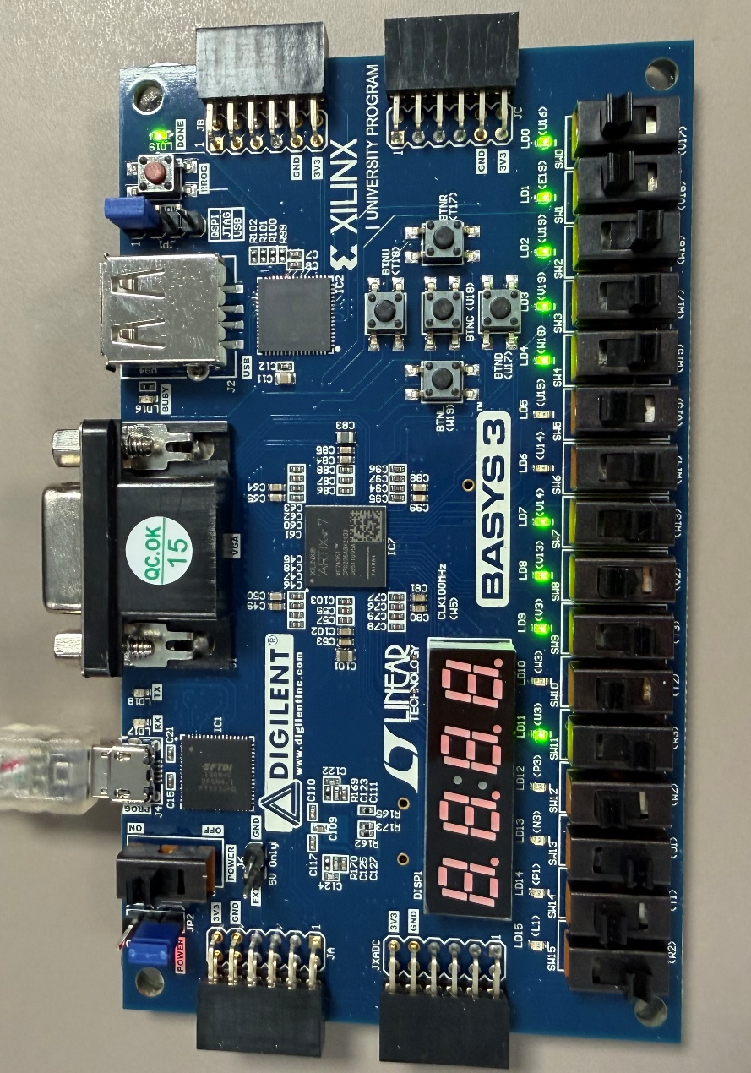
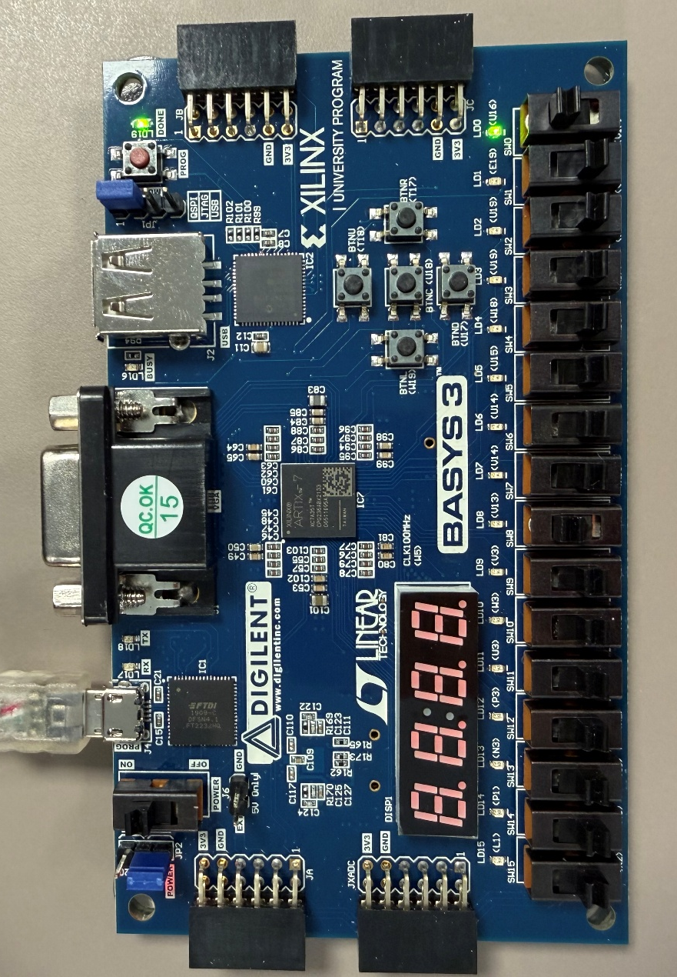
Figure 42 - Wallace tree multiplier real results with inputs 01 and 01
Figure 43 - Wallace tree multiplier real results with inputs 23 and 55

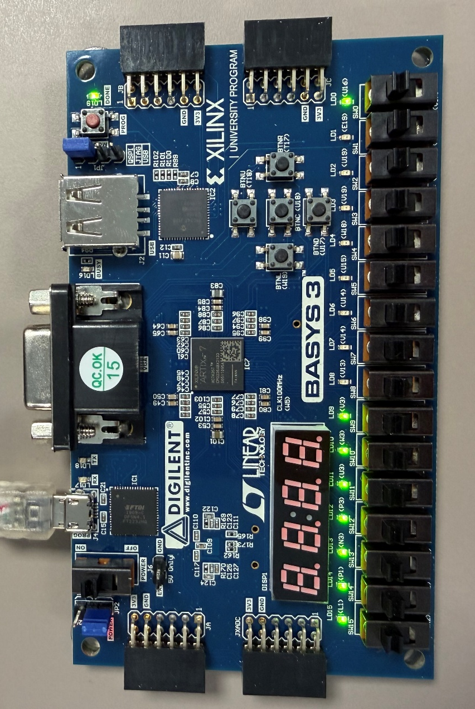
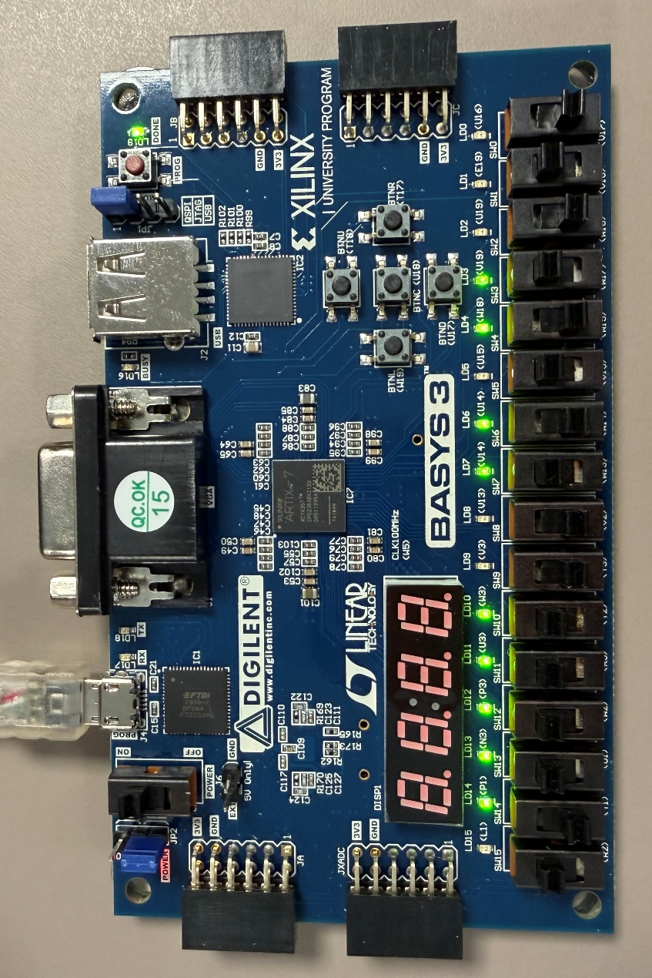
Figure 44 - Wallace tree multiplier real results with inputs aa and bc
Figure 45 - Wallace tree multiplier real results with inputs ff and ff

Comparison

Results comparison
The Braun and Wallace tree multipliers were synthesized and implemented using Vivado to compare their performance. Although the Wallace tree is designed to reduce the propagation delay by compressing partial products into parallel, the difference between the results is minimal. The maximum delay of the adders is better on the Wallace, at 31ns, compared to the Brauns 41ns, which is a delay improvement of about 25%.
The worst negative slack (WNS) of the synthesized Brauns multiplier was 24.655ns, while the synthesized Wallace tree WNS was 18.453ns. After implementation, the Brauns reported 18.44ns, compared to 13.037ns for the Wallace. Both designs met all timing constraints with no failing endpoints, meaning both implementations operated correctly within the specified 45ns clock period. Despite the Wallace having a better theoretical propagation delay, the post implementation reports show the Brauns had a slightly higher WNS, which is likely down to how the synthesized implementations were optimized in Vivado.
The power analysis was also very similar. Both the Brauns and Wallace tree multipliers consumed 0.08W of total on-chip power, with static power taking up 89-90% of the total consumption. Dynamic power also remained low for both designs, ranging between 10-11%, with the I/Os contributing to most of the dynamic power.
Similarly, the resource utilization was very similar, with the Brauns requiring 90 LUTs and the Wallace tree requiring 89 LUTs. This shows the Wallace tree is more resource efficient than the Brauns and has a smaller footprint, agreeing with the theory on Wallace tree multipliers. Both designs used 27 slices and 32 I/O pins, which shows that implementing the Wallace reduction structure did not significantly affect FPGA resource usage for an 8x8.
Overall, the results of the Viviado simulations indicate that there is not much difference between the Braun array and Wallace tree when implemented as an 8x8 design. Despite the Wallace tree architecture theoretically is faster due to its parallel reduction of partial products, the designs being an 8x8 multiplier limits the potential performance improvements Wallace trees can provide. As a consequence, both multipliers have nearly identical timing, power consumption and resource utilization.

Recommendations for future improvements
The Wallace tree is expected to provide greater performance improvements for larger multipliers, such as 16x16, 32x32 or 64x64. As the number of partial products increases, the reduction stages become more complex, allowing the Wallace trees benefits to show more clearly. The parallel reduction technique would significantly reduce the propagation delay compared to a regular Brauns array at these larger multiplier sizes. Future work therefore should investigate larger multipliers to better demonstrate the performance gains of the Wallace architecture and noting the changes in resource utilization and power consumption.
Further investigation in other multiplier architectures, like the booth and Baugh Wooley would provide a greater comparison and provide a better understanding of signed and unsigned multiplication techniques. This would give a wider comprehension of multipliers and allow a better idea on which one performs the best.
Based on the findings of this report and the theory of multipliers, I would recommend a Brauns for 8x8 multipliers due to its simplicity and similar performance to the Wallace. If high performance is the focus, then the Wallace tree would be the best choice. For larger multipliers, I would recommend the Wallace tree due to its higher performance.

Conclusion
To conclude, this report has presented a comprehensive study of several multiplier architectures, with a focus on the implementation and evaluation of an 8x8 Braun array and Wallace tree in an FPGA. The synthesis and implementation results both successfully met the timing constraints and worked correctly in simulation and real hardware testing. Although the Wallace tree theoretically reduces propagation delay by parallel partial product reduction, the measured improvement for the 8x8 was minimal. The Wallace achieved a lower critical path at 31ns, compared to the Brauns 41ns, but post implementation showed minimal differences. Both multiplier designs showed similar on chip power usage, nearly identical LUT and slice usage, indicating similar FPGA efficiency.
Overall, the results indicate that at small operand sizes, architectural differences between the two multipliers are hard to distinguish due to hardware constraints and synthesis optimization. Future work should investigate larger word sizes and other architectures to better expose the performance trade-offs in practical applications.

References

[1] | D. Rao, “An In-Depth Exploration of Digital Multipliers: Architectures and Implementations,” Diverse Daily, 3 August 2025. [Online]. Available: https://diversedaily.com/an-in-depth-exploration-of-digital-multipliers-architectures-and-implementations/. [Accessed 26 June 2026].
[2] | R. Gorla, “Multipliers in Digital Circuits,” VLSI Web, 21 April 2024. [Online]. Available: https://vlsiweb.com/multipliers/. [Accessed 26 June 2026].
[3] | M. Raghu, M. Aishwarya and M. P. K. Reddy, “Design of 4-Bit Braun Multiplier using CNTFET technology,” International Journal of research and analytical reviews, vol. 10, no. 2, pp. 579-582, 2023.
[4] | Ravindra College of Engineering Women, “VLSI Unit 4,” [Online]. Available: https://www.recw.ac.in/v2.0/wp-content/uploads/2019/04/vlsi-unit4.pdf. [Accessed 27 June 2026].
[5] | B. Singroul and P. Jaiswal, “A Review on Performance Evaluation of Different Digital Multipliers in VLSI using VHDL,” INTERNATIONAL JOURNAL OF ENGINEERING RESEARCH & TECHNOLOGY, vol. 7, no. 5, pp. 57-64, 2018.
[6] | S. Kaur, “FPGA Implementation of efficient modified Booth Wallace Multiplier,” Department of Electronics & Communication Engineering Thapar University, Patiala, 2011.
[7] | C. Ananda and M. Gudhimetla, “COMPARISON OF DIFFERENT TYPES OF MULTIPLIERS WITH RESPECT TO SPEED, AREA AND POWER,” in 35th IRF International Conference, Bengaluru, 2017.
[8] | D. R. Bolimera, P. S. S. Reddy, I. Anu and P. S. Krishna, “4*4 Braun Multiplier using Adder Cells,” International Journal of Data Science And IOT Management System, pp. 395-399, 2025.
[9] | V. Bagyaveereswaran, L. Jesima W, A. Nelapati and A. R, “Comparative Study of High performance Braun’s Multiplier using FPGA,” IOSR Journal of Electronics and Communication Engineering, vol. 1, no. 4, pp. 33-37, 2012.
[10] | M. H. Al Mijalli and M. H. Rais, “Field Programmable Gate Arrays based Design, Implementation and delay study of Braun's multiplier,” Journal of Computer Science 7, pp. 1894-1899, 2011.
[11] | A. Munoz and A. Jimenez, “Very-Large-Scale Integration (VLSI) Implementation and Performance Comparison of Multiplier Topologies for Fixed- and Floating-Point Numbers,” Applied sciences, pp. 1-14, 2025.
[12] | H. Brunda, H. Jayalazmi, H. Aritha, A. R. Patil and G. Manjushree, “Comparative Analysis of Various Multipliers Based on Performance,” Scientia, vol. 2, no. 5, pp. 100-108, 2025.
[13] | L. Dadda, “Some Schemes for Parallel Multipliers,” Alta Frequenza, vol. 34, pp. 349-356, 1965.
[14] | B. Ramkumar, V. Sreedeep and H. M. Kittur, “A Design Technique for Faster Dadda Multiplier,” VIT University, Vellore.
[15] | J. Sreeja, K. Srima, C. parameshwari and G. Samatha, “DESIGN AND ANALYSIS OF A 4×4 DADDA MULTIPLIER IMPLEMENTED USING 45NM CMOS TECHNOLOGY,” International Journal for Research Trends and Innovation, vol. 10, no. 3, pp. 319-327, 2025.
[16] | A. D. Booth, “A Signed Binary Multiplication Technique,” Quarterly Journel of Mechanics and applied Math, vol. 4, no. 2, pp. 236-240, 1950.
[17] | L. P. Rubinfield, “A Proof of the Modified Booth's Algorithm for Multiplication,” pp. 1014-1015, 1975.
[18] | ProgrammerSought, “[HDL] series multiplier (3) - Baugh-Wooley multiplier,” [Online]. Available: https://www.programmersought.com/article/94273319704/. [Accessed 28 June 2026].
[19] | P. Kishore, B. Akash, G. Aditya and N. Harika, “Design and Analysis of Low Power and High-Speed Baugh Wooley Multiplier using Modified Gate Diffusion Input Technique,” in 3rd International Conference for Innovation in Technology, Bangalore, 2024.
[20] | S. Kulkarni, L. Kulkarni and V. Kunchigi, “High speed and area efficient vedic multiplier,” in International Conference on Devices, Circuits and Systems, Coimbatore, 2012.
[21] | E. J. Rao, D. Nandan, R. V. Krishna and K. J. Kumar, “A Systematic Journal of Multipliers Accuracy,” International Journal of Engineering and Advanced Technology, vol. 8, no. 6, pp. 965-969, 2019.
[22] | M. K. Islam, K. Hasan, N. Sultana and M. H. Bhuyan, “Comparative Analysis of Different Multiplier Circuits Using Cadence at Different Circuit Design Technologies and Nodes,” in International Conference on Electrical, Computer, and Communication Engineering, Chattogram, 2025.
[23] | R. Khubnani, T. Sharma and C. Subramanyam, “Applications of Vedic multiplier - A Review,” in Virtual National Conference on Materials for Electronics Applications, Bangalore, 2021.
[24] | I. Haddadi, I. Qiqieh, R. Shafik, F. Xia, M. Al-hayanni and A. Yakovlev, “Run-time Configurable Approximate Multiplier using Significance-Driven Logic Compression,” in IEEE 39th International Conference on Computer Design (ICCD), 2021.
[25] | D. Rao, “An In-Depth Exploration of Digital Multipliers: Architectures and Implementations,” Diverse Daily, 3 August 2025. [Online]. Available: https://diversedaily.com/an-in-depth-exploration-of-digital-multipliers-architectures-and-implementations/. [Accessed 28 June 2026].

Appendices

Appendix A – Brauns VHDL Code
library IEEE;
use IEEE.STD_LOGIC_1164.ALL;
use IEEE.STD_LOGIC_ARITH.ALL;
use IEEE.STD_LOGIC_UNSIGNED.ALL;

entity BraunsMultiplier is
Port ( A : in STD_LOGIC_VECTOR (7 downto 0);
B : in STD_LOGIC_VECTOR (7 downto 0);
P : out STD_LOGIC_VECTOR (15 downto 0));
end BraunsMultiplier;

architecture Behavioral of BraunsMultiplier is

signal A1B0, A0B1,
A2B0, A1B1, A0B2,
A3B0, A2B1, A1B2, A0B3,
A4B0, A3B1, A2B2, A1B3, A0B4,
A5B0, A4B1, A3B2, A2B3, A1B4, A0B5,
A6B0, A5B1, A4B2, A3B3, A2B4, A1B5, A0B6,
A7B0, A6B1, A5B2, A4B3, A3B4, A2B5, A1B6, A0B7,
A7B1, A6B2, A5B3, A4B4, A3B5, A2B6, A1B7,
A7B2, A6B3, A5B4, A4B5, A3B6, A2B7,
A7B3, A6B4, A5B5, A4B6, A3B7,
A7B4, A6B5, A5B6, A4B7,
A7B5, A6B6, A5B7,
A7B6, A6B7,
A7B7
: std_logic;

signal C1, C2, C3, C4, C5, C6, C7, C8, C9, C10, C11, C12,
C13, C14, C15, C16, C17, C18, C19, C20, C21, C22, C23, C24,
C25, C26, C27, C28, C29, C30, C31, C32, C33, C34, C35, C36,
C37, C38, C39, C40, C41, C42, C43, C44, C45, C46, C47, C48,
C49, C50, C51, C52, C53, C54, C55, C56
: std_logic;

signal S2, S3, S4, S5, S6, S7, S8,
S10, S11, S12, S13, S14, S15, S16,
S18, S19, S20, S21, S22, S23, S24,
S26, S27, S28, S29, S30, S31, S32,
S34, S35, S36, S37, S38, S39, S40,
S42, S43, S44, S45, S46, S47, S48
: std_logic;

component FullAdder
port (A : in STD_LOGIC;
B : in STD_LOGIC;
Cin : in STD_LOGIC;
S : out STD_LOGIC;
Cout: out STD_LOGIC);
end component;

component HalfAdder
port (A : in STD_LOGIC;
B : in STD_LOGIC;
S : out STD_LOGIC;
Cout : out STD_LOGIC);
end component;

begin

A1B0 <= A(1) AND B(0);
A0B1 <= A(0) AND B(1);

A2B0 <= A(2) AND B(0);
A1B1 <= A(1) AND B(1);
A0B2 <= A(0) AND B(2);

A3B0 <= A(3) AND B(0);
A2B1 <= A(2) AND B(1);
A1B2 <= A(1) AND B(2);
A0B3 <= A(0) AND B(3);

A4B0 <= A(4) AND B(0);
A3B1 <= A(3) AND B(1);
A2B2 <= A(2) AND B(2);
A1B3 <= A(1) AND B(3);
A0B4 <= A(0) AND B(4);

A5B0 <= A(5) AND B(0);
A4B1 <= A(4) AND B(1);
A3B2 <= A(3) AND B(2);
A2B3 <= A(2) AND B(3);
A1B4 <= A(1) AND B(4);
A0B5 <= A(0) AND B(5);

A6B0 <= A(6) AND B(0);
A5B1 <= A(5) AND B(1);
A4B2 <= A(4) AND B(2);
A3B3 <= A(3) AND B(3);
A2B4 <= A(2) AND B(4);
A1B5 <= A(1) AND B(5);
A0B6 <= A(0) AND B(6);

A7B0 <= A(7) AND B(0);
A6B1 <= A(6) AND B(1);
A5B2 <= A(5) AND B(2);
A4B3 <= A(4) AND B(3);
A3B4 <= A(3) AND B(4);
A2B5 <= A(2) AND B(5);
A1B6 <= A(1) AND B(6);
A0B7 <= A(0) AND B(7);

A7B1 <= A(7) AND B(1);
A6B2 <= A(6) AND B(2);
A5B3 <= A(5) AND B(3);
A4B4 <= A(4) AND B(4);
A3B5 <= A(3) AND B(5);
A2B6 <= A(2) AND B(6);
A1B7 <= A(1) AND B(7);

A7B2 <= A(7) AND B(2);
A6B3 <= A(6) AND B(3);
A5B4 <= A(5) AND B(4);
A4B5 <= A(4) AND B(5);
A3B6 <= A(3) AND B(6);
A2B7 <= A(2) AND B(7);

A7B3 <= A(7) AND B(3);
A6B4 <= A(6) AND B(4);
A5B5 <= A(5) AND B(5);
A4B6 <= A(4) AND B(6);
A3B7 <= A(3) AND B(7);

A7B4 <= A(7) AND B(4);
A6B5 <= A(6) AND B(5);
A5B6 <= A(5) AND B(6);
A4B7 <= A(4) AND B(7);

A7B5 <= A(7) AND B(5);
A6B6 <= A(6) AND B(6);
A5B7 <= A(5) AND B(7);

A7B6 <= A(7) AND B(6);
A6B7 <= A(6) AND B(7);

A7B7 <= A(7) AND B(7);

P0 : P(0) <= A(0) AND B(0);

P1 : HalfAdder port map (A => A1B0, B => A0B1, S => P(1), Cout => C1);

S_2 : FullAdder port map (A => A2B0, B => A1B1, Cin => C1, S => S2, Cout => C2);
P2 : HalfAdder port map (A => S2, B => A0B2, S => P(2), Cout => C9);

S_3 : FullAdder port map (A => A3B0, B => A2B1, Cin => C2, S => S3, Cout => C3);
S_10 : FullAdder port map (A => S3, B => A1B2, Cin => C9, S => S10, Cout => C10);
P3 : HalfAdder port map (A => S10, B => A0B3, S => P(3), Cout => C17);

S_4 : FullAdder port map (A => A4B0, B => A3B1, Cin => C3, S => S4, Cout => C4);
S_11 : FullAdder port map (A => S4, B => A2B2, Cin => C10, S => S11, Cout => C11);
S_18 : FullAdder port map (A => S11, B => A1B3, Cin => C17, S => S18, Cout => C18);
P4 : HalfAdder port map (A => S18, B => A0B4, S => P(4), Cout => C25);

S_5 : FullAdder port map (A => A5B0, B => A4B1, Cin => C4, S => S5, Cout => C5);
S_12 : FullAdder port map (A => S5, B => A3B2, Cin => C11, S => S12, Cout => C12);
S_19 : FullAdder port map (A => S12, B => A2B3, Cin => C18, S => S19, Cout => C19);
S_26 : FullAdder port map (A => S19, B => A1B4, Cin => C25, S => S26, Cout => C26);
P5 : HalfAdder port map (A => S26, B => A0B5, S => P(5), Cout => C33);

S_6 : FullAdder port map (A => A6B0, B => A5B1, Cin => C5, S => S6, Cout => C6);
S_13 : FullAdder port map (A => S6, B => A4B2, Cin => C12, S => S13, Cout => C13);
S_20 : FullAdder port map (A => S13, B => A3B3, Cin => C19, S => S20, Cout => C20);
S_27 : FullAdder port map (A => S20, B => A2B4, Cin => C26, S => S27, Cout => C27);
S_34 : FullAdder port map (A => S27, B => A1B5, Cin => C33, S => S34, Cout => C34);
P6 : HalfAdder port map (A => S34, B => A0B6, S => P(6), Cout => C41);

S_7 : FullAdder port map (A => A7B0, B => A6B1, Cin => C6, S => S7, Cout => C7);
S_14 : FullAdder port map (A => S7, B => A5B2, Cin => C13, S => S14, Cout => C14);
S_21 : FullAdder port map (A => S14, B => A4B3, Cin => C20, S => S21, Cout => C21);
S_28 : FullAdder port map (A => S21, B => A3B4, Cin => C27, S => S28, Cout => C28);
S_35 : FullAdder port map (A => S28, B => A2B5, Cin => C34, S => S35, Cout => C35);
S_42 : FullAdder port map (A => S35, B => A1B6, Cin => C41, S => S42, Cout => C42);
P7 : HalfAdder port map (A => S42, B => A0B7, S => P(7), Cout => C49);

S_8 : HalfAdder port map (A => A7B1, B => C7, S => S8, Cout => C8);
S_15 : FullAdder port map (A => S8, B => A6B2, Cin => C14, S => S15, Cout => C15);
S_22 : FullAdder port map (A => S15, B => A5B3, Cin => C21, S => S22, Cout => C22);
S_29 : FullAdder port map (A => S22, B => A4B4, Cin => C28, S => S29, Cout => C29);
S_36 : FullAdder port map (A => S29, B => A3B5, Cin => C35, S => S36, Cout => C36);
S_43 : FullAdder port map (A => S36, B => A2B6, Cin => C42, S => S43, Cout => C43);
P8 : FullAdder port map (A => S43, B => A1B7, Cin => C49, S => P(8), Cout => C50);

S_16 : FullAdder port map (A => C8, B => A7B2, Cin => C15, S => S16, Cout => C16);
S_23 : FullAdder port map (A => S16, B => A6B3, Cin => C22, S => S23, Cout => C23);
S_30 : FullAdder port map (A => S23, B => A5B4, Cin => C29, S => S30, Cout => C30);
S_37 : FullAdder port map (A => S30, B => A4B5, Cin => C36, S => S37, Cout => C37);
S_44 : FullAdder port map (A => S37, B => A3B6, Cin => C43, S => S44, Cout => C44);
P9 : FullAdder port map (A => S44, B => A2B7, Cin => C50, S => P(9), Cout => C51);

S_24 : FullAdder port map (A => C16, B => A7B3, Cin => C23, S => S24, Cout => C24);
S_31 : FullAdder port map (A => S24, B => A6B4, Cin => C30, S => S31, Cout => C31);
S_38 : FullAdder port map (A => S31, B => A5B5, Cin => C37, S => S38, Cout => C38);
S_45 : FullAdder port map (A => S38, B => A4B6, Cin => C44, S => S45, Cout => C45);
P10 : FullAdder port map (A => S45, B => A3B7, Cin => C51, S => P(10), Cout => C52);

S_32 : FullAdder port map (A => C24, B => A7B4, Cin => C31, S => S32, Cout => C32);
S_39 : FullAdder port map (A => S32, B => A6B5, Cin => C38, S => S39, Cout => C39);
S_46 : FullAdder port map (A => S39, B => A5B6, Cin => C45, S => S46, Cout => C46);
P11 : FullAdder port map (A => S46, B => A4B7, Cin => C52, S => P(11), Cout => C53);

S_40 : FullAdder port map (A => C32, B => A7B5, Cin => C39, S => S40, Cout => C40);
S_47 : FullAdder port map (A => S40, B => A6B6, Cin => C46, S => S47, Cout => C47);
P12 : FullAdder port map (A => S47, B => A5B7, Cin => C53, S => P(12), Cout => C54);

S_48 : FullAdder port map (A => C40, B => A7B6, Cin => C47, S => S48, Cout => C48);
P13 : FullAdder port map (A => S48, B => A6B7, Cin => C54, S => P(13), Cout => C55);

P14 : FullAdder port map (A => C48, B => A7B7, Cin => C55, S => P(14), Cout => P(15));

end Behavioral;

Appendix B – Constraints code for Brauns simulations
set_operating_conditions -design_power_budget 0.25
set_property IOSTANDARD LVCMOS33 [get_ports {A[7]}]
set_property PACKAGE_PIN V17 [get_ports {A[0]}]
set_property IOSTANDARD LVCMOS33 [get_ports {A[6]}]
set_property IOSTANDARD LVCMOS33 [get_ports {A[5]}]
set_property IOSTANDARD LVCMOS33 [get_ports {A[4]}]
set_property IOSTANDARD LVCMOS33 [get_ports {A[3]}]
set_property IOSTANDARD LVCMOS33 [get_ports {A[2]}]
set_property IOSTANDARD LVCMOS33 [get_ports {A[1]}]
set_property IOSTANDARD LVCMOS33 [get_ports {A[0]}]
set_property IOSTANDARD LVCMOS33 [get_ports {B[7]}]
set_property IOSTANDARD LVCMOS33 [get_ports {B[6]}]
set_property IOSTANDARD LVCMOS33 [get_ports {B[5]}]
set_property IOSTANDARD LVCMOS33 [get_ports {B[4]}]
set_property IOSTANDARD LVCMOS33 [get_ports {B[3]}]
set_property IOSTANDARD LVCMOS33 [get_ports {B[2]}]
set_property IOSTANDARD LVCMOS33 [get_ports {B[1]}]
set_property IOSTANDARD LVCMOS33 [get_ports {B[0]}]
set_property PACKAGE_PIN V16 [get_ports {A[1]}]
set_property PACKAGE_PIN W16 [get_ports {A[2]}]
set_property PACKAGE_PIN W17 [get_ports {A[3]}]
set_property PACKAGE_PIN W15 [get_ports {A[4]}]
set_property PACKAGE_PIN V15 [get_ports {A[5]}]
set_property PACKAGE_PIN W14 [get_ports {A[6]}]
set_property PACKAGE_PIN W13 [get_ports {A[7]}]
set_property PACKAGE_PIN V2 [get_ports {B[0]}]
set_property PACKAGE_PIN T3 [get_ports {B[1]}]
set_property PACKAGE_PIN T2 [get_ports {B[2]}]
set_property PACKAGE_PIN R3 [get_ports {B[3]}]
set_property PACKAGE_PIN W2 [get_ports {B[4]}]
set_property PACKAGE_PIN U1 [get_ports {B[5]}]
set_property PACKAGE_PIN T1 [get_ports {B[6]}]
set_property PACKAGE_PIN R2 [get_ports {B[7]}]
set_property IOSTANDARD LVCMOS33 [get_ports {P[15]}]
set_property IOSTANDARD LVCMOS33 [get_ports {P[14]}]
set_property IOSTANDARD LVCMOS33 [get_ports {P[13]}]
set_property IOSTANDARD LVCMOS33 [get_ports {P[12]}]
set_property IOSTANDARD LVCMOS33 [get_ports {P[11]}]
set_property IOSTANDARD LVCMOS33 [get_ports {P[10]}]
set_property IOSTANDARD LVCMOS33 [get_ports {P[9]}]
set_property IOSTANDARD LVCMOS33 [get_ports {P[8]}]
set_property IOSTANDARD LVCMOS33 [get_ports {P[7]}]
set_property IOSTANDARD LVCMOS33 [get_ports {P[6]}]
set_property IOSTANDARD LVCMOS33 [get_ports {P[5]}]
set_property IOSTANDARD LVCMOS33 [get_ports {P[4]}]
set_property IOSTANDARD LVCMOS33 [get_ports {P[3]}]
set_property IOSTANDARD LVCMOS33 [get_ports {P[1]}]
set_property IOSTANDARD LVCMOS33 [get_ports {P[2]}]
set_property IOSTANDARD LVCMOS33 [get_ports {P[0]}]
set_property PACKAGE_PIN U16 [get_ports {P[0]}]
set_property PACKAGE_PIN E19 [get_ports {P[1]}]
set_property PACKAGE_PIN U19 [get_ports {P[2]}]
set_property PACKAGE_PIN V19 [get_ports {P[3]}]
set_property PACKAGE_PIN W18 [get_ports {P[4]}]
set_property PACKAGE_PIN U15 [get_ports {P[5]}]
set_property PACKAGE_PIN U14 [get_ports {P[6]}]
set_property PACKAGE_PIN V14 [get_ports {P[7]}]
set_property PACKAGE_PIN V13 [get_ports {P[8]}]
set_property PACKAGE_PIN V3 [get_ports {P[9]}]
set_property PACKAGE_PIN W3 [get_ports {P[10]}]
set_property PACKAGE_PIN U3 [get_ports {P[11]}]
set_property PACKAGE_PIN P3 [get_ports {P[12]}]
set_property PACKAGE_PIN N3 [get_ports {P[13]}]
set_property PACKAGE_PIN P1 [get_ports {P[14]}]
set_property PACKAGE_PIN L1 [get_ports {P[15]}]

set_operating_conditions -design_power_budget 0.25
create_clock -period 45.000 -name virtual_clk
set_max_delay -from [get_ports A*] -to [get_ports P*] 41.000

Appendix C – Wallace tree VHDL code

library IEEE;
use IEEE.STD_LOGIC_1164.ALL;

-- Uncomment the following library declaration if using
-- arithmetic functions with Signed or Unsigned values
--use IEEE.NUMERIC_STD.ALL;

-- Uncomment the following library declaration if instantiating
-- any Xilinx leaf cells in this code.
--library UNISIM;
--use UNISIM.VComponents.all;

entity WallaceMultiplier is
Port ( A : in STD_LOGIC_VECTOR (7 downto 0);
B : in STD_LOGIC_VECTOR (7 downto 0);
P : out STD_LOGIC_VECTOR (15 downto 0));
end WallaceMultiplier;

architecture Behavioral of WallaceMultiplier is

signal A1B0, A0B1,
A2B0, A1B1, A0B2,
A3B0, A2B1, A1B2, A0B3,
A4B0, A3B1, A2B2, A1B3, A0B4,
A5B0, A4B1, A3B2, A2B3, A1B4, A0B5,
A6B0, A5B1, A4B2, A3B3, A2B4, A1B5, A0B6,
A7B0, A6B1, A5B2, A4B3, A3B4, A2B5, A1B6, A0B7,
A7B1, A6B2, A5B3, A4B4, A3B5, A2B6, A1B7,
A7B2, A6B3, A5B4, A4B5, A3B6, A2B7,
A7B3, A6B4, A5B5, A4B6, A3B7,
A7B4, A6B5, A5B6, A4B7,
A7B5, A6B6, A5B7,
A7B6, A6B7,
A7B7
: std_logic;

signal C1, C2, C3, C4, C5, C6, C7, C8, C9, C10, C11, C12,
C13, C14, C15, C16, C17, C18, C19, C20, C21, C22, C23, C24,
C25, C26, C27, C28, C29, C30, C31, C32, C33, C34, C35, C36,
C37, C38, C39, C40, C41, C42, C43, C44, C45, C46, C47, C48,
C49, C50, C51, C52, C53, C54, C55, C56, C57, C58, C59, C60, C61, C62, C63, C64
: std_logic;

signal S2, S3, S4, S5, S6, S7, S8, S9, S10, S11, S12, S13, S14, S15, S16,
S18, S19, S20, S21, S22, S23, S24, S25, S26, S27, S28, S29, S30, S31, S32,
S34, S35, S36, S37, S38, S39, S40, S41, S42,
S44, S45, S46, S47, S48, S49, S50, S51, S52, S53
: std_logic;

component FullAdder
port (A : in STD_LOGIC;
B : in STD_LOGIC;
Cin : in STD_LOGIC;
S : out STD_LOGIC;
Cout: out STD_LOGIC);
end component;

component HalfAdder
port (A : in STD_LOGIC;
B : in STD_LOGIC;
S : out STD_LOGIC;
Cout : out STD_LOGIC);
end component;

begin

A1B0 <= A(1) AND B(0);
A0B1 <= A(0) AND B(1);

A2B0 <= A(2) AND B(0);
A1B1 <= A(1) AND B(1);
A0B2 <= A(0) AND B(2);

A3B0 <= A(3) AND B(0);
A2B1 <= A(2) AND B(1);
A1B2 <= A(1) AND B(2);
A0B3 <= A(0) AND B(3);

A4B0 <= A(4) AND B(0);
A3B1 <= A(3) AND B(1);
A2B2 <= A(2) AND B(2);
A1B3 <= A(1) AND B(3);
A0B4 <= A(0) AND B(4);

A5B0 <= A(5) AND B(0);
A4B1 <= A(4) AND B(1);
A3B2 <= A(3) AND B(2);
A2B3 <= A(2) AND B(3);
A1B4 <= A(1) AND B(4);
A0B5 <= A(0) AND B(5);

A6B0 <= A(6) AND B(0);
A5B1 <= A(5) AND B(1);
A4B2 <= A(4) AND B(2);
A3B3 <= A(3) AND B(3);
A2B4 <= A(2) AND B(4);
A1B5 <= A(1) AND B(5);
A0B6 <= A(0) AND B(6);

A7B0 <= A(7) AND B(0);
A6B1 <= A(6) AND B(1);
A5B2 <= A(5) AND B(2);
A4B3 <= A(4) AND B(3);
A3B4 <= A(3) AND B(4);
A2B5 <= A(2) AND B(5);
A1B6 <= A(1) AND B(6);
A0B7 <= A(0) AND B(7);

A7B1 <= A(7) AND B(1);
A6B2 <= A(6) AND B(2);
A5B3 <= A(5) AND B(3);
A4B4 <= A(4) AND B(4);
A3B5 <= A(3) AND B(5);
A2B6 <= A(2) AND B(6);
A1B7 <= A(1) AND B(7);

A7B2 <= A(7) AND B(2);
A6B3 <= A(6) AND B(3);
A5B4 <= A(5) AND B(4);
A4B5 <= A(4) AND B(5);
A3B6 <= A(3) AND B(6);
A2B7 <= A(2) AND B(7);

A7B3 <= A(7) AND B(3);
A6B4 <= A(6) AND B(4);
A5B5 <= A(5) AND B(5);
A4B6 <= A(4) AND B(6);
A3B7 <= A(3) AND B(7);

A7B4 <= A(7) AND B(4);
A6B5 <= A(6) AND B(5);
A5B6 <= A(5) AND B(6);
A4B7 <= A(4) AND B(7);

A7B5 <= A(7) AND B(5);
A6B6 <= A(6) AND B(6);
A5B7 <= A(5) AND B(7);

A7B6 <= A(7) AND B(6);
A6B7 <= A(6) AND B(7);

A7B7 <= A(7) AND B(7);

P0 : P(0) <= A(0) AND B(0);

P1 : HalfAdder port map (A => A1B0, B => A0B1, S => P(1), Cout => C1);

S_2 : FullAdder port map (A => A2B0, B => A1B1, Cin => A0B2, S => S2, Cout => C2);
P2 : HalfAdder port map (A => S2, B => C1, S => P(2), Cout => C17);

S_3 : FullAdder port map (A => A3B0, B => A2B1, Cin => A1B2, S => S3, Cout => C3);
S_18 : FullAdder port map (A => S3, B => A0B3, Cin => C2, S => S18, Cout => C18);
P3 : HalfAdder port map (A => C17, B => S18, S => P(3), Cout => C33);

S_4 : FullAdder port map (A => A4B0, B => A3B1, Cin => A2B2, S => S4, Cout => C4);
S_5 : HalfAdder port map (A => A1B3, B => A0B4, S => S5, Cout => C5);
S_19 : FullAdder port map (A => S4, B => S5, Cin => C3, S => S19, Cout => C19);
S_34 : HalfAdder port map (A => C18, B => S19, S => S34, Cout => C34);
P4 : HalfAdder port map (A => S34, B => C33, S => P(4), Cout => C43);

S_6 : FullAdder port map (A => A5B0, B => A4B1, Cin => A3B2, S => S6, Cout => C6);
S_7 : FullAdder port map (A => A2B3, B => A1B4, Cin => A0B5, S => S7, Cout => C7);
S_20 : FullAdder port map (A => C4, B => S7, Cin => S6, S => S20, Cout => C20);
S_35 : FullAdder port map (A => S20, B => C5, Cin => C19, S => S35, Cout => C35);
S_44 : HalfAdder port map (A => S35, B => C34, S => S44, Cout => C44);
P5 : HalfAdder port map (A => S44, B => C43, S => P(5), Cout => C54);

S_8 : FullAdder port map (A => A6B0, B => A5B1, Cin => A4B2, S => S8, Cout => C8);
S_9 : FullAdder port map (A => A3B3, B => A2B4, Cin => A1B5, S => S9, Cout => C9);
S_21 : FullAdder port map (A => S9, B => S8, Cin => C6, S => S21, Cout => C21);
S_22 : HalfAdder port map (A => A0B6, B => C7, S => S22, Cout => C22);
S_36 : FullAdder port map (A => S21, B => S22, Cin => C20, S => S36, Cout => C36);
S_45 : HalfAdder port map (A => S36, B => C35, S => S45, Cout => C45);
P6 : FullAdder port map (A => S45, B => C44, Cin => C54, S => P(6), Cout => C55);

S_10 : FullAdder port map (A => A7B0, B => A6B1, Cin => A5B2, S => S10, Cout => C10);
S_11 : FullAdder port map (A => A4B3, B => A3B4, Cin => A2B5, S => S11, Cout => C11);
S_23 : FullAdder port map (A => S11, B => S10, Cin => C8, S => S23, Cout => C23);
S_24 : FullAdder port map (A => A1B6, B => A0B7, Cin => C9, S => S24, Cout => C24);
S_37 : FullAdder port map (A => S24, B => S23, Cin => C21, S => S37, Cout => C37);
S_46 : FullAdder port map (A => S37, B => C22, Cin => C36, S => S46, Cout => C46);
P7 : FullAdder port map (A => S46, B => C45, Cin => C55, S => P(7), Cout => C56);

S_12 : HalfAdder port map (A => A7B1, B => A6B2, S => S12, Cout => C12);
S_13 : FullAdder port map (A => A5B3, B => A4B4, Cin => A3B5, S => S13, Cout => C13);
S_25 : FullAdder port map (A => S13, B => S12, Cin => C10, S => S25, Cout => C25);
S_26 : FullAdder port map (A => A2B6, B => A1B7, Cin => C11, S => S26, Cout => C26);
S_38 : FullAdder port map (A => S26, B => S25, Cin => C23, S => S38, Cout => C38);
S_47 : FullAdder port map (A => S38, B => C24, Cin => C37, S => S47, Cout => C47);
P8 : FullAdder port map (A => S47, B => C46, Cin => C56, S => P(8), Cout => C57);

S_14 : FullAdder port map (A => A6B3, B => A5B4, Cin => A4B5, S => S14, Cout => C14);
S_27 : FullAdder port map (A => S14, B => A7B2, Cin => C12, S => S27, Cout => C27);
S_28 : FullAdder port map (A => A3B6, B => A2B7, Cin => C13, S => S28, Cout => C28);
S_39 : FullAdder port map (A => S27, B => S28, Cin => C25, S => S39, Cout => C39);
S_48 : FullAdder port map (A => S39, B => C26, Cin => C38, S => S48, Cout => C48);
P9 : FullAdder port map (A => S48, B => C47, Cin => C57, S => P(9), Cout => C58);

S_15 : FullAdder port map (A => A7B3, B => A6B4, Cin => A5B5, S => S15, Cout => C15);
S_29 : FullAdder port map (A => A4B6, B => A3B7, Cin => C14, S => S29, Cout => C29);
S_40 : FullAdder port map (A => S15, B => S29, Cin => C27, S => S40, Cout => C40);
S_49 : FullAdder port map (A => S40, B => C28, Cin => C39, S => S49, Cout => C49);
P10 : FullAdder port map (A => S49, B => C48, Cin => C58, S => P(10), Cout => C59);

S_16 : HalfAdder port map (A => A7B4, B => A6B5, S => S16, Cout => C16);
S_30 : FullAdder port map (A => A5B6, B => A4B7, Cin => C15, S => S30, Cout => C30);
S_41 : HalfAdder port map (A => S16, B => S30, S => S41, Cout => C41);
S_50 : FullAdder port map (A => S41, B => C29, Cin => C40, S => S50, Cout => C50);
P11 : FullAdder port map (A => S50, B => C49, Cin => C59, S => P(11), Cout => C60);

S_31 : FullAdder port map (A => A7B5, B => A6B6, Cin => A5B7, S => S31, Cout => C31);
S_42 : HalfAdder port map (A => S31, B => C16, S => S42, Cout => C42);
S_51 : FullAdder port map (A => S42, B => C30, Cin => C41, S => S51, Cout => C51);
P12 : FullAdder port map (A => S51, B => C50, Cin => C60, S => P(12), Cout => C61);

S_32 : HalfAdder port map (A => A7B6, B => A6B7, S => S32, Cout => C32);
S_52 : FullAdder port map (A => S32, B => C31, Cin => C42, S => S52, Cout => C52);
P13 : FullAdder port map (A => S52, B => C51, Cin => C61, S => P(13), Cout => C62);

S_53 : HalfAdder port map (A => A7B7, B => C32, S => S53, Cout => C53);
P14 : FullAdder port map (A => S53, B => C52, Cin => C62, S => P(14), Cout => C63);

P15: HalfAdder port map (A => C53, B => C63, S => P(15), Cout => C64);

end Behavioral;

Appendix D – Constraints code for Wallace tree simulations
set_operating_conditions -design_power_budget 0.25
set_property IOSTANDARD LVCMOS33 [get_ports {A[7]}]
set_property PACKAGE_PIN V17 [get_ports {A[0]}]
set_property IOSTANDARD LVCMOS33 [get_ports {A[6]}]
set_property IOSTANDARD LVCMOS33 [get_ports {A[5]}]
set_property IOSTANDARD LVCMOS33 [get_ports {A[4]}]
set_property IOSTANDARD LVCMOS33 [get_ports {A[3]}]
set_property IOSTANDARD LVCMOS33 [get_ports {A[2]}]
set_property IOSTANDARD LVCMOS33 [get_ports {A[1]}]
set_property IOSTANDARD LVCMOS33 [get_ports {A[0]}]
set_property IOSTANDARD LVCMOS33 [get_ports {B[7]}]
set_property IOSTANDARD LVCMOS33 [get_ports {B[6]}]
set_property IOSTANDARD LVCMOS33 [get_ports {B[5]}]
set_property IOSTANDARD LVCMOS33 [get_ports {B[4]}]
set_property IOSTANDARD LVCMOS33 [get_ports {B[3]}]
set_property IOSTANDARD LVCMOS33 [get_ports {B[2]}]
set_property IOSTANDARD LVCMOS33 [get_ports {B[1]}]
set_property IOSTANDARD LVCMOS33 [get_ports {B[0]}]
set_property PACKAGE_PIN V16 [get_ports {A[1]}]
set_property PACKAGE_PIN W16 [get_ports {A[2]}]
set_property PACKAGE_PIN W17 [get_ports {A[3]}]
set_property PACKAGE_PIN W15 [get_ports {A[4]}]
set_property PACKAGE_PIN V15 [get_ports {A[5]}]
set_property PACKAGE_PIN W14 [get_ports {A[6]}]
set_property PACKAGE_PIN W13 [get_ports {A[7]}]
set_property PACKAGE_PIN V2 [get_ports {B[0]}]
set_property PACKAGE_PIN T3 [get_ports {B[1]}]
set_property PACKAGE_PIN T2 [get_ports {B[2]}]
set_property PACKAGE_PIN R3 [get_ports {B[3]}]
set_property PACKAGE_PIN W2 [get_ports {B[4]}]
set_property PACKAGE_PIN U1 [get_ports {B[5]}]
set_property PACKAGE_PIN T1 [get_ports {B[6]}]
set_property PACKAGE_PIN R2 [get_ports {B[7]}]
set_property IOSTANDARD LVCMOS33 [get_ports {P[15]}]
set_property IOSTANDARD LVCMOS33 [get_ports {P[14]}]
set_property IOSTANDARD LVCMOS33 [get_ports {P[13]}]
set_property IOSTANDARD LVCMOS33 [get_ports {P[12]}]
set_property IOSTANDARD LVCMOS33 [get_ports {P[11]}]
set_property IOSTANDARD LVCMOS33 [get_ports {P[10]}]
set_property IOSTANDARD LVCMOS33 [get_ports {P[9]}]
set_property IOSTANDARD LVCMOS33 [get_ports {P[8]}]
set_property IOSTANDARD LVCMOS33 [get_ports {P[7]}]
set_property IOSTANDARD LVCMOS33 [get_ports {P[6]}]
set_property IOSTANDARD LVCMOS33 [get_ports {P[5]}]
set_property IOSTANDARD LVCMOS33 [get_ports {P[4]}]
set_property IOSTANDARD LVCMOS33 [get_ports {P[3]}]
set_property IOSTANDARD LVCMOS33 [get_ports {P[1]}]
set_property IOSTANDARD LVCMOS33 [get_ports {P[2]}]
set_property IOSTANDARD LVCMOS33 [get_ports {P[0]}]
set_property PACKAGE_PIN U16 [get_ports {P[0]}]
set_property PACKAGE_PIN E19 [get_ports {P[1]}]
set_property PACKAGE_PIN U19 [get_ports {P[2]}]
set_property PACKAGE_PIN V19 [get_ports {P[3]}]
set_property PACKAGE_PIN W18 [get_ports {P[4]}]
set_property PACKAGE_PIN U15 [get_ports {P[5]}]
set_property PACKAGE_PIN U14 [get_ports {P[6]}]
set_property PACKAGE_PIN V14 [get_ports {P[7]}]
set_property PACKAGE_PIN V13 [get_ports {P[8]}]
set_property PACKAGE_PIN V3 [get_ports {P[9]}]
set_property PACKAGE_PIN W3 [get_ports {P[10]}]
set_property PACKAGE_PIN U3 [get_ports {P[11]}]
set_property PACKAGE_PIN P3 [get_ports {P[12]}]
set_property PACKAGE_PIN N3 [get_ports {P[13]}]
set_property PACKAGE_PIN P1 [get_ports {P[14]}]
set_property PACKAGE_PIN L1 [get_ports {P[15]}]

set_operating_conditions -design_power_budget 0.25
create_clock -period 45.000 -name virtual_clk
set_max_delay -from [get_ports A*] -to [get_ports P*] 31.000

