Name: Naseem Khan
I.D: 1807432
Module: BMHP5003 BIRM
Lecturer: Mumtaz Ghoolam

INTRODUCTION TO PHYSIOLOGY

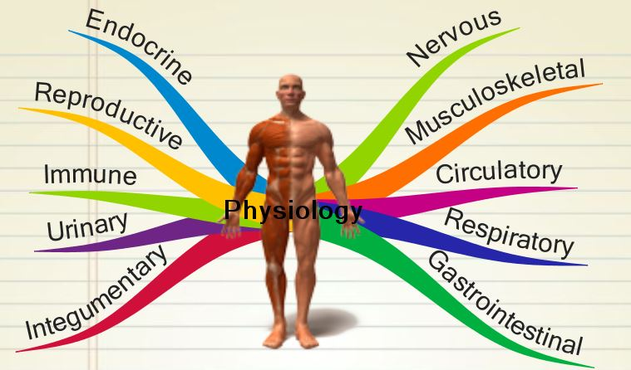

Appendicular View
The cranium known as the skull supports the face and protects the brain. The skull is subdivided into two parts, the facial bones, and the brain case. The facial bones underlie the facial structure of a person such as the nasal cavity, enclosure for the eyeballs and support the teeth. The brain case supports and protects the brain. The skull in an adult is made up of 22 individual bones, 21 of those bones are immobile and formed into a single unit. The mandible (lower jaw) is the 22nd bone which is a moveable bone in the skull. (A) Other than your mandible and your vomer all facial bones are arranged in pairs allowing our faces to be symmetrical, for example the two zygomatic bones from your eye sockets and your cheek bones on both sides of your face. (G)

The Sternum which is also known as the Breastbone and is a flat bone that can be felt in the middle of the front of the chest just under your skin. The upperpart of the Sternum is known as the manubrium and joins with the clavicles at the sternoclavicular joints and also with the first two pair of ribs. The middle part of the Sternum allows attachment of the ribs. The bottom part of the Sternum known as the xiphoid process is attached to the diaphragm, the linea alba and to the muscles of the anterior abdominal wall.

The Humerus is the bone in the upper part of the arm. The head of this bone sits within the glenoid cavity of the scapula which forms the shoulder joint. The shoulder joint consists of a ball and socket joint and is the most mobile in the whole body, it is one of least stable joint and therefore prone to dislocation especially in young children. (B)
The Ulna and the Radius are located in the forearm, the ulna is longer than the radius and join with the humerus at the elbow joint and with the carpal bones at the wrist joint.
The Pelvis is formed by the hip bones namely the sacrum and the coccyx. The brim of the pelvis is divided into upper and lower parts. There is a difference between the male and female pelvis, the female pelvis allows for the passage of a baby during childbirth. Compared to the male pelvis the female pelvis has lighter bones, has more rounded bone and is shallower.

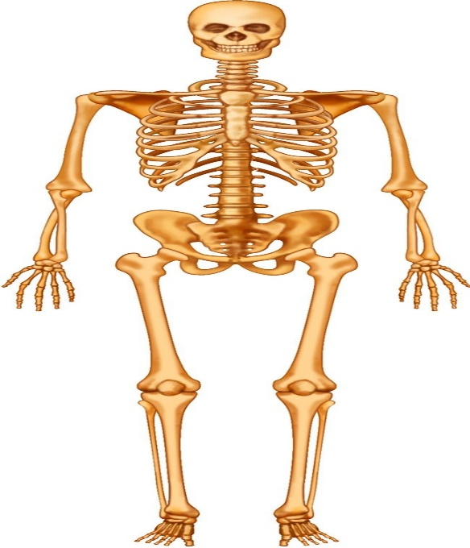
The Tibia is the bone in the lower leg and is known as the shin bone, the fibula and the patella known as the kneecap are also located in the lower leg. The knee is a hinge joint, so movement is only possible in one direction forwards and backwards, the knee and elbow are both examples of hinge joint. (D)
The Femur is the bone in the thigh, the pelvic girdle is attached to the lower part of the backbone and forms the hip bone with the femur. (C)
The Fibula is the lower leg bone which is extended from the knee to the lower ankle and is parallel to the tibia (shinbone). Contact sport such as football or rugby increase the risk of traumatic injury to the fibula. Sports that require sharp twist also make you vulnerable to injuries. The Fibula stabilises the ankle and supports the lower muscles in the leg. A severe sprain in the ankle which usually occurs in the National Football League could cause a fracture in the Fibula as the energy travels up the leg and exits near the upper part of the Fibula. People can tolerate malignment of a fracture in the upper part of the Fibula as well as the mid portion. It is crucial for normal alignment to take place near the ankle in order to allow the normal function/motion of the ankle, this will prevent and minimize the risk of post traumatic arthritis. (E)
The are seven Tarsal bones which form the posterior part of the foot namely the ankle. One of the bones, the talus is in joint with the tibia and fibula at the ankle joint.
The Ribs (Thoracic cage) are curved elongated bones and are anchored posteriorly to the 12 thoracic vertebrae. The first seven ribs are jointed directly with the Sternum and are known to be the true ribs, the next 3 ribs at the bottom attach only indirectly. In all cases the costal cartilages fasten the ribs to the sternum. (F)
The Patella is a sesamoid bone which is quite triangular shaped, this bone forms part of the anterior wall of the knee joint.
The Metatarsals are the bones in the foot, they consist of five bones which form the large part of the sole (dorsum).
The Phalanges consist of 14 bones which are arranged similar to those in the fingers.

Main Functions of the Skeletal System

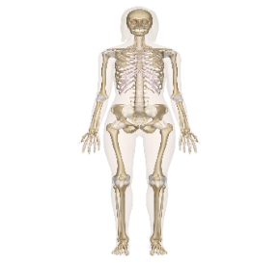
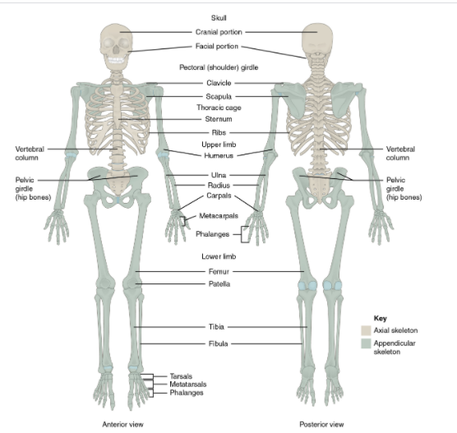
What is the Skeletal system?
The Skeleton is divided into two major divisions – THE AXIAL and the APPENDICULAR

The Skeletal system is bone tissue, it is hard, dense and a connective tissue that makes up most of the adult skeleton. Its main job is to support the internal structure of the body that can support the body weight against the force of gravity, it also provides a structure upon which the muscles in our body can act to produce movements.

Primary functions of the bones
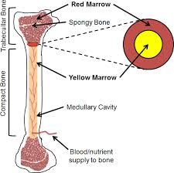
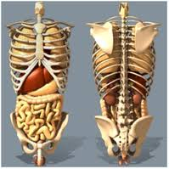
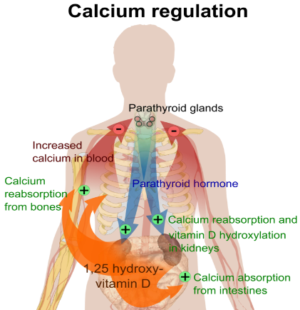
The bones enable the production of red blood cells(haemopoiesis) in the red bone marrow which is found in the ends of the long, flat, and irregular bones. (H)
“Bones contain approximately 99% of the body’s calcium, 85% phosphate, and 50% of its magnesium”, (Bartle and Bartle 2017) (J)

Bone tissue acts as a reservoir for storage of minerals which are crucial for the functioning of the human body, especially calcium and phosphorus. The minerals that are stored in the bone tissue can be released back into the blood stream to maintain and support the levels in the physiological processes our body goes through, this is known as homoeostasis. An example is this the mineral needed for muscle contractions and nerve impulses which is calcium. (I)

The lower part of our skeleton is extensive for stability in walking or running, the upper part has a wider mobility and range of motion as its main features are to allow us to move, carry, lift objects as well as being able to turn our heads and trunk.
The Skeleton has protective functions, the internal organs such as the brain, spinal cord, lungs, heart, and pelvic organs are protected.

REFERENCE LIST

(A) Anatomy and Physiology. Available from https://opentextbc.ca/anatomyandphysiology/chapter/7-1-the-skull/ Accessed:30th September 2020.
(B) Waugh, A. and Grant, A. (2018) Ross and Wilson, Anatomy and Physiology in health and illness. 13th ed. Poland: Elsevier Ltd. Page 63
(C) Murray, M. and Howitt, R. (2019) Sport Science. London: Hodder Education.
Pg 82
(D) Murray, M. and Howitt, R. (2019) Sport Science. London: Hodder Education.
(E) Hartford Hospital (2020) Fractured Fibula. Available at:https://hartfordhospital.org/services/bone-joint-institute/conditions/sports-injuries/fractured-fibula (Accessed 1st October 2020).
(F) Waugh, A. and Grant, A. (2018) Ross and Wilson, Anatomy and Physiology in health and illness. 13th ed. Poland: Elsevier Ltd. pg438
(G) BBC (2014) Skeleton – Skull. Available at: http://www.bbc.co.uk/science/humanbody/body/factfiles/skull/skull.shtml (Accessed: 2nd October 2020).
(H), Waugh, A. and Grant, A. (2018) Ross and Wilson, Anatomy and Physiology in health and illness. 13th ed. Poland: Elsevier Ltd. pg, 422
(I) Biga, L.M. et.al. (n.d) Anatomy and Physiology. 1sted. OpenStax: Oregon State University.
(J) Nursing Times (2020). Skeletal system 1: the anatomy and physiology of bones. Available at: https://www.nursingtimes.net/clinical-archive/orthopaedics/skeletal-system-1-the-anatomy-and-physiology-of-bones-27-01-2020/ (Accessed: 2nd October 2020).

