Appendices

Appendix 1

CONSENT FORM

Please initial box

- I confirm that I have read and understand the information sheet dated 10/1/20 for the above study.

- I understand that my child’s participation is voluntary and that I am free to withdraw my child from the study at any time, without giving any reason.

- I understand that my child can choose to withdraw at any time, without giving a reason.

- I understand that the information given by my child will be used in a university assignment.

- I understand that my child’s name will remain anonymous.

- I agree for my child to take part in the above study.

- I agree for my child’s voice to be recorded in interviews (and later destroyed after the investigations completed).

_____________________ _____________________________ __________
Child’s name Parent signature Date

When completed, please return the consent form to Mrs Jackson by 17/1/10

Thank you.

Appendix 2

INFORMATION sheet

PROJECT TITLE: How does the use of randomised questioning contribute to effective learning in years 4 and 5?

Dear Parent/Guardian,

Our names are Lowri Ellison and Michael Scourfield and we are currently student teachers at your child’s school. As part of our course at the university of Wales Trinity St David, we are required to carry out a research project. We would like to invite your child to participate in our research project. The project will focus on how the use of randomised questioning contributes to effective learning in years 4 and 5. In order to answer our research question, we are required to observe each other’s lessons and interview three pupils on their views on the use of standardised questioning afterwards.

All names will be kept strictly confidential and will only be known by the both of us. Your child’s participation in this study is completely voluntary so you or your child can withdraw from the study at any stage. Your child will also be asked to give their assent before the beginning of the study.

After careful and precise analysis of the data obtained from the lesson observation and group interview, we would be happy to provide you with a copy of the findings at your request. The results of the research will be discussed in a university assignment that will contribute to our PGCE course. The results of this study will be stored on a confidential university one drive and all raw data will be destroyed once the assessment has been marked.

We thank you in advance for your time. If any questions do arise, feel free to contact us at your convenience.

Yours sincerely,

Lowri Ellison & Michael Scourfield

Email: 1901652@student.uwtsd.ac.uk

Appendix 3

Assent form

Name: ………………………………

Miss Ellison and Mr Scourfield want to find out what you think of using randomised questioning in the classroom.

Please colour in whether or not you are happy to take part in the research.

Thank you.




Appendix 4

The Leuven Scale

- Extremely Low
The child seems absent and displays no energy. They stare into space or look around to see what others are doing. There is no concentration and an absent attitude.

2 Low
The child is engaged in the lesson but there are some moments of non-activity when they stare into space or are distracted by what is going on around.

3) Moderate
Mainly continuous activity. They are engaged in the lesson but there are few signs of real involvement and are easily distracted. They listen to some of the children’s answers.

4) High
Continuous activity with intense moments. The child’s activity has intense moments and at all times they seem involved and participate in discussion. They are not easily distracted. The child displays body language showing that they are thinking of an answer during the designated thinking time. They listen intently to children’s responses to questions being asked.

5) Extremely high
The child shows continuous and intense activity and shows an eagerness to answer questions. They are concentrating, energetic and persistent throughout the observed period. The child displays body language suggesting that they are thinking of an answer during the designated thinking time. They voice an opinion on the other children’s answers and show whether they agree or disagree with their peers’ answers.
Rating on the Leuven scale | Child A | Child B | Child C
- Extremely low
- Low
- Moderate
- High
- Extremely high
Additional comments
Appendix 5
Appendix 6 Semi-structured interviews: Focus group questions

- What is the first thing which enters your mind when lollipop sticks/dojo selector are being used?
- How do you feel when you are selected? (your group)
- How do you feel when you are not selected? (your group)
- Do you think other pupils within the class pay more attention once they are being used?
- Do you pay more attention when they are being used?
- Do you ever feel nervous or uncomfortable in any way when these strategies are being used?
- Do you think they make anybody else feel nervous or uncomfortable in any way when they are being used?
- Do you think they should be used more often, less often or do you think there shouldn’t be any change?
- Why do you think teachers use them?
- Do you think the process is fair?
- How could I have made their use/ lesson better?

Appendix 7
Rating on the Leuven scale | Child A | Child B | Child C
- Extremely low
- Low |  | Starter | Starter
- Moderate |  | Main activity | Main activity
- High | Main activity | Plenary | Plenary
- Extremely high | Starter  Plenary
Additional comments | Eager to answer.  Outspoken.  Wants the question to be passed on to them.  Works very independently. | Not very outspoken.  Seems to be easily distracted.  Stares in to space.  Little involvement with their partner. | Nervous when their name was selected.  Showed eagerness when sat at the table.

Appendix 8
Rating on the Leuven scale | Child D | Child E | Child F
  - Extremely low
  - Low
- Moderate | Main |  | Starter  Plenary
- High | Plenary | Starter | Main
- Extremely high | Starter | Main  Plenary
Additional comments | First to shout out when asked a question. Leads their group.  Focused on main task, however takes a while to begin/is distracted | Very interested in other groups answers.  Participates a lot and answers questions with their group during the plenary and starter.  Very focused on main activity. | Appearing to switch off when their group isn’t chosen.  Places their hands up when the whole class is being asked a question.  On task during the main. Engages in discussion about the work. Continuously asks the TA for reassurance although they appear to understand the work.

Appendix 9 – answers to questions (group 1)

Here are child A, B and C’s answers to the questions in the order of the questions being asked.
This sentence has been added only for the purpose of the Turnitin requirement to include twenty words and should not be marked.

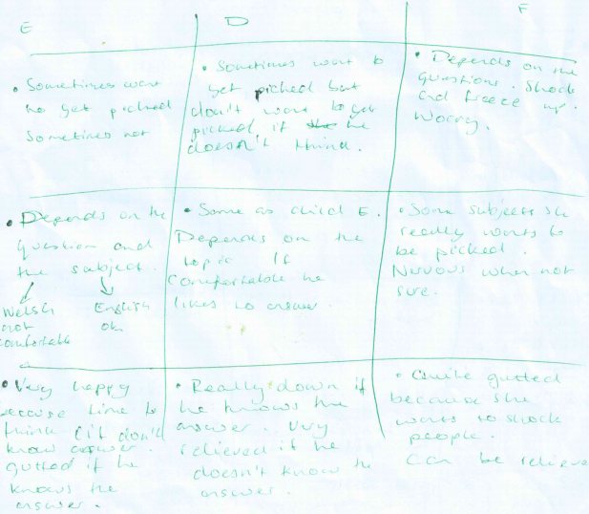

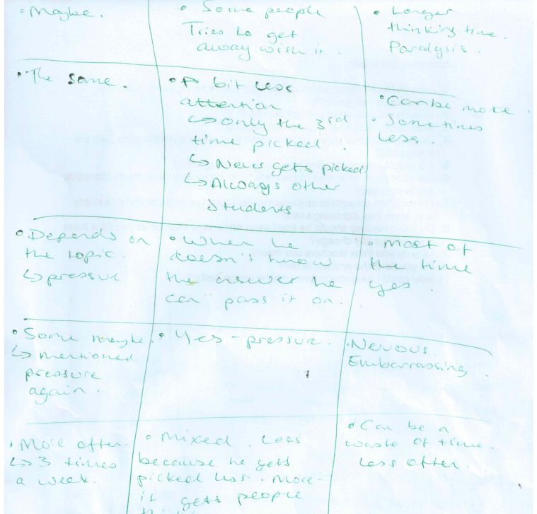

This sentence has been added only for the purpose of the Turnitin requirement to include twenty words and should not be marked.
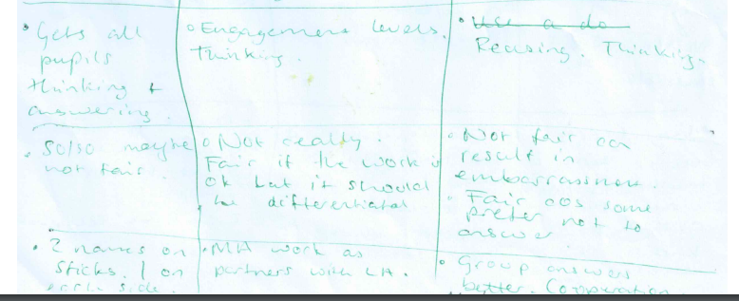

This sentence has been added only for the purpose of the Turnitin requirement to include twenty words and should not be marked.

Appendix 10- answers to questions (group 2)
Here are child D, E and F’s answers to the questions in the order of the questions being asked.

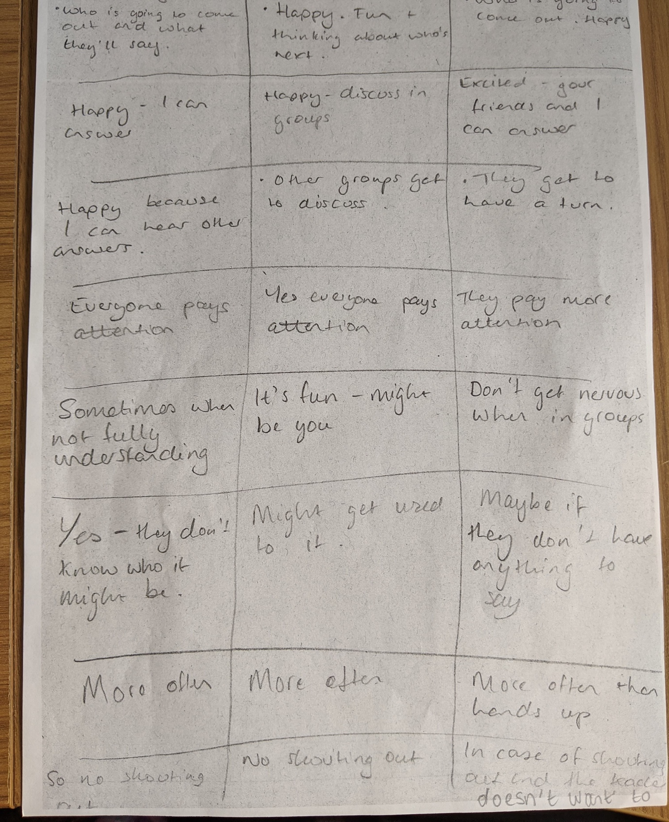

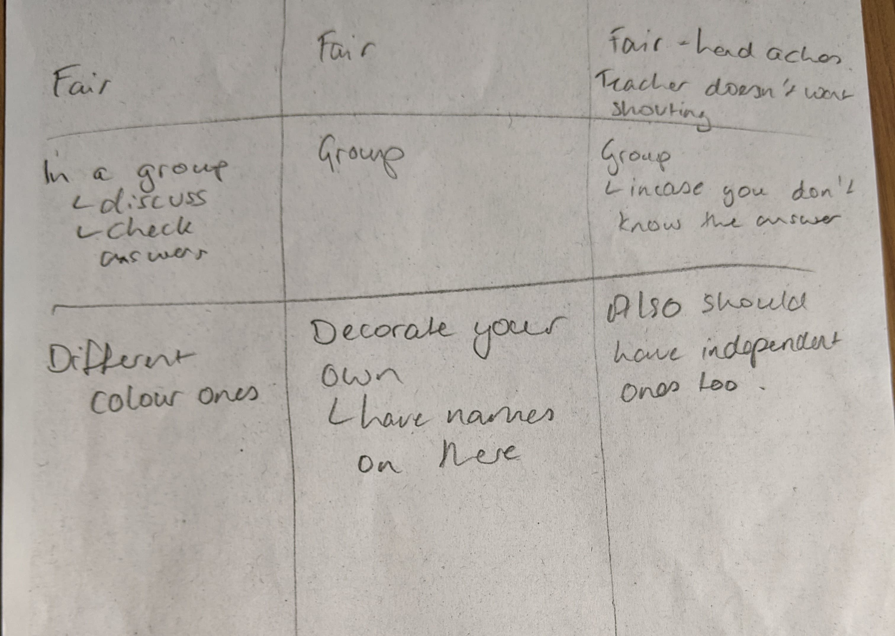

This sentence has been added only for the purpose of the Turnitin requirement to include twenty words and should not be marked.

