Academic
and employability skills.

Adriana nae
2125291
Term 1 group 3
Bmsw 4001

Table of content:
Introduction…………………………………………………………………………………………....3
Using Gibb s model of reflection for time management……………………………3
Using Gibb s model of reflection for academic writing……………………………..6
Using Gibb s model of reflection for summarising…………………………………….8
Personal reflection………………………………………………………………………………….11
Conclusion ……………………………………………………………………………………………..12
References ……………………………………………………………………………………………..13

Introduction:
Learners are required to integrate academics capabilities and expertise in perspective in particular to be wholeheartedly career-ready, and particular academic prowess requires further emphasis and refinement (Alri]ai and Raju, 2019). Businesses, for instance, frequently identity shortcomings in English and written instructions, such as notes, emails, and sophisticated technological presentations. This reinforces the premise that the majority of the written document students would experience in their professions, including instruction manuals and journal articles, is informative in composition, and they should therefore be intellectually be prepared to study and use these resources (Kornelakis and Petrakaki, 2020). There are some other valuable employability skills that the students pursuing higher education must consider. The report elucidates the academic employability skills including time management, academic writing, summarising and public speaking along with presentation skills that becomes mandatory to acquire academic expertise.

Using Gibb's Model of reflection for time management
Graham Gibbs has efliciently proposed the model a] reflection through which a learner can systematically contemplate on the learning and recall them as and when required (Sekarwinahyu er a/., 2019). The reflection model acts as a tool whereby any specific activity is comprehended and by the learner through his or her experience.The model is used while drawing conclusions and devising action plan simultaneously to remember specific incidents.The model is applied in this topic of time management through the stages of description,feelings,evaluation,analysis,conclusion,and action plan(Pieper et al 2021).
While describing the significance of time management,it can be projected that the capacity to spend one s time effectually and competently is alluded to as time management.It might also be seen of as the skill of obtaining enough hours to execute whatever is planned by the student for the purpose of study,completing assignment or doing revision for summative examination one has to do without becoming concerned about something else.It appears easy,but it is considerably difficult in actually.
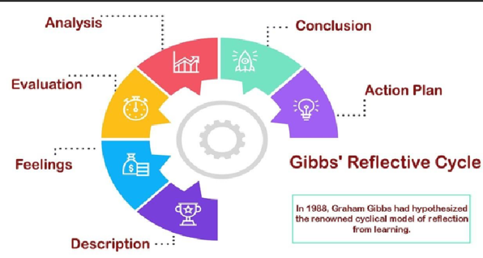
Figure 1: Gibbs reflective model used for different academic and employability skills.(Source: Sekarwinahyu et al 2019).
The feelings of adopting a technique named as Pomodoro are instantaneously difficult.This approach empowers an individual to work along side,instead of against,the opportunity they have.
A learner can use this strategy to divide the workweek into 25 minutes pieces interrupted by seven different intervals.This durations are known as pomodoros.A learner can take a lenghter rest of 20 minutes after around four timed practice.(Lowes ,2020)
According to the time management evolution methodology,reconciling a students professional and personal development it is a component of multitasking that may enable becoming a graduate learner more fulfilling and pleasurable.
Blending students work and personal life can help them di-stress,prevent stress -related diseases,and preserve any helpful connections as they continue throughout their degree.(Baker et al 2019).When faced with high-stress scenarios such as entrance and extensive examinations,research papers, and projects, a student can tremendously gain advantage Tram implementing both working and play thoroughly.
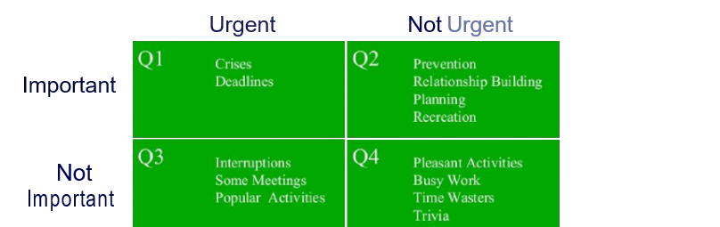
Figure 2: time management tool for effective time management.
(Source : Lowes ,2020)
The analysis a] time planning abilities resolve motivational difficulties successfully, which may help enhance students' work habits throughout graduate programme by eliminating distractions. They might try compiling a checklist o1 what motivates and demoralizes individuals when it pertains to their coursework and other modifications (Landrum, 2020). Rather than focusing on possessing the flawless document or presentation before delivering their project, they concentrate on getting anything tiny done, such as an overview or a brie] executive summary of a repon. They might also presume that the learners will need to edit in consideration oT comments 1rom their supervisor, another teacher, or a peer. In conclusion, it may be projected that from this perspective a] managing time with efficient tools and techniques the student receive feed forward from the educators (Baker e/ a/., 2019). For devising an action plan, the learner the unimportant tasks will be left out and ma¡or priority will be provided to the urgent tasks at hand.

Using Gibbs's Model of reflection for academic writing
Academic writing is undoubtedly the most crucial talent in academic situations because communication is the primary mode oT educational progress. Academic writing in its description is straightforward, succinct, focused, systematic, and evidence-based (Weerawardane and Byrne, 2021). Its objective is to improve the narrator's comprehension. It has a professional attitude and language; however it is not sophisticated and therefore does not necessitate the inclusion a] prolonged phrases or extensive language. Every subject field will have its own collection of written norms, terminology, and spies a] discursive that the undergraduate will get acquainted with during their programme.
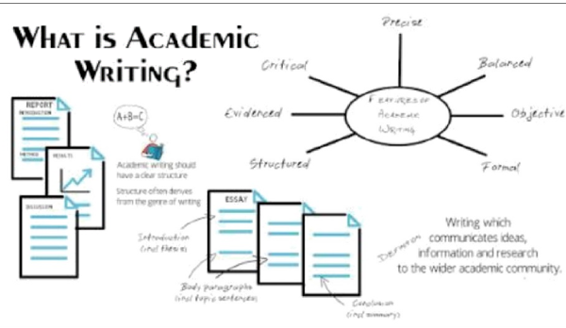
Figure 3: An outline of academic writing (Source: Freeling, Douhleday and Connell, 20I9)
Inflection is one o] the most important 1actors to consider when examining homework assignments. There is a presumption with feelings in academic papers in APA or Harvard style that the approach would be impartial, free a] emotional expressions and assessments that might suggest prejudice. A precise organisation should be present in academic papers. The style is frequently influenced by the literary genre that is being evaluated in diflerent academic assignments (Baker et al., 2019). A report, for instance, will have an introductory paragraph, a methodology portion, a discussion part, and so on, whereas an essay will include an opening (containing a synopsis), coherent supporting details with subject phrases, and a closing. The language should be comprehensive, with natural sequence continuously, along with being unified, with the various elements oT the text obviously related.
Academic writing is much more than a description as analysed by the educators.. As an educational researcher, one should not take anything they learn at 1ace value. Individuals must reassess the material they are composing about, or make judgments about it, prior deciding how and what to include it into their creative work. This is referred to as critical assessment. Reflective writing necessitates extensive study in need for the author to get a thorough comprehension o] the issue in ability to be really analytical a] it. In conclusion, considering the somewhat specialised character o1 academic writing, it may appear intimidating to students when they first commence (Mitchell and Clark, 2018). Students can enhance their academic writing skills by giving attention to input Tram instructors or classmates and focusing on panicular aspects Tar improvement. Reading more is another method Tar them to improve their course work. They can have a deeper knowledge o1 the characteristics that distinguish academic writing from other types of writing by studying academic publications or books.The action plan that the students may take in enhancing their academic writing is being precise and balanced by avoiding any bias and inculcating the practice of using technical vocabulary.
Using Gibb s model of reflection for Summarising .
The description of summarizing is the process of expressing a concept in a condensed form,whereas paraphrase is the process of expressing a notion in depth in the learners own words,using the majority of the material from the primary sources without affecting the significance of the concept(Lillis 2019).There is artistry to effective summarization.Remember that the student s goal is to utilize the textual evidence by connecting the concepts in the synopsis to the overall argument they are conveying.The feelings involved in summarising are the greatest approach for them to demonstrate their perspective and persuade the writer that they comprehend what they are saying.The learner must mention the resource using an in-text connection and offer complete information of the author in their list of references when paraphrased or summarising.Numerous coursework include a list of required and/or recommended readings that can be evaluated based on their summarization(Conney,Darcy and casey 2018).Synopsis of content may be employed to provide an insight of the output of one or more writers,hence they are considerably precise than the actual material.They are highly beneficial when a student needs to highlight the argument supplied for and/or against whichever perspective they are adopting in their argumentation since they are very concise sketches of justifications stated.
Analysis on summarising of content involves dependence of student excessively on summaries since it is the easiest thing for them to compose.If students are stymied by a tough writing topic,describing The Great Gatsby s narrative may be more enticing than glancing at the laptop for three hours trying to figure out how much to comment regarding F.Scott Fitzgerald s usage of colour symbolism(Heng,Hamid and Khan 2020).And besides the story is frequently the most straightforward aspect of a composition.A student might have to study the material they are composing on in addition to creating a more analytic research,with an emphasis on the aspects that are pertinent to their argument.
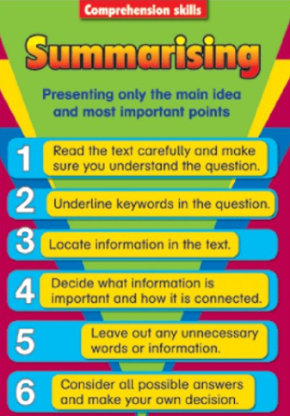
Figure : Summarising poinfs to be remembered by the students
(Source: Lillis, 20I9)
In conclusion, it should be noted that an assessment entails dissecting anyhing down into components (such as a narrative, poetry, drama, philosophy, or argumentation) so that students may grasp how those components combine to form entirety. They should ypically commence analysing a material as they watch and read it rather than delaying till they are finished—it may assist students to make notes basic observations as they study (Rossi, 2022). Students' observations for the action plan might include significant aspects or concepts that they observe, and almost anything that interests, ba1fIes, thrills, or frustrates them. They must recollect that analytical communication extends transcend the apparent to address issues a] ¡ust how and why—so they must inquire questions.
Personal reflection about presentation:
Before the presentation started I repeated in the mirror ,I was very sure of myself,that I will not be nervous and I wil be able to present academic si professional.
When the class started I wanted to go first but something hold me back,I I become a little bit nervous and stressed in the same time.When I saw my collegues doing the presentation I encouraged myself and I raised my hand.
Before me were another 5 persons,and the emotions starded to grow slowly.When a girl that presented before me started to shake and was not able to read and speak I become panicked.
Finally was my turn,and I had a speech prepared,but when I seen everybody staring at me,I forgot everything,and for a few seconds I had to focus and concentrate to get it
together.I started to speak very fast,and I lost my breath.I felt like I was presenting the news.
I just wanted to finish it quick to be able to catch my breath.
I was not very satisfied with my presentation,but I put a lot of effort in this assignement and my collegues and teacher were very supportive and I thank them for this.
I hope in the future I will be able to control my emotions better when I will present my assignement .

Conclusion:
In summary,it may be projected that student s interactions with others are influenced by their personal qualities,behaviours,and perspectives.Employers respect professional skills since they indicate how well a student gets together with other colleagues and customers,and also how effectively a learner is capable to control professional development and career achievement.Employers respect these distinguishing characteristics in skilled personnel since they are indeed required for a profitable and well-functioning workplace.

References
AlriTai, A.A. and Raju, V., (2019). The employability skills oT higher education graduates: A review oT literature. argument, 6{3).
Baker, R., Evans, B., Li, Q. and Cung, B., (2019). Does inducing students to schedule lecture watching in online classes improve their academic performance? An experimental analysis oT a time management intervention. Research in I-Iigher Education, 60{4), pp.521• 552.
Burhanuddin, A., (2021). Improving Students' Oral Communication Skills in Public Speaking through Individual Presentation Task. Jumal Lingua idea, f2{2), pp.159-167.
Cooney, A., Danny, E. and Casey, D., (2018). Integrating reading and writing: supposing students' writing 1rom source. Journal of University Teaching & Learning Pmcrice, UI(5), p.3.
Freeling, B., Doubleday, Z.A. and Connell, S.D., (2019). Opinion: How can we boost the impact oT publications? Try better writing. Proceedings of the National Academy of Sciences, 1 l@2), pp.341 •3A3.
Heng, K., Hamid, M. and Khan, A., (2020). Factors influencing academics' research engagement and productivity: A developing countries perspective. Issues in Educational Research, J0{3), pp.965-987.
Huang, Y.Y., (2020). Public speaking and presentation.

Kornelakis, A. and Petrakaki, D., (2020). Embedding employability skills in UK higher education: Between digitalization and marketization. Industry and Higher Education, 54(5), pp.290-297.
Landrum, B., (2020). Examining Students' Confidence to Learn Online, Self-Regulation Skills and Perceptions o1 Satisfaction and Usefulness oJ Online Classes. Online Learning, ?4(3), pp.128•146.
LeFebvre, L., LeFebvre, L.E. and Allen, M., (2018). Training the bufierflies to fly in formation: Cataloguing student fears about public speaking. Communication Education, 6fl3), pp.3AB• 362.
Lillis, T., (2019). ‘Academic literacies’: sustaining a critical space on writing in academia. Journal of Learning Development in Higher Education, (15).
Lowes, R., (2020, July). Knowing you: personal tutoring, learning analytics and the Johari Window. In frontiers in Education (vol. s, p. 101). Frontiers.

Mitchell, K.M. and Clark, A.M., (2018). Five steps to writing more engaging qualitative reseamh. International Journal of Oualitative /\Methods, I 7{1), p.1609406918757613.
Pieper, M., Roelle, J., vom Hole, R., Salle, A. and Berthold, K., (2021). Feedback in reflective journals fosters reflection skills of student teachers. Psychology Learning & Teaching, 2o{1), pp.107-127.
Rossi, S.L., (2022). Revisioning paraphrasing instruction. In Academic Integrity in
Canada (pp. 411-429). Springer, Cham.

Sekarwinahyu, M., Rustaman, N.Y., Widodo, A. and Riandi, R., (2019, February). Development of problem based learning for online tutorial program in plant development using Gibbs’ reflective cycle and e-portfolio to enhance reflective thinking skills. In Journal of Physics: Conference Series (Vol. 1157, No. 2, p. 022099). IOP Publishing.
Weerawardane, D. and Byrne, P., (2021). An introduction to critical thinking, academic writing and Harvard referencing.

