

Name - Elina Znotina
Student number – 2409079
Lecturer’s name – Eric Osei
Programme: BA (Hons) Leadership and Management Skills for the Workplace
Module Title: LCLM 5001 Understanding and Engaging Stakeholders
Assignment Title: Understanding the importance of Stakeholders Engagement in successful commencement and completion of project.

Executive Summary
This report presents an understanding of the importance of a stakeholder engagement strategy for completion of a project in timely manner with strategically set goals. It shows necessary stages to support the design and launch of a new wearable health device by CMR Surgical. Based on strategic management and stakeholder theory, the analysis highlights that structured and proactive stakeholder engagement is essential for success in the regulated medical technology sector.
The strategic analysis was evaluated using SWOT and PESTLE frameworks, which identified CMR Surgical’s strengths in technological innovation, particularly the Versius device, alongside challenges such as regulatory barriers and competitive pressures. These findings relayed of the creation of SMART objectives to ensure clarity and measurability in project planning.
Stakeholders were systematically classified into internal groups—Product Development, Marketing, Sales, and Operations teams (Johnson et al., 2008)—and external groups including healthcare providers, regulators, investors, and consumers (Harrison and St. John, 2010). Their respective roles, interests, and influence were analyzed to guide engagement priorities.
To manage these relationships, the report recommends applying the Stakeholder Matrix (Muzny et al., 2020) and RACI Chart (Gurova et al., 2020. Transparent communication, conflict-sensitive processes, and the 4Cs Model (Christopher et al., 2013) are proposed to encourage collaboration.
Effective stakeholder management is expected to enhance product development, accelerate regulatory approval, strengthen market entry, and secure investment, positioning CMR Surgical for sustainable market leadership.

Table of Contents
1. Introduction 4
2. Situation analysis of CMR Surgical 5
2.1 SWOT Analysis 5
2.2 PESTLE Analysis 5
2.3 SMART Objectives 6
3. Identification of Key Stakeholders 7
3.1 Internal Stakeholders 7
3.2 External Stakeholders 7
4. Core Stakeholder Roles and Responsibilities 8
4.1 Product Development Team 8
4.2 Marketing Department 8
4.3 Sales Team 8
4.4 External Stakeholder (Healthcare Providers, Regulatory Bodies, Investors, Consumers) 9
5. Engagement Frameworks, Models, and Theories 10
5.1 Stakeholder Matrix 10
5.2 RACI Matrix 11
5.3 Engagement Plan 11
5.4 Communication Plan 12
5.5 Stakeholder Theory 12
6. Process of Stakeholder Engagement/Conflict Management 13
6.1 Stakeholder Engagement Process 13
6.2 Conflict Management by the 4Cs Model 13
6.3 Conflict Resolution 14
7. Business Performance under Stakeholder Engagement 15
7.1 Assessment of Engagement 15
7.2 Key Areas Affected 15
7.3 Recommendations 16
Conclusion 17
References 18

Table of Figures
Figure 1: CMR Surgical's Logo 4
Figure 2: Stakeholder Matrix 10
Figure 3: RACI Matrix 11
Figure 4: Stakeholder Theory 12

1. Introduction

CMR Surgical is a giant company in the United Kingdom that manufactures robotic surgical systems. CMR Surgical, the company that was created in 2014, is rapidly developing the industry of minimally invasive wearable health device. Versius, the flagship product of the company, is a high-technology robot wearable health device system that is supposed to enhance patient precision and recovery time. As a global business, CMR Surgical has distributed its operations to over 20 countries, collaborating with health care providers to improve surgical outcomes. It employs over 300 specialists in various areas like engineering, medical research, and business development (CMR Surgical, 2022).
Figure 1: CMR Surgical's Logo
Source: (CMR Surgical, 2022)
CMR Surgical is a Cambridge, UK-based company that deals with the development of new medical technologies that can address the evolving needs of the healthcare industry. The company has a strategic intent to provide surgeons with more efficient, precise, and minimally invasive tools in wearable health device. CMR Surgical's market presence is continually growing, and it tends to expand in the worldwide market, particularly in Europe and North America, since its products are available in all hospitals worldwide (Chen et al., 2019).

2. Situation analysis of CMR Surgical
According to Emet GÜREL and Merba TAT study of a literature review of SWOT analysis it is determined that SWOT is a part of strategic management process where external and internal analysis must be conducted to get an overview of organizations external focus on the environmental threats and opportunities and internal analysis where organizational strengths and weaknesses are defined. (Merba et al., 2017)

2.1 SWOT Analysis
- Strengths: CMR Surgical possesses the most recent robotic machine and its flagship product, Versius, is the most precise in the least invasive surgery. Foreign partners enable the company to improve goods and grow at a very high rate (Peters et al., 2018).
- Weaknesses: The cost and creation of technology may be a limit to scalability. There are also regulatory risks in the different markets and reliance on specific market segments like hospitals and health care providers (Kong et al., 2019).
- Opportunities: CMR Surgical can tap into new healthcare markets where wearable health devices are quickly emerging. Research and development partnerships can also enhance both innovation and positioning in the market (Peters et al., 2018).
- Threats: Potential threats are the regulatory environment and the existence of other wearable health device companies. Market uncertainty and rising healthcare costs would also have an impact on profitability (Sultan, 2015).

2.2 PESTLE Analysis
PESTEL analysis is used by multinational corporations with a designed framework to assess political, economic, social, technological, environmental, and legal factors to modify their strategic decisions (Yusop, 2018).
- Political: Stringent regulation of medical equipment, particularly wearable health device systems, could impact penetration. The politics of major markets must be stable for the operations.
- Economic: CMR Surgical may innovate a premium wearable health device. Profitability entails adequate funding of the cost structures and R&D. Recessions can impact healthcare spending and demand (Kong et al., 2019).
- Social: The rising adoption of wearable health devices in healthcare systems presents the possibility for CMR Surgical to grow its user base. Public awareness campaigns can be adopted (Sultan, 2015).
- Technological: Artificial intelligence, machine learning, and robot technologies will be used to innovate wearable devices and give CMR Surgical an opportunity to overtake the competition (Peters et al., 2018).
- Legal: The regulations of medical devices, safety standards, and intellectual property laws should be followed to eliminate legal problems (Sultan, 2015).
- Environmental: Compliance and corporate responsibility. Wearable devices are gaining significance in the production and disposal environment (Peters et al., 2018).

2.3 SMART Objectives
Bjerke and Renger (2017) emphasize that when first introduced by Doran (1981) SMART method was defined by specific, measurable, assignable, realistic, and time-related management goals however in today’s world, the SMART method in management is commonly stated as the standard for developing effective, measurable goals and objectives. (Bjerke et al., 2017).
Within 6 months, be ready to launch the wearable health device and meet regulations.
90 percent product testing and congruence with the stakeholders. This includes the contributions of key stakeholders such as the healthcare providers, consumers and regulatory entities (Ashcroft et al., 2016).
Use the existing experience in the sphere of healthcare technology and the history of CMR Surgical to develop innovative medical equipment. Incorporate in-house research and development and partner with hospitals and regulatory experts to speed up the development and approval processes (Peters et al., 2018).
- Relevant: Align the product launch with the general business expansion plan of CMR Surgical to the consumer health monitoring market using wearable health devices (Sultan, 2015).
- Time-based: Build and release the wearable device within 6 months in a way that the product will be available on time and will be regulated to fulfil the market.

3. Identification of Key Stakeholders
Conti (2003) argues that stakeholders is a collective concept used to identify the interested parties in any organization, author notes that these parties can be classified as subjects whose interests are to different extents bound to the organization and are entitled to benefits in return (Conti, 2003).

3.1 Internal Stakeholders
Product Development Team: The team will involve engineers, designers and technical developers who will develop the wearable health device. They are crucial in the assurance of the functionality, quality and technological innovations of the product, translating research into market-ready solutions (Lin et al., 2016).
Marketing Department: The marketing department will undertake brand positioning, product promotion strategies and awareness creation. They create advertisements to introduce a wearable device in the market to healthcare providers and consumers. Their work forms the image of the product and drives it into the market (Buttle and Maklan, 2019).
Sales Team: The Sales team will participate in direct selling of the wearable health device, distributing it to the healthcare providers and end-users. They dictate customer relations, bargain contracts, and give after-sales services to retain customers (Howard, 2021).
Operations Team: This team is involved with the production of the product, quality and efficient production lines. They also do logistics and inventory, which are shipped to hospitals and retailers on time. Processes are critical to fulfil product launch schedules and the efficiency of the supply chain (Howard, 2021).

3.2 External Stakeholders
Healthcare Providers (Hospitals, Clinics): Healthcare Providers are the primary consumers of the wearable device. They will provide useful comments on its performance, applicability and effectiveness in a clinical setting. Their approval and acceptance of the device are vital to the success of the device in the market (Howard, 2021).
Regulatory Bodies: These organizations certify that the wearable health device is under the standards of medicine and health. They play a vital role in the approval process because they guarantee that the product is safe, efficacy, and quality to be marketed (Banerjee et al., 2018).
Investors/Shareholders: Shareholders and investors will provide the project with the capital needed. They are critical to the success and prosperity of the firm and to additional innovation. They care about how well the device will fare in the market (Thiebes et al., 2023).
Consumers (Patients and Healthcare Professionals): The primary stakeholders in the wearable device development are end-users (patients and healthcare professionals). The patient feedback helps in enhancing the product; the health workers make sure that the machine is clinically relevant and helps in a better patient outcome (Buttle and Maklan, 2019).

4. Core Stakeholder Roles and Responsibilities

4.1 Product Development Team
Roles: The Product Development Team will create, develop, test and debug the wearable health device. They involve making the product work and technically fit, integrating hardware and software, and broad range testing to determine the safety and effectiveness (Lin et al., 2016).
Advantages: The staff is creative and skilled in engineering, design, and technology, implying that the wearable item is not only effective but also comfortable and usable in a clinical and consumer setting (Gurova et al., 2020).
Challenges: There is a threat of technological breakdown that will harm the product development. The complex structure of compliance control and the schedules are also a matter of concern (Gurova et al., 2020).

4.2 Marketing Department
Roles: The marketing Department will handle the promotional strategies, advertise the wearable device and branding of the product. It will involve market research, target markets, and online and offline campaigns (Buttle and Maklan, 2019).
Advantages: The marketing unit helps position the wearable health device in the competitive market, which facilitates consumer awareness and interest. They also strive to establish the brand identity and trust (Thiebes et al., 2023).
Challenges: Building a strong campaign capable of competing with the existing market leaders in terms of consumer trust and credibility is one of the challenges that the marketing team is facing. They are also answering the question of whether the device is effective and compatible with existing healthcare systems (Buttle and Maklan, 2019).

4.3 Sales Team
Roles: Sales Team discusses the utility of the wearable health device with the potential customers, the healthcare providers and consumers and supports the sales processes between product Introduction and after-sales services (Howard, 2021).
Advantages: The sales personnel directly impact on the income gathering and market penetration in terms of supporting product adoption and client relationship management. They assist in converting the leads to actual sales and product reach (Buttle and Maklan, 2019).
Challenges: The biggest challenge is resistance from healthcare providers and consumers, particularly towards new technology. The sales force would need to negotiate product reliability, price, and its place in existing healthcare practices to seal the deals (Howard, 2021).

4.4 External Stakeholder (Healthcare Providers, Regulatory Bodies, Investors, Consumers)
Roles: External stakeholders are healthcare providers, regulatory bodies, investors and consumers; each of them plays a key role in the success of the wearable device. Clinicians can give feedback about how the device is doing and help in aligning it to the clinical needs. The regulators assist in safety and health standards compliance. Investors post and consumers comment on ways of using them favorably (Ashcroft et al., 2016).
Advantages: Regulatory acceptance will enable market entry, and the contribution of healthcare providers will enhance product design and functionality. Finance also avails funds to finance more to develop products and expand into markets. Consumer response makes it possible to adjust the product to the needs (Lin et al., 2016).
Challenges: The threats are addressing the strict medical device regulations of the different parts and fulfilling the various needs and expectations of the consumers and the healthcare providers (Banerjee et al., 2018).

5. Engagement Frameworks, Models, and Theories

5.1 Stakeholder Matrix
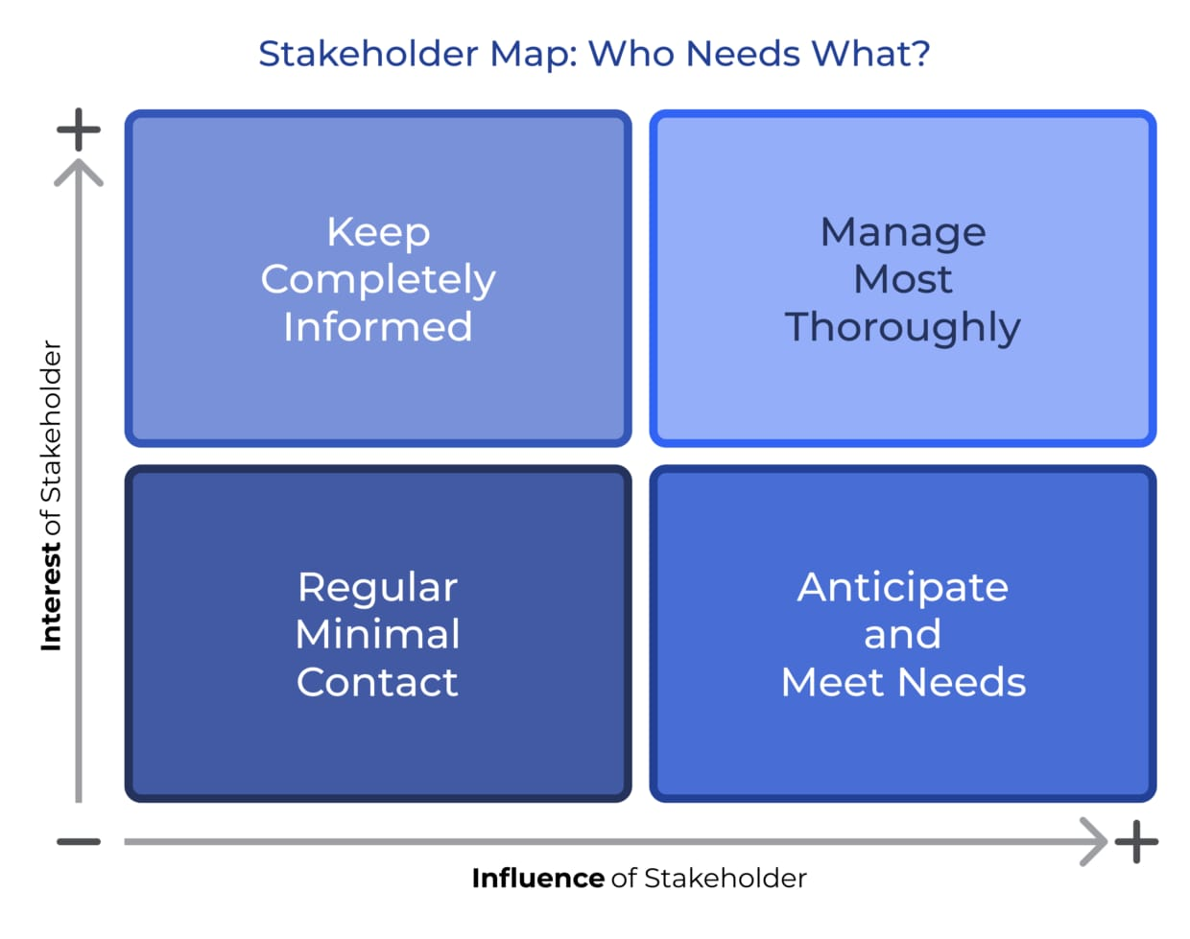
The Stakeholder Matrix map illustrates the stakeholders based on their interest and influence within the project (Muzny et al., 2020). It is subdivided into four categories:
Figure 2: Stakeholder Matrix
Source: (Muzny et al., 2020)
High Influence, High Interest: These stakeholders are to be regarded as frequent and active participants.
High Influence, Low Interest: These stakeholders can be informed less frequently yet more often.
Low Influence, High Interest: Consult with them to get feedback and feed product improvement (Muzny
Low Influence, Low Interest: Pay no particular attention to this group, unless there is a compelling reason, but focus on other groups. This matrix ensures efficient and specific communication that allocates resources to the stakeholders who can have the greatest impact (Ellis et al., 1991).

5.2 RACI Matrix
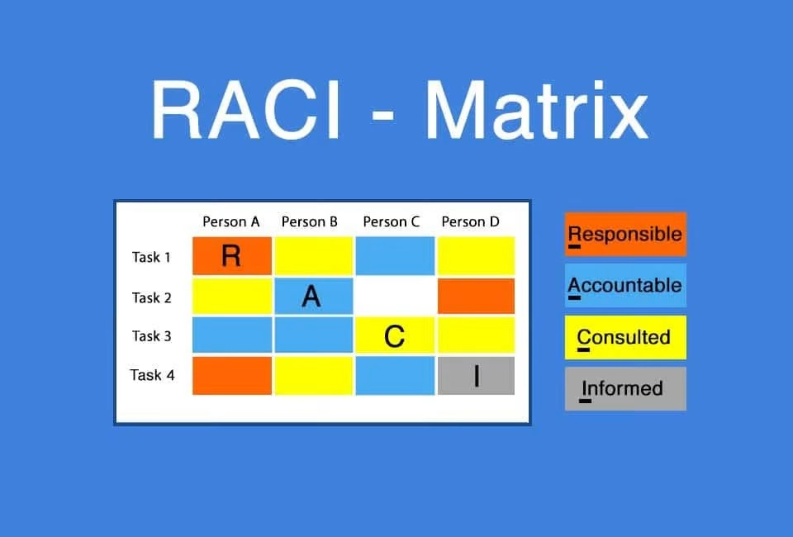
The RACI Matrix shows the positions and duties of project stakeholders.

Figure 3: RACI Matrix
Source: (Gurova et al., 2020)
Responsible: The individuals or teams who conduct the work, i.e. the Product Development Team, to design and test the wearable device (Gurova et al., 2020).
Accountable: The party who ensures that the job is done, e.g. the Project Manager who is the one who ensures that the product is developed and launched.
Consulted: The representatives consulted are healthcare providers and regulatory bodies (Banerjee et al., 2018).
Informed: The investment team and sales team, among others, must be informed regularly. This matrix has well-distributed roles and accountable members.

5.3 Engagement Plan
The Engagement Plan gives an outline of how to reach all stakeholder groups. To high-influence, high-interest stakeholders (e.g., healthcare providers), make sure communication is frequent, direct (e.g., via meeting, email, update). Low-interest, but high-influence stakeholders (e.g., investors) should receive quarterly reports and frequent email updates. In low-influence high-interest groups (e.g. consumers), surveys, social media and feedback would be suitable to gather insights (Ashcroft et al., 2016).
Communication has to be adapted to the needs of the respective groups, in a way that the most crucial stakeholders are informed on time and in a meaningful way (Ellis et al., 1991). The character and strength of engagement will be adjusted to the effect and the interest of stakeholders (Buttle and Maklan, 2019).

5.4 Communication Plan
The stakeholder engagement has certain goals, processes, and a time in the Communication Plan. These objectives are to educate the stakeholders, set up expectations and get valuable feedback. The communication channel will vary: updates on email and project management software, high-priority stakeholders’ meetings, and social media communication with consumers (Christopher et al., 2013). The stakeholders will be communicated regularly (weekly to the internal team, monthly to the investors, quarterly to the healthcare providers and regulatory bodies) (Banerjee et al., 2018). Transparency, trust, and engagement are realised during the project lifecycle, and stakeholders are informed at every step with the plan (Buttle and Maklan, 2019).

5.5 Stakeholder Theory
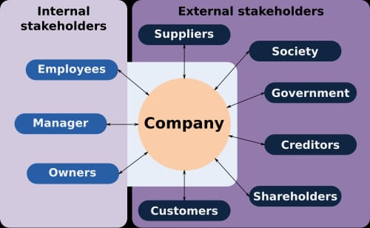
Stakeholder Theory addresses the necessity to regulate relationships with internal and external stakeholders. It supposes that organisations must negotiate the interests of all parties that influence or are influenced by the project. In the CMR Surgical wearable health device, this would include product developers, marketers, healthcare providers, regulators and consumers (Ashcroft et al., 2016).

Figure 4: Stakeholder Theory
Source: (Ashcroft et al., 2016)
All the stakeholders and their concerns can be met by the company, and this can make the product successful in the market. When stakeholder relations are well managed, trust, collaboration, and ownership of the project are developed, better results and longer-term business are achieved (Christopher et al., 2013)

6. Process of Stakeholder Engagement/Conflict Management

6.1 Stakeholder Engagement Process
As a project manager, the stakeholder engagement process will start by identifying clear and consistent communication channels to establish alignment and keep all stakeholders up to date on the project. Regular updates through the various tools, such as meetings, newsletters and project management software, are essential. Meetings with key stakeholders should be regularly held, such as the healthcare providers, regulatory team, and product development team, to report on the progress, challenges, and milestones. This leaves expectations to be managed and stakeholders to be involved in the decision-making (Ellis et al., 1991).
Project software can be used to track project progress, deadlines, and activities and offer transparency and allowing stakeholders to see real-time updates. In addition, it is possible to identify roles and responsibilities before the start of the project to ensure that the various stakeholder groups understand their specific roles (Minaoglou et al., 2024). Regular updates through newsletters or emails will ensure that all external stakeholders, like investors and consumers, are informed of product developments and any changes to the schedule or scope as the project progresses. This communication must also be ongoing to create trust and make stakeholders feel a part of the process and important (Ashcroft et al., 2016).

6.2 Conflict Management by the 4Cs Model
The development of the project is important in conflict management to launch the wearable device on time. The Model of Communication, Cooperation, Coordination and Collaboration 4Cs provides a strong model of stakeholder relations and conflict resolution.
Communication: This requires good communication to prevent misunderstandings that leads to conflict. Project milestones, challenges and timelines should be communicated to the stakeholders regularly (Ellis et al., 1991). Communication must be short, honest, and targeted at a given group of stakeholders, be it through emails, meetings or presentations. This is to keep all stakeholders informed to prevent confusion and misalignment (Christopher et al., 2013).
Coordination: Co-ordination within cross-functional teams is a requisite in project execution. This will ensure that all departments are coordinated: product development, marketing, sales and operations. Lack of alignment of teams creates conflicts, and regular coordination meetings and project management tools will help to keep everyone on track and prevent unnecessary tensions (Freitas et al., 2020).

Cooperation: An interactive setting would make the stakeholders feel valued and heard. Stakeholders will be ready to collaborate, creating a sense of mutual good. The sense of ownership and friction is reduced by rewarding the work of all stakeholder groups, whether it is the technical contribution of the R&D team or the promotional work of the marketing team (Kaptein and Van Tulder, 2017).
Collaboration: Cooperation is necessary during conflict. The problem-solving process involves the stakeholders help identify win-win solutions. Open communication will provide constructive criticism and encourage innovative ways of solving problems. The stakeholders are incorporated into the decision-making process at an early stage, and therefore, they feel part of the process and are hence supportive and dedicated to the project (Cheng et al., 2020).
The 4C's Model allows the project manager to manage the relationship with stakeholders proactively, align and solve conflicts effectively.

6.3 Conflict Resolution
There is also a need to conflict manage to ensure that the working environment is favorable and that the project is not lagging. The project manager is expected to create a non-threatening and free atmosphere so that the parties involved can air their problems in case of disputes. To determine the source of conflict, active listening is needed (Young et al., 2016).
It should concentrate on negotiation and compromise to discover the way out, which would consider the interests of all the stakeholders and retain the overall objectives of the project. The mutually beneficial solutions that can be palatable to everyone can be revealed after a talk with the representatives of other groups (e.g., product development and regulatory bodies) (Banerjee et al., 2018).
Also, feedback loops need to be incorporated regularly in the project, and the stakeholders can present their concerns and suggestions. This will not only help solve the conflict but also foster an ongoing dialogue that eliminates future problems. This transparent and respectful atmosphere will easily resolve conflicts, and the project will be easily launched (Christopher et al., 2013).

7. Business Performance under Stakeholder Engagement

7.1 Assessment of Engagement
The stakeholders will be key to the successful launch of the product, especially in the healthcare sector. A project manager can detect and address problems during the early phases of the project, hence the product will be developed without hitches. Ongoing feedback provided by the medical practitioners will make the wearable health device sensitive to the medical conditions of the clients, and the interaction will facilitate the complex approval processes. Stakeholders will also feel valued and engaged and will spread project success.
Furthermore, it may be refined through involving consumers at an early and regular stage to make the product more palatable in the market. This will improve testing of the products and reduce delays in the regulatory approvals. Moreover, investors and shareholders will provide the project with the funds it requires to stay on schedule during the process of development. The net outcome is a quicker product development cycle, quicker approvals and increased market acceptance, which is directly reflected in business expansion and profitability.

7.2 Key Areas Affected
Product Development: The development process may be enhanced with the assistance of healthcare providers, regulatory bodies, and product testers. Medical staff can then give an example of how the equipment works and can be used in clinical practice, and the design and performance can be improved. The regulatory bodies further intensify the quality and compliance of the product by ensuring that the device is safe and effective (Banerjee et al., 2018).
Market Penetration: Consumers and marketing teams should lead market penetration. Early identification of consumer needs and concerns will help in placing the product to sell more units. The positive recommendations and comments by medical gurus can also build awareness and make the device a trustworthy device in the medical sector.
Regulatory Approval: The wearable health device is marketed to the medical device level as it meets the regulatory authority. Prompt negotiations with the regulatory authorities will facilitate the process of approval, which will save time wastage, and allow quick access to the market. Technology is geared towards regulatory requirements that have facilitated seamless access to healthcare systems worldwide.
Financial Performance: The role of Shareholders/Investors is to fund the project. A regular update and demonstrating to them what the product is capable of can give them the confidence to invest in future innovation. They must also increase the geographical and other healthcare fields of the device with direct influence on the bottom line of the firm.

7.3 Recommendations
Establish Better Relationships with the Healthcare Providers: A long-lasting relationship with the healthcare providers may create a feeling of ownership and trust. CRM Surgical can build a wearable health device to suit the practical needs of health practitioners by asking their input at an early stage and by retaining the feedback. Ongoing workshops, focus groups and testing with medical practitioners will assist in developing the product and will result in more successful adoption.
Enhance Feedback Loops: There must also be good feedback loops to keep on improving the product. CMR Surgical should also use surveys, one-on-one meetings, and user reviews as a feedback source on the healthcare provider and end-user level. The device and overall user experience should be refined using feedback to ensure that they resonate with the underlying customer expectations and clinical needs.
Create More Initiative Communication Plans: Open and active communication is the key to keeping all the stakeholders in the project lifecycle. Webinars, newsletters, and special project management tools will be used to update internal and external stakeholders on a regular basis. Moreover, a clear chain of problems or ideas will assist in solving the problems in time.
Interact more with Investors: It can further be augmented by interacting with shareholders and investors in order to acquire financial backing. Detailed, data-driven product progress, market trends, and future financial outlook reporting will be a source of trust and a sign that the product can be a long-term success. Interested and informed investors will be ready to contribute resources that will be required in subsequent innovations and expansions.
Use the strength of Digital and Social Media Interaction: To accelerate market penetration and consumer confidence, CMR Surgical must expand its online presence by posting educational material, product videos, and testimonies. It will be made more visible with the help of social media, LinkedIn, Twitter, and specialized medical forums. The online campaigns will also support traditional marketing, strengthening product awareness.

Conclusion
Engaging the stakeholders is also a key to the effective introduction of the wearable health device because it will help to unite all the stakeholders and resolve any difficulties in the early stages. Communication, coordination and collaboration with internal and external stakeholders (product development team, marketing team, sales team, healthcare providers, regulatory agencies and consumers) to create the product and make it acceptable in the market takes place. Involving stakeholders early will help the firm to make sure that the wearable product meets the clinical and regulatory requirements and will be better positioned to succeed in the market (Chen et al., 2019).
Stakeholder management is the key to business success, product innovation, and regulatory approval. Stakeholders in the product development cycle create an environment of trust, openness and continuous improvement. Their reviews help in making the product better, fit the regulations and adoption in the market. Stakeholder engagement helps the company to not just enhance the quality and functionality of the device but also enhance its competitiveness in the healthcare market (Gurova et al., 2020).
In order to deepen stakeholder engagement strategies, we would suggest that the company develop stronger relations with healthcare providers to acquire valuable lessons in developing the product. Periodic surveys and focus groups should also be included in the feedback loop to ensure that the product is on track in relation to the needs of the users. One of the tools of transparency and trust maintenance among the stakeholders is active communication, i.e., regular updates provided using digital media (Christopher et al., 2013). Finally, better rapport with the investors through provision of information about progress reports will lead to subsequent developments being financed later.

References
Ashcroft, J., Childs, R., Myers, A. and Schluter, M. (2016) The relational lens: Understanding, managing and measuring stakeholder relationships. Cambridge: Cambridge University Press.
Banerjee, S., Hemphill, T. and Longstreet, P. (2018) ‘Wearable devices and healthcare: Data sharing and privacy’, The Information Society, 34(1), pp. 49–57.
Buttle, F. and Maklan, S. (2019) Customer relationship management: concepts and technologies. Abingdon: Routledge.
Chen, B.P., Clymer, J.W., Turner, A.P. and Ferko, N. (2019) ‘Global hospital and operative costs associated with various ventral cavity procedures: a comprehensive literature review and analysis across regions’, Journal of Medical Economics, 22(11), pp. 1210–1220.
Cheng, F.F., Wu, C.S. and Chang, J.Y. (2020) ‘Interproject conflict management through cooperation in an enterprise system implementation program’, Project Management Journal, 51(6), pp. 582–598.
Christopher, M., Payne, A. and Ballantyne, D. (2013) Relationship Marketing: Creating Stakeholder Value. Saint Louis: Taylor and Francis.
CMR Surgical (2022) CMR Surgical. [online] Available at: https://cmrsurgical.com/ [Accessed 13 Nov. 2025].
Conti, T. (2003) ‘A strategic view of organizational stakeholders’, Quality into the 21st Century, p. 1.
Ellis, C.A., Gibbs, S.J. and Rein, G. (1991) ‘Groupware: some issues and experiences’, Communications of the ACM, 34(1), pp. 39–58.
Freitas, M.R.D., Pimenta, M.L., Hilletofth, P., Jugend, D. and Oprime, P.C. (2020) ‘Demand management: the role of cross-functional integration in a context of political turbulence’, Asia Pacific Journal of Marketing and Logistics, 32(3), pp. 817–839.
Gurova, O., Merritt, T.R., Papachristos, E. and Vaajakari, J. (2020) ‘Sustainable solutions for wearable technologies: mapping the product development life cycle’, Sustainability, 12(20), 8444.
Howard, M. (2021) ‘Wearables, the marketplace and efficiency in healthcare: How will I know that you’re thinking of me?’, Philosophy & Technology, 34(4), pp. 1545–1568.
Kaptein, M. and Van Tulder, R. (2017) ‘Toward effective stakeholder dialogue’.
Kong, X.T., Luo, H., Huang, G.Q. and Yang, X. (2019) ‘Industrial wearable system: the human-centric empowering technology in Industry 4.0’, Journal of Intelligent Manufacturing, 30(8), pp. 2853–2869.
Lin, K.Y., Chien, C.F. and Kerh, R. (2016) ‘UNISON framework of data-driven innovation for extracting user experience of product design of wearable devices’, Computers & Industrial Engineering, 99, pp. 487–502.
Merba, T.A.T. (2017) ‘SWOT analysis: A theoretical review Emet GÜREL•’, The Journal, 10(51).
Minaoglou, P., Efkolidis, N., Manavis, A. and Kyratsis, P. (2024) ‘A review on wearable product design and applications’, Machines, 12(1), 62.
Muzny, M., Henriksen, A., Giordanengo, A., Muzik, J., Grøttland, A., Blixgård, H., … and Årsand, E. (2020) ‘Wearable sensors with possibilities for data exchange: Analyzing status and needs of different actors in mobile health monitoring systems’, International Journal of Medical Informatics, 133, 104017.
Peters, B.S., Armijo, P.R., Krause, C., Choudhury, S.A. and Oleynikov, D. (2018) ‘Review of emerging surgical robotic technology’, Surgical Endoscopy, 32(4), pp. 1636–1655.
Sultan, N. (2015) ‘Reflective thoughts on the potential and challenges of wearable technology for healthcare provision and medical education’, International Journal of Information Management, 35(5), pp. 521–526.
Thiebes, S., Gao, F., Briggs, R.O., Schmidt-Kraepelin, M. and Sunyaev, A. (2023) ‘Design concerns for multiorganizational, multistakeholder collaboration: a study in the healthcare industry’, Journal of Management Information Systems, 40(1), pp. 239–270.
Young, J.C., Searle, K., Butler, A., Simmons, P., Watt, A.D. and Jordan, A. (2016) ‘The role of trust in the resolution of conservation conflicts’, Biological Conservation, 195, pp. 196–202.
Yusop, Z. (2018) ‘PESTEL analysis’. Paper presented at COMRAP, pp. 34–39.

