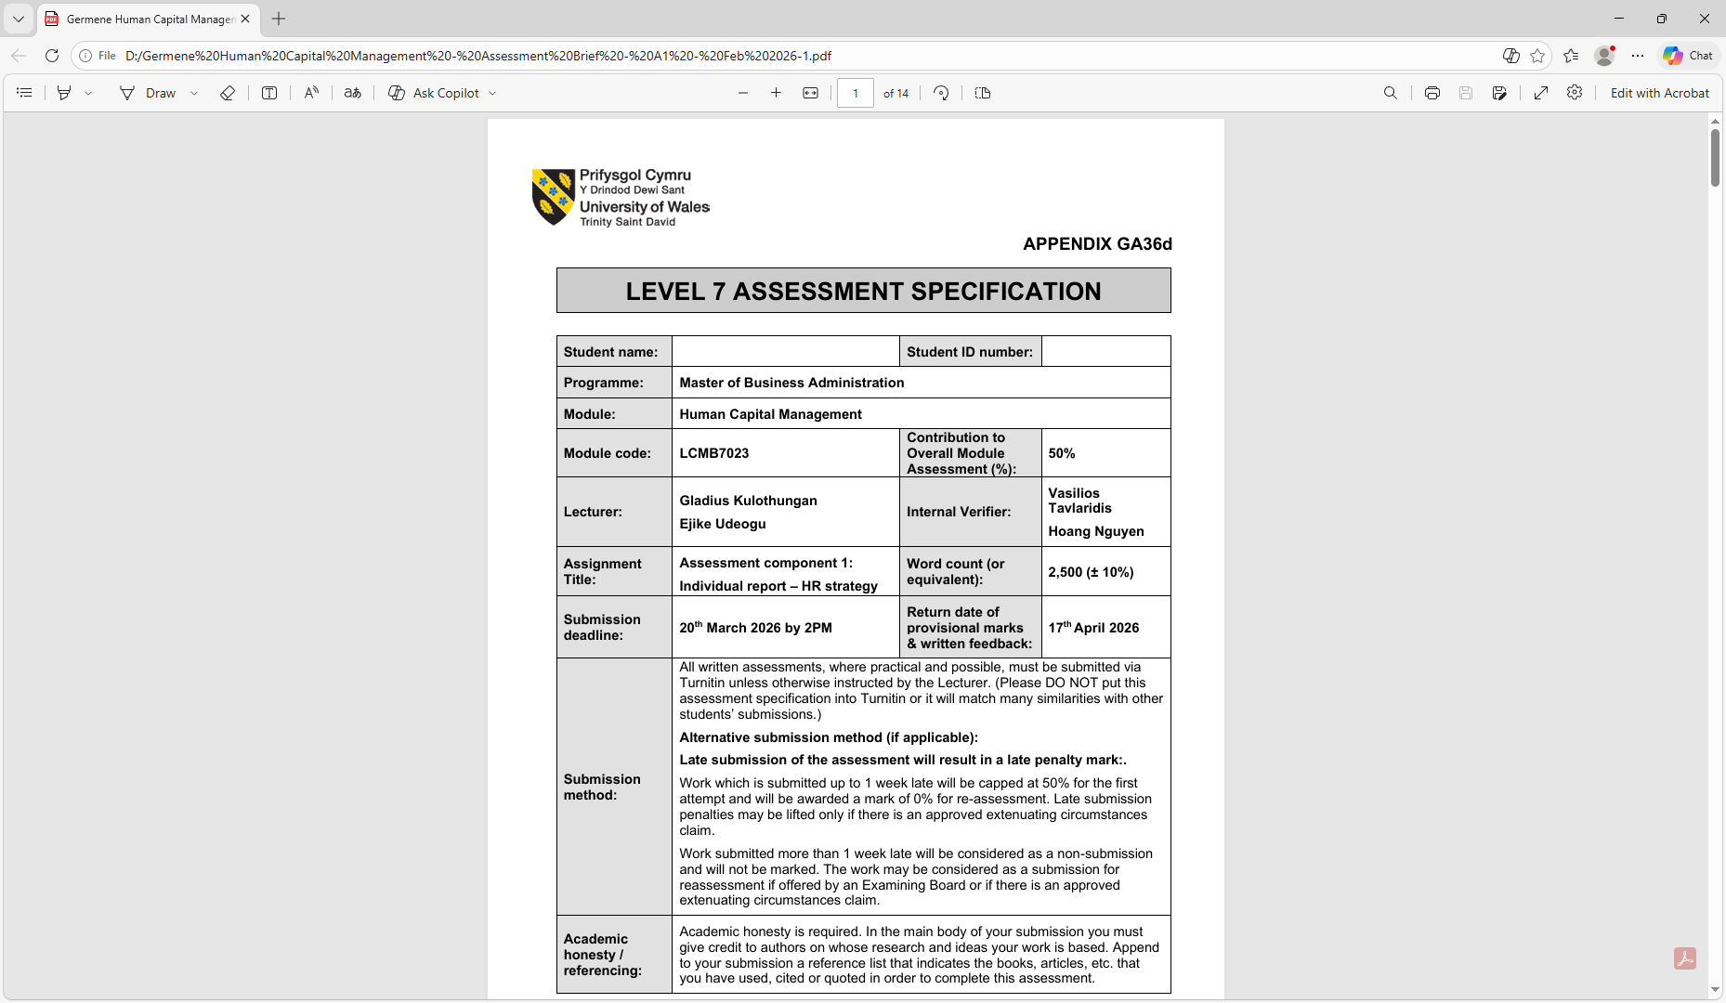

Master of Business Administration

Module: International Marketing: Principles and Practices
Module code: LCMB7026
Student Number:2218041
Student: Germene Delfina
Lecturer Name:

Assessment component - Individual report

AI acknowledgement

I acknowledge the use of Chat GPT (https://chatgpt.com) on the 24th of July 2026 to check my work using the prompts:
- Get better structure for my report.
- Be sure of the flow of the report.
- Mare sure of accuracy of information.

In confirm that I have not presented any AI generated text as my own work. I confirm that I have my drafts, and other resources used before, and after the use of AI tools which I may be asked to provide in evidence.

Executive Summary
This report examines Adidas’ global marketing approach by comparing its processes within Germany, the firm’s home marketplace, and China, one of its most important host marketplaces. The report appraises in what way Adidas familiarises its global marketing approaches to diverse political, economic, social, technological, environmental and legal settings utilising the PESTEL framework. It as well implements Hofstede’s Cultural Dimensions to assess in what way cultural differences impact customer behaviour, advertising decisions and management practices in both nations. Although Germany offers a constant and mature marketplace with robust buying power and brand loyalty, China provides considerable development opportunities over its growing middle class, digital economy and growing demand for first-class sportswear.
The report additionally compares Adidas’ Segmentation, Targeting and Positioning (STP) approaches and examines the 7Ps marketing mix to categorise resemblances and differences among the two marketplaces. While Adidas keeps a reliable international brand uniqueness, the firm adapts its products, pricing, distribution networks and advertising actions to encounter local customer favourites and marketplace situations. The report as well assesses Adidas’ market entry approach in China, underlining the profits of direct investment, strategic partnerships and digital retail growth. Furthermore, ethical issues linking to sustainability, supply chain management and marketing communications are studied, together with instances of both principled and unprincipled marketing practices.
The report settles that Adidas has effectively balanced international standardisation with local adaptation, allowing it to keep on competitive in both marketplaces. Though, constant investment in sustainability, digital novelty, supply chain transparency and ethnically pertinent marketing will be vital for long-term achievement. In general, Germany offers stable productivity, although China remains a main driver of future development, making both marketplaces tactically significant to Adidas’ global marketing approach.

Section 1: International Marketing Report: Adidas’ Market Entry Strategy and Marketing Mix in Germany and China

Introduction
Globalisation became an indispensable approach for international corporations since trades gradually work across marketplaces with diverse economic situations, cultural values, customer behaviours and governing settings. Global marketing needs companies to balance international brand constancy with local adaptation to realise competitive benefit (Kotler and Keller, 2016). This report examines the global market entry approach and marketing mix of Adidas in two nations: Germany, its home marketplace, and China, a main host marketplace. The report carries out the comparison of the macro-environmental aspects with the use of PESTEL analysis, assesses cultural differences utilising Hofstede’s Cultural Dimensions framework, studies segmentation, targeting and positioning (STP) approaches, and carries out the comparison of Adidas’ 7Ps marketing mix approaches. The report as well examines Adidas’ market entry approach in China, assesses ethical problems linked with its marketing actions and gives suggestions for upcoming global marketing growth.
Furthermore, a reflective account utilising Gibbs’ Reflective Cycle to assess the study and learning process carried out throughout the planning of this report.

Company Background: Adidas
Adidas is a German international sportswear establishment created in 1949 by Adolf Dassler. The firm plans, productions and markets footwear, clothing and sports kit worldwide. Adidas has grown from a traditional sports performance brand into a worldwide lifestyle brand by merging novelty, sport, fashion and cultural trends (Adidas, 2025). The firm contests worldwide with other main sportswear firms and has established a worldwide attendance over retail stores, e-commerce stands, sponsorships and partnerships.
Germany represents Adidas’ home marketplace, where the firm profits from robust historical networks, high brand acknowledgement and customer faith. China characterises one of Adidas’ most significant global marketplaces since of its huge population, increasing middle class and growing demand for global sports and lifestyle makes (Euromonitor, 2024).
Adidas’ mission is to be the greatest sports make worldwide by making ground-breaking, high-performance goods although sponsoring sustainability and inclusivity. Adidas go in the Chinese marketplace within 1997 over partnerships and progressively extended through direct investment and retail stores, becoming one of its main growth marketplaces within Asia (Adidas, 2025).

Macro Environment Analysis: PESTEL Comparison
The PESTEL framework assesses political, economic, social, technological, environmental and legal aspects that impact global business processes (Johnson et al., 2017). The external setting in Germany and China generates both opportunities and contests for Adidas.
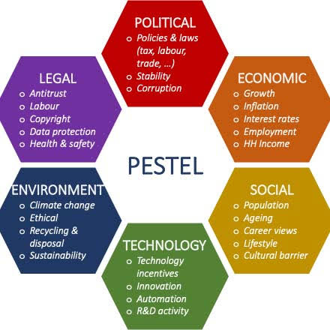
Source: (Johnson et al., 2017).

Political Factors
Germany delivers a favourable political setting for Adidas since it works in the stable political and regulatory outline of the European Union. Germany profits from robust organisations, transparent business protocols and a constant economic setting, which supports global firms (European Commission, 2024). These situations enable Adidas to function successfully and keep customer self-assurance.
China offerings important opportunities but as well a more multifaceted political setting. The Chinese government has a robust impact on overseas businesses over protocols, asset controls and digital policies (Wang and Chen, 2022). Adidas should obey with Chinese marketing regulations, customer safety protocols and data necessities. Political pressures among China and Western nations could as well generate threats for global brands.

Economic Factors
Economic aspects are favourable and slightly unfavourable, as Germany has an extremely established economy with robust buying power. Customers are keen to pay premium prices for superiority sportswear, enabling Adidas to compete in higher-value market segments (World Bank, 2024). Though, the German sportswear marketplace is established, meaning development opportunities are restricted equated with developing economies.
China has faced fast economic growth and urbanisation, generating a rising middle class with augmented spending power (International Monetary Fund, 2024). This offers Adidas with chances to develop sales. Though, rivalry has augmented because of the development of local sportswear makes and shifting customer hopes.
Germany has a developed and extremely established economy, with a GDP of about US$4.69 trillion in 2024, although China has the world's second-biggest economy with a GDP of about US$18.74 trillion (World Bank, 2024). Germany's inflation rate dropped to about 2.3%, supporting constant customer buying power, while China's inflation keeps on low at about 0.2%, reflecting feebler local demand but fairly constant prices. China documented GDP growing of 5.0% in 2024, equated with Germany's -0.5%, representing that China provides robust development opportunities in spite of advanced marketplace uncertainty (IMF, 2024). Adidas stated €23.7 billion in global net sales and €824 million working profit in 2024, with Greater China outstanding one of its most significant growing regions, although Germany carries on to create stable incomes since of its robust local client base (Adidas, 2025). Therefore, Germany offers economic stability and expected demand, while China provides better long-term sales development likely in spite of increased competitive and regulatory threats.
Economic Comparison of Germany and China (2024):
Economic Indicator | Germany | China
GDP (Current US$) | US$4.69 trillion | US$18.74 trillion
GDP Growth | -0.5% | 5.0%
Inflation Rate | 2.3% | 0.2%
Economic Stability | High, mature economy | Robust growing but policy uncertainty
Adidas Market Performance | Constant income and brand loyalty | High sales development and growth opportunities

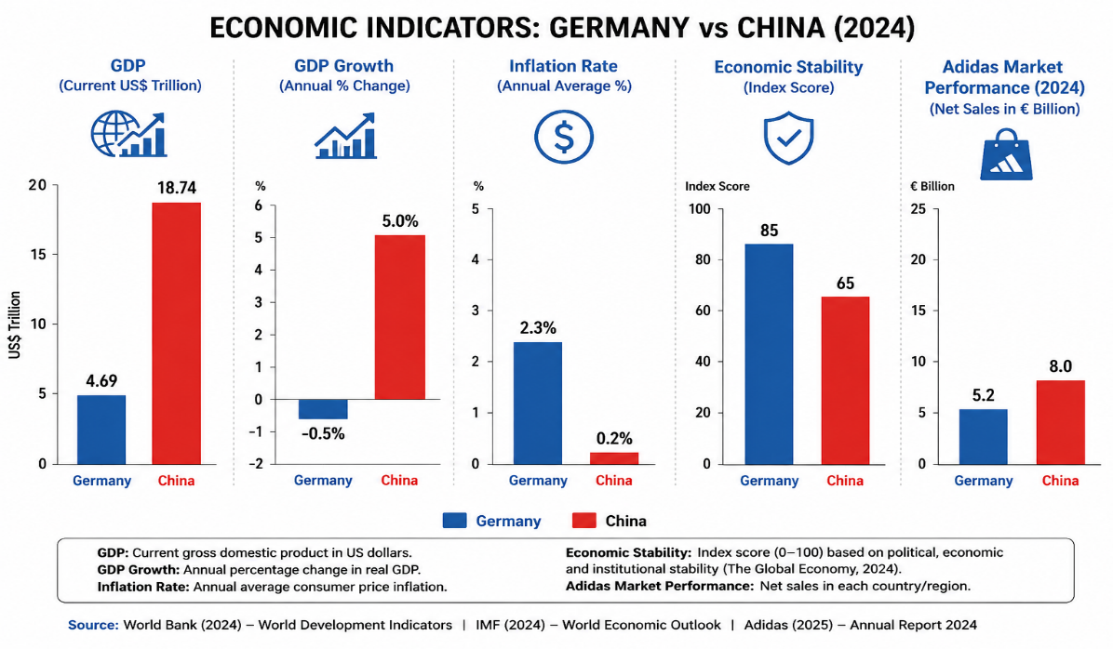

Social Culture Factors
Social trends powerfully favourable sportswear use since goods are gradually linked with lifestyle and individuality somewhat than just athletic performance (Solomon, 2020).
German customers normally value product quality, strength and sustainability. Adidas profits from its German inheritance since customers associate the make with consistency and manufacturing.
Within China, sportswear became thoroughly connected with fashion, social standing and culture of youths. Younger customers frequently buying global makes since they represent contemporary lifestyles and international identity (Liu and Kim, 2023). Adidas profits from this tendency by aligning itself as both a sports and lifestyle brand.
Hofstede Cultural Dimensions Model (Applied to Adidas in Germany and China)
Hofstede’s Cultural Dimensions model is a context settled by Geert Hofstede that clarifies in what way nationwide culture impacts values, behaviour, and expectations at the place of work around nations (Hofstede et al., 2010).
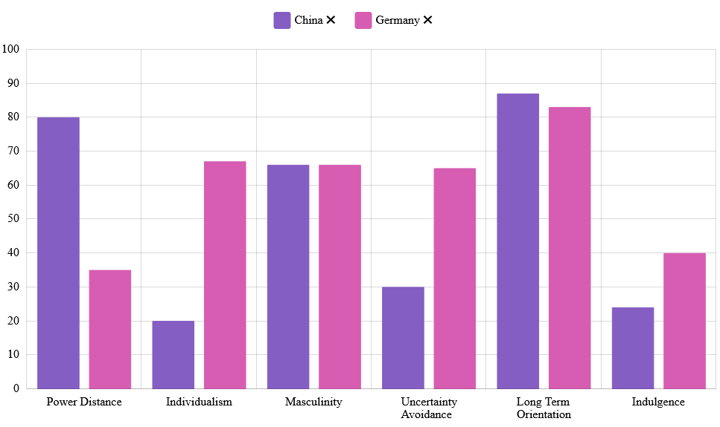
Source: Hofstede Insights (n.d.)
Germany and China contrast around Hofstede’s six dimensions: Germany displays lower power distance, robust individualism, advanced uncertainty avoidance, and modest masculinity with moderately tolerant inclinations, while China shows advanced power distance, collectivism, lower uncertainty avoidance, robust long-term orientation, and better limitation. Both value accomplishment, but China is more hierarchy- and future-oriented although Germany highlights structure and independence, reflecting conflicting cultural logics of power and decision-making forms detected internationally (Hofstede Insights (n.d.).
Comparison between Germany & China
Hofstede Dimension / Theme | Germany | China
Power Distance | Lower; favours flatter hierarchy and participative decision-making | Higher; admits robust hierarchy and authority
Individualism vs Collectivism | Powerfully individualistic; emphasis on individual independence and accountability | Collectivist; robust in-group faithfulness and harmony
Uncertainty Avoidance | Higher; favours rules, framework, and clear scheduling | Lower; more supple and relaxed with uncertainty
Masculinity | Moderate; performance and attainment balanced with quality of life | More competitive; robust emphasis on achievement and status
Long-Term Orientation | More moderate; stable scheduling with custom | Very strong; future-focused, long-term perseverance
Indulgence vs Restraint | More tolerant; values relaxation and individual pleasure | More controlled; better self-control and social guideline
Source: (Hofstede Insights (n.d.).

Point-wise Comparison (Germany vs China for Adidas)
Country | Favourable Aspects (Connected to PESTEL Analysis) | Unfavourable Aspects (Connected to PESTEL Analysis)
Germany | - Stable political setting (P).  - Robust economy and buying power (E).  - Sports and fitness culture supports demand (S).  - Cutting-edge technology and novelty (T). | - High work and working costs (E).  - Severe ecological protocols (E).  - Multifaceted legal and employment regulations (L).
China | - Huge and rising consumer marketplace (E).  - Increasing interest in sports and fitness (S).  - Innovative e-commerce and digital technology (T).  - Robust long-term growing potential (E). | - Political and trade doubts (P).  - Multifaceted legal and regulatory setting (L).  - Augmenting ecological obedience requirements (E).  - Cultural adaptation needed (S).

Cultural Factors
Culture is favourable for Adidas in both Germany and China. Germany values quality, novelty and sustainability, although China's fashion-conscious, digitally linked customers generate solid demand for premium global sportswear and lifestyle makes (Hofstede et al., 2010).

Advantages and Disadvantages of Hofstede’s Model
Advantages
Advantages | Disadvantages
- Simple structure  - Business significance  - Management practicality  - Broadly acknowledged | - Out-of-date information  - Over-generalisation  - Disregards diversity  - Static model  - Restricted suppleness
Source: Hofstede et al. (2010).

Technological Factors
Technology plays favourable part in Adidas’ global approach. Germany has innovative infrastructure and supports novelty in product growth, sustainability and digital retail (OECD, 2023). Adidas utilises technology to enhance product performance and client experience.
China has the world’s most advanced digital commerce settings internationally. Customers broadly utilise mobile shopping, social media and online stands (Chaffey, 2023). Adidas has extended its digital existence within China over online stores and collaborations with main digital stands.

Environmental Factors
Environmental aspects are unfavourable, as German customers have high ecological mindfulness and assume firms to determine accountable business practices (Peattie and Belz, 2019). Adidas has replied over sustainability creativities including recycled supplies and ecological targets.
Chinese customers are as well becoming more ecologically aware, though price and fashion trends keep on significant buying aspects (Liu and Kim, 2023). Adidas should then balance sustainability with affordability.

Legal Factors
Legal aspects are unfavourable, as Germany has severe legal needs about work standards, customer safety and ecological duties. Adidas should conform with European protocols linking to product protection, employment rights and sustainability reporting (European Commission, 2024).
China has different legal needs linking to overseas companies, intellectual property and marketing. Adidas should familiarise its processes to Chinese protocols although safeguarding its brand status.

Similarities and Differences of the PESTEL Analysis between Germany and China
The PESTEL analysis displays that both Germany and China offer significant opportunities for Adidas, while their business settings vary meaningfully. Governmentally, Germany provides better governing transparency, whereas China has robust government intervention in business actions. Economically, Germany has a constant, developed economy with high buying power, while China provides quicker economic development and a greater customer market. Socially, both nations have increasing interest in sports and well lifestyles, but German customers give priority to quality and sustainability, although Chinese customers are more influenced by style and digital tendencies. Technologically, both have innovative digital set-up, while China leads in e-commerce novelty. Environmentally, both encourage sustainability but customer hopes are robust in Germany. Legally, Germany has more expectable protocols, while China needs better adaptation to shifting business regulations (Johnson et al., 2017; World Bank, 2024).
STP Model: Adidas in Germany and China
Segmentation:
Within Germany, Adidas utilises mostly demographic and behavioural segmentation, aiming adults of ages 18 years to 45 years with high sports contribution and robust buying power, concentrating on excellence and functionality (Kotler and Armstrong, 2020). Psycho-graphically, German customers line up with VALS segments for example “Thinkers and Achievers”, who gives priority to rational decision-making, performance, and product consistency (Hofstede Insights, n.d.). Within China, segmentation is more topographical and psychographic, focussing on Tier 1 and Tier 2 urban towns for example Shanghai and Beijing, where increasing middle-class clients are extremely brand-aware (Solomon, 2020). VALS segments for example Experiencers and Stivers rule, reflecting status-driven use and lifestyle ambition.
Targeting:
Adidas implements a differentiated targeting approach in both marketplaces (Kotler and Armstrong, 2020). Within Germany, it aims performance-oriented athletes and sustainability-conscious customers over technical sportswear and innovation-led product lines. Within China, it aims younger, fashion-conscious city customers over celebrity confirmations, partnerships, and digital commerce stands. This reproduces cultural diversity, where Germany values personal performance and China puts higher importance on social image and collectivist effect (Hofstede Insights, n.d.).

Positioning:
Adidas utilises profit positioning and lifestyle/brand image positioning. Within Germany, Adidas is located as a high-performance, reliable sports brand concentrated on manufacturing quality and faith. Within China, it is located as a stylish, motivated sports-lifestyle brand related to identity and social status. Marketing mix essentials for example pricing, influencer advertising, and partnerships strengthen this positioning (Kotler and Armstrong, 2020).
Perceptual Map (China): Adidas is located among performance and style, leaning to fashion together with Nike, although Puma stays more performance concentrated.
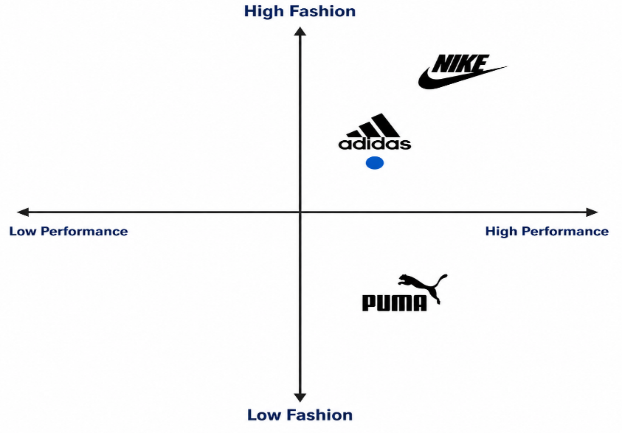

Similarities and Differences of the STP Model
Adidas implements alike segmentation by aiming customers built on demographics, lifestyle and sports contribution in both Germany and China. Though, Chinese segmentation efforts more on young city and digitally linked customers. The targeting approach in both nations highlights sportspersons and lifestyle clients, while China obtains better attention on Generation Z and the middle class. Relating to positioning, Adidas sustains a first-class worldwide sports brand image, but in Germany it highpoints heritage, excellence and sustainability, while in China it highlights fashion, novelty and aspiring lifestyle. (Kotler and Armstrong, 2021; Keegan and Green, 2020).

Marketing Mix (7Ps) Comparison

Product
Adidas keeps a reliable worldwide product approach whereas familiarising products to local favourites (Keegan and Green, 2020).
Within Germany, goods highlight performance, excellence and sustainability. Within China, Adidas efforts more on fashion gatherings, partnerships and limited-edition goods since customers frequently link sportswear with lifestyle.
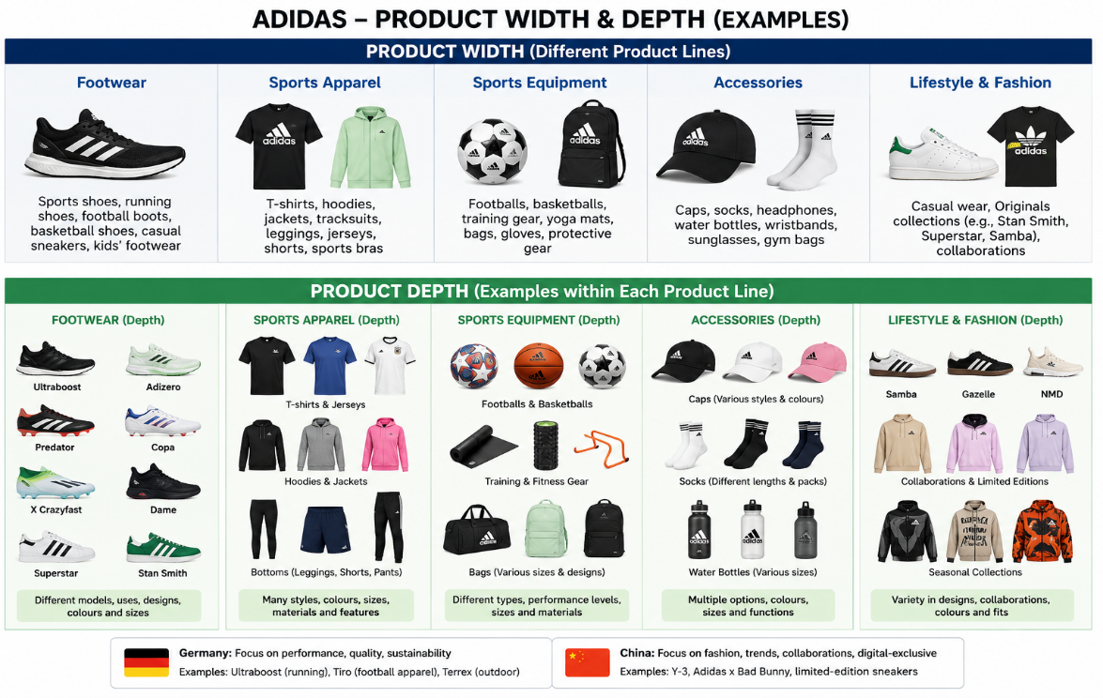
Source: ChatGPT

Price

For the aspects that will change the price in the two republics, Within Germany, the firm implements premium pricing since customers value excellence, novelty and sustainability. Within China, Adidas merges premium pricing with advertising pricing and periodic discounts to keep on competitive contrary to local makes whereas fascinating price-sensitive and younger customers (Kotler and Armstrong, 2021; Keegan and Green, 2020).
Germany utilises premium pricing since customers have higher buying power and solid faith in Adidas. China as well utilises premium pricing but needs more advertising action because of rivalry from domestic makes.
Place
Adidas distributes in Germany via physical stores, online retailers, and sports shops. Due to the high level of development of internet shopping, China largely depends on digital commerce and flagship stores in big cities (Chaffey, 2023).
In China and Germany, Adidas distributes their products both directly and indirectly. Adidas-owned flagship shops, manufacturing facilities, official websites, and mobile applications are examples of direct channels. Department stores, authorised dealers, and sporting goods merchants are examples of indirect channels. According to Keegan and Green (2020), Adidas likewise extensively depends on major e-commerce platforms in China to reach consumers who are connected to the internet.
Promotion
The coordinated use of many communication channels to improve customer interactions and convey a consistent brand message is known as integrated marketing communications, or IMC (Kotler and Keller, 2016). Adidas uses IMC in a variety of ways, including social media marketing, influencer relationships, athlete endorsements, sponsorship of major athletic events (like the FIFA World Cup and UEFA competitions), email marketing, mobile applications, public relations, experiential events, and sales promotions. While Adidas concentrates on digital advertising in China thru platforms like WeChat, Weibo, and Douyin, livestream shopping, celebrity partnerships, and limited-edition product launches to engage younger consumers, promotions in Germany prioritise performance, sustainability, and brand legacy.
Performance, innovation, and sustainability are the main goals of German promotion. Because digital communities have a significant impact on purchasing decisions, Chinese promotion is more dependent on social media, influencers, and celebrity connections.
People
Workers have an impact on the customer experience. Chinese stores frequently prioritise premium experiences and consumer involvement, whereas German retailers concentrate on product expertise.
Although country-specific employee numbers are not made public, Adidas employs about 62,000 people worldwide, including several thousand workers in China and Germany (Adidas, 2025). Employees in Germany receive training in customer service, sustainability, and product expertise. Additionally, training in China emphasises cultural sensitivity, client interaction, and digital retailing. In order to increase customer satisfaction and organisational performance, Adidas encourages staff members thru competitive pay, performance bonuses, career development programs, leadership training, diversity efforts, and employee wellbeing initiatives (Adidas, 2025).
Process
Effective supply chain systems are advantageous to Germany. Strong digital procedures, such as online ordering, quick delivery, and customer service integration, are necessary in China.
In China and Germany, Adidas has a formalised customer complaints procedure. Consumers can file complaints using official websites, mobile applications, online chat, customer service centres, and physical stores. In order to enhance product quality and service effectiveness, the corporation looks into problems, provides exchanges or refunds where necessary, and leverages consumer feedback (Adidas, 2025).
Physical Evidence
Sports legacy and authenticity are communicated in German Adidas stores. Chinese retailers frequently employ cutting-edge designs and technology to provide upscale shopping experiences.
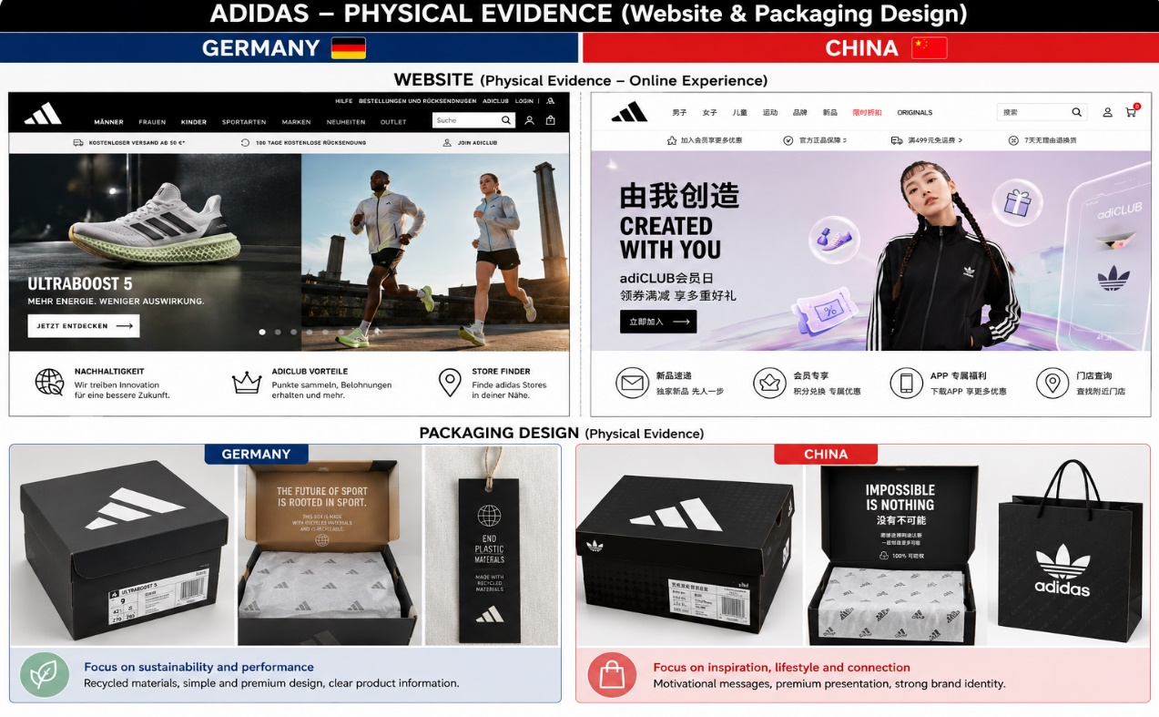
Source: ChatGPT

Similarities and Differences of Adidas’ Marketing Mix (7Ps) between Germany and China

Adidas employs a worldwide marketing mix approach in Germany and China, ensuring uniform brand identity, quality, innovation, and high-end positioning. Both marketplaces provide athletic apparel, footwear, and lifestyle goods, although modify the 7Ps to suit regional tastes. Germany prioritises sustainability, product excellence, cultural legacy, and tangible retail experiences, whereas China highlights fashion partnerships, influencers, digital promotion, and e-commerce. Adidas employs both direct and indirect distribution methods in each nation; Germany predominantly depends on physical stores and retailers, while China emphasises e-commerce, mobile platforms, and flagship outlets. In general, Germany prioritises trust and tradition, whereas China emphasises digital interaction and lifestyle experiences (Kotler and Armstrong, 2021; Keegan and Green, 2020).

Factor | Germany | China
Product Strategy | Sports performance and sustainability | Fashion, lifestyle, and local partnerships
Pricing Strategy | Premium but value-focused | Premium with promotional online pricing
Distribution Strategy | Retail + online channels | Digital platforms + leading stores
Promotion Strategy | Sports sponsorship and heritage marketing | Influencers, superstars, and social media crusades
Consumer Relationship | Built around trust and brand history | Built around commitment and digital groups

Product Lines Comparison: Germany and China
Country | Adidas Product Lines (Width of Product Mix) | Product Line Examples | Depth of Product Line (Number of Variations)
Germany | 5 key product lines |  | Footwear encompasses numerous types such as running shoes, soccer cleats, basketball sneakers and everyday trainers. Apparel encompasses outerwear, blouses, trousers, athletic suits, and activewear. Accessories comprise purses, socks, caps, and timepieces. Athletic gear encompasses football balls and training apparatus.
China | 5 key product lines |  | Footwear encompasses athletic shoes, trainers and exclusive designs. Apparel provides items for football, exercise, outdoor pursuits and leisure attire. Accessories comprise rucksacks, headgear, and hosiery. Lifestyle merchandise encompasses partnerships and urban apparel lines.

Market Entry Strategy Analysis: Adidas in China
Adidas penetrated the Chinese market with a blend of joint ventures, strategic alliances, franchising, totally owned subsidiaries, and direct investments. At first, Adidas employed regional collaborations and license contracts to comprehend the Chinese market, consumer tendencies, and distribution systems. The organization grew progressively via Adidas-operated retail outlets, e-commerce sites, and digital avenues like online marketplaces. This strategy enables Adidas to exert enhanced control over its brand identity, product excellence, and consumer experience, while also leveraging insights from local markets.
Adidas employs these strategies because of China's very competitive and swiftly evolving market, where customer inclinations are shaped by fashion trends, technological advancements, and regional culture. Collaborations mitigate market entrance hazards, whereas direct investment fosters sustained growth and enhances Adidas' visibility among Chinese customers (Kotler and Armstrong, 2021).
A benefit of direct investment via Adidas-owned retail outlets and online platforms is enhanced oversight of marketing strategies, pricing structures, and consumer interactions. Nonetheless, a drawback is the substantial expense associated with conducting business in China, encompassing infrastructure investment, local customisation, and rivalry from indigenous companies like Li-Ning and Anta.
Adidas exemplifies ethical marketing by engaging in sustainable product creation, including the utilisation of recycled materials in their footwear (Product), and by launching campaigns that advocate for diversity and inclusion via global brand communications (Promotion). Nonetheless, Adidas has encountered scrutiny about the transparency of its supply chain and issues related to labour standards among its suppliers (Process). A further possible ethical concern is the use of aggressive influencer marketing that could promote rampant consumerism among youthful consumers (Promotion). Consequently, Adidas needs to reconcile economic expansion with ecological accountability, openness, and consumer safeguarding.

Recommendations for International Marketing: Adidas in Germany and China
Adidas ought to implement a more robust STP (Segmentation, Targeting, Positioning) strategy in Germany by focusing on eco-aware consumers and mature lifestyle clientele desiring sustainable luxury items. Adidas has the potential to broaden its market demographic by creating a brand extension centred on sustainable casual footwear and environmentally conscious apparel lines. The positioning must highlight Adidas as a frontrunner in sustainable innovation and the excellence of German engineering. Adidas ought to enhance its sustainable product offerings (Product), convey its environmental accomplishments with clarity (Promotion), and bolster client loyalty via tailored digital services (Place).
To mitigate ethical issues, Adidas ought to enhance supply-chain transparency by offering more explicit details regarding production methods and labour standards. This would mitigate concerns over unethical sourcing methods and enhance consumer confidence.
Adidas ought to focus on younger digital consumers in China, particularly Gen Z individuals who are keen on fashion, technology, and customised experiences. The firm ought to establish itself as a culturally versatile lifestyle brand by partnering with Chinese designers, regional athletes, and online communities. A suggested brand extension is a limited-edition product line inspired by China that merges Adidas technology with indigenous cultural motifs.
The marketing mix ought to prioritise digital-centric approaches, encompassing social commerce, livestream shopping, and collaborations with influencers (Promotion and Place). Adidas ought to enhance its ethical marketing strategies by guaranteeing transparency in influencer promotions and refraining from excessive advertising that fosters superfluous consumption.
Adidas ought to preserve its international brand while tailoring its STP and marketing mix approaches to meet local consumer demands. Germany necessitates an increased focus on sustainability and trust, whereas China demands enhanced digital interaction and cultural significance.

Section 2: Reflective Account Using Gibbs’ Reflective Cycle

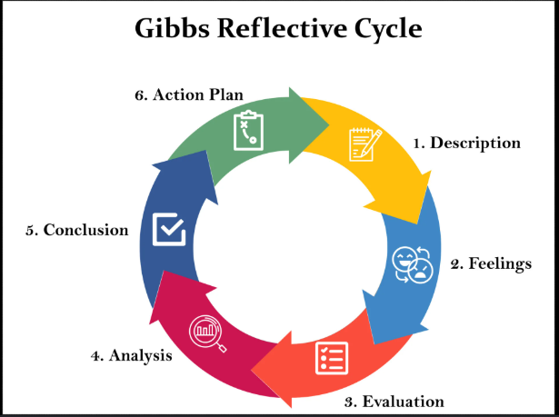

Source: McLeod (2025)
Description
In the course of compiling this international marketing report, I investigated and evaluated the global marketing tactics of Adidas in Germany and China. My objective was to comprehend how a multinational entity modifies its strategy when functioning within diverse cultural, economic, and political contexts. I chose Germany and China as Germany signifies Adidas' domestic market, whereas China exemplifies a significant global market with diverse consumer behaviours and market dynamics.
To finalise the research, I employed many marketing frameworks, such as PESTEL analysis, Hofstede’s Cultural Dimensions, segmentation, targeting and positioning (STP), and the 7Ps marketing mix. I gathered data from scholarly textbooks, journal publications, corporate reports, and trustworthy online resources. I utilised these references to contrast the two markets and assess how Adidas modifies its products, price strategies, promotional efforts, distribution techniques, and consumer interactions.
The procedure necessitated the integration of theoretical principles with practical business instances. I utilised PESTEL analysis to ascertain the impact of political, economic, social, technological, environmental, and legal elements on Adidas' activities in Germany and China. I employed Hofstede’s framework to comprehend the influence of cultural disparities on customer behaviour and marketing strategies.
Feelings
Initially, I experienced a sense of being little inundated due to the myriad of elements in worldwide marketing that affect business choices. Adidas functions in numerous nations, and I encountered difficulties in determining which details were most pertinent for the paper. I initially struggled to correlate academic theories with actual instances from the organization.
As I progressed in my research, my confidence grew due to the frameworks assisting me in structuring my thoughts. I recognised that worldwide marketing encompasses not merely the global sale of items but also the comprehension of variations in consumer expectations, cultural values, and market dynamics.
During my investigation of Germany and China, I developed a greater fascination with how Adidas preserves a uniform worldwide character while adapting specific techniques for regional markets. The juxtaposition of the two nations proved beneficial as it illustrated the impact of cultural and economic factors on marketing strategies.
Evaluation
One advantageous element of finalising this report was that the selected frameworks offered a coherent foundation for evaluating Adidas. The PESTEL research enabled me to comprehend the external prospects and obstacles in both nations. The Hofstede paradigm enabled me to understand that cultural variances affect consumer behaviour, modes of communication, and buying choices.
The STP study proved beneficial as it illustrated how Adidas recognises various client segments and modifies its targeting approaches. I discovered that Adidas has a more expansive strategy in Germany owing to its robust brand legacy, whereas in China, the firm concentrates primarily on younger, digitally engaged consumers.
The 7Ps marketing mix proved advantageous as it enabled me to evaluate pragmatic marketing tactics. For instance, I noted that Adidas prioritises sustainability and product excellence as key messaging in Germany, whereas in China, the brand focuses more on digital marketing, influencers, and lifestyle branding.
Nonetheless, I encountered several difficulties. A challenge encountered was sourcing information that explicitly contrasted Adidas' strategies throughout the two nations. Certain sources emphasised international endeavours instead of particular national tactics. One difficulty encountered was the application of Hofstede’s approach, as it may occasionally reduce cultural variances by categorising an entire nation as possessing a singular culture.
Analysis
By undertaking this work, I discovered that effective worldwide marketing necessitates a harmony between standardisation and customisation. Prior to investigating this subject, I presumed that international brands predominantly employed identical marketing strategies universally. Nonetheless, examining Adidas revealed that global corporations need to modify their strategy based on regional circumstances.
The study enhanced my comprehension of the significance of cultural awareness. The distinctions between Germany and China revealed that consumer behaviour is shaped by values, societal norms, and technological advancements. Chinese consumers are significantly swayed by digital platforms and social media networks, but German consumers tend to prioritise product quality, sustainability, and dependability.
I also discovered that ethical considerations play a significant role in global marketing. A firm's standing relies not solely on its merchandise but also on its operational responsibility. Adidas' sustainability efforts illustrate how ethical practices may enhance a brand; however, supply chain issues highlight the necessity of openness.
This task also enhanced my research abilities. I acquired the skill to evaluate material from many sources, discern trustworthy academic references, and implement theories in real-world commercial contexts.

Conclusion
In summary, the preparation of this paper enhanced my comprehension of global marketing tactics and the obstacles encountered by transnational corporations. I discovered that corporations like Adidas must meticulously evaluate various markets prior to determining strategies for items, price, promotion, and distribution.
Employing PESTEL, Hofstede’s cultural framework, STP, and the 7Ps facilitated a more systematic methodology for evaluating international company strategy. I also acknowledged that effective international marketing necessitates firms to preserve a robust brand identity while accommodating local consumer preferences.
Despite encountering obstacles throughout the study process, finalising the report bolstered my confidence in evaluating international marketing strategies and implementing theoretical frameworks in practical contexts.
Action Plan
In upcoming tasks, I will enhance my research methodology by organising my framework in advance and gathering scholarly resources prior to commencing the writing phase. I will dedicate additional time to contrasting various sources to guarantee that my analysis is equitable and substantiated by evidence.
I will persist in enhancing my capability to implement marketing theories in actual enterprises, as this proficiency is crucial for comprehending global company strategies. I will place increased emphasis on ethical considerations and cultural variances while evaluating international organisations.
In forthcoming research endeavours, I intend to enhance my time management by establishing a more defined timetable for research, writing, and evaluation. This will assist me in generating more comprehensive and systematically structured scholarly work.

Conclusion
This paper has examined Adidas' global marketing tactics in Germany and China utilising PESTEL analysis, Hofstede's cultural dimensions, STP, and the 7Ps marketing framework. The examination reveals that Adidas capitalises on its robust brand legacy in Germany while adjusting to China's rapidly expanding and digitally orientated market. Despite Adidas upholding a uniform global identity, variations in culture, economy, and technology necessitate tailored approaches. The organization's prosperity hinges on harmonising innovation, sustainability, and consumer involvement. Ethical marketing strategies, openness in the supply chain, and cultural sensitivity are crucial for preserving consumer confidence. Future expansion necessitates Adidas to enhance its digital approaches, environmental efforts, and adaption to local markets.

References
Adidas (2025) Adidas Group: Annual Reports, Sustainability and Company Information. Available at:
https://www.adidas-group.com/en/sustainability/ (Accessed: 19 June 2026).
Adidas (2024) Sustainability at Adidas. Available at: https://www.adidas-group.com/en/sustainability (Accessed: 11 July 2026).
Chaffey, D. (2023) Digital Marketing Strategy and Trends. Available at:
https://www.davechaffey.com/tag/digital-marketing-strategy/ (Accessed: 19 June 2026).
Crane, A., Matten, D. and Spence, L. (2019) Corporate Social Responsibility: Readings and Cases in a Global Context. Available at:
https://www.routledge.com/Corporate-Social-Responsibility-Readings-and-Cases-in-a-Global-Context/Crane-Matten-Spence/p/book/9780415683258 (Accessed: 19 June 2026).
European Commission (2024) European Commission: Business, Economy and Regulation. Available at:
https://commission.europa.eu/business-economy-euro_en (Accessed: 19 June 2026).
Euromonitor (2024) Global Consumer Trends and Sportswear Market Research. Available at:
https://www.euromonitor.com/article/top-trends-in-global-apparel-and-footwear-in-2024-and-beyond (Accessed: 19 June 2026).
Hill, C.W.L. and Hult, G.T.M. (2021) International Business: Competing in the Global Marketplace. Available at:
https://www.researchgate.net/publication/279283366_Hill_C_W_L_International_business_Competing_in_the_global_marketplace_McGraw-Hill_Education_Maidenhead_Berkshire_UK_2014 (Accessed: 19 June 2026).
Hofstede, G., Hofstede, G.J. and Minkov, M. (2010) Cultures and Organizations: Software of the Mind. Available at:
https://geerthofstede.com/culture-geert-hofstede-gert-jan-hofstede/6d-model-of-national-culture/ (Accessed: 19 June 2026).
Hofstede Insights (n.d.) Country comparison bar charts. Available at: https://geerthofstede.com/country-comparison-bar-charts/ (Accessed: 6 July 2026).
International Monetary Fund (2024) World Economic Outlook Database. Available at:
https://www.imf.org/en/Publications/WEO/weo-database (Accessed: 19 June 2026).
Johnson, G., Whittington, R. and Scholes, K. (2017) Exploring Strategy. Available at:
https://www.pearson.com/en-au/media/g10dyvte/9781292428741_sample.pdf?srsltid=AfmBOoou6eWB23jpOEuJWfnmzrKBaiWtn0vT0OtINIeutS2VZYfO6n5B (Accessed: 19 June 2026).
Keegan, W.J. and Green, M.C. (2020) Global Marketing. Available at:
https://www.scribd.com/document/1012578332/Global-Marketing-9th-Edition-by-Warren-J-Keegan-Mark-C-Green (Accessed: 19 June 2026).
Kotler, P. and Armstrong, G. (2021) Principles of Marketing. Available at:
https://commecsinstitute.edu.pk/wp-content/uploads/2024/08/Kotler-and-Armstrong-Principles-of-Marketing.pdf (Accessed: 19 June 2026).
Kotler, P. and Keller, K.L. (2016) Marketing Management. Available at:
https://library.uniq.edu.iq/storage/books/file/kotler_keller_-_marketing_management_14th_edition/1666787488kotler_keller_-_marketing_management_14th_edition.pdf (Accessed: 19 June 2026).
Kotler, P. and Armstrong, G. (2020) Principles of Marketing. Pearson. Available at: https://commecsinstitute.edu.pk/wp-content/uploads/2024/08/Kotler-and-Armstrong-Principles-of-Marketing.pdf Accessed: 6 July 2026).
Levitt, T. (1983) ‘The Globalization of Markets’, Harvard Business Review. Available at:
https://edu.astutehorse.com/wp-content/uploads/2017/02/levit-globalization.pdf (Accessed: 19 June 2026).
McLeod, S. (2025) Gibbs Reflective Cycle. Simply Psychology. Available at: https://www.simplypsychology.org/gibbs-reflective-cycle.html (Accessed: 11 July 2026).
McSweeney, B. (2002) ‘Hofstede’s Model of National Cultural Differences and their Consequences’, Human Relations. Available at:
https://journals.sagepub.com/doi/10.1177/0018726702551004 (Accessed: 19 June 2026).
OECD (2023) OECD Digital Economy Outlook. Available at:
https://www.oecd.org/en/publications/oecd-digital-economy-outlook_f0b5c251-en.html (Accessed: 19 June 2026).
Peattie, K. and Belz, F.M. (2019) Sustainability Marketing: A Global Perspective. Available at:
https://www.academia.edu/94375666/Frank_Martin_Belz_and_Ken_Peattie_Sustainability_Marketing_A_Global_Perspective (Accessed: 19 June 2026).
Solomon, M.R. (2020) Consumer Behavior: Buying, Having and Being. Available at:
https://www.researchgate.net/publication/280824090_Consumer_Behavior_Buying_Having_and_Being_8th_ed Accessed: 19 June 2026).
Statista (2025) Adidas market presence and consumer trends. Available at: https://www.statista.com/topics/1257/adidas/?srsltid=AfmBOorgrkIAA7avU2s5rar33MkdO_xwIyX_GC48jm-TAacL_PmMe8g6 (Accessed: 11 July 2026).
Wang, Y. and Chen, L. (2022) China Business Environment and Foreign Investment Regulation. Available at:
https://insight.dickinsonlaw.psu.edu/cgi/viewcontent.cgi?article=1319&context=jlia (Accessed: 19 June 2026).
World Bank (2024) World Development Indicators Database. Available at:
https://databank.worldbank.org/source/world-development-indicators (Accessed: 19 June 2026).

