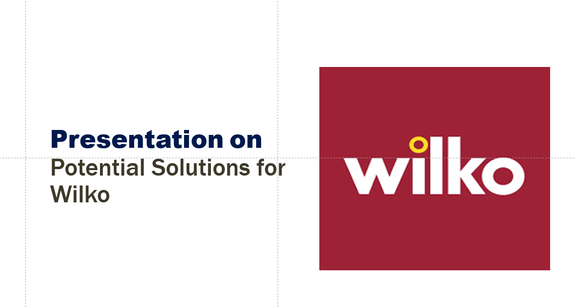

Petru Alexandru Stanescu
Student ID:2244123

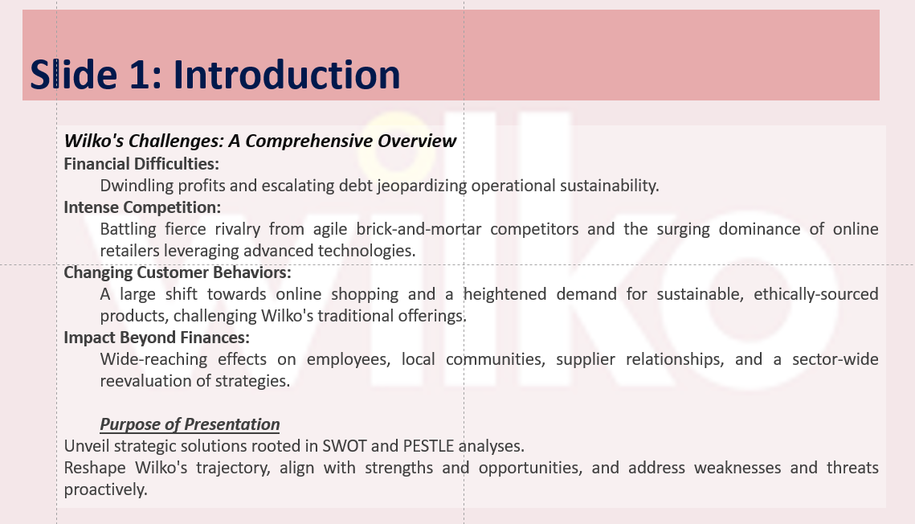Wilko, for years, has been a reputable household brand accredited with a trusty customer base, whose relationship is centred on and sustained by goods and services. On the other hand, the industry of retail is nowadays rapidly changing to meet up with the recent diversity, therefore for Wilko to stay up with this fast speed, it also has to change. These retailers encounter the most difficulties in developing websites and maintaining operating costs that are too high. The purpose of this is to deal with challenges in the way of our growth figure out the best directions of our growth and identify the areas where Wilko has the most potential, we submit a detailed SWOT and PESTLE analysis. By utilizing this analysis, Wilko can make informed decisions and choose the best strategic options for their growth. We are confident that with the right approach, Wilko can continue to thrive in the ever-changing retail landscape and maintain its status as a beloved retailer among their devoted customers.

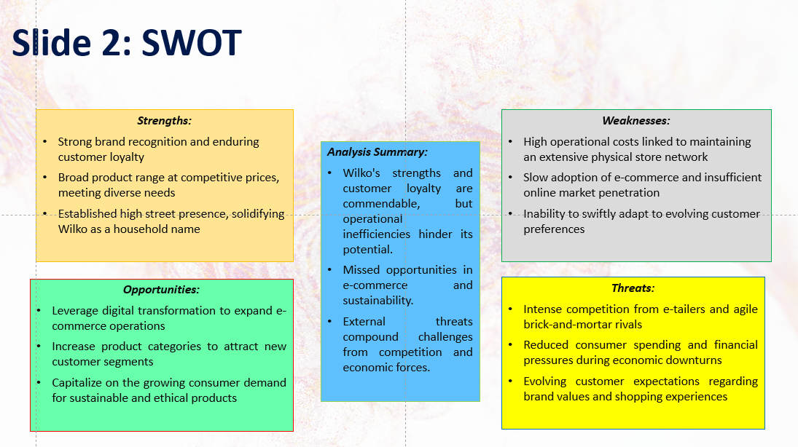
The strengths of Wilco's include then are high product awareness and a base of regular customers. Nevertheless, it encompasses low web presence and high operational costs as disadvantages. This path will give opportunities to explore the growing e-commerce sector and the market for green products. Risky online competitors and constant higher economic challenges are sources of trouble.

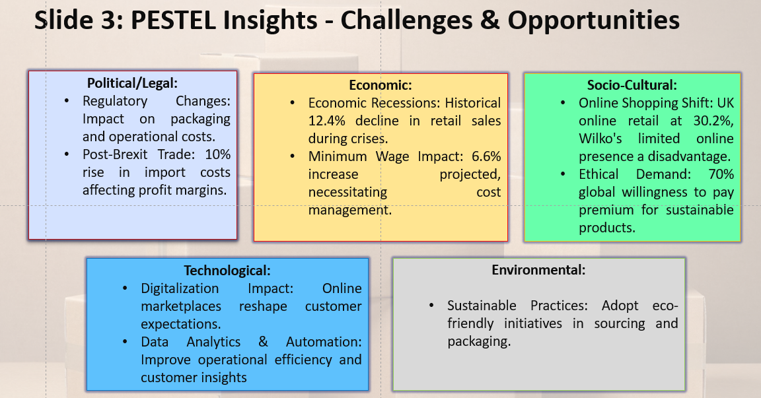
The political && legal factors including regulations and Brexit can significantly affect a company. Economic variants such as inflation or minimum wage modification may hinder profit margins. Factors of a social and cultural nature such as online services and ecological attitudes have to be considered. Since technology is the keyword that is present in e-commerce platforms and data analysis, it provides opportunities for both. People take into account environmental influences, like sustainability concerns when making decisions.

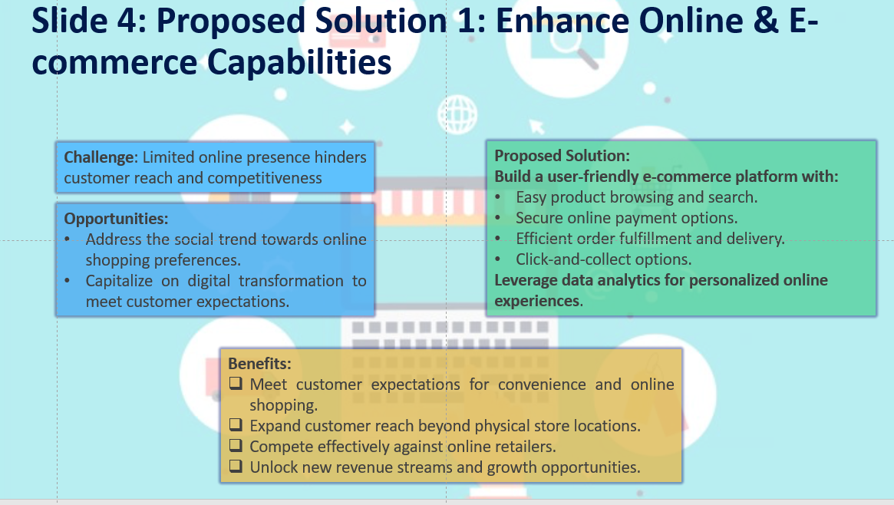
This part will be dedicated to discussing the implementation details, regarding the e-commerce platform we are planning to develop. We will discuss the development of a pleasant platform with search and browsing characteristics. Security of the payment and effectiveness of the order processing will be ensured, using modern methods. On the other hand, analytics of data will be used to cater for the online shopping experience that is more personalized for customers. Wilko's absence in online platforms restricts its potential customer base as well as its competitiveness. We will construct a strong to fill the gap that exists in digital commerce. The platform will have a simplified shopping process with features like easy product browsing, secure payment systems, and efficient delivery. It stays tuned to the changing customer expectations and fights in the online market having fair odds.

Conclusion
Finally, Wilko is at a major crossroads. For the growing and constantly changing world of retail, it is required the application of a full reformation approach. To make the customers’ experience smoother and more enjoyable and meet the present-day classy needs of customers, Wilko can broaden its e-commerce platform, fine-tune the operations, and expand its stock towards environmental protection. The data-based developed mosaic of the approach will therefore enable Wilko to rapidly adapt and further develop the business to achieve long-term viability, thanks to the multiple customer touch points and the lean operating processes that represent the company's single channel and compelling sustainability value proposition. The fire now is this roadmap may it become a secret weapon to revitalize Wilko and put forward a leader in this new retail scenery.

