​

Module: Developing and Managing Individuals and Teams (LCLM5002)

Individual Report: Strategic HRM Analysis of Marks & Spencer

Student name: Tetiana Kovenia
Student ID: 2422022

Submission Date: 01.05.2026
Lecturer Sukhpreet Grewal

Table of Contents
​1. Introduction 2
​2. Factors Influencing HRM Practices 2
​2.1 Technological Advancement: Beyond Digitisation 2
​2.2 Talent Acquisition and Retention: The Post-Brexit Landscape 3
​2.3 Diversity, Equity, and Inclusion (DEI): A Strategic Asset 3
​3. Evaluation of HR Practices through Theory 4
​3.1 Maslow’s Hierarchy of Needs: A Critical Application 4
​3.2 Humanistic Theory (Carl Rogers) 5
​3.3 Expectancy (Vroom) and Equity (Adams) Theories 5
​4. Strategic Stress Management in a High-Pressure Environment 8
​5. Conclusion and Strategic Recommendations 9
​​6. Reference List 10

1. Introduction
​Marks & Spencer (M&S) remains a cornerstone of British retail, yet it operates within an increasingly volatile and hyper-competitive landscape. The UK retail sector is currently defined by a "double-edged" pressure: the dominance of e-commerce giants like Amazon, which have redefined customer expectations for speed and digital integration, and the aggressive expansion of budget retailers such as Aldi and Lidl, which have shifted the focus toward extreme cost-efficiency. In this "retail apocalypse" era, a firm's competitive advantage no longer rests solely on its products, but on the agility and engagement of its human capital.
​The purpose of this report is to provide a critical evaluation of the Strategic Human Resource Management (SHRM) practices within M&S. Rather than merely describing existing policies, this analysis investigates how HR strategies—specifically regarding technological advancement, talent retention, and Diversity, Equity, and Inclusion (DEI)—align with broader corporate objectives. By applying key motivational and humanistic theories, such as Maslow’s Hierarchy, Rogers’ Humanistic Theory, and Vroom’s Expectancy Theory, this report assesses the efficacy of M&S's approach in fostering a high-performance culture. Furthermore, it examines the pivotal role of line managers in implementing these strategies with the urgency required to sustain business resilience and long-term growth.

2. Factors Influencing HRM Practices

2.1 Technological Advancement: Beyond Digitisation
Technology has transitioned from a supporting tool to a core driver of HRM strategy at M&S. The implementation of the "Digital First" strategy is not merely about replacing paper with screens; it is about leveraging data to enhance decision-making.
M&S utilizes Artificial Intelligence (AI) and automated screening algorithms in its recruitment process to manage the high volume of applications, especially during peak seasonal periods. While this increases efficiency by filtering candidates based on key competencies, it raises critical questions regarding "algorithmic bias" and the loss of the "human touch" in candidate experience. Furthermore, the integration of the MyCareer portal and M&S Learning platform empowers employees to take ownership of their development.
However, a significant challenge is the "Digital Divide" within the workforce. M&S employs a multi-generational demographic, and older employees may experience "technostress" or feel alienated by the rapid shift to handheld stock devices and automated till systems. HRM must, therefore, balance rapid tech adoption with comprehensive digital literacy programs to ensure no segment of the workforce is left behind.

2.2 Talent Acquisition and Retention: The Post-Brexit Landscape
In the wake of Brexit and the subsequent end of free movement, the UK retail sector has faced a chronic labour shortage. M&S has responded by strengthening its Employer Branding, positioning itself not just as a retailer, but as a "career destination."
To compete with the gig economy and other high-street rivals, M&S has moved beyond basic pay. The commitment to the London Living Wage and the rejection of zero-hour contracts are strategic moves to provide financial security—satisfying what Maslow (1943) terms "Safety Needs."
Moreover, M&S has pioneered Flexible Working initiatives, such as the "Worklife" program, which allows store managers to opt for four-day compressed weeks or job-sharing. This flexibility is a crucial differentiator in attracting "Generation Z" and parents, shifting the focus from mere presence to output and well-being.

2.3 Diversity, Equity, and Inclusion (DEI): A Strategic Asset
Under the "Plan A" initiative, DEI is no longer a "tick-box" exercise but a strategic driver of innovation. M&S recognises that a workforce that mirrors the diversity of the UK population is better equipped to understand and anticipate the needs of a diverse customer base.
- Inclusion as Innovation: When employees from different ethnic, cultural, or neurodiverse backgrounds collaborate, they bring "cognitive diversity." This helps M&S tailor its product ranges (e.g., adaptive clothing lines or diverse food ranges) more effectively.
- The "Belonging" Factor: By fostering an environment where employees feel they can bring their "authentic selves" to work, M&S reduces turnover rates and increases discretionary effort.

Tabel 1: Comparison of External Factors and HR Strategic Responses
Factor | Impact on M&S | HRM Strategic Response
Technological Shift | Risk of digital exclusion and operational inefficiency. | AI-driven recruitment & "MyCareer" lifelong learning portal.
Brexit & Labour Gap | Shortage of skilled retail staff and high turnover. | Enhanced Employer Brand, Living Wage, and Apprenticeships.
Societal Expectations | Demand for ethical business and representation. | "Plan A" DEI integration & Inclusive leadership training.
Work-Life Balance | High stress and burnout in retail environments. | Compressed work weeks and flexible "Worklife" scheduling.

Visualizing the Impact: The "Force Field" of M&S HRM
- External Pressures: Brexit, AI Evolution, Competitor Pricing (Aldi/Lidl).
- Internal Needs: Employee Well-being, Digital Literacy, Retention of Expertise.

3 Evaluation of HR Practices through Theory

3.1 Maslow’s Hierarchy of Needs: A Critical Application
Marks & Spencer (M&S) systematically addresses the levels of Maslow’s pyramid (Figure1) to maintain a motivated workforce, though a critical lens reveals a more complex picture than a simple linear progression.
- Satisfying Deficiency Needs: At the foundational level, M&S addresses Physiological and Safety needs through competitive pay and the rejection of zero-hour contracts, providing the "economic harm" protection mentioned in your lecture notes.
- Social and Esteem Needs: The "Buddy System" for new hires facilitates social integration, while "Spotlight Awards" satisfy the need for recognition and status. This aligns with the lecture slide stating that "the need to be recognised for achievement" is a core driver of self-esteem.
- Critical Evaluation: According to your course materials, Maslow’s theory is often criticised for assuming everyone moves through levels in the same way. In the retail context of M&S, a store manager might be driven by Self-Actualisation (potential), whereas a seasonal part-time worker might be purely focused on Physiological needs (wages). M&S’s HR must, therefore, avoid a "one-size-fits-all" approach, recognising that for some, the lack of safety (job security) will completely negate any attempt at "Social" motivation.

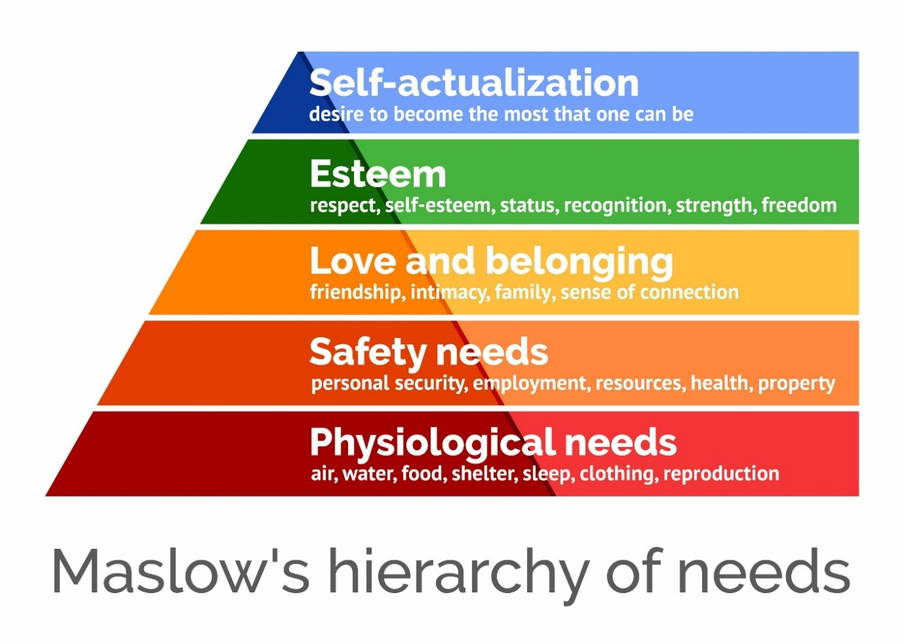
Figure 1: Maslow`s hierarchy of needs

3.2 Humanistic Theory (Carl Rogers)
Rogers’ theory posits that individuals grow if provided with empathy, genuineness, and acceptance. M&S applies this through its "open-door" policy and regular 1-on-1s.
- Self-Concept: M&S helps employees bridge the gap between their Actual Self and Ideal Self by providing autonomous learning paths on the MyCareer portal.
- Unconditional Positive Regard: By fostering a "Recognition Culture," M&S managers provide the acceptance necessary for employees to reach "Self-Actualisation" without fear of failure when trying new digital tools.

3.3 Expectancy (Vroom) and Equity (Adams) Theories
Motivation at M&S is also a cognitive process, as explained by Vroom and Adams.
- Vroom’s Expectancy Theory: For a staff member to be motivated to complete digital training, they must believe that:
  - Expectancy: Their effort will lead to successful completion.
  - Instrumentality: Completion will lead to a reward (e.g., promotion).
  - Valence: The reward is personally valuable. M&S ensures high Instrumentality by clearly linking training milestones to career progression.
- Adams’ Equity Theory: Retail employees are highly sensitive to "Equity Gaps." If a shop-floor worker perceives that their "input" (hard work during peak hours) is not fairly rewarded compared to their "output" (salary) or compared to their peers, motivation declines. M&S maintains transparency in pay scales to mitigate this risk.

Tabel 2: Comparison of Motivational Techniques at M&S
Technique | Theory Link | M&S Implementation Example
Competitive Base Pay | Maslow (Safety/Physiological) | Above National Living Wage.
Morning Huddles | Maslow (Social) / Rogers (Empathy) | Daily team briefings for connection.
MyCareer Portal | Rogers (Self-Actualisation) | Self-directed digital learning.
Performance Bonuses | Vroom (Valence/Instrumentality) | Clear rewards for hitting sales targets.

The table above illustrates how Marks & Spencer (M&S) strategically aligns its operational techniques with established motivational theories to foster a high-performance culture. By providing Competitive Base Pay, M&S addresses the most fundamental levels of Maslow’s Hierarchy, ensuring that employees' physiological and safety needs are met, which serves as a prerequisite for further engagement. The use of Morning Huddles reflects a humanistic approach, drawing on Rogers’ theory of social connection and empathy to build a sense of belonging within teams.
​Furthermore, the My Career Portal empowers staff through self-directed learning, facilitating Self-Actualisation by bridging the gap between their current skills and their "Ideal Self." Finally, the implementation of Performance Bonuses is grounded in Vroom’s Expectancy Theory; by creating a clear link between effort (hitting sales targets) and a highly valued reward (valence), M&S ensures that staff remain motivated to maintain high productivity levels. Collectively, these diverse techniques demonstrate a holistic SHRM approach that balances financial incentives with psychological growth.

To effectively manage workplace stress and ensure the seamless integration of digital HR practices, departmental managers must understand the evolving nature of team dynamics. As M&S introduces new automated systems, teams do not immediately become productive; instead, they progress through predictable phases of development. The following figure (Figure 2) illustrates the transition from the initial "Anxiety" of the Forming stage to the high-efficiency Performing stage, highlighting the critical intervention points for line managers.
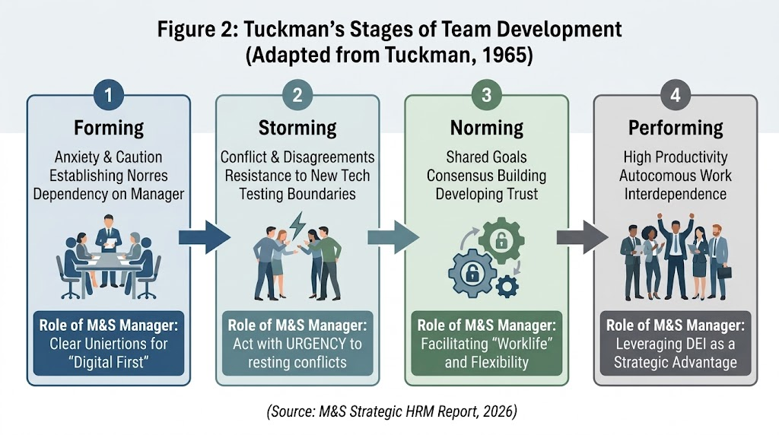
As shown in Figure 1, the Storming stage represents the highest risk for M&S, where "Individual Stressors" and resistance to change are most prevalent. It is at this juncture that managers must act with "urgency" to prevent team regression. By avoiding "vague delegation" and addressing "favouritism"—as identified in the Week 8 management modules—departmental leaders can facilitate the transition to the Norming stage. In this phase, consensus-building and shared goals regarding the "Digital First" strategy begin to emerge. Ultimately, successful management moves the team into the Performing stage, where cognitive diversity (DEI) becomes a competitive advantage rather than a source of conflict.

4. Strategic Stress Management in a High-Pressure Environment
​The fast-paced nature of the retail sector, compounded by technological changes and labour shortages, makes stress management a priority for M&S departmental managers. Stress in the workplace often occurs when demands exceed the resources available to employees. To mitigate this, managers at M&S utilize the "Buddy System," which provides immediate social and emotional support for new joiners, helping them navigate the "Anxiety" associated with the Forming stage of team development.
​From a strategic perspective, managers must identify "Individual Stressors"—such as the fear of being replaced by AI or the pressure of meeting sales targets—and address them through open communication. By applying Rogers’ Humanistic Theory, managers should offer empathy and create a non-judgmental environment where staff can voice concerns about their workload. Furthermore, the implementation of "Pulse Checks" via digital platforms allows managers to monitor team morale in real-time. Addressing stress is not merely a welfare issue but a strategic necessity; it reduces absenteeism and prevents high turnover rates, ensuring that the team can move swiftly from the "Storming" conflict phase to the high-productivity Performing stage.

Conclusion and Strategic Recommendations
​In summary, Marks & Spencer’s HRM strategy successfully addresses the triple challenge of technological disruption, Brexit-induced labour shortages, and the necessity for a robust DEI framework. The integration of AI-driven recruitment and the My Career portal demonstrates a forward-thinking approach to talent management. However, the theoretical analysis highlights that digital tools alone are insufficient; the "human touch," guided by Rogers' Humanistic Theory, remains vital. The resilience of M&S depends on its ability to maintain high employee morale through fair pay and inclusive practices while navigating the complexities of the modern retail environment.
​To ensure the long-term sustainability of these contemporary HR practices, M&S should implement the following actions with urgency:
​Leadership Development: Launch mandatory workshops for departmental managers focusing on "Empathetic Leadership" to reduce technostress during digital transitions.
​Targeted Retention: Strengthen the "Worklife" program by introducing more flexible shift-modelling AI that balances business needs with employee well-being, specifically targeting the post-Brexit retention gap.
​Inclusion Audits: Conduct regular "Diversity Pulse Checks" to ensure that the AI recruitment algorithms remain unbiased and that the "Belonging" factor is consistently felt across all demographic groups.
​Continuous Feedback Loops: Move beyond annual reviews to a real-time feedback system, allowing managers to identify and resolve team conflicts during the "Storming" stage immediately.

Reference List
​1. Adams, J. S. (1963) ‘Towards an understanding of inequality’, Journal of Abnormal and Social Psychology, 67(5), pp. 422-436.
​2. Armstrong, M. (2020) Armstrong’s handbook of human resource management practice. 15th edn. London: Kogan Page.
​3. Beardwell, J. and Claydon, T. (2017) Human Resource Management: A Contemporary Approach. 8th edn. Harlow: Pearson Education.
​4. Lawler, E. and Albers, S. (2003) Creating a Strategic Human Resources Organisation. Stanford: Stanford University Press.
​5. Maslow, A. H. (1943) ‘A theory of human motivation’, Psychological Review, 50(4), pp. 370-396.
​6. Marks & Spencer (2024) Annual Report and Financial Statements 2024. Available at: https://corporate.marksandspencer.com/ (Accessed: 28 April 2026).
​7. Mullins, L. J. (2019) Organisational behaviour in the workplace. 12th edn. Harlow: Pearson Education Limited.
​8. Rogers, C. R. (1959) A Theory of Therapy, Personality, and Interpersonal Relationships. New York: McGraw-Hill.
​9. Tuckman, B. W. (1965) ‘Developmental sequence in small groups’, Psychological Bulletin, 63(6), pp. 384-399.
​10. Vroom, V. H. (1964) Work and Motivation. New York: Wiley.
​11. Wilkinson, A., Redman, T. and Dundon, T. (2016) Contemporary Human Resource Management: Text and Cases. 5th edn. Harlow: Pearson Education.

