Indie Game Development
  - Lecture 7 Lab Tutorial Exercise

Game World 2: Controlling the Agent AI Enemy Character

Objectives
In today’s exercise, you will write the code to make the Agent AI enemy character(s) attack.

Exercise 1: Updating Outfitter Script
This exercise fixes problems with the previous outfitter script. As I am a bad workman, I am blaming my tools – you get what you pay for!
- Open up your project from last week.
- There was an error in the Outfitter script. Download the new copy from Moodle and replace your file with this one.
- You will need to make a couple of additional changes as follows.

Game Event
- Open up the GameEvent Script.
- Make sure your GameEvent script has the following event.

Character Class
- Open up the Character Class.
- Check that you have an OnWeaponStateChangeCompleted method and it looks like the following. If not, add one.
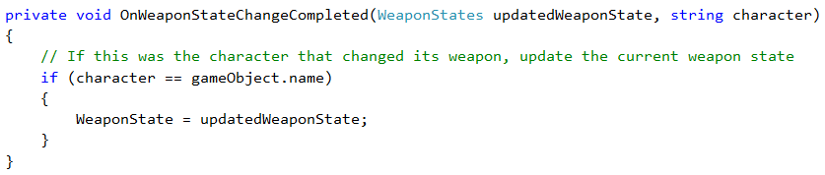
- Register to listen to the WEAPON_STATE_CHANGE_COMPLETED event in the Awake method. Note: You will need the types of the two parameters (same applies for next step).
- Stop listening to the WEAPON_STATE_CHANGE_COMPLETED event in the OnDestroy method.

Exercise 2: Making Enemy Attack

Enemy AI Script
- Open up the Enemy AI script class.

Can Attack Method
In this method, you will detect if the enemy character can attack the target. You will use Raycasting for this.
- Create a new private method with a return type of Boolean called CanAttack.
- BEGIN IF: Check if target is null (nothing to chase)
  - Return and exit early
- END IF
- First calculate the distance to the target.
- Now calculate the square magnitude of the calculated distance and store in a float variable called sqrDistance.
- Declare a RaycastHit variable called hit.
- Note: The attack distance will vary depending on the current weapon type. To keep things simple, we will use:
  - The value stored in ShootRange for Pistol and Rifle
  - All others will use the character’s body width
- Set the default attack distance as follows:
- BEGIN IF: Check if the current weapon state (stored in WeaponState) is a Pistol or Rifle
  - Set attack Distance to Shoot Range.
- END IF
- BEGIN IF: Check if distance is within range (less than or equal to) of attack distance using the squared distances (don’t forget to square the attack distance)
// Target is close enough to hit, lets cast a ray to see if it will hit the target
  - Declare a Vector3 variable to store a reference to the half-height position of the character controller (along y-axis only)
// Get the position of the character's height * half in along y-axis (upwards) direction only (approx. waist position)
  - Get the upper body position
  - BEGIN IF: Cast a ray (origin: the body position, direction: distanceToTarget.normalized, maximum distance: attack distance) and don’t forget to get the raycast hit as an output parameter.
    - BEGIN IF: Check if tag of what was hit equals “Player”
      - Look at the target
// Look at the target before attacking
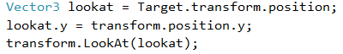
      - Return true
    - END IF
  - END IF
- END IF
- Return false

Check Target Direction Method
- Locate the Check Target Direction Method
- Locate the part of the if { … } block that checks if the character is running and modify as shown with the highlighted.
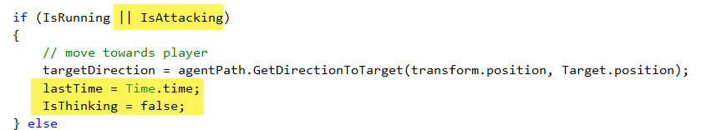
- .

Check Is Moving Method
- Locate your Check Is Moving method.
- Just before you return Not IsThinking, insert the following (highlighted) above this line
// Agent is still following path and is moving when NOT thinking
// or if attacking, when not chasing to attack
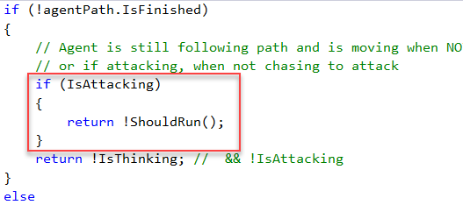

Update Method
- Go to the Update Method
- Insert the following highlighted code just after checking if not jumping
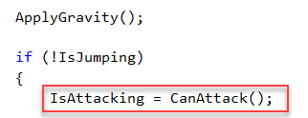
- In the if { … } block where it checks if IsAttacking, add the following:
  - Set lastTime variable to current time
  - Set IsThinking to false
  - Set IsMoving using a call to CheckIsMoving()

Character Class Script
- Open up the Character class.
- Add the following additional new variables. Remember to copy and paste all.
protected Outfitter weaponsOutfitter { get; private set; }

protected Transform[] hands { get; private set; }

[SerializeField]
private float _handsAttackRange = 1.0f;
protected float HandsAttackRange
{
get { return _handsAttackRange; }
set { _handsAttackRange = value; }
}

[SerializeField]
private float _Damage = 1.0f;
protected float Damage
{
get { return _Damage; }
set { _Damage = value; }
}

[SerializeField]
private float _Health = 100.0f;
protected float Health {
get { return _Health; }
set { _Health = value; }
}

protected float MaxHealth { get; set; }

Awake Method
- Initialise the weaponsOutfitter variable to the Outfitter component attached to the game object.

Check Hit Target Method
- Create a new protected virtual method with a return type of Boolean called CheckHitTarget.
- Make it return false. The child classes are going to override this method.

Wait For Next Attack Method
You will create a new coroutine method to make the animator pause a bit before replaying the attack animation if continuously attacking.
- Create a new private method with a return type of IEnumerator called WaitForNextAttack.
  - The method should accept a single float parameter called waitTime
- Yield control over to other code for waitTime seconds.
- Call Check Hit Target method.
- Set was Attacking to false.

Update Animator Method
- Go to the UpdateAnimator method
- Locate the block that checks if IsAttacking and add the following after setting was Attacking to true.
  - Get the play back time of the current animation state.
// Get current playback time of current animation state
  - Start the coroutine method you created in the last step.
- Save your changes and test. Please note: there is a small bug, will be sorted later or you give it a try.

Exercise 3: Applying Attack
In this exercise, you will start to apply the attack – inflict damage.

Game Event Class
- Open up the Game Event Class
- Create two new events, one for when player is hit and the other for when enemy is hit:
  - HIT_PLAYER
  - HIT_ENEMY

Death Types Enum
- Create a new Enum Type called DeathTypes
- Add the following types to the enum: a, b, c

Character Class
- Open up the Character class.

Get Hands Method
This method gets and stores a reference to the character’s hands to store and use when fighting unarmed.
- Create a new private method with a return type of void called GetHands
- Start by initialising the hands property
// Initialise the hands variable
- Then you need to get all the child game objects in this game object, so you can loop through and find the hands.
// Locate all the child objects in the character game object
- Loop through them all and check if it is a hand, if yes, store a reference to it.
// Loop through each of them to find the hands
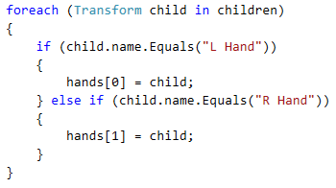

Start Method
- Locate the Start Method.
- Call the Get Hands method you just created in the last step.
- Set MaxHealth to the value of Health.

Hurt Method
- Create a new protected method with a return type of void called Hurt.
  - The method should accept a float parameter called damage
- Decrease the Health property by the damage inflicted, but limit the decrease so it does not go beyond zero (Hint: you will need to use the Mathf.Max function).
- BEGIN IF: Check if the damage inflicted was greater than zero
  - Yes, make the character show some pain. Play the pain animation.
// Hurt, show some pain
- END IF

Hurt Method
- Create a new protected method with a return type of void called Die.
  - This method should accept a parameter of type DeathTypes called deathType.
- Make the character die, play the corresponding animation.

Enemy AI Class
Return to the Enemy AI Class. You will start by making the enemy inflict damage on the player.
Note: There is, however, a problem. There are no colliders or rigid bodies attached to the characters or their weapons, so you cannot use the regular Unity collision detection methods. You have to cast a ray from the weapon and see if it is making contact with the player. This presents an additional problem, weapons have different sizes and in the case of fists … We will keep things simple for the exercise, I will leave you to do the hard work if you wish

Check Hit Target Method.
- Create a new override protected method called CheckHitTarget with a return type of Boolean. It overrides the method in the parent.
- This method is very similar to the Can Attack method.
- Declare a RaycastHit variable called hit.
- Declare an array of type Transform called attackWeapons.
- Declare a float variable called attackDistance and initialise it to the ShootRange.
- BEGIN IF: Check if the character’s weapon state is currently unarmed.
// Character is fighting with hands, attack distance needs to be smaller
  - Set the attackWeapons variable to the hands property (you initialised the hands earlier in the Character class).
  - Set the attackDistance to the value of HandsAttackRange
- ELSE
  - Set attack Weapons by calling the GetCurrentWeapons in the outfitter script. A reference to the outfitter script is stored in weaponsOutfitter.
// Get the current weapons character is kitted with from the outfitter script
- END IF
- BEGIN FOR: Loop through each of the weapons and check to see if they are hitting the player
  - Work out the distance between the target and the weapon (Hint: check what you did in CanAttack – use weapon.position).
  - Now calculate the square magnitude of the calculated distance and store in a float variable called sqrDistance.
  - BEGIN IF: Cast a ray with the following – (Origin: weapon position, direction: distanceToTarget.normalized, maximum distance: attack distance) and don’t forget to get the raycast hit as an output parameter.
    - BEGIN IF: Check if tag of what was hit equals “Player”
      - Broadcast a HIT_PLAYER event with the Damage (it is a float variable)
      - Return true.
    - END IF.
  - END IF
- END FOR
- Return false

The Player Class
The player needs to respond to the damage inflicted by the enemy
- Open the Player Class
- Create a new private method with a return type of void called OnHitPlayer that will respond to the HIT_PLAYER event and receive the damage inflicted. The method should.
  - Call the Hurt method with the damage.
  - Log a message to the console for now.
  - If the health reaches zero,
    - Call the Die method with a death type of your choice. More needs to be done here – another lecture
    - Set Managers.IsGameOver to true.
- Register to listen to the HIT_PLAYER using the method created in the last step and remember to stop listening to it when the game object dies.
- That’s all for today.

