

Name of the student: Aleksandar Mihaylov Ivanov
Student ID: 2512500
Module code: LCLM4005
Module: Employability and Career Development
Lecturer name: Dr. Inderjit Grewal

1.Table of contens
2.Introduction
3.Job Adverts and Key Skills
4.Personal Self-Assesment
5.Evidence of Readiness
6.Employment Goals
7.Personal Development Plan
8.Refferences

Introduction

Development of a trade in the businesses that need specific skills, experience and knowliege demand also personal develoment focused and oriented in similar fashion throught teory rediness and baseline practise.
Some businesses requare specific degree or courses similar as CITB (Construction Industry Training Board) or NVQ (Diplomas) for gven trade or practices. Others requare minimal practic level of experience in given areas of trade wich also include personals skills already proven.
As mentioned above adversting for given job and desired skills for that trade also can provide skills and similar experience wich cover another trade but both teoretecly and practicly can achive same result in terms of improvements that can sustain the bussines based on adverted job/jobs.

Job Adverts and Key Skills
Based on Job advert for Hocim.uk (Assistant Asphalt Plant Manager) and similar job advert for (Asphalt Plant Operator) keys skills looks similar for the trade that can carry on.
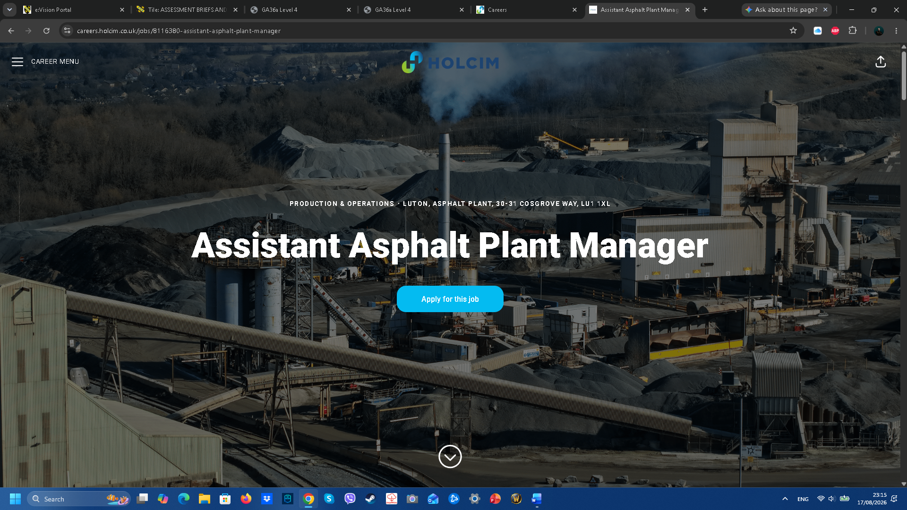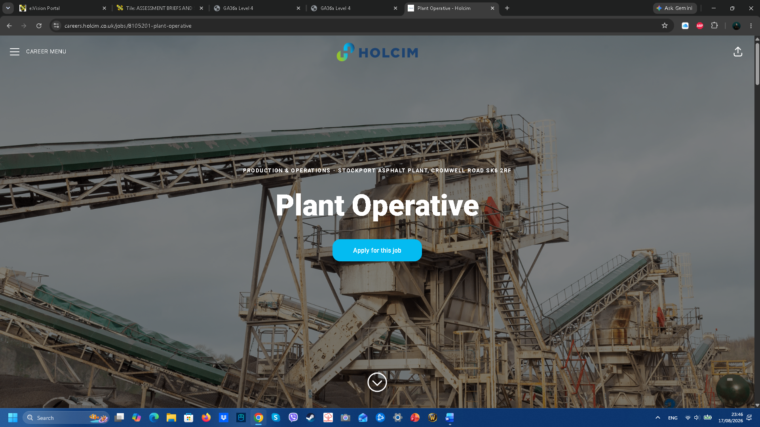
Key skills mentioned in the advert for almost similar jobs that reaquare experience, solid knowliege and teory about the desired skills needed for that job. 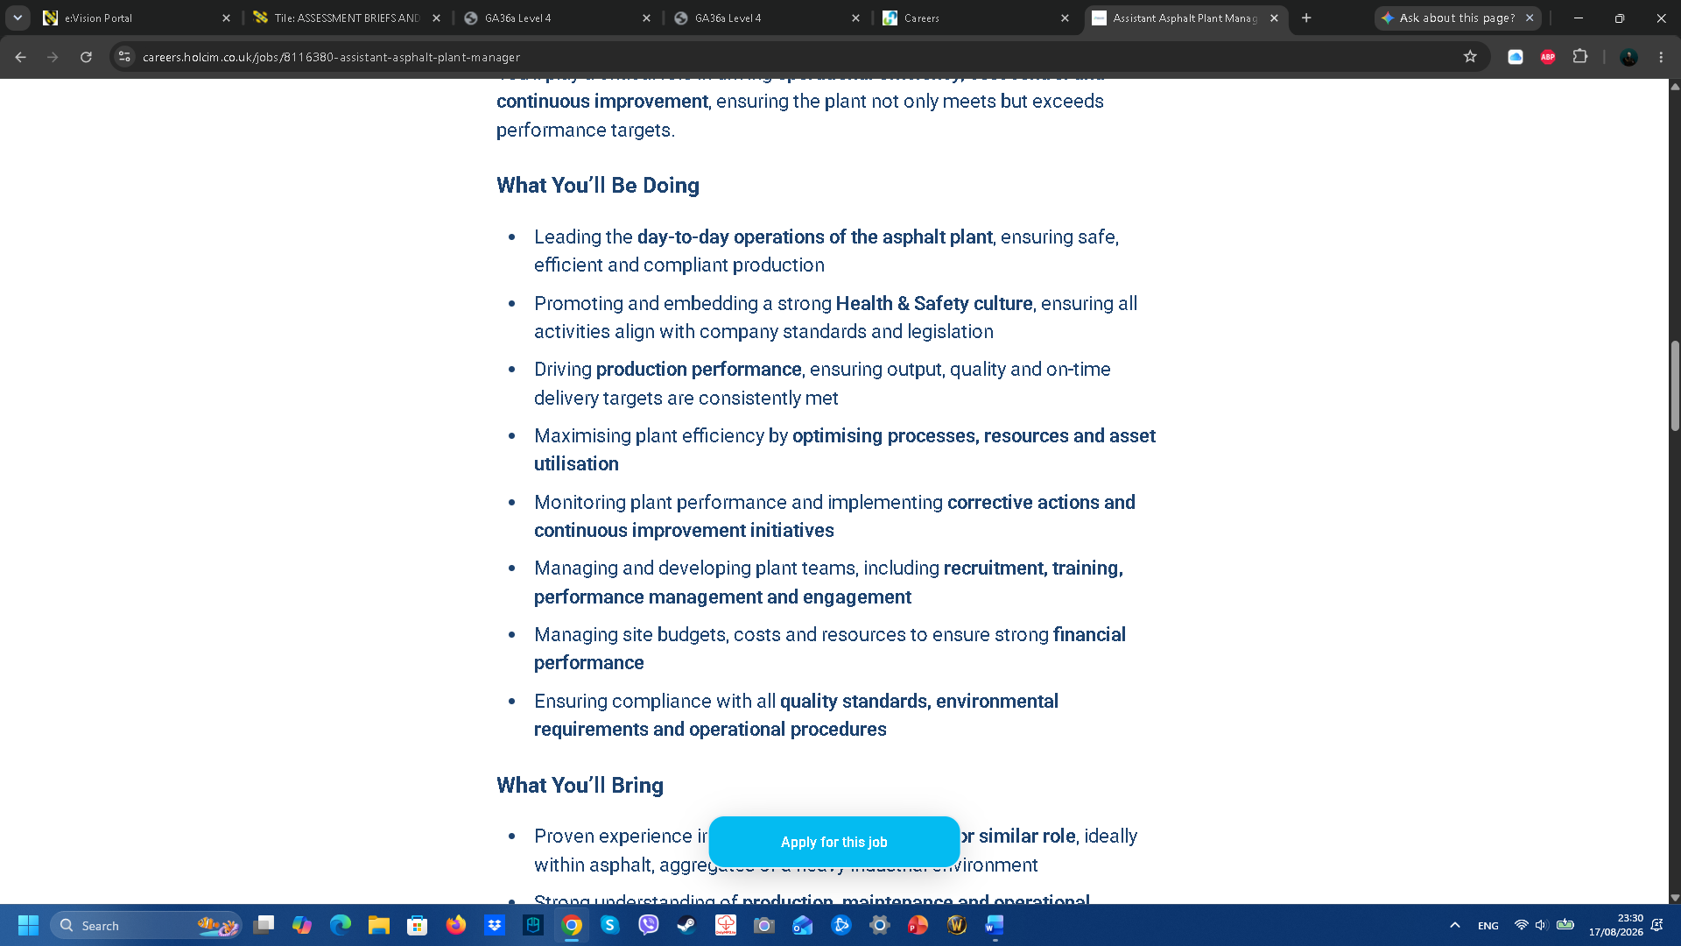 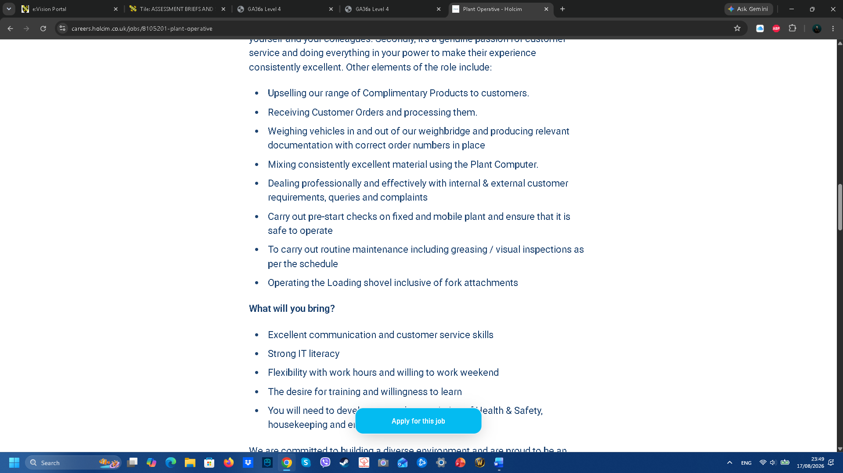

Excellent communication and customer service skills, Strong IT literacy, Flexibility with work hours and willing to work weekend, desire for training and willingness to learn are one of the key skills wich also cover in similar or direct way to:
Driving production performance, ensuring output, quality and on-time delivery targets are consistently met.
Maximising plant efficiency by optimising processes, resources and asset utilisation.
Monitoring plant performance and implementing corrective actions and continuous improvement initiative.
As an Asphalt Plant Manager Strategic Oversight is holding ultimate accountability for large-scale output, coordinate laboratory testing, material compliance with highway standards, and logistics are seamless delivery to major infrastructure sites.
As a Highly Experienced Asphalt Plant Operator monitor real-time production on advanced systems, maintaining strict temperature controls and mix consistency throughout the shift, ensuring the immediate batch meets the job specification.

Personal Self-Assesment

With my given extensive experience in managing teams of up to 16 people, production planning, logistics, and commissioning flagship mobile plants like the Benninghoven MBA 200, my profile already operates at a management tier, significantly exceeding the scope of a standard plant operator.
Although even with experience more than 20 years in total for Industry Construction 14 of wich are focused on production planing, comissioning and operating plants, and managing sometimes getting desired job is almost imposible.
My SWOT analys can show and direct me in improvement and realisation my future development:
Strenghts:
Proven Operational Experience: Successfully managed the production of over 1.1 million tonnes of asphalt for critical infrastructure (motorways, airports), proving your ability to deliver under high pressure and strict deadlines.
Multi-Brand Technical Expertise: Deep hands-on knowledge of leading global plant manufacturers (Benninghoven, Lintec, Teltomat, SIM, Marini). This makes you exceptionally adaptable to any fleet or machinery setup.
On-Site Leadership & Safety Code: Proven track record of leading and coordinating a multidisciplinary team of 16 personnel (operators, mechanics, logistics), combined with a strict commitment to health and safety (HSE) standards.
Weaknesses:
High-Level Financial Focus: My profile is heavily weighted towards engineering, production, and logistics, meaning corporate-level strategic budget management (CapEx/OpEx) and corporate P&L (Profit and Loss) responsibilities are less highlighted.
Formal Green Certifications: While I do have strong practical RAP experience, I lack formal carbon accounting qualifications or experience with environmental auditing, which are increasingly critical for modern eco-standards.
Opportunities:
Transition to Net-Zero Infrastructure: The surging UK and global demand for Warm Mix Asphalt (WMA) and higher RAP recycling percentages opens doors for operational leaders who can implement these sustainable technologies rapidly.
Global Shortage of Technical Managers: The industry faces a significant deficit of operations managers who possess a dual understanding of materials technology (laboratory quality control) and heavy plant engineering.
Positioning for "Director of Production" Roles: My record of pioneering new plant commissions (such as the company's first Lintec and Benninghoven units) place me like an ideal candidate for business expansion and market entry strategies.
Treaths:
Environmental Regulations: UK and European emission standards for asphalt plant burners demand rapid technological adaptation, such as transitioning from traditional fuels to biofuels or hydrogen.
Automation and Workforce: rise of fully automated, remotely monitored asphalt plants requires a shift in leadership style, moving towards software control and data analysis over traditional team supervision.
Raw Material and Energy: bitumen prices and energy costs require incredibly agile inventory planning and supply chain strategy to protect profit margins.

Evidence of Readiness
Technical Innovation and Material Mastery
Volumetric Authority: Produced over 1.1 million tonnes of asphalt, proving long-term operational consistency.
Critical Infrastructure Reliability: Successfully supplied major, zero-failure tolerance projects including motorways and airports.
High-Capacity Management: Commanded continuous operations of heavy plants outputting 160–200 tonnes per hour.
Commercial Diversification: Expanded the company's product portfolio by successfully introducing cold asphalt mix production.
Specialist Product Delivery: Directed high-spec chemical and structural processes, including Polymer-Modified Bitumen (PMB) and Stone Mastic Asphalt (SMA).
Sustainability Integration: Implemented circular economy practices by embedding RAP technology into active production lines.
Cross-Functional Leadership: Managed a multidisciplinary workforce of 16 plant operators, mechanics, and logistics staff, aligning them with strict laboratory quality controls.
Asset Maximisation: Maintained peak plant efficiency with minimal downtime through proactive, preventative maintenance planning and robust supply chain procurement.

Employment goals
For a short-term goal:
Digital Brand Optimisation (LinkedIn):
What: Completely overhaul my LinkedIn profile to reflect UK executive standards, shifting the focus from a "plant operator" to an "Asphalt Operations Manager / Head of Production".
Why it matters: In the UK and international markets, LinkedIn is the primary tool used by executive headhunters. A modern, polished profile acts as a digital passport that bridges the gap between my current location and international opportunities.
Mastering Corporate & Financial Industry Language:
What: Acquire the executive-level business language required in the boardroom. This includes taking specialized short courses in Finance for Non-Financial Managers and CapEx/OpEx budgeting.
Why it matters: To move from regional plant management to senior corporate roles (Operations Director), I must speak the language of profitability, asset lifecycle management, and Return on Investment (ROI), rather than just technical machine maintenance.
For my long-term goal:
Securing a Senior International Operations / Production Director Role
What: To secure a senior leadership position within a major civil engineering or road construction firm that fully utilizes my heavy-industry expertise, while overcoming the geographical/cultural transition from Bulgaria.
Why it matters: My core career aspiration is to lead high-capacity asphalt manufacturing networks on a macro level. Managing over 1.1 million tonnes of asphalt and commissioning world-class plants (Benninghoven, Lintec) proves I have the capability; my long-term goal is simply to scale this expertise within a global corporate structure.

Personal Development Plan

Alignment to UK Highways Specifications
Objective: To ensure my extensive materials technology expertise is seamlessly translated into the exact technical standards mandated by National Highways.
Specific Actions:
Review the latest UK technical specifications and carbon-saving mandates for Warm Mix Asphalt (WMA), which is rapidly becoming the default requirement on major UK road schemes.
Deep dive into the formal structural layout of the MCHW (Manual of Contract Documents for Highway Works), specifically Volume 1: Specification for Highway Works – Series 900 (Road Pavements – Bituminous Materials).
Timeline: Months 1–3 (running parallel to software training).
Resources Needed:
Free, unrestricted digital access to official government frameworks portal.
Measuring Progress (KPIs): Ability to discuss with a UK technical director or laboratory manager how my practical experience with RAP percentages, PMB, and SMA mixtures complies with Series 900 clauses.

Corporate Business Language & Financial Management
Objective: To master executive-level commercial vocabulary so I can confidently discuss corporate budgeting, capital investments, and cost-efficiency with UK directors.
Specific Actions:
Complete a structured professional short course focused on corporate finance fundamentals tailored for operational managers.
Master key UK commercial metrics, focusing on processing costs per tonne, supply chain risk mitigation, and building investment business cases (ROI).
Timeline: Months 3–4.
Resources Needed:
“Finance for Non-Financial Managers” short courses on platforms like Coursera, Udemy, or LinkedIn Learning
UK heavy industry business insights from trade publications
Measuring Progress (KPIs): Attainment of a course certificate and the successful integration of advanced commercial terms (CapEx, OpEx, ROI, Supply Chain Optimization) into my active CV and cover letter materials.

Refferences

National Highways (2021). Highways England accelerates switch to lower carbon asphalts. Available at: GOV.UK (Accessed: August 2026).
Heidelberg Materials UK (2023). Road to net zero – asphalt. Available at: Heidelberg Materials (Accessed: August 2026).
Tarmac (2022). Tarmac leads the change to low temperature asphalt in net zero drive. Available at: Tarmac.com (Accessed: August 2026)

