Student Name: Lee Canning
Student number: 2116294
Module: Network Programmability (ACCA5029)
Course: BSc Computer Networks and Cyber Security
Assignment Title: How the field of computer networking has moved towards software, with a focus on cloud computing.
Submission Date: 15th December 2023

Table of Contents

Introduction 3
How the shift towards cloud computing has impacted the industry. 4
How the role of network professionals has evolved to meet the technical challenges of the cloud. 6
How RESTful Web Services have been used to facilitate these changes. 7
Why software defined networking has become so heavily adopted by industry, despite meaning an adaptation to the job role of network engineers. 8
Why standards such as JSON and REST have been selected and utilised. 10
Conclusion 12
References 13
Table of Figures 14

Introduction

This report focuses on computer networking’s shift towards software and cloud services, the effect it has had on the industry, in particular network professionals, and how a set of open standards have invigorated its development into an extremely popular concept which has brough a raft of benefits to its clients, from small businesses to global corporations and governments. Network automation, virtualisation, and software-based solutions have played a significant role in the adaptation that network professionals have had to undergo to deliver and manage agile, scalable networks that perform to their maximum capabilities.

How the shift towards cloud computing has impacted the industry.
The increase in internet speed and computer processing power has facilitated the widespread use of mobile devices and the IoT (Internet of Things). This has had a profound effect on computing in recent years, possibly the most since the widespread adoption of the internet itself.
In the field of traditional computer networking, before cloud computing, organisations would house their own servers and datacentres, bearing the cost of installation and maintenance from both a financial and labour perspective. Increasing the size of networks meant purchasing new equipment and depending on the requirements, reconfiguring the network. Intermediate devices and infrastructure would need updating and replacing. Plans were needed if capacity were to be increased in the future. Software or software licences would be purchased, and the infrastructure would need to be secured both physically and logically. Traditionally, dynamic scalable networks can be expensive.
Cloud computing can trace its origins as early as the 1960’s, became popular in the early to mid-2000’s and has grown at an exponential rate. Amazon Web Services (AWS) launched its public cloud in 2002 and since then many other providers have sought to offer similar services, which include Software as a Service (SaaS), Infrastructure as a Service (IaaS), and Infrastructure as Code (IaC).
Cloud based vendors provide resources such as networking, VMs (virtual machines), servers, storage. processing capacity, web and mobile apps, and lease these cost-effectively in an on-demand basis to clients [1]. From the clients’ perspective, utilizing cloud resources means that they no longer need to invest or maintain their own infrastructure, as this is part of the service from the trusted providers.
The shift from traditional networks to private and public clouds, or hybrid (a combination of these) has been profound. The benefits of enhanced performance, efficiency, security, and scalability, without having to be physically responsible for the infrastructure have proven extremely popular. In Cisco’s 2022 Global Hybrid Cloud Trends Report, 82% of respondents have adopted hybrid cloud, and 92% use at least two public cloud providers [2].
Organisations can effectively scale their resources up or down as required, and no longer need to plan for future infrastructure demands. If a company increases its network size and more storage, servers, or virtual machines are required, they simply lease these from the provider. This alleviates the client from the financial burden of purchasing the infrastructure and managing it on premise, as this is the responsibility of the vendor. It also increases agility and scalability.
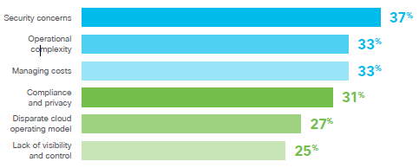
Figure 1. Top operational challengers when utilising multiple cloud environments.

Employees can now access the workplace remotely because applications and services are hosted on a central platform. This has become particularly relevant since the COVID-19 pandemic, where there has been a major shift towards remote or hybrid working.
Security is considered a major challenge when it comes to cloud, Disaster Recovery is imperative, and clients can now prepare simple disaster recovery plans knowing that the cloud vendors have policies and procedure in place should this be needed, which provides client with the necessary resilience and redundancy required. Risk can be managed by balancing their placement, with their workloads hosted in a variety of public or private clouds. However, operating in multiple environments increases operational complexity, and security teams need a strategy for each cloud [3].

How the role of network professionals has evolved to meet the technical challenges of the cloud.

Traditionally, a network professional’s role would include the design, deployment, configuration, installation, maintenance, upgrade, and monitoring of the network infrastructure and associated devices. Engineers or administrators must physically connect to these devices to configure them, which would need to be for each device. On a small network this is simple enough, however this means managing large-scale complex environments is expensive and time-consuming [4]. Scalability and agility are a challenge, if new devices are needed or network capacity must be increased.
There was concern of the affect adoption of cloud computing would have on the IT industry, particularly networking professionals, but the requirements of are now more software focused. To meet the technical challenges involved in the era of cloud services, network professionals have had to adjust their working practices and upskill, to embrace IaC and SaaC, and processes such as network automation and network virtualisation.
Network professionals face the challenge and complexities of multi-cloud strategies and hybrid cloud architectures. Networks that span multiple public and private cloud providers, as well as on-premise infrastructure. This requires knowledge of provider-specific networks.
Possibly the biggest benefit of the shift towards cloud computing is automation; software is used to automate tasks such as configuration and maintenance. Frameworks such as Ansible and Kubernetes can be adopted to assist with this.
Utilising IaC allows management of infrastructure with configuration files. Resources and infrastructure are defined in human-readable configuration files. It eases the process of tracking resource changes and communicates with cloud platforms and services via their APIs.
SDN (Software Defined Network) is a vital service in the new era of cloud-based networking and is discussed in more detail in later in this report. It can be used alongside NFV (Network Function Virtualisation), the process of moving network services from physical hardware onto a virtualised environment to harness gains in hardware capabilities [5]. Routers, firewalls, load balancers, IDS (Intrusion Detection Systems) can then be centrally managed.
The benefit is that the design, implementation, and management of networks can be done far more efficiently than before. For example, Cloud computing is prone to threats such as DDoS, unauthorised access, and data breaches. Security measures such as encryption, VPNs, firewalls, and access control need to be deployed. Crucially, not only can this be done centrally, but it can be done remotely.
Network professionals now operate as part of a cross-functional team, collaborating with DevOp and CloudOp teams, and are often now considered NetOps. It is essential that the network infrastructure aligns with software deployments and network configuration management should consider Agile practices.

How RESTful Web Services have been used to facilitate these changes.

RESTful Web Services are based on the REST (REpresentational State Transfer) architectural style which specifies a set of constraints that must be satisfied for an API (Application Program Interface) to be considered RESTful.
Uniform interface: Fundamental to the service, each part can evolve independently because the architecture is simplified and decoupled [6]. This provides interoperability.
Stateless: The HTTP server treats every request as a new one, so no sessions are stored. Workloads can fluctuate in cloud environments,
Cacheable: Can be implemented on both client and server sides and reduces the load and increases response times which can improve scalability.
Client-server: Client and server applications must be able to develop independently. AS with uniform interface, this increases interoperability.
Layered system: Clients are not able to differentiate between the location which APIS and data are stored. This allows cloud-based systems to expose modular functionality.
Services are based on a standard communication protocol (in this case HTTP) and based on the resources associated with URIs (Uniform Resource Identifiers) [7]. Requests are sent to server, which responds with a representation of the resource in a format like JSON or XML.
They can be used to facilitate automation, as is the case with network automation. This dramatically reduces the time it takes to configure, update, rescale a network. They easily integrate with other services and applications. Because access is standardised and engineers no longer need to configure devices manually, troubleshooting and maintenance are reduced and simplified.
SOAP an alternative exchange format that is more structured and rigid than the REST architecture. Compared to SOAP (Simple Object Access Protocol), REST supports more data formats. SOAP supports only XML, whereas REST leverages the benefits of XML, JSON, an HTML. RESTs messages are smaller and have caching support, therefore they perform more quickly. Compared to SOAP, rest is easy to scale as it is stateless. Every message is processed independently.

Why software defined networking has become so heavily adopted by industry, despite meaning an adaptation to the job role of network engineers.

SDN (Software Developed Networking) is a network architecture approach which separates the control pane from the data plane. A network engineer can now design, manage and control the infrastructure via a centralised pane, rather than device by device. It separates network control from the hardware, providing administrators with more control and a better overview of the entire network [8]. SDN determines how/where to send traffic, and the hardware is left simply to physically move it. They can create a virtual network by simply adding devices on other networks, secure these networks with distributed and gateway firewalls, and perform load balancing.

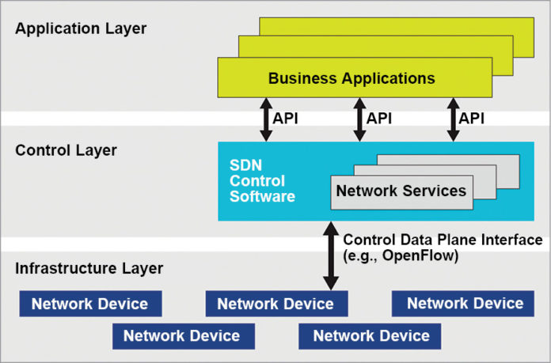
Figure 2. Diagram of SDN architecture

As an emerging network architecture, SDN allows network administrators to control and manage an organisation’s network dynamically [9]. SDNs are scalable and dynamic, achieved by disassociating the system allowing for infrastructure abstraction [10]. They are easily customisable and give the administrator increased control and added flexibility.
Considering the challenges of manually administrating a large-scale network, one of the major benefits of SDN is automation: Testing, change deployment and repetitive and trivial tasks can be automated across the entire infrastructure. Similarly, an administrator can identify vulnerabilities and implement patches or fixes across the entire network in one go. This decreases the risk against attacks such as DDoS. With security being the primary concern in cloud infrastructure, this is particularly pertinent.
SDN can overcome multivendor hardware incompatibility. The use of multiple web services and networks from different vendors increases the challenge and complexity, but SDN can virtualise these separate elements and enables the user to manage them as one network. This allows frees the engineers or administrators from the constraints of having to purchase compatible hardware, as they can choose components from the vendor of their choice.
The provisioning time can be reduced from hours to minutes. One engineer can configure the entire network in an extremely short amount of time. Not only is this time efficient but is cost efficient too.

Why standards such as JSON and REST have been selected and utilised.

Interoperability can be considered as the ability of disparate systems to be able to communicate in the same language and interpret the data.
Standards such as REST and JSON are designed be used on a variety of applications and services. Because RESTful web services are stateless, servers do not need to keep track of client sessions. This improves scalability as a server can immediately free up resources once a request has been dealt with [11].
HTTP and JSON are open standards. Open standards provide an ideal way to improve interoperability and portability. Publicly available and vendor-neutral, they can be accessed and processed by most cloud vendors and platforms. JSON is preferred for data representation and REST for web services. Alongside these, APIs and gateways provide a standardised way of accessing and updating data. They can also be considered “cloud agnostic”, and that code developed for one cloud provider can be easily transferred to another, due to the separation of the UI (user interface) from server and data storage.
REST constraints do not specify that these must be used, however most developers choose these [12], and they are accepted by the IETF (Internet Engineering Task Force). All modern languages can consume and produce JSON objects, which simplifies the management and exchange of information.
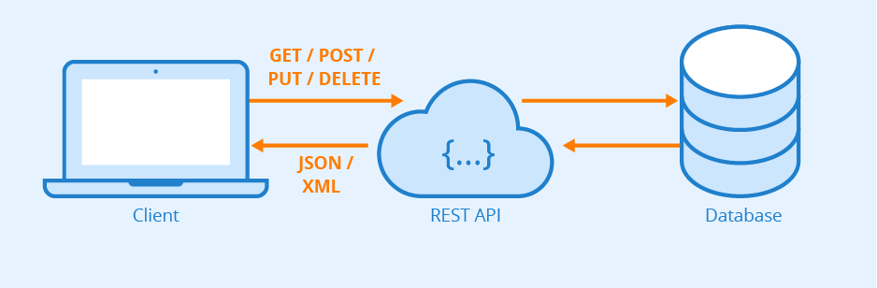
Figure 3. Simple representation of REST.

REST architecture is generally scalable and light, and easily maintainable. REST utilises a uniform interface. In This case, HTTP(s), which is familiar web protocol and widely used. Although REST does not add any specific functionality to HTTP [13], It uses the GET, POST, PUT and DELETE operations to read, create, update, or delete data. This is based on the CRUD acronym. FTP can be used, but this is less common. The requested information can be delivered in multiple formats: YAML, JSON, XML, HTML or even plain text.
JSON is a format for storing and transporting data using simple key-value pair notation and arrays, which makes it human-readable. XML is a workable alternative for data storage and transportation, JSON is far more lightweight, which means it has little overhead. It can be used by open-source automation systems such as Ansible and Kubernetes.

Because of the layered system the client only needs to be aware of the immediate layer it is communicating with. This means the client won’t be affected by a load balancer or proxy server, security can be added as a layer on top of web services with no ill-effect, and that a server can call multiple servers to generate a response [14].

Conclusion

Connectivity has come a long way since dial-up internet. Cloud based services have changed the face of the IT industry and the technologies used. Network professionals have had to adapt to this and become part of a multidisciplinary team. They must welcome new technological advances and services, such as IaaS, IaC, and the use of SDN and NFV. Open standards such as RESTful web services and JSON supply many benefits and are considered interoperable, which is a key component of their success. The efficiency at which networks can be designed and managed has vastly improved and, in many ways, simplified many of the repetitive tasks faced by network engineers, increasing productivity and security. These cost and time efficient standards are readily available and customisable. Overall, the shift towards cloud-based networking is one that evolved organically because of cloud-based services becoming popular and the demand for digital services continually growing. This will likely continue and develop for years to come, and those organisations that best embrace the new technologies and standards will be well placed for the future.

References

[1] A. Kobusińska and C. Hsu, "Towards increasing reliability of clouds environments with RESTful web services," Future Generation Computer Syst., vol. 87, pp. 502-513, 2018. [Online]. Available: https://www-sciencedirect-com.ezproxy.uwtsd.ac.uk/science/article/pii/S0167739X17316709
[2], [3] Cisco Systems Inc, “2022 global hybrid cloud trends report,” 2023. [Online]. Available: https://www.cisco.com/c/dam/en/us/solutions/collateral/hybrid-cloud/2022-trends-report-cte.pdf.
[4], [8] M. Jammal et al, "Software defined networking: State of the art and research challenges," Computer Networks, vol. 72, pp. 74-98, 2014. [Online]. Available: https://www.sciencedirect.com/science/article/pii/S1389128614002588
[5] D. Huang, A. Chowdhary, and S. Pisharody, Software-Defined Networking and Security: From Theory to Practice, First edition. Boca Raton, FL: CRC Press, 2018.
[6] Fielding, Roy Thomas (2000). "Chapter 5: Representational State Transfer (REST)". Architectural Styles and the Design of Network-based Software Architectures (Ph.D.). University of California, Irvine, 2013.
[7] A. Soltanian et al, "A Cloud-Based Architecture for Multimedia Conferencing Service Provisioning," IEEE Access, vol. 6, pp. 9792-9806, 2018.
[9] [10] V. Kaushik, A. Sharma and R. Tomar, "Virtualizing network functions in software-defined networks," in Innovations in Software-Defined Networking and Network Functions Virtualization, 2018. [Online]. Available: https://services-igi-global-com.ezproxy.uwtsd.ac.uk/resolvedoi/resolve.aspx?doi=10.4018/978-1-5225-3640-6.ch002
[11] [12] [14] K. Lange, "The little book on REST services," 2016. [Online]. Available: https://Www.Kennethlange.Com/Books/the-Little-Book-on-REST-Services.pdf
[13] A. Jain. “REST vs HTTP endpoint” Sixt Research & Development India. Available: https://medium.com/the-sixt-india-blog/rest-stop-calling-your-http-apis-as-restful-apis-e8336e3e799b [Accessed Dec 11, 2023].

Table of Figures

Figure 1. Top operational challengers when utilising multiple cloud environments. 3
Figure 2. Diagram of SDN architecture 6
Figure 3. Simple representation of REST. 8

