

Student Name: Vishvarajsinh Surendrasinh Vaghela

Student ID:2430811

Module Name: International Marketing:
Principles And Practices

Module Code: LCMB7026

Lecturer Name: Muhammad Tariq

Assignment Title: International Marketing:
Principles And Practices

Term 2

Table of Contents
Introduction 3
Brand overview 3
Comparison of the social-cultural context of Country A and Country B 4
Environmental Factors 6
Comparison of Brand’s STP strategies in Country A and Country B 7
Comparison of Marketing Mix Strategies in Country A and Country B 10
Evaluation of the performance of marketing strategies 13
Evaluation of marketing ethics practice 15
Recommendation and Conclusion 17
References 20

Introduction
International marketing principles and practices involves adaption of marketing mix strategies to different international markets which is done through intensive market research and comprehension of legal, cultural, and economic differences (Bilgihan and Ricci, 2024). In this report, Coca-Cola is taken as an organisation which is one of the world's largest beverage companies, and it has been able to maintain its presence across the world. The marketing strategies of the company can be widely recognized for their adaptability to local environments, while also maintaining global brand identity. In addition to that, this report analyses the international marketing strategies of Coca-Cola in two diverse and major markets, such as India (an emerging market) and the United Kingdom (UK) (developed economy). This comparative analysis helps in exploring how the company tailors its strategies to effectively suit macro-environmental conditions. This report also covers PESTLE analysis, STP and 7Ps of marketing mix in both countries. The present report also evaluates the effectiveness of strategies adopted in both countries and addresses ethical considerations of Coca-Cola's marketing practices.

Brand overview
Coca-Cola is one of the world's largest beverage companies, and the company was founded in 1886 in Atlanta, USA. The company operates in more than 200 territories and countries each day, and there are also more than 700,000 people employed in the company, helping to bring economic opportunity to local communities across the world. The beverage portfolio has expanded to more than 200 brands as well as thousands of beverages across the world, from waters and soft drinks to teas and coffee (Coca-Cola Company, 2025). In the UK, the company has maintained its strong presence since 1900, with major production facilities and local bottlers contributing significantly to the UK's beverage industry. Similarly, in India, Coca-Cola re-entered the market in 1993 and is now operating as HCCB (Hindustan Coca-Cola Beverages). For Coca-Cola, India represents the fastest-growing market, which is driven by youth demographics and rising disposable income.
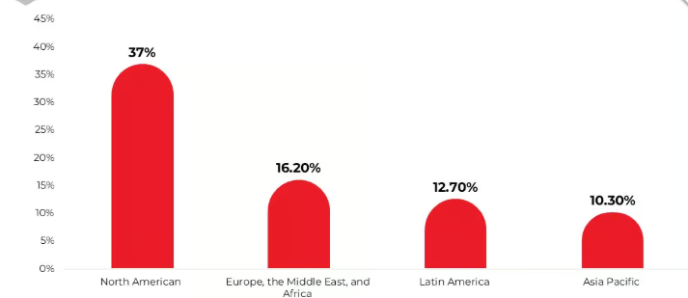
Figure 1: Coca-Cola Regional Statistic
(Source: Oceana, 2025)

Comparison of the social-cultural context of Country A and Country B
Political Factors
Within the UK, strong regulatory frameworks, political stability, and health-driven government initiatives have significantly shaped the operations of Coca-Cola. The SDIL (Soft Drinks Industry Levy) 2018 imposed taxes on high-sugar beverages, which compelled the company to promote low-calorie alternatives and reformulate products (Molinero, 2025). On the other hand, political factors of India revolve around the FDI (Foreign Direct Investment) polices, water usage rights, and agricultural regulations. In India, the company has also faced scrutiny for groundwater depletion in states such as Kerala, which led to stricter compliance. However, the Indian Government's steps, such as 'Make in India', have effectively encouraged Coca-Cola to invest in bottling plants as well as rural distribution.
Economic Factors
The UK is an economically stable country, and due to this stability, the country offers stable consumer purchasing power. Moreover, the beverage consumption patterns are shifting towards sustainability and health consciousness. So, this offers a huge opportunity for the company to promote low-sugar options as well as recycling packaging. However, it has also been analysed that the inflation rates in the UK are rising exponentially which is posing a huge challenge for the company to attract middle-income customers and consumer spending and increasing popularity of healthy beverage options have become major economic drivers (Watson et.al 2023). While in India, the country exhibits high market potential due to its rapid urbanisation and middle class. However, rural demand and price sensitivity necessitate affordable pricing strategies and small packaging formats.
Socio-cultural factors
Over the years, people in the UK have become highly health-conscious and environmentally aware, and this has resulted in reduced demand for high-sugar soft drinks (Euromonitor International, 2023). Within the country, the growing health consciousness among customers and the need for catering to different cultural preferences and diverse local tastes have become key social factors for the company. However, the company has effectively responded to it by ‘Share a Coke’ personalisation advertising campaigns, thus emphasising both connection and emotion. However, in India, customers are influenced by youth-driven consumption patterns and aspirational lifestyles. So, the company capitalises on this through numerous culturally-fit advertising campaigns such as ‘Thanda Matlab Coca-Cola’ and ‘Open Happiness,’ thus integrating celebrity endorsements and local language. Moreover, in India, changing lifestyles, public health campaigns, and growing demand for sustainable and healthy products have become influential for the company. Thus, it has become vital for the company to meet these factors to survive in the industry.
Technological Factors
The UK is a highly technologically advanced country offering numerous companies to leverage from such technological standards to attract customers. Due to such technological advancements, UK markets and companies benefited from digital marketing ecosystems (Ali et.al 2023). In this case, Coca-Cola is effectively leveraging AI-driven e-commerce collaborations and customer analytics with Amazon and Tesco. In addition to that, it can also be analysed that in the UK, innovation can be seen in supply chain management, distribution systems, and sustainable packaging technology, which has also proven essential for the growth of the company in the UK. On the other hand, in India, Coca-Cola is leveraging numerous social media platforms such as Instagram, Facebook, WhatsApp and mobile-first marketing to effectively engage digitally savvy but cost-conscious customers. India, being a developing country, advances in F&B technology can be witnessed, including digital marketing technology and packaging innovation, which is proving vital for Coca-Cola to maintain competitiveness in the industry.
Legal Factors
Both countries have enforced stringent food safety as well as labelling laws. Within the UK, Coca-Cola is adhering to UK/EU health labelling standards, which has allowed the company to offer safe beverages to its customers. Similarly, in India, Coca-Cola adheres to FSSAI (Food Safety and Standards Authority of India), which governs nutritional transparency and product safety (Agarwal et.al 2024). So, following such safety standards in the country has allowed the company to become the safest drinks to drink and is being trusted by millions of customers.
In addition to fundamental food safety and labelling regulations, the two countries are enacting stricter laws on obesity and environment-related rules, which directly influence the legal compliance cost of Coca-Cola (Law et al., 2020). The Soft Drinks Industry Levy (sugar tax) and Advertising Standards Authority regulations regarding the marketing of high-fat, salt, and sugar (HFSS) foods to children in the UK have compelled reformulation, the front-of-pack labelling, and tighter media targeting of cola product brands. In India, beverage brand owners are legally liable to collect and recycle plastic packaging under the plastic waste management regulations and the 2022 guidelines on the Extended Producer Responsibility (EPR), in addition to the nationwide single-use plastic ban in July 2022 (Forde, 2021).

Environmental Factors
Both India and the UK have become macro factors that are putting Coca-Cola under significant pressure to address environmental concerns. The rapid growth of packaged beverages in India has heightened criticism of plastic waste and water use (YOGANANDHAM, 2024). India today ranks as one of the biggest plastic waste producers in the world, with low recycling levels and a large proportion of plastic being burned or leaking into the environment.
In the UK, the most critical environmental drivers are strict packaging and recycling laws, which include extended producer responsibility and the introduction of depositors and deposit returns in the future, which will bring about a greater financial burden of packaging waste to producers. Meanwhile, the global vision of a World Without Waste that Coca-Cola has set ensures that the company and its key bottlers will strive to have 100 percent of primary packaging recyclable, and to have at least 50 percent of PET bottle content recycled by 2030 (The Coca-Cola Company, 2025). Some parts of the European operations are already moving at a very rapid pace in this direction.
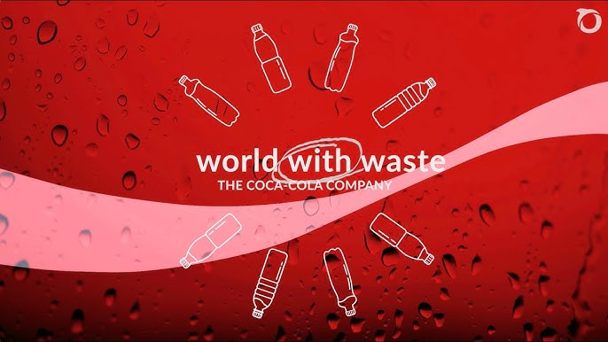
Figure 2: World with Waste
(Source: The Coca-Cola Company, 2025)

Comparison of Brand’s STP strategies in Country A and Country B
Segmentation
Coca-Cola in India has a large and diverse market, which is handled through multi-dimensional segmentation. Geographically, it distinguishes metros, Tier 2/3 cities, and rural villages based on infrastructure, income, and access to cold chain. It is also demographically very youth- and young-adult-oriented, but product portfolios are also aimed at families (Multi litre PET) and at the go urban customers (cans, 250-300ml PET) (Coca-Cola HBC, 2022). The behavioural segmentation is observed through dividing heavy consumers of cola drinks (e.g., Thums Up) from occasional consumers or consumers who prefer fruit-type or refreshing beverages like Sprite and Maaza. Psychographic segmentation appeals to more aspirational, westernised urban youth who are responsive to global campaigns and celebrity promotions, versus more traditional, value-conscious rural consumers who are approached with price-point packs and culturally ingrained messages, such as Thanda Matlab Coca-Cola.
Segmentation in the UK is health-conscious, lifestyle, and occasion-driven rather than being driven by basic access. The market is a mature one with a high per capita consumption, yet the concern towards sugar and obesity is on the increase. Coca-Cola markets by health orientation (regular and diet/zero sugar) and life stage and occasion of use. Diet Coke and Coca Cola Zero Sugar target the calorie-conscious adults and especially women and young professionals, whereas Coca Cola Original Taste targets the taste and indulgence (Coca-Cola, 2024). The segmentation based on occasion distinguishes between take-home multipacks (families), on-the-go single bottles and cans (commuters, lunch breaks), and out-of-home consumption in pubs, QSR chains, and events. In greater detail, Gen Z and millennials are becoming polarized in terms of their sustainability and authenticity, and digital campaigns, limited edition flavours, and personalisation (e.g., Share a Coke reboot) are made to attract these generations.
Targeting
Coca-Cola in India has a differentiated targeting strategy where it positions brands and packs based on various segments instead of targeting one mass market. The leader of cola brands in India, Thums Up, which is now a billion-dollar brand, targets mainly the young male consumers who prefer the taste of a strong drink (Economic Times, 2022). Coca-Cola are aimed at a larger number of youth and families, whereas Maaza and Minute Maid are focused on the fruit drink consumers and occasions that can be considered more family-friendly. Small packs (0.10-0.20): Cheaper small packs are specifically aimed at rural and low-income markets where affordability and accessibility of the pack are crucial; in India, more than 400 million incremental transactions were achieved through these packs in H1 2024, and the packs are currently sold in over 50% of all commercial beverage outlets in India (Agron Food Processing, 2024). Mobile-centric, digital-first campaigns are aimed at city youth, featuring influencers and short-form video content written in the local language.
In the UK, the One Brand strategy of Coca Cola incorporates Coca Cola Original Taste, Diet Coke, and Coca Cola Zero Sugar as one master brand, and appeals to different consumer requirements in the fields of taste and sugar content. The company is particularly focused on health-conscious segments, with Coca-Cola Zero Sugar and Diet Coke, which feature the logos "no sugar" and "no calories" and urge consumers to substitute for regular colas in the context of the Soft Drinks Industry Levy (Kwan et al., 2025). Simultaneously, regular Coca-Cola will focus on loyal cola beverage consumers, as well as occasional treat consumers, who are willing to pay a premium. Portion control and price sensitivity are dealt with through segment-specific campaigns and pack formats (e.g., smaller cans, multi-pack offers). Digital, experiential, and influencer campaigns (e.g., #ShareTheMagic and “Create Real Magic activations) are aimed at the desired audience (Gen Z and millennial consumers) and stimulate user-generated content and sharing on TikTok and Instagram.
Positioning
In India, the central positioning of Coca-Cola is a blend of refreshment, happiness, and inspirational modernity, and it is used to improve the profound localisation. Advertisements in various languages of the region, with Bollywood celebrities and cricketing heroes, brand the brand as being a part of the social life of Indians in the village and in the multiplex theatres and IPL viewing events (Muktadir, 2022). To the rural consumer, the brand is being marketed as cheap, convenient, and a real refreshment backed by visible coolers, signage, and visibility in local fairs and markets.
The Coca-Cola brand is a recognizable, stable, but dynamic brand in the UK that provides choice in a health-controlled and sustainability-aware world. It is the most well-known brand of soft drinks in the UK, and the brand awareness of online respondents is approximately 98 percent. Coca-Cola Original Taste remains the leader of the convenience channel sales with 798 million in 2024 (Statista, 2024). However, positioning pays more and more attention to choice and responsibility: there is a Coke that everyone can drink, there are sugar-free versions of Coke, clear labelling of nutritional values, and reduced portion size. Other campaigns, like the relaunching of the discontinued Share a Coke in 2024, and seasonal platforms like The World Needs More Santas, emotionally narrate, socialise, and normalise low and no-sugar in the same brand world.
STP | India | UK
Segmentation | • Geographic: Metros, Tier 2/3, rural• Demographic: Youth, families, on-the-go urban consumers  • Behavioural: Heavy cola drinkers (Thums Up), fruit-drink users  • Psychographic: Aspirational urban vs value-conscious rural | • Health & lifestyle based  • Demographic: Adults, young professionals, families  • Behavioural: Sugar-conscious vs taste-seeking; on-the-go vs take-home  • Psychographic: Gen Z & millennials focused on sustainability
Targeting | • Thums Up → young males  • Coca-Cola → youth & families  • Maaza/Minute Maid → fruit-drink seekers  • Small packs → rural & low-income markets  • Digital-first campaigns → urban youth | • One Brand strategy  • Zero/Diet Coke → health-conscious adults  • Original Coke → loyal taste consumers  • Small cans/multipacks → portion control & price sensitive  • Digital & experiential campaigns → Gen Z & millennials
Positioning | • Refreshment, happiness, modernity  • Localised messaging with celebrities & sports icons  • Affordable refreshment for rural markets | • Iconic, responsible brand  • Emphasis on choice (Original, Diet, Zero)  • Clear nutrition labelling & sugar reduction  • Emotional, personalised campaigns (Share a Coke, seasonal ads)

Comparative insight
In general, STP of Coca-Cola in India is anchored in breadth of coverage, affordability, and cultural integration to ensure that the brand and its local versions are available wherever consumption events take place, primarily among young people and in rural markets (Jewela and Kalam, 2022). In the UK, STP is more geared towards the mature, highly-regulated market by repositioning the portfolio to zero-sugar variants, premium experiences, and responsible indulgence, and by defending leadership in a slow-growth category. The similarity here is a stable global brand platform and a strong local adoption of messages, product mix, and price pack structure. Comparison of the Marketing Mix Strategies in Country A and Country B.

Comparison of Marketing Mix Strategies in Country A and Country B
Product
Coca-Cola has a broad portfolio in India that includes different power brands that are strong in the local markets, like Thums Up (a billion-dollar brand in India) and Maaza, which are essential in ensuring that the brands remain at the top of the cola and fruit drinks categories (Prasad and Patil, 2021). The product is focused on taste profiles that fit the Indian palate (spicier cola, sweeter mango drinks), various pack sizes, packaging appropriate for hot climates, and long-distance distribution. The recent advances have been ultra-lightweight PET bottles that have increased shelf life, which will enhance affordability and access to remote outlets.
The portfolio and sugar reduction are the main product strategies in the UK (Bandy et al., 2021). The product range consists of Coca Cola Original Taste, Diet Coke, Coca Cola Zero Sugar, and flavoured versions, and the allied brands such as Fanta and Sprite. Coca-Cola and other soft drink companies made massive reformulations in response to the SDIL; the average sugar content of taxed carbonated soft drinks in the UK dropped by an average of 4046kcal between 2014 and 2018, and many of the beverages were reformulated to be below the levy levels. The success of this product has led to Coca-Cola Zero Sugar achieving sustained double-digit volume growth and value share of total cola in Great Britain.
Price
Pricing policies are radically different. India Coca-Cola operates on penetration and affordability pricing, where small pack SKUs, with low price points (₹10 and more), are used to appeal to price-sensitive consumers and high frequency of consumption is encouraged, particularly in rural and semi-urban markets (Srivastava et al., 2025). Price pack architecture is a tactic employed by the company to divide the market based on income and occasion (e.g., returnable glass bottles, low-income, multi-litre PET family, cans, modern trade).
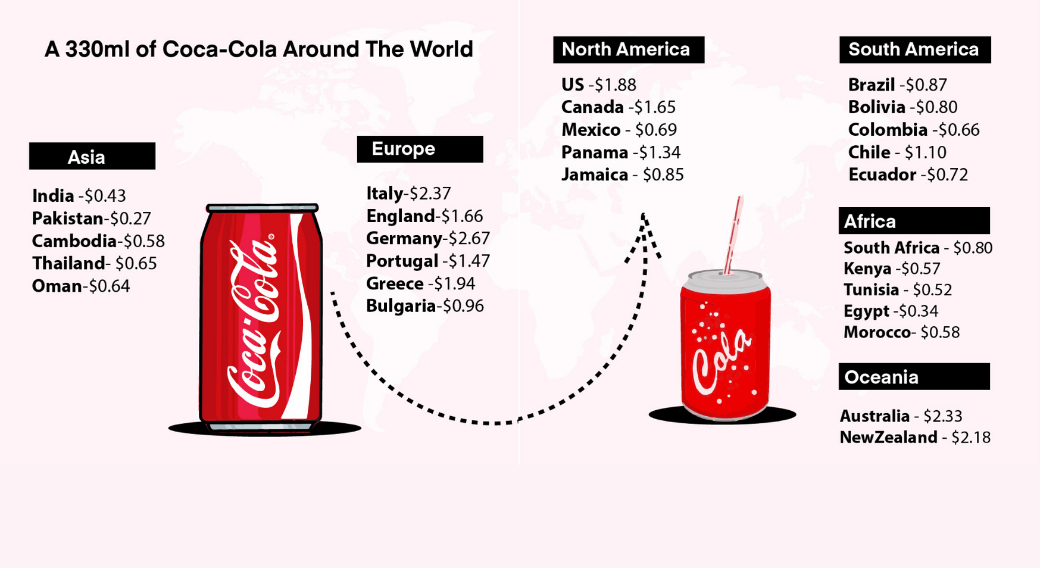
Figure 3: Coca-Cola prices
(Source: The Post India 2025)
The prices in the UK are higher, though under control, due to the sugar levy and high competition in grocery retail (Fearne et al., 2022). The 2023 24 results of CCEP indicate that revenue per unit case at the European scale, including Great Britain, increased sharply as a result of the increase in headline prices and positive brand/pack mix, although volumes were generally flat.
Place (Distribution)
Distribution is also a core competitive advantage in India. Coca-Cola and its bottlers have established an extensive, multi-layered network based on the hub-and-spoke model to cover more than 100,000 villages, investing in more trucks, smaller vehicles, and rural coolers (The Wire 2025). Previously, efforts to cover rural areas grew exponentially with the introduction of more than 200,000 fridges and thousands of trucks to ensure a supply of cold food in rural shopping centres. The latest performance news is that India is still increasing its retail penetration, with approximately 350,000 new stores being added in the first quarter of 2025. Products can be transported deeper into remote markets at a reduced cost because of ultra-lightweight bottles with an extended shelf life. In India, in the city, distribution occurs in Kirana stores, modern trade, food service, cinema chains, and rapid commerce platforms.
Coca-Cola in the UK uses a distribution that is very efficient, albeit somewhat saturated, and spearheaded by CCEP (Fabbian, 2021). The brand is virtually available in supermarkets, convenience stores, petrol stations, vending machines, pubs, quick service restaurants, and entertainment venues. The growth is less of an increase in physical reach than an increase in pack mixes across channels (e.g., single serve in convenience, multipacks in grocery, draught in hospitality) and increased out-of-home flows with the recovery of tourism and events.
Promotion
In India, promotion is a mixture of mass media narration and hyperlocal activation. Present-day campaigns combine Bollywood with cricket sponsorships, festival-based activations (e.g., Maha Kumbh sales drives) with heavy television advertising and outdoor branding (WARC, 2024). Digital marketing has emerged at a speedy rate: Coca-Cola India relies on Instagram, YouTube, and collaboration with influencers to appeal to young mobile-first consumers, which is supported by the fact that the world is digitizing its marketing, and influencer marketing takes up a significant portion of the marketing budget in Coca-Cola.
Coca-Cola promotion is very integrated/experiential in the UK and is in balance between tradition and innovation. In turn, emotional campaigns like Share a Coke (reintroduced in 2024) focus on people's nostalgia and the sense of community, promoting social media interactions and user content (Dai, 2021). Brand visibility is supported with the help of sports and music sponsorships and cooperation with global and local influencers. Meanwhile, promotional communications are increasingly focusing on sugar-free options and disclosing nutrition facts to align with popular health discourse and regulatory demands.
People, Process, and Physical Evidence
The people dimension in India includes a vast chain of sales representatives, distributors, and retailers that have maintained the display, refrigeration, and merchandising at the point of sale. The training is focused on maintenance in coolers, the planogram implementation, and the local building of relationships (Bisen and Tekade, 2025). Processes are focused on cold chain values in hot weather, rapid replenishment in peak summer and during festivals, and good collaboration with small retailers. Physical evidence includes ubiquitous red signage, painted village walls, branded coolers, event kiosks, and local activations, ensuring the brand is evident in both contemporary and traditional trade.
In the UK, CCEP has customer-facing teams, referred to as people, including category managers and merchandisers, who serve large retail and hospitality chains (Simakova 2025). Processes focus on data-based category management, forecasting, and joint business planning for the large customers. The physical evidence is presented by the regular application of the iconic colour that is red, contour bottle visuals, branded chillers, vending machines, and sports and music events setups. The two markets, therefore, are capitalizing on good visual identity; however, India will be more dependent on the grassroots retail implementations, whilst the UK will depend on advanced retail associations and the experience branding.
Hofstede cultural dimension and adaptation
Dimension | India Score | UK Score | Marketing Implications of Coca-Cola
Power Distance | 77 | 35 | High power distance in India refers that Coca-Cola get benefited from celebrity-endorsed campaigns, authority-based campaigns, and respect-driven messaging. While in the UK, here hierarchy is less emphasised and the company uses friendly, informal communication and inclusive branding.
Individualism | 48 | 89 | The UK’s individualistic culture aligns with the lifestyle-oriented messaging, personalised consumption experiences, and self-expression. On the other hand, India is a collectivist culture that focuses on family, thus the company focuses on community engagement, family-centric ads, and festival campaigns.
Uncertainty Avoidance | 40 | 35 | Consumers in the UK are mote comfortable with experimentation that allows the company to innovate frequently and launch new flavours. However, there is a moderate avoidance in India that encourages Coca-Cola to stress in reliability, product safety, and consistency.

Evaluation of the performance of marketing strategies
The marketing strategies of Coca-Cola have been demonstrated to be quite successful in India and generally successful, but more restrained in the UK, based on the performance data.
Even with the emerging local brands, Coca-Cola and PepsiCo continue to command the carbonated soft drinks in India. In India alone, Thums Up broke the USD 1 billion annual sales mark in 2021, an indicator of the local brand positioning and performance (Economic Times, 2022). According to the global performance of Coca-Cola Company, India has been identified as the key driver of growth, numerous times: in 2023, India and Brazil saw the unit case volume growth, and in Q2 2024, the company saw the worldwide increase in the unit case volumes 2% with India, Brazil, and the Philippines contributing the most (Economic Times, 2024).
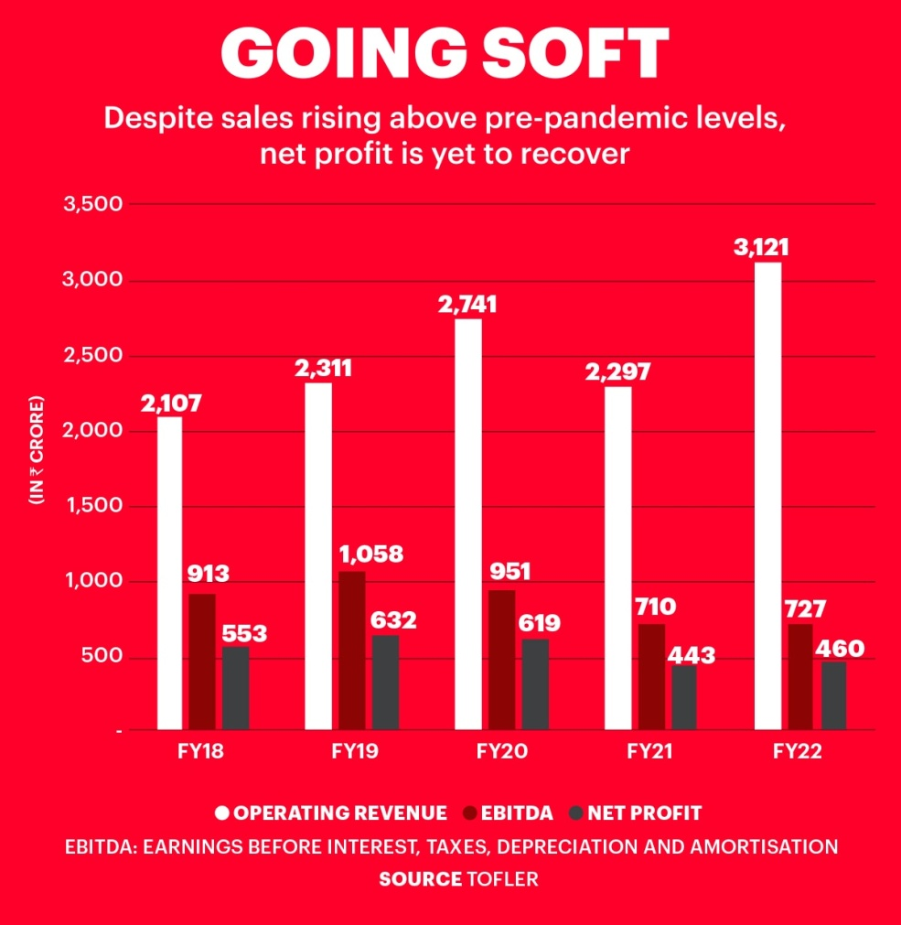
Figure 4: Thumbs up sales
(Source: Business Today 2023)
The innovation of packaging through ultra-lightweight, cost-effective bottles created over 400 million new transactions in India during the first half of 2024 and is currently available in over half the commercial beverage outlets in India, showing that the price, pack, and distribution strategy has been effective. Coca-Cola also experienced a growth of volumes at the end of Q1 2025 with the addition of approximately 350,000 retail outlets in India, another encouraging development that proves high market momentum (Business Standard, 2025). Collectively, these pointers indicate that the STP and 7Ps of Coca-Cola in India are effectively increasing volume, penetration, and brand equity in an environment where competition is growing and health issues are on the rise.
The UK has a good performance in brand measurements and is worth a more mixed performance on volume. Coca-Cola is still the leading-selling brand of soft drink in the UK convenience stores: regular Coca-Cola generated nearly £798 million in sales in the convenience channel in 2024, surpassing Pepsi Max and other brands (Statista, 2024). Overall, cola flavours still occupy the largest market share in the carbonated soft drinks in the UK, with Coca-Cola, Pepsi Max, and Diet Coke being the top three carbonated brands. The brand awareness is outstanding: according to survey results, Coca-Cola is known to approximately 98% of online surveys in the UK, which makes Coca-Cola the best-known brand of soft drinks in the country. Coca-Cola also has high usage, popularity, and loyalty scores among soft drink drinkers.
Financially and in share terms, the European operations of CCEP, including Great Britain, provided stable revenue and an increase in profits in 2023, with the revenue per unit case increasing by approximately 8-9 per cent and value share improvement, especially to Coca Cola Zero Sugar. GB volumes are, however, widely flat, which indicates maturity, health-driven consumption changes, and intensity of competition (The Coca-Cola Company, 2023). The fact that the repositioning of Coca Cola Zero Sugar, which achieved an increase in volume of over double digits and value share of over one percentage point of the total cola in GB, demonstrates that health-oriented marketing and product positioning can maintain relevance and share even when cola volumes are declining.
Performance Factor (India and the UK)
Performance Factor | UK | India
Market Maturity | High mature market, stable beverage market | Diverse, price-sensitive, and growing
Consumer preferences | Sustainable products and preferences of low-sugar diet | Value packs, traditional flavours, and strong demand for affordability
Brand positioning | Premium, lifestyle-driven, and health-focused messaging | Cultural relevance, family-oriented marketing, and mass-market appeal
Distribution Strength | Advanced logistics and strong retail penetration | Major semi-urban and rural growth potential and expanding distribution
Growth Potential | Market saturation limits expansion | High and long-term growth potential due to population and rising disposable incomes.
It can be analysed from the comparison that UK represents a premium-focused and mature market that requires Coca-Cola to focus on sustainability, health innovation, and brand differentiation. However, India represents high-growth strategic opportunity where the company need to prioritise localisation, deep distribution reach, and affordability to strengthen long-term competitiveness as well as diverse consumer environment.

Evaluation of marketing ethics practice
Ethical assessment should be in regard to health effects, environmental accountability, transparency, and effects on the community (Akinrinola et al., 2024). Coca-Cola has also done better at some practices, but is still being criticized in both nations.
The most pressing ethical concerns in India are associated with water consumption, environmental pollution, and the healthiness of products. The case of Plachimada in Kerala is still symbolic: residents and activists complain that a Coca-Cola bottling plant profoundly depleted groundwater, polluted wells and soils, and applied sludge containing heavy metals, making the land less productive (Karmakar, 2024). It was closed, and a panel set up by the state government advised huge compensation, but community organizations insist no compensation has been paid, and demonstrations have continued even after 20 years. This protracted conflict creates doubts about the water stewardship of Coca-Cola, respect for local livelihoods, and responsiveness to afflicted communities.
Coca-Cola is also known to be among the top plastic polluters in the world, as shown in branded plastic waste audits in India (Oceana, 2025). India's new plastic waste and EPR regulations are directly aimed at brand owners, who are the major contributors to unmanaged waste through their single-use packaging. Although Coca-Cola has set global goals for a world without garbage (100 percent recyclable packaging and 50 percent new-content recycled PET bottles by 2030), systemic issues like poor collection infrastructure and the informal waste sector still affect the country's practice, which questions the ethical validity of the promises.
The ethical issues in the UK and the European region focus on population health and greenwashing. On health, Soft Drinks Industry Levy and burdensome ASA regulations have compelled Coca Cola and other producers to drastically reduce sugar content, with the average sugar content of taxed soft drinks reducing by more than 40% between 2014 and 2018, and approximately 89% of beverages passing below the levy limit (Weatherwax, 2025).
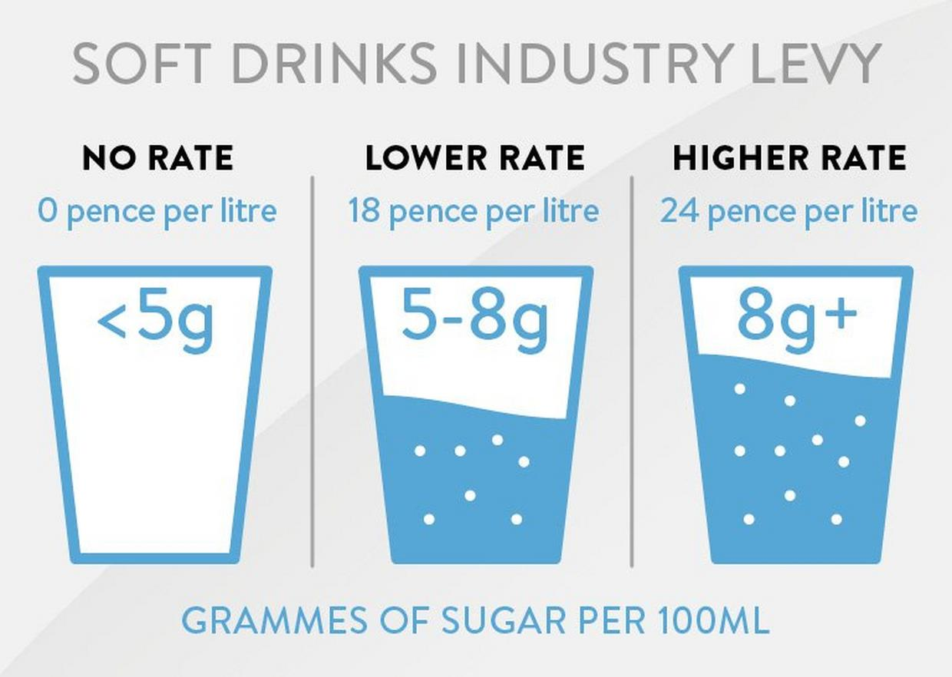
Figure 5: Soft Drinks Industry Levy
(Source: Brake 2025)
The new move by Coca-Cola to Coca-Cola Zero Sugar and Diet Coke, with the help of the front-of-pack labelling, can be considered a good ethical action towards addressing the issue of obesity. Nevertheless, the brand continues to spend on aspirational marketing on sugary versions, and HFSS prohibitions against marketing to children need to be kept vigilant to prevent indirect targeting via influencers, sports sponsorships, or family-oriented media.

Recommendation and Conclusion
The international marketing of Coca-Cola, which is achieved through the comparative analysis, implies that its strategies in India and the UK are commercially effective, yet they should be more closely aligned with the health, environmental, and community expectations. The recommendations to be implemented are aimed at improving long-term performance and legitimacy.
- To begin with, Coca-Cola must accelerate the transition to low- and no-sugar drinks, especially in India. The UK experience shows that repositioning and vigorous marketing of Coca-Cola Zero Sugar would save value and market share in a highly health-aware, regulated environment (Vogel et al., 2021). Stricter sugar regulation is necessary to manifest in India before it can get the required momentum. This means putting more investment into zero-sugar colas, flavoured waters, and lower-sugar fruit juices with the help of straightforward labelling and educational campaigns instead of focusing on emotive appeals and celebrity endorsements.
- Second, the company ought not to see water stewardship/community relations in India as a matter of risk management, but also a strategic management matter (Calvat, 2022). Attending to old grievances, like Plachimada, by paying compensation, having an open conversation, and involving third-party mediation would be an indication of true responsibility and may restore confidence amongst the affected societies. Coca-Cola ought to provide high-risk locations with raw, independently audited water balance information, to invest in local watersheds repair, and cooperate with communities to develop communal water access initiatives.
- Third, Coca-Cola in India and the UK should not be content with compliance with circular packaging but should strive to be in the lead. This is in addition to the minimum requirements of EPR and deposit returns in the UK and formal EPR targets in India (Ramasubramanian et al., 2023). Some of these are: quick ramping up of refillable and returnable packaging in urban centres; moving up recycled PET contents beyond the current trends where recycling is technically possible; redesign of packs, which minimise use of materials; and infrastructure to facilitate collection and sorting, especially in cities of India where informal systems prevail. There should not be unconditional statements, such as 100 percent recycled, in marketing communications; more focus on the quantifiable progress that was independently measured, without any further greenwashing issues.
- Fourth, Coca-Cola ought to enhance ethical guardrails in the marketing of its products to children and vulnerable populations (Ndebele et al., 2022). This means that in both countries, it will restrict the internal policy to a higher degree than the legal minimum of HFSS advertising around schools, on programming aimed at children, or through influencers attractive to the youth. The campaigns must target adults and family decision makers, not normalise the high sugar drinks intake as daily hydration, and accompany the festive messages with the responsible consumption signs.
- Fifth, it has a prospect to localise digital and experience marketing even more and anticipate sustainability and inclusivity (Theofanous et al., 2024). The campaigns in India might better be seen as more visual on recyclable or refillable packs, community water projects, and contributing to local sports and culture, and providing refreshment and fun. Future campaigns of the type Share a Coke may be expanded in the UK, where consumers will be invited to litter cleanup activities, refill campaigns, or recycling challenges, with emotional branding being associated with the actual environmental behaviours.
Finally, the international marketing conducted by Coca-Cola in India and the UK indicates the high adaptability of STP and marketing mix in the two environments, which has resulted in leading the market, high brand recognition, and strong financial results in both settings. Nevertheless, it is ethical and sustainability issues, especially sugar consumption, plastic waste, and water use, which, likewise, are intensified with the help of the same strategies. The way that Coca-Cola can move towards a health, environmental stewardship, and community wellbeing integrated model as the primary focus of its value creation, both in India and the UK, will determine future success

References
Agarwal, M. S., Sain, A., Mishra, S. K., Kumar, M. K., Rai, D. V. S., and Chandra, S. (2024). Examining India’s Product Liability Framework In The Context Of The Food Sector: A Comparative Study With Reference To The United States Of America.
Agron Food Processing (2024) India Drives Coca-Cola’s 2% Volume Growth with 400 Million Transactions in H1 2024. [Online]. Available at: https://agronfoodprocessing.com/india-drives-coca-colas-2-volume-growth-with-400-million-transactions-in-h1-2024/ [Accessed: 28 November 2025]
Akinrinola, O., Okoye, C. C., Ofodile, O. C., and Ugochukwu, C. E. (2024). Navigating and reviewing ethical dilemmas in AI development: Strategies for transparency, fairness, and accountability. GSC Advanced Research and Reviews, 18(3), 050-058.
Ali, I., Aboelmaged, M., Govindan, K., and Malik, M. (2023). Understanding the key determinants of IoT adoption for the digital transformation of the food and beverage industry. Industrial Management and Data Systems, 123(7), 1887-1910.
Bandy, L. K., Hollowell, S., Harrington, R., Scarborough, P., Jebb, S., and Rayner, M. (2021). Assessing the healthiness of UK food companies’ product portfolios using food sales and nutrient composition data. PLoS One, 16(8), e0254833.
Bilgihan, A., and Ricci, P. (2024). The new era of hotel marketing: integrating cutting-edge technologies with core marketing principles. Journal of Hospitality and Tourism Technology, 15(1), 123-137.
Bisen, D. A., and Tekade, A. (2025). TRAINING AND DEVELOPMENT IN SUPERIOR DRINKS COCA COLA PVT LTD BUTTIBORI, NAGPUR. International Journal of Innovation Studies, 9(1), 355-361.
Brake (2025) Soft Drink Industry Levy. [Online]. Available at: https://www.brake.co.uk/news/industry/soft-drink-industry-levy (Accessed: 28 November 2025)
Business Standard (2025) Coca-Cola's India sales, drives Q1 volume growth. [Online]. Available at: https://www.business-standard.com/companies/news/maha-kumbh-boosts-coca-cola-s-india-sales-drives-q1-volume-growth-125042901287_1.html [Accessed: 28 November 2025]
Business Today (2023) How Coca-Cola turned Thums Up, Sprite into billion-dollar brands. [Online]. Available at: https://www.businesstoday.in/interactive/longread/how-coca-cola-turned-thums-up-sprite-into-billion-dollar-brands-230-09-01-2023 (Accessed: 28 November 2025).
Calvat, C. (2022). Corporate Water Stewardship: Assessing the Performance of Non-Governmental Organization-Corporate Coalitions in the Food and Beverage Sector (Doctoral dissertation, Duke University).
Coca-Cola (2024) What's the difference between Coca-Cola Zero Sugar and Diet Coke? [Online]. Available at: https://www.coca-cola.com/gb/en/about-us/faq/what-s-the-difference-between-cocacola-zero-sugar-and-diet-coke [Accessed: 28 November 2025]
Coca-Cola Company., (2025). Our Company. [Online]. Available through: <https://www.coca-colacompany.com/about-us>. [Accessed on:11 November 2025].
Coca-Cola HBC (2022) Integrated Annual Report 2022. [Online]. Available at: https://www.coca-colahellenic.com/content/dam/cch/us/documents/oar-2022/Coca-Cola-HBC-2022-IAR.pdf.downloadasset.pdf [Accessed: 28 November 2025]
Dai, Y. (2021, March). Comparison of emphasis point towards marketing strategies between Pepsi & Coca-cola. In 6th international conference on financial innovation and economic development (ICFIED 2021) (pp. 79-83). Atlantis Press.
Economic Times (2022) Thums Up becomes a billion-dollar brand. [Online]. Available at: https://economictimes.indiatimes.com/industry/cons-products/food/thums-up-becomes-a-billion-dollar-brand/articleshow/89486419.cms?from=mdr [Accessed: 28 November 2025]
Economic Times (2024) Coca-Cola India business witnesses robust growth in 2023. [Online]. Available at: https://economictimes.indiatimes.com/industry/cons-products/food/coca-cola-india-business-witnesses-robust-growth-in-2023/articleshow/107668752.cms?from=mdr [Accessed: 28 November 2025]
Euromonitor International., (2023). Sugar Reduction and Soft Drinks in 2023. [Online]. Available through: <https://www.euromonitor.com/sugar-reduction-and-soft-drinks-in-2023/report>. [Accessed on:11 November 2025].
Fabbian, S. (2021). Global brands connect with the local culture: advertising strategies of Coca-Cola in China.
Fearne, A., Borzino, N., De La Iglesia, B., Moffatt, P., and Robbins, M. (2022). Using supermarket loyalty card data to measure the differential impact of the UK soft drink sugar tax on buyer behaviour. Journal of Agricultural Economics, 73(2), 321-337.
Forde, H. (2021). Changes to marketing in response to sugary beverage taxation: the Soft Drinks Industry Levy in the United Kingdom (Doctoral dissertation).
Jewela, M. H., and Kalam, K. (2022). The Importance and Level of Adaptation of STP Strategies for Growth in Foreign Markets: In the Case of Coca-Cola Company. Journal of International Business Studies.
Karmakar, G. (2024). Plachimada Struggle and the Environmentalism of the Poor:(In) justice and Activism in Mayilamma: The Life of a Tribal Eco-Warrior. Current Writing: Text and Reception in Southern Africa, 36(2), 124-137.
Kwan, Y. H., Tang, H., Qi, L., Yap, A. F. H. W., Yan, L., Li, Y. X., and Fong, W. (2025). Coke zero for the zero: A randomized controlled trial examining coke zero consumption on night call inpatient course and mortality. Proceedings of Singapore Healthcare, 34, 20101058251318113.
Law, C., Cornelsen, L., Adams, J., Pell, D., Rutter, H., White, M., and Smith, R. (2020). The impact of UK soft drinks industry levy on manufacturers’ domestic turnover. Economics & Human Biology, 37, 100866.
Molinero, L., (2025). The UK government wants to expand the sugar tax to milkshakes and plant-based drinks – here’s what you need to know. [Online]. Available through: <https://theconversation.com/the-uk-government-wants-to-expand-the-sugar-tax-to-milkshakes-and-plant-based-drinks-heres-what-you-need-to-know-255646#:~:text=The%20soft%20drinks%20industry%20levy,containing%20over%208g%20per%20100ml.>. [Accessed on:11 November 2025].
Muktadir, M. (2022). Marketing Communication Strategies of Beverage Industries: A comparison between the Advertisement of Coca-Cola & Pepsi.
Ndebele, P., Krisko, P., Bari, I., Paichadze, N., and Hyder, A. A. (2022). Evaluating industry attempts to influence public health: Applying an ethical framework in understanding commercial determinants of health. Frontiers in Public Health, 10, 976898.
Oceana (2025) Coca-Cola's World With Waste. [Online]. Available at: https://oceana.org/wp-content/uploads/sites/18/2025/03/Coca-Colas-World-With-Waste-Oceana-Report-2025-DOI-reduced-size.pdf [Accessed: 28 November 2025]
Oceana (2025) Coca-Cola's World With Waste. [Online]. Available at: https://oceana.org/wp-content/uploads/sites/18/2025/03/Coca-Colas-World-With-Waste-Oceana-Report-2025-DOI-reduced-size.pdf (Accessed: 28 November 2025).
Prasad, M. R., and Patil, L. (2021). A Study on Analysis of Coca Cola Company. Post Covid 19-Economic Opportunities & Challenges in India, 93.
Ramasubramanian, B., Tan, J., Chellappan, V., and Ramakrishna, S. (2023). Recent advances in extended producer responsibility initiatives for plastic waste management in Germany and UK. Materials Circular Economy, 5(1), 6.
Simakova, E. (2025). Internal Market Orientation and Customer Orientation: Effects on Service Employees and Customer Experience (Doctoral dissertation, University of Westminster).
Srivastava, P., Tiwari, K. J., and Mohanty, A. (2025). MULTI NATIONAL COMPANIES AND INDIAN MARKET. GWALIOR MANAGEMENT ACADEMY, 117.
Statista (2024) Top selling UK soft drink brands 2024. [Online]. Available at: https://www.statista.com/statistics/629118/soft-drink-brand-ranking-in-the-united-kingdom-uk-by-convenience-sales-value/ [Accessed: 28 November 2025]
The Coca-Cola Company (2023) Coca-Cola Reports Third Quarter 2023 Results and Raises Full-Year Guidance. [Online]. Available at: https://www.coca-colacompany.com/media-center/coca-cola-reports-third-quarter-2023-results [Accessed: 28 November 2025]
The Coca-Cola Company (2025) Sustainability. [Online]. Available at: https://www.coca-colacompany.com/about-us/sustainability [Accessed: 28 November 2025]
The Post India (2025) How Much Does Coca-Cola Cost Around the World? [Online]. Available at: https://thepostindia.co.in/how-much-does-coca-cola-cost-around-the-world/ (Accessed: 28 November 2025)
The Wire (2025) Coca-Cola's Bottling Partners Bolster India's Logistics Network with Fleet EV Expansion and Welfare Push. [Online]. Available at: https://thewire.in/ptiprnews/coca-colas-bottling-partners-bolster-indias-logistics-network-with-fleet-ev-expansion-and-welfare-push [Accessed: 28 November 2025]
Theofanous, G., Thrassou, A., and Uzunboylu, N. (2024). Digital inclusivity: Advancing accessible tourism via sustainable e-commerce and marketing strategies. Sustainability, 16(4), 1680.
Vogel, C., Crozier, S., Penn-Newman, D., Ball, K., Moon, G., Lord, J., and Baird, J. (2021). Altering product placement to create a healthier layout in supermarkets: outcomes on store sales, customer purchasing, and diet in a prospective matched controlled cluster study. PLoS Medicine, 18(9), e1003729.
WARC (2024) Brand in action: How Coca-Cola India aligns global brand values with local festive culture. [Online]. Available at: https://www.warc.com/newsandopinion/opinion/brand-in-action-how-coca-cola-india-aligns-global-brand-values-with-local-festive-culture/en-gb/6684 [Accessed: 28 November 2025]
Watson, D., Zhai, Y., and Lichy, J. (2023). FOOD AND BEVERAGE. The Market: International Journal of Business, 50.
Weatherwax, J. J. (2025). Recycling the Rules: How Coca-Cola's Recent Legal Battles Highlight the Need for Modernizing Sustainability Advertising Laws to Protect Consumers and Businesses. W. New Eng. L. Rev., 47, 122.
YOGANANDHAM, G. (2024). PLASTIC CONSUMPTION IN TAMIL NADU: UNPACKING ECONOMIC IMPACTS, POVERTY DYNAMICS, WATER PACKAGING, AND INTERNATIONAL POLICY SOLUTIONS. Degrés, 9(5).

Appendix



