


mitigate vunerabilities in selective smart home devand propose recommendations to achieve security
by
Connor Osborne(1800742)

Supervisor: Nitheesh Kaliyamurthy
Project submitted as part of the requirements for the award of BSc (Hons) Computer Networking and cyber security.

April 2021

Declaration of Originality
I, Connor Osborne declare that I am the sole author of this Project; that all references cited have been consulted; that I have conducted all work of which this is a record, and that the finished work lies within the prescribed word limits.
This work has not previously been accepted as part of any other degree submission.

Signed : Connor Osborne
Date : 23/04/2021

FORM OF CONSENT:
I, Connor Osborne hereby consent that my Project, submitted in candidature for the B.Sc.(Hons) Computer Networks degree, if successful, may be made available for inter-library loan or photocopying (subject to the law of copyright), and that the title and abstract may be made available to outside organisations.
Signed : Connor Osborne
Date : 23/04/2021

Copyright Acknowledgement
I acknowledge that the copyright of this project report, and any product developed as part of the project, belong to University of Wales Trinity Saint David, Swansea.

Abstract
This project is mainly focusing on the security of smart home devices. The aims and objectives are to research popular smart home devices and experiments that have been done from them. Then to use that research to make an experiment and test to see if the security flaw has been fixed. The methods for this project are that the mono-method is used as the question is mainly being answered by a single way that is an experiment. The project is also focused on realism as it is mainly concerned about the security of devices. Another methodology is deductive. As the project is mainly using the data from the experiment with linking to the literature review, it is mainly only using the data gathered from it. The findings from the project are that the security of the devices are relatively secure as the casting device in the experiment needed the device to be connected using the Wi-Fi to use it. This allowed the device to function as it should be and cannot be connected from a separate network. This answers the question asking if smart devices are secure. This isn’t very much of a concrete answer as only a single device was tested. Future work would include increasing the amount of smart device tested including multiple brands of smart devices. This would allow the question to be answered with more results to showcase if smart home devices are secure or not.

Contents
Abstract 1
Chapter 1 3
Chapter 1.1-Introduction 3
Chapter 1.2 – flow of work 3
Chapter 1.3-Aim 3
Chapter 1.4-Objectives 3
Chapter 2- Research & review of literature 4
Chapter 2.1-What are smart home device and what does the future look like? 4
Chapter2.2- 4
First types of smart home devices 4
Chapter 2.3-Problems with smart home devices 5
Chapter 2.4 – Different attacks 5
Chapter 2.5 - Solutions 6
Chapter 2.6 - gap 7
Chapter 3-Research methodology 7
Chapter 3.1- Philosophies 8
Chapter 3.2- Approach 8
Chapter 3.3- strategies 8
Chapter 3.4- Choices 8
Chapter 3.5- time horizons 8
Chapter 3.6- techniques and procedures 9
Chapter 4-Design and implementation 9
Chapter 4.1 design 9
Chapter 4.1.1- Requirements 9
Chapter 4.2.1 experiments 10
Chapter 4.2.1.1 experiment 1 10
Chapter 4.3.1-Implementation 12
Chapter 5-Evaluation 15
Chapter 5.2 – literature review 15
Chapter 5.2- objectives 15
Chapter 5.3 - aims. 16
Chapter 5.4 – evaluating answers. 16
Chapter 5.5 – what would be done differently next time. 17
Conclusion 17
Future work 17
Reflection 18
Bibliography 19

Chapter 1

Chapter 1.1-Introduction

The project is the security of smart home devices. As smart home devices are becoming more common place it is important to have a secured smart home. As devices such as the amazon echo, doorbell cameras and smart lights have become more common place, it is important to have them secure. This project will mainly be reviewing security flaws and recent events looking over a span of 8 years to gain an understanding of what the main issue with smart security is and how it can be mitigated. This will be done with a guide on how to securely set up or add over time new smart devices and what to look for when first connecting them.

Chapter 1.2 – flow of work
This project will be done by first deciding the aims and objectives. After that, the project will be looking into the literature review for the project. After the

Chapter 1.3-Aim
In this section the project will be talking about the aims and objectives and how they will be achieved. This will be done by first by listing out the aims and then creating the main objectives to complete them. The main aim is how secure are smart homes and how they can be better protected. This aim contains three smaller aims that make up the main aim. This includes what smart devices people are mainly using. How secure these smart devices are and finally how they can be improved.
This project will mainly be focusing on the security of the smart home devices. This will entail three aims that will make the main aim on to investigate smart home devices and their security.
- What smart devices are commonly used?
- How secure are smart devices.
- How secure are some of these smart devices.

Chapter 1.4-Objectives
- Researching the advancement of smart homes with how the security is improved over the years.
- The main features of smart home devices
- What is the main security of smart devices that are built in from out of the box such as standard passwords.
- How to mitigate the security issues by creating a guide on what to do when setting up a network with smart devices.
The main objective of this project is to satisfy the aim and allow the project to answer the question how secure smart devices are. The survey will mainly be used to collect what devices most people would use in their homes. This would set a base of what devices to review and develop the experiment and recommend at how to avoid them. Part of the experiment will be seeing what data is sent vs what data is mentioned when setting the device up. This is a main part of the experiment as it can help with setting a basis on what information would be needed to be protected with the guidelines.

In conclusion, the main aim is how to secure home networks and what the most used smart home devices are. This will allow for the objectives to be done such as what the main features are and how they have change overtime. This will mainly be looked at from a survey that will give the author an idea of what the most common smart home devices are. From there the project will be looking at what the companies that supplies these due then make a guide on how people could safely set up a smart home environment.

Chapter 2- Research & review of literature
In this section the project will reviewing different aspects of networking and smart home devices. This will include what makes a smart home device what it, why they are important and the problems with current solutions. The project will mainly be reviewing the development of smart home devices and how they have improved. Different experiments will be reviewed show casing attacks that have been done and how they have been resolved.

Chapter 2.1-What are smart home device and what does the future look like?
The first piece of research that the project has looked at that has been done in this field is juniper research. “Juniper Research has found that there will be almost 13.5 billion smart home devices in active use by 2025.” [1] This research is mainly focusing on what each company is doing and what the next five years look like for the smart home devices. An interactive scenario tool was made showing a forecast of what devices are expected to be used and how many are installed in homes. This research allows the project to limit the area in which what smart home devices are commonly used now to the expected amount in five years’ time. This piece of research is mainly being used to showcase how common smart home devices are becoming and what the overall numbers will look like.
Another piece of research that will be looked at is wireless technologies for ambient assisted living and healthcare. Chapter 10 looks at security in smart home environment. In this section they separate smart home devices into different categories. The categories are home appliances, home entertainment system, communication, and security. The main three that we will be looking at are home appliances and communication. These are the main factors that will be looked into as they are the main part of smart home security. One of the more secure methods of communication is ZigBee. This is used as a low-cost solution to connecting multiple smart home devices. This allows multiple devices to be connected together and be controlled with an app. A device that uses ZigBee is secured as they use three keys. The three keys used are network key, link key and the master key. The network key is used to communicate with other devices. They are split into two different types one being standard where the communication is open, but the message is still secured and high security where the key is encrypted. [1]

Chapter2.2-First types of smart home devices
One of the first smart home devices is the ECHO IV. This was used to connect different parts of the home together by a bunch of servers to allow control of the house from a single interface. This is done with a very simple option of off and on. As only simple commands were able to be used, it was developed to turn the heating or the tv on with a simple on or off. As this was mainly done by a one-to-one connection, it was done this way as the internet wasn’t really used. [2]
Another of the first smart devices is a toaster that automatically made toast when it was placed in the toaster. This was mainly done by connecting a toaster to a computer that would automatically lower and regulate the heat to make the toaster. As this was done in the 90s, it mainly relied on the processing power of the computer. This was once again a one-to-one link that relied more on detecting the bread and then executing the command. [3]
These were mainly designed with the single goal of making things easier to do. With the increase in products connected to the internet, goals have been set of what should be set with 2022 having emotional artificial intelligence. This is all done to improve standard of living but with more information smart devices get a hold of the more information that can be taken and sold.

Chapter 2.3-Problems with smart home devices
One of the problems with smart home devices are that they use very basic CPUs. This is done to save money when developing the product and then allows minimal security to the device. The basic problem stems from that smart home devices have the simple security of username and password. This is a major problem as most of these devices are reliant on apps or the home network. This is an issue as most people don’t secure their network.
Another problem problems with smart home devices is that there was a security camera that was infected in 98 seconds after being plugged in. Rob Graham plugged in an off-brand security camera that was infected 98 seconds within connecting it to the network [4]. This was able to be done as the default username and password were still set after being sent and then used to instantly gain access to the device. This is one of the main problems with smart devices as a default username and password are used when creating the product. Due to this is, it is easy to gain access to the device and infect the rest of the network as the device can be accessed by anyone. This issue stems further as small companies that make them will commonly use default usernames and passwords are set that allows people to easily access them. With more major companies, they may set more unique usernames and passwords but ultimately may still use default username and passwords.
As devices have basic CPUs and data protection, it is easy to gain access to devices as they are meant to do simple tasks. some attacks for smart home assistance are made to download applications or even firm ware that leaves them vulnerable. One such attack is made by downloading an app on the Alexa app that would then download over app to the Alexa that would allow an attacker to view voice recording and other sensitive information.

Chapter 2.4 – Different attacks

One of the most common IoT devices attack is Echobot. Echobot is a malware that targets multiple vulnerabilities of devices. It is used to target multiple smart devices connected to the internet of things. The most common use is to infect multiple devices and use then to do a denial-of-service attack on companies. This malware is mainly the same as Mirai malware but with extra modules added to target more vulnerabilities. Echobot also targets mostly everything connected to the internet so it will affect the whole network. This is mainly done as it allows hackers to find with botnets are still working by targeting multiple vulnerabilities at once. [2]
One attack that happened was the cast hack attack. This attack was done around 2015 where they targeted smart printers and casting devices where they would a message asking them to subscribe to a youtuber and changing the devices name. this attack was simply done by two people who would board cast this message by searching the internet for vulnerable machines [5]. This was allowed to happen as the manufacturers denied aby fault as it was mainly caused by a feature of the router being left on. This feature was universal plug and play. As this was a very useful protocol that allowed any traffic into the network. This caused many issues with smart home devices as they need to connect to the internet of things and to other devices in the home. As this was caused by the universal plug and play, the company that made the casting device denied all fault as it is the router settings that allowed that to happen.
Another attack that was done on smart home devices was installing custom applications on a smart home assistant [6]. The attack was mainly done by showing an update on a person’s device that said to download this smart home assistant devices update. This update didn’t do anything to the smart home personal assistant but downloaded other applications that allowed the attacker to view information on the devices. This allowed the attack to see location, voice recordings and other sensitive information. As the device was linked to amazon, it was also possible to view credit card and debit card information and find out their home address and phone number. This vulnerability was quickly rectified as it was mainly found from an unknown sources download. This was solved in a day which shows the companies acknowledgement that there was an issue.

One of the issues is that most of the targets of smart home devices is that the network is the main target with all the attacks. This can be seen form the diagram below. These are mainly targeted for smart home devices and can cause further attacks.
Table1: different layers with their respective protocols and threats
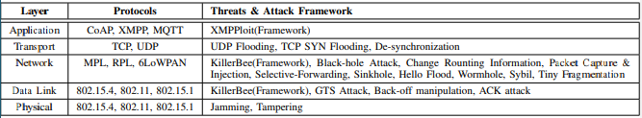

What can be seen from here is that most of the attacks happen on the network layer. This can be used to determine where the main area of focus should be. Due to the number of threats and attacks, it is important to focus on what can be done on the network layer.
Another part of the project’s research is smart devices network protocols. As the project looks at the security of smart home devices, it is important to have an understanding on how each device uses to communicate with each other and the router to connect to the internet. One protocol used is ZigBee. This is used to connect multiple smart devices to each other with profiles. This is one of the more commonly used with smart devices as Samsung has made a device called SmartThings that is used with ZigBee to connect all the devices together. This is useful as ZigBee uses a centralized security model. This means that all the encrypted information is locked with a new network key that is routinely changed. This means that if an attack acquires a key, they have a limited time use before all the keys are changed to a brand new one. [3]

Chapter 2.5 - Solutions
One such defence is an intrusion-prevention system. This is very useful as it learns from day-to-day use. This is important as it will monitor the traffic and block harmful traffic. This is important as it would stop denial of service attacks and flooding. It can also be used to monitor the network and see where the attack happened. This is useful as it can be used to see where the security is limited. The intrusion-prevention system also makes use of an updating list that has all the attacks that have been done recorded. This can be used to protect against basic attack with the signature-based system. Then there is an anomaly-based system that monitors any suspicion activity and then blocks it. This isn’t the best as it needs to detect the behaviour, but it updates the list in real time when the signature-based would need to be updated manually.
Some of the current solutions is to have a virtual private network connected to the router. This is done so that the information is encrypted when it connects to the network. This allows for the devices to be hidden from the outside making the main issue the devices on the inside of the network are still vulnerable.
One more solution that can be implemented is a separate guest network. This is useful as it can separate the network keeping all the smart home devices in one network. This allows for control of all the devices to be in one space where any guest would be led to a separate network that has no connection to the smart home devices in the home. This protects from scanning the network and also can change the bandwidth in the network. The password can also be simple compared to the main network with all the devices making it easier to access whereas the other password could be 25 characters long.

Chapter 2.6 - gap
With an increase in smart home devices, it is imperative to understand steps to take to protect your home network. This is less concerning with the younger generation but is becoming more of a problem for the older generation as they get smart home devices to help with everyday life. As the advancement of smart home devices continues, security will continue to improve but issues will also be developed. This is a continuous issue as no security measure will be 100% effective.
Another gap is smart home devices applications. The main concept of smart home devices are that all the devices can communicate to each other and control them from your phone, but the main point of contempt is with apps. As different devices from different companies are introduced in the same household, an app could be used on each different device. This is useful for security as gaining access to one device won’t make it so that all the devices can be controlled unless the owner’s phone is hacked. The main issue that comes with different apps is that people may try to find applications that allow them to control all devices in their household.
Another gap is that most people don’t want to get smart home devices as they don’t know how to set them up whereas millennials don’t want to get them do to security problems. This creates a limited target audience that smart home devices can be aimed at. This creates an issue when the field is continuously expanding making it difficult to get people to adopt new technology. This can be difficult to get the technology adopted as it is new, and most people aren’t tech savvy. This is mainly caused by security issues and not knowing how to use the devices. This can mostly be solved with guides on how to set everything up from standard security to setting up the devices.
In conclusion, the evolution of smart home devices have improved from where security was not an issue where it has developed into one of the more president issues. The main issue with smart home devices is that cost is an important factor, but it can impact the security of the device. Although security is an issue, nothing is perfectly secure but basic security is needed to allow the device to be moderately secure so just not everyone can access the device.

Chapter 3-Research methodology
This section is going to be looking over the research methodology with how the project decided to do what they are doing going forward. With this the writer will be deciding what experiment they will be doing and what using that method will add to the project. Using the onion methodology, each section will be looked at to deduce at which section of each layer the project falls under.
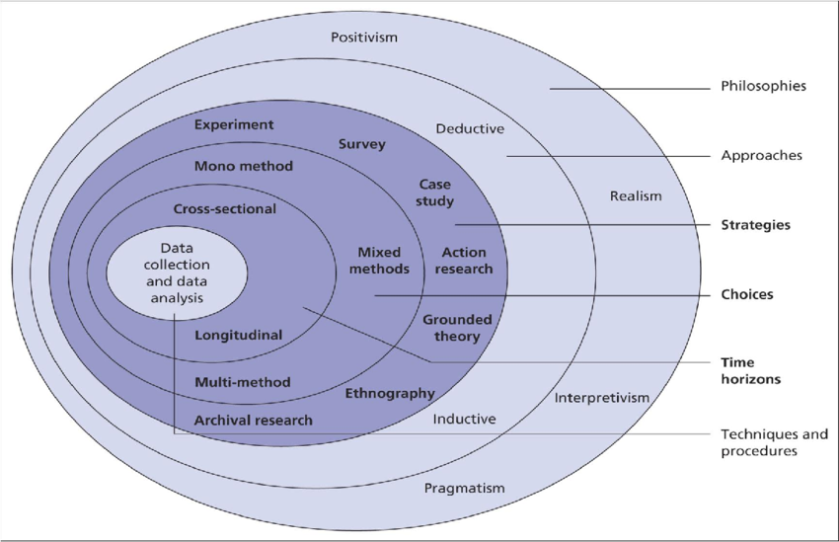
Figure1 - diagram of the onion research method
Here you can see the different layers of the research onion. This section of the project will mainly be looking at each section and deciding a method used for each one.

Chapter 3.1- Philosophies
The first approach the project looks at is the philosophies. The philosophy for this project is realism. As the project is focusing on security of devices, real results would be needed to answer the question. Multiple experiments have been done with companies doing pen testing for their network and cases such as the Alexa exploit where 3rd party applications allowed for attacks to gain information from the device. This was quickly solved and can help answer the question.

Chapter 3.2- Approach
The project is mainly deductive as they are looking at are smart devices home devices secure. This question can be answered with a no as there is no such thing as an absolute secure network. This doesn’t mean that security is pointless as it is evolving each day as new problems keep coming up, but solutions are made each day. This was chosen as the approach as it can be tested using popular smart home devices. As using devices such as casting devices and smart home assistants are being used, they can show how difficult they can be to attack or easy. The main advantages of this is that the question can be answered with an experiment for the main question being asked. The main disadvantage is that the security deferrers between smart home devices. With security updating between each device being different, it can be easy to find devices that are difficult to attack but difficult to find devices that are easy to attack. The project will mainly be using casting devices as they are more commonly used and don’t have much defence.

Chapter 3.3- strategies
The next bit the project will be talking about is the strategies used. The project will have an experiment as it allows for the project to have a concrete example of how secure common smart home devices are. The advantage of this is that with a real-life example of the security of smart home devices, it allows for the project to showcase how secure different devices can be and show how easy they are to be attacked. The disadvantages can be different devices have different levels of security. Originally a smart home assistant was going to be used but the vulnerability was patched so it was changed to a casting device. As casting devices are simpler to attack. This allowed for a simple experiment to be created with concrete evidence showing how easy it is to attack a device or how difficult.

Chapter 3.4- Choices
The next bit that the project is looking at is the mono-method. This project mainly focuses on qualitive data. This is mainly decided as with the experiment attacking a device, it can come out either success or failed. This is useful as the research mainly focuses on different attacks. As the data is mainly separate cases of attacks, the main advantage of the mono-method is that the data gathered is all that is needed. As the project will have an experiment to show how secure a device is, it is easy to show if it is or isn’t. the disadvantage is that the type of experiments are limited. This isn’t much of an issue as the experiment that are normally done show numbers that aren’t up for interpretation.

Chapter 3.5- time horizons
The next layer of the project that will be talked about is cross-sectional time horizon method. The project will be using this method as they are researching the security of the smart home devices. As the project is mainly looking at the current security of devices, this method was mainly picked as it supported what was happening now. The advantages of this is that as the study is mainly looking at the security of smart home devices, it hasn’t long since started increasing in the boom of smart home development. As it is a field that is expanding, it is useful to look at devices that are being used. One of the disadvantages of this method is that smart home devices are increasing with the amount that are available, this also leads to advancement in security so problems that have popped up today could be changed by tomorrow. This isn’t an issue as it doesn’t really affect the research much as it improves the view on how secure devices are.

Chapter 3.6- techniques and procedures
The final layer is the data collection and data analysis method. The method used to gather information would be testing the devices that would be used. As the project is mainly looking at the security of devices, it is important to have data that can either say yes to the question or no. As perfect security is difficult to achieve, basic security would be needed. For this the casting device experiment in the literature review is a good target to replicate with a different casting device to compare the results and see if the devices are secure.
In conclusion, the project is mainly looking at the security of smart home devices. The methodology is mainly deductive as the project is reliant on the results from the experiment to be compared to the experiment conducted in the literature review. This allows the project to have a concrete answer to the research question are smart home devices secure. The project also makes use of the mono-method as the results are mainly being taken from an experiment. This is done as it allows the projects main objectives and aims to be met easily.

Chapter 4-Design and implementation
In this next section the project will be talking about the design of the experiment. This section will be looking over what requirements were needed for the experiment needed to be able to showcase the projects main point. This involves on deciding with how the experiment will be run and what it needs to entail. This includes what device is being used, how many experiments and what the outcomes would be measured in.

Chapter 4.1 design

Chapter 4.1.1- Requirements
The first thing that the project fought about was the requirements for the experiment. As the experiment is mainly looking at how to gain access through different channels, it can be difficult to make an experiment for this area of research. The first thing that needed to be looked at was what device was going to be used as the main concern. This was decided to be a smart home casting device. The next requirement was deciding on how the attack was going to be done. Two different methods have been decided to be done as it allows for show casing how easy it is to attack devices using different methods. The final requirement was deciding on how this could be used to show monetary damage as that is the more common use of attacks or using ransom attacks.

The main problem is looking at the security of smart home casting devices. The main question is are they secure? This is a simple question that can normally be answered with yes or no. the main way that this can be answered is by actually attacking the device. For this to be done certain items would be needed to do this attack. one of the tools that will be used is kali linux. This is mainly being used as it allows for a virtual machine to be used and has all the tools that could be needed for the device.
When it came to the design of the experiment, the project went over multiple designs for the experiment. The original experiment was going to attack a smart home personal assistant device. This was mainly decided as it was one of the more commonly decided devices, but it was difficult to do as the devices main security issue was revolved used that was the main concern with them. The next choice then was a smart casting device. These devices was the next choice as they have had an increase of use do to the pandemic with meetings and classes. This was also chosen as they have major security flaws. One of the flaws is how easy they can be connected to. Some need to be connected to via wireless which isn’t much of an issue, but some casting devices use universal plug and play. This is a feature on routers that allow devices to connect to the internet via certain ports. As these ports are mostly open, they allow requests that use cURL commands to make requests. This can cause other issues as with these ports open it is possible to find the devices on the internet. This allows for personal information to be easily found. With all these factors it was easier to pick casting devices compared to personal assistant devices.
The next thing the project investigated was looking at is the attack that was going to be used. as mentioned above cURL commands is one way that the project was going to use to attack with. As the device is connected to the internet and can be connected to in close vicinity, multiple ways to attack the device are possible. The main methods that the project will be using is directly connecting to the device and sending a command over the internet using cURL. This covers most of the attacks possible attacks as by being to attack close to the device or from across the world are real world possibilities. This was also used when it came to deciding the devices as most other devices are difficult or easy to attack such as smart home assistants and smart home cameras. Smart home assistants need an application to make the attack successful. This is done by making an application that would download other applications that allow the data to be stolen and viewed. This isn’t really viably as multiple apps that would need to be created to be able to view the information. There was also an update that prevented this which makes it an ineffective way to do the attack.
The final requirement was a way to do monetary damage. This would be done using a casting device to make a smart home personal assistant to make the purchase. This was decided as it can be done in a controlled environment and allow for showing how the attack can damage someone without proper security setting. This experiment was decided as it involves a live environment that can be controlled and stopped before doing damage. This was also decided as it can showcase what is possible when attack smart home devices.

Chapter 4.2.1 experiments

Chapter 4.2.1.1 experiment 1
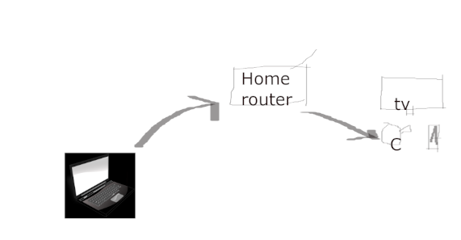
Figure2- physical design of experiment 1
The first experiment is attacking the device in the same network. This was decided as it allows for show casing attacking the device from the same network. This would be done using two attacks. The first attack would be connecting to the device using brute force with the more popular passwords. This is a simple way that needs to be done in close proximity that makes it a less than likely way to do the attack with finding the longest distance needed to do the attack. The second way is to do the attack using cURL attacks. This is more than likely done from a distanced location but still possible to do close proximity without needed to directly connecting to the device. This was mainly decided to be done as it allows for the attack to be done from close proximity showing how easy it is for the neighbour to do the attack.
For connecting to the device to do the attack, social engineering and brute force would be done to attack the device. As the device is a basic casting device, not much security can be implemented in the device. This can cause some problems with using cURL commands but perfect for brute force as not much security is present. The experiment is successful if the device played the content and failed if nothing happens.

Chapter 4.2.1.2 experiment 2

The next part of the experiment is attacking the smart home casting device from a different network. This experiment will mainly use cURL commands to do the experiment. As the attack is mainly from a different network, meaning directly connecting to it from a close location cannot be done. As the attack is mainly being done from a separate network, it can accurately show how a casting device can be changed from different networks. As only social engineering would be used to gain access to the device, it is a bit more advance as the ip address would be needed to send the request. This could be easily found from the internet as it is easy to find websites or programs to search for ip addresses for smart devices. The experiment is successful is a video is played and the name is changed of the casting device.
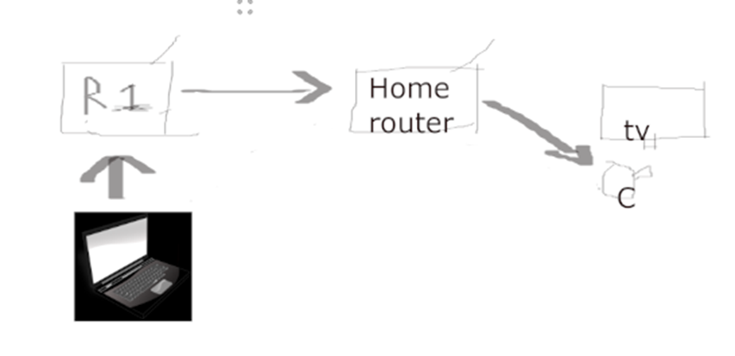
Figure3- physical design of experiment 2

Chapter 4.2.1.3- experiment 3
The final experiment is attacking a network to make a purchase using a smart home assistant. This experiment is similar to the first one when it comes to the network as it is mainly looking at making a purchase from a device than changing settings. This is more so showing the damage that can be done from using unsecured smart devices. The experiment has more steps as it can be done using different methods to be successful. One method is searching for ip addresses to find homes that have both devices. This is a more tedious approach to do the attack as it is reliable on not only finding both but the smart home casting device being public and not having the correct security. Another method is finding the casting device and searching the network for smart home assistants. This is difficult as it can be a bit hit or miss as you need to be able to connect to the device, but the assistant needs to be on the same network. This is a better method as a bot could be created to gather the ip addresses and to send the command to search for the smart assistant. This method is more efficient to attack. The final method is to send out surveys to find targets to do the attack. This method allows the data to be gathered that allows the writer to find the information needed but needs responses so is less reliable. Overall, the second method is better for this attack but is reliant on no security being on the second device. This experiment would be successful if the purchase were made.

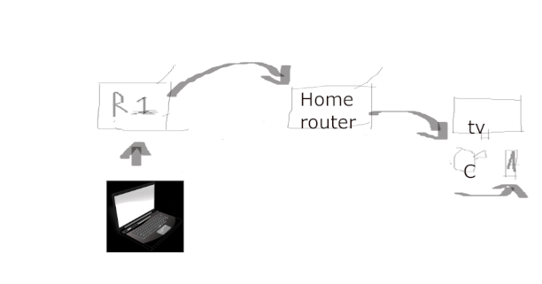
Figure4- physical design of experiment 3

These can make the experiment easily fabricated which can be a problem with the result. This will be avoided by listing each step with evidence showing how to reach the end results. This was done as it can show how easy it can be to gain access to devices or do something that shouldn’t be done. As their multiple ways to do each part of the experiment, the more practical ways would be done. This is because less steps are involved, and they better simulate an attack that would be made using this method. After the initial experiment is completed, if they are successful then proper security would be implemented to prevent the attack. This would be done with authentication, more complete passwords, child protection and two factor authentication purchasing. These would be implemented when it comes to the network as they are the more easily explained solutions that a person could implement to their network and devices without much issue.

Overall, the experiments are mainly being done from the same network, a different network and using the device to give a command to a personal assistant device. Experiments will also be done to see how long it takes to gain access to the device and pinging the device from different networks. This is done so that it allows the project to have concrete data on the differences between attacks and compare them as they are being done twice but on different networks. This allows the outcome of the experiment to be fair with no bias as it is replicated easily.

Chapter 4.3.1-Implementation

Chapter 4.3.1.1- experiment 1
In this next section of project will be implementing the experiments. The first experiment the project will have is brute force in the same network. The smart home casting device is immediately plugged into the television and attempting passwords have started. The passwords used are taken from cybernews. After the device is normally plugged in and is on that channel, it would show the ip address and password. For this experiment it will be assumed that the attacker does not have direct access. From cybernews, the top 10 used passwords will be used to try and connect to the device to avoid searching for the ip address of the device.
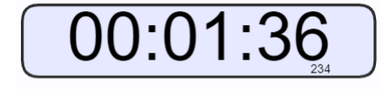
A total of 1 minute 36 seconds was needed to gain access to the device using the 10 most popular devices. This took next to nothing to complete as the password was 12345678. This allowed for easy access making it not secure.

Chapter 4.3.1.2-experiment 2
The next experiment is using cURL commands form the same network. This experiment was a lot more difficult as lengthy commands would be needed. Due to this a python script would be used to simplify the commands to three values. The three values used are the target device, the action that is from a pre-set parameter that allows for videos to be played and changing the name. and the final value is the actual value of what is being played or what the new name would be. This will all be done using kali linux as it uses python and allows for this experiment to be done on a secure laptop. This has caused issues with the project as there was difficulty running the virtual machine making it difficult to do the experiment in short time. The command that will be used is CCEK.py -t 192.168.203.1-a set Name -v “hacked”. This was difficult to use the python script, so the full cURL code. this was a successful as the device name was changed to hacked.
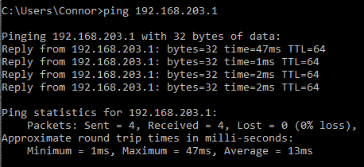
Here the devices ip address was pinged to see if a reply would be given. This was done to test to see if the device was reachable.

Chapter 4.3.1.3-experiment 3
The next experiment was attacking the device from a different network. This experiment was similar to the one before but is attacking the device from a separate network. This is mainly being done as the device used acts as its own network. This makes it easier to set it up as it can all be done in the same area. The same command will be used as it is being done to the same device. The experiment was a failure. This was unexpected as the attack used in the literature review used a casting devices to display videos and change the device name. this was mainly the outcome as the device needs the devices directly connected to it to do the commands. This is useful as it allows for security but doesn’t have the safest password.
As the experiment was a failure, it was decided upon to ping the casting device using the same network and a different network. This confirmed both experiments as it failed on the separate network but was successful with the same network. This was further done by trying to ping a device on the casting device network and trying to ping a device from the network with the casting device to a different network. Pinging the device on the network from a different network was a failure as the device couldn’t be reached. Pinging a device from the network with the casting device was a success. This can conclude two possible theories, as the device doesn’t allow device to target devices in the network, it is either the device is really poor and doesn’t allow outside interference or that the device can’t handle request even with port 8008 is open.
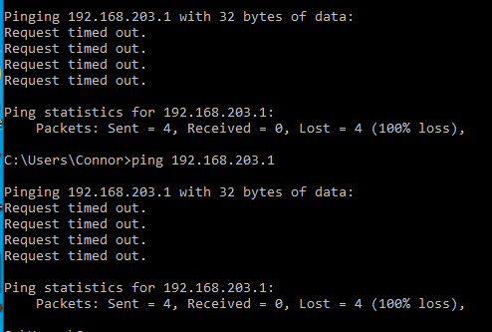
Here the device was pinged from a separate network. Both attempts gave back a time out meaning the device was not reachable.

Chapter 4.3.1.4 – experiment 4
The final experiment is using a command to play a video on the casting device to make a purchase using a smart home assistant. This experiment is mainly showcasing possible damage that can be done to smart home devices as different models can be used for casting devices. This scenario isn’t very likely to happen as the attack would need to find both a casting device and a smart home assistant. In this scenario the attacker is attacking from the same network as that is the only way possible to do this experiment. The code for this experiment is CCEK.py -t 192.168.203.1-a play -v and the URL to the video. The video needs to be specific to the network being attacked as there are different smart home assistants. This doesn’t make much of a difference as a person wouldn’t really do this type of attack and even if they did a bot, they could simply send out a mass number of requests including multiple commands to play videos for different devices.

Chapter 4.3.2.1- correlation
As the experiment is mainly doing attacks. The there is some correlation to different showcases as the only successful attacks was from the same network. This can link to individual security instead of smart home security as the device used denied requests from devices not connected to it. This is useful for home security but not so much for open networks. As people will connect to free networks when going to a restaurant, these experiments show how vulnerable devices can be. This can be concerning to.
There aren’t really any correlations between results. As the experiments are mainly attacking devices to try and gain access for the attacker to do certain features. As the experiment was mainly focusing on if the attack was successful or not, it is difficult to show the results in a visual way. As the data is mainly a yes or no, it can be difficult to make charts but is simple to show as its just yes or no.
The answers were not what the writer expected to happen. As the project was mainly doing a similar experiment to one mentioned in the literature review. The experiment is attacking chrome casting devices with videos and changing the name. It was decided to implement this method using a different casting device to see if the results were the same as no information was shown of them fixing the issue as it was more of a port issue than a device issue. A different casting device but fundamentally the attacker believed that the all the tests would be successful. What made the experiments fail the attack was that the casting device acted as a router that the attacker needed to connect to that would then connect to the router acting as a separate network. This made the device more secure, but the performance wasn’t the best when streaming compared to a normal google Chromecast.

All the experiments support each other as they are mainly doing different attacks on the same casting device. All the attacks are simple to do and can even be run with a script. As they are mainly doing different stages of the attack for the ultimate goal being to make a purchase. This can be linked to the literature review as mainly security is being looked at for smart home device but can be linked to other devices in smart homes.

Chapter 5-Evaluation
In this next section, the entire paper will be evaluated and comparing it to see if the aims and objectives were met. This will mainly be done by looking at the whole project and seeing if it meets what needs to be done. The first thing the author will be looking at is what conclusions can be made from the data. Not many conclusions can be drawn from the authors experiment as it is very limited due to the simplicity of the experiment. The conclusion that is mainly being drawn is that the security of the casting device is secure. This is true but has pros and cons if a person were to buy the casting device. The device has good security as it only allows for commands for a person connected to that network. As the password is one of the ten most common passwords, it isn’t secure on site but difficult to attack off site. This means that generally the device is secure without needing to change much outside of the box. another problem with this is that only one casting device was used for the experiment. This doesn’t make the conclusion very concrete as the results could be very different for different casting devices. This makes the conclusion that the casting device true but untrue for all casting devices.

Chapter 5.2 – literature review
The next bit of the project is doing the data support or denies the information in the literature review. The projects data gathered from the experiment disagrees with the literature review and doesn’t at the same time. As the experiment used in the literature review used a Chromecast, the results from the experiment used a different type of casting device. This both links to the literature review as the results are different when it came to the experiment but links overall to the security aspects where it was said that most of the devices don’t have security options. This proved wrong as the devices security only allowed for devices on the same network to send requests to it. This shows that the misconception that they don’t have the best security was wrong when compared to the other experiment.

Chapter 5.2- objectives
The next bit of the projects is reviewing is the objectives set met. Most of the objectives weren’t met. One of the objectives was a survey of what smart home devices were being used. this was not completed as it was difficult to give out the survey. This didn’t really affect the project as most of the project changed from a guide to an experiment testing a smart home device. This stayed aligned with the aims as it still mainly looks at security.
The next objective was researching the advancement of smart home devices. This was met after the experiment results as they can be compared to the literature review. By replicating an attack that was done a couple of years ago, it is possible to compare the results from then and now.
Another objective was the main features of smart homes. This wasn’t really met as only two smart home devices were talked about. This is both in the literature review and the experiment. So, some were talked about but not deeply looked into. As the security was looked into and some of the performance of the device but only one device was looked into in this regard.

The next two objectives were looking into the security with out of the box and creating a guide on how to securely set up the devices. Only the security was looked into as the guide wasn’t really needed from the fact that the device tested was secure. As the only changes needed to be to the casting devices password and enable two factor authentication on sites used to make purchases. Those are the main security that needs to be done and are generally simply to set up. The only thing that may be needed to be explained is how to close ports but shouldn’t really be messed with.

Chapter 5.3 - aims.
The next thing the project will be reviewing is if the aims were met or not. The first aim was finding out the more commonly used smart devices. This was mostly done as two of the more commonly used smart home devices were looked into which were casting devices and smart home assistants. The smart home assistant is a more commonly used device as they were on sail in 2019 making it very accessible. This can link to other devices with people using it with consoles. The device can also communicate with smart phones making it a commonplace device that can be used. there is also the casting device that has picked up during 2020. The casting devices are being used more so to steam the computer screen to the television to allow people to clearly see the screen.
The next aim was how secure are smart home devices. This was mainly done in the literature review with looking at the evolution of smart home device and the security of them. The overall look of the smart home devices are that they are relatively secure. This was mainly from looking at the amazon Alexa which was one of peoples more concerned devices. These were addressed where the project discussed one of the more major flaws with smart home devices.
The final aim was how secure are some of the smart devices. This is directly linked to the experiment and literature review.as the project looked at casting devices, they were able to compare experiments where they can directly see how secure the device were. This was mainly done with one casting device. This shows how secure that one device is but can be seen as bias as only one device was. This generally answers the question but can be improved later on with further experimenting if ever done again. When comparing the results from the experiment with the results from literature review, the results can be compared but are entirely separate and have zero effect on each other. The scenario for this would be if a person bought a Chromecast and another person bought a casting device, the person with the Chromecast would be most likely to be attacked.

Chapter 5.4 – evaluating answers.
The next thing of the project is evaluating is if the answers were what they expected or not. The answers are mainly correct as all of the aims and most of the objectives are correct. The ones that weren’t answered wasn’t important to the new end goals. This was important as over the course of the project’s duration, the project needed to do an experiment that changed most of the paper. This still didn’t change most of the project as the guide wasn’t really needed after the experiment results. As this was only the real difference from the objectives. For all the other aims and objectives, they were mainly completed after the experiment and literature review.

Chapter 5.5 – what would be done differently next time.
The final thing the project will be looking at is what they would do different next time. One thing the author would have done again is ad a bigger testing range of casting devices and use different smart home devices. The main reason the author picked a casting device was that it was one of a more common device and they have picked up during the coronavirus lock down to stream meetings. Another reason was that previous experiments had been made with a quote from google saying that no
Problems were with the device and it was a router security issue, this was the main choice for picking that one device so using different types of casting devices and different models from the same company to have a wider range of results to conclude if they are secure. By allowing for more a wider range to test from, more tests can be done to recommend what is the better choice of a smart home device.
Another thing that can be done is using different smart home devices. As smart cameras have been used and smart garages, more testing of different devices would allow the author to recommend smart home devices into homes. This can be tricky as the main problem would be budget which is the same as using more casting devices. As part of testing, costliness would be an added factor as it can add on to if a person should purchase this device. As cheap smart home devices are a basic choice as it gets the job done or picking a more expensive option as the price tag should mean it is better in terms of quality and security. By using a range of different devices, it can allow the author to see what is useful to add when it comes to making a choice when picking devices.

Conclusion
In conclusion, majority of the objectives set at the start the project have been met to answer the overall question. The main objective was how secure are smart home devices. This was first investigated in the literature review where the different stages of smart home devices throughout history and how they have changed for better or worse. Part of the literature review looked at some attacks in which the project aimed to replicate the experiment using a different casting device. The experiment mainly separated into three parts where it was attacking the device in the same network, a separate network and then using the device to attack a smart home personal assistant. This completed the need of an experiment and helped meet the objectives with the main question being how secure smart home devices are. This was decided after looking at the research onion and deciding each piece. After deciding what to do with the experiment and completing it, it was found that the only drawback of the smart home casting device was that the password was simple. This showed cast that smart home devices are secure answering mostly all the objectives and answering the question are smart home devices secure.

Future work
For this project, future work can be done with testing smart home casting devices and other devices. As the scope is so large with the only two devices being tested in this project, it has a high amount of future work that can be done. As the project mainly looked at two different smart casting devices, one being in the literature review and the other being in the experiment, it is possible to see the development of security and can be further expanded by repeating the test for other casting devices or new devices that may be released.
Another piece of future work could be making an app that allows for all the smart home devices to be controlled from an app. As multiple devices are designed to interact with the app developed for the company and multiple apps that are dangerous to use but allows all the devices to be connected to one. By developing an app to do these functions, it allows for an understanding of how the devices work and allows for security to be implemented.

Reflection
During the duration of the project, multiple changes have been made to the project. The original goal was to develop a guide on how to safely make a secure smart home. This goal was later changed as an experiment was needed for the project. This needed research into different devices and their security. This was simply to do but do to covid it was important to find something simply to attack but is widely used. this was done by picking a casting device as they have picked up during covid and an experiment was done which was easily to replicate. The whole process of finding a case to allow for an experiment to be done. This is both simple and complicated as depending on the device, the attack could be as simple as gaining access or viewing hidden documents. The experiment was simple as it was mainly looking to see if access can be granted or if the command could work. The experiment could have been done better by having a wider range of devices. As only one device was used and it was compared to the one in the literature review, not much has gone into it.

Bibliography

[1] | N. Komninos, "Security in Smart Home Environment," 01 2010. [Online]. Available: https://www.researchgate.net/publication/232923869_Security_in_Smart_Home_Environment. [Accessed 13 12 2020].
[2] | d. spicer, "THE ECHO IV HOME COMPUTER: 50 YEARS LATER," CHM BLOG, 31 may 2016. [Online]. Available: https://computerhistory.org/blog/the-echo-iv-home-computer-50-years-later/. [Accessed 13 01 2021].
[3] | J. Elder, "The internet’s first thing – John Romkey’s ‘smart’ toaster," avast, 3 09 2019. [Online]. Available: https://blog.avast.com/the-internets-first-smart-device. [Accessed 15 11 2020].
[4] | d. coldewey, "this security camera was infected by malwar 98 seconds after it was plugged in," techcrunch, 18 11 2016. [Online]. Available: https://techcrunch.com/2016/11/18/this-security-camera-was-infected-by-malware-in-98-seconds-after-it-was-plugged-in/. [Accessed 19 10 2020].
[5] | p. brusseel, "Hacking ChromeCasts for fun," brussec security tools, 11 01 2019. [Online]. Available: https://www.brussec.com/2019/01/11/hacking-chromecasts-for-fun/. [Accessed 09 01 2021].
[6] | K. Kundu, "Amazon Alexa Could Have Been Hacked to Access Private Data, Voice History," beebom, 13 augest 2020. [Online]. Available: https://beebom.com/alexa-hacked-private-data-voice-history/. [Accessed 15 01 2021].
[7] | C. Price, "Smart Home devices to exceed 13 billion by 2025," tech digest, 24 11 2020. [Online]. Available: https://www.techdigest.tv/2020/11/smart-home-devices-to-exceed-13-billion-by-2025.html. [Accessed 01 12 2020].
[8] | E. Kovacs, "Echobot Malware Drives Significant Increase in OT Attacks," security week, 11 02 2020. [Online]. Available: https://www.securityweek.com/echobot-malware-drives-significant-increase-ot-attacks. [Accessed 01 01 2021].
[9] | v. Rudresh, "ZIGBEE SECURITY: BASICS (PART 2)," device security, 8 11 2017. [Online]. Available: https://research.kudelskisecurity.com/2017/11/08/zigbee-security-basics-part-2/#:~:text=ZigBee%20devices%20and%20associated%20silicon%20platforms%20provide%20multi-layered,the%20key%20to%20decrypt%20it.%20More%20items.... [Accessed 14 12 2020].

