
Module Name: Digital Skills for Personal and Professional Growth
Module Code: BMSW4008
Assignment Name: E-Portfolio
Student Name: Nikolaya Velinova
Student Number: 2412929
Lecturer: Muhammad Cassamo
Deadline: 12 December 2025

Wordcount: 1894

AI Acknowledgement
Examples of statements If you have not used AI
I confirm that I have not presented any AI generated materials as my own work.
I confirm that I have copies of my drafts, notes, and other resources I used, which I may be asked to provide in evidence.
Examples of AI statements if you have used AI
Example 1:
I acknowledge the use of Grammarly (https://www.grammarly.com/) on Date to check my work using the prompt(s):
1. Please check the following text for readability, grammar and syntax.
I confirm that I have not presented any AI generated text as my own work. I confirm that I have copies of my drafts, notes, and other resources I used before, and after the use of AI tools which I may be asked to provide in evidence.
Example 2:
I acknowledge the use of SciSpace (https://typeset.io/) on 7 March 2024 to support my research using the prompt(s):
1. Please provide me with materials on the biology of the liver.
2. Please provide me with materials on liver cells.
I confirm that I have not presented any AI generated text as my own work. I confirm that I have copies of my drafts, notes, and other resources I used before, and after the use of AI tools which I may be asked to provide in evidence.
Example 3:
I acknowledge the use of ChatGPT (https://chatgpt.com/) on 13 April 2024 to write my notes into submission format using the prompt(s):
1. Please write up these bullet points as an essay paragraph at university level.
I confirm that I have not presented any AI generated text as my own work. I confirm that I have copies of my drafts, notes, and other resources I used before, and after the use of AI tools which I may be asked to provide in evidence.
Example 4 - acknowledgement of the use of multiple AI tools:
I acknowledge the use of SciSpace (https://typeset.io/) on 28 June 2024 to support my research using the prompt(s):
1. Please provide me with materials on the American Civil War.
2. Please provide me with materials on the reception of Gone with the Wind.
I confirm that I have not presented any AI generated text as my own work. I confirm that I have copies of my drafts, notes, and other resources I used before, and after the use of AI tools which I may be asked to provide in evidence.
I acknowledge the use of Adobe Express (https://www.adobe.com/express/) on 24 June 2024 to edit photographic material:
1. Remove background from Figure 1.
I confirm that I have not presented any AI generated materials as my own work. I confirm that I have copies of my drafts, notes, and other resources I used before and after the use of AI tools which I may be asked to provide in evidence.

E-Portfolio



MODULE NAME: Digital Skills for Personal and Professional Growth
MODULE CODE: BMSW4008
Student NAME: NIKOLAYA VELINOVA
STUDENT NUMBER: 2412929
LECTURER NAME: Muhammad Cassamo
WORDCOUNT: 1894

TABLE OF CONTENT:
TASK 1 Market research and website development project
- Questionnaire and responses
  - What is your favourite dinner?
  - Which of the following are healthy fats?
  - Which of the following would you buy? Choose one, please!
  - How much would you pay for your favourite from question 8?
  - The remaining 5 questions from my questionnaire
- Website
- Marketing materials
  - Billboard
  - Business card
  - Leaflet
- Audience Segmentation
- SEO strategy
- References
TASK 2 Microsoft Excel spreadsheet and Essay on the importance of Excel in the digital era.

TASK 1 Market research and website development project
- Questionnaire and responses
As my business is directly related to the sale of healthy and high-quality food, the questionnaire included several questions focusing on eating habits and consumer preferences. The aim was to gain a deeper understanding of what people enjoy eating, how they define healthy food, and how much they would be willing to pay for specific dishes. This information provided valuable insights for designing the menu and setting appropriate pricing strategies for Nikolaya’s Delicious Place.
1.1 What is your favourite dinner?
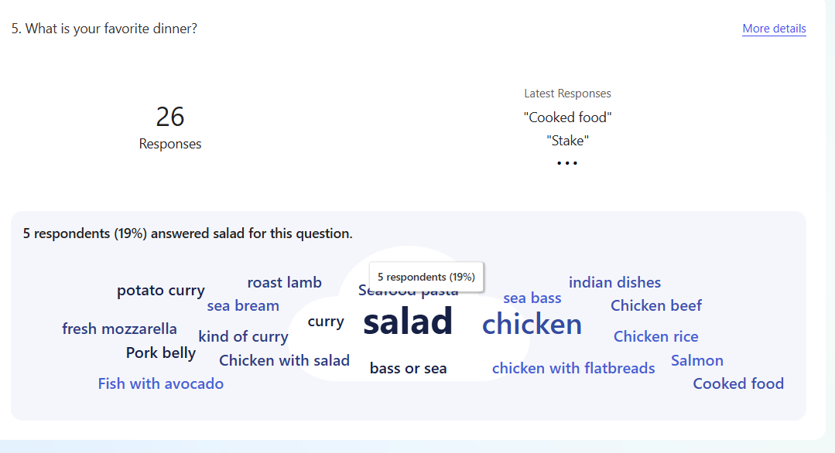
When asked “What is your favourite dinner?”, most respondents indicated that they prefer meals consisting of vegetables (often salads) served with various types of meat. Therefore, I decided to include similar dishes in the menu of Nikolaya’s Delicious Place to reflect these preferences. This information also helped shape my overall business strategy by confirming that offering fresh, balanced meals with high-protein options and plenty of vegetables meets the expectations of my target market and supports the brand’s focus on healthy eating.
1.2 Which of the following are healthy fats?
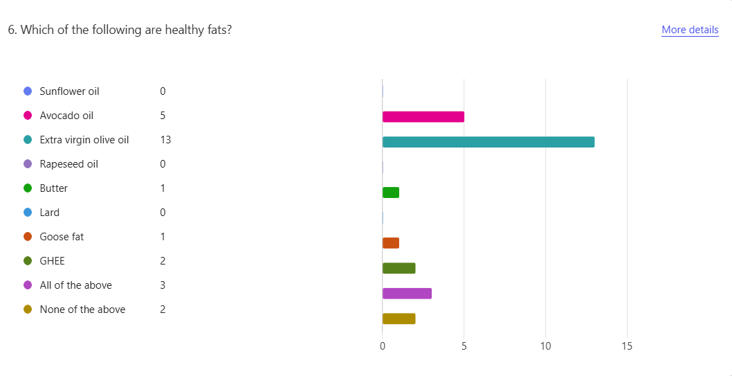
When asked “Which of the following are healthy fats?”, the majority of respondents identified extra virgin olive oil and avocado oil as the healthiest options. These results influenced my decision to use only these two types of fats in the preparation of meals at Nikolaya’s Delicious Place. In addition, both oils will be highlighted and actively promoted within my marketing strategy, as they align strongly with the brand’s focus on providing healthy and high-quality food choices.
1.3 Which of the following would you buy? Choose one, please!
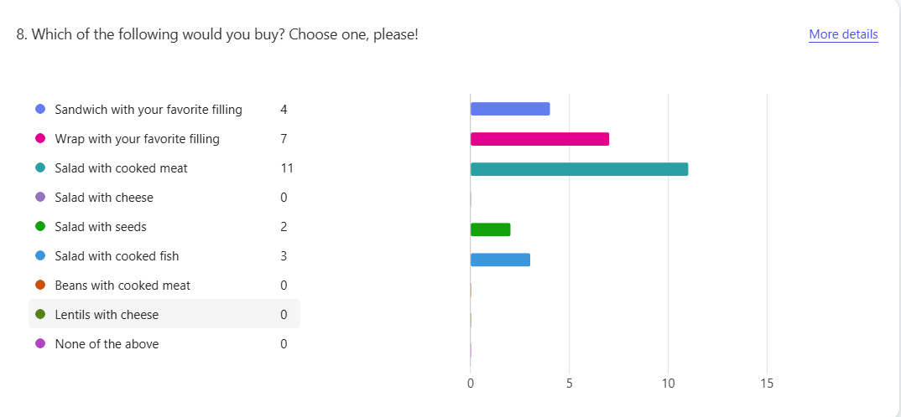In response to my question, “Which of the following would you buy? Choose one, please!”, 11 participants selected “Salad with cooked meat,” 7 chose “Wrap with your favourite filling,” and 4 chose “Sandwich with your favourite filling.” This trend helped me estimate the potential sales for the first few weeks and determine which products should be stocked in larger or smaller quantities. I also used these dishes in my promotional materials — including my business card, billboard, website, and video advertisement — as they reflect the preferences of my target customers. Additionally, I considered these results when creating my Excel Cash Flow Forecast, using them to estimate expected sales volumes and revenue projections.
1.4 How much would you pay for your favourite from question 8?
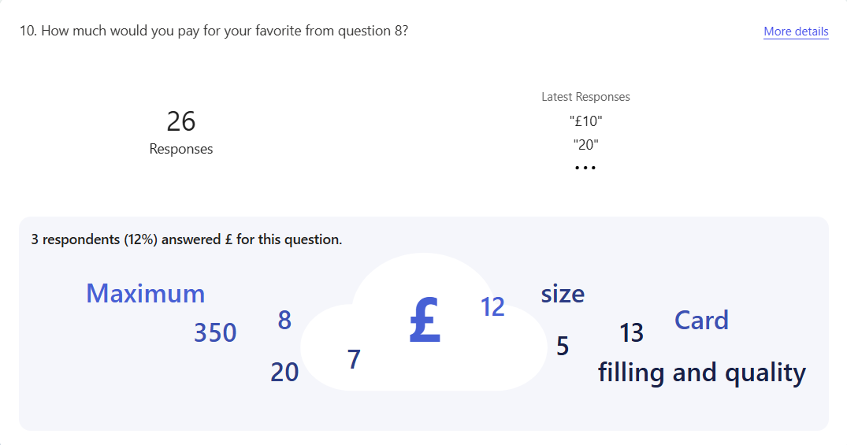
In response to my question, “How much would you pay for your favourite from question 8?”, participants helped me establish my pricing structure. For each selected product, I calculated the average price based on the prices suggested by the respondents. This approach ensured that my pricing strategy reflects customer expectations while remaining competitive within the local market.

- Salad suggested prices
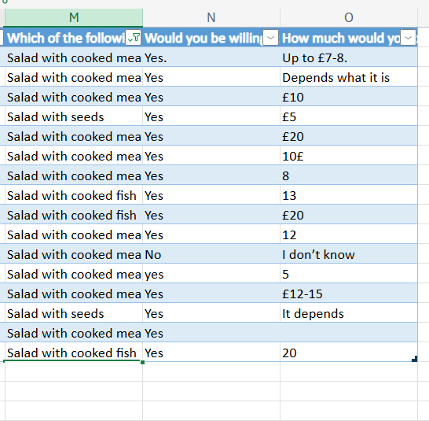
- Wrap suggested prices
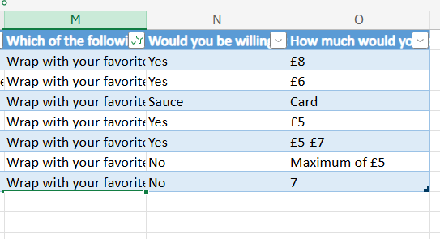
- Sandwiches suggested prices
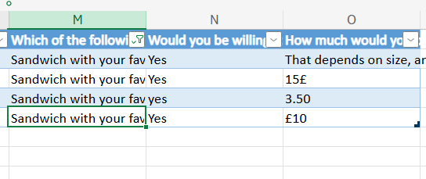
1.5 What is your favorite sauce?
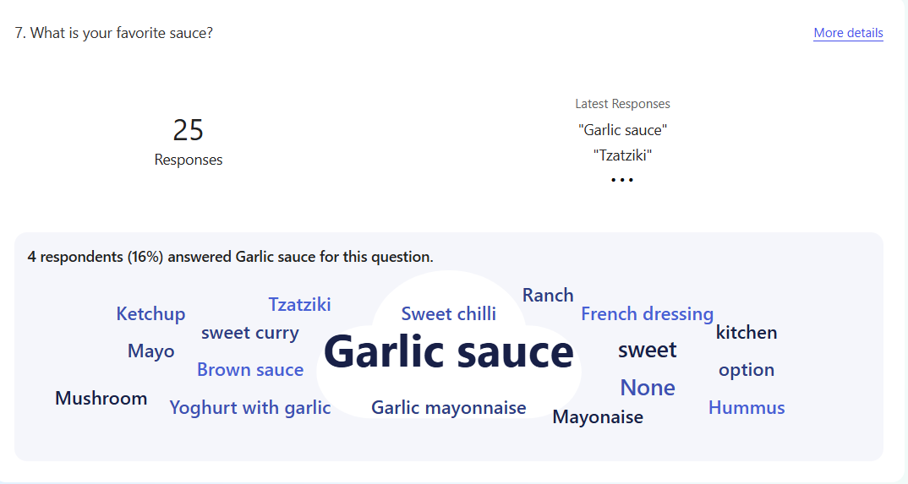In response to the question, “What is your favourite sauce?”, the majority of participants answered garlic sauce. Therefore, I expect this to be the best-selling sauce, and it will be included as a key option in the selection of sauces offered. It will also be featured in my marketing materials to highlight its popularity and appeal to customers.
1.6 The remaining 5 questions from my questionnaire
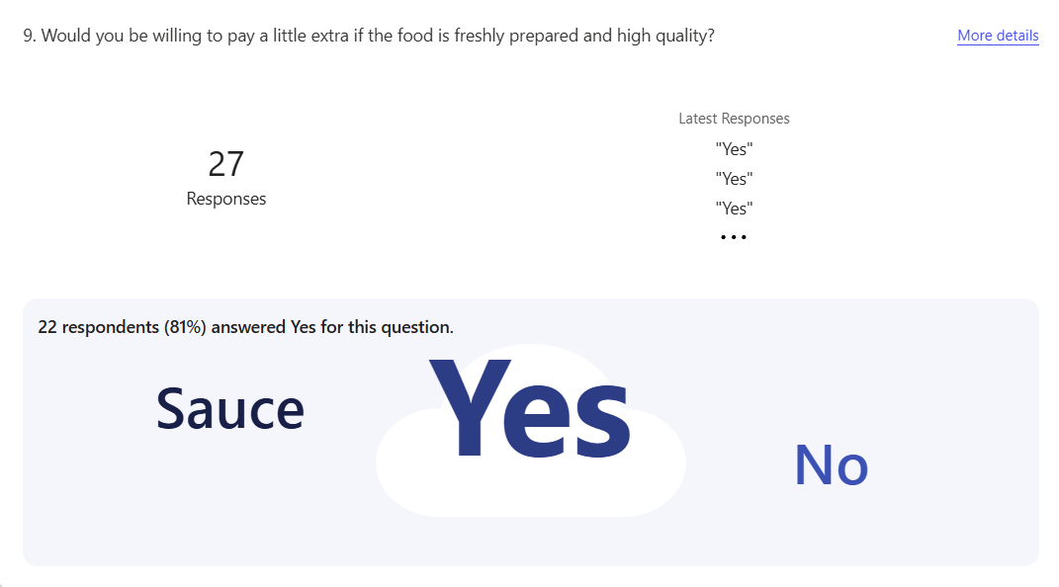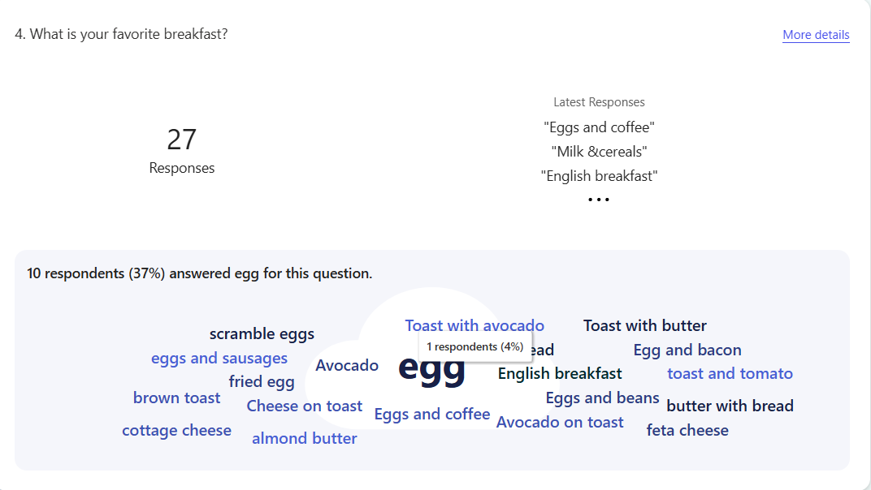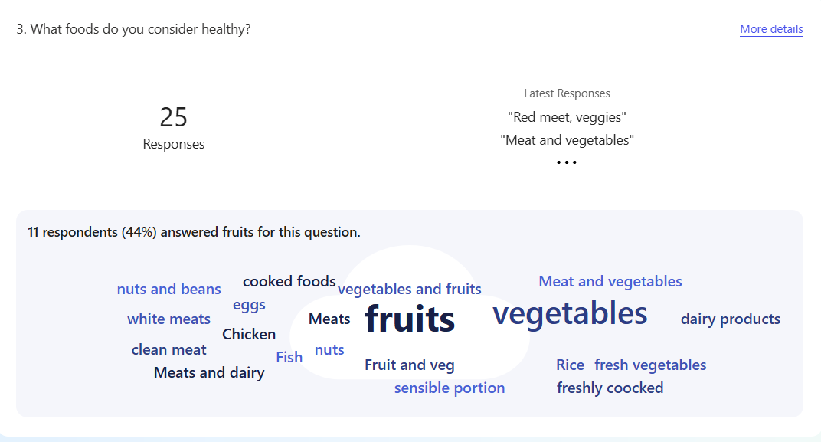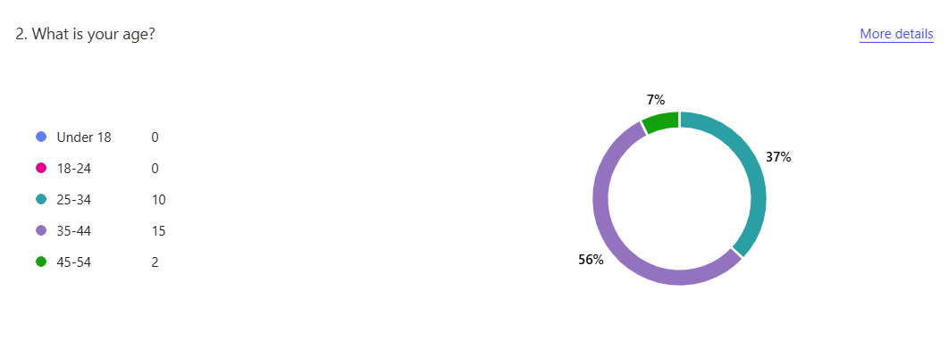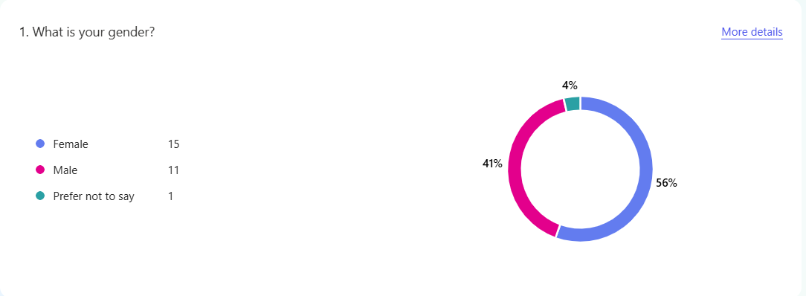
- Website - https://nikolayas-delicious-place.square.site/
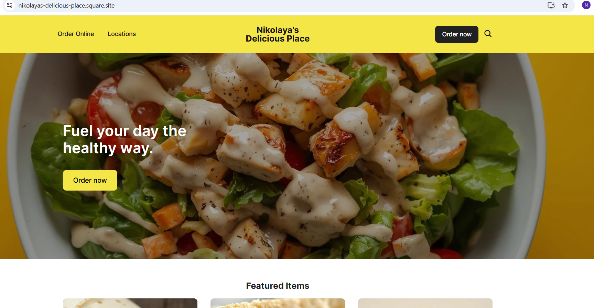
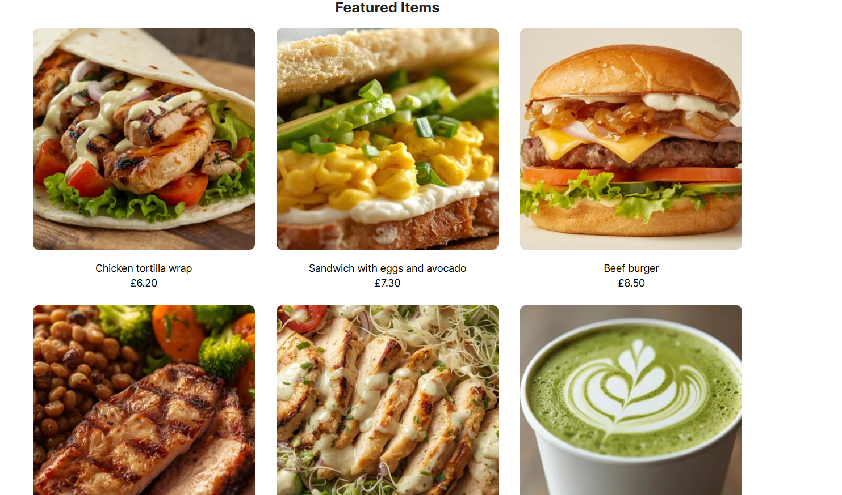
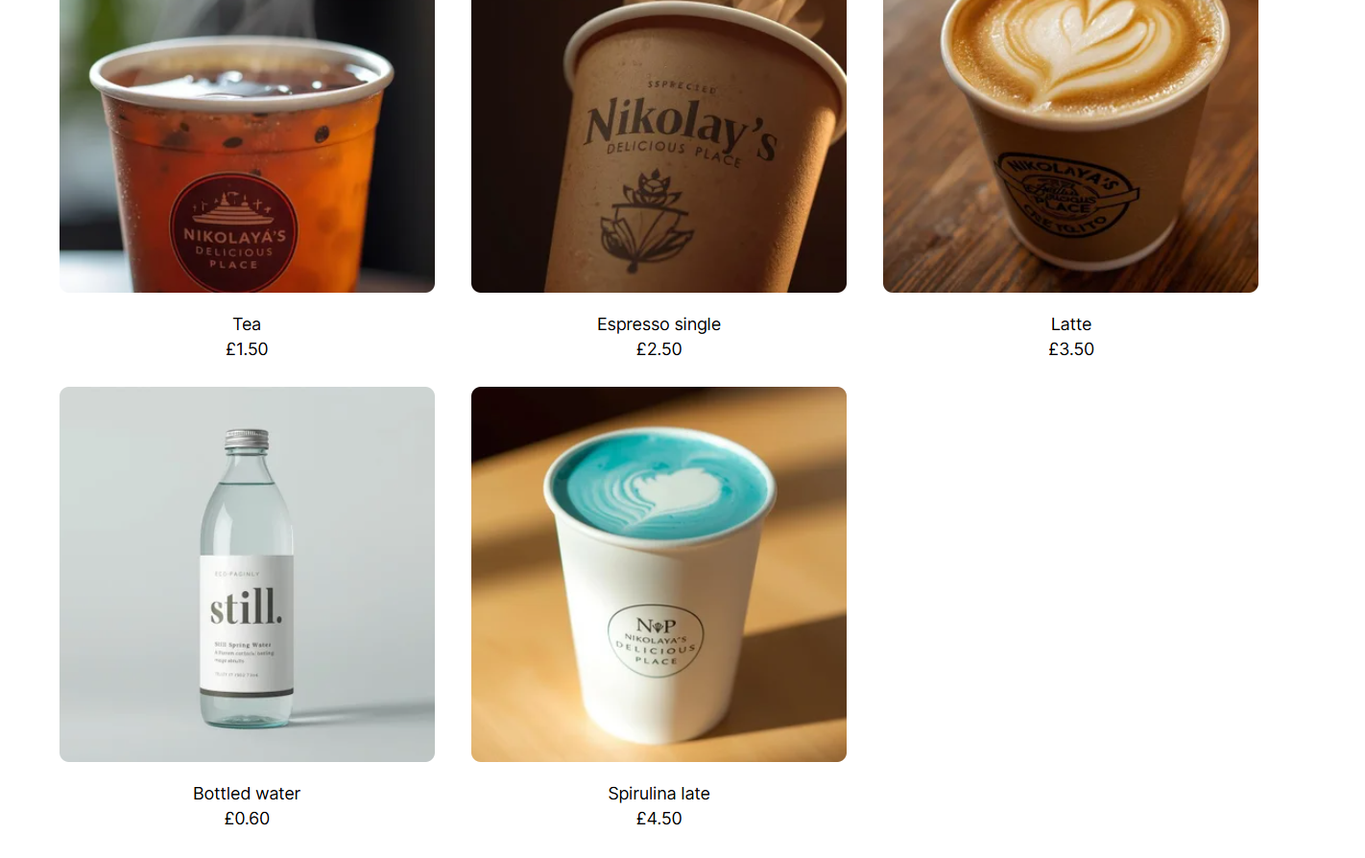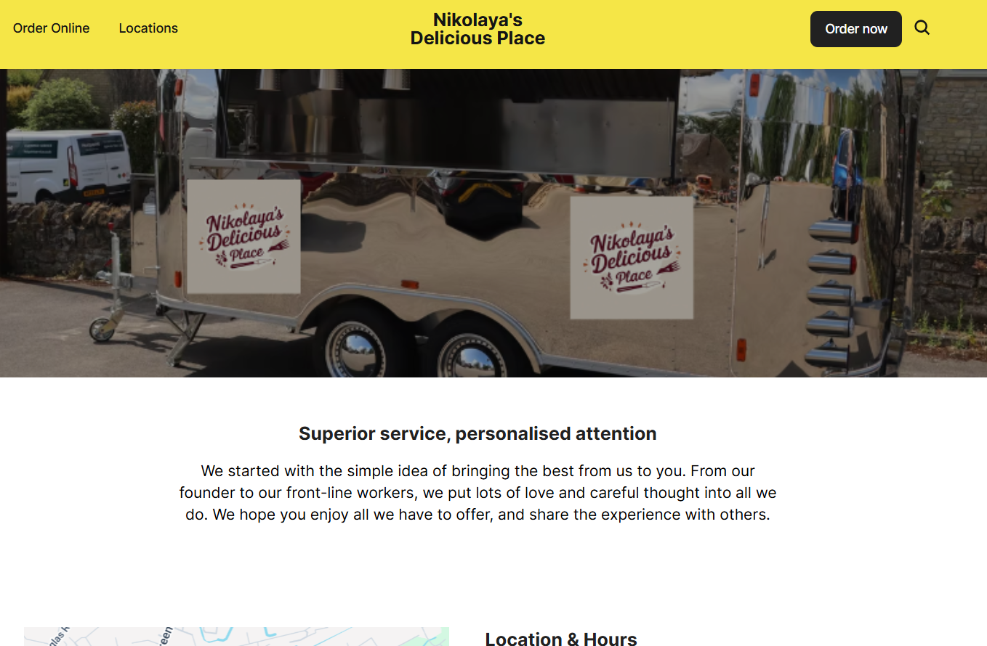
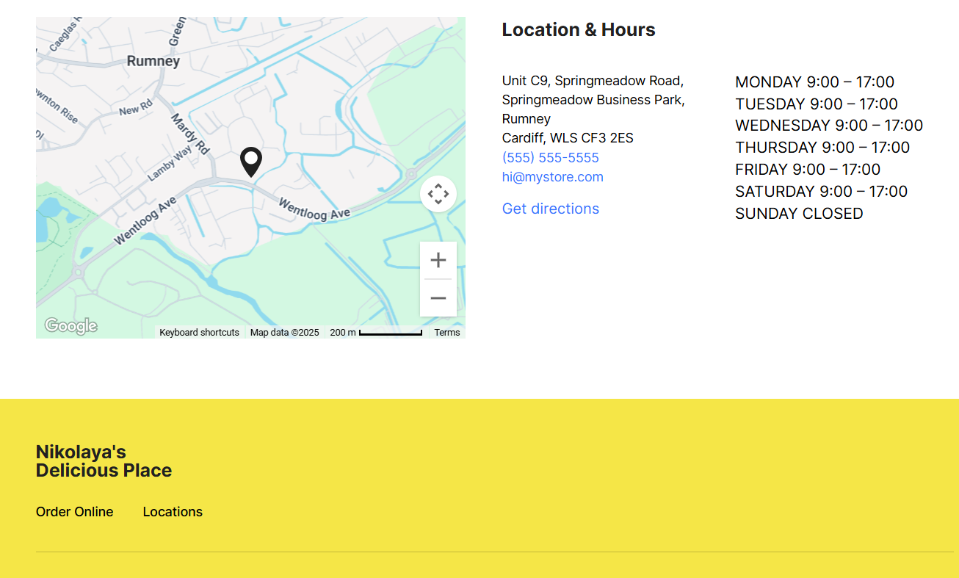
For the homepage of the website, I used an image of a salad with roasted chicken because, according to the participants of the questionnaire, this dish is likely to be the most appealing to customers. I arranged the featured items based on the preferences indicated in the questionnaire. This included a tortilla with chicken and vegetables and a sandwich filled with eggs, garlic sauce, avocado, and chopped green onions. I also included drinks (water, spirulina latte, matcha latte, coffee and tea) that are currently popular and considered healthy and promoting the brand focus on nutritious options (Bullet proof, 2025) (Corporate personal wellbeing, 2025).
- Marketing materials
  - Billboard
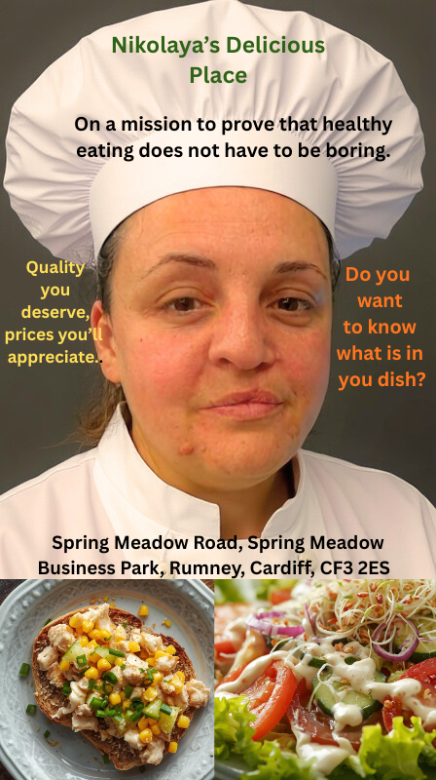
  - Business card
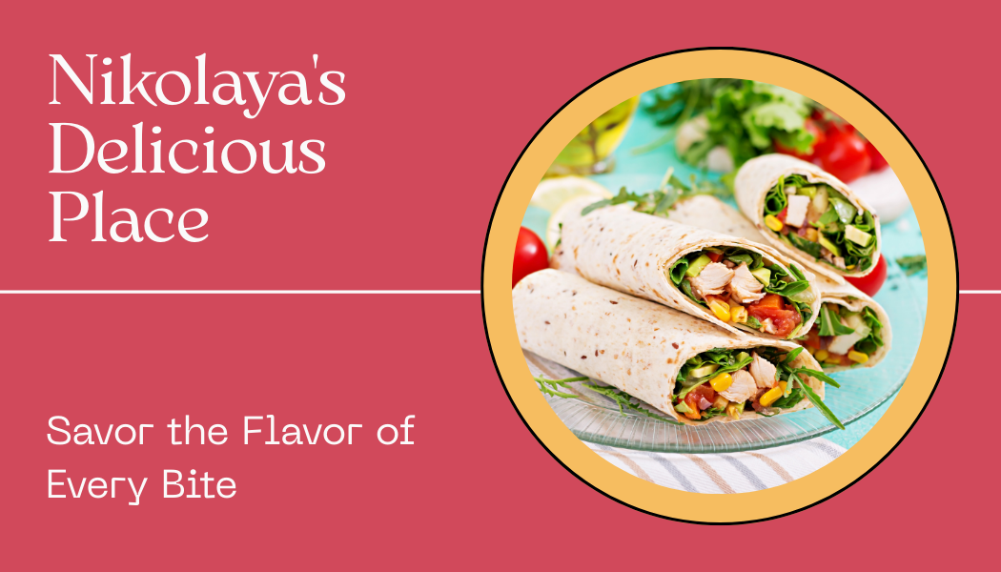
  - Leaflet
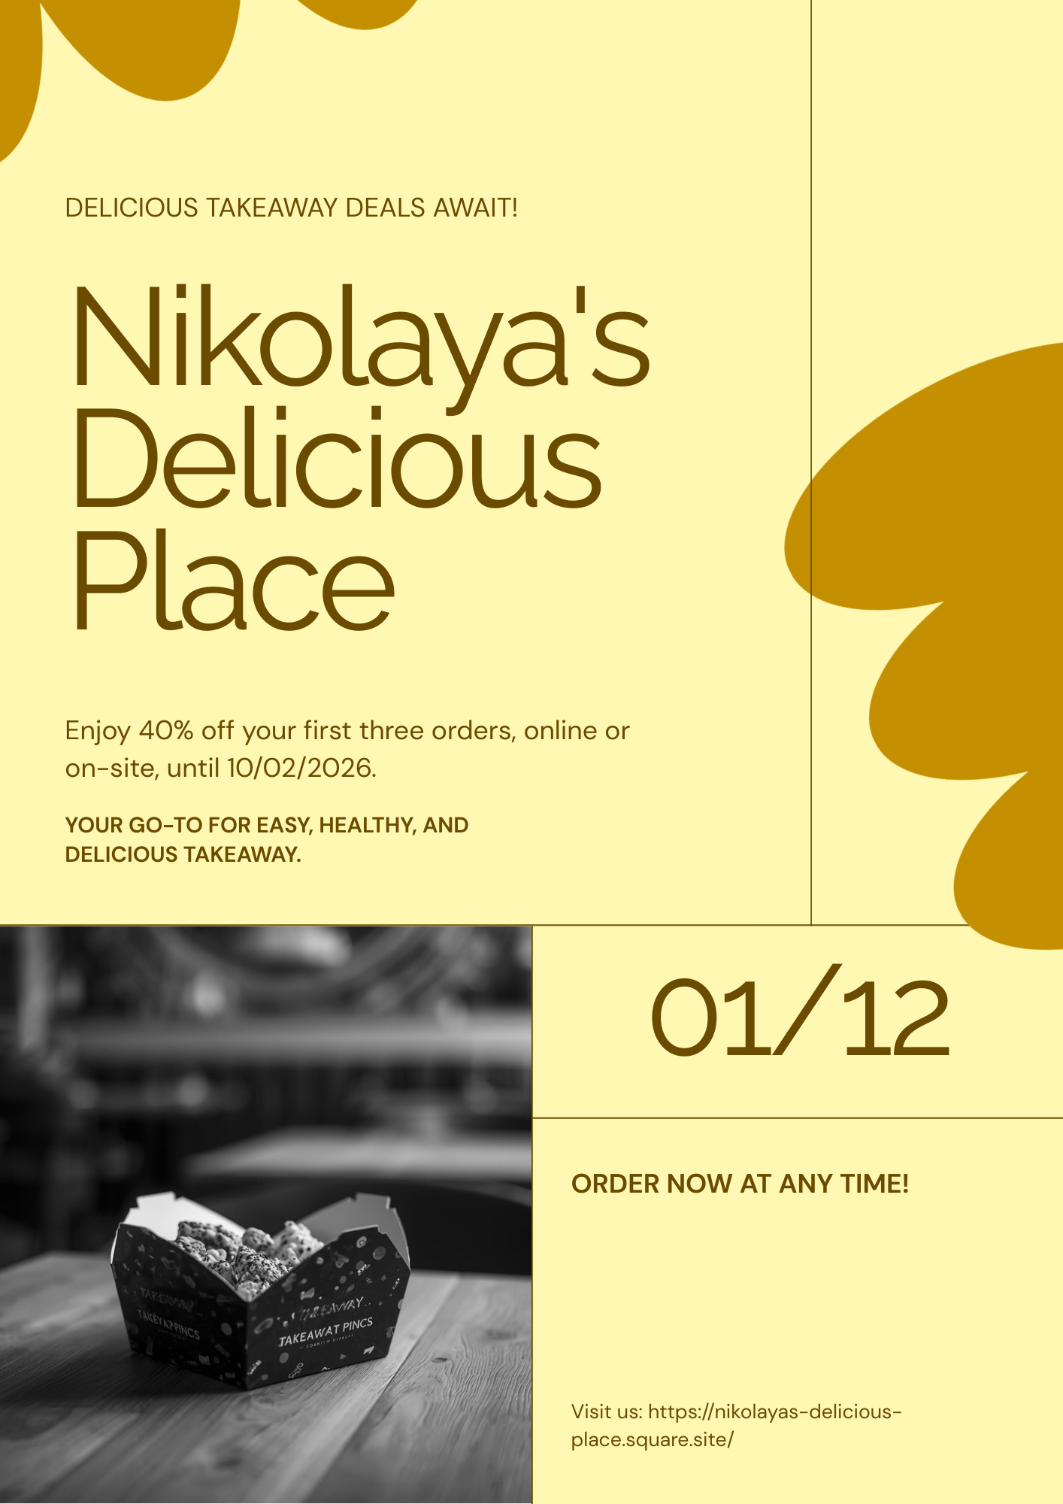
- Audience Segmentation (King,2021)
Demographic Segmentation
- Age: 25–60 years old (based on questionnaire participants)
- Gender: Both male and female, with equal appeal to health-conscious consumers
- Income Level: Middle to upper-middle income, willing to pay for quality, healthy meals
- Occupation: Office workers, factory employees, business professionals, and parents looking for convenient, nutritious meals (Nica, Gajanova and Kicova, 2019).
Geographic Segmentation
- Location: Cardiff, especially areas near Spring Meadow Business Park, offices, factories, and nearby residential neighbourhoods
- Accessibility: Customers prefer locations with easy access for takeaway, on-site pickup, or delivery
Psychographic Segmentation
- Lifestyle: Health-conscious individuals interested in balanced, nutritious meals (Boncompagni, 2025)
- Values: Prioritize quality ingredients, fresh food, and healthy cooking methods
- Behavioural Traits: Busy individuals or families who want convenient meals without compromising on health (Jenkins et al., 2021).
Behavioural Segmentation
- Purchase Behaviour:
  - Prefer meals with vegetables, protein-rich options (meat or fish), and healthy fats (extra virgin olive oil, avocado oil).
  - Frequently purchase ready-made meals 2+ times per week, but want healthier alternatives (Alsubhi et al.,2023).
- Usage Rate: Medium to high; likely to buy breakfast, lunch, and dinner options throughout the week
- Occasions: Daily meals, quick lunch breaks, family dinners, or events/festivals (mobile kitchen opportunities)
- Benefits Sought:
  - Healthy, fresh, and balanced meals
  - Convenience (takeaway or delivery)
  - Taste and variety (tortillas, sandwiches, salads, beverages)
4P’s strategy:
- Product: healthy dishes like roasted chicken salad, tortillas, and egg sandwiches with healthy sauces, made with healthy oils
- Price: mid-range, because more people can afford it
- Place: Mobile kitchen and online orders
- Promotion: On a mission to prove that healthy eating does not have to be boring. Targeted social media ads and influencer partnerships to reach local office workers and residents

- SEO strategy
SEO Goals:
- Increase visibility in local search results for healthy takeaway and delivery in Cardiff
- Drive traffic to the website and online ordering platform
- Generate awareness and engagement on social media and online directories
- Improve brand authority and trust in the health-conscious food niche
Keyword Research:
Focus on high-intent and local keywords:
- Primary Keywords:
  - Healthy takeaway Cardiff
  - Healthy food delivery Cardiff
  - Fresh meals Cardiff
  - Calorie-counted meals (Story Chief, 2023)
- Secondary Keywords:
  - Salad with chicken Cardiff
  - Healthy lunch options
  - Wraps and sandwiches healthy
  - Nutrition-friendly meals (Food Hub for business, 2025).
- Long-Tail Keywords:
  - Where to order healthy food near me
  - Best healthy takeaway for busy office workers
  - Meal plans with calculated calories
Local SEO
- Create and optimize Google My Business profile
- Include NAP (Name, Address, Phone) consistently across all platforms
- Encourage customer reviews on Google, Yelp, and TripAdvisor
- List on local directories and food apps (Just Eat, Deliveroo, Uber Eats)
- Add local content on the website: blog posts about Cardiff events, local sourcing, and nutrition tips (The web designer, 2024).

- References
  - Alsubhi, M., Blake, M., Nguyen, T., Majmudar, I., Moodie, M. and Ananthapavan, J., 2023. Consumer willingness to pay for healthier food products: A systematic review. Obesity Reviews, 24(1), p.e13525.
  - Boncompagni, A., 2025. How healthy are you? Segmenting psychological and behavioral diversity in healthy food choices. Italian Journal of Marketing, pp.1-20.
  - Bullet proof (2025) Blue Spirulina Latte. Available at: https://www.bulletproof.com/recipes/eating-healthy/blue-spirulina-latte-recipe-2b3c/ (Accessed: 12 December 2025).
  - Corporate personal wellbeing (2025) HEALTHY HOT DRINKS. Available at: https://corporatepersonalwellbeing.com/news/healthy-hot-drinks/ (Accessed: 12 December 2025).
  - Food Hub for business (2025) Increase Orders & Visibility: Local SEO Tips for Takeaways and Restaurants. Available at: https://foodhubforbusiness.com/blogs/restaurant-local-seo-strategies (Accessed: 12 December 2025).
  - Jenkins, E.L., Legrand, S., Brennan, L., Molenaar, A., Reid, M. and McCaffrey, T.A., 2021. Psycho-behavioural segmentation in food and nutrition: A systematic scoping review of the literature. Nutrients, 13(6), p.1795.
  - King, L. 2021. FSA Consumer segmentation. https://doi.org/10.46756/sci.fsa.bmo506
  - Nica, E., Gajanova, L. and Kicova, E., 2019. Customer segmentation based on psychographic and demographic aspects as a determinant of customer targeting in the online environment. Littera Scripta, 12(2), pp.108-126.
  - Story Chief (2023) SEO Keywords: How to Find Them (15 Real Examples). Available at: https://storychief.io/blog/seo-keyword-research-examples (Accessed: 12 December 2025).
  - The web designer (2024) Local SEO Strategies for Cardiff Businesses. Available at: https://thewebdesignercardiff.co.uk/blog/local-seo-strategies-for-cardiff-businesses (Accessed: 12 December 2025).

TASK 2Microsoft Excel spreadsheet and Essay on the importance of Excel in the digital era.

In today’s digital era, organisations and professionals rely on powerful tools to manage, analyse, and communicate information effectively. Among these tools, Microsoft Excel remains one of the most essential and widely used software applications worldwide. Since its release in the mid-1980s, Excel has evolved from a basic spreadsheet program into a dynamic platform for data analysis, financial modelling, business intelligence, and decision-making support. Its versatility, accessibility, and integration capabilities make it indispensable in modern workplaces, education, and personal productivity.
At its core, Excel is a spreadsheet application that enables users to organise and analyse data in grid format using formulas, functions, charts, and tables. Its features support everything from simple arithmetic to complex statistical and analytical tasks. This flexibility allows users in finance, marketing, human resources, project management, and beyond to interpret and act on data quickly and effectively. In fact, Excel’s adaptability across industries is one reason it remains critical despite the rise of specialised database, analytics, and business intelligence platforms (Rosenberg, 2024).
One of the most important applications of Excel in the digital era is data management and organisation. In any business setting, data is generated at an unprecedented rate—sales figures, customer records, inventory levels, financial transactions, and performance metrics. Excel provides a structured environment where this data can be entered, sorted, filtered, and categorised for further analysis. Its grid-based interface and robust sorting tools allow users to transform raw data into meaningful summaries without specialised programming skills. This accessibility makes Excel a valuable tool for employees at various skill levels (Geeksforgeeks, 2025).
In addition to organisation, Excel excels at data analysis and visualisation. Users can apply built-in formulas such as SUM, AVERAGE, IF, and VLOOKUP to calculate key metrics (School of Coding & AI, 2025). More advanced tools like pivot tables, Power Query, and Visual Basic for Applications (VBA) enable users to summarise large datasets, uncover patterns, automate repetitive tasks, and build dynamic reports. Visualisation features, including charts and graphs, help stakeholders interpret results quickly and communicate insights effectively. These analytical capabilities support decision-making processes at both operational and strategic levels (Mahmud et al., 2024).
Excel also plays a crucial role in financial planning and budgeting—a priority for organisations of all sizes. Financial professionals routinely use Excel to build budgets, monitor expenses, forecast future performance, and conduct scenario analysis. The ability to model cash flows, projections, and profitability allows businesses to prepare for uncertainty and allocate resources more efficiently. Even in small enterprises without specialised financial software, Excel remains a cost-effective solution for maintaining financial discipline and reporting accuracy (Srbinoska, Hristova and Kazic, 2023).
Beyond business, Excel is highly relevant in education and research settings. Students and educators use Excel to analyse research data, perform statistical calculations, and present findings visually. The ability to organise large datasets and derive insights is foundational to many academic disciplines, from social sciences to engineering. For learners, proficiency in Excel not only improves data literacy but also builds analytical reasoning skills that are transferable to other digital environments. Employers increasingly view Excel literacy as a fundamental competency for graduates entering the workforce (Geeks for Geeks, 2025).
Despite the availability of more advanced analytics tools and programming languages, Excel remains a cornerstone of digital workflows because of its accessibility and universal recognition. Fourthly, Excel’s ubiquity means that professionals from diverse backgrounds share a common digital language for data manipulation and reporting. Whether in entry-level administrative roles or senior management positions, the ability to use Excel effectively is often a prerequisite for productivity and career advancement. Recent educational research highlights that Excel proficiency is correlated with positive employment outcomes, particularly in business and finance disciplines (Bakir, Salaza and Babb,2025).
However, it is important to acknowledge that Excel is not without limitations. As datasets grow into the millions of entries, performance issues can arise, and the risk of human error increases with manual data entry. Organisations must balance the convenience of Excel with governance practices such as data validation, error checking, and collaboration controls to ensure data integrity. Additionally, as data science and artificial intelligence tools become more prevalent, professionals must complement their Excel skills with knowledge of specialised analytics platforms where appropriate (Gaoual et al., 2025).
In conclusion, Microsoft Excel remains a vital tool in the digital era due to its unmatched versatility, analytical power, ease of use, and broad applicability across industries. From organising data and performing financial analysis to driving decision-making and enabling educational research, Excel is deeply embedded in digital workflows. Its ability to integrate with other systems and support complex data management tasks ensures that it will remain relevant even as technology evolves. For individuals and organisations alike, developing Excel competence is an investment in productivity, insight, and career readiness in a data-driven world.

- References
  - Rosenberg, E. (2024) The Importance of Excel in Business. Available at: https://www.investopedia.com/articles/personal-finance/032415/importance-excel-business.asp Accessed: 10 December 2025).
  - Geeks for Geeks (2025) Importance of Microsoft Excel in the Workplace (With Real-World Examples). Available at: https://www.geeksforgeeks.org/excel/importance-of-microsoft-excel-in-workplace/ (Accessed: 10 December 2025).
  - Mahmud, M.M., Wong, S.F., Qazi, A., Ramli, N.F.M., Zakaria, S.F. and Rusli, R., 2024, March. Excel-Ling in Data Visualization: Evaluating Microsoft Excel's User-Friendliness, Visual Appeal, and Reputation Impact. In 2024 12th International Conference on Information and Education Technology (ICIET) (pp. 507-513). IEEE.
  - School of Coding & AI (2025) Importance of Microsoft Excel in Business. Available at: https://schoolofcodinguk.com/blog/importance-of-microsoft-excel-in-business/ (Accessed: 10 December 2025).
  - Srbinoska, D.S., Hristova, S. and Kazic, V., 2023. Why Budgeting in Small and Medium Enterprises Matters?. Timisoara Journal of Economics & Business, 16(2).
  - Geeks for Geeks (2025) Importance of Microsoft Excel in College and Universities. Available at: https://www.geeksforgeeks.org/excel/importance-microsoft-excel-college/ (Accessed: 11 December 2025).
  - Bakir, N., Salazar, L.R. and Babb, J., 2025. Foundations of Practical Analytic Skills: An Examination of Undergraduate Business Students’ Self-Efficacy Using Excel. Journal of Information Systems Education, 36(3), pp.257-276.
  - Gaoual, Y., Aliat, Z., Cherif Chefchaouni, A., Mahyaoui, A., Merhom, O. and Rahali, Y., 2025. Mitigating Risks in Hospital Stock Management: A Structured Method for Validating Excel Files. Hospital Pharmacy, p.00185787251337614.

