1600211
CAMF5003
Assignment 1
Pre-production portfolio

Contents
Treatment 3
Step Outline/Beat Sheet 5
Script 6
Extended Step Outline 12
Mask Designs 14
Actor Request Advertisment 16
Blank Release Forms
Location 17
Talent 18
Equipment Booking Form 20
TREATMENT
Working Title – Safe Room
Genre – Crime Thriller
Duration – ~7 minutes
Target Audience – Fans of crime thrillers.
Inspirations –
Reservoir Dogs (1993), Movie, Quentin Tarentino
Payday: The Heist (2011), Video Game, Overkill Software
Payday 2 (2013), Video Game, Overkill Software
Hotline Miami 2: Wrong Number (2015), Video Game, Devolver Digital
Hateful Eight (2016), Movie, Quentin Tarentino
Plot Outline – CHIEF, MIDGE, HOCKEY and GHOST are in a Safe Room, attempting to stay calm as the police are outside searching for them. Chief recieves a message from a blocked number: ‘THERE’S A RAT –S’. This ignites a spark in a room full of dry fuel and people start to suspect each other. Hockey turns on Ghost accusing him on the grounds of him trying to shut down his ex-bosses enemies. A fight breaks out between the two. Next thing we know Hockey is sat on the bed, a bloody bandage wrapped around his head, covering his eye and Ghost is just glaring at him, bandage tied tight around his upper arm. But the room is no calmer. Chief has gotten more agitated and Midge more bored. Sights then turn to Chief and his mysterious contact, Straps. As he starts to actually explain who he is he gets another message: ‘SHUT UP MATT’. Chief tries to end the conversation quickly leading to him losing it and smacking midge, knocking her out. He then leaves the room, claiming that he needs air. Leaving Ghost and Hockey alone with a now unconscious Midge.
Character Breakdowns –
CHIEF: Male. 34. Caucasian. Ex-Police. Commanding. “The Mastermind”. Chief was sacked from the Halcyon Police Department(HPD) at 31 and served 12 months Jail time after several major violations of the Code of Conduct. This past makes it difficult to get an honest job now so he turned to crime to keep himself, his ex-girlfriend and his kid from starving.
MIDGE: Female. 19. Caucasian. Ex-Student. Hyperactive(ADHD). Short. “The Technician”. Can’t stand having to not be able to do something. Midge is a Computer Science student at Halcyon University of Technology and Engineering(HUTE) who chose crime as “the fastest way to pay off student debt”. She recently served jail time after being caught meddling with the HPD’s criminal database. This Jail time was cut off after she was broken out by Ghost. She is now in crime full time.
HOCKEY: Male. 23. Caucasian. Ex-Hockey Player. Paranoid. “The Enforcer”. Hockey used to play for the Halcyon Diamondbacks field hockey team, as a forward Enforcer, before he was banned for causing a fight on the pitch during a championship game leading to multiple people being beaten to death and his team being disqualified.
GHOST: Male. Unknown. Caucasian. Ex-Mafia. “The Fugitive”. Refuses to reveal his face to the crew. Ghost is the son of crime boss Jonathan James Jarko. Jarko having openly admitted to hating the crew. Ghost left his employ, took up the mantle of Ghost and approached the crew saying that he used to be with Jarko but recently decided to get out of there and finally, as a proof of loyalty, broke Midge out of prison. Ghost has choesn never to reveal his true identity to the crew, even so far as keeping his mask on whenever he’s with them, on fear of death either at their hands or his fathers.
STRAPS: Not much is known about Straps but he is always watching the crew, making sure to relay to Chief what’s going on and doing his best to keep them all out of Jail. Only Chief has direct contact with him in the crew but apparently Straps has contacts everywhere. (Only ever mentioned by name in the script, makes no appearance in the production)

Step Outline
Part 1, Hocky vs Ghost
- CHIEF, HOCKEY, MIDGE and GHOST are in the safe room, attempting to stay calm.
- Midge is getting bored.
- Chief gets a message from Straps: “THERE’S A RAT”.
- Hockey accuses Ghost.
- They argue.
- Ghost attacks Hockey.
Part 2, Chief loses it
- Hockey and Ghost are Bandaged.
- Midge is still bored.
- Ghost and Midge question Chief about Straps.
- Chief gets another message: “SHUT UP MATT”.
- Chief loses it and smacks Midge.
- Chief leaves the safe room.

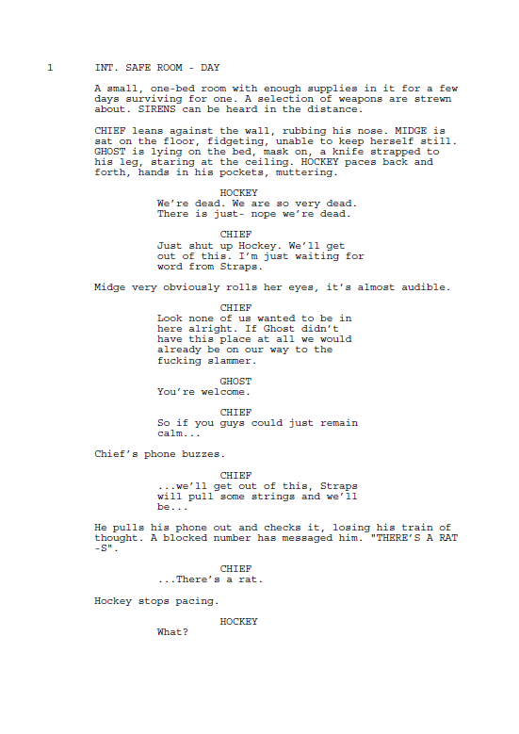

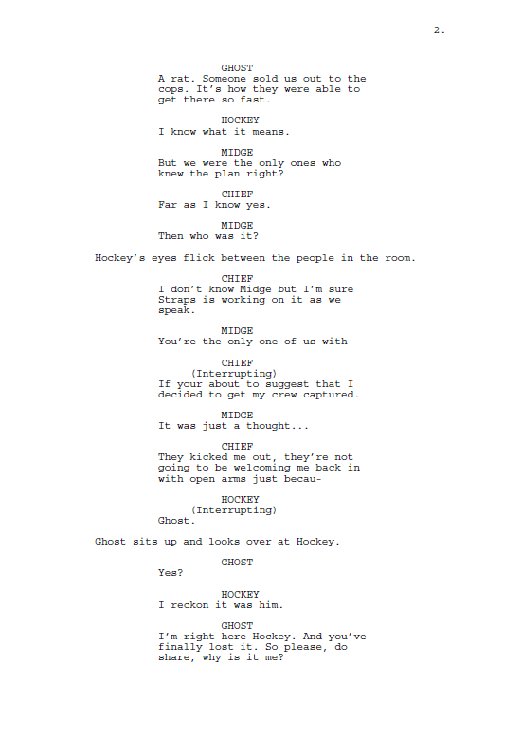

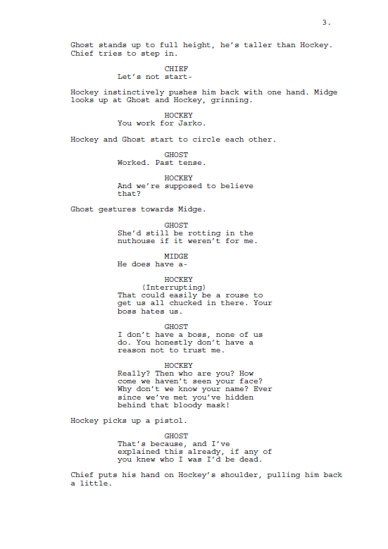

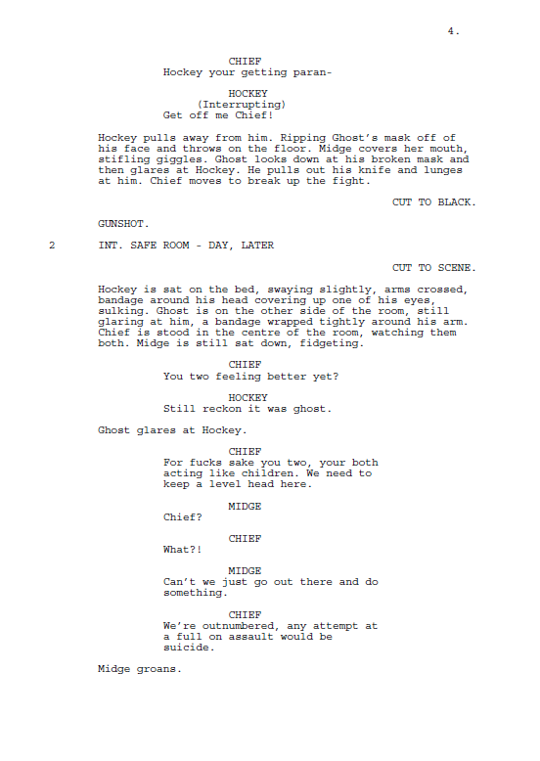

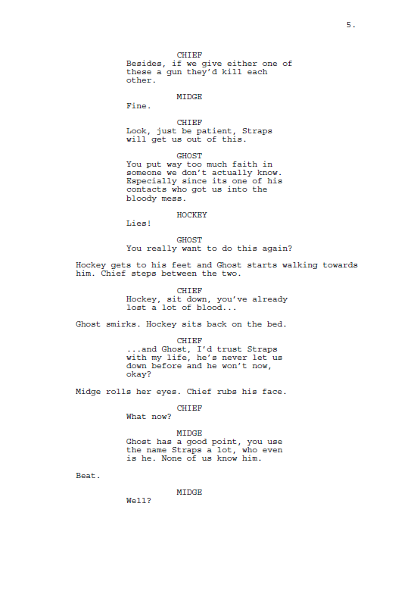

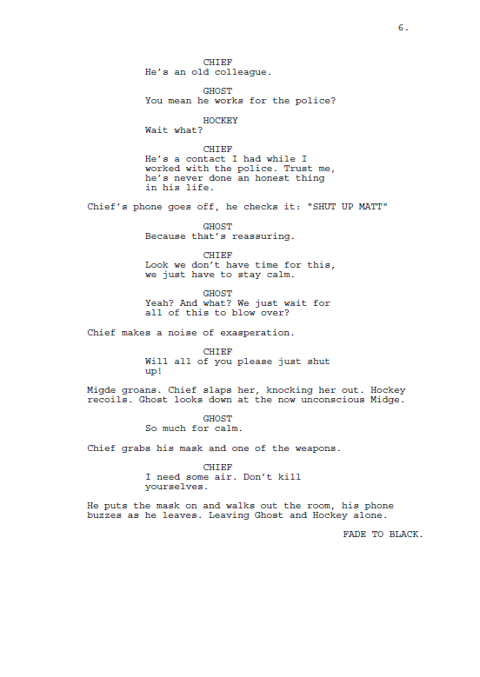
Extended Step Outline
Scene No. | 1 | Page No. | 1 – 4
Slugline | INT SAFE HOUSE – DAY
Endpoint of last scene | N/A
Characters in scene | Chief, Midge, Hockey and Ghost.
Point of scene | To ignite tension and start the breaking process of Chief.
Conflict | Argument between Ghost and Hockey.
Ending/central question | What’s going to happen?
Key Micro elements employed and brief description of their use | One-Bed, first aid kit, laptop, radio, tins of beans and bottles of water (Both full and empty) all set dressing to show that the room is set up for surviving in. Variety of assault rifles, shotguns, pistols and melee options plus the masks to show that they are criminals.
Scene description (without dialogue) focusing on key micro aspects (mise-en-scène, camera, sound, editing, etc)

Equipment: Cannon 700d, 18-55 lens, 70-300 lens Tri-pod, Shotgun Microphone, boom pole, sound recorder, clapper board, Panel Lights. A Dolly may prove useful for the scene.

Continuity: Position of objects in the room, Positioning of people in the room, specifically Midge who spends the entire time sat down. Weather outside, could potentially keep curtains shut. Position of Ghost’s mask once removed by Hockey.

Sound: Sirens and ending gunshot will be added in post. Music to be decided upon during post.

Other: Mirror in room may be problematic.

Scene No. | 2 | Page No. | 4 – 6
Slugline | INT SAFE HOUSE – DAY, LATER
Endpoint of last scene | Ghost lunging at Hockey.
Characters in scene | Chief, Midge, Hockey and Ghost.
Point of scene | To finish breaking Chief.
Conflict | Who is Straps, can they trust him.
Ending/central question | What’s going to happen?
Key Micro elements employed and brief description of their use | One-Bed, first aid kit, laptop, radio, tins of beans and bottles of water (Both full and empty) all set dressing to show that the room is set up for surviving in. Variety of assault rifles, shotguns, pistols and melee options plus the masks to show that they are criminals. The bandaging done to Hockey and Ghost to let the audience know what they did to each other.
Scene description (without dialogue) focusing on key micro aspects (mise-en-scène, camera, sound, editing, etc)

Equipment: Cannon 700d, 18-55 lens, 70-300 lens Tri-pod, Shotgun Microphone, boom pole, sound recorder, clapper board, Panel Lights.

Continuity: Position of objects in the room, Positioning of people in the room, specifically Midge who spends the entire time sat down. Weather outside, could potentially keep curtains shut. Amount of blood on Hockey and Ghost’s bandaging. Where Ghost’s mask is (it would have been moved since end of last scene).

Sound: Sirens will be added in post. The sound of the slap will be amplified in post. Music to be decided upon during post.

Action: Chief slapping Midge will need to be practiced a few times before hand.

Other: Mirror in room may be problematic.

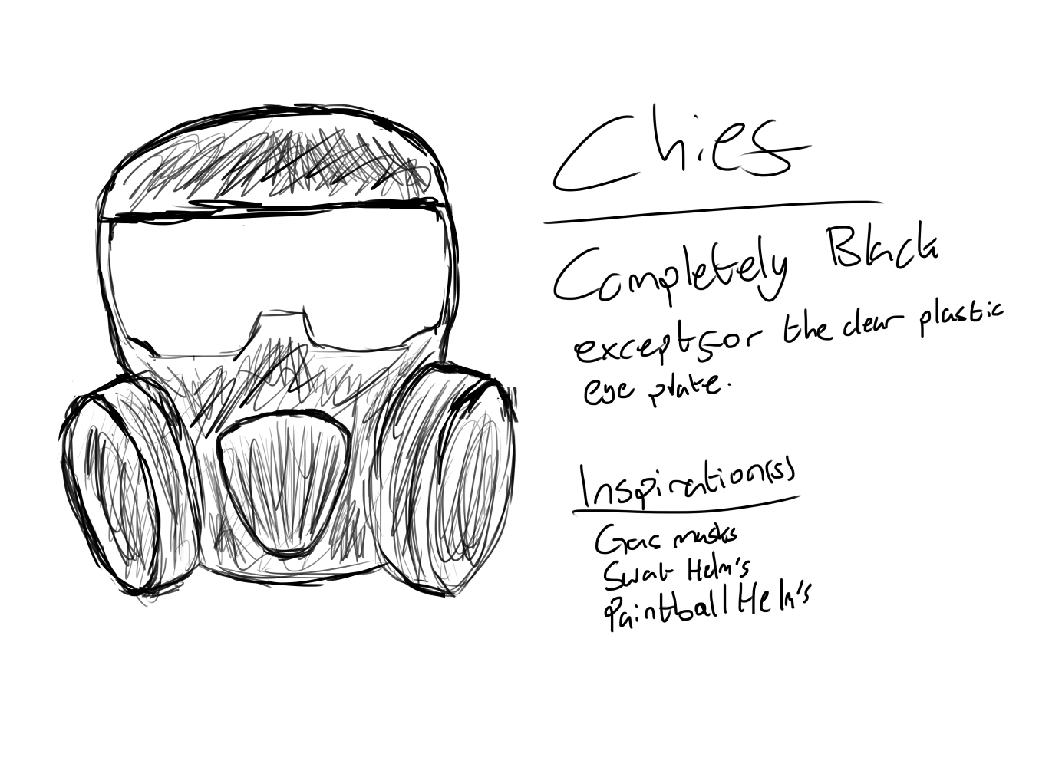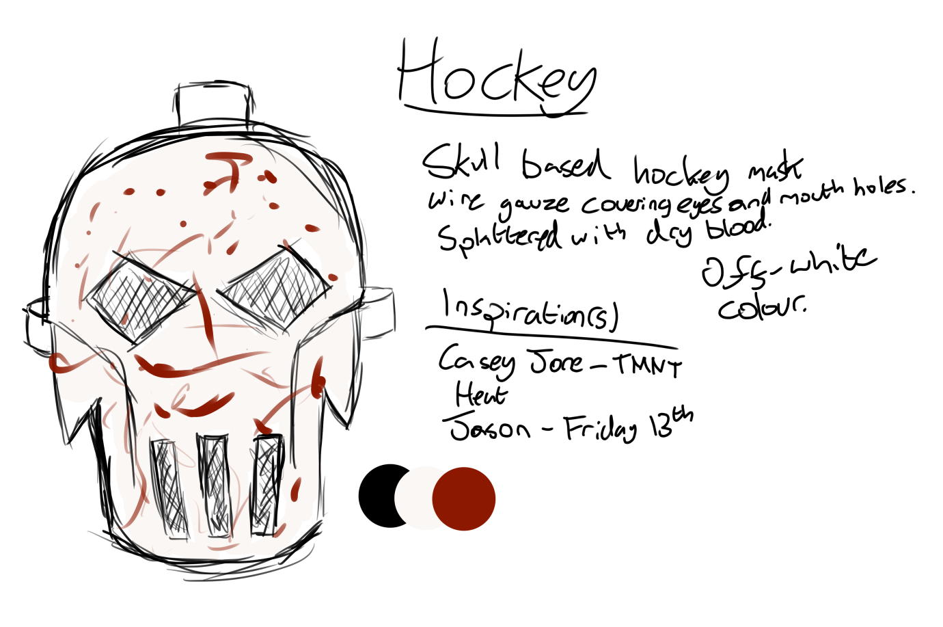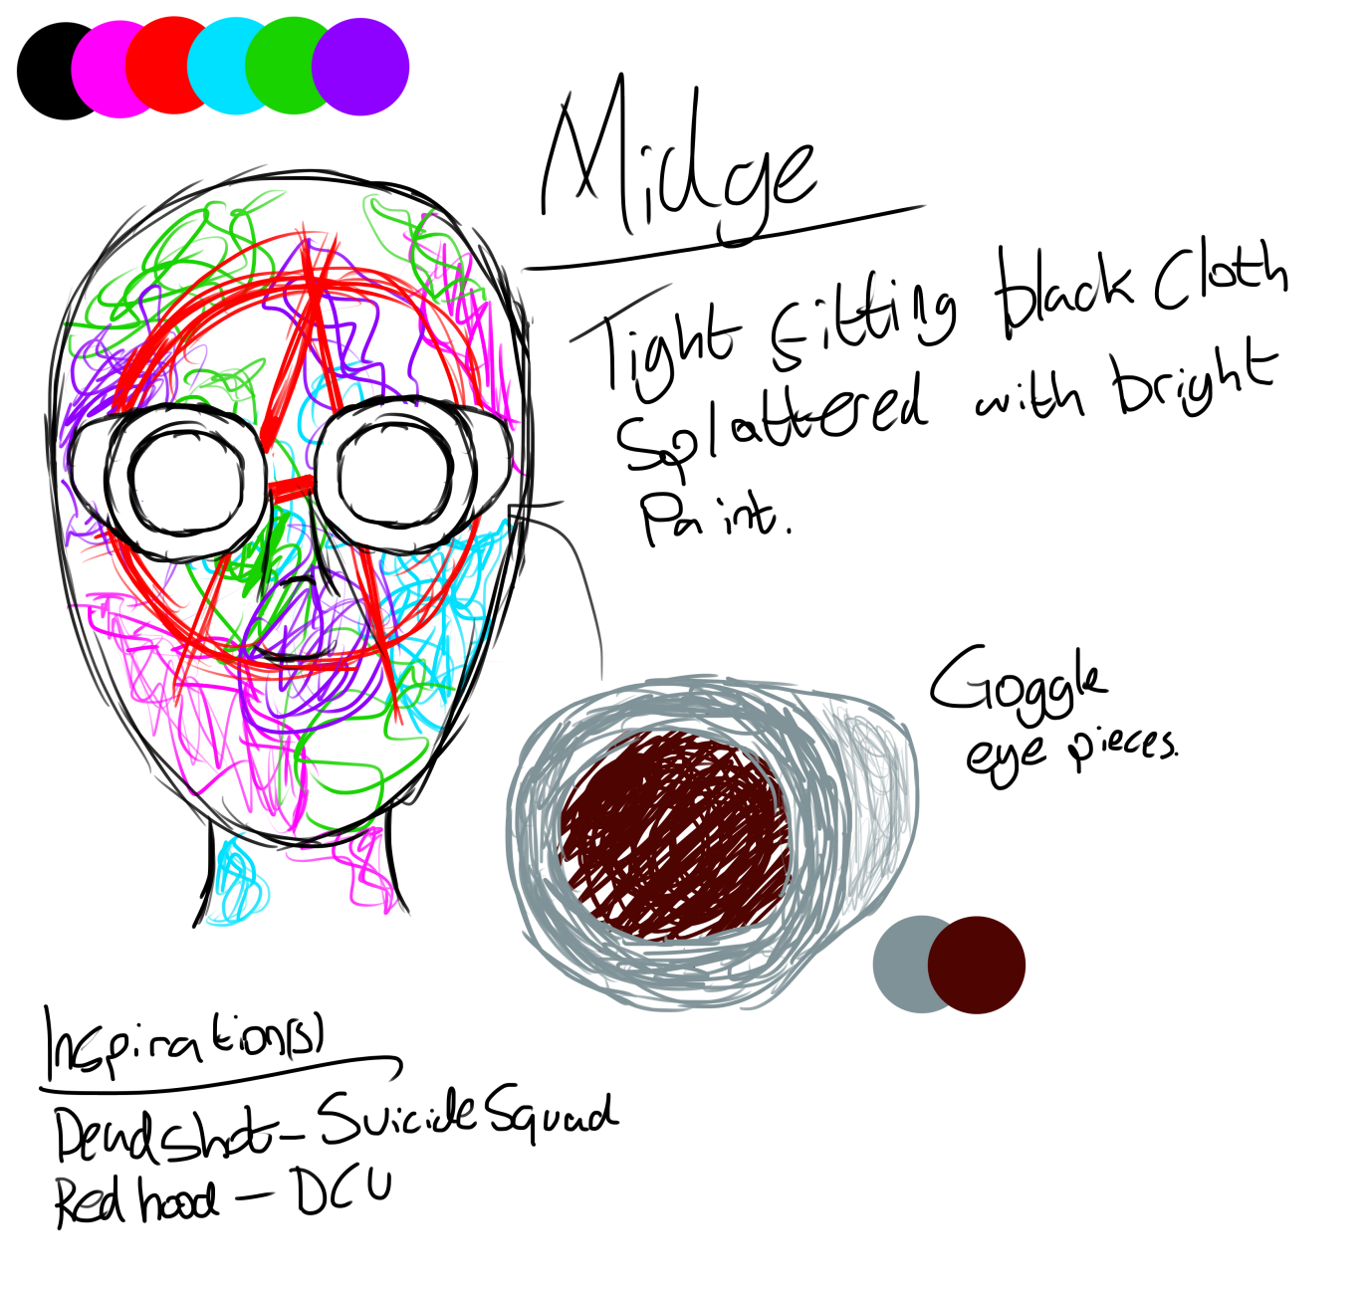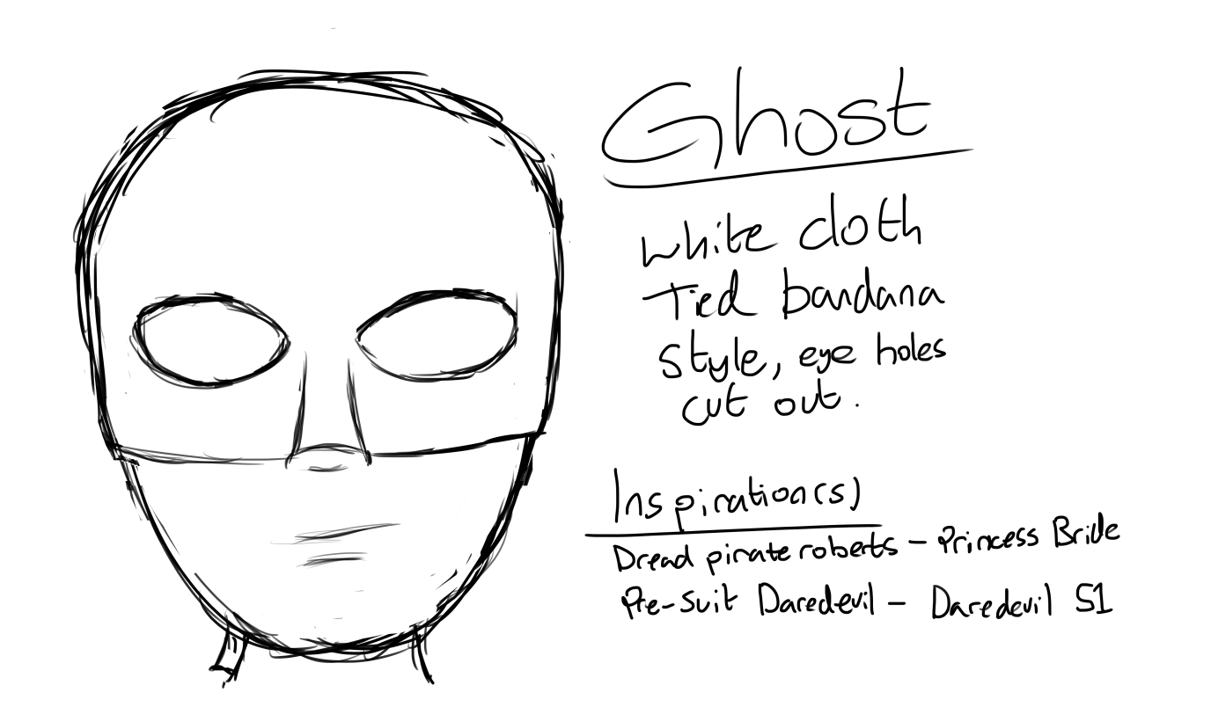
Actor Request Advertisment
Hey guys, my name is Andrew and I am in need of 3 male actors for my Script to Screen project, called Safe Room, this semester.
The characters I need are as follow:
CHIEF: Male. 34. Ex-Police. Commanding. “The Mastermind”. Chief was sacked from the Halcyon Police Department(HPD) at 31 and served 12 months Jail time after several major violations of the Code of Conduct. This past makes it difficult to get an honest job now so he turned to crime to keep himself and his ex-girlfriend and kid from starving.
HOCKEY: Male. 23. Ex-Hockey Player. Paranoid. “The Enforcer”. Hockey used to play for the Halcyon Diamondbacks field hockey team, as a forward Enforcer, before he was banned for causing a fight on the pitch during a championship game leading to multiple people being beaten to death and his team being disqualified.
GHOST: Male. Unknown. Ex-Mafia. “The Fugitive”. Refuses to reveal his face to the crew. Ghost is the son of crime boss Jonathan James Jarko. Jarko having openly admitted to hating the crew. Ghost left his employ, took up the mantle of Ghost and approached the crew saying that he used to be with Jarko but recently decided to get out of there and finally, as a proof of loyalty, broke Midge out of prison. Ghost has choesn never to reveal his true identity to the crew, even so far as keeping his mask on whenever he’s with them, on fear of death either at their hands or his fathers.
The ages listed are not too important for the role so don’t worry about it too much. Attatched is a link to the script, if you are interested please contact me by 16/11/2017. I hope to hold an informal audition on 17/11/2017 at 1:00pm in the studio in the TL Building.
E-mail: andrewr.dsc@gmail.com
Mobile: 07766827899
Script: https://drive.google.com/file/d/1S17i5JMa2cD5uSiL-CjmG22Vqz3-n3i4/view?usp=sharing
LOCATION RELEASE FORM
SERIES / PROGRAM TITLE: Safe Room
PRODUCTION DATE: To Be Determined
Permission is hereby granted to Andrew de-Ste-Croix to use the property located at:
University of Wales Trinity St. David
Carmarthen
Carmarthenshire
SA31 3EP
consisting of
Tower Accommodation
for the purpose of photographing and recording scenes for the above program produced by Andrew de-Ste-Croix.
Permission includes the right to bring personnel and equipment onto the property and to remove them after completion of the work. The permission herein granted shall include the right, but not the obligation, to photograph the actual name connected with the premises and to use such name in the program(s).
The undersigned hereby gives to Andrew de-Ste-Croix, its assigns, agents, licensees, affiliates, clients, principals, and representatives the absolute right and permission to copyright, use, exhibit, display, print, reproduce, televise, broadcast and distribute, for any lawful purpose, in whole or in part, through any means without limitation, any scenes containing the above described premises, all without inspection or further consent or approval by the undersigned of the finished product or of the use to which it may be applied.
Andrew de-Ste-Croix hereby agrees to hold the undersigned harmless of and free from any and all liability and loss which Andrew de-Ste-Croix, and/or its agents, may suffer for any reason, except that directly caused by the negligent acts or deliberate misconduct of the owner of the premises or its agents.
The undersigned hereby warrants and represents that the undersigned has full right and authority to solely enter into this agreement concerning the above described premises, and that the undersigned hereby indemnifies and holds Andrew de-Ste-Croix, and/or its agents, harmless from and against any and all loss, liability, costs, damages or claims of any nature arising from, growing out of, or concerning the use of the above described premises except those directly caused by the negligent acts or deliberate misconduct of Andrew de-Ste-Croix, or his agents.
Property Owner Name: ___________________________________________
E-Mail ___________________________________________
Contact Number ___________________________________________
Signature: ___________________________________________
Date: ___________________________________________

Filmmaker Signature: ___________________________________________
Date: ___________________________________________
TALENT RELEASE AGREEMENT
To Whom It May Concern:
I (the undersigned) hereby grant to Andrew de-Ste-Croix the right to photograph me and to record my voice, performances, poses, actions, plays and appearances, and use my picture, photograph, silhouette and other reproductions of my physical likeness in connection with the motion picture tentatively entitled Safe Room.
I hereby grant to Andrew de-Ste-Croix, its successors, assigns and licensees the perpetual right to use, as you may desire, all still and motion pictures and sound track recordings and records which you may make of me or of my voice, and the right to use my name or likeness in or in connection with the exhibition, advertising, exploiting and/or publicizing of the picture. I further grant the right to reproduce in any manner whatsoever any recordings including all instrumental, musical or other sound effects produced by me, in connection with the production and/or postproduction of the Picture.
I agree that I will not assert or maintain against Andrew de-Ste-Croix, your successors, assigns and licensees, any claim, action, suit or demand of any kind or nature whatsoever, including but not limited to those grounded upon invasion of privacy, rights of publicity or other civil rights, or for any reason in connection with your authorized use of my physical likeness and sound in the Picture as herein provided.
By my signature here I understand that I will, to the best of my ability, adhere to the schedule agreed to prior to the beginning of my engagement. Additional, I agree, to the best of my ability, to make myself available should it be necessary, to rerecord my voice and/or record voice-overs and otherwise perform any necessary sound work required after the end of filming. Should I not be able to perform such sound work, I understand that Andrew de-Ste-Croix may enter into agreement with another person to rerecord my dialogue and/or record voice-overs and use this sound work over my picture or however they deem appropriate.
I hereby certify and represent that I am over 18 years of age and have read the foregoing and fully understand the meaning and effect thereof.
TALENT NAME:
ADDRESS:
PHONE:
EMAIL:
CHARACTER NAME:

Talent Signature ___________________________________________
Date: ___________________________________________


