University of Wales Trinity Saint David
School of Engineering

Energy In A Flywheel
Engineering Science 1 - M4X00385

Craig Petherbridge
1904036
03/02/2020


Contents
1 Introduction 1
2 Experimental Procedure 2
3 Results 4
4 Analysis 5
5 Conclusion 9
6 Evaluation 11
7 Further Work 11
8 References 12

Table 1: Equipment List 2
Table 2: Raw data from Experiment-1 (31/01/2020) 4
Table 3: Raw data from Experiment 2 (07/02/2020) 4
Table 4: Analysed Data and Calculations from Experiment 1 5
Table 5: Analysed Data and Calculations from Experiment 2 7
Table 6: Inertia (gradient) calculated from Experiment 2 Graph 10
Table 7: KE Based on Theoretical Values and Experimental Values 10

Figure 1: Equipment ES9 2
Figure 2: PE Maximum 3
Figure 3: KE Maximum 3
Figure 4: Graph showing Moment of Inertia Experiment 1 6
Figure 5: Graph showing Moment of Inertia Experiment 2 9

Introduction

Aims
The aim of this experiment is to explore how a flywheel stores and uses its energy, to achieve this an experiment will be conducted. The experiment will require us to load the flywheel with variable masses of 0.1Kg, 0.2Kg, 0.3Kg, 0.4Kg, 0.5Kg and raising this to a predetermined height of 0.28M. The mass will fall from this height accelerating the flywheel whilst converting its potential energy into kinetic energy, when the flywheel reaches its lowest point the Kinetic Energy will be at its maximum and is used to lift the mass back up. If the flywheel has returned the mass back to its original height, then the flywheel would have given up all its Kinetic Energy to the mass.

Objectives
- Set up the Potential and Kinetic Energy kit ES9 found in Engineering Science lab (IQ007) and conduct experiment, repeat if necessary to get the best possible set of results.
- Record raw data from the experiment finding the best results whilst identifying patterns.
- Analyse data and record findings in a results table, compare theoretical with experimental values.
- Investigate any discrepancies found during the experiment and report.
- Report how well the experiment was executed and explain how it could be improved.

Experimental Procedure
Experimental procedure In line with the Engineering Science Guidance Notes – Potential and Kinetic Energy Kit ES9 (Tecquipment Ltd, 2012)
- Assemble flywheel and pulley block and attach to the work panel, should be located at the top, centre of work panel.
- Fit plastic guide to the bottom of weight hanger.
- Check the length of cord, this should be just under 290mm.
- Attach weight hanger and allow this to fall to the bottom of its travel
- Place magnetic steel rule behind the weight hanger, so its 0mm edge aligns with the plastic guide.
- To achieve a mass of 0.1Kg, use 90g to account for the weight hangers mass.
- Slowly lift the weight hanger until the bottom of the weight hanger reaches 280mm (h1)
- Record the time it takes for the mass to fall from 280mm to the 0mm position and back up to its maximum height (h2), stop recording as soon as the mass reaches this position.
- Increase the mass to 0.2, 0.3, 0.4, 0.5Kg respectively and repeat steps 7-8.
- Repeat the test for each mass several times to gain a good average of readings.

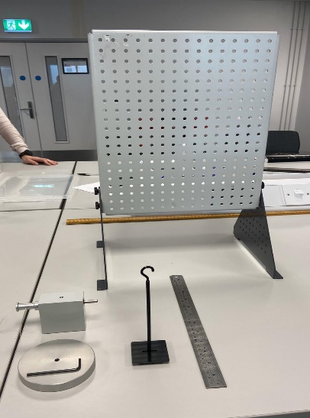
Equipment
Figure 1: Equipment ES9
Equipment List | Quantity
Work Panel | 1
Pulley Block | 1
Flywheel | 1
Weight Hanger | 1
Magnetic Steel Rule | 1
Allen Key | 1
Stopwatch | 1
290mm Cord | 1
10g Mass | 49
Table 1: Equipment List
Nominal values for Flywheel; Inertia; I = 3.862x10⁻⁴kg.m²
Nominal values for shaft and pulley; Inertia; I = 0.834x10⁻⁴kg.m²
Allowing for the cord r = 0.0065
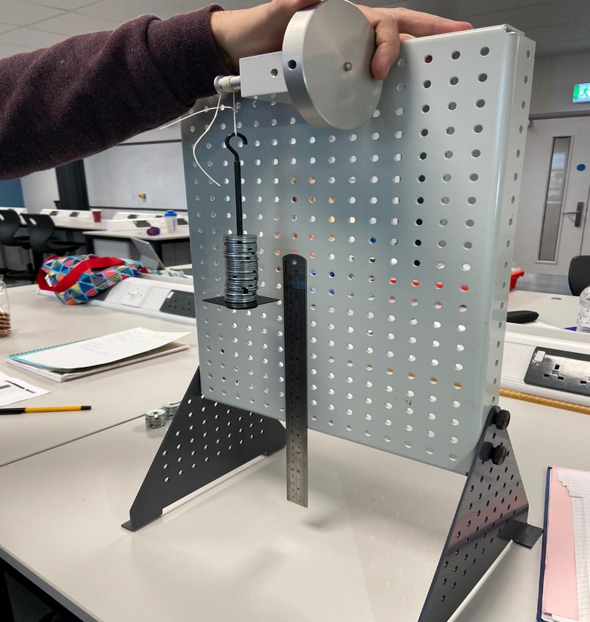
Figure 2: PE Maximum
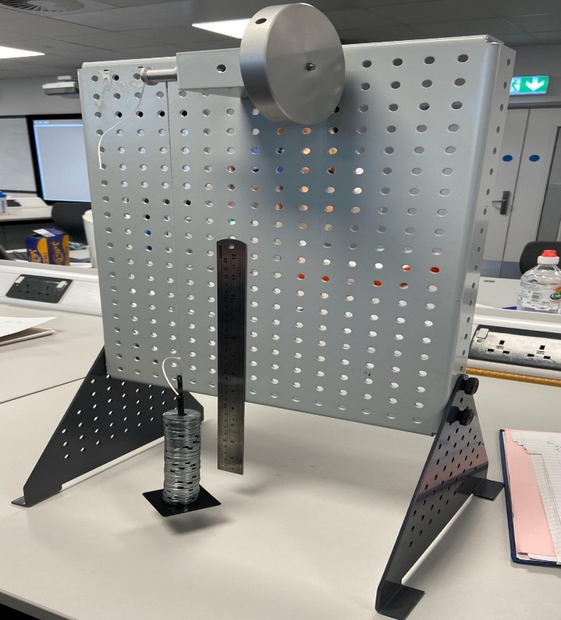

Figure 3: KE Maximum

Results

Experiment 1 Raw Data
After analysing data from the first experiment there was no pattern forming with relation to h2, this was due to large discrepancies in results recorded. If we look at the Table 1 below paying attention to 0.2Kg a result of 0.252M and 0.239 this large variation in results caused mixed readings across the heights recorded and failed to display a pattern, because of this a second experiment was carried out.
Table 2: Raw data from Experiment-1 (31/01/2020)

Experiment 2 Raw Data
When testing 0.1Kg, 0.2Kg, 0.3Kg the flywheel returned the mass to a greater height. Beyond this at 0.4Kg & 0.5Kg larger energy losses were witnessed. it was expected that a greater mass would have a greater potential energy and return the mass higher, this didn’t happen. During both tests a large bounce was witnessed causing it to sway and spin this could explain why the energy was lost.
Table 3: Raw data from Experiment 2 (07/02/2020)

Analysis

Experiment 1

Table 4: Analysed Data and Calculations from Experiment 1

Graphical Data – Experiment 1
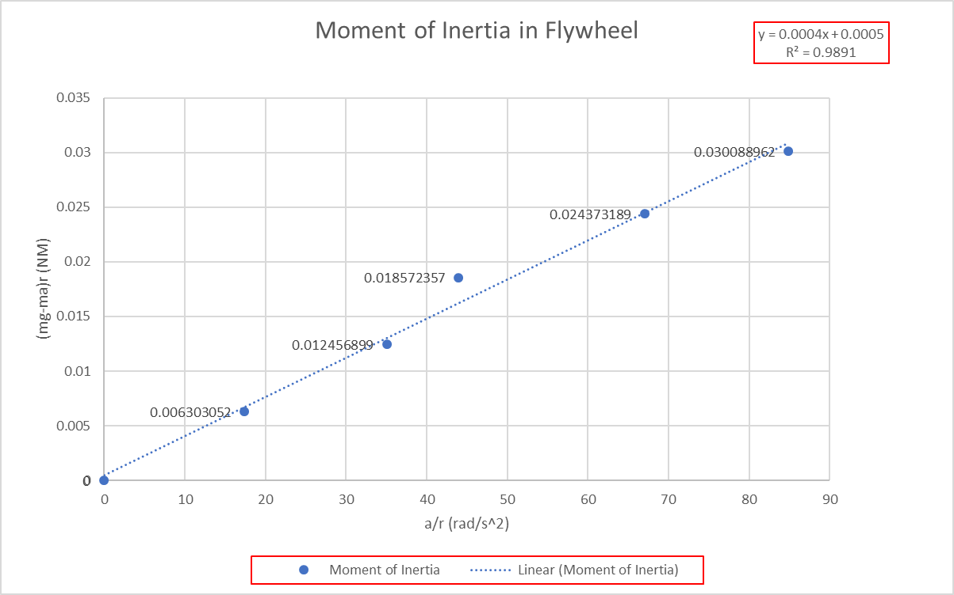
Figure 4: Graph showing Moment of Inertia Experiment 1

Experiment 2
Table 5: Analysed Data and Calculations from Experiment 2

Findings
The data shows KE is greater than PE, It is not possible to create more energy than the initial potential energy available. Results from timing discrepancies may have caused an error with angular velocity, the smallest change to time would have a large impact on the angular velocity, as the velocity is squared when calculating KE (KE=Iω²).
In many aspects a more likely pattern formed on increasing the mass, areas such as time to fall and rise got less, potential energy loss increased, and acceleration became greater. The loss of height failed to form a consistent pattern. When testing 0.1Kg, 0.2Kg, 0.3Kg the mass returned these each to a greater height over the previous. Beyond this at 0.4Kg & 0.5Kg larger energy losses were witnessed.

Graphical Data - Experiment 2
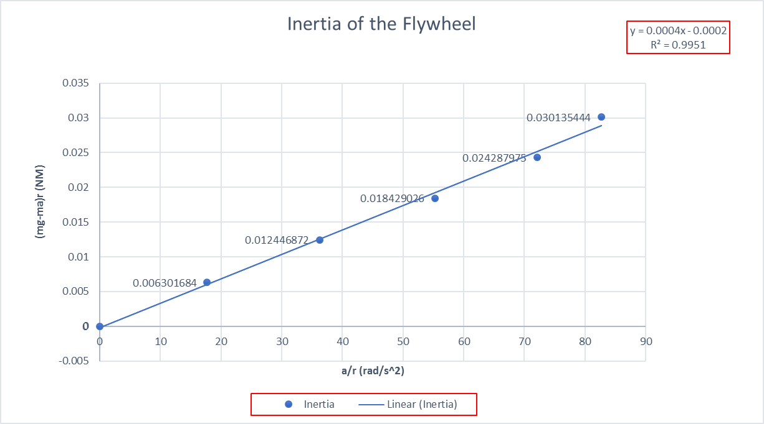
Figure 5: Graph showing Moment of Inertia Experiment 2

Conclusion

Kinetic Energy
The Kinetic Energy calculated was higher than the initial Potential Energy this is an unusual result and several theories were made, the initial assessment lead us to believe it was caused by timekeeping errors and affected the calculation for angular velocity. It’s understood that speed of the flywheel plays a major part when calculating KE as the velocity is squared (Flywheel Energy Storage -The Greenage website) ʺThe speed that the flywheel rotates has a larger effect on the energy stored within it compared to the moment of inertia. If you take the flywheel and double the speed at which it spins, you quadruple the potential energy that it can storeˮ. Although this is unlikely to be the sole cause as the error was carried through on both experiments.

Nominal Values
The Inertia of the flywheel and pulley block were given as nominal values and used within the experiment. If these values were incorrect then it could explain why our readings for Kinetic Energy were above our potential energy values. The Average Inertia values calculated from the gradient of our graphical data (Table-6) show that inertia value should be much lower. The difference in Inertia values between nominal and experiment show a deviation of 24.28% which is a considerable difference and would explain our high KE values.
Table 6: Inertia (gradient) calculated from Experiment 2 Graph
Table-7 shows KE using experimental values for Inertia, these figures would be more realistic and display energy losses in line with what is expected but discrepancies are still shown, other errors with respect to the accuracy of timing and height monitoring could account for these losses.
Table 7: KE Based on Theoretical Values and Experimental Values

Energy Losses
As the mass is falling and rising the energy is having to overcome external forces and work will be done overcoming these. If no external forces acted upon the mass the mass will raise and lower itself indefinitely. The mass failed to do this, returning the mass to a lower height (h2). To understand the reasons why the flywheel lost energy we must consider the following.
Work Done – The flywheel is having to overcome the weight (mg) lifting the mass to h2 it is said the work done is equivalent to its potential energy and would account for larger losses as the mass is increased.
Friction - Some of this energy would be transferred to thermal energy through friction, it is known that even well lubricated bearings will still have a frictional force.
Air resistance – this would act against the falling mass and the rotating flywheel in the form of drag, although this would have little effect on the experiment it cannot be overlooked.
Cord Stretch – As the mass increased a greater amount of torque would cause the cord to stretch resulting in a loss of energy.
In principle friction/ air resistance is always present and work done overcoming friction is certainly a factor in the loss of energy in this experiment. (Energy and Power, St Andrews) website ʺPotential energy and kinetic energy can be interchanged, although always with some loss (heat)ˮ.

Evaluation
Human interaction influenced the results, almost every part of this experiment relied on it, this caused errors with timekeeping due to delays when initiating and stopping the timer, difficulties setting the mass exactly to the predetermined height, readings for h2 were always an estimate like h1 this was dependant on eyeline.
Other external factors outside our control such as the cord stretching, friction and air resistance would also influence results. Given that the theoretical values are calculated based under ideal conditions and don’t allow for such errors would explain why the data from the experiment differs considerably form the theoretical values.
Conducting the experiment twice proved to be valuable, showing KE error in both sets of results lead us to believe the error couldn’t have been to do with how the experiment was conducted and pointed to the nominal values given for Inertia. If the experiment was to be repeated it is recommended that the Inertia values measured prior to testing. Inertia could be calculated using formula I = T/α.
The principle of conservation of energy, states that energy can neither be created nor destroyed it can only be converted from one form to another, but it is found that a loss of energy in any one form is always accompanied by an equivalent increase in another form (Zammit, 1987,p.32). The total energy is always the same, a loss of potential energy this will be accompanied by an equivalent increase in kinetic energy. It’s understood that external forces will affect the energy, this is not accounted for when looking at the equation PE=KE and in reality the equation should be;
PE – work done against friction = KE.

Further Work
To improve accuracy, the experiment should be run from an automated system using precision measuring equipment. A data logger and use of timing gates could accurately record timing, with height being measured off a digital height gauge and therefore reducing human interaction.
The loss of energy through the cord stretching could be overcome by replacing the fibre cord with a tough cable.
Looking at the design of modern Flywheel, they rotate at high speeds with little friction or air resistance, they overcome these issues by operating the flywheel within a vacuum chamber preventing air resistance and loaded on magnetic bearings to eliminate friction.

References
- TecQuipment (2012) Engineering Guidance Notes Potential Energy and Kinetic Energy Kit ES9
- SJ Zammit (1987) Motor Vehicle Engineering Science for Technicians. U.K.: Longman
- The GreenAge - Flywheel Energy Storage future ideas available at: https://www.thegreenage.co.uk/tech/flywheel-energy-storage/
- St- Andrews University - Energy and Power, available at https://www.st-andrews.ac.uk/~wjh/jumping/power.htm

