
ECAP5008
Caitlin Morgan Rees
Education in Action
Portfolio

Contents Page

- Contents Page
- Overview
- Correspondence with Lecturer
- Correspondence with Placement
- Correspondence between Lecturer and Placement
- DBS
- Attendance Form
- Activity 1 – Baking Skills
- Activity 2 – Money Recognition
- Activity 3 – Emotion Recognition
- Activity 4 – Life Skills
- Activity 5
- Reflective Account

Overview

This placement took place in a home with support individuals with autism. Learning disabilities and down syndrome. The home supported 8 individuals at the time of the placement who all ranged in the severity of their learning disabilities. This placement allowed for five different educational activities to take place over the period. This portfolio will cover correspondence between placements and lecturers, an account of the activities that were planned and the outcomes. This portfolio also looks at the DBS check that took place, an attendance form, and a reflective account of the placement.

Correspondence with Lecturer
This is an overview of the correspondence between the lecturer and me while arranging a placement setting.
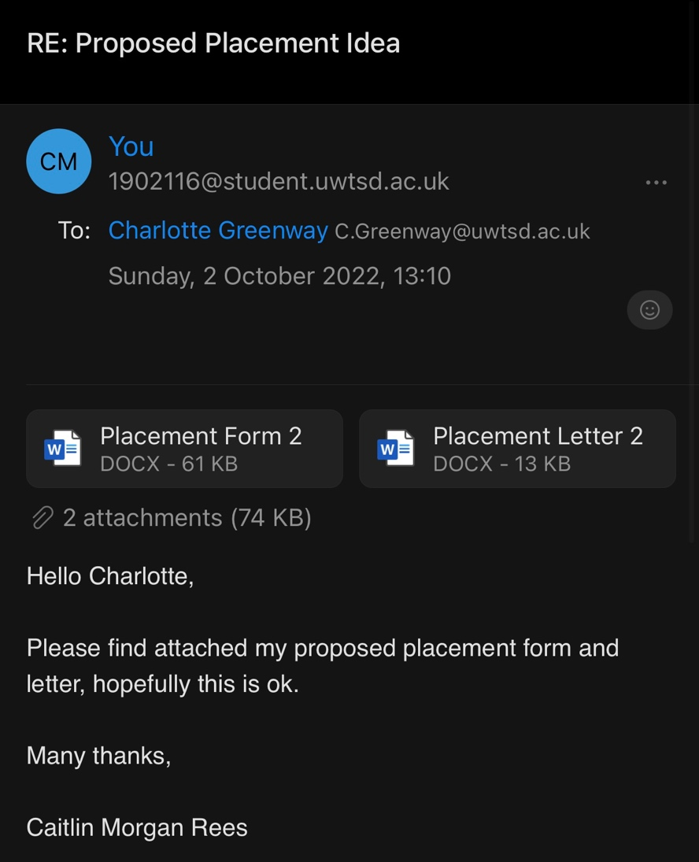
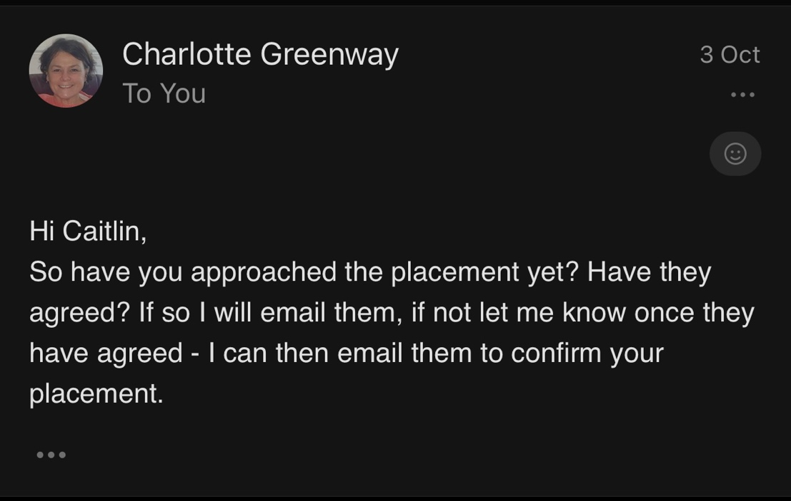

Correspondence with Lecturer – continued

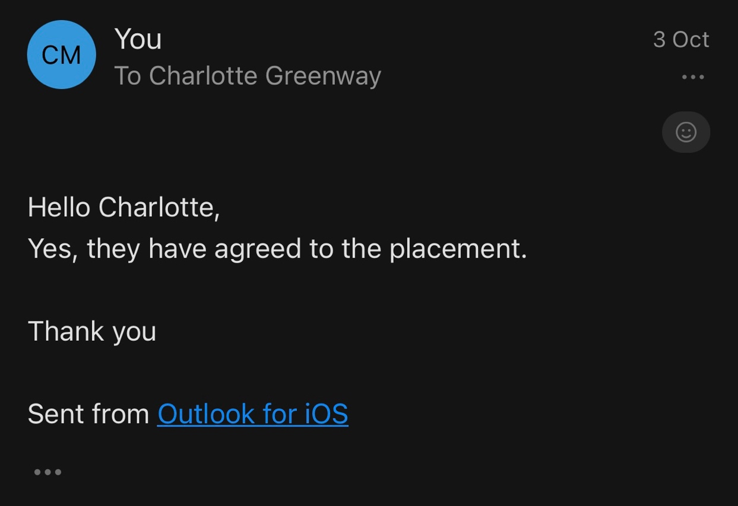

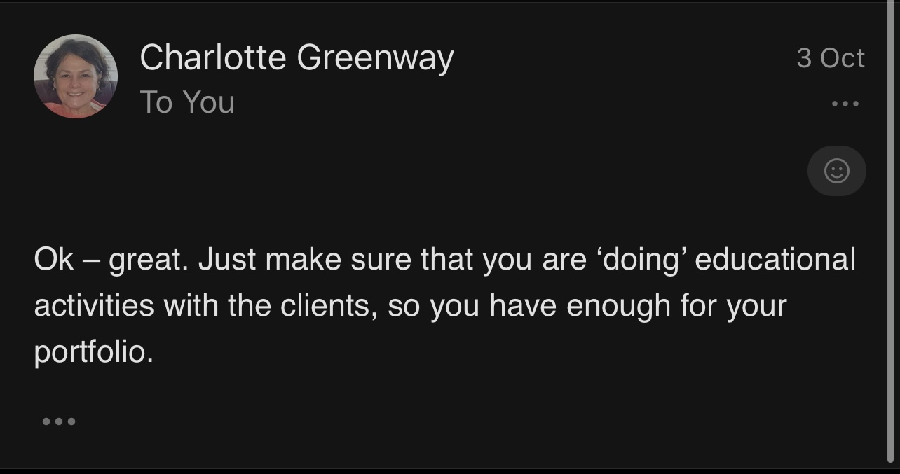

Correspondence with Placement

This is correspondence between me and the placement before beginning the placement which include the letter to placement and emails.

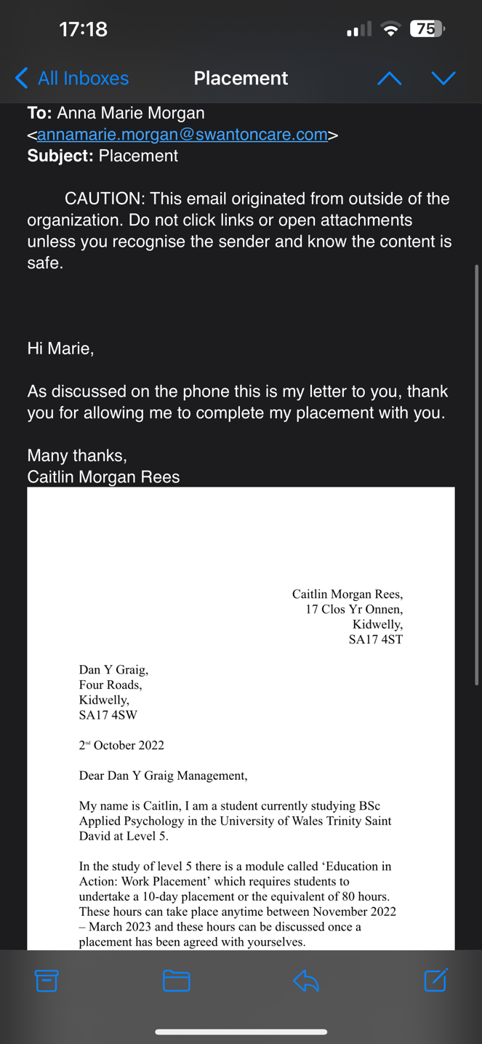
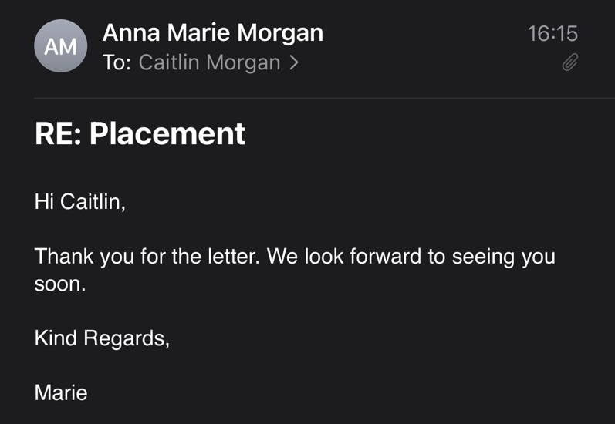

Correspondence with Placement – continued
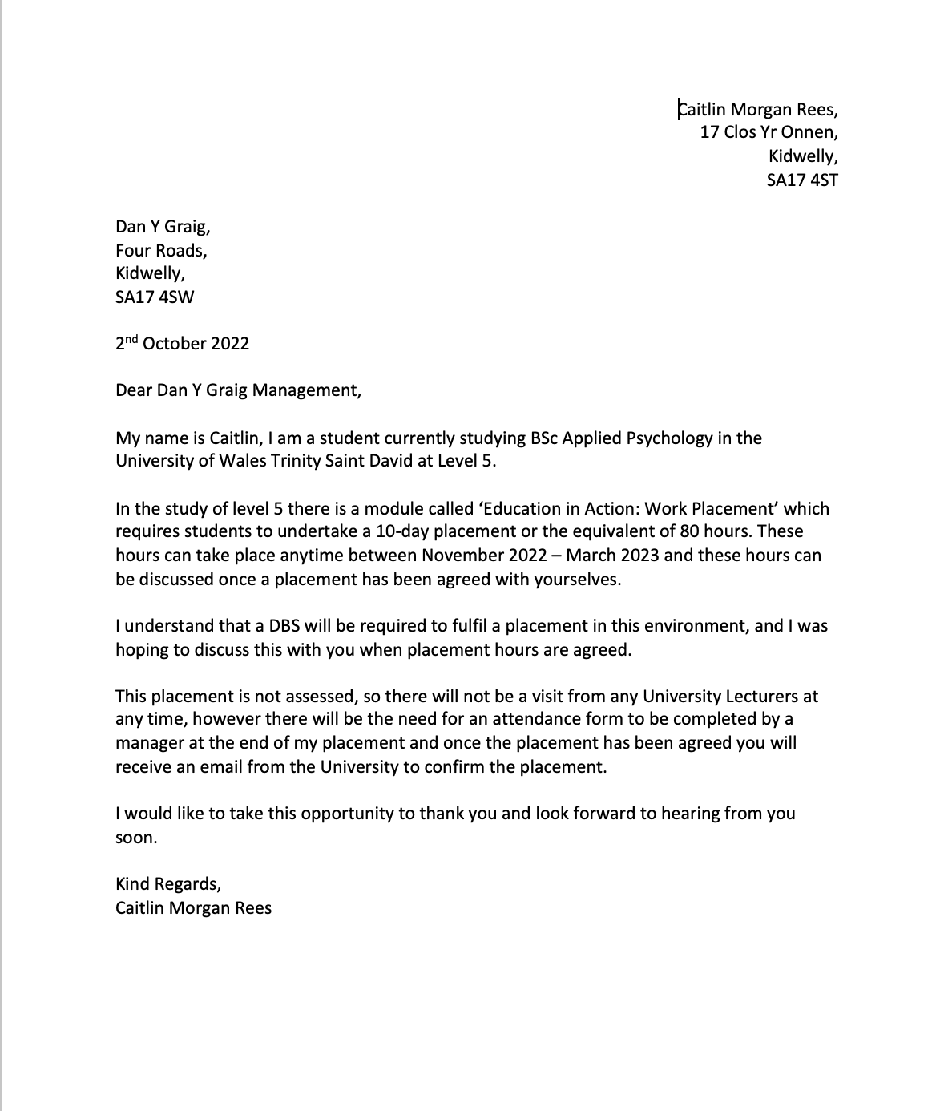

Correspondence between Lecturer and Placement

This is the correspondence between the lecturer and the placement before beginning the placement and when I had completed the Placement.

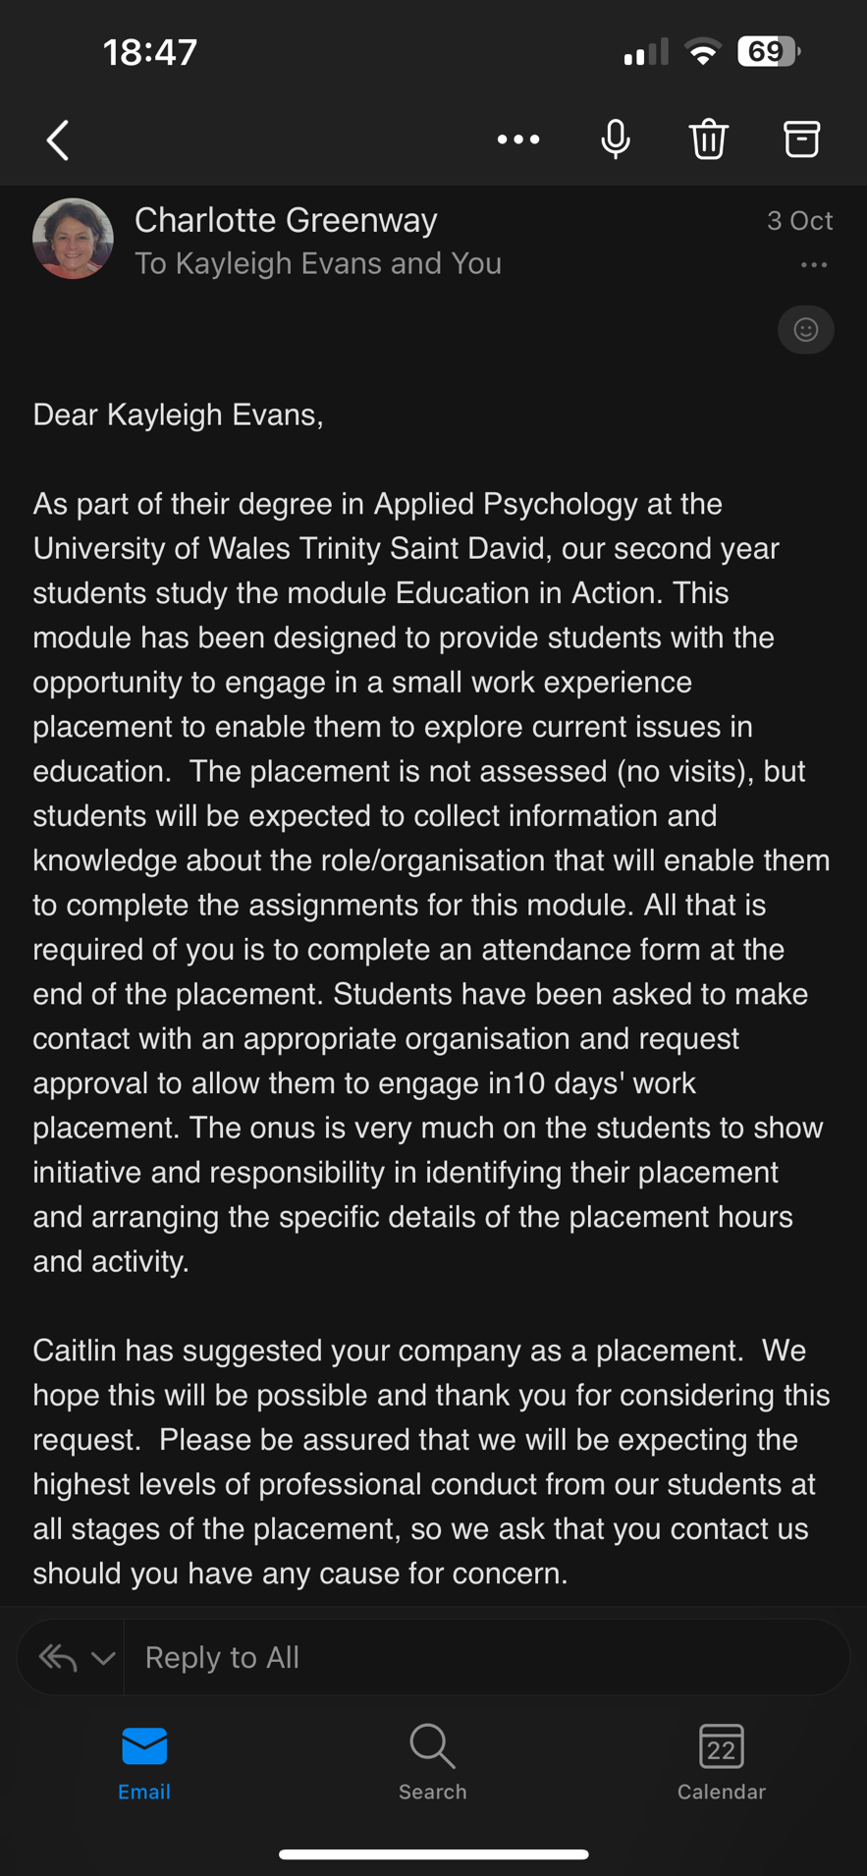

Correspondence between lecturer and Placement – continued.
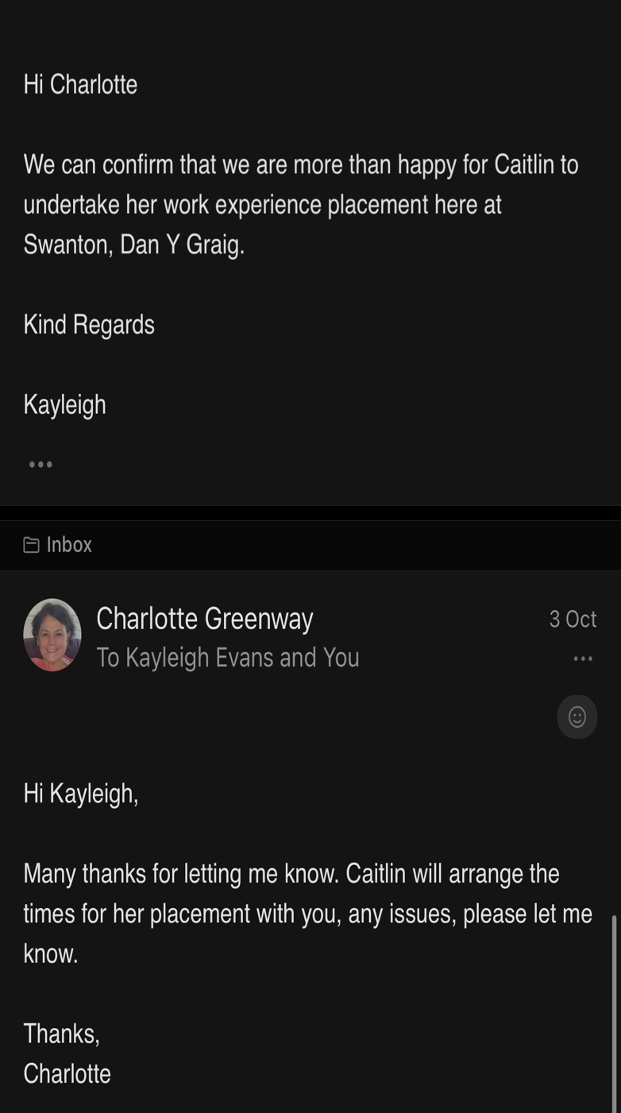
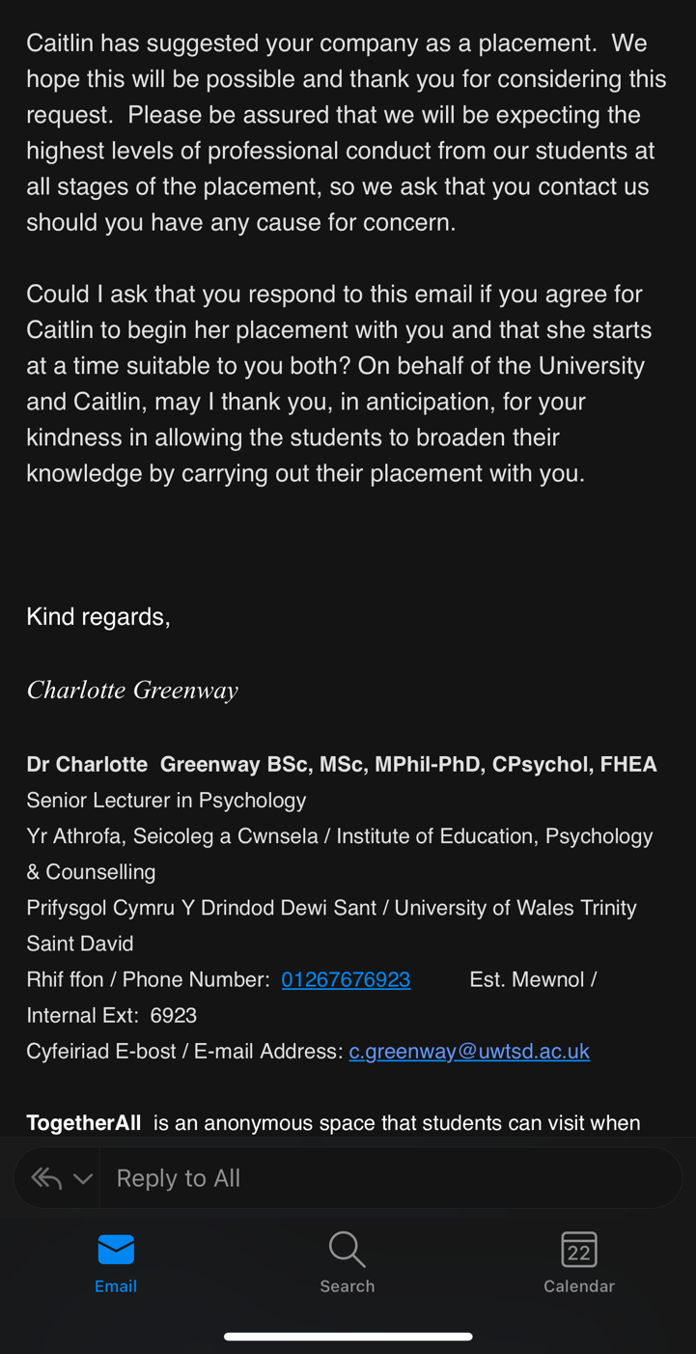

DBS

This is a copy of my DBS, which allowed me to complete my placement in this environment.
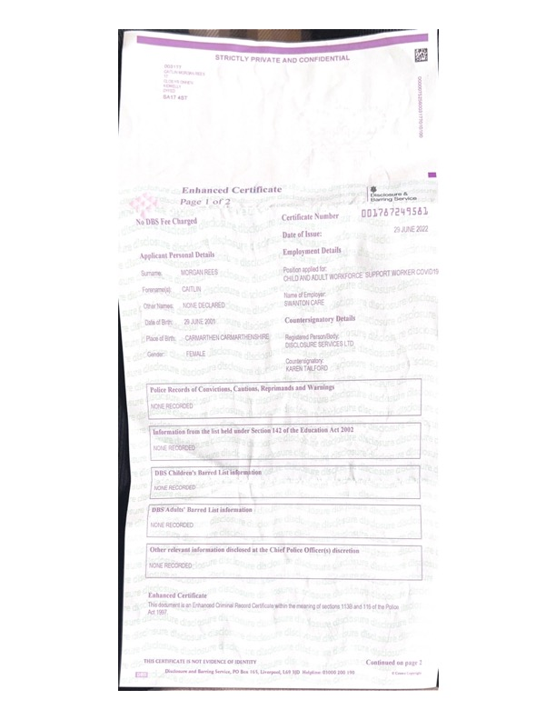

Attendance Form
This is a copy of my completed attendance form.
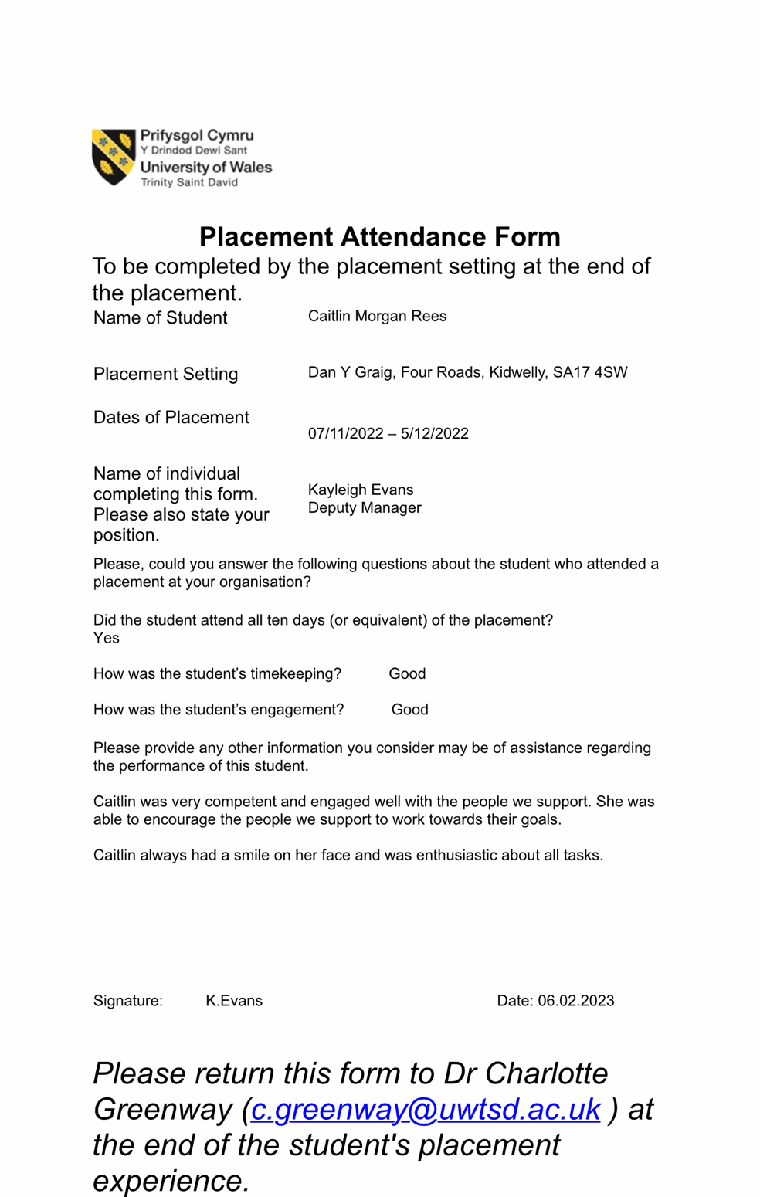

Activity One – Baking

This activity was arranged by me, it was explained to the service user they would be required to select a recipe, select the appropriate ingredients and kitchen equipment, and then follow the steps to complete the recipe. They were able to follow the recipe with some support and completed all steps involved, which was the aim of the task when initially set. My role was to support the service user when selecting a recipe, help in selecting what equipment would be needed and being able to provide support when completing the recipe if needed.

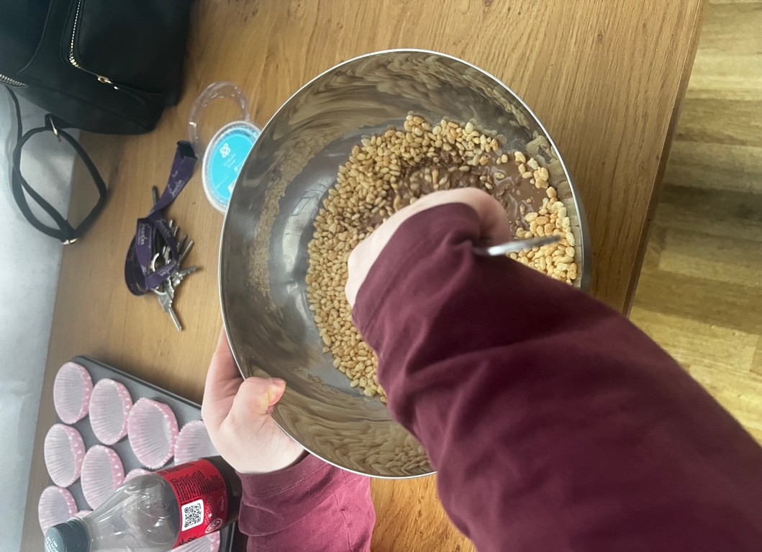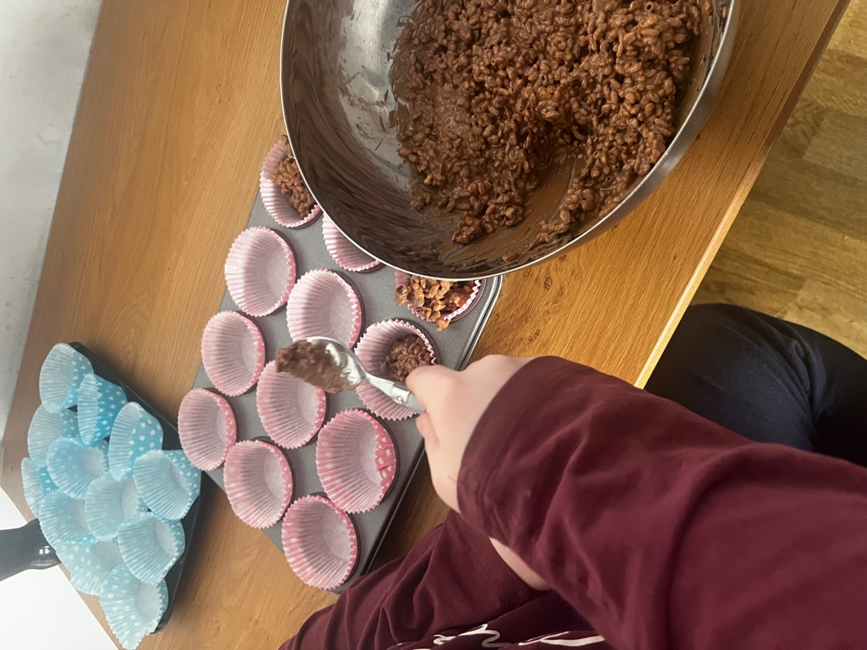

Activity Two – Money Recognition

This activity was arranged by me, as a goal this service user wanted to improve his awareness around money, so we began with counting money on sheets as a base to his knowledge and discussing how coins all hold different values and what these values were to understand how much knowledge they already had. The service user had set his own aim for this task and my role was to support him in reaching this and assist when needed.

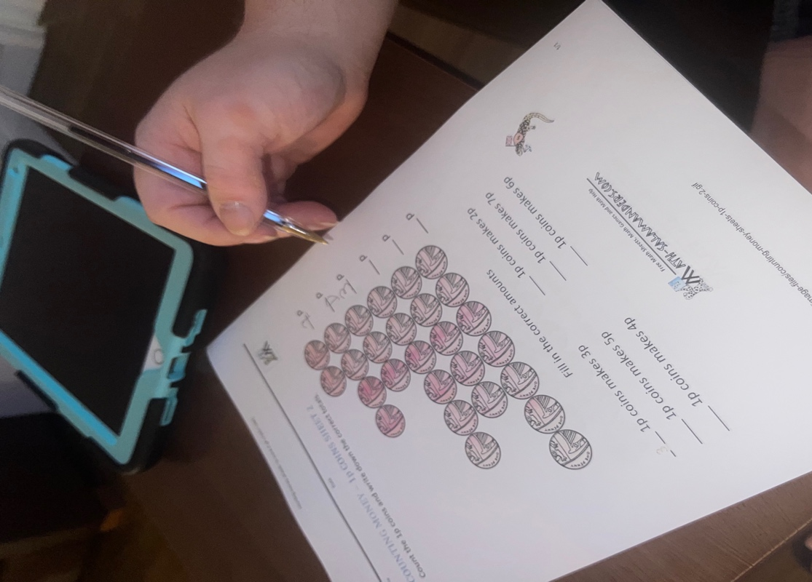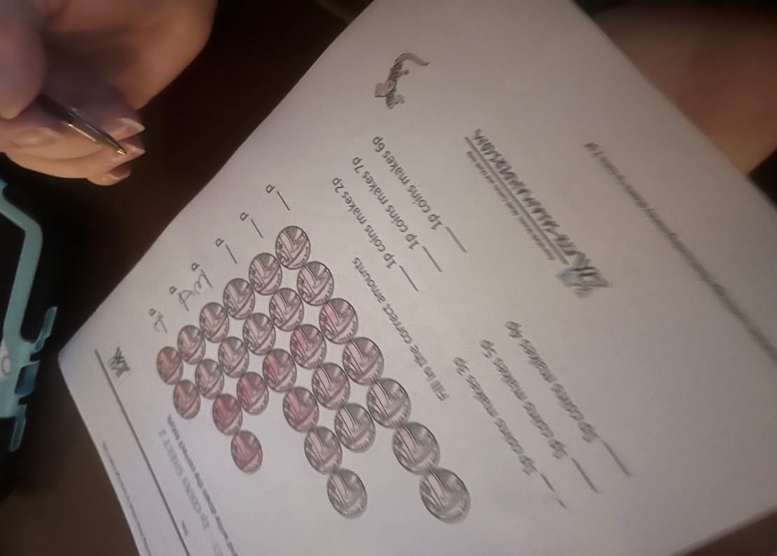

Activity Three – Emotion Recognition

This activity was set by the team leader on the day to support an individual who required support with behaviour and emotions. The task required him to match up the different types of emotions to the face that would correspond. After matching up each face to the correct emotion, we discussed the feelings that each emotion may cause and the possible reasons. The aim of this task was to explore different emotions, why they might feel that way and to understand other people’s emotions and how to recognise this. My role in this task was to ensure it was completed, support the individuals, and provide clear explanations to allow for a better understanding.

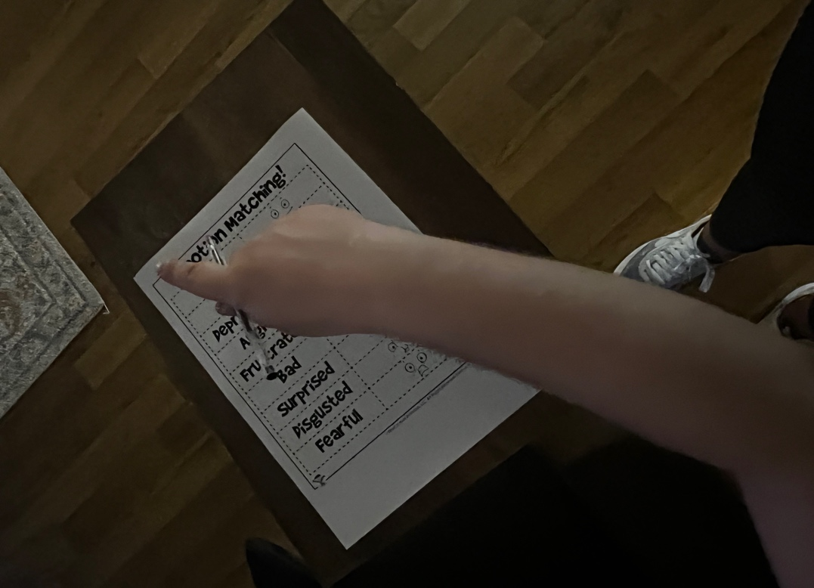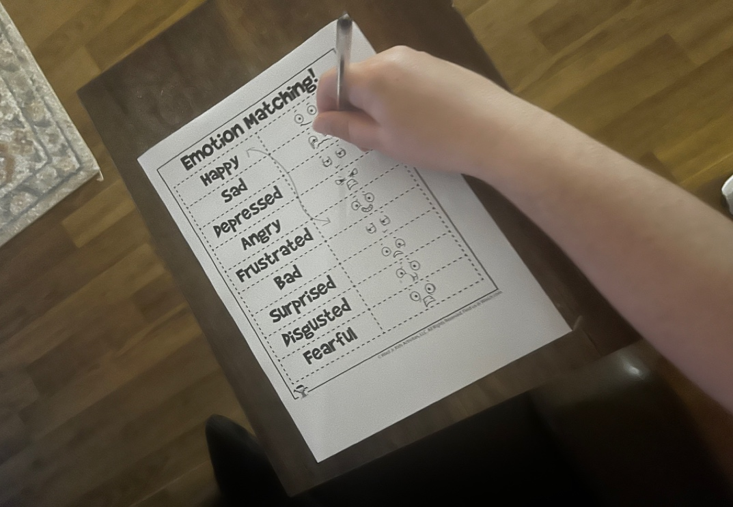

Activity Four – Life Skills

This activity was set by me, it was to encourage a service user to develop a skill set and knowledge around using the washing machine. This service user was non-verbal, so was taught through using a set of symbol cards and by providing clear instructions. We then went to the washing machine, and I demonstrated what he would need to do, the service user was then able to repeat what I had shown him with some verbal prompting. The aim of this task was to allow the individual to build skills which could be repeatedly used and to form the skill. My role in this task was to plan the activity, carry out the activity and provide support while completing the activity.

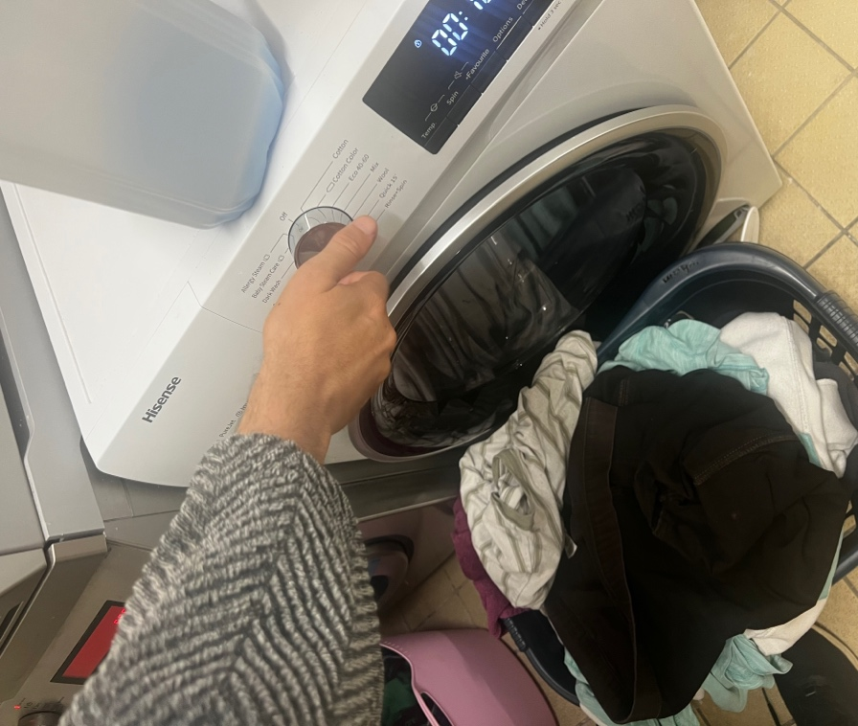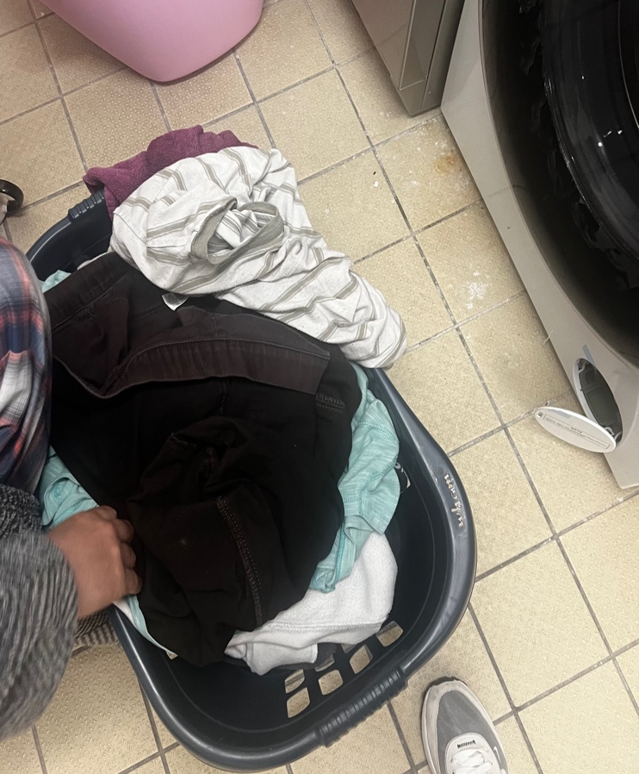

Activity Five – Lesson Plan for Activity Four

This section shows the planning which was required for activity four due to the gentleman being non-verbal, he communicated best with simple and clear instructions and with the use of flashcards with symbols/images.
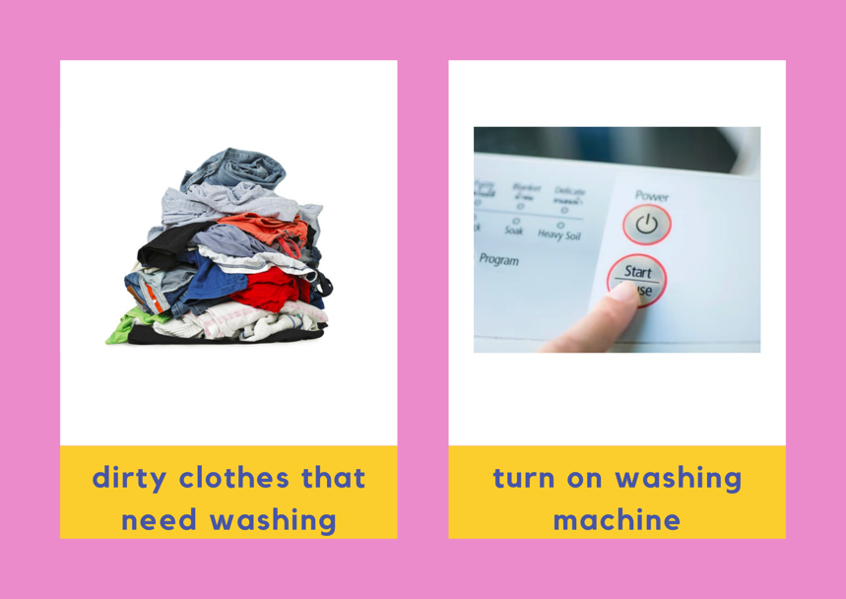
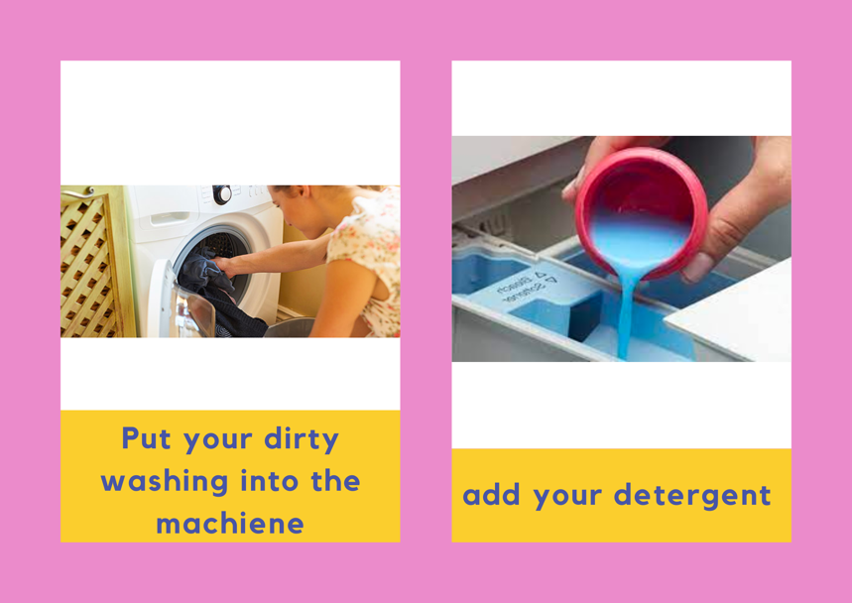
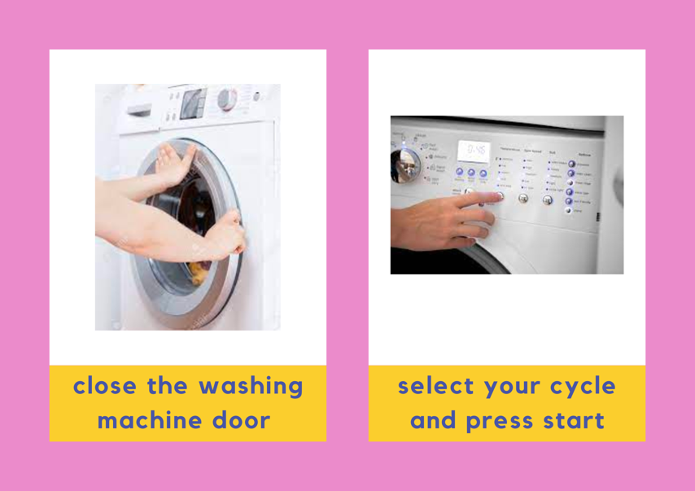

Reflective Account

Educational placements are an essential component, this placement took place in a care home setting for adults between the ages of 18-60 with learning disabilities. This placement allowed me to gain a large amount of knowledge around education, various learning disabilities and educating those with varying needs. This placement taught me ways to communicate with those with different styles of communication and how educational activities can be adapted to suit everyone. Another aspect of the placement that was new to me was planning activities, this improved skills I had like time management and creative thinking.
There were a few aspects of this placement which were new, which included planning effective educational activities, supporting others to complete educational activities, and working with adults with learning difficulties, some of which already had goals and aims in mind of things they would like to learn or skills they would like to develop. Until this point I was not required to plan effective educational activities, this placement allowed me to plan actives which were required to be adapted to suit the different clients within the home as they had different needs, I needed to bear this in mind while planning various activities which meant that all the activities were completed on a one to one basis with clients to allow to provide them with the assistance they needed. This was the first time I had supported others to complete others with educational activities, to do this I ensured I understood the activity before beginning and discussed with staff in the home the best ways to communicate with the adult I was going to be completing the task with to allow them to have the best experience. The last thing which was new within this placement was working with individuals, some of which already had goals in mind of what they would like to learn or achieve. This meant I needed to communicate with these individuals before planning any activities to see if there would be ways, I could support the clients in meeting these goals before planning activities for them.
These adults at times could show some challenging behaviours, this could include becoming verbal or at times becoming physically aggressive. The colleagues in this placement had built good relationships with the clients and knew the best ways to communicate with them and how to manage the situation due to the training they had received for times when incidents of this sort happened. During these situations staff discussed they best ways to de-escalate the situation and provided advice on what to do or say if it was to happen again.
This placement was not overwhelmingly challenging however there were aspects of the placement that were challenging at first, for example being required to adapt educational activities that I had in mind before beginning the placement to suit the clients and suit the goals that they had in mind. This meant I needed to find ways to adapt the activities to suit those who were non-verbal.
There were many aspects of this placement that were satisfying for example being able to support the clients to complete the activities and supporting the clients to meet their goals. Another aspect of this placement which was a benefit was being able to build relationships with the clients while undertaking the placement and finding ways for myself to be able to support them more effectively without needing to seek assistance from staff.
One problem during this placement was regarding clients not wanting to participate in the activities at first. I feel this could be due to them not having spent much time with me and feeling that they needed to have a better relationship with me before taking part. To resolve this issue, I communicated with the clients to build a rapport and after this the clients were more interested in completing the activities. If I was to complete another placement or be placed in this situation again before doing anything with the clients, I would build relationships and have a clear understanding of their needs to work with them in the most effective way.
During this placement I experienced a range of feelings, the main feelings were joy, anxiety at times and satisfaction. This placement provided me with knowledge on educational careers and working with a range of individuals. This placement allowed me to feel joy as I was supporting clients to complete activities and meet goals which allowed the clients to feel satisfied within themselves once the activity was completed and they had tried something news. I at times felt nervous due to being within a new environment and trying something new.

