Introduction
This assignment consists of a feasibility study of the potential of a pop-up business model in the chosen town of Carmarthen, in Carmarthenshire South Wales.
In this report into the feasibility of pop up shops will begin by conducting background research into the existing business and state of the chosen town of Carmarthen.
Following this there will be an analysis of the origin of pop-up businesses and why they have become more common in recent years and what are the ideal events for a pop-up business to be in by considering location and time of year for the pop-up business to operate.
Finally, there will be an evaluation of the positives and negatives of setting up a pop-up business within Carmarthen whilst drawing from the success and failure of preceding pop up businesses within the town.

Town centres in their existing state
Over the past few years in many towns across Wales and the rest of the United Kingdom town centres have suffered by the emergence of large out of town retail parks and online shopping giants drawing shoppers away from town centres and towards a much more condensed style of shopping where all you may need is at arms reach within a retail park and a fingers reach over the internet. The falling amount of businesses in town centres has not suddenly emerged it has been constantly there for many years although has only become bad enough not that people have taken notice only to find that it is already to late with little that can be done to revitalise town centres without extensive financial support. which does not seem to be coming as could be seen 2017 when Mary Portas presented a report on how to revitalise twelve town centres across England and after presenting the government with the report was only given one million two hundred thousand pounds to proceed with (Hattenstone, 2019).
There have been many other signs of the decline of the town centre with the customers preference for online ease other a want for a physical shopping experience. This observation can be seen when in 2015 Amazon surpassed Walmart as they most valuable retailer in the United States and then increasing its value even further to that of two point five times greater than the value of Walmart (Moore, 2019).
Town centres have had a hard time over the pest recent years in terms of closures and size reductions with shops that are an integral part to the highstreets closing such as Woolworths closing for good with many other shops such as Toys R Us, Debenhams, House of Fraser and Mother care either reducing their number of stores to stay profitable or accepting termination.
In 2018 there were 22,000 jobs lost as a result of the struggling state of the countries struggling high streets, from shop closures and retail administration it has been found that more the seven thousand people have lost their jobs. Furthermore, there are a following nine thousand five hundred job roles expected to be cut due to planned closures and an additional five thousand one hundred roles are in doubt as a result of Poundland going into administration (Benson and Ugolini, 2003).

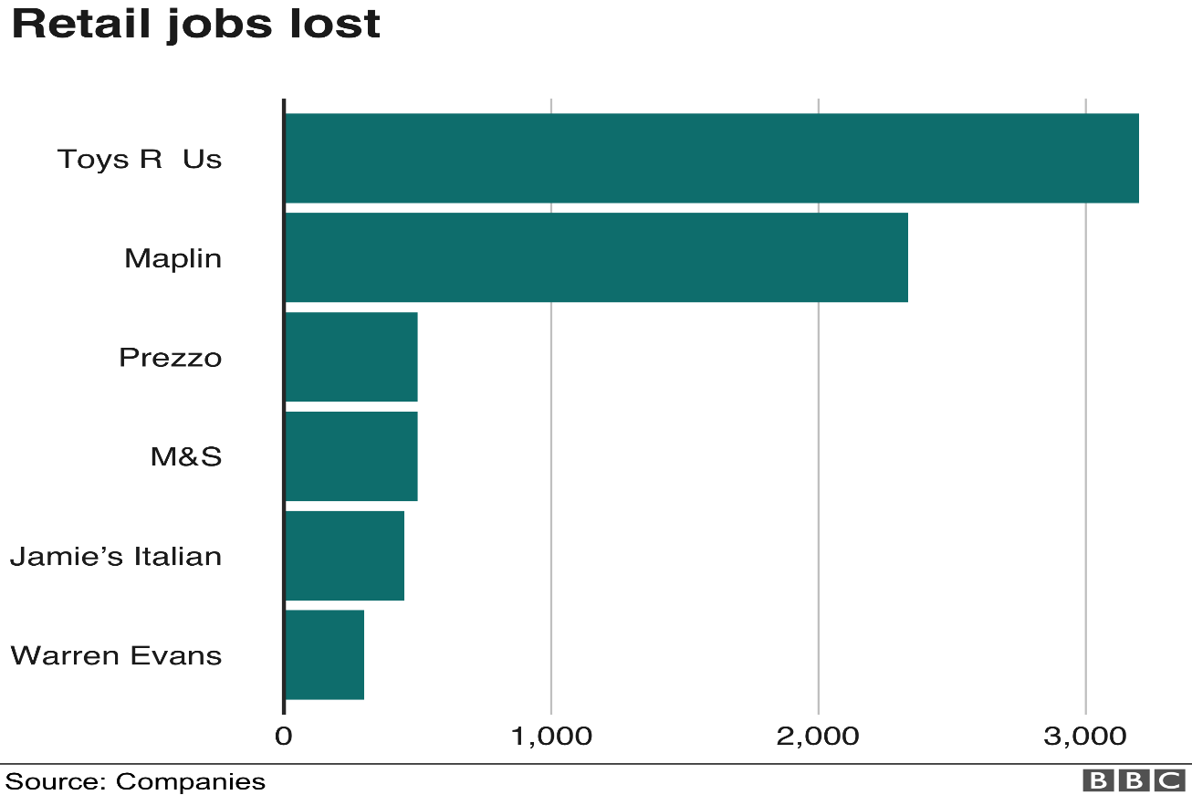
Above you can see six retail stores with high job losses over the past year and this trend is set to continue with more store closures planned and job losses threatened. From the graph bellow you can see that there is the expectation for six thousand job losses from house of Fraser alone with few losses expected from retailers such as New look and Marks and Spencer’s.
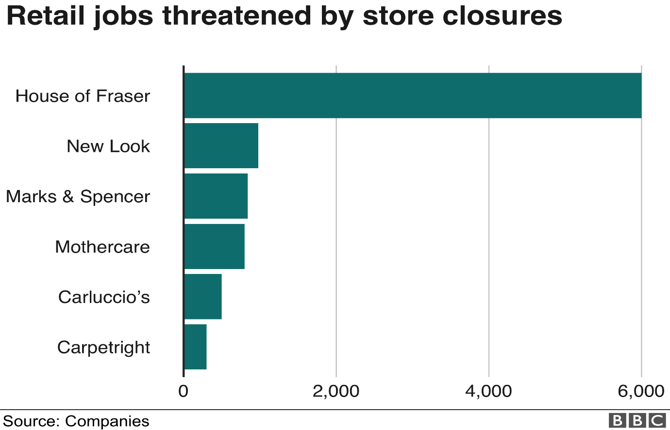
Despite the current state of the retail industry and the future plans for further decline national unemployment is still at a forty year low showing that two million and ninety-two thousand people worked in retail (BBC News, 2019).

What is behind the Highstreet crisis
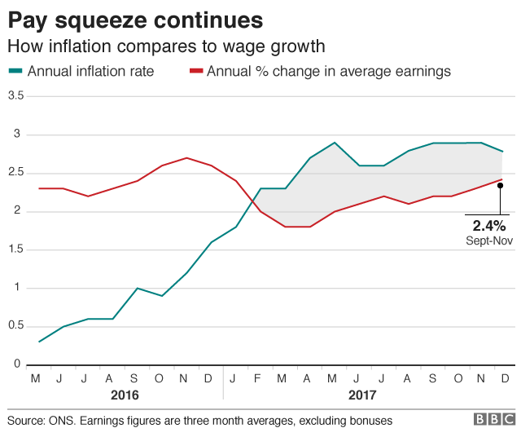
Possibly the largest factor that has attributed to Highstreet crisis is a more pressed income with a weak wage growth and spike in rising prices has led to a fall in retail spending. This can be attributed to a steep drop in the value of the pound by almost fifteen percent since the Brexit vote which has led to an increase in inflation by three percent, far above the national target of the bank of England of two percent. Inflation has risen at a higher rate than average earnings as can be seen below means that people have less disposable income (BBC News, 2019).
Brexit is not the sole reason for the struggling rate of income but was the straw that broke the camel’s back as the retail sector was already experiencing difficulties such as high business rates and online shopping taking business, however since the EU referendum retail growth sales have become much weaker than anticipated.
The largest online retailer is amazon, amazon has had an enormous impact on the Highstreet because of the ease that it provides by removing the physical need to look through multiple stores for a single item you can now enter the name of the product that you are searching for and find a multitude of different options to choose from and are often at cheaper prices than in retail stores.
In attempt to combat online stores retailers are adapting the ways in which their stores function such as Debenhams and John Lewis holding more instore events in an attempt to attract more customers, if shops fail to do this in an affective way by either providing convenience, value or a new experience they may fail and force to close (Grimsey, 2012).

As time goes on tastes change and stores should be able to recognize this and change the way in which they function to accommodate the new needs of their customers. When stores do not change with tame become stagnant and often lead to difficulty as was the case with Toys R Us which couldn’t be saved as it was not reflective of what customers wanted from a store anymore.
Increasing overheads are a source of concern for retailers these overheads are not just inflation but also increases to the national minimum wage and living wage for over twenty-five year olds increase businesses overheads. The national living wage alone costs industry between one and a half and three billion per year.

The current state of Carmarthen
Carmarthen is a small town in South West Wales located up from Llansteffan on the river towy. Carmarthen began as a small port and transformation hub in the middle ages which primarily delt in cattle and dairy. Carmarthen has a population of over thirteen thousand people with Carmarthenshire as a county having a population of over one hundred and eighty thousand people across its county, from the total population two-point eight percent of the population receive job seekers allowance which is less than the rest of Wales’s counties which receive on average of three-point six percent receive job seekers allowance (Morgan, n.d.).
Carmarthen’s economy mainly depends on agriculture such as farming livestock and crops, forestry and fishing however the largest economic factor that impacts Carmarthen is its tourism industry. This is because of the low levels of profitability from the fishing and forestry industry as well as Carmarthen being a desired tourism destination for visitors from across the United Kingdom and further on.
As a tourism destination Carmarthen offers a large range of outdoor activities such as the millennium costal park, the Dylan Thomas boathouse and Carmarthen’s Medieval castle that attract tourists all year round. Another attraction in Carmarthen with historically significant is St. Peters church which was constructed in the fourteen century and is the largest church in the diocese of St. David’s being sixty meters long and fifth teen meters wide and because of its historical significance is a listed building within the town (Andrews et al., 2004).
To get to Carmarthen it is rather simple as there is only one main road that leads into Carmarthen, this link begins at London with the M4 and ends in Carmarthen giving tourists an easy time locating the town. Carmarthen then is linked by only two other main roads one leading to Llandeilo and the other leading to Pembrokeshire which is also a notable tourist destination by to reach there all must first travel through Carmarthen. Historically this has meant that Carmarthen is a vital trading and transportation hub linking the South West of Wales with the rest of the world although today this translates to Carmarthen being an overly congested bottleneck.
Carmarthen is a well-developed town, Carmarthen has grown is size over the years as the population increases and Carmarthen’s economy is growing which can be seen between 2015 and 2016 with the creation or birth of six hundred and sixty-five businesses and the closure or death of 615 businesses showing that more businesses are being created than there are businesses closing within the town. This shows that there is the demand for more shops in the town and people are seeing opportunities to create their own businesses and strive for further success. (Carmarthenshire.gov.wales, 2019)

There and new developments in Carmarthen such as St. Catherin’s Walk which has introduced many new businesses to Carmarthen such as Pizza Express, Debenhams and a Vue cinema to the town. However, these new development areas have mean that the primary economic area of the town has been moved causing shops that are in other areas of town such as in Kings street to suffer from the fall in foot traffic. To combat this there have been pre-emptive regneration solutions such as Merlin’s walk by alerting the aesthetic of the street to appeal more to shoppers before too much business is lost from the area.
Carmarthen has a wide range of events that are ongoing through the town that attract visitors such this year being the first year that Carmarthen has hosted a Winter Wonderland to has attracted many to the town’s population and more from across the county. Before this Carmarthen was involved in the Tour of Britain that involved revitalising the towns roads and most areas of the town where visually enhanced to hopefully attract visitors to the town who watched the Tour on television (Carmarthentowncouncil.gov.uk, 2019).

What is a pop-up shop?
pop-up retail shops open on a temporary basis to take advantage of a trend and temporary products such as Christmas related products that are only popular in the last few months of the year on the run up to Christmas. Demand for products in retail pop-up shops are often short lived and usually appear in the toy industry with the target market of children and families, retail industry selling clothes and fashionable items to young adults however the target demographic changes based on the specific items sold. Also, pop-up shops that focused around selling food are incredibly popular as they can offer a new experience compared to pre-existing restaurants and food venders in the area. (Investopedia, 2019).
In 1298 pop up retailers emerged in Vienna during the December markets and the Christmas markets that followed around Europe. Pop up stores then expended as opportunistic entrepreneurs realised that seasonal periods and holidays offered a business opportunity that could be very profitable. Holidays such as seasonal farmers markets, Halloween costume shops, firework stalls and event specific retailing where some of the initial examples of pop up retailing opportunities.
With pop up businesses there are many advantages over that of stationary traditional businesses one such example is low overheads, pop up businesses are able to take advantage of prime locations as rent us usually lower because they are a non-permeant fixture in the retail area and also usually do not have to pay large upfront costs and fees that other larger stores would have to pay for the location. Pop up stores are also able to close if they do not meet targeted overheads.
Pop up businesses are able to market test their products so that they are able to identify what products are selling better than others, this information can be used to work out what will be in demand in the future and accommodate this. Pop up businesses also generate a buzz within a town as they are new and offer a new experience and range of products that is not found within the town’s usual shops. As pop-up shops are delivering new types of products, they have increased levels of sales as they are the sole supplier of certain products and services. This is only inflated when a pop-up shop is focused around a holiday event where people usually spend more than usual such as Christmas and Halloween (Shoppinpal.com, 2019).

Pop-up business opportunity in Carmarthen
The pop-up business that I would set up is a sporting goods store that focuses on officially branded clothes and footwear from accredited supplies that supply products from companies such as Nike, Adidas, Under Armour and Lonsdale.
The reason that I would choose to set up this type of pop us store is that there is no other shop in the town that sells sporting goods and gear, the closest shop that sells sporting great is sports direct which is located off of the Pensarn road in Stephens Way retail park. This is a fifteen-minute walk out of town as can be seen bellow.
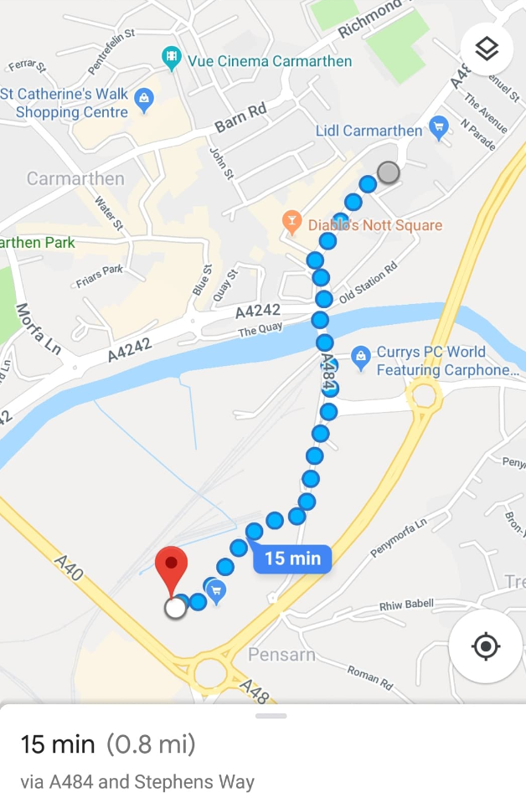
The location I would like for the pop-up shop would be alone St. Catherin’s walk in the centre on Carmarthen, this location will be ideal for a pop-up business as the area has high levels of foot traffic and is close to a multi-storey car park as well as the market stalls that also attracts people to this area of the town.
The demographic that will be targets will be primarily between the teenager and young adult demographic with an age range of fifth teen to twenty-seven years old. The ideal time to open the store will be in mid-September because it will be open in time for the students return to university as well as generate interest on the run up to Christmas. Then staying open the end of January, for the January sales in the beginning of the month and then further student sales as students return from their Christmas break at the end of January.

Bibliography

Andrews, R., Brown, J., Humphreys, R., Lee, P., Reid, D. and Teller, M. (2004). The Rough guide to Britain. New York: Rough Guides.
BBC News. (2019). High Street woes hit 22,000 jobs in 2018. [online] Available at: https://www.bbc.co.uk/news/business-44676494 [Accessed 17 Jan. 2019].
BBC News. (2019). Six reasons behind the High Street crisis. [online] Available at: https://www.bbc.co.uk/news/business-43240996 [Accessed 17 Jan. 2019].
Benson, J. and Ugolini, L. (2003). A nation of shopkeepers. London: I.B. Tauris.
Carmarthenshire.gov.wales. (2019). Economy. [online] Available at: https://www.carmarthenshire.gov.wales/home/council-democracy/research-statistics/economy/#.XD9Wzlz7RhE [Accessed 17 Jan. 2019].
Carmarthentowncouncil.gov.uk. (2019). News & Events - Carmarthen Town Council. [online] Available at: http://www.carmarthentowncouncil.gov.uk/News__and__Events_1927.aspx [Accessed 17 Jan. 2019].
Grimsey, B. (2012). Sold out. Filament.
Hattenstone, S. (2019). Mary Portas: 'I'm one of the best in the world at retail'. [online] the Guardian. Available at: https://www.theguardian.com/lifeandstyle/2014/may/17/mary-portas-im-one-of-the-best-in-the-world [Accessed 17 Jan. 2019].
Investopedia. (2019). Pop-Up Retail. [online] Available at: https://www.investopedia.com/terms/p/pop-up-retail.asp [Accessed 17 Jan. 2019].
Moore, R. (2019). After the retail apocalypse, what next for the high street?. [online] the Guardian. Available at: https://www.theguardian.com/society/2018/dec/01/everything-must-go-what-next-for-the-high-street-new-retail-empty-shops [Accessed 17 Jan. 2019].
Morgan, K. (n.d.). Carmarthen through time.
Shoppinpal.com. (2019). Benefits of Popping Up a Pop-Up Shop – ShoppinPal. [online] Available at: https://www.shoppinpal.com/benefits-of-popping-up-a-pop-up-shop/ [Accessed 17 Jan. 2019].

