Introduction
Launched in 2018 by Welsh Government, “A Healthier Wales” (AHW) focuses on the transformation required to achieve an integrated whole system approach to health and social care. The overall vision of this long-term plan is to support people to stay well, providing a person-centred and community-based approach to care using the latest medicines and technologies (Gething, 2021). Accelerated by COVID-19, elements of transformational change have already occurred with investment in digital technology supporting new models of care, however a subsequent review brought to light some new priorities in 2021 (Paget, 2022).
A key focus remains on ‘community-based’ care, the rationale being that this will help take pressure off hospitals, reduce treatment wait times, and when individuals need to be in hospital reduce length of stays. One revised action is to “Develop value based, whole system care pathways for prevention, detection, treatment and ongoing care as close to home as possible and ensure that relevant measures are developed to capture the outcomes that matter to patients” (Gething, 2021).
There are several different required elements which this specific aim encompasses including the provision of seamless care and integrated services, with a focus on more services being available locally. Improved information sharing and data access is going to be a key service improvement required to help achieve this aim. Services will be safer and more effective if the full picture of an individual’s care and treatment is shared with those responsible, enabling personalised plans of care to support clinical decision making and provide more predicable outcomes.
For services to be seamless, relationships between providers and processes need to be built upon, including step-up/step-down from community to hospital admission. It is key that the NHS works with patients, carers, and communities in partnership across NHS organisational boundaries and with other public services including Regional Partnership Boards. Reducing variation and ensuring equal services to patients wherever they live is particularly challenging in rural areas of Wales. For example, within Powys there are no district general hospitals so multiple services are commissioned to other trusts, including those in England. Therefore, to provide care “as close to home as possible” community hubs and primary care services need to be developed.
Having up-to-date, accurate and accessible data will be key in enabling detection and prevention as advanced analytical methods can be applied to interpret and model data using tools such as artificial intelligence (AI) and machine learning (ML). For this to occur there needs to be investment in the digital workforce with teams developing these technical capabilities.
Investing in assistive technologies and remote monitoring will allow data to be streamed from individuals’ homes, offering real-time support and provide opportunities for patients and professionals to detect early signs of potential deterioration. These intelligent alerts will enable patients to remain independent in their homes for longer and provide a more holistic view of a patient’s wellbeing than would be achieved from fixed-interval outpatient appointments (Martin, 2020).
Providing patients with a platform to contribute and access their data will also enable patients to become more involved in their care, enabling patients to make informed decisions regarding their preferred treatment, find appropriate services as well as create feedback mechanisms. Involvement and engagement with patients will help to build a platform where measures which are important to patients can be determined, helping to achieve another key part of the community-based aim. Agreeing data standards and setting person-centred measures will subsequently enable the use of data to improve service delivery.
Methods
Considering the service improvements identified, technological requirements were derived based on a combination of literature research, conversations with colleagues and personal experience of application design, data storage and data analysis. Known best practice and technical standards formed a basis in determining several digital requirements.
As per the process model of requirements elicitation (Sommerville, 2016) conversations with stakeholders highlighted certain requirements which could then be classified and grouped together. Taking a socio-technical systems design (STSD) approach (Baxter & Sommerville, 2010), considering both technical and organisational aspects provided a better understanding of how work is done, and systems are used. Subsequently leading to a technology which can be developed based on real operational demands.
Multiple software engineering quality models were considered for requirements identification, one being the commonly used FURPS model which considers functionality, usability, reliability, performance, and supportability. A comparative study by Al-Qutaish (2010) found this model to consider the least number of factors and determined the ISO 9126-1 model to be the most useful as developed based on international consensus and agreements from ISO organisations. ISO 9126-1 substitutes performance and supportability, with maintainability, efficiency, and portability.
Additionally building upon Lean and Agile development, the Scaled Agile Framework (SAFe) requirements model (Scaled Agile, 2021) provided a framework for expressing system behaviours through Epics, Features, User Stories etc. Within the Powys Teaching Health Board (PTHB) informatics team these are already familiar concepts as are used for work planning within Azure DevOps. Scaled Agile (2021) also recommend a features and benefits (FAB) matrix as the best method of identifying functionality which will benefit users in multiple roles.
Specific literature such as the Department of Health & Social Care’s guide on good practice for digital and data-driven health technologies (2021) and the NHSX developed Digital Technology Assessment Criteria (DTAC) (2021) provides a clear direction for the purchase and build of digital health technologies, of which the baseline criteria ensures standards for clinical safety, cyber security, interoperability, and accessibility are met.
In terms of carrying out a gap analysis, Leonard & Bottorff (2022) suggest a four-step approach; first identifying the current situation and most important aspects, before determining SMART goals to remove ambiguity and provide the opportunity to measure progress and success. Lastly, by evaluating gaps establishing a plan to close them, which is closely linked and leads on to the options appraisal. Discussions with colleagues has evidenced current perceived gaps in relation to the AHW community-based care aim. Due to the aims focus on having a seamless whole pathway approach, drawing on evidence from Audit Wales’ (2020) assessment of the Welsh Community Care Information System (WCCIS), a system intended to enable the integration of community care, also helped identify gaps in this specific system.
An options appraisal was subsequently used to review and identify the most fitting delivery model and implementation strategy. Conducted using the principals set out within the Local Partnerships Options Appraisal Workbook (2012), the service need, key objectives, and potential delivery options were identified. Consideration was given on how to undertake the appraisal, the evaluation criteria. Information gathered from the gap analysis was used to make an informed assessment. The appraisal was conducted by scoring against weighted criteria, and as endorsed by NICE (2007), SWOT analysis was used per option to identify strengths, weaknesses, opportunities, and threats.
Results
To support the identified service improvements key technological requirements have been split into separate categories.
Functionality – As per STSD, it is important for the functional requirements of the system to detail what the system should do and therefore are based on data collected from conversations with users and professionals. Such conversations highlighted areas of functionality which were particularly important to users of the system including elements missing from current systems.
The system needs to:
- Interface and link patient records together, displaying data from across all health systems to provide a seamless/whole care pathway. It should be clear which system a specific data item has come from.
- Have search functionality across multiple elements including patient demographics such as NHS and hospital number, name, date of birth, address, as well as custom search criteria for example clinic appointments for the current day, all patients open to a certain team/consultant or with a certain diagnosis. Returning records which are relevant and an accurate reflection of the search criteria.
- Have a secure data access model, allowing all individuals involved in a patients care to view their full care record. To provide the ability for staff to grant and revoke access as required.
- Have a patient portal so patients can access their own record of care. Providing the opportunity to self-refer, directly contact to health professionals and comment on elements of their care record.
- Have an online help/chat bot facility to provide both patients and professionals with the latest, reliable advice/guidance and appropriate signposting.
- Have workflows enabling review and approval cycles guiding users to follow consistent business processes.
- Provide diary and appointment scheduling across multiple settings including outpatient, community, group, and virtual, linking to Office365 Outlook calendars.
- Send and receive message notifications including e-mail as well as producing and printing physical letters.
- Supply automated alerts to system users and professionals when certain events are scheduled, or changes identified with patient data.
- Provide a clear view of inpatient stays including the patient’s current location using ward and bed management.
- Enable the recording of physical observations and diagnostics. Acting as a central location for patients’ results such as blood and urine tests as well as X-Rays and ultrasounds.
- Provide the functionality for patients to upload and monitor their own stats from assistive and remote monitoring devices.
- Provide general functionality and fields for patient demographics, referrals, appointment records and case notes.
- Meet the specific requirements for individual workstreams or service areas. As an example, the detail recorded, and fields required by physiotherapy professionals will be different to health visitors and midwives.
- Have audit functionality within the system for clinical and patient safety. Records should automatically be updated with create and modified dates and retain a clear audit trail displaying who has accessed and viewed certain records, any changes made, and specifically what the new and previous values were.

Non-functional requirements (NFR) - In terms of NFR, whilst more generalised, several requirements are defined by best practice and legislation.
The system needs to:
- Be compliant with the Clinical Safety Standards; DCB0129 and DCB0160 which are mandated under the Health and Social Care Act 2012 (NHS Digital, 2020a).
- Be available and secured over the public internet, enabling professionals to work flexibly from a range of locations with different access methods in line with NHS England’s Internet-first policy and principles for digital service (NHS Digital, 2020b). Facilitating mobile/offline working in areas with no internet or network coverage.
- Be compatible with different internet browsers and computer systems.
- Comply with cybersecurity legislation, meeting the OWASP Application Security Verification Standards. (Department of Health & Social Care, 2021)
- Use multi-factor authentication (MFA) to provide additional system security such as the prevention of phishing attacks (The National Cyber Security Centre, 2018)
- Use Single Sign-on (SSO) to “reduce the threat of untimely termination/identity decommissioning” reducing the amount of separate and incompatible user accounts required for different NHS systems and preventing “identity sprawl” (Davis, 2020).
- Meet ISO standard 9241-210:2019, the best practice guidance ensuring users are at the centre of the decision-making process (Väänänen, 2022).
- Allow evolutionary development and customisations including adding additional reference data, the creation of additional system fields and whole screens based on new data requirements or service requests
- Have an easy to navigate user interface, uncomplicated to use. Organise system modules and present data clearly, grouping relevant data items together.
- Have an intuitive system flow developed with real use cases in mind, preventing the need for workarounds and inconsistent use.
- Be accessible and useable by those with different physical, cultural, and learning needs.
- Meet level AA, the minimum government accessibility requirement for the internationally recognised Web Content Accessibility Guidelines (known as WCAG 2.1) (GOV.UK 2021).
- Consider Welsh language requirements in line with the Welsh Language (Wales) Measure 2011 and the Code of Practice for the Welsh Language Standards Regulations 2015 (Welsh Language Commissioner, 2015).
- Have good, reliable performance with limited downtime. Define SLAs to monitor this, specifying expected availability percentage, mean time between failures, as well as acceptable load, refresh, and user response times.
- Be scalable and have the capacity to cope with increased workloads.
- Be GDPR compliant and in line with data protection laws and the Caldicott Principles.
- Contain data which is dependable. Any system calculations need to be accurate.
- Have disaster recovery and business continuity plans in place, including system recovery and failover process.
- Provide technical assurance, with appropriate test environments so validation, load performance and regression testing can be carried out.
- Have appropriate data linkage procedures.

Data collection and analysis – Data forms an important element of the required service improvements especially in terms of capturing measures that are meaningful to patients, enabling informed decisions to be made, assisting in prediction, detection, and prevention.
- Have mechanisms in place so that patient feedback, including specific patient-reported outcome measures (PROMs) and patient-reported experience measures (PREMs) can be obtained.
- Patient records must be complete and of good, accurate quality. Data needs to be consistently recorded and accessible.
- The system needs to balance fields which are mandatory, containing options for specific reference data values as well as free-text fields which could be reported on using Natural Language Processing (NLP).
- Fields within the system need to be designed so that they are used consistently. For example, having generic and unspecific date fields leaves the interpretation of what the data item relates to down to personal perception.
- System data should be stored in a live database such as SQL Server for structured and MongoDB for unstructured data. The likes of which would be regularly backed up and have failover clusters.
- Information teams should be easily able to access, extract, transform and load (ETL) both stream and batch data into local data stores. Recommendation that local storage of data be within a cloud data lakehouse, combining the flexibility, cost, and scale of a data lake with the benefits of a traditional data warehouse (Oreščanin & Hlupic, 2021)
- Data processing and analysis to be unrestricted in the language used such as Python, R, and T-SQL
- ETL should be unrestricted and be possible through a range of tools such as SSIS, Azure Data Factory, Databricks and Kafka
- To utilise cloud-based technology for ML and AI. Using predictive analytics to aid early detection, inform future investments, and highlight patterns within data.
- Use data visualisation tools such as PowerBI to present data in an eye-catching and engaging way, providing insights, and driving business decisions.
- Invest in data engineering and data science to ensure teams have the technical skills to carry out and present useful analysis.

Knowledge management – Wachter’s (2016) review identified gaps in digital skills and training, and similarly Neve et al. (2020) emphasised the need for an increased presence of digital health within the medical curriculum. As well as embedding digital health technology within undergraduate courses, education and training also needs to be integrated into continuing professional development (CPD), with defined competencies which are regularly assessed.
- There needs to be a consistent national approach and direction for use and development, including rapid decision cycles so required changes can be implemented without delay.
- Best practices for both system users and system administrators should be documented and openly shared, with services and teams having consistent workflow processes.

Technical standards - To provide a seamless care journey, it is important that relevant technologies in the health and social care system are interoperable, in terms of hardware, software and the data contained within them.
The system needs to:
- Be in line with the UK Government open standards principles (GOV.UK, 2018)
- Be in line with NHS Digital (2020c) Interoperability Toolkit which is aligned with HL7, providing specifications and technologies which are consistent across multiple domains and locations.
- Utilise the global industry standard for passing healthcare data between systems using Fast Healthcare Interoperability Resources (FHIR), a free and open healthcare API created by HL7. Have developed information models, defined specific resources and common data items using FHIR setting a common standard so they can be shared between providers and across applications (Smithies, 2014).
- Use standards for data items and indicators as detailed within the NHS Data Dictionary, as well as by NICE and Professional Record Standards Body
- Use single clinical terminology SNOWMED-CT to provide a global common language, irrelevant of language dialects and local terminology (HM Government, 2020).
- Map SNOWMED-CT to the National Clinical Coding Standards ICD-11 and OPCS-4 to ensure specific clinical concepts, diagnosis and procedures can then be identified for statistical data analysis (WHO, 2022)

Gap Analysis – When assessing the current situation there are clear gaps with existing, siloed technology being a major one. There are multiple systems in use not only across Wales but also within individual health boards, very few of which interact and talk to each other.
WCCIS is in use by social care and the community teams in some parts of Wales but with no interface or interoperability to other systems only partial information surrounding a patient is recorded. The intention for WCCIS to be rolled out across Wales has not happened, and poor performance coupled with missing functionality has been hard to address with the supplier leading to staff frustration (Audit Wales, 2020).
In house developments by DHCW such as the Welsh Clinical Portal (WCP) and Welsh Nursing Care Record (WNCR) have a positive perception from users (Beadle, 2022). WCP covers a number of the identified digital requirements for example uses SSO and MFA, sends notifications regarding patients, provides access to certain test results and images, and has a mobile application (DHCW, 2021). However, despite combining data from some sources, it doesn’t include patient data from English trusts or that carried out by community teams, social care or private carers.
In a review of community services, commissioners cited that the greatest challenge to making improvements has been “a lack of robust activity, cost and quality data” (Monitor, 2015). There are certainly barriers from a reporting perspective as access to data through a central database is not currently possible, and there are examples where data is not shared with local information teams at all including that from other health boards and primary care.
System users implement system work arounds and data recorded can be inconsistent. The way that the same data is recorded and reported between health boards also differs and attempts to develop a national approach with national methodologies aren’t always reflective of ways that local areas work. There can also be disagreement between the decisions made nationally which aren’t always made in conjunction with local teams. There are national data standards for certain data sets however currently no official submission is required for community care. Similarly, there aren’t nationally defined PROMs and PREMs.
Communication and relationships between other health boards as well as social care is a manual process that can sometimes be delayed and inconsistent. Conversations between professionals from different organisations are happening faster through email, however the details of such are then not visible within any system.
Providing patients know where to look there are resources available for guidance/support. Patients are not able to access their data themselves and are unable to easily see what is happening with their plan of care, and therefore not empowered or made to feel like active participants. With no direct data access for patients to get access to their own data is a difficult process with subject access requests being timely and complex to complete.
Digital literacy of the workforce has not formally been assessed however there are training opportunities and digital champions promoting digital transformation across the health boards in Wales. The importance of data and digital systems are evolving to become part of NHS training and university curriculum.
NHS software engineering and digital roles do not have competitive salaries compared to the private sector, so health boards find it hard to recruit into these roles, however options for remote working is helping to address this problem. Locally there is limited capacity and skills within PTHB’s information team to specifically utilise advanced analytic technology. In terms of predicting and potentially preventing deterioration of patients, remote monitoring/assistive devices are not being used as widely as they could, for example the PTHB information team are not currently streaming data and creating proactive alerts from such devices.
The below SMART goals should be a good starting point in which to assist the closure of existing technological gaps;
- Validate and develop more detailed/specific technical requirements which will remove ambiguity for system developers. By working closely with service areas to detail the business work process, recorded as user stories within Azure DevOps.
- Invest in Cloud computing so that information teams are better able to work with large amounts of data, share code through git repositories, and enable access to cloud technology which will assist in providing access to ML models, AI and cognitive service platforms.
- Train and invest in information teams so that staff have the capability and infrastructure required to carry out advanced analysis such as ML and predictive analytics as well using AI for business process automation.
- Establish national PROMS and PREMS so that patient measures are captured. Data channels and working groups will keep check of progress.
- Assess the availability of internet of things devices within health boards and promote their benefits and usage to enable real-time alerts.

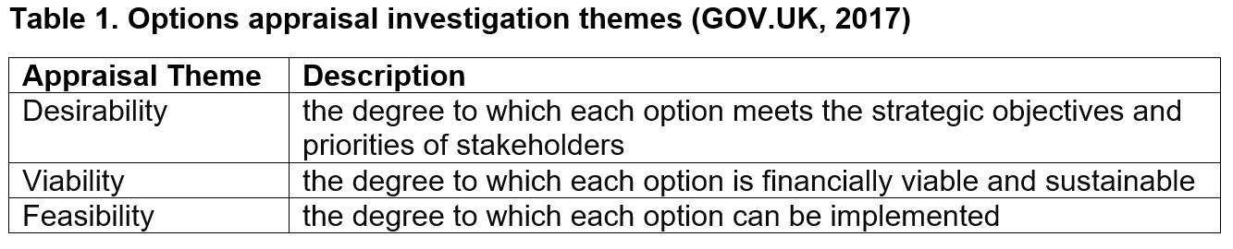
Options Appraisal – Research carried out for the gap analysis has provided the understanding of the current context and technological requirements. Based on the business model testing framework (Bland and Osterwalder, 2020) the appraisal focuses on three high level themes: desirability, viability, and feasibility. Taken from GOV.UK (2017) the definitions of these themes look to balance what is desirable for stakeholders with what is technologically feasible and economically viable (Table 1) so have been weighted equally. Mapped to specific appraisal criteria, the weighted score was highest overall for the build option (Table 2). The build option ranked highest in terms of desirability and viability, providing best capability to meet the requirements, and a more sustainable option enabling future development. The buying option scored higher for feasibility due to the supplier having expert technical skills and the lessened impact on NHS staff in terms of resource and management of existing workload. Buying may lead to quicker implementation following a procurement process but the build option could utilise existing code. A do nothing and maintain the status quo option was not considered in this analysis as this would not enable the identified service improvements to be met.
SWOT Analysis for the build or buy options (Table 3) also identified more opportunities and strengths with the build option; facilitating a co-design process, sharing of skills across health board teams, and controlled/prioritised feature implementation. Buying would likely be a more costly option in the long run as would require an ongoing support and maintenance package. Additionally having amendable in-house code should lead to a more maintainable and evolutionary system.
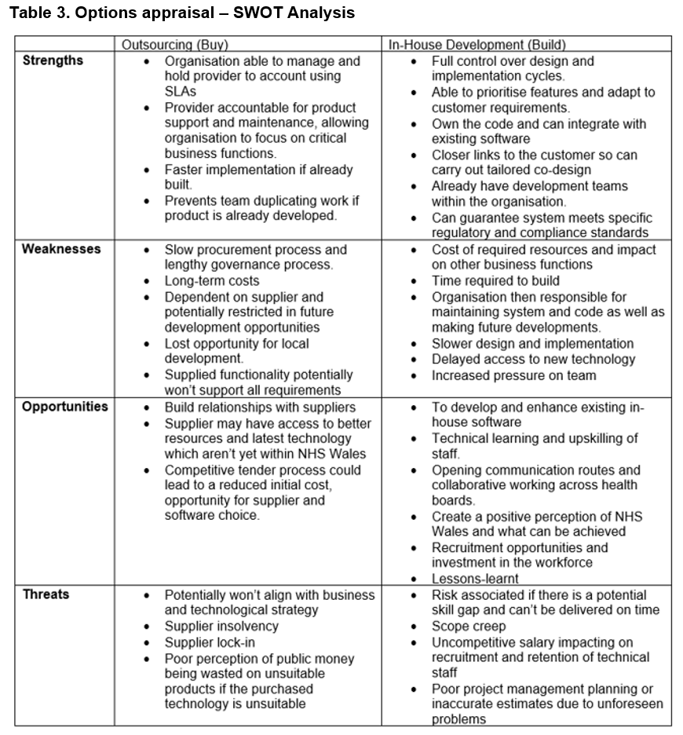
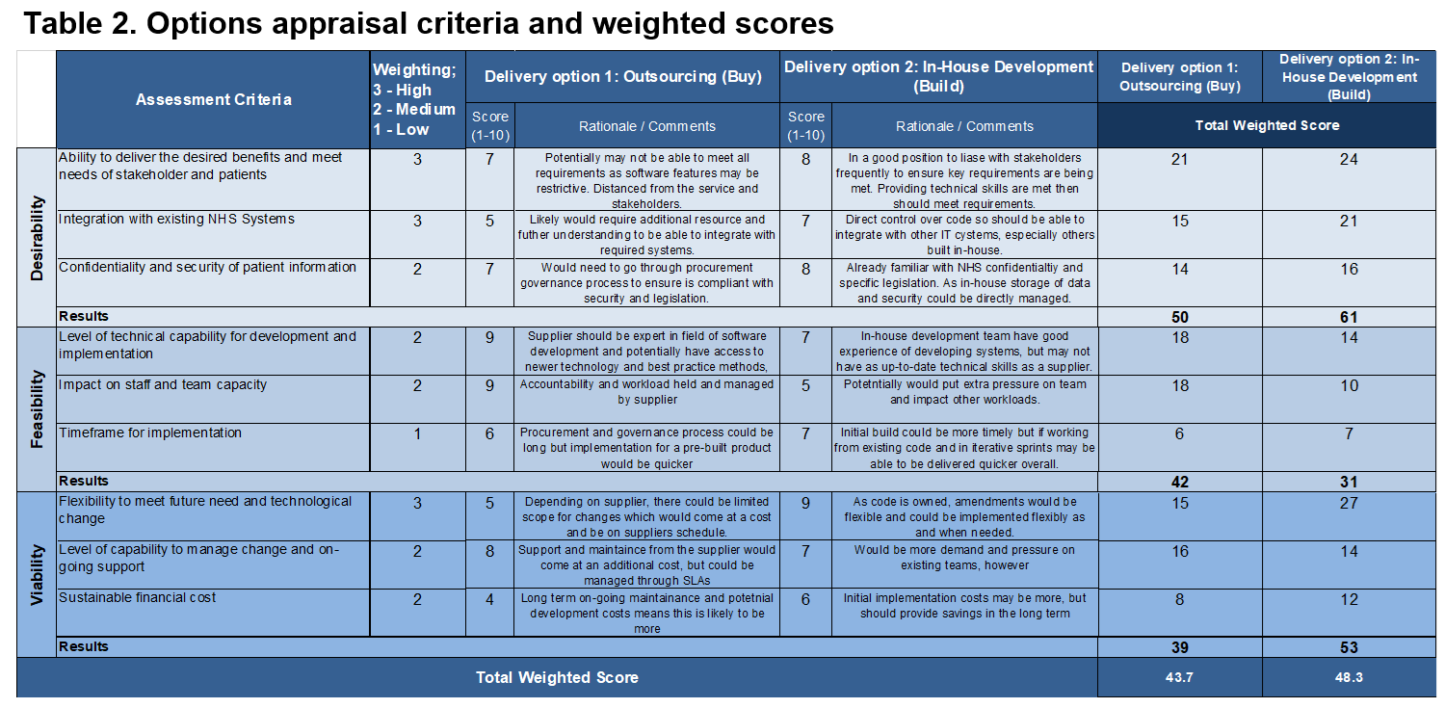
Discussion
At this stage building is the preferred option, but further detailed work on the existing skill set and capacity within current development teams across NHS Wales is needed to truly to confirm if this is a feasible option, especially once specific software requirements have been better defined using Sommerville’s requirements engineering process spiral to elicit more detail (2015).
Ideally the opportunity to develop and enhance the existing WCP system, which already goes so far to address the concept of combining data from different sources, will lead to a functional product which is already familiar to staff enhancing engagement. Having technology designed with the users and patients at the centre is the future of sustainable electronic heath systems, and combining lessons learned from previous digital implementations mitigates risk of repeating mistakes. Developers need to really understand the local operational business needs, so engagement needs to happen across health boards, both with development and informatics teams, as well as at professional and patient levels. This way co-productive design can happen in a sequential process which validates and manages evolving requirements.
Using the FITT framework (Ammenwerth et al. 2006) and the TPOM Model (Cresswell et al. 2020) considering the wider environment during development and implementation of the system will help evaluate the usability and suitability of the technology, potentially identifying areas with a poor fit between model attributes. Using Normalization Process Theory (NPT) to guide the development of the implementation plan will offer a framework to assess conditions which sees the embedding of the technology become part of routine practice (Ross et al. 2018).
Carrying out the engineering and design process through iterative sprints in line with Agile methodology will enable quicker deployments that can be reactive to feedback and changing requirements. Good links with the stakeholders will help to manage expectations, enabling the prioritisation of feature development. Using Azure DevOps and Kanban Boards for task tracking will provide a clear direction of travel and sprint planning setting reasonable deadlines. Git repositories and pipelines within Azure DevOps will support the sharing and reuse of code, as well as test plan automation and continuous integration and development (CI/CD).
Assigning a project manager to take responsibility for developing a project plan; detailing risks, requirements, timelines, and overall project scope will provide a clear focus and structured approach for development and implementation. Establishing a project team and involving developers from across the health boards will create a pool of staff who can share skills, develop, and maintain the technology. National testing and analysis will mitigate the risk of only a small portion of individuals being involved, subsequently enabling a comprehensive evaluation to be undertaken, identifying local pain points which could otherwise be missed. As part of the acquisition strategy a business case should encourage and justify the recruitment of additional technical staff, resource, and training, whilst a benefits realisation plan will assist in evaluating the impact and success of implementation.
Additionally, the Lilford et al. (2010) extension of the Donabedian causal chain model provides a framework for evaluation. A mixed methods approach should be used to make qualitative and quantitative observations at different levels within the causal chain including clinical processes and patient outcomes. Utilising the combined data made available because of this strategy should result in information teams being able to produce predictive reports which can then be evaluated, hopefully enabling staff to make more informed decisions and work in a more succinct and proactive way. The integrated system should reduce staff time trying to find missing information and overall burnout. Interviews with staff should be specific in trying to measure and capture such outcomes. Scoring using Likert scales will evaluate progress in reaching the identified service improvements. Continued engagement with patients is important so any evaluation will have to ensure that this is still the case and be evidenced through the development and reporting on PROMS and PREMS.
References
Al-Qutaish, R.E. (2010) Quality Models in Software Engineering Literature: An Analytical and Comparative Study. Journal of American Science 6(3) pp.166-175
Ammenwerth, E., Iller, C. and Mahler, C. (2006) “IT-adoption and the interaction of task, technology and individuals: a fit framework and a case study”, BMC Medical Informatics and Decision Making, 6(3). doi:10.1186/1472-6947-6-3
Audit Wales (2020) Welsh Community Care Information System Report of the Auditor General for Wales - October 2020 [online] Available at: https://www.audit.wales/sites/default/files/WCCIS-Eng_10.pdf [Accessed 9 February 2022].
Baxter, G. & Sommerville, I. (2011) Socio-technical systems: From design methods to systems engineering. Interacting with Computers, 23, pp.4-17, doi: 10.1016/j.intcom.2010.07.003
Beadle, F. (2022) The Welsh Nursing Care Record’s journey to success – PRSB. [online] Available at: https://theprsb.org/the-welsh-nursing-care-records-journey-to-success/ [Accessed 13 May 2022].
Bland, D.J. & Osterwalder, A. (2020) Testing Business ideas: A field Guide for Rapid Experimentation. Wiley, Hoboken
Coiera, E. (2015) Guide to Health Informatics (3rd Edition). 3rd ed. London: CRC Press.
Cresswell, K., Williams, R., and Sheikh, A. (2020) “Developing and Applying a Formative Evaluation Framework for Health Information Technology Implementations: Qualitative Investigation”. J Med Internet Res, 22(6):e15068. doi: 10.2196/15068
Davis, J. (2020) Quick wins – single sign-on (SSO) and Multi-Factor Authentication (MFA), Microsoft [online] Available at: https://www.microsoft.com/security/blog/2020/03/03/single-sign-on-sso-multi-factor-authentication-mfa/
Department of Health & Social Care. (2021) A guide to good practice for digital and data-driven health technologies. Gov.UK Guidance. [online] Available at: https://www.gov.uk/government/publications/code-of-conduct-for-data-driven-health-and-care-technology/initial-code-of-conduct-for-data-driven-health-and-care-technology
DHCW (2022). Welsh Clinical Portal. [online] Digital Health and Care Wales. Available at: https://dhcw.nhs.wales/systems-and-services/secondary-care/welsh-clinical-portal/ [Accessed 13 May 2022].
Gething, V. (2021) Written Statement: A Healthier Wales Action Review (24 March 2021) | GOV.WALES. [online] Available at: https://gov.wales/written-statement-healthier-wales-action-review [Accessed 5 April 2022].
GOV.UK (2021) Accessibility and assisted digital; Making your service accessible: an introduction [online] Available at: https://www.gov.uk/service-manual/helping-people-to-use-your-service/making-your-service-accessible-an-introduction#meeting-government-accessibility-requirements [Accessed 5 April 2022]
GOV.UK (2018) Open Standards Principles. Cabinet Office Policy Paper [online] Available at: https://www.gov.uk/government/publications/open-standards-principles/open-standards-principles [Accessed 5 April 2022]
GOV.UK (2017). Stage 5: options appraisal. [online] Available at: https://www.gov.uk/government/publications/libraries-alternative-delivery-models-toolkit/stage-5-options-appraisal [Accessed 16 May 2022].
HM Government. (2020) Personalised Health and Care 2020; Using Data and Technology to Transform outcomes for Patients and Citizens. A Framework for Action. National Information Board Report [online] Available at: https://assets.publishing.service.gov.uk/government/uploads/system/uploads/attachment_data/file/384650/NIB_Report.pdf [Accessed 5 May 2022]
Leonard, K. & Bottorff, C. (2022) Gap Analysis Template, Forbes Advisor [online] Available at: https://www.forbes.com/advisor/business/gap-analysis-template/ [Accessed 13 April 2022].
Lilford, R. et al., (2010). Evaluating policy and service interventions: framework to guide selection and interpretation of study end points. BMJ 341:c4413. doi: 10.1136/bmj.c4413
Local Partnerships LLP. (2012) Options Appraisal Workbook. [online] Available at: https://www.local.gov.uk/sites/default/files/documents/pas-options-appraisal-wor-7f5.pdf [Accessed 13 April 2022].
Martin, M. (2020) The role of remote monitoring in the future of the NHS. [online] Available at: https://www.nhsx.nhs.uk/blogs/role-remote-monitoring-future-nhs/ [Accessed 26 April 2022]
Monitor (2015) Improving Community Services [online] Available at: https://assets.publishing.service.gov.uk/government/uploads/system/uploads/attachment_data/file/397429/Improving_community_services.pdf [Accessed 26 April 2022]
National Cyber Security Centre (2018) Multi-factor authentication for online services [online] Available at: https://www.ncsc.gov.uk/guidance/multi-factor-authentication-online-services [Accessed 5 May 2022].
Neve, G., Fyfe, M., Hayhoe, B., & Kumar, S. (2020) Digital health in primary care: risks and recommendations. British Journal of General Practice, 70(701), pp.609-610. doi: 10.3399/bjgp20X713837
NHS Digital (2020a). Clinical risk management standards - NHS Digital. [online] Available at: https://digital.nhs.uk/services/clinical-safety/clinical-risk-management-standards [Accessed 5 May 2022].
NHS Digital (2020b) Internet First Policy - NHS Digital. [online] Available at: https://digital.nhs.uk/services/internet-first/policy [Accessed 5 May 2022].
NHS Digital (2020c) Interoperability Toolkit - NHS Digital. [online] Available at: https://digital.nhs.uk/services/interoperability-toolkit [Accessed 5 May 2022].
NHSX (2021) The Digital Technology Assessment Criteria for Health and Social Care (DTAC) Version 1.0.22 February 2021. https://www.nhsx.nhs.uk/key-tools-and-info/digital-technology-assessment-criteria-dtac/
NICE (2007) How to change practice. National Institute for Health and Care Excellence https://www.nccmt.ca/uploads/media/media/0001/02/1200a0027a05725accd75602cea8ff141b69d31b.pdf
Oreščanin, D., & Hlupic, T. (2021). Data Lakehouse - a Novel Step in Analytics Architecture. 2021 44th International Convention on Information, Communication and Electronic Technology (MIPRO), pp.1242-1246.
Paget, J. (2022) A Vision for health and social care in Wales in the Sixth Senedd with Judith Paget CBE. Welsh NHS Confederation Conference. Available at: https://www.youtube.com/watch?v=iA6LvaOf22c
Ross, J. et al. (2018) Developing an implementation strategy for a digital health intervention: an example in routine healthcare. BMC Health Services Research, 18(794), doi: 10.1186/s12913-018-3615-
Scaled Agile (2021). Features and Capabilities - Scaled Agile Framework. [online] Scaled Agile Framework. Available at: https://www.scaledagileframework.com/features-and-capabilities/ [Accessed 28 April 2022].
Smithies, R. (2014) FHIR and JSON Powerpoint, . [online] HL7 Available at: https://www.hl7.org.uk/wp-content/uploads/HL7UK_Media/Documents/Technical/HL7_UK_FHIR_and_JSON_20140203.pdf [Accessed 5 May 2022].
Sommerville, I. (2016) Software engineering. Tenth Global edition. Boston: Pearson.
Väänänen, T. (2022) How a 20-year-old standard is still relevant today. [online] NHS Digital Blog. Available at: https://service-manual.nhs.uk/whats-new#:~:text=NHS%20Digital%20Design%20Matters%20blog%20Tero%20V%C3%A4%C3%A4n%C3%A4nen%20says,NHS%20service%20standard%20and%20the%20GOV.UK%20service%20standard. [Accessed 5 April 2022].
Welsh Language Commissioner (2015) Code of Practice for the Welsh Language Standards (No. 1) Regulations 2015. [online] Available at: https://www.welshlanguagecommissioner.wales/media/hgqdctio/code-of-practice-regulations-1.pdf [Accessed 5 April 2022]
Welsh Government (2018) “A Healthier Wales: our Plan for Health and Social Care” Cardiff: Welsh Government [online] Available at: https://gov.wales/sites/default/files/publications/2021-09/a-healthier-wales-our-plan-for-health-and-social-care.pdf [Accessed 5 April 2022].
WHO. (2022) ICD-11 2022 release; ICD-11 is now officially in effect for the national and international recording and reporting of causes of illness, death - and more. [online] World Health Organisation Available at: https://www.who.int/news/item/11-02-2022-icd-11-2022-release [Accessed 5 May 2022]

