

Assessment Component 1
Case study - Supporting Paper


Student name: Tea Shchepanovich
Student ID: 2026173
Module name: Children, Young People and Families
Module code: (BMHP5004_LON)
Lecturer name: Dr Laila Surani
Word count: 1101

Table of Contents

Introduction 2
Vulnerability 3
Case Study 4
Theory 4
Policies 5
Analysis 6
Assessment Framework 6
Evaluation 7
Recommendations 7
References 8

Introduction

A child, according to the Convention on the Rights of the Child (1989), is any person under the age of eighteen who requires special care and assistance. Children must be provided with a steady environment that supports their development, including access to opportunities for education and growth, adequate health and nutrition, and safety from threats (World Health Organization, 2022). Vaccinations, exclusive breastfeeding, prompt medical attention when ill clean air, water, and hygienic facilities are all factors in a child's healthy growth and development (World Health Organization, 2022).
The Ministry of Housing, Communities and Local Government in England oversees the Troubled Families Programme (TFP), which carries out focused interventions for families dealing with a variety of issues, such as domestic violence, truancy, criminal activity, and anti-social behaviour (Loft, 2020). Families must meet two of the six requirements – criminality and antisocial behaviour; education; life prospects; living standards; domestic violence; and mental and physical health – in addition to having dependent children in order to be eligible for the programme (Loft, 2020).

Vulnerability

The most exposed time in a person's life is childhood because they depend on a grown person to provide their basic needs (Bagattini, 2019). Troubled Families Programme released study case from Bristol about unemployed, depressed single mother with 2 vulnerable children both with anti-social behaviour (GOV.UK, 2014).
Children were in a position of vulnerability because, as single-parent family, they didn’t have a source of income, their mother was depressed with lack of motivation and will to improve parenting skills, lack of nuclear family structure, and absence of needed support for whole family. Children were deficient in control, boundaries, and support; therefore, they began to avoid basic obligations such as school and study, domestic violence, showed symptoms of anti-social behaviour, and son showed symptoms of depression.

Case Study

Theory

By applying Maslow's theory of needs to the aforementioned theory, we can see which levels have been achieved or not.
According to Maslow’s hierarchy of needs (1943), people progress through a core set of hierarchical motivations, which are, in ascending order of significance: physiological, safety, belongingness, love, self-esteem, self-actualization and self-transcendence. Figure 1 gives a clearer overview of the mentioned needs.
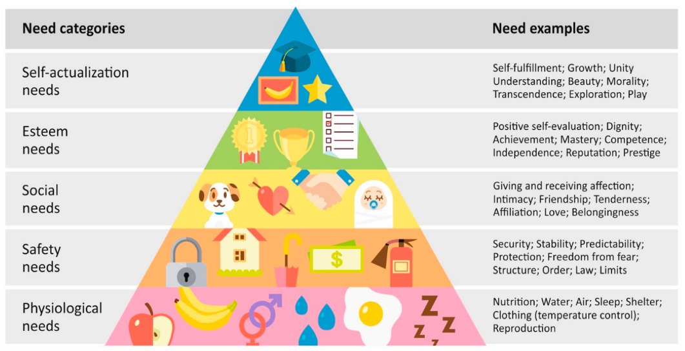Figure1 (Desmet and Fokkinga, 2020)
There is no conclusive proof from the case study provided that even the first level of the pyramid has been met. It can be assumed, based on the mental and material condition of the family, that the children did not have regular meals and did not have the necessary sleep or clothing. "Deficiency needs" are the needs at the bottom of the pyramid (Henwood et al., 2014). After a deficit need is met, the person might climb the ladder to seek objectives and satisfy higher level wants (Henwood et al., 2014).
The impact of the social environment on development can be explained using Bronfenbrenner's Bioecological theory (1979), which is also applicable in this situation. Every aspect of a person's future life is impacted by the environment in which he is raised (Tudge et al., 2017). A hungry child will behave differently in class than one who has eaten (Tudge et al., 2017). Based on this theory and the situation of the family, a different engagement of children in all fields can be expected, and this is given in the case study: avoidance and non-attendance at school, disconnection with peers, anti-social behavior, and finally the onset of depression in the child.

Policies

The Children Act (1989) incorporates the rights of the United Nations Convention on the Rights of the Child (1989), ensuring that children receive the care and protection they require for their well-being, as well as the right to privacy, family, and home.
The Human Rights Act (1998) incorporates the European Convention on Human Rights (1950) and ensures that children are protected from abuse and neglect, as well as have the right to an education and freedom.
The Education Act (2002) created the requirement for protecting children from abuse or neglect with outlining the tasks and obligations of educators and people with child protection authority.
The Equality Act (2010) protects children against discrimination, harassment, and victimisation.
The Children and Families Act (2014) aims to bring about change by allowing the establishment of childminding agencies.
The Children and Social Work Act (2017) lays out parenting guidelines to help the council as a whole deliver the best care possible for the children.
Working Together to Safeguard Children (2018) ensures that child is in focus when decisions are made, the welfare of every child must be safeguarded and encouraged.

Analysis

Assessment Framework

The Triangle Assessment Framework is a useful tool in gathering all information about children and their families, to decide if children are in needs and what those needs are, to analyse and provide support to meet those needs, and to track progress (Thurrock Council, 2020).
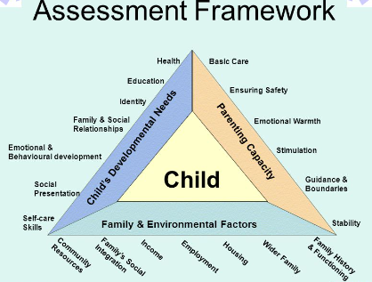(Alvord, 2015)
According to the assessment framework and the case study, the mother's parenting capacity is harmed because she is depressed and a single parent, and there is no basic care, safety, emotional warmth, guidance, boundaries, stimulation, or stability. When we look at family and environmental factors, the mother is not employed, and they as a family don’t have a source of income, with debts. The third aspect that is important is child developmental needs, and in the case study, it is given that children have high non-attendance in school, emotional and behavioural development is affected, and children are anti-social.
Multi-disciplinary services within the case study are police, school, and children’s mental health services. The police were familiar with the situation of the family; they were visiting them quite often because of the aggressive behaviour and domestic violence of her son. Children’s mental health services helped the son with his mental health problems.

Evaluation

The family intervention worker approached the mother with a constructive attitude, outlining the circumstances and possible outcomes if it continued. Additionally, the essential support for improving parenting skills was provided, which enhances family communication. Participating in a parenting programme improves the parent-child relationship, which improves the child's long-term psychological wellbeing (Vseteckova, Boyle and Higgins, 2021).
All agencies involved in this case developed positive relationship with family. A core social work value is the significance of relationship development because parents who formed good relationships with professionals were more likely to see positive outcomes (Vseteckova, Boyle and Higgins, 2021).
Outcomes that are achieved are: mothers' improved parenting skills; domestic violence stopped; a son is engaged in an education course; and a daughter with set boundaries has improved school attendance.

Recommendations

Early detection and earlier intervention would have helped a lot in the given situation, and there would have been no exclusion from school, joining of gangs, or aggressiveness on the part of the son (Early Intervention Foundation, 2018).
Including a debt advisor in the case would resolve the money-management problem and provide possible benefits that she can claim and further guidance (GOV.UK, 2022).
Home visits may occur several times during the day or on a weekly basis. That will benefit the mother, and she will be supported and supervised in preparing meals for the family and all other housework and daily tasks (Helping Hands Home Care, 2021).

References

Alvord, E. (2015). Welcome to CAF Training Working Together for Derbyshire Services: Better Outcomes for Children. Slideplayer.com. Available at: https://slideplayer.com/slide/3840608/. (Accessed: 23/11/2022)
Bagattini, A. (2019). Children’s well-being and vulnerability. Ethics and Social Welfare, 13(3), pp.211–215. doi:10.1080/17496535.2019.1647973. (Accessed: 16/11/2022)
Bronfenbrenner, U. (1979). The Ecology of Human Development: Experiments by Nature and Design. Harvard University Press. https://doi.org/10.2307/j.ctv26071r6. (Accessed: 20/11/2022)
Desmet, P. and Fokkinga, S. (2020). Beyond Maslow’s Pyramid: Introducing a Typology of Thirteen Fundamental Needs for Human-Centered Design. Multimodal Technologies and Interaction, [online] 4(3), p.38. doi:10.3390/mti4030038. (Accessed: 16/11/2022)
Early Intervention Foundation (2018). What Is Early intervention? [online] Early intervention foundation. Available at: https://www.eif.org.uk/why-it-matters/what-is-early-intervention. (Accessed: 23/11/2022)
Equality Act 2010 (2010). Equality Act 2010. Legislation.gov.uk. Available at: https://www.legislation.gov.uk/ukpga/2010/15/contents. (Accessed: 20/11/2022)
GOV.UK (1989). Children Act 1989. Legislation.gov.uk. Available at: https://www.legislation.gov.uk/ukpga/1989/41/contents. (Accessed: 20/11/2022)
GOV.UK (2014). Children and Families Act 2014. Legislation.gov.uk. Available at: https://www.legislation.gov.uk/ukpga/2014/6/contents/enacted. (Accessed: 20/11/2022)
GOV.UK (2014). Troubled families: Bristol. Available at: https://www.gov.uk/government/case-studies/troubled-families-bristol. (Accessed: 16/11/2022)
GOV.UK (2017). Children and Social Work Act 2017. Legislation.gov.uk. Available at: https://www.legislation.gov.uk/ukpga/2017/16/section/1/enacted. (Accessed: 20/11/2022)
GOV.UK (2019). Education Act 2002. [online] Legislation.gov.uk. Available at: https://www.legislation.gov.uk/ukpga/2002/32/contents. (Accessed: 20/11/2022)
GOV.UK (2022). Money and Pensions Service. [online] GOV.UK. Available at: https://www.gov.uk/government/organisations/single-financial-guidance-body. (Accessed: 23/11/2022)
Helping Hands Home Care (2021). Who is Visiting Care for? Available at: https://www.helpinghandshomecare.co.uk/visiting-care/who-is-visiting-care-for/. (Accessed: 23/11/2022)
Henwood, B.F., Derejko, K.-S., Couture, J. and Padgett, D.K. (2014). Maslow and Mental Health Recovery: A Comparative Study of Homeless Programs for Adults with Serious Mental Illness. Administration and Policy in Mental Health and Mental Health Services Research, [online] 42(2), pp.220–228. doi:10.1007/s10488-014-0542-8. (Accessed: 20/11/2022)
Human Rights Act (1998). Human Rights Act 1998. Legislation.gov.uk. Available at: https://www.legislation.gov.uk/ukpga/1998/42/contents. (Accessed: 20/11/2022)
Loft, P. (2020). The Troubled Families Programme (England). commonslibrary.parliament.uk. Available at: https://commonslibrary.parliament.uk/research-briefings/cbp-7585/. (Accessed: 14/11/2022)
Maslow, A.H. (1943). Preface to Motivation Theory. Psychosomatic Medicine, [online] 5(1), pp.85–92. Available at: https://journals.lww.com/psychosomaticmedicine/abstract/1943/01000/preface_to_motivation_theory.12.aspx. (Accessed: 16/11/2022)
Thurrock Council (2020). Common assessment framework | Children’s care professionals processes | Thurrock Council. [online] Thurrock.gov.uk. Available at: https://www.thurrock.gov.uk/childrens-care-professionals-processes/common-assessment-framework. (Accessed: 23/11/2022)
Tudge, J.R.H., Merçon Vargas, E.A., Liang, Y. and Payir, A. (2017). Theories of Early Childhood Education. New York : Routledge, 2017.: Routledge. doi:10.4324/9781315641560. (Accessed: 20/11/2022)
United Nations (1989). Convention on the Rights of the Child. OHCHR. Available at: https://www.ohchr.org/en/instruments-mechanisms/instruments/convention-rights-child. (Accessed: 14/11/2022)
Vseteckova, J., Boyle, S. and Higgins, M. (2021). A systematic review of parenting interventions used by social workers to support vulnerable children. Journal of Social Work, p.146801732110372. doi:10.1177/14680173211037237. (Accessed: 23/11/2022)
Working Together to Safeguard Children. (2018). gov.uk, HM Government, p.9. Available at: https://assets.publishing.service.gov.uk/government/uploads/system/uploads/attachment_data/file/942454/Working_together_to_safeguard_children_inter_agency_guidance.pdf. (Accessed: 20/11/2022)
World Health Organisation (2022). Child health. Available at: https://www.who.int/health-topics/child-health#tab=tab_1. (Accessed: 14/11/2022)

