Student Name: Jessica Isaac

P Number: 2204034

Programme of Study: BA Graphic Design

Module: ADAD4019 Ways of Perceiving

Tutor’s Name: Martin Bush

Word Count: 1657

Curating a Hypothetical Exhibition: Fight for Us

Curation is a key mechanism of sociality in a digital era (Davis, 2016, p. 770-783). Curation can be choosing artworks for an exhibition to sharing a post online, and in the 21st century, it is making it easier for curators to choose what they want to handle. Through this curation, I will show the rights of the LGBT+ community and women and how they were fighting and currently fighting for their rights. ‘Queer theory is a field of study that challenges existing traditional ideas about identity, sexuality, and gender.’ (LGBTQ Nation, 2021). This also links to feminism, to quote IWDA (International Women’s Development Agency), ‘It’s about respecting diverse women’s experiences, identities, knowledge and strengths, and striving to empower all women to realise their full rights.’ (IWDA, Unknown).
My chosen space for my exhibition will be Trafalgar Square, I chose this location because it was named after ‘Britain’s victory in the Battle of Trafalgar in 1805.’ (London & Partners, 2011). I find this is a very impactful location to use because there was a battle and using it for my exhibition ‘Fight for Us’, it will make it more powerful to the audience. I believe that having the pieces outside near the fountains will bring more of a what is this type of question, which is what I want from my audience.

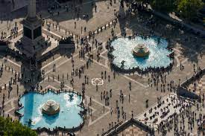
4
3
2
5
1
(Treadway, Unknown).

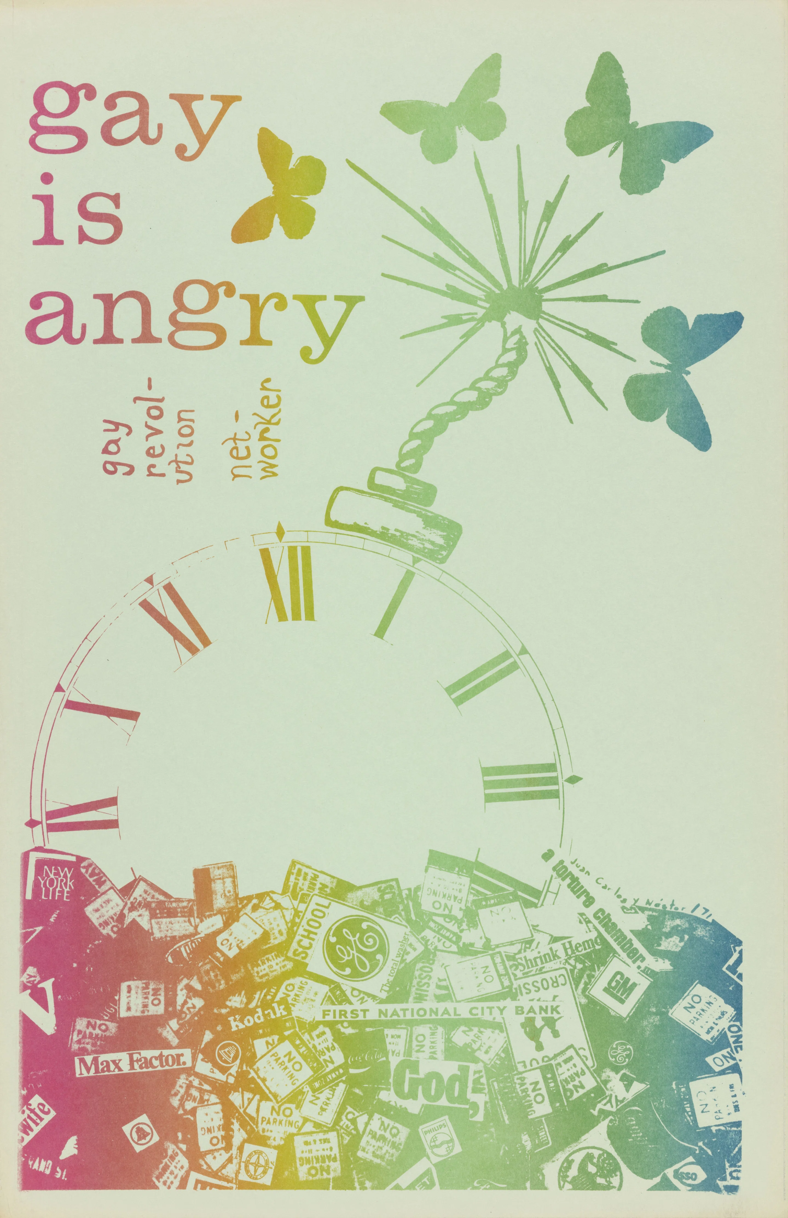
Fig 1. Gay is Angry, Juan Carlos Vidal and Nestor Latronico, 1971

Anger is such a powerful emotion, ‘anger has strong communication aspects for human beings and therefore has great constructive potential’ (Rothenberg, 2006, pp. 454-460). This is a natural human emotion, so it is right the gay community are angry at the world for continuously fighting repeatedly for the same rights. Anger can be used in different ways, yelling, screaming, shouting, crying, but it all depends on the person, because sometimes it can be from unbottled emotions that have burst to the surface, which is the background of this poster.
The 1960s and 70s were a massive part in the LGBT history, ‘we witnessed first-hand the resurgence of feminism as well as the rise of gay liberation. (D’Emilio and Freedman, 1997, p. 2). It only started after the police raided the Stonewall Inn, also known as the ‘Stonewall Riots’, but it had ‘ignited a new atmosphere of militant gay liberation. A new generation of activist organisations emerged, including the Gay Liberation Front and the Gay Activist Alliance.’ (Making History, 2022). The Liberation Movement’s vision for the future was to ‘complete sexual liberation for all people cannot come about unless existing social institutions are abolished’. (Ashley, 2015, pp 28-32)

The designers of this piece created this after the Third World Gay Revolution, which is an additional Gay Rights Movement that was organised in 1970. Vidal and Latronico wanted their poster to ‘imply both the hopes of destruction, but also of transformation.’ (Days of Rage, 2022). The curators of the ‘Days of Rage’ exhibition, wanted to ‘produce subjective reflections on the interdependence of design and activism.’ (Days of Rage, 2022), and they have honoured Vidal and Latronico’s piece by including it in their exhibition. The goal of their exhibition is ‘this is about how design lives through us: our bodies, our memories, our activated minds.’ (Days of Rage, 2022.)

I included this piece in my exhibition because it links to my title of ‘Fight for Us’, with the way that it shows bombs and the term angry, making it a vocal statement for the exhibition.

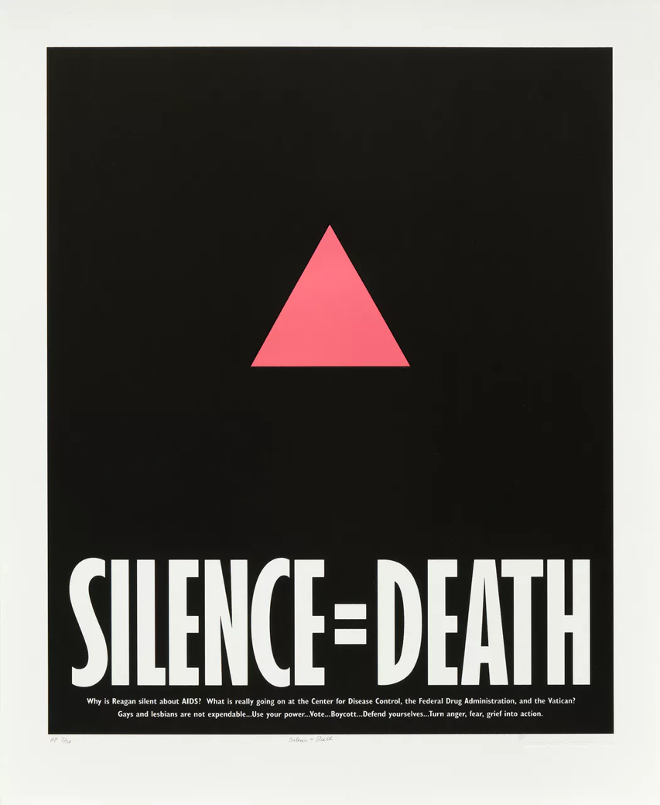

Fig 2: Silence=Death, Avram Finkelstein, Brian Howard, Oliver Johnston, Charles Kreloff, Chris Lione, and Jorge Socarrás, 1987.

Silence is ‘a situation in which someone refuses to talk about something’. (Oxford Learner’s Dictionaries, Silence). It mainly happens when people are afraid or in denial to talk about a topic, or to keep silent about it, which is the main point of this poster. The poster was created by the Silence=Death project ‘to spread the word about the epidemic’ (Half the Picture: A Feminist Look at the Collection, 2018). The epidemic during the 1980s was the start of the AIDS crisis, and ‘Act Up’ which stands for Aids Coalition to Unleash Power, they started this when the government stayed quiet about it, which was killing thousands of gay men and it remains an issue to this day with it remaining ‘a global health issue, with nearly 40 million people living with HIV at the end of 2017’ (Half the Picture: A Feminist Look at the Collection, 2018), with it affecting both men and women across the globe.

One of the designers’ decisions was to use abstract imagery to reach multiple audiences. Imagery can be a powerful symbol, and the designer’s decision to use such a powerful and well-known symbol in theirs was a risk but it gathered people’s attention. ‘Symbolism and Imagery have always been at the forefront of human expression: from cave paintings to heraldry to modern logos.’ (Joseph, A. 2021). The symbol used in the poster is the ‘Pink Triangle’, its history was used to ‘identify the thousands of gay men who were sent to concentration camps,’ (Trouble and Strife, 1996). It was a decision that Gay rights groups including ‘Act Up’ used the symbol to ‘reclaim the trauma’ and to ‘unite the gay community and to reclaim their own narrative and their own dignity’ (Joseph, A. 2021). The curators of the ‘Silence=Death’ Exhibition in New York honoured this impactful poster by having it on display in the busy street of New York; one of the curators, Avram Finkelstein describes it as “the poster comes for you in ways art simply can’t. The poster comes for you where you live” (Finkelstein, 2021).

This piece was included in my exhibition because of the powerful significance of the imagery and typography.
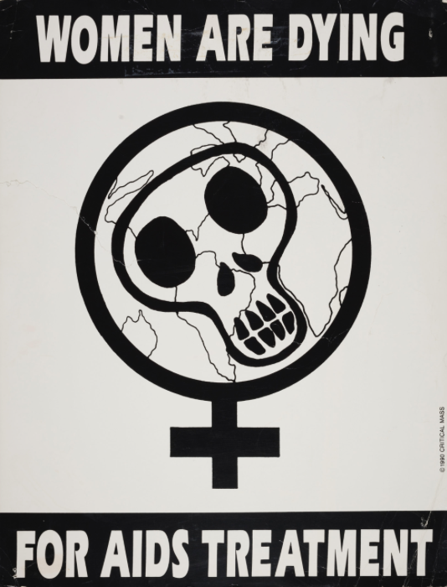
Fig 3. Women are Dying for AIDS Treatment, Critical Mass, 1990

This poster was created because there were ‘various ways that AIDS manifested, women were denied care, and needed access to life-extending services.’ (Days of Rage, 2022). 1990 was the most impactful year for the fight against AIDS, and the LGBT community, where thousands of people attended protests across the United States and the demands of the government pursuing this issue. In July 1990, ‘Act Up make ten demands including a conference on women with HIV and a women’s committee… we demand a natural history study of women and HIV which finally begins in 1993’ (Act Up, unknown) and return at the end of the year to ‘demand the immediate expansion and revision of its narrow definition of AIDS.’ (Act Up, unknown).

However, the designers also relied on heavy symbols as their message, one of them being the ‘sign of Venus is long used in feminist activism’ (Days of Rage, 2022). This symbol is used for women and has been used by society for decades and is associated with women, which has been incorporated with LGBT symbols to this day, linking it with women and women relationships, as well as transgender. Using symbols is a good way for the designers to portray the same message if they don’t want to use typography. The symbol of Venus can mean many things, but in mythology, ‘Venus was recognized as the goddess of love, passion, fertility, prostitution, and victory.’ (Muscato, 2022) and that ‘could be vengeful, she could be sweet, she could be cruel or mischievous or kind.’ (Muscato, 2022). The creators using such a powerful symbol in their work with a mythological figure that is linked to sex is a phenomenal way of associating it with the AIDS crisis.

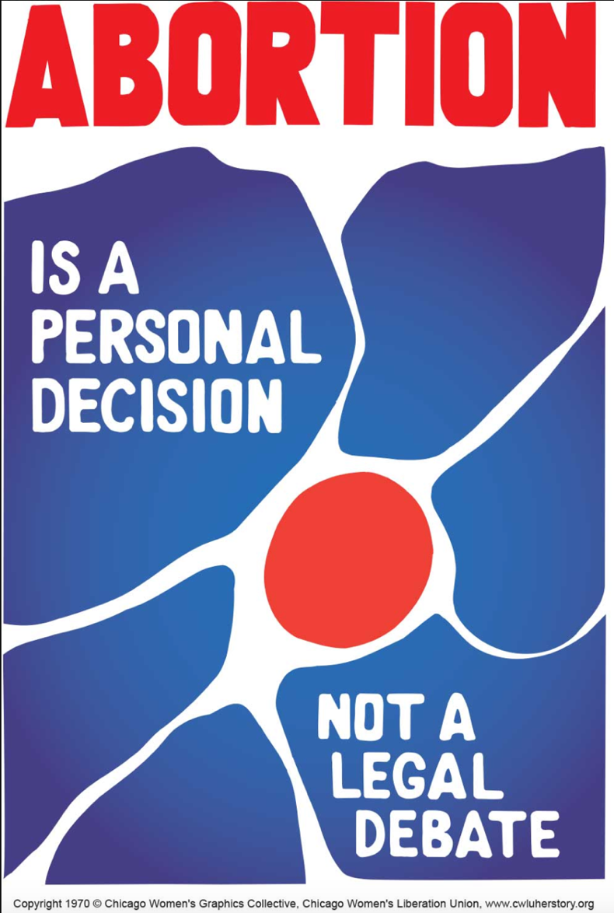

Fig 4. Abortion is a personal decision, not a legal debate, Chicago Women’s Graphics Collective, 1970

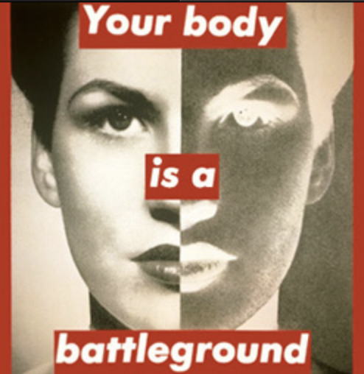

Fig 5. Your Body is a Battleground, Barbara Kruger, 1989

In relation to figure 4 and figure 5, abortion rights is a fight for women, both in the past and in the present. This piece was produced for the Women’s March on Washington in support of the reproductive freedom. Here, fighting for rights is a common occurrence even today with the controversy of the Abortion laws and whether women should be allowed to have an abortion. In 1973, ‘for the first time, Roe v Wade placed women’s reproductive choice… by conferring the highest degree of constitutional protection,’ (Reproductive Rights, Unknown). A basic human right shouldn’t have to be fought for in the first place, and the fact that millions of women died for a right to have a say, just so that it got over turned in 2022. This links to my exhibition with it being a ‘fight’, a continuous one where women will have to fight for their rights again.

The curators describe Kruger as she ‘address media and politics in their native tongue: tabloid, sensational, authoritative, and direct.’ (Barbara Kruger Collection, Unknown). They also depict how Kruger describes her work, ‘it visually personifies the image of a woman who abides by all the assigned aesthetic standards… the flame of controversy and passion for fighting for her own rights are burning.’ (Public Delivery, 2020). Kruger explains that “I’m fascinated with the difference between supposedly private and supposedly public and I try to engage the issue of what is means to live in a society that’s seemingly shock-proof yet still is compelled to exercise secrecy.” (Public Delivery, 2020).

Choosing to focus on the LGBT+ and women’s rights, I wanted to immediately focus on the continuous fighting, which is why I used the terms ‘Fight for Us’, it is still an ongoing fight over AIDS and abortion. That is why I chose Trafalgar Square as the location for my exhibition, a space where a battle was held and protests are currently being held to this day; fighting is a huge part of our history and our current story, and everyone’s rights are important to fight for and I wanted to show that.

To summarise, the goal of my exhibition would be to present people with reoccurring fights that may not affect them but their friends, family, or someone that they know, represented by the artworks that I have chosen to display. Hopefully by using these designs, this will give people the knowledge that to this day, the LGBT+ community are still fighting for their rights, and it may seem like we are going back in time, we need to go forward, and by having more people aware that this is an ongoing fight, it may achieve change.

Bibliography:
Act Up (Unknown) Act UP Capsule History 1990. Available at: https://actupny.org/documents/cron-90.html. (Accessed: 14th April 2023)
Ashley, C.P. (2015) ‘New Labour Forum’, Gay Liberation: How a Once Radical Movement Got Married and Settled Down, 24(3), pp 28-32. Available at: https://www.jstor.org/stable/24718619 (Accessed: 12th April 2023)
Barbara Kruger Collection. (Unknown). [Exhibition]. The Broad. Unknown Dates. Available at: https://www.thebroad.org/art/barbara-kruger. (Accessed: 14th April 2023)
Davis, J.L. (2017) ‘Curation: a theoretical treatment’, Information, Communication and Society, 20(5), pp. 770-783.
DOI: 10.1080/1369118X.2016.1203972
Days of Rage (2022). [Web Exhibition]. Digital. April 13th 2022-Current. Available at: https://daysofrage.onearchives.org/poster/gay-is-angry/ and https://daysofrage.onearchives.org/poster/women-are-dying-for-aids-treatment/ (Accessed: 12th April 2023)
D’Emilio, J. and Freedman, E.B. (1997) Intimate Matters: A History of Sexuality in America. 2nd edn. New York: Harper and Row. Available at: https://books.google.co.uk/books?hl=en&lr=&id=VlGHUz8GfVsC&oi=fnd&pg=PR4&dq=a+history+of+sexuality+in+america&ots=i44O-A_Llo&sig=eANx_pWtqM71bQqBIwiaHYUIxjs&redir_esc=y#v=onepage&q=a%20history%20of%20sexuality%20in%20america&f=false (Accessed: 12th April 2023)
Finkelstein A. (2021) Available at: https://www.davidzwirner.com/exhibitions/2021/more-life/silence-equals-death (Accessed: 12th April)
Half the Picture: A Feminist Look at the Collection, (2018). [Exhibition]. Brooklyn Museum, New York. August 23rd 2018 to March 31st 2019. Available at: https://www.brooklynmuseum.org/opencollection/objects/159258. (Accessed: 13th April 2023)
IWDA (Unknown) What is Feminism?. Available at: https://iwda.org.au/learn/what-is-feminism/ (Accessed: 8th April 2023)
Joseph, A. (2021) ‘Reclaiming the Pink Triangle: LGBT+ People and the Holocaust’, Holocaust Centre North [blog]. 24th February 2021. Available at: https://hcn.org.uk/blog/reclaiming-the-pink-triangle/. (Accessed: 13th April 2023)
LGBTQ Nation (2021) What is Queer Theory & Why is it important? Available at: https://www.lgbtqnation.com/2021/10/queer-theory-101-matters/ (Accessed: 8th April 2023)
London and Partners. (2011) Visit London. Available at: https://www.visitlondon.com/things-to-do/place/283774-trafalgar-square (Accessed: 8th April 2023)
Making History. (2022). [Exhibition]. Kansas City. March 1st, 2022, to April 1st, 2022. Available at: https://info.umkc.edu/makinghistory/ (Accessed: 12th April 2023).
Muscato, C. (2022) Venus, Goddess of Love and the Mother of Rome. Available at: https://study.com/learn/lesson/venus-roman-goddess-love-mythology-symbolism-importance.html. (Accessed: 14th April 2022)
Oxford Learner’s Dictionaries, Silence. [Online] Available at: https://www.oxfordlearnersdictionaries.com/definition/american_english/silence_1. (Accessed: 12th April 2023)
Public Delivery (2020) Barbara Kruger – Your Body Is A Battleground. Available at https://publicdelivery.org/barbara-kruger-battleground/. (Accessed 14th April 2023)
Reproductive Rights. (Unknown) ‘Roe v. Wade and the Right to Privacy’. Available at: https://reproductiverights.org/sites/default/files/documents/roeprivacy_0.pdf. (Accessed: 14th April 2023)
Rothenberg, A. (2006) ‘On Anger’, The American Journal of Psychiatry’, 128(4), pp. 454-460). DOI: https://doi.org/10.1176/ajp.128.4.454
Silence=Death. (2021). [Exhibition]. New York. June 24th 2021 to August 3rd 2021. Available at: https://www.davidzwirner.com/exhibitions/2021/more-life/silence-equals-death. (Accessed: 12th April 2023)
Treadway, A. (Unknown) An aerial view of Trafalgar Square in London, England, United Kindgom, Europe. Available at: https://www.westend61.de/en/imageView/RHPLF17730/an-aerial-view-of-trafalgar-square-in-london-england-united-kingdom-europe (Accessed: 20th March 2023)
Trouble and Strife. (1996) ‘Triangles and tribulations: The gay appropriation of Nazi symbols’, Journal Of Homosexuality, 30(34). Available at: http://www.troubleandstrife.org/articles/issue-34/triangles-and-tribulations-the-gay-appropriation-of-nazi-symbols/. (Accessed: 13th April 2023)

List of Figures:

Figure 1: Gay is Angry, Juan Carlos Vidal and Nestor Latronico, 1971. Available in: Campbell, A. (2019) Queer X Design. 1st edn. New York: Black Dog & Leventhal
Figure 2: Silence=Death, Avram Finkelstein, Brian Howard, Oliver Johnston, Charles Kreloff, Chris Lione, and Jorge Socarrás, 1987.
Figure 3: Women are Dying for AIDS Treatment, Critical Mass, 1990. Available at: https://www.itsnicethat.com/articles/one-archives-foundation-studio-lutalica-days-of-rage-graphic-design-archive-150622 (Accessed: 20th March)
Figure 4: Abortion is a personal decision, not a legal debate, Chicago Women’s Graphics Collective, 1970. Available at: https://www.cwluherstory.org/poster-gallery (Accessed: 10th April 2023)
Figure 5: Your Body is a Battleground, Barbara Kruger, 1989. Available at: http://www.barbarakruger.com/art.shtml (Accessed: 10th April 2023)

