

University of Wales Trinity Saint David
Technical Authoring ACDA 5024

Ordnance, Munitions and Explosives (Beng)
Academic Year 2023- 2028

Joseph Compton
Analysis of electromagnetic wave propagation

Supervisor: Stalin Jacob
April 2025

This thesis is submitted in partial fulfilment of the requirements for the degree of Ordnance, Munitions and Explosives (Beng)
(NB. Remove if the degree award is based solely on examination of the thesis)

© UWTSD 2025. All rights reserved. No part of this publication may be reproduced without the written permission of the copyright owner.

Contents
Abstract 4
1. Introduction 4
1.1 Overview of Electromagnetic Radiation 4
1.2 Waveguides and Their Function 4
1.3 Impact of Dielectric Materials 4
1.4 Dipole Antennas 5
1.5 Project Objectives 5
2. Method 5
2.1 Task 1a Rectangular Waveguide with Vacuum 5
2.1.1 Waveguide Dimensions and Setup 5
2.1.2 Theoretical Cutoff Frequency Calculations 6
2.1.3 Simulation Output – Field and Mode Analysis 6
2.2 Task 1b: Rectangular Waveguide with Teflon 15
2.2.1 Waveguide setup with Dielectric Material 15
2.2.2 Theoretical Cutoff frequency calculations 15
2.2.3 Simulation output – Field and Mode Analysis 16
2.3 Task 2: Half-Wave Dipole Antenna 26
2.3.1 Design Inputs and Calculations 26
2.3.2 Simulation output 27
3 Results 28
3.1 Task 1a: Vaccum-Filled Rectangular Waveguide 28
3.1.1 Theoretical vs simulated cutoff frequencies 28
3.2 Task 1b: Teflon-Filled Rectangular Waveguide 29
3.2.1 Theoretical vs Simulated Cutoff Frequencies 29
The table below shows the corresponding cutoff frequencies with the inclusion of a dielectric material (Teflon, ϵ_{r} ​= 2.1): 29
3.3 Task 2: Half-Wave Dipole Antenna 29
3.3.1 Calculated vs Simulated Operating Frequency 29
4 Discussion 29
4.1 Rectangular Waveguide with Vacuum 29
4.2 Rectangular Waveguide with Teflon 30
4.3 Half-Wave Dipole Antenna 31
4.4 Overall Evaluation 32
5 Conclusion 33
References 34

Table of figures:
Figure 1 - Rectangular plot of cutoff frequencies (Vaccum waveguide) 7
Figure 2 - Portfield display - Mode 1 8
Figure 3 - Portfield Display - Mode 2 8
Figure 4 - Portfield Display - Mode 3 9
Figure 5 - Magnitude of Electric Field - Mode 1 9
Figure 6 - Vector of Electric Field - Mode 1 10
Figure 7 - Magnitude of Magnetic field - Mode 1 10
Figure 8 - Vector of Magnetic Field - Mode 1 11
Figure 9 - Magnitude of Electric Field - Mode 2 12
Figure 10 - Vector of Electric Field - Mode 2 12
Figure 11 - Magnitude of Magnetic Field - Mode 2 13
Figure 12 - Vector of Magnetic Field - Mode 2 13
Figure 13 - Magnitude of Electric Field - Mode 3 14
Figure 14 - Vector of Electric field - Mode 3 14
Figure 15 - Magnitude of Magnetic field - Mode 3 15
Figure 16 - Vector of Magnetic Field - Mode 3 15
Figure 17 - Portfield Display Mode 1 17
Figure 18 - Portfield Display mode 2 18
Figure 19 - Portfield Display Mode 3 19
Figure 20 - Magnitude of Electric Field - Mode 1 20
Figure 21 - Vector of Electric Field - Mode 1 20
Figure 22 - Magnitude of Magnetic Field - Mode 1 21
Figure 23 - Vector of Magnetic Field - Mode 1 21
Figure 24 - Magnitude of Electric Field - Mode 2 22
Figure 25 - Vector of Electric Field - Mode 2 22
Figure 26 - Magnitude of Magnetic Field - Mode 2 23
Figure 27 - Vector of Magnetic Field - Mode 2 23
Figure 28 - Magnitude of Electric Field - Mode 3 24
Figure 29 - Vector of Electric Field - Mode 3 24
Figure 30 - Magnitude of Magnetic Field - Mode 3 25
Figure 31 - Vector of Magnetic Field - Mode 3 25
Figure 32 - Cutoff Frequencies Teflon Waveguide 26
Figure 33 - Wider Design view of Half-Wave Dipole Antenna 28
Figure 34 - Design of Half-Wave Dipole Antenna 28
Figure 35 - Scattering Parameter Plot (S11) - Dipole Antenna 28
Figure 36 - Radiation Pattern of Dipole Antenna 29

Table of Tables:
Table 1 - Theoretical cutoff frequencies for the first three TE modes in a vaccum filled rectangular waveguide 7
Table 2 - Theoretical Cutoff Frequencies for Teflon-Filled Waveguide 16
Table 3 - Comparison of theoretical and simulated cutoff frequencies for the vacuum-filled rectangular waveguide 29
Table 4 - Comparison of theoretical and simulated cutoff frequencies for the Teflon-filled rectangular waveguide 30
Table 5 - Comparison of theoretical and simulated resonance frequency for the half-wave dipole antenna 30

Table of Equations:
Equation 1 - Cutoff frequency for TE modes in a vacuum-filled rectangular waveguide 7
Equation 2 - Cutoff frequency for TE modes in a dielectric-filled waveguide 17
.

Abstract
This report investigates the propagation of electromagnetic waves through two types of rectangular waveguides and a half-wave dipole antenna using ANSYS HFSS. The first task involves the design and analysis of a waveguide with Perfect Electric Conductor (PEC) walls filled with vacuum, followed by a second waveguide filled with Teflon dielectric material. The third task focuses on the design of a half-wave dipole antenna operating at a frequency derived from the student ID.
Each simulation is supported with theoretical calculations of cutoff frequencies, electric and magnetic field distributions, and scattering parameters. The results demonstrate a clear shift in cutoff frequency due to the presence of the dielectric, and the dipole antenna exhibits the expected radiation pattern and resonant behaviour at the target frequency. These findings align with classical electromagnetic theory and validate the simulation approach used.

Introduction

1.1 Overview of Electromagnetic Radiation
Electromagnetic radiation is crucial in modern engineering applications, including communications [1], radar, and sensing systems. It involves the propagation of electric and magnetic fields through space and materials. Understanding how electromagnetic waves behave in different environments and structures is essential for designing efficient systems.

1.2 Waveguides and Their Function
Waveguides are hollow, usually metal, structures that guide and confine electromagnetic waves between two points. Waveguides are popular in applications at microwave frequencies for their ability to offer high power handling and low loss. Of the numerous forms, the most popular is the rectangular waveguide that can support several modes of wave propagation each with a distinct electric as well as magnetic field configuration.
There is mode-dependent propagation in a waveguide, and there is a cutoff frequency for each mode—the lowest frequency at which it can propagate. "Generally the TE₁₀ mode has the lowest cutoff frequency and is called the dominant mode." [2] In rectangular waveguides.

1.3 Impact of Dielectric Materials
The characteristics of a waveguide can be altered by changing the material inside it. In this report, simulations are conducted for both vacuum-filled and Teflon-filled waveguides. Teflon, having a relative permittivity of 2.1, affects the cutoff frequencies by lowering the phase velocity of the wave inside the guide. This shift in propagation characteristics is essential to understand in real-world applications where dielectric materials are often used for reasons such as shrinking the dimensions. [3]

1.4 Dipole Antennas
Dipole antennas are basic radiating elements in applications across a broad spectrum of different communication systems. The half-wave dipole is resonant at its length corresponding frequency, often λ/2. It is easy to analyze and build, and is used as a standard antenna in most studies of designs. Both the impedance and radiation pattern which is the well-known donut shape or more correctly a torus surrounding the antenna with no space in the middle [4]. Are thoroughly known for the dipole, so it is perfect for simulation as well as for verification in line with theoretical predictions.

1.5 Project Objectives
This report presents a simulation-based investigation into the propagation of electromagnetic waves in:
- A rectangular waveguide with Perfect Electric Conductor (PEC) walls filled with vacuum
- A rectangular waveguide of the same dimensions filled with Teflon
- A half-wave dipole antenna designed to resonate at a frequency derived from the student ID
All simulations were carried out using ANSYS HFSS, and the results are compared to theoretical values to demonstrate the accuracy and behaviour of each design.

2. Method

2.1 Task 1a Rectangular Waveguide with Vacuum

2.1.1 Waveguide Dimensions and Setup
A rectangular waveguide was designed using ANSYS HFSS with Perfect Electric Conductor (PEC) walls and filled with vacuum. The waveguide dimensions were calculated based on the student ID (2314594), using the following approach:
- Width (a): First 2 digits of ID = 23 mm
- Height (b): 3rd and 4th digits divided by 2 = 14 ÷ 2 = 7 mm
- Length (z-axis): 50 mm
The waveguide was assigned two ports: Wave Port 1 and Wave Port 2, with three supported modes specified. A frequency sweep from 2 GHz to 30 GHz was applied to analyse the waveguide’s modal behaviour.

2.1.2 Theoretical Cutoff Frequency Calculations
The cutoff frequency for each mode is calculated using the formula:
Equation 1 - Cutoff frequency for TE modes in a vacuum-filled rectangular waveguide
$$F_{C}= \frac{C}{2} \sqrt{{(\frac{m}{a})}^{2}+ {(\frac{n}{b})}^{2}}$$
Where:
- c = 3x10^8 m/s
- a = 0.023m, b = 0.007m
Table 1 - Theoretical cutoff frequencies for the first three TE modes in a vaccum filled rectangular waveguide
Mode | Indices (m, n) | Cutoff Frequency (GHz)
TE10 | (1, 0) | 6.52
TE20 | (2, 0) | 13.04
TE01 | (0, 1) | 21.43

The TE₁₀ mode is dominant, with the lowest cutoff frequency. Modes only begin to propagate above their respective cutoff values.

2.1.3 Simulation Output – Field and Mode Analysis
The following Simulation outputs were generated for visualising field distributions:
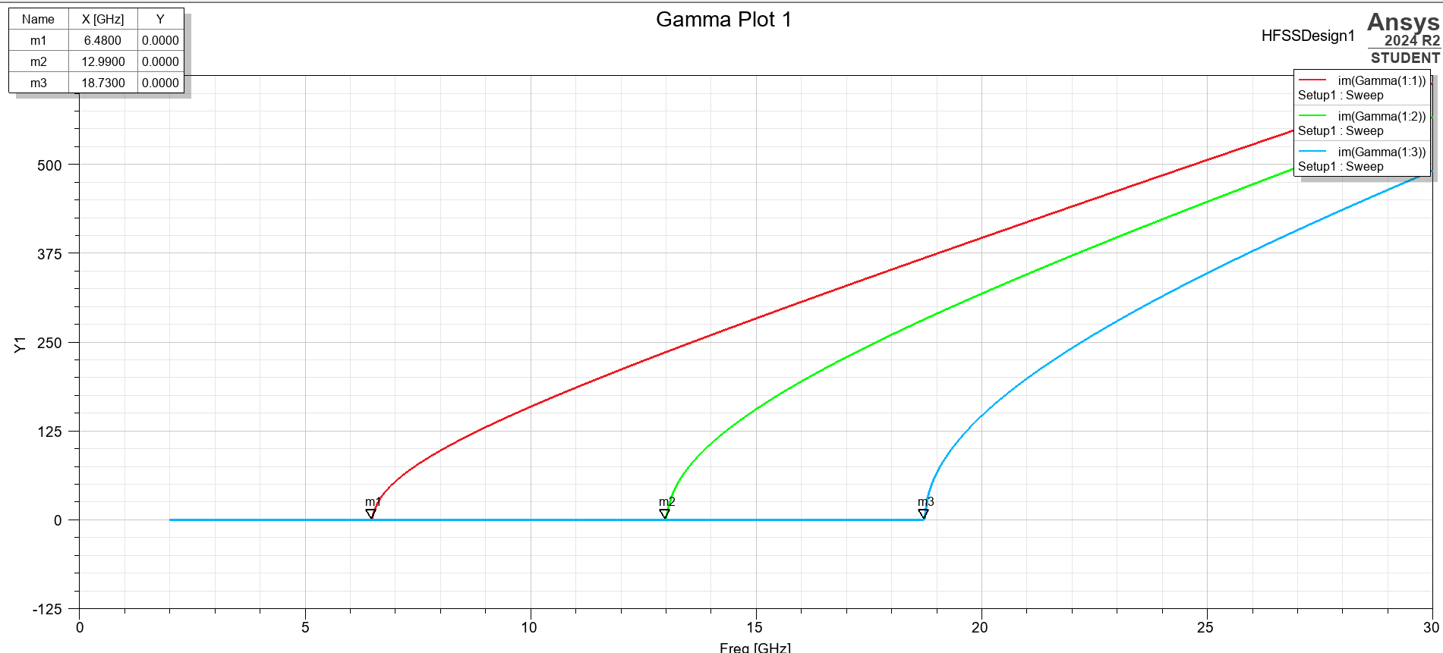
Figure 1 - Rectangular plot of cutoff frequencies (Vaccum waveguide)
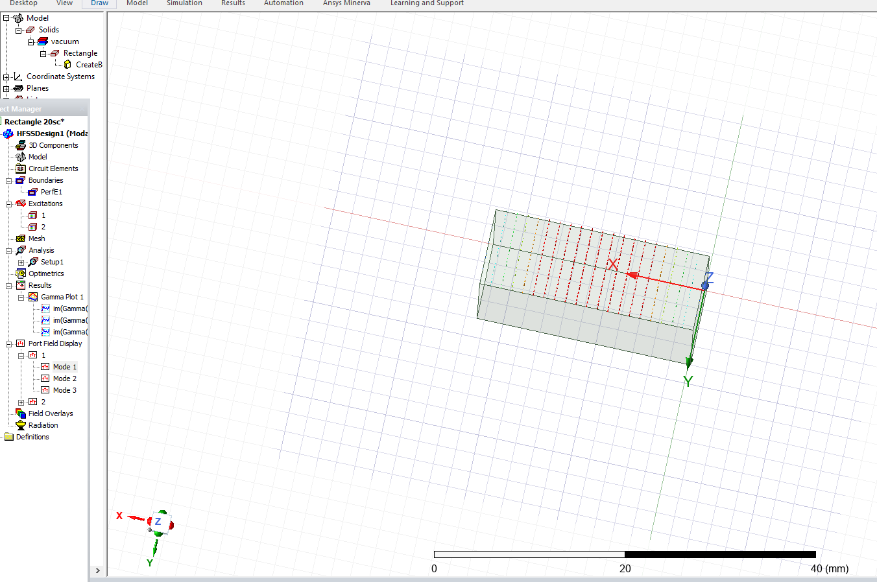
Figure 2 - Portfield display - Mode 1
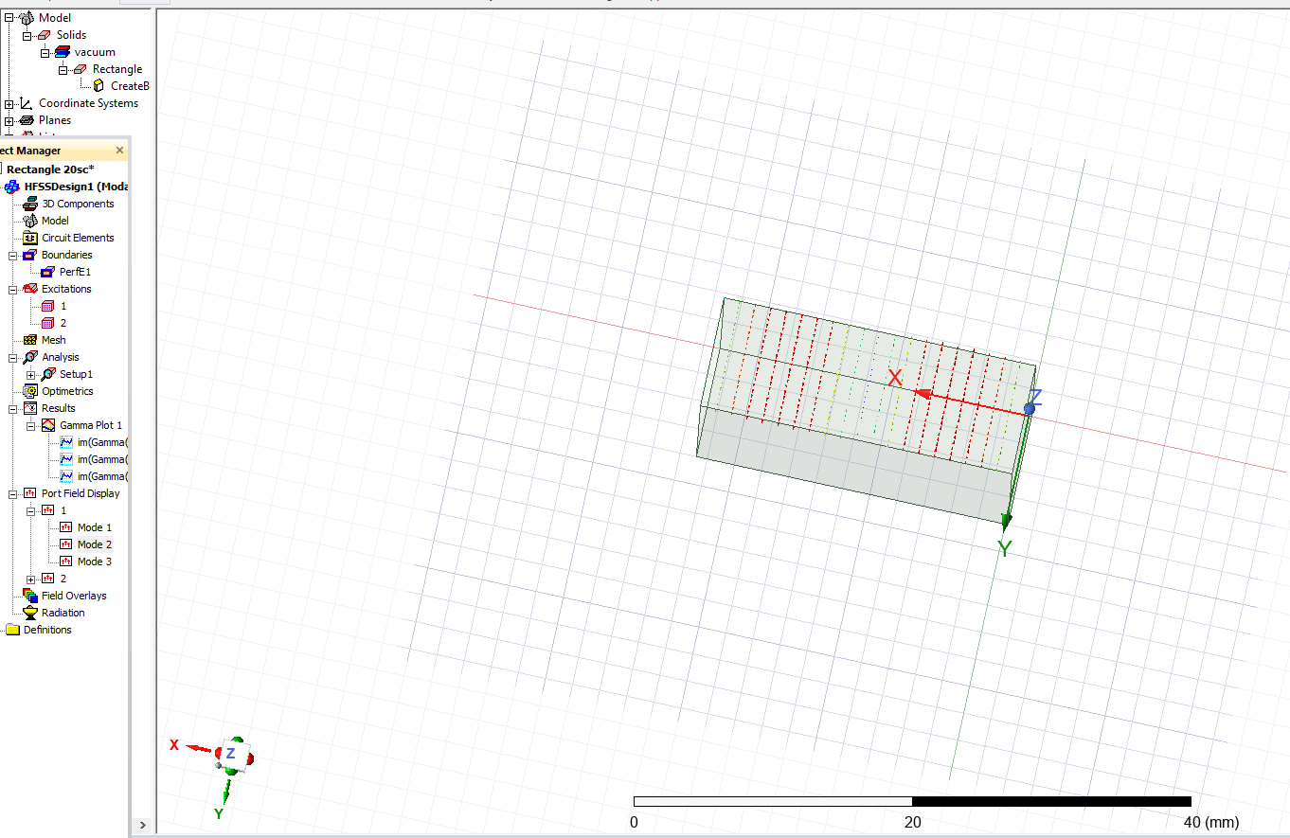
Figure 3 - Portfield Display - Mode 2

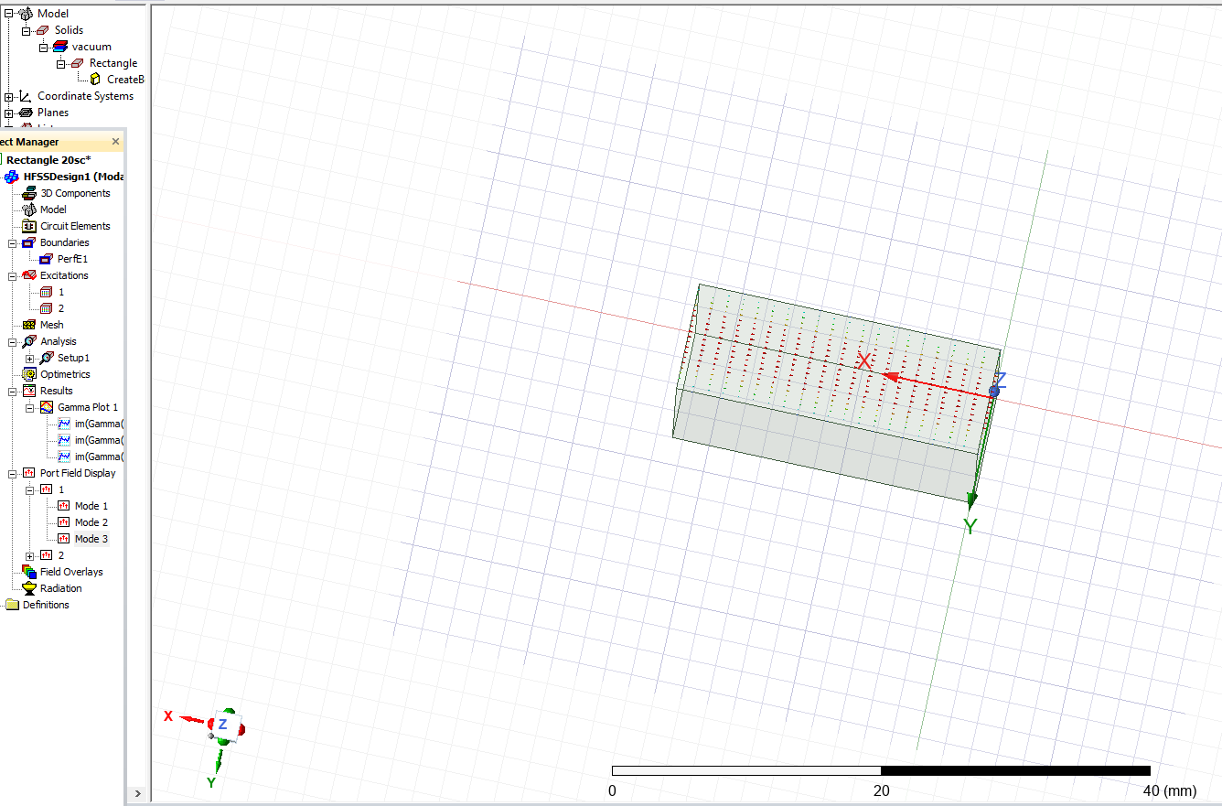
Figure 4 - Portfield Display - Mode 3
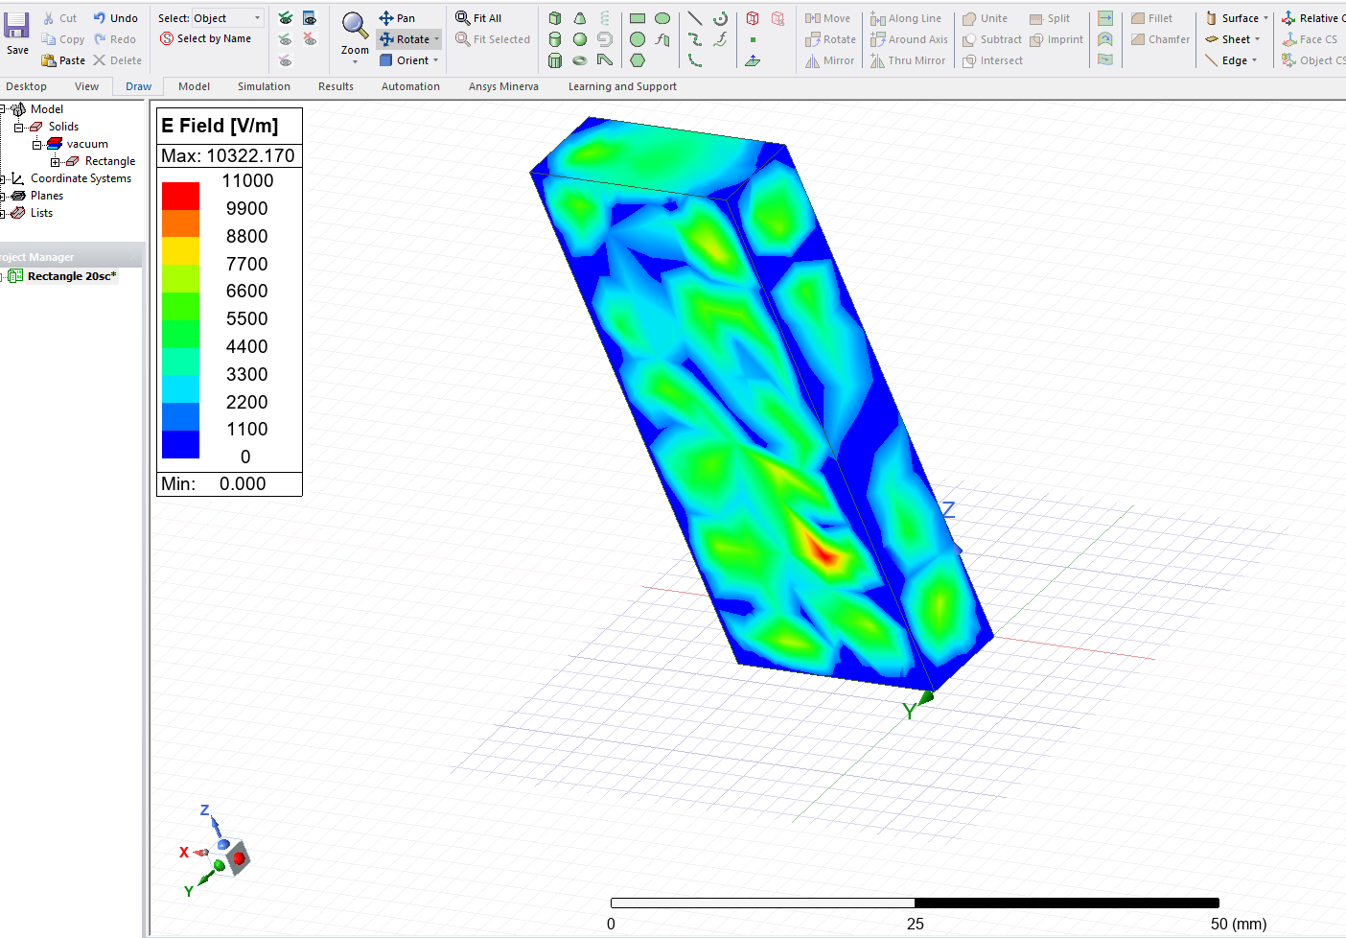
Figure 5 - Magnitude of Electric Field - Mode 1
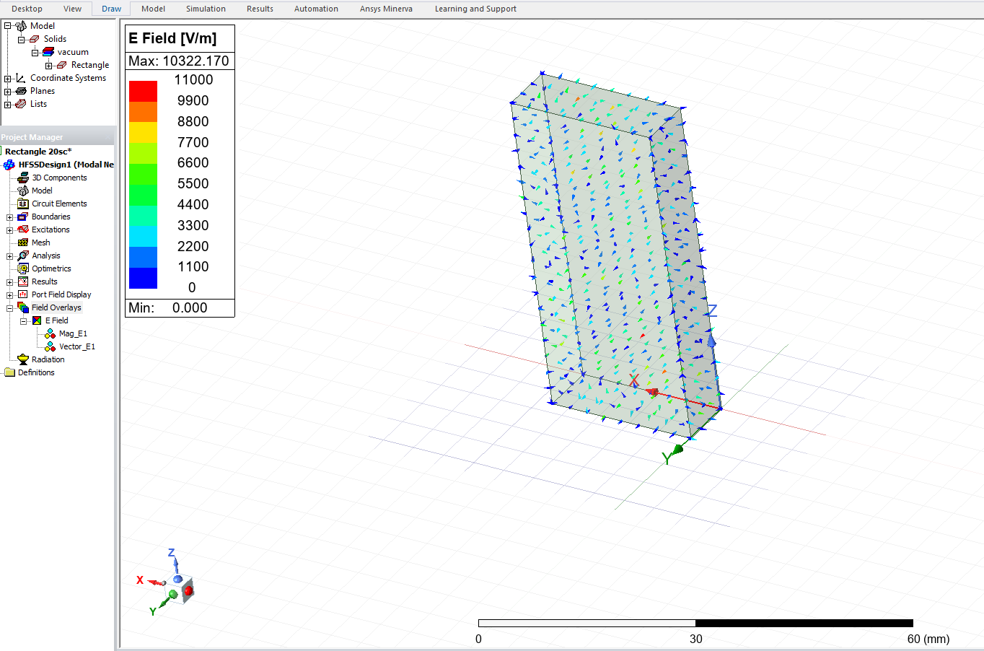
Figure 6 - Vector of Electric Field - Mode 1
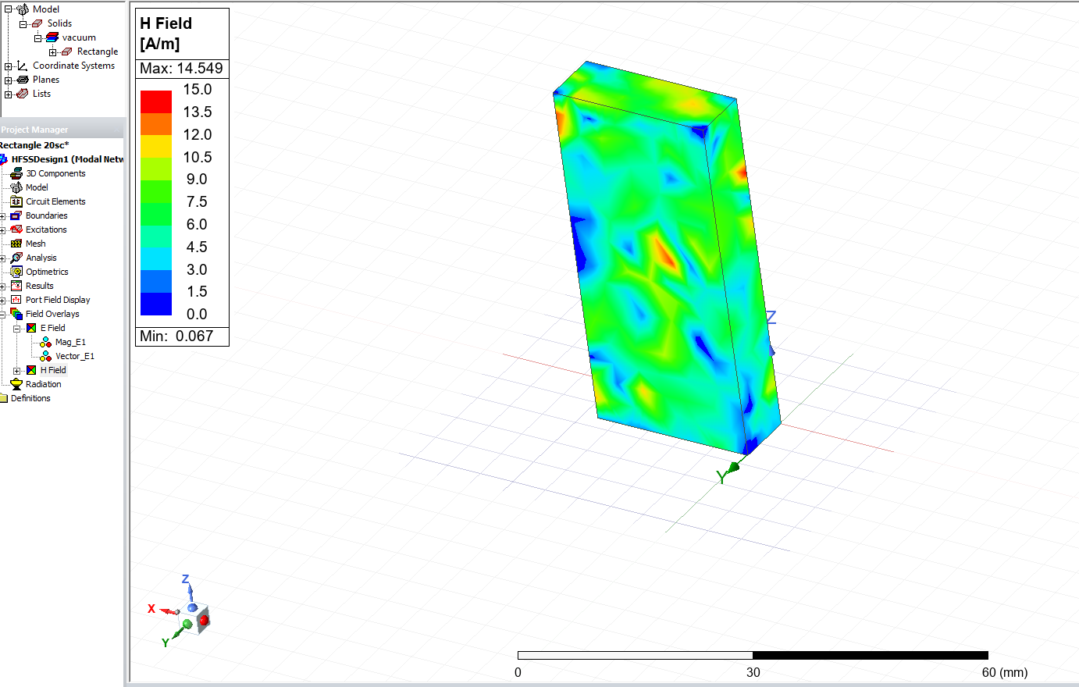
Figure 7 - Magnitude of Magnetic field - Mode 1
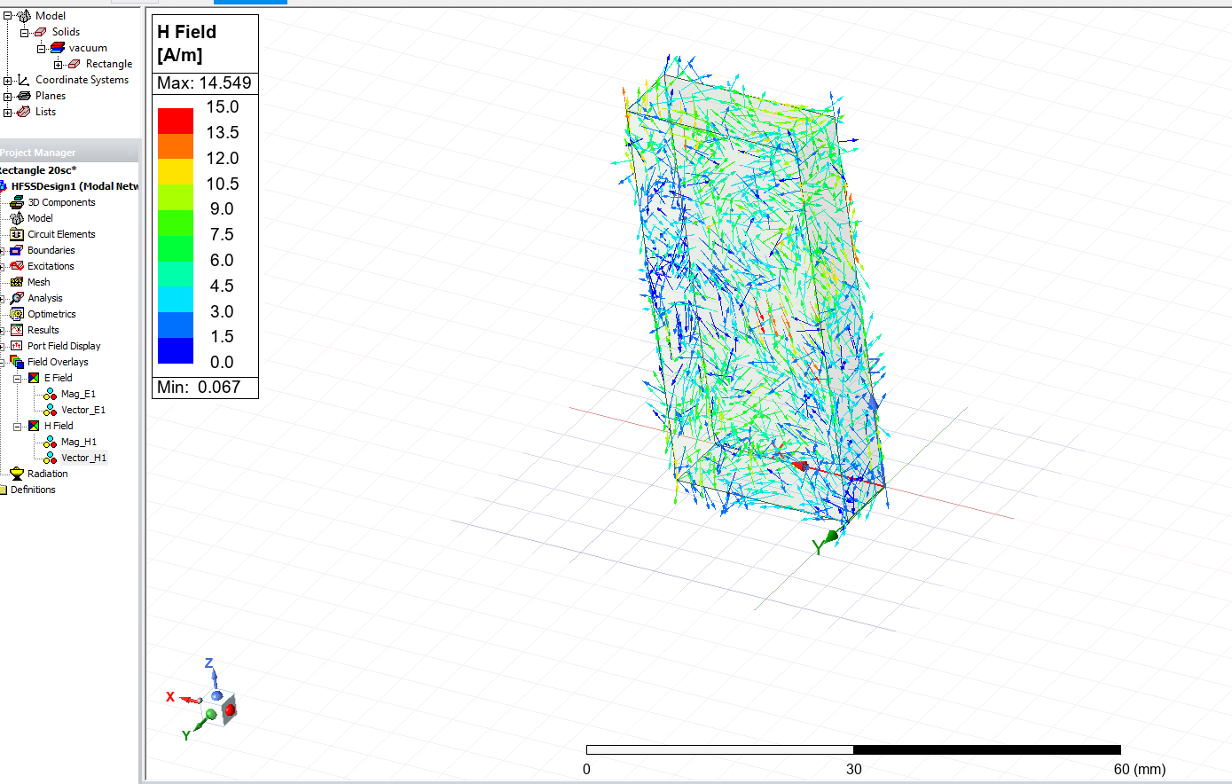
Figure 8 - Vector of Magnetic Field - Mode 1
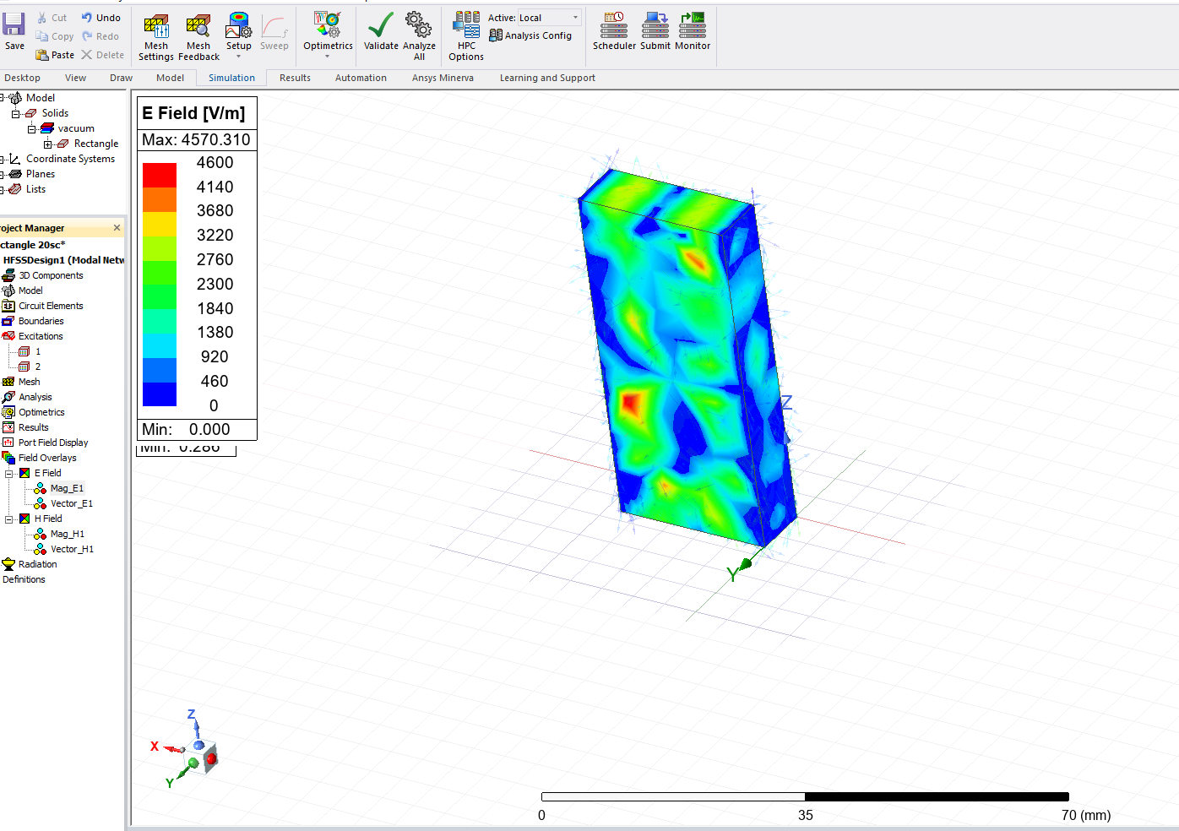
Figure 9 - Magnitude of Electric Field - Mode 2
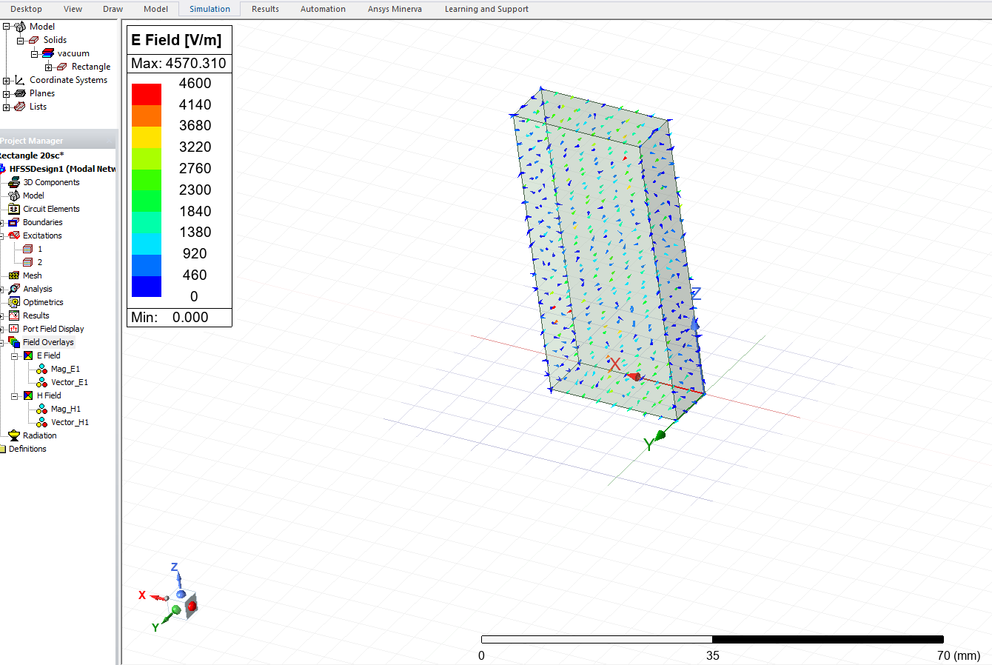
Figure 10 - Vector of Electric Field - Mode 2
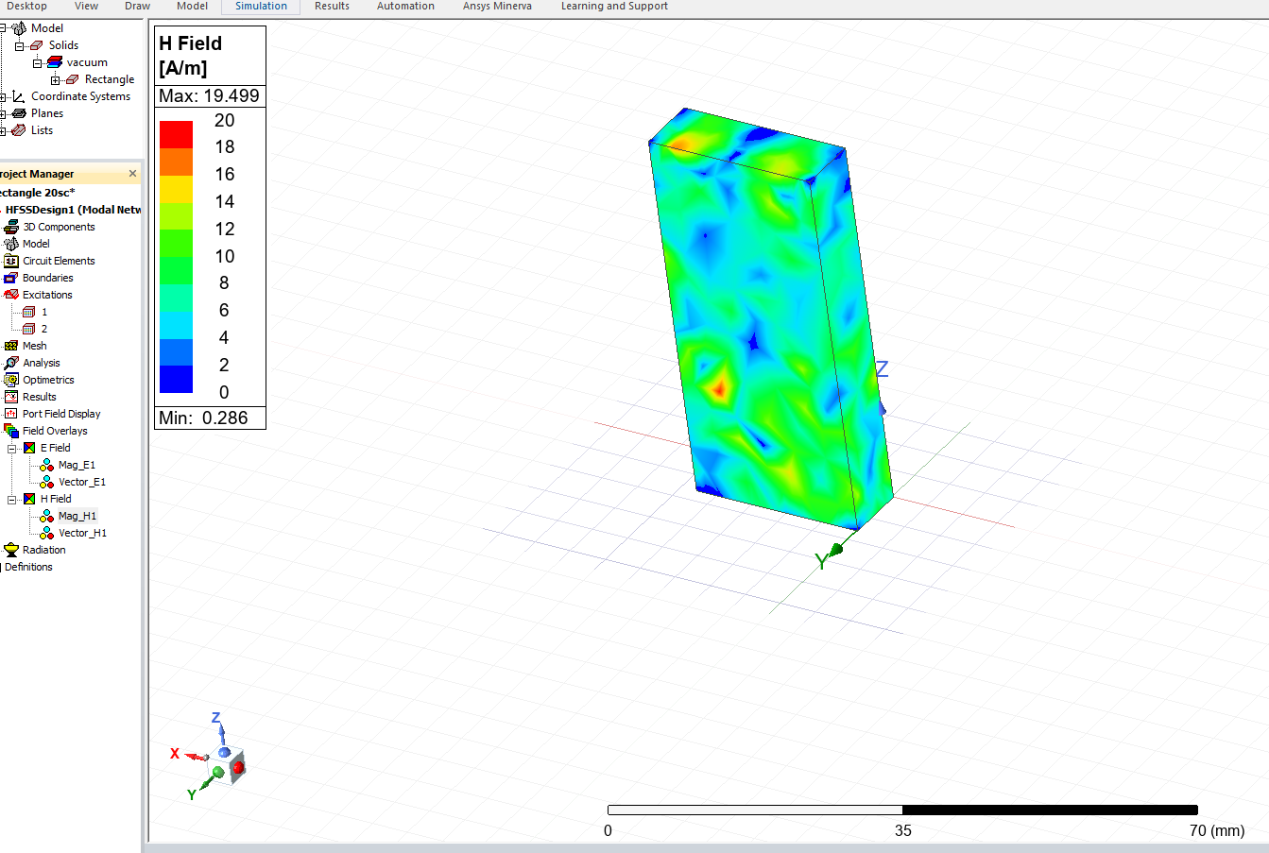
Figure 11 - Magnitude of Magnetic Field - Mode 2
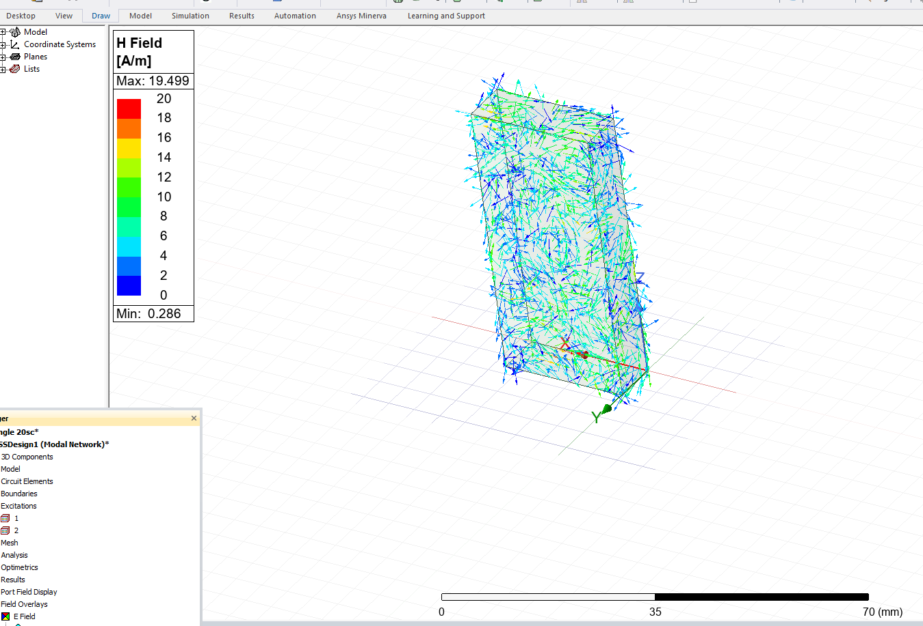
Figure 12 - Vector of Magnetic Field - Mode 2
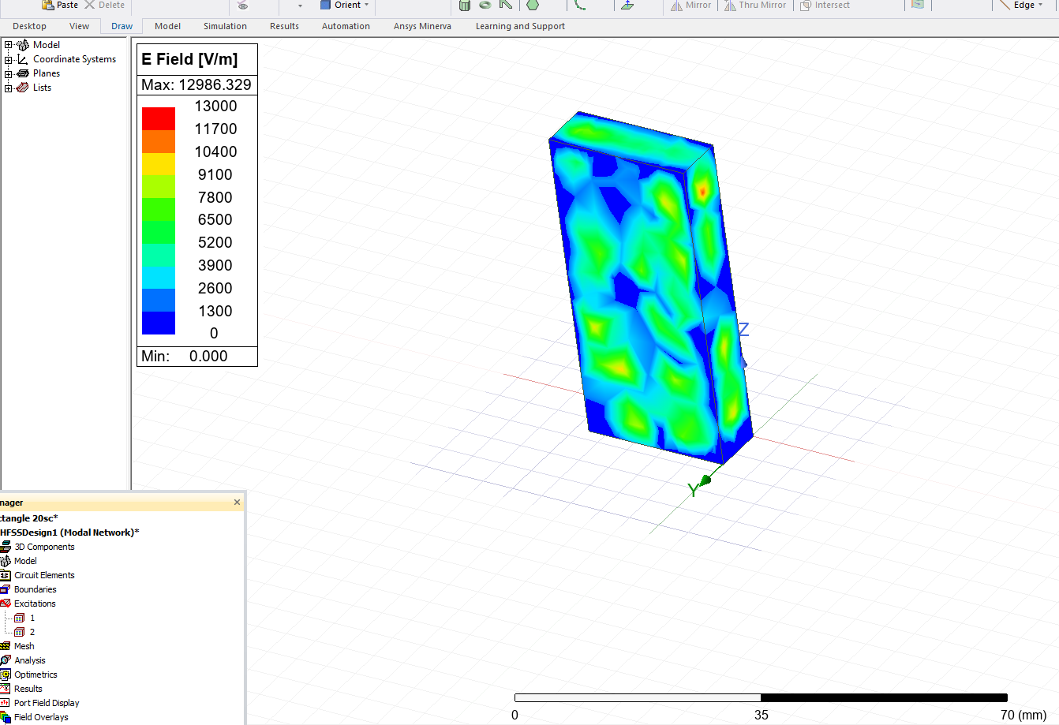
Figure 13 - Magnitude of Electric Field - Mode 3
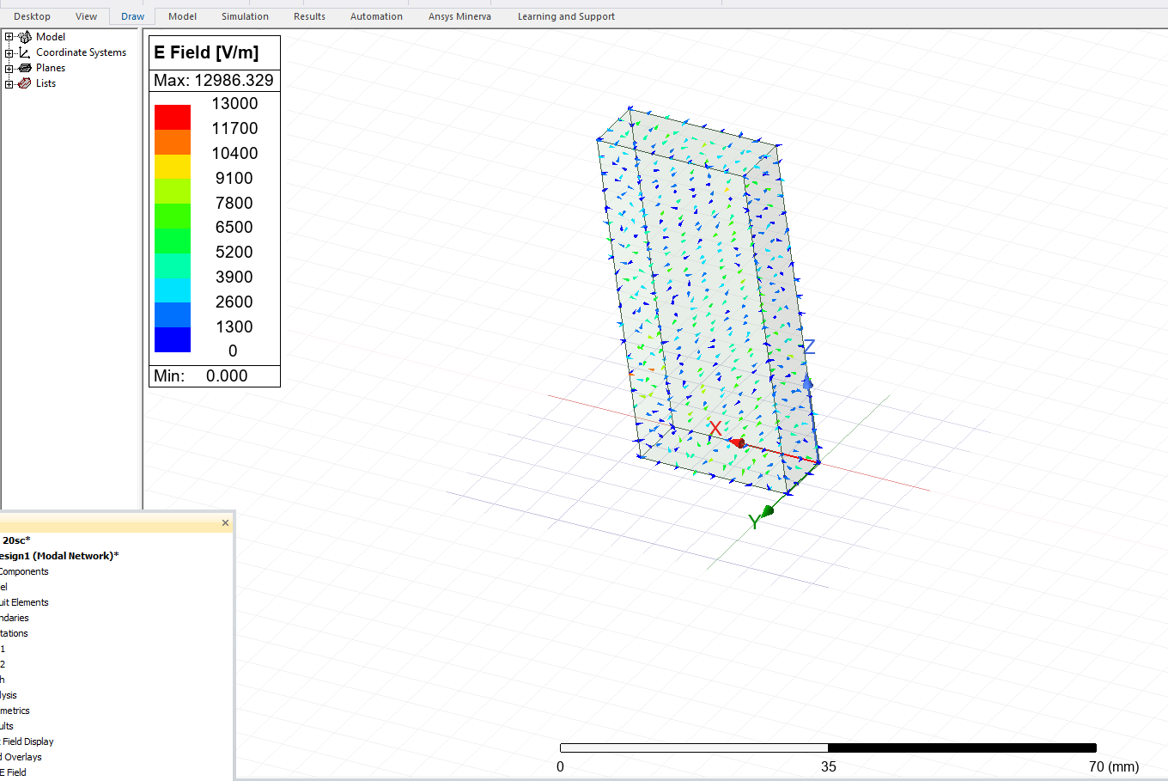
Figure 14 - Vector of Electric field - Mode 3
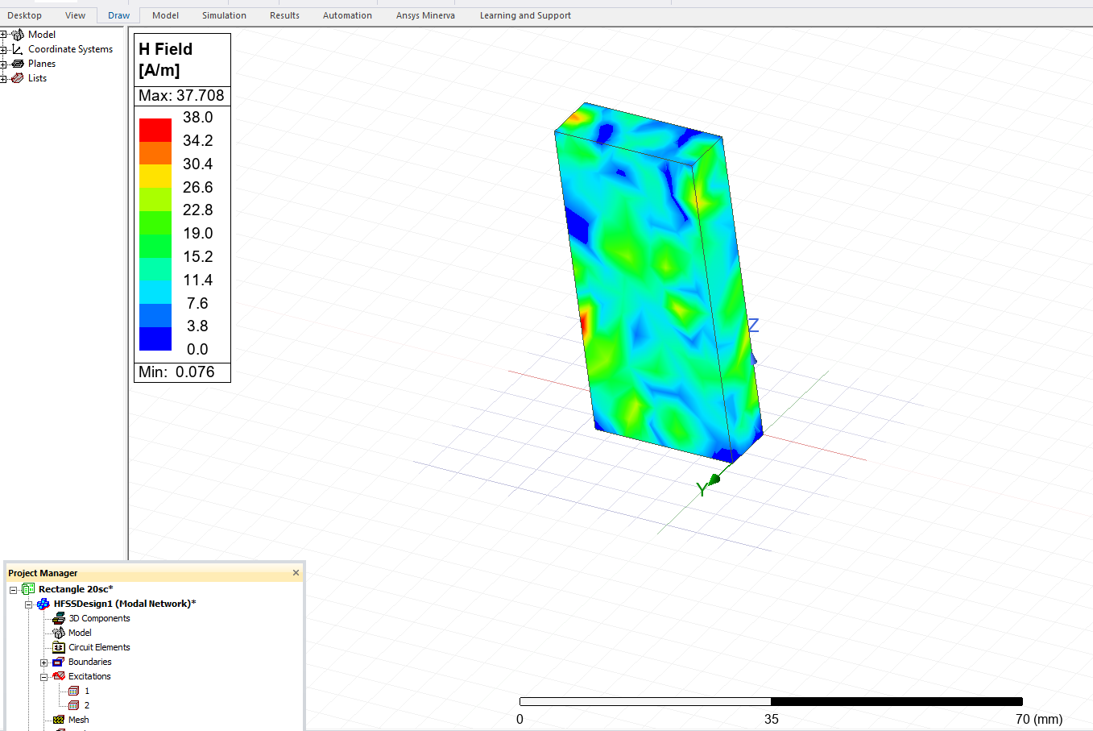
Figure 15 - Magnitude of Magnetic field - Mode 3
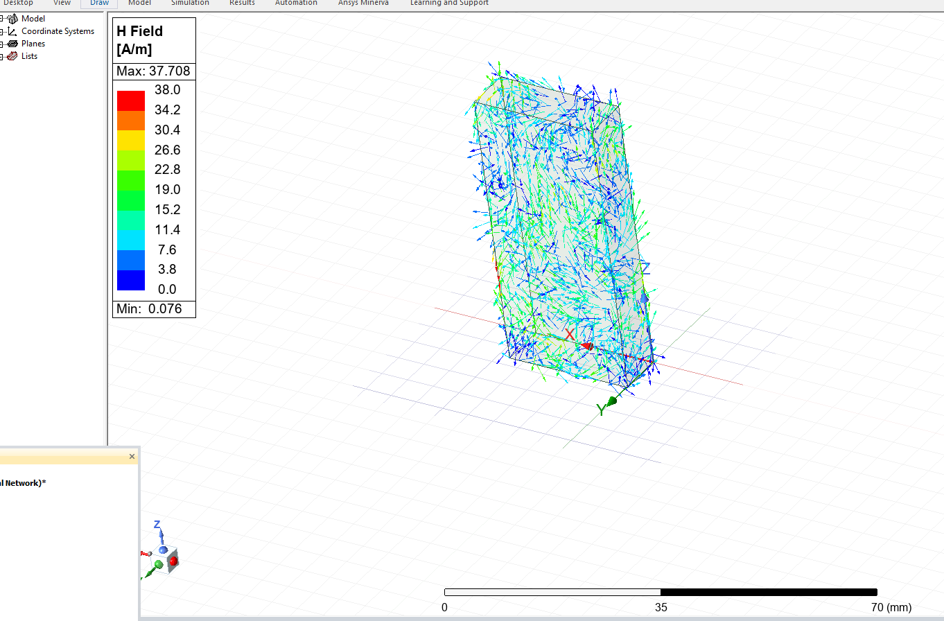
Figure 16 - Vector of Magnetic Field - Mode 3

2.2 Task 1b: Rectangular Waveguide with Teflon

2.2.1 Waveguide setup with Dielectric Material
The second simulation task involved designing a rectangular waveguide identical in size and structure to the vacuum-filled model, but this time filled with Teflon. Teflon has the following material properties:
- Relative permittivity: 2.1
- Relative permeability: 1.0
The dimensions of the waveguide remained the same:
- Width (a): 23 mm
- Height (b): 7 mm
- Length (z-axis): 50 mm
Wave Port 1 and Wave Port 2 were assigned as before, and three supported modes were simulated. A frequency sweep from 2 GHz to 30 GHz was performed.

2.2.2 Theoretical Cutoff frequency calculations
The cutoff frequency in a dielectric-filled waveguide is calculated using the modified formula:
Equation 2 - Cutoff frequency for TE modes in a dielectric-filled waveguide
$$F_{C}= \frac{c}{2\sqrt{ε}r} \sqrt{{\left(\frac{m}{a}\right)}^{2}+ {\left(\frac{n}{b}\right)}^{2}}$$

Where:
- ϵ_{r} = 2.1
- a = 0.023m, b = 0.007m
- c = 3 x10⁸ m/s
Here are the theoretical cutoff frequencies for the Teflon-filled waveguide:
Table 2 - Theoretical Cutoff Frequencies for Teflon-Filled Waveguide
Mode | Indices (m, n) | Cutoff frequencies (GHz)
TE₁₀ | (1, 0) | 4.50
TE₂₀ | (2, 0) | 9.00
TE₀₁ | (0, 1) | 14.79

As expected, the presence of dielectric lowers the cutoff frequencies for all modes compared to the vacuum-filled waveguide.

2.2.3 Simulation output – Field and Mode Analysis
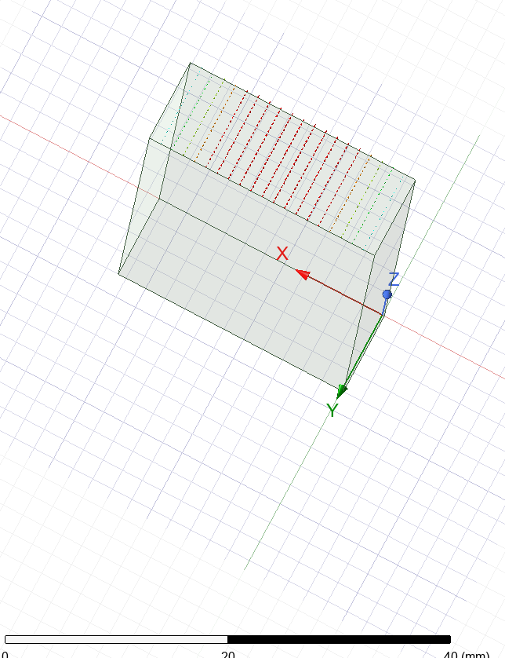
Figure 17 - Portfield Display Mode 1
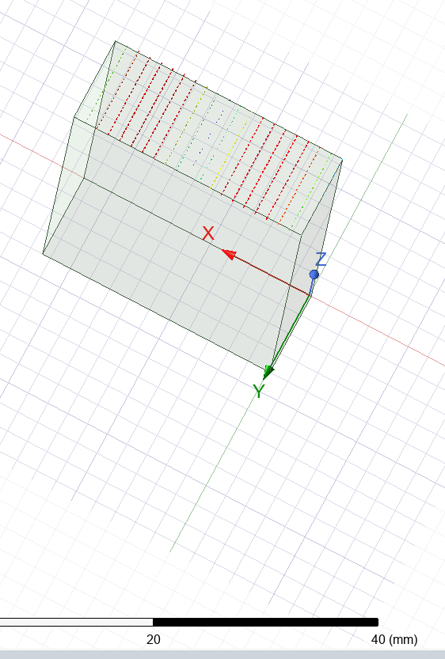
Figure 18 - Portfield Display mode 2
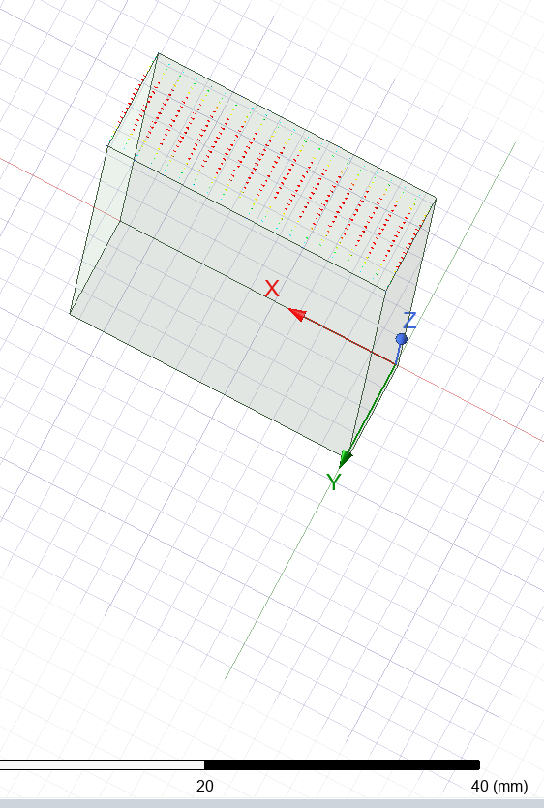
Figure 19 - Portfield Display Mode 3
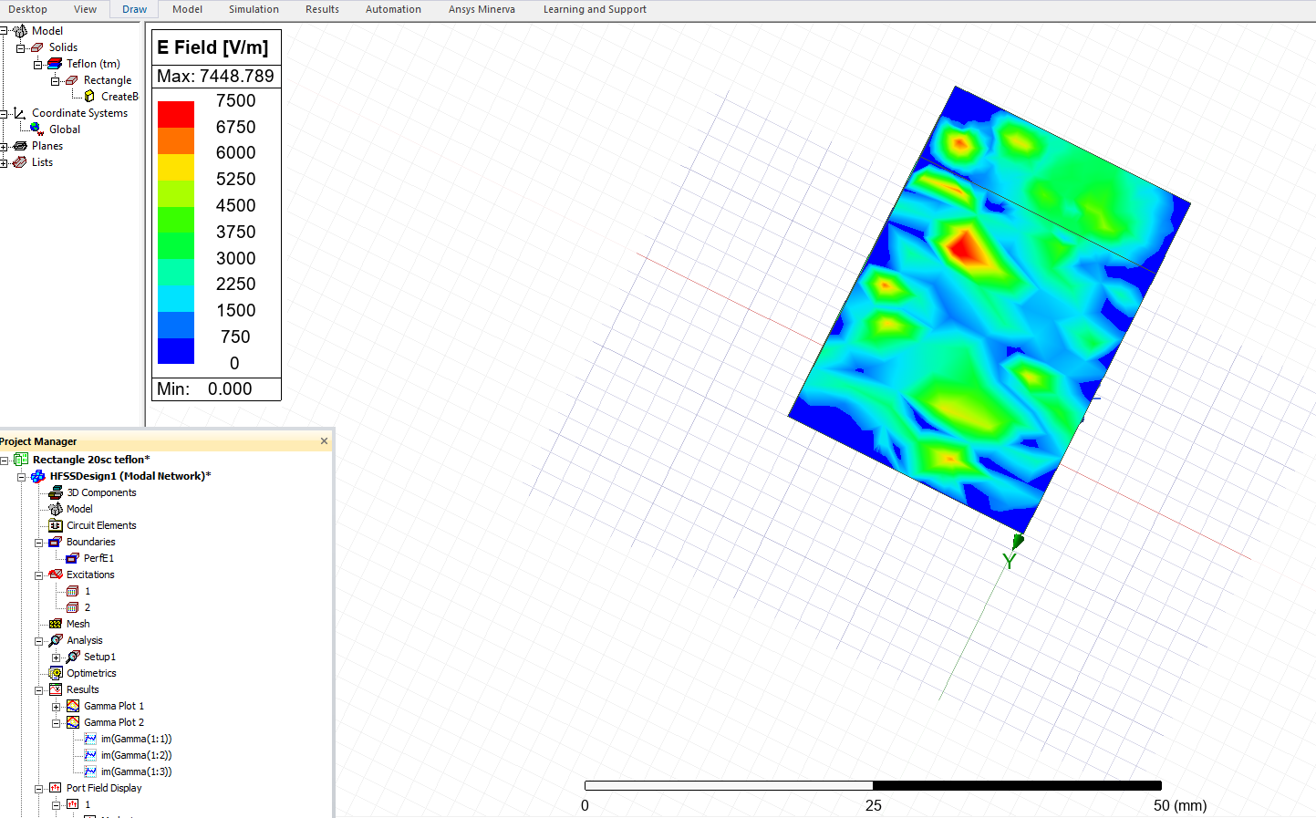
Figure 20 - Magnitude of Electric Field - Mode 1
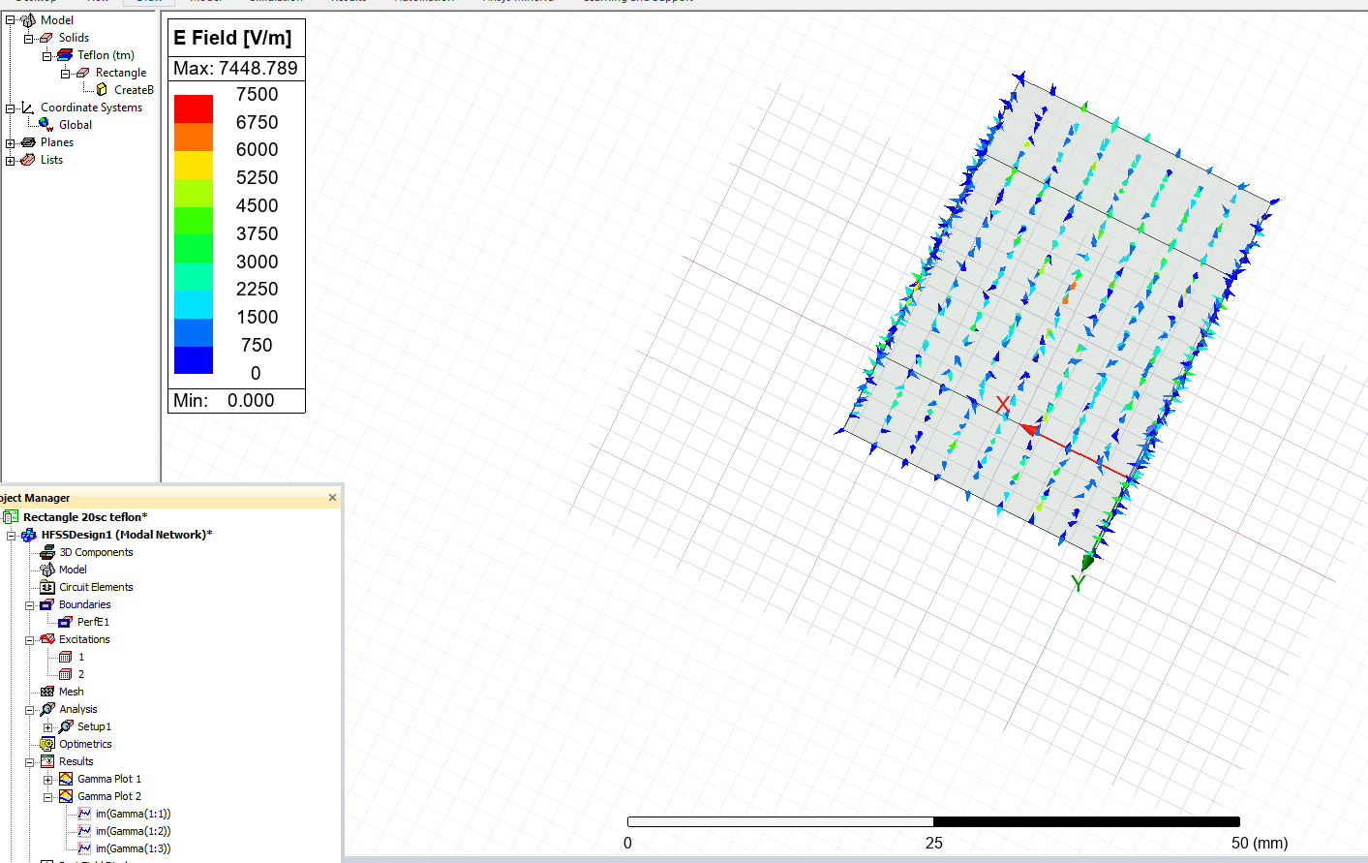
Figure 21 - Vector of Electric Field - Mode 1
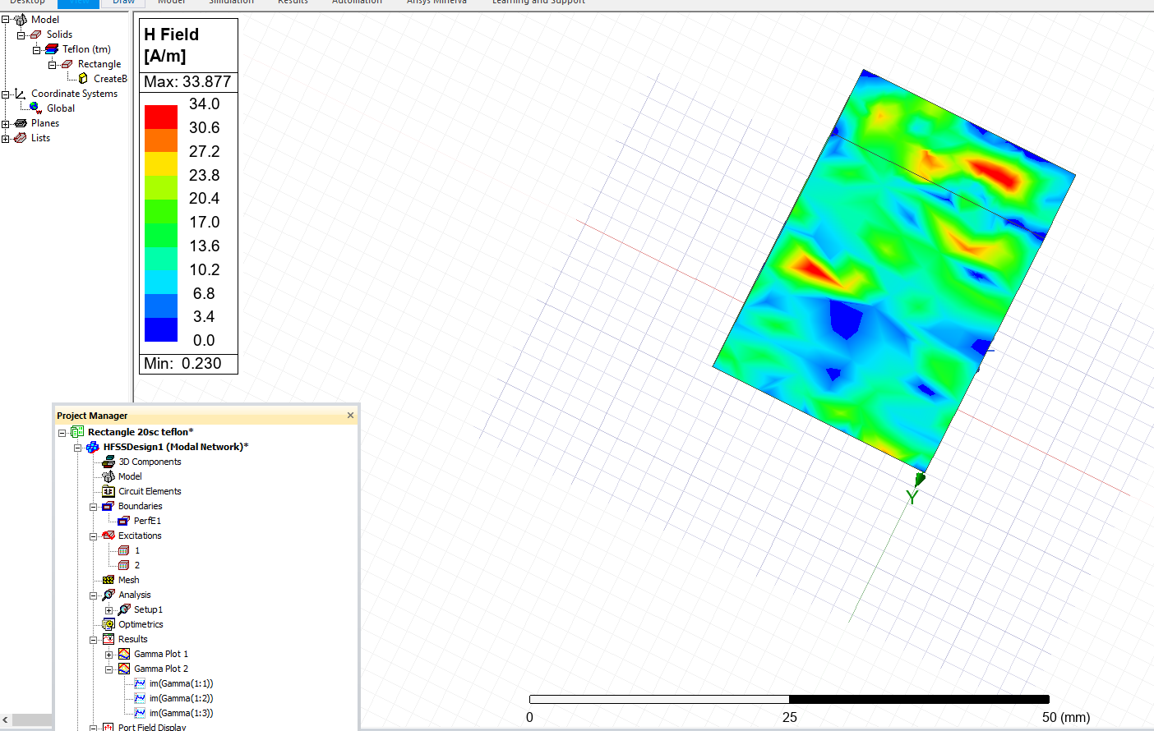
Figure 22 - Magnitude of Magnetic Field - Mode 1
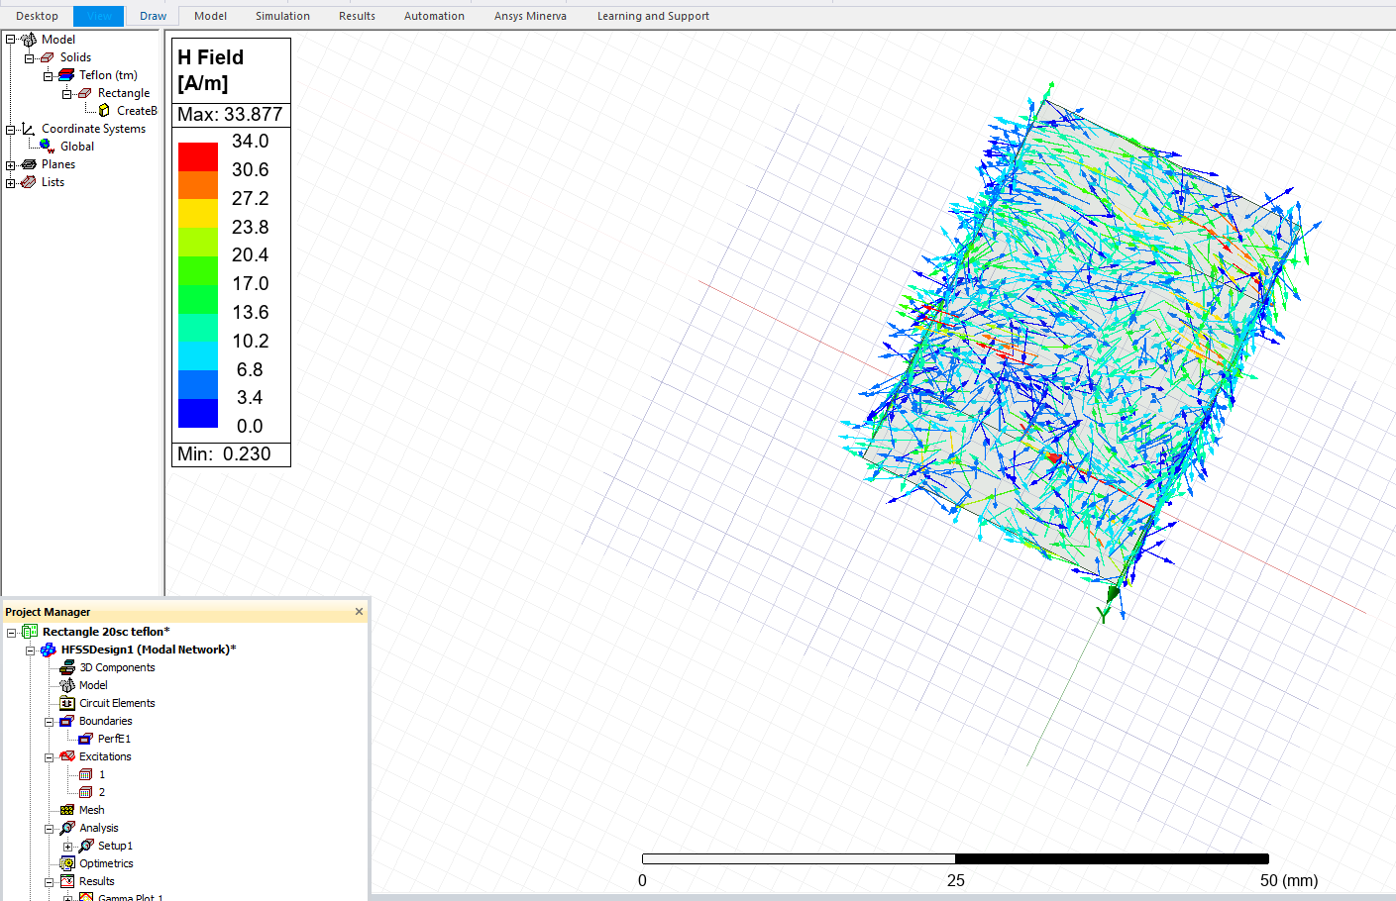
Figure 23 - Vector of Magnetic Field - Mode 1
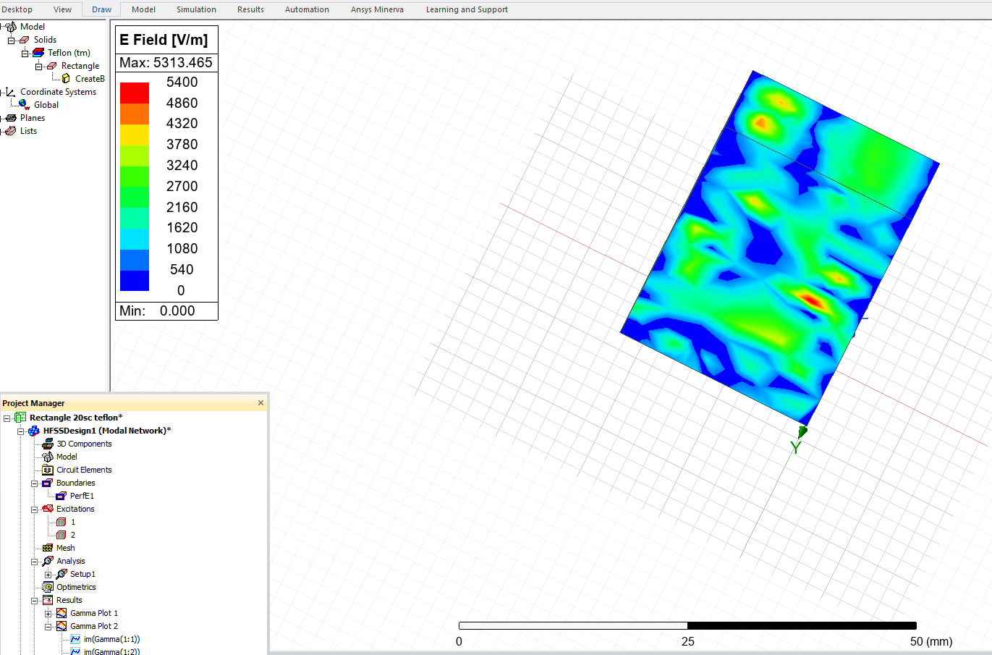
Figure 24 - Magnitude of Electric Field - Mode 2
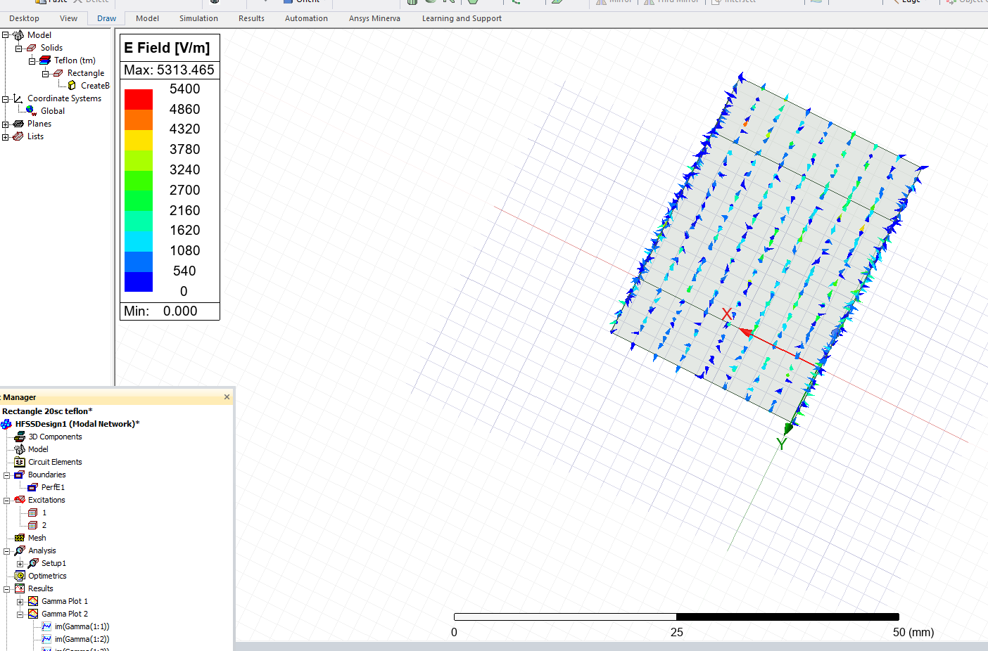
Figure 25 - Vector of Electric Field - Mode 2
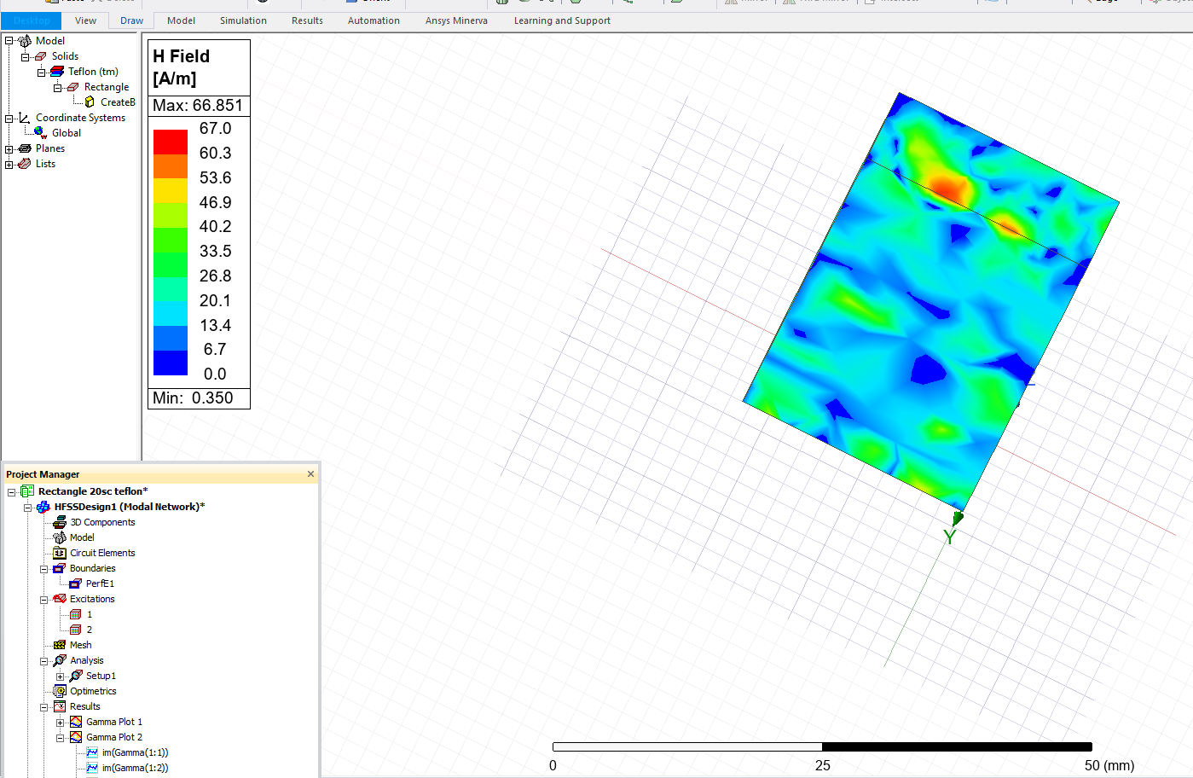
Figure 26 - Magnitude of Magnetic Field - Mode 2
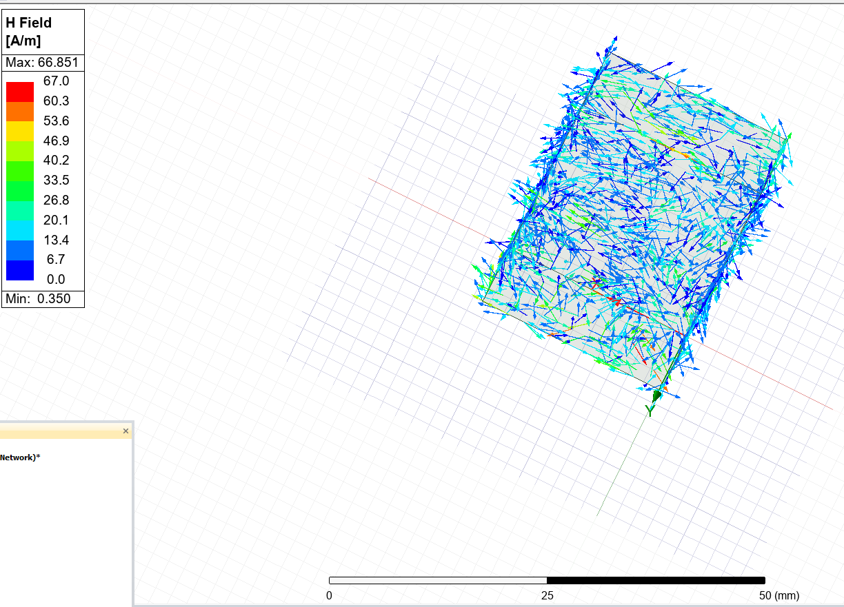
Figure 27 - Vector of Magnetic Field - Mode 2
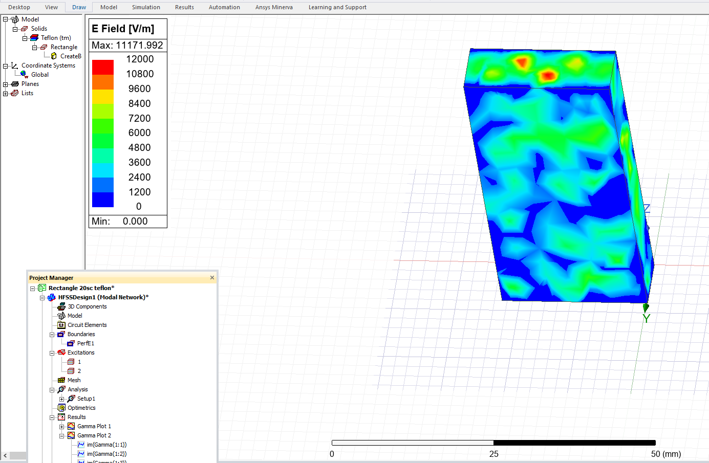
Figure 28 - Magnitude of Electric Field - Mode 3
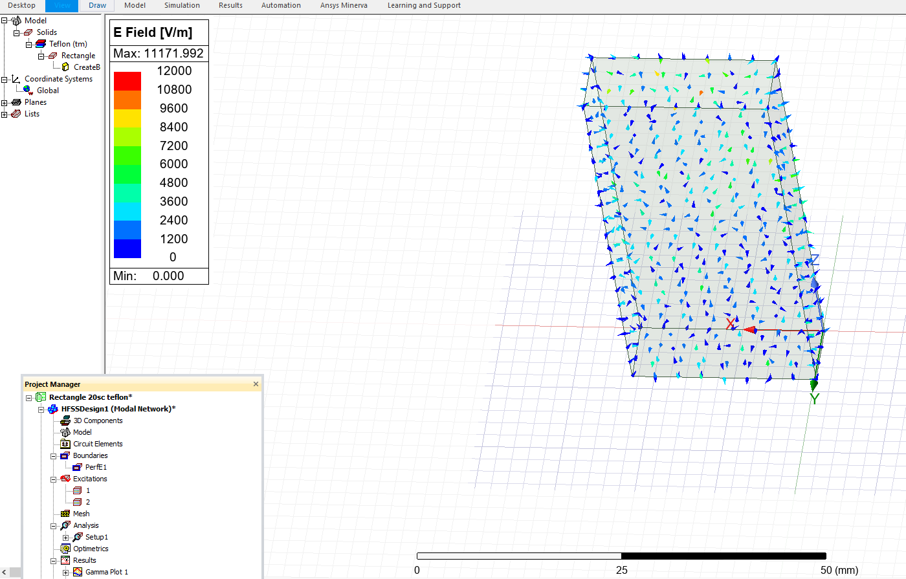
Figure 29 - Vector of Electric Field - Mode 3
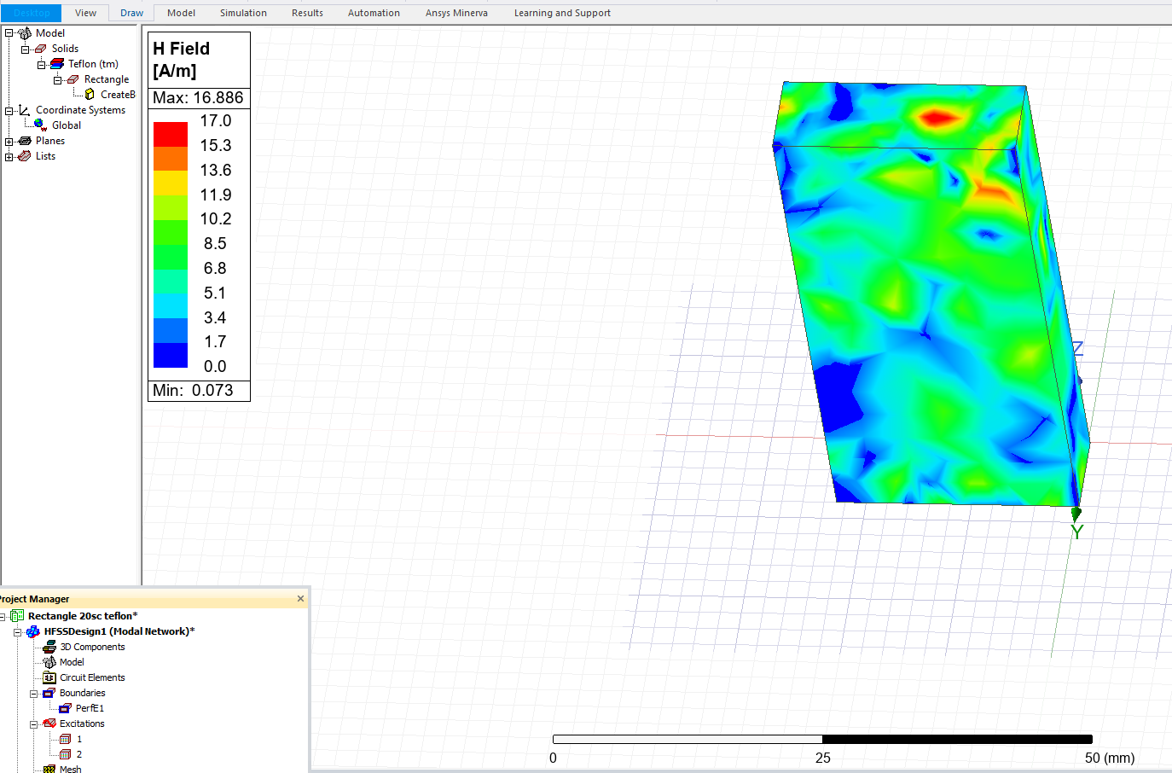
Figure 30 - Magnitude of Magnetic Field - Mode 3
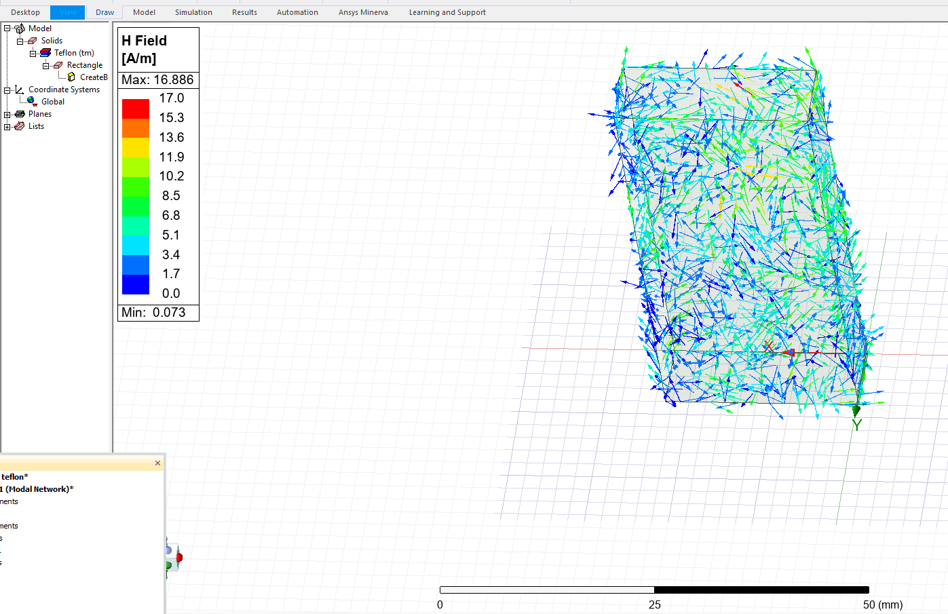
Figure 31 - Vector of Magnetic Field - Mode 3
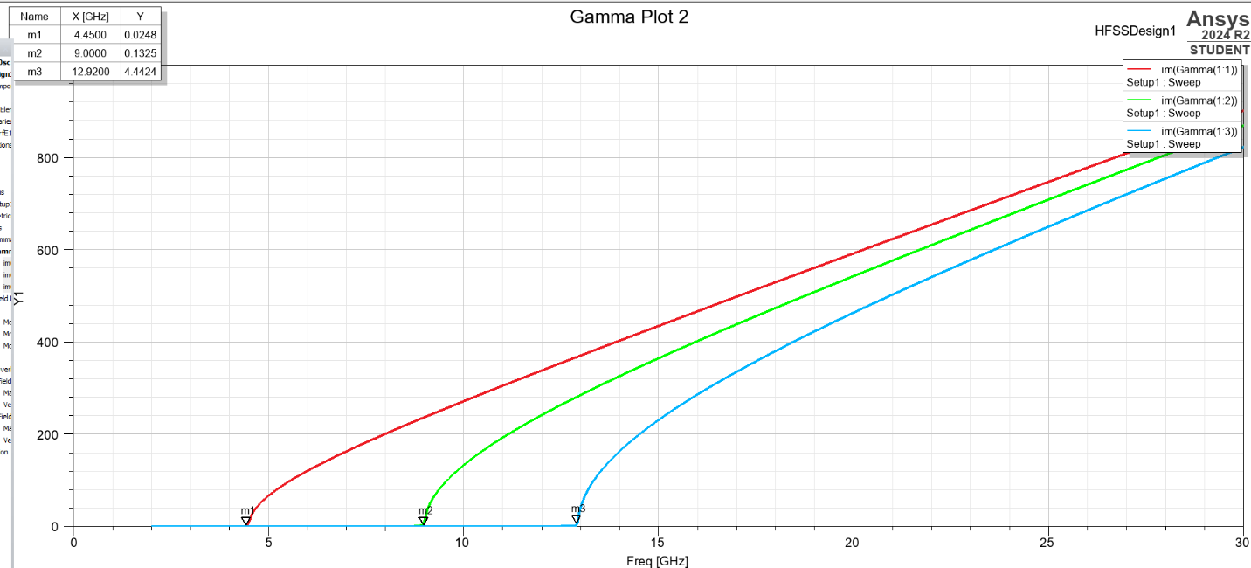
Figure 32 - Cutoff Frequencies Teflon Waveguide

2.3 Task 2: Half-Wave Dipole Antenna

2.3.1 Design Inputs and Calculations
The final task involved the design and simulation of a half-wave dipole antenna using ANSYS HFSS. The antenna was constructed from a PEC (Perfect Electric Conductor) with a radius of 1 mm, and excited using a 50-ohm lumped port. The dipole was placed inside a rectangular radiation boundary box to allow the wave to radiate freely in space.
The Wavelength (λ) was determined using the first three digits of the student ID:
- Student ID: 2314594
- λ = 231 mm
From this, the Dipole length and operating frequency were calculated as follows:
Dipole Length Calculation:
$$L= \frac{λ}{2}= \frac{231}{2}=115.5mm=116mm$$
Operating Frequency Calculation:
$$f= \frac{c}{λ}= \frac{{3x10}^{8}}{{231x10}^{-3}}=1.30 x {10}^{9} Hz=2.3 GHz$$
The antenna was designed to operate at a target frequency of 2.3 GHz with a length of 116mm.

2.3.2 Simulation output
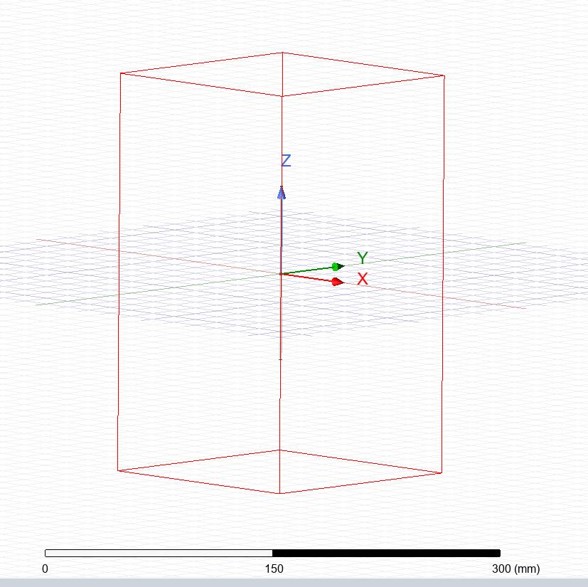
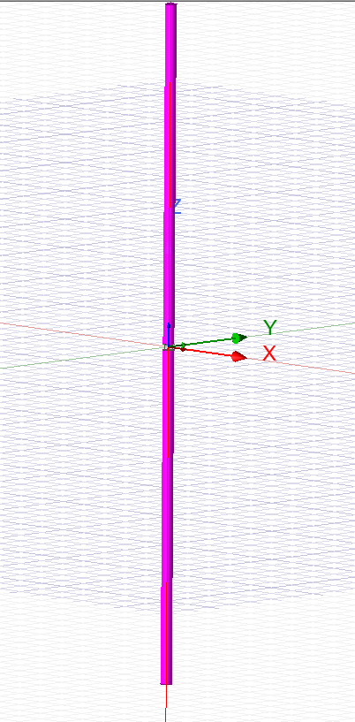
Figure 33 - Wider Design view of Half-Wave Dipole Antenna
Figure 34 - Design of Half-Wave Dipole Antenna
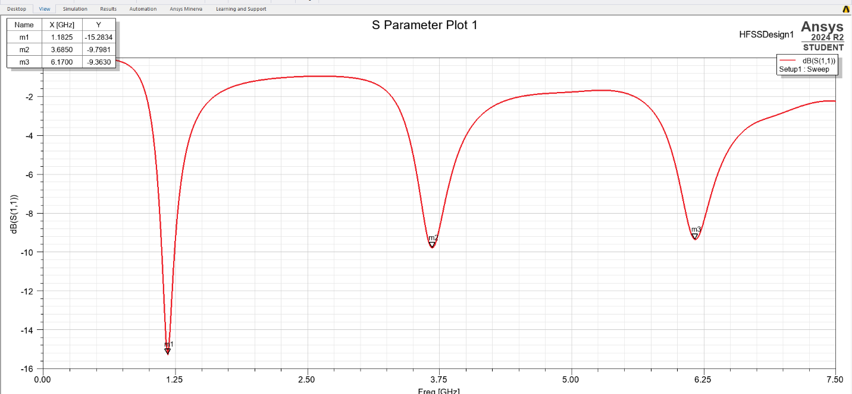
Figure 35 - Scattering Parameter Plot (S11) - Dipole Antenna
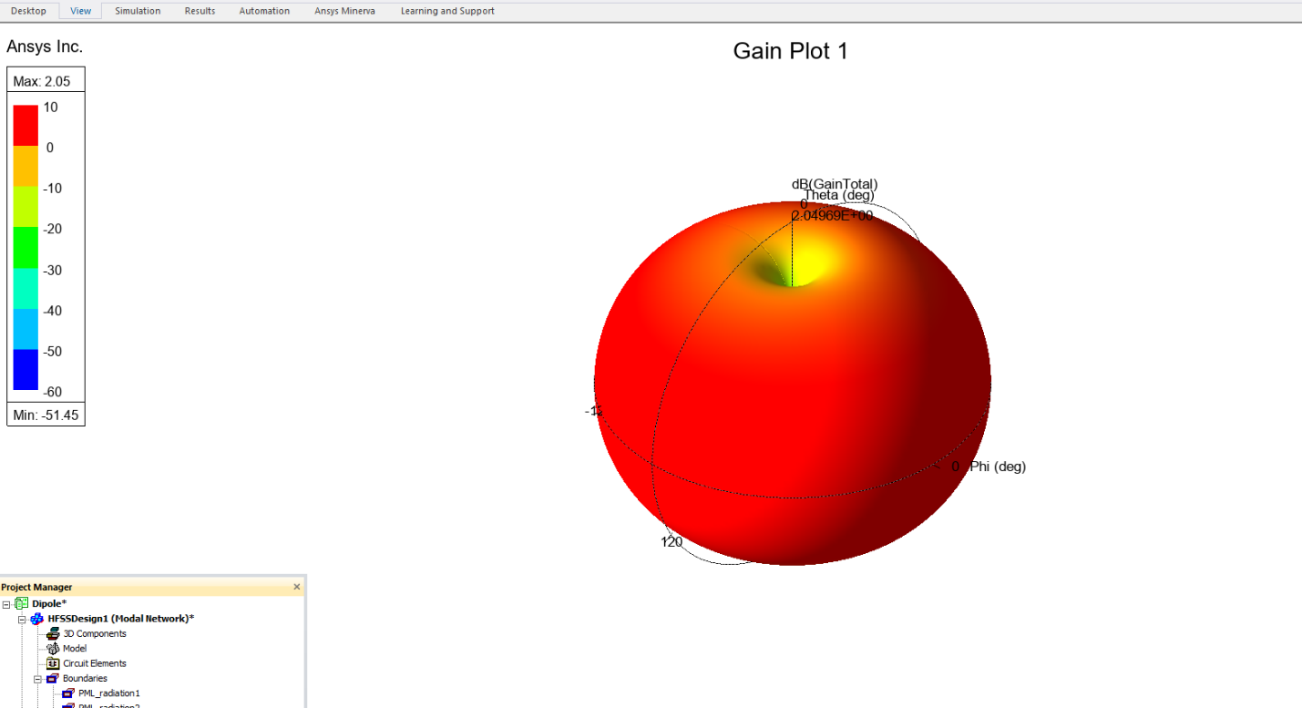
Figure 36 - Radiation Pattern of Dipole Antenna

3 Results

3.1 Task 1a: Vaccum-Filled Rectangular Waveguide

3.1.1 Theoretical vs simulated cutoff frequencies
The table below compares the theoretical cutoff frequencies for the first three TE modes with the observed behaviour from the HFSS simulation.
Table 3 - Comparison of theoretical and simulated cutoff frequencies for the vacuum-filled rectangular waveguide
Mode | Indices (m, n) | Theoretical Cutoff Frequencies (GHz) | Simulated Cutoff Frequencies (GHz) | Propagation above
TE₁₀ | 1, 0 | 6.52 | 6.48 | 6.48 GHz
TE₂₀ | 2, 0 | 13.04 | 12.99 | 12.99 GHz
TE₀₁ | 0, 1 | 21.43 | 18.73 | 18.73 GHz

3.2 Task 1b: Teflon-Filled Rectangular Waveguide

3.2.1 Theoretical vs Simulated Cutoff Frequencies

The table below shows the corresponding cutoff frequencies with the inclusion of a dielectric material (Teflon, ϵ_{r} ​= 2.1):
Table 4 - Comparison of theoretical and simulated cutoff frequencies for the Teflon-filled rectangular waveguide
Modes | Indices (m, n) | Theoretical Cutoff Frequencies (GHz) | Simulated Cutoff Frequencies (GHz) | Propagation Above
TE₁₀ | 1, 0 | 4.50 | 4.45 | 4.45 GHz
TE₂₀ | 2, 0 | 9.00 | 9.00 | 9.00 GHz
TE₀₁ | 0, 1 | 14.79 | 12.92 | 12.92 GHz

3.3 Task 2: Half-Wave Dipole Antenna

3.3.1 Calculated vs Simulated Operating Frequency
Table 5 - Comparison of theoretical and simulated resonance frequency for the half-wave dipole antenna
Parameter | Value
Wavelength (λ) | 231mm
Theoretical Frequency | 2.30 GHz
Dipole Length | 116mm
Simulated Resonant Frequency | 1.18 GHz (S₁₁ = -15.28dB)

4 Discussion

4.1 Rectangular Waveguide with Vacuum
The simulation of the vacuum-filled rectangular waveguide effectively replicated the propagation characteristics of transverse electric (TE) modes theoretically predicted by electromagnetic theory. For the assignment requirement, we had to find the dominant mode, acquire visualizations of the electric and magnetic fields, compute the theoretical cut-off frequencies, and benchmark these against the simulation output. Ansys HFSS software and analytical computation were used to achieve this.
As can be demonstrated by Table 2, the theoretical value of the TE₁₀ mode cutoff frequency is 6.52 GHz and the simulated one is 6.48 GHz with an almost negligible error value equal to 0.61%. TE₂₀ and TE₀₁ also showed close conformity, except for TE₀₁, whose simulated value of the cutoff frequency is far lower (18.73 GHz compared to 21.43 GHz). Such differences could be the outcome of mesh resolution or finite size of the ports or internal reflections in the 50 mm waveguide. Anyway, these findings agree with theory predictions and demonstrate that TE₁₀ is the dominant mode in this geometry setup.
The port field display and field overlay (Figure 2–16) contain qualitative measures of the mode patterns. In Photo 2, the TE₁₀ mode has one lobe of electric field variation along the broader dimension, as is found in textbook TE mode patterns. For example [5], this mode exhibits a maximum electric field at the centre of the waveguide’s width and zero at the side walls, forming a single half-sinusoidal variation across the broad face of the guide. Likewise, the vector plots (Figures 5, 6) reflect orthogonal orientations of the electric and magnetic fields, typical in TE waves in which there is no component to the electric field in the propagation direction. (Figure 7, 8) similarly, confirm the predicted behaviour of the H-field.
Moreover, the simulation created an associated cutoff plot (Figure 1), which shows the imaginary part of the propagation constant (Gamma). Where the points on Gamma go through zero are the mode cut-on frequencies. This verifies our knowledge that below the cut-off, the modes display evanescent behaviour, and above the cut-off, there is real propagation. The assignment task to "record port field displays and obtain field magnitudes and vectors" is answered completely.
The vacuum waveguide model illustrates how the dimensions of the waveguide limit the allowed modes. It supports the concept that propagation is impossible below cutoff frequencies and smaller cross-sectional sizes produce greater cutoff values. Both are cornerstones to the designing of microwave systems and are used extensively in radar and satellite communication equipment.

4.2 Rectangular Waveguide with Teflon
The second part of Task 1 involved replacing the vacuum medium with Teflon (εₛ = 2.1), which alters the effective phase velocity of the wave within the guide. As shown in Table 3, the cutoff frequencies for the TE modes are noticeably lower than in the vacuum-filled case. For example, TE₁₀ shifts from 6.52 GHz to 4.50 GHz theoretically, and the simulated result was 4.45 GHz. This validates the theoretical model:
$$fc= \frac{c}{\sqrt[2]{ϵr}} \sqrt{({\frac{m}{a})}^{2 }}+ {(\sqrt{\frac{n}{b})}}^{2}$$
This reduction in cutoff is also evident in the field plots and Gamma diagram (Figure 17–32). Compared to the vacuum model, the field patterns remain qualitatively similar, but with slightly shorter wavelengths. This is due to the reduced phase velocity caused by the increased permittivity. The assignment asked for a comparison between the two models, and this contrast clearly shows how material loading affects waveguide performance.
Theoretical versus simulated discrepancies were minor for TE₁₀ and TE₂₀ but more substantial for TE₀₁, where the simulated value (12.92 GHz) was lower than the theoretical 14.79 GHz. This might stem from:
- Inaccurate port excitation for modes with higher-order variation in the narrower dimension
- Meshing irregularities around sharp field gradients
- Dielectric loss or boundary condition interactions
By filling the waveguide with Teflon, we effectively slowed down wave propagation, increasing the electrical length of the waveguide. This technique is commonly employed in compact or embedded microwave systems where reducing physical size is important. The results demonstrate an excellent application of wave propagation principles in practical engineering design [6].
From an academic perspective, this task fulfills the learning outcome to "analyse results obtained from the application of specific electromagnetic modelling techniques and correlate those results with physical characteristics." By comparing vacuum and Teflon-filled models, the physical impact of permittivity on propagation becomes clearly visible.

4.3 Half-Wave Dipole Antenna
Task 2 required the design and evaluation of a half-wave dipole antenna using a student-ID-based wavelength (λ = 231 mm), yielding a design frequency of 2.30 GHz and a length of 116 mm. However, simulation results shown in Photo 34 indicate a primary resonance at 1.18 GHz. This is a significant deviation from theoretical expectations.
While the calculated length-to-frequency relationship appears valid on paper:
$f= \frac{c}{λ}$ and $L= \frac{λ}{2}$
simulation environments introduce several practical variables:
- The fringing effect at the dipole tips extends the current distribution beyond the physical length, effectively lowering the resonant frequency. [7]
- The airbox/radiation boundary might not have been large enough to fully approximate free space, causing standing waves or reflections that detune the resonance.
- The feed gap and lumped port setup might introduce inductive or capacitive loading, shifting the resonant point.
Despite the discrepancy, the antenna has a good match at 1.18 GHz with -15.28 dB return loss, which implies high energy transfer to radiation. Other notches observed at 3.69 GHz and 6.17 GHz hint towards higher-order harmonics or internal resonances in the structure.
The radiation pattern (Figure 36) indicates a standard doughnut-shaped field profile as one might expect from a half-wave dipole in free space. This verifies that the antenna is designed to radiate mostly broadside to the dipole's longitudinal axis, with nulls in the feed line's direction. The form and symmetry in the plot also verify the correct excitation and boundary in HFSS.
Even though the task anticipated an accurate match between simulated and calculated values, it is instructive to see how simulation adds complexity. Such variations highlight iterative prototyping and tuning as essential in antenna design. This task also fulfils the requirement to "obtain radiation pattern of the antenna" and demonstrates the benefit of using analytical and numerical means.
In practice, antenna tuning entails geometry or matching network adjustment in response to real-world observations. Here, we have hands-on experience with non-idealities due to modelling assumptions, excitation techniques, and limited software capabilities. Deviation also presents a wonderful chance to reflect on the boundaries of analytical equations in moving from theory to practice to application.

4.4 Overall Evaluation
This coursework reflects how electromagnetic wave propagation is affected by geometry, material characteristics, and environmental configuration throughout both assignments. The waveguide assignments highlighted the role of cutoff frequency and mode propagation, while the antenna assignment introduced real-life complications like impedance matching and radiation behaviour.
All simulation outcomes were compared with theory and confirmed by field plots and Gamma/S-parameter plots. The outcomes meet the learning outcomes covered by this module on learning about magneto-static and time-harmonic fields and match established theory.
Additionally, experimentation with HFSS enabled hands-on exposure to one of the most advanced tools in RF and microwave engineering. The visuals created (Figures 1–36) enabled detailed interpretation of mode shapes, electric and magnetic field dynamics, and performance of antennas.
Overall, this work illustrates the interplay between simulation and theory, showing how analytical expressions give a first-order approximation, but simulation provides a strong means to investigate and affirm more subtle electromagnetic effects.

5 Conclusion
This report has demonstrated a comprehensive analysis of electromagnetic wave propagation through two types of rectangular waveguides and a half-wave dipole antenna. Using ANSYS HFSS, both vacuum- and Teflon-filled waveguides were modelled to observe TE mode behaviour, and their simulated cutoff frequencies were compared against theoretical calculations. The results confirmed that material permittivity significantly influences wave propagation, with Teflon reducing cutoff frequencies due to slower phase velocity.
The dipole antenna, designed to operate at 2.30 GHz based on the student ID-derived wavelength, exhibited its strongest resonance at 1.18 GHz. This deviation highlighted the impact of simulation boundaries, fringing fields, and port configuration on antenna performance. Nonetheless, the antenna radiated effectively with a classical dipole pattern.
Overall, the work fulfilled the module learning outcomes by combining theoretical analysis with simulation-based investigation. It reinforced key principles in waveguide and antenna design while providing hands-on experience in modelling real-world electromagnetic behaviour.

References
[1] M. Fazli, A. Sayed, and Latif Maftunzada, “THE ROLE OF ELECTROMAGNETIC WAVES IN MODERN COMMUNICATIONS,” vol. 5, no. 7, pp. 80–89, Jul. 2024, Available:https://www.researchgate.net/publication/382968481_THE_ROLE_OF_ELECTROMAGNETIC_WAVES_IN_MODERN_COMMUNICATIONS
[2] Mit.edu, 2023. https://web.mit.edu/6.013_book/www/chapter13/13.4.html
[3] “Microwaves101 | Dielectric-Loaded Waveguide,” Microwaves101.com, 2025. https://www.microwaves101.com/encyclopedias/dielectric-loaded-waveguide (accessed Apr. 09, 2025).
[4] C. Gandy, “Dipole antennas,” 2006. Accessed: Apr. 09, 2025. [Online]. Available: https://downloads.bbc.co.uk/rd/pubs/whp/whp-pdf-files/WHP132.pdf
[5] “Rectangular waveguides.” Available: https://www.qwed.com.pl/RectangularWaveguides.pdf
[6] R. Collin, “A C LA SSlC REISSUE Foundations for Microwave Engineering SECOND EDITION.” Available: https://radfiz.org.ua/share/sheva_s8_DEK/SECONDARY/%E4%C5%D2%D6/%E4%C5%D2%D6/%CE%D7%DE%20%D4%C5%C8%CE%A6%CB%C1/%CC%A6%D4/Collin.%20Foundations%20for%20Microwave%20Engineering.pdf
[7] K. Smith, “The Half-Wave Dipole: Design Developed by.” Available: https://innovationspace.ansys.com/courses/wp-content/uploads/sites/5/2022/07/TheHalfWaveDipole-Design.pdf

‌

‌

‌

