23/09/2024
Jamie Leung
Renishaw
PLC Control – Developments & Functional Specifications
Control Technology

Contents
1 Contents 1
2 Table of Figures 2
3 Introduction 3
4 Task 1 – PLC 3
4.1 History 4
4.2 Technological Advancements 6
4.3 Hardware 7
4.4 Software 7
4.5 Impact from PLCs 8
5 Task 2 – Functional Design Specification 9
5.1 System Overview 9
5.1.1 Purpose 9
5.1.2 Hardware Systems Components 9
5.2 Definitions 10
5.3 Scope / Objectives 11
5.4 System Requirements 11
5.4.1 Functional 11
5.4.2 Environmental 13
5.4.3 Safety and Compliance 13
5.5 Software 14
5.6 Testing and Validation 14
5.7 Best Practices & Common Challenges 15
6 Conclusion 15
7 References 16

Table of Figures

Figure 1 - Block Diagram PLC 3
Figure 2 - Old System 4
Figure 3 - Modicon PLC 5
Figure 4 - Bulletin 1774 6
Figure 5 - Common PLC Size 7
Figure 6 - Definitions 10
Figure 7 - Flowchart 12
Figure 8 - EU Conformity 13
Figure 9 - UK Conformity 13

Introduction

The advancement of the Programmable Logic Controller (PLC) is a fundamental aspect of current industrial automation, serving as an opportunity for process optimisation, productivity enhancement, and industry safety assurance. The history of PLCs, technological developments, and their influence on industrial practice are all covered in the first segment of this two-part report.

This assignment's second section examines the creation of a functional design specification, or FDS. This section will go over the crucial steps in creating an FDS for a PLC control system, as well as the important elements and typical problems that arise throughout system development.

Task 1 – PLC

The term PLC, or programmable logic controller, refers to a type of microprocessor controller that is used to track inputs and manage outputs to a process according to its logic or program. PLCs are programmable controllers that utilise programmable memory to store instructions and may be used for a variety of control functions. A wide range of operations, including material handling, production line manufacturing, and agricultural, depend on PLCs (Bolton, 2015).
Figure 1 shows a block schematic of the essential parts of a typical PLC below.
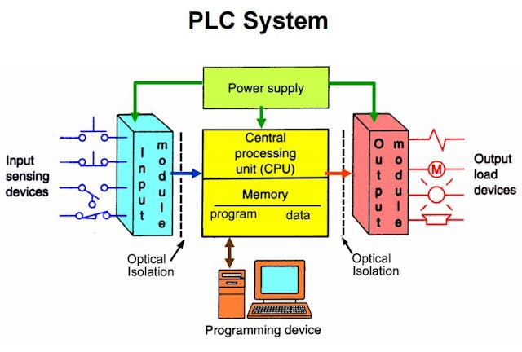

Figure 1 - Block Diagram PLC

History

PLC history dates back to the 1960s, a time when the industry used electromechanical relay circuits to manage systems instead of PLCs. These kinds of systems encounter several difficulties, such as the intricate design and construction of the panels. Furthermore, these systems are not very flexible; every modification to the procedure involves rewiring the control panel. These hard-wired relay systems were replaced in the late 1960s by PLCs. Figure 2 shows an image of an old control panel.
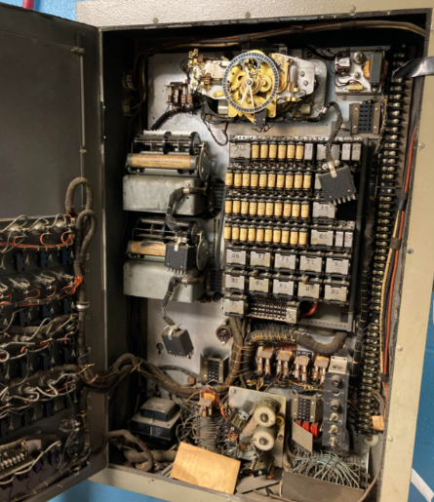
Figure 2 - Old System

In 1968, Bill Stone of General Motors Corporation gave design specifications for a "machine controller" to four separate manufacturers, according to an article titled Nidec and a research titled History of PLC by Vanessa Romero Segovia and Alfred Theorin. Bill Stone also explained the difficulties that he was experiencing with the machines in his plant. The four companies can be seen below:
- Bedford Associates
- Century Detroit
- Allen-Bradley, by way of Michigan-based Information Instruments, Inc
- Digital Equipment Corporation (DEC)
(Nidec, 2024)

It was Bedford Associates that met the criteria in 1969, and many people refer to Richard Morely of Bedford Associates as the "father" of PLCs (Vavra, 2017). The PLC, called 084, was designed by Richard Morely and his team, which included Mike Greenberg, Jonas Landau, Tom Boissevain and George Schwenk. Since it was the 84th project for the corporation, it was given the title 084. The founding group founded Modicon (MOdular DIgital CONtroller), a new business, in 1968. This new business collaborated with Bedford to develop the controller, which they were referring to as the programmable controller (Romero and Theorin, 2012). Figure 3 shows the first Modicon PLC.

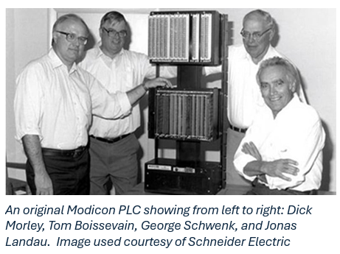
Figure 3 - Modicon PLC

As shown in Figure 3, the original PLC structure was made in a modular approach. The 084 has to be modular such that any basic part or subassembly might be switched out quickly for repairs or replacements. In addition, a Control Automation Article states that the PLC's original requirements were immediate mapping into memory, the elimination of processing interruptions, and a requirement that the system be reusable (Peterson, 2022).

Other key milestones in the PLC industry involves the 1970s. All different manufacturers started to create different types of controllers including in 1973 Allen Bradley or known as Rockwell when they took over in 1985 created the Bulletin 1774 PLC.
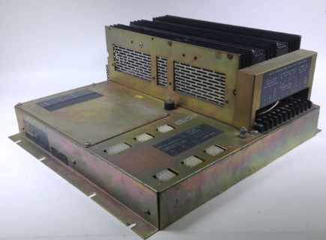
Figure 4 - Bulletin 1774

In 1982, the International Electrotechnical Commission (IEC) 61131-3 standard was released, marking another important milestone in the development of PLCs. For electrical and related technology, the IEC is the organisation that establishes international standards. The five programming languages listed below are those defined by IEC 61131-3 and are often used for PLC programming:
- Ladder Logic (LL)
- Structured Text (ST)
- Functional Block Diagram (FBD)
- Sequential Function Chart (SFC)
- Instruction List (IL)
(Devasia, 2021)

Technological Advancements
PLC technology has advanced significantly over time to increase control system efficiency and flexibility. These developments might include better-performing hardware and software. Below are some notable examples of technological advancements to transform the PLCs;

Hardware

One of the primary components of the PLC is the CPU, which controls its operation. Processing power appears to have grown throughout time, moving from relays to simple CPUs to powerful microprocessors. Basic microprocessors with limited logic operations capabilities were a characteristic of early PLCs. With powerful multi-core processors, modern PLCs can perform real-time data processing and other complex control techniques are supported by these processors (Sapot, 2024).

The PLCs' size has also drastically shrunk. Compared to the 084 PLC in Figure 3 and the PLC shown in Figure 5, the first PLC was around the size of a “19-inch TV,” according to a ManufacturingNet article. Users may observe the size differences and advancements made by PLCs over the years. PLCs with smaller sizes are perfect for applications with limited physical space. Because of their small form factor and ability to fit into small locations, these PLCs are perfect for space efficiency (Canada, 2023).

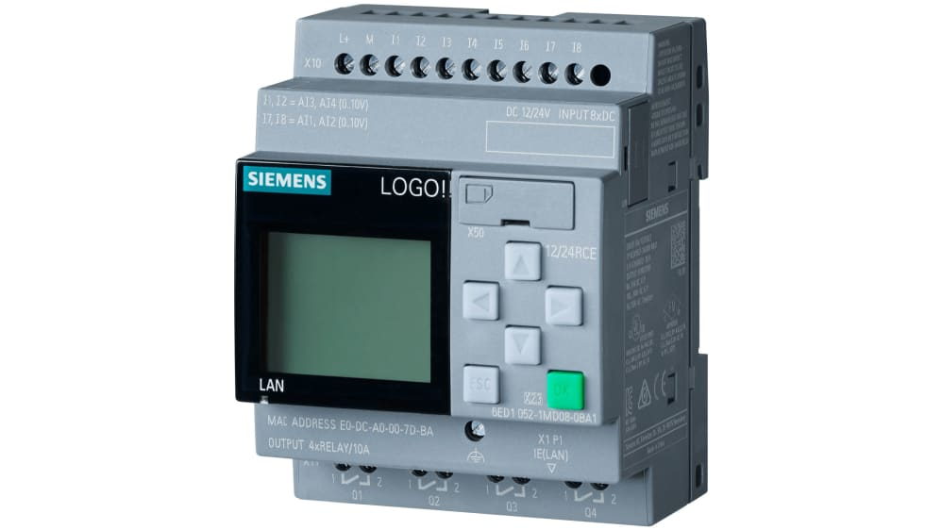

Figure 5 - Common PLC Size

Software

Time has changed since the invention of the PLC, leading to the use of PLC simulators. Before implementing programs for control to real equipment, developers can design and test them in a virtual setting using simulation software, which functions as a virtual PLC. This speeds up development, lowers mistake rates, and permits extensive testing without stopping the manufacturing process (Stuve, 2023).
Real-time information data represents one of the most significant developments for PLCs. This capability enables engineers to regularly track system performance and obtain knowledge about the effectiveness of operations.

In addition to this, PLC technology has been changed via remote access. PLC control systems may now be accessed and managed remotely by engineers, allowing for continuous monitoring and modifications from any point in the world. This is ideal for engineers that have reactive tasks to complete when off-site. Additionally, it allows engineers to work remotely without restriction.

Impact from PLCs

Manufacturing processes have changed dramatically since PLCs were introduced. Prior to PLCs, manufacturing processes depended on hardwired and manual control systems – refer to Section 4.1 for more history on PLCs. With the use of PLCs, production processes can now be precisely controlled. Additionally, new processes may be quickly programmed and adjusted without requiring significant physical modifications to the control system.
PLCs have a huge influence on productivity in addition. Production lines are now operating at significantly higher production rate thanks to PLCs and an automation system, which can automate repetitive operations that were formerly done manually (Whitehouse, 2023). As seen in section 5.2 – the introduction of PLCs can reduce the amount of downtime in production by tools like real time date and built in diagnostic capabilities.
Industry Standards and Practices have also been impacted by PLCs. The industry developed standards like IEC 61131-3, which was discussed in section 4.1 above, as a result of the extensive use of PLCs.

Task 2 – Functional Design Specification

A functional design specification (FDS) is a formal document that describes the intended requirements that the system must fulfil. In terms of a PLC control system, the FDS will include information such as operational details, hardware or software design and functional requirements. Before the PLC system is constructed, all stakeholders or engineers are guaranteed to have a clear grasp of the desired functionality and design thanks to the FDS, which acts as the structure for the system's creation, programming, validation, and installation (ImperiumDynamics, 2023).

There are several steps that make up the functional design specification, and each one is crucial to the system. The sequential procedures and key phases in creating an FDS for a PLC control system are shown below.

System Overview

A system overview provides a summary of the entire system and is a critical part of the functional design specification for a PLC control system. Below are key features of a typical PLC system overview;

Purpose

This is essential as it gives users and stakeholders an overview of the system and is likely the first item they will look at. This is intended to provide background information along with an explanation of the PLC control system's main functions and purpose.

Hardware Systems Components

This section covers the PLC hardware that will be utilised within the system, including the model, performance, and other important features of the PLC unit. Stakeholders can also read this and make sure that the CPU and memory have enough power and capacity to handle the control logic and data processing requirements of the system. In order to minimise hardware component mismatches and data loss or communication problems, it is essential to choose the appropriate hardware component that will interact with logic and other equipment such as sensors, input/output components and power supplies.

In addition to this, an input list of devices that is used in the system can be identified here and can establish how inputs from switches, sensors, and other equipment should be processed by the system. This involves processing signals and interpreting sensor data.
Furthermore, the outputs define the parameters that determine how the system should handle outputs, such as triggering alarms, switching on lights, or regulating actuators in response to input and control logic. This may include a list of outputs within the system and expected behaviour for each one.

Definitions

A typical FDS has a definitions section, which aid in identifying both the full word and its abbreviations across the system. This keeps everyone in the loop and prevents misunderstandings. An example of definitions in a PLC control system can be found in Figure 6.
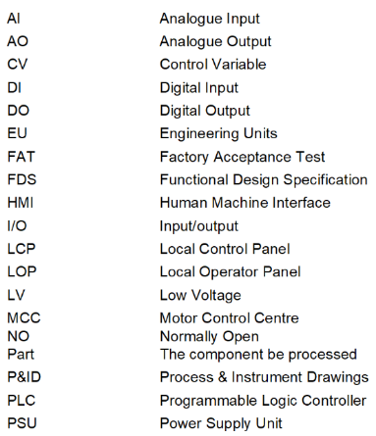
Figure 6 - Definitions

Scope / Objectives
The scope details the precise requirements for the control system and key information such as;

- Project deadlines
- Costs
- The goals and objectives
- Deliverables
- Justification for the control system
- Identify Stakeholders

The scope makes sure that all engineers and stakeholders are aware of the targets and outcomes of the project. In order to prevent miscommunication, the scope of the FDS might be considered one of the most important factors (Johansson, 2023).

When dealing with limitations like resources or time, project managers may use the scope to help them prioritise activities and decide where to concentrate their efforts. Early in the project, the scope aids in the identification of possible hazards. Teams may prepare for obstacles by having a clear understanding of the project's requirements.
Throughout the course of the project, the scope is an essential component of the documentation, acting as a guide (Martins, 2024).

System Requirements

Functional
It is also essential to specify the functional requirements. The functions and tasks that must be carried out by the PLC control system are specified by functional requirements, this can include detailing what certain equipment does within the system. (Altexsoft, 2023). A few examples of this for a PLC system would include;

User interface
Identifying different user interface equipment that may be used within the system and how interaction is achieved. This may consist of Human-Machine Interface (HMI) which describes the screen arrangements, and input techniques that operators will use to interact with the system. For instance, joysticks, touchscreens, mouse, keyboard and barcode scanners.

Performance
The requirements for performance could involve response time, which indicates the speed at which the system must react. Furthermore, it is important to document the accuracy based on the specific application. For example, the temperature sensors will read the temperature ensuring to maintain the temperature within a specific range. If the system's performance is related to manufacturing, it may additionally include predetermined objectives for the quantity of goods it must generate.

Process Control
The PLC's process management methodology is described in this stage. It will include a brief description of many different elements of the system along with an explanation of how it will work and serve its purpose. For example, it has to control the system's fluid levels and motors.

Communication
The communication part identifies how the PLC will communicate with the other systems. A few examples of this can be systems like SCADA or protocols like EtherNET/IP. Furthermore, this section would indicate which communication protocols, such as serial, are being used. RS-232 and RS-485 are common serial communication protocols.

Workflow
This contains a sequence of activities that outlines the necessary steps to be taken in the correct order, in addition to time specifications and task dependencies. A PLC flowchart diagram is one example of this; it gives a visual representation of the actions the system should carry out and in what order (Asana, 2022). A flowchart diagram of a Renishaw operation can be seen below in Figure 7.
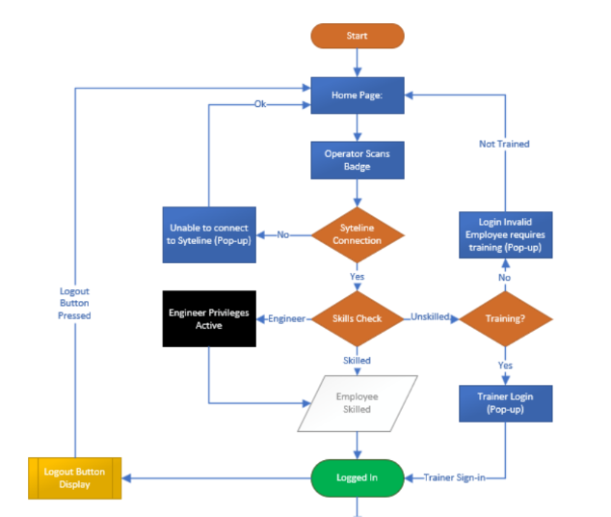

Figure 7 - Flowchart

Environmental

An additional requirement is environmental. Every aspect of the operating environment, including humidity and temperature, that the system may encounter should be included in this section. Where the system will be utilised, such as indoor use, can also be determined by this section. This part should also address vibrations and shock resistance in order to assess the system's resilience and capacity to withstand high vibration conditions, as well as the potential effects on it.

Safety and Compliance

For a PLC control system, there are a number of requirements that need to be included during an FDS, such as safety and compliance. The user is responsible for identifying any safety-related requirements within this sector and making sure that industry standards, including IEC 61131-1, are followed. Safety and emergency functions can also be included in this section or the functional sector in 7.3.3. These functions can consist of identifying safety features like emergency stops or interlock systems.
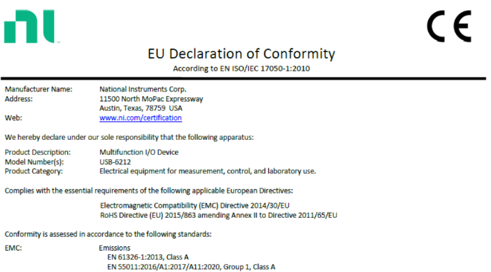
Compliance is a key part of a FDS as compliance is the system's conformity to certain rules, regulations, and specifications. To guarantee that the system is operationally and legally acceptable, compliance standards can be included in an FDS. In a PLC system there are many declaration forms that must be fulfilled such as for any pneumatic equipment. Below in figures 8 & 9 are examples of UK/EU declaration of conformity forms.
Figure 8 - EU Conformity
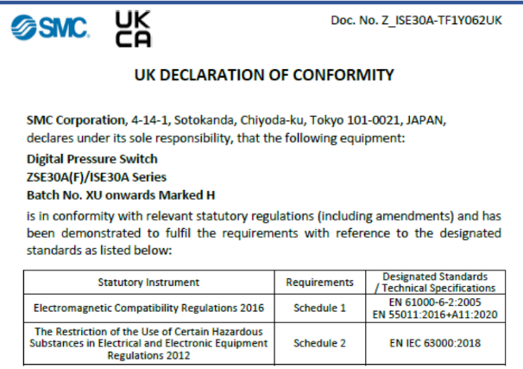
Figure 9 - UK Conformity
Functional requirements are crucial because they give precise directions on what the system needs to accomplish, directing the development of the control logic, hardware, and software. It ensures that the finished product satisfies all requirements for performance, safety, and operations.

Software
An FDS's software design section is crucial as it offers information on potential control system architecture. The software that will be utilised throughout the PLC control system may be highlighted in this section. This information might aid the team in determining which engineer is most familiar with the program, or it could lead them to research which software is most appropriate for this particular usage.

It is also necessary to divide the system into many modules, each of which should be in charge of particular tasks including input, output, and user interface. The engineers can now understand precisely what is required, which may aid in the program's design.
In accordance with IEC 61131-3 standards, this part aids in identifying the kinds of programming languages that will be utilised in the system. Programming languages, for instance, might be ladder diagrams (LD).

Testing and Validation
The testing and validation procedures in the FDS must be accomplished in order to ensure that the control system operates as effectively as possible. It contains setting up an extensive plan that details how the PLC control system will be inspected, tested, and validated to ensure that all requirements are met (Sharma, 2019).
The system may be subjected to several forms of testing, including system and unit testing. While system testing evaluates the entire system to make sure it satisfies requirements, unit testing allows the user to test individual system components to make sure they function as intended. Testing results in system validation, which verifies that the system satisfies the initial functional requirements as outlined in the project scope. In addition to this, the testing can be split into different sections again with internal testing and virtual testing. Internal testing consists of setting up a test environment that will reflect the proposed set up on site and the same or equivalent equipment. Whereas virtual testing can be implemented through different software’s without using any physical hardware (Ashlin, 2021).
Documentation of all testing and commissioning should include keeping track of and logging all trial test results, together with any changes or problems and any corrective measures that were implemented.

Best Practices & Common Challenges

Renishaw's Lens Potting Jig on the Encoder production line served as the primary example of a real-world FDS. Having thorough documentation is one of the best practices to follow when working with a functional design specification. When documentation is clear, users are able to comprehend it without having to worry about misinterpreting it during the design phase, which might result in expensive changes down the line. To maintain agreement on requirements, it's also critical to include all stakeholders and other professionals early in the development process. Employing a modular PLC control system, which manages specific functions for individual modules, is another recommended approach. Due to this, upgrading or replacing the system when necessary is made simpler.
Security concerns are only one of the many possible issues that arise during the development of a PLC control system. Since most PLC systems need networks to function correctly, both the system and the business are susceptible to cyberattacks (Mavis, 2024). An article on Control Engineering states that taking precautions against security concerns should start even before a breach is discovered. One method to seek for warning signs of a cyberattack is to use a 24/7 network monitoring service to check for unusual network communication (Vavra, 2020).
A potential barrier in the process of developing a PLC control system is the requirement for highly qualified programmers. Systems are becoming increasingly sophisticated, depending on the application, which contributes to the demand for qualified programmers. Lack of access to skilled programmers increases the likelihood of badly written code, which can result in errors, inefficiencies, and operational issues (Sapot, 2024a).

Conclusion

In conclusion, PLC systems' dependability, adaptability, and real-time functioning make them crucial to present industrial automation. They are scalable and programmable, which allows for flexibility in response to changes, and they increase efficiency by automating tasks. Important topics including PLCs' origins which Richard Morely is credited for were covered in Task 1's evaluation. PLC hardware and software have also seen notable technical advancements, such as the shrinking of PLC size over time.
Task 2 described the structure of a functional design specification, including the importance of the functional requirements, overview, and scope. Furthermore, crucial elements that need to be included in an FDS were emphasised, including hardware selection and testing/validation. The paper also discussed other difficulties encountered during the system's development, including security threats and the requirement for additional qualified programmers.

References
Altexsoft (2023). Functional and Non-functional Requirements: Specification an. [online] AltexSoft. Available at: https://www.altexsoft.com/blog/functional-and-non-functional-requirements-specification-and-types/ [Accessed 26 Aug. 2024].
Asana (2022). What is a Flowchart? Symbols, Types, and How To Read it • Asana. [online] Asana. Available at: https://asana.com/resources/what-is-a-flowchart [Accessed 28 Aug. 2024].
Ashlin (2021). How to do the commissioning and testing of a PLC? [online] Instrumentation and Control Engineering. Available at: https://automationforum.co/how-to-do-the-commissioning-and-testing-of-a-plc/ [Accessed 3 Sep. 2024].
Bolton, W. (2015). Programmable Logic Controllers. [online] Google Books. Newnes. Available at: https://www.google.co.uk/books/edition/Programmable_Logic_Controllers/sDqnBQAAQBAJ?hl=en&gbpv=1&dq=plc+programmable+logic+controller&pg=PP1&printsec=frontcover [Accessed 30 Jul. 2024].
Brown, H. (2021). The Father of PLC’s: How Richard Morley Revolutionized the Automation Industry. [online] blog.radwell.com. Available at: https://blog.radwell.com/the-father-of-plcs-how-richard-morley-revolutionized-the-automation-industry [Accessed 14 Aug. 2024].
Canada, C. (2023). Difference Between Compact PLC and Modular PLC. [online] Controlsoft Canada. Available at: https://controlsoft.ca/plc-programming/difference-between-compact-plc-and-modular-plc/ [Accessed 18 Aug. 2024].
Devasia, A. (2021). An Overview of IEC 61131-3 in Industrial Automation Systems - Technical Articles. [online] control.com. Available at: https://control.com/technical-articles/an-overview-of-iec-61131-3-Industrial-Automation-Systems/ [Accessed 16 Aug. 2024].
ImperiumDynamics (2023). How to Write a Functional Design Document. [online] Imperiumdynamics.com. Available at: https://imperiumdynamics.com/blog/How-to-Write-a-Functional-Design-Document.html [Accessed 23 Aug. 2024].
Johansson, J. (2023). What is project scope? | Plus 7 steps to help you define scope. [online] Work Life Balance Tips & Work Scheduling Blog | Resource Guru. Available at: https://resourceguruapp.com/blog/project-management/what-is-project-scope [Accessed 23 Aug. 2024].
ManfacturingNET (2007). PLCs – Past, Present and Future. [online] Manufacturing.net. Available at: https://www.manufacturing.net/home/article/13055504/plcs-past-present-and-future [Accessed 18 Aug. 2024].
Martins, J. (2024). How to Write a Project Scope in 8 Easy Steps • Asana. [online] Asana. Available at: https://asana.com/resources/project-scope [Accessed 23 Aug. 2024].
Mavis (2024). Understanding PLC Cybersecurity: The Definitive Guide | TXOne Networks. [online] TXOne Networks. Available at: https://www.txone.com/blog/ultimate-guide-to-plc-cybersecurity/#:~:text=Protecting%20PLCs%20is%20essential%20to [Accessed 1 Sep. 2024].
Maxodeals (n.d.). Allen Bradley 1774-P1 Bulletin 1774 PLC Programmable controller Ser E UMP. Available at: https://www.maxodeals.com/mdenglish/allen-bradley-1774-p1-e-ump [Accessed 14 Aug. 2024].
Nidec (2024). The history of PLCs. [online] Nidec.com. Available at: https://acim.nidec.com/en/drives/control-techniques/News-And-Media/Blog/Drive-Basics/Articles/2017/05/01/The-History-Of-PLCs [Accessed 14 Aug. 2024].
Peterson, D. (2022). The Origin Story of the PLC - Technical Articles. [online] control.com. Available at: https://control.com/technical-articles/the-origin-story-of-the-plc/ [Accessed 13 Aug. 2024].
Realpars (2024). What is a Functional Design Specification (FDS)? - RealPars. [online] Realpars.com. Available at: https://www.realpars.com/blog/fds [Accessed 1 Sep. 2024].
Romero, V. and Theorin, A. (2012). History of Control History of PLC and DCS. [online] Available at: https://archive.control.lth.se/media/Education/DoctorateProgram/2012/HistoryOfControl/Vanessa_Alfred_report.pdf [Accessed 12 Aug. 2024].
Sapot, B. (2024a). Mingo Smart Factory. [online] Mingo Smart Factory. Available at: https://www.mingosmartfactory.com/plc-programmable-logic-controller-manufacturing-explained/#:~:text=While%20the%20future%20of%20PLCs [Accessed 1 Sep. 2024].
Sapot, B. (2024b). PLC – Programmable Logic Controller: Manufacturing Explained. [online] Mingo Smart Factory. Available at: https://www.mingosmartfactory.com/plc-programmable-logic-controller-manufacturing-explained/ [Accessed 18 Aug. 2024].
Sharma, L. (2019). Why is Testing Necessary and Important? | ISTQB. [online] TOOLSQA. Available at: https://www.toolsqa.com/software-testing/istqb/why-is-testing-necessary/ [Accessed 1 Sep. 2024].
Stuve, B. (2023). The Benefits of Virtual Commissioning of Machines. [online] Emixa.com. Available at: https://www.emixa.com/blog/the-benefits-of-virtual-commissioning-of-machines [Accessed 3 Sep. 2024].
Vavra, C. (2017). Dick Morley remembered as ‘Father of the PLC’. [online] Control Engineering. Available at: https://www.controleng.com/articles/dick-morley-remembered-as-father-of-the-plc/ [Accessed 9 Aug. 2024].
Vavra, C. (2020). How to protect PLCs and PACs from cybersecurity threats. [online] Control Engineering. Available at: https://www.controleng.com/articles/protect-plcs-and-pacs-from-cybersecurity-threats/ [Accessed 1 Sep. 2024].
Whitehouse, S. (2023). Automated processes for better quality, productivity and efficiency. [online] www.winman.com. Available at: https://www.winman.com/blog/automated-processes-for-better-quality-productivity-and-efficiency [Accessed 20 Aug. 2024].

