Adam Chapman has written that playing video games can be historically meaningful as a means of producing ‘intertextual historical narrative’. Choose a video game (or a small selection of video games) which concentrate on war and conflict and assess the extent to which Chapman’s ideas are applicable to their output? (2500 words)
Video games centred on war and conflict have always proved among the most popular games on the market, with famous examples being the Call of Duty and Halo series, and many of these games profess to be historical in their basis, even if they carefully don’t claim to be ‘historically accurate’. This, a distinction that though subtle is the basis for much of the criticism that Chapman refutes when claiming video games can provide an ‘intertextual historical narrative’ is noticeable in games which offer the player a chance to interact with an alternate version of history, rewriting events through their actions. Critics such as Galloway argue that such gameplay creates an absence of history, that it ruins any of the integrity the medium may otherwise have possessed, and that video games as a medium have no place in historical debate; this can simply be ascribed to be academic snobbery – the only medium he accepts as valid is academic literature, inaccessible to the majority of the public – and his arguments are mainly rehashed versions of that used against films in history. Whilst video games cannot profess to be academic explorations in their own right; and what would their interest be to the majority if they were; they can nevertheless be useful within historical debate by encouraging interaction with, and understanding of, the period of history in which they have their roots.
The game I have chosen to examine for this is War Thunder, a free-to-play, massively multiplayer combat game, with so the website claims, over 10 million players – a massive appeal within a market saturated with games claiming to be historical. The game itself is based on 20th century military vehicular combat, with the main dates of focus between the early 1930s for tutorial play, up to the Second World War and early Cold War for advanced players, and features aviation, tanks, and most recently warships each with “authentic characteristics”. The developers Gaijin also claim that the game makes use of ‘80 maps, representing the main battle theatres’ of the period, and that the player vehicles are ‘carefully crafted from historical documents and surviving sources’, surely a claim for some measure of historical accuracy within the game. Chapman cites this interaction with primary sources as being typical for the historical accuracy of games, though like almost all historical games, the developers do not interact with secondary sources. The player interface for each unlocked vehicle displays a brief overview of these characteristics and a link to the developer’s own database where more detailed information about the particulars of each vehicle and the optional developments are available. Theoretically, players progress from simple “Arcade Missions” where the reality is limited, and the vehicles used in initial levels are slow and simple to control, to “Realistic Battles” or “Historical Campaigns” in early jet aircraft and advanced tanks, where more skill, and perhaps historical knowledge is expected of the participants in these more complex missions. An encyclopaedia, inbuilt into the game is also available to explain the terms and manoeuvres included within gameplay.
(Below: a player interface showing options for Realistic Battles and Historical Campaigns)
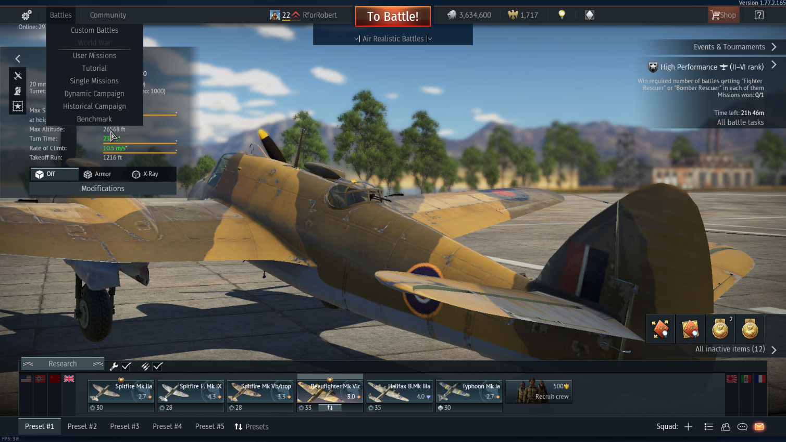
I have chosen this game as I have been a player for a long while, have explored the different game options, and whilst I am by no means an avid gamer, have been able to progress to a point where I am familiar with the characteristics of gameplay and the quirks of the game. All the screenshots within this essay are from my account, and therefore may differ from players who have interacted with the game differently or who have progressed further – War Thunder allows players to interact with the game in different ways and thus as they progress each player will find they vary further from others depending on their skill, or interests, or lack of either. As such my essay will be mainly focussed on the aviation aspects of gameplay, this being by far the main focus of my experiences within the game.
In truth, War Thunder allows players to choose how much they interact with the history of the game, and even for those players who choose to interact within the most detailed of options – Realistic Historical Campaigns – the developers do not claim historical accuracy, but ‘alternate history’ a pseudo-historical mode where the scenario is based on a particular campaign or event, but does not necessarily progress the same – players maintain the ability to alter the outcome through gameplay – even as they are constrained in other ways as if they were really controlling the vehicle, with fuel and ammunition constraints, and the possibility of crashing if exceeding the ability of their vehicle. However, these outcomes only affect the game session in progress, no lasting change comes from the event of any action within the game as a whole in the same way as the game is not fixed on the events of history – providing the flexibility required to host gamers as both Allied and Axis nations who might get disparaged if nothing they could do could allow them victory. Instead these scenarios are used to challenge players and promote interest as Juul expects of any video game. Instead the game uses history as what Chapman terms a ‘framework’ to which the actions of players provide added complexity to create an intertextual narrative and therefore, an interactive platform for players to develop their understanding. Players even at the most advanced levels are able to minimise their interactions with the history of games beyond this mere framework and the detailed packets of historical information within the coding of the game by picking the appropriate options – “arcade” mode and choosing to limiting the information they absorb to the mission briefing at the start of each session – whilst players at the most basic levels can interact with the history far more by reading up on the historical information when unlocking each vehicle, paying attention to the more detailed maps and briefings available and accessing the information available opened up on the developer’s website for instance. The level of interaction is purely dependent on the personal preference of the individual player, though some interaction is inevitable in order to progress as each vehicle has to be unlocked through research and development based upon the previous models and therefore a chronology is established, and even the most abstract of gameplay modes uses maps based upon theatres of conflict from the time period. Other extras, such as camouflages and decals used by players are also unlocked in the same way, based on vehicle specific requirements based on using these vehicles in the same way as they were used in reality providing a rewards system for historically accurate gameplay, though there is no penalty for inaccurate gameplay.
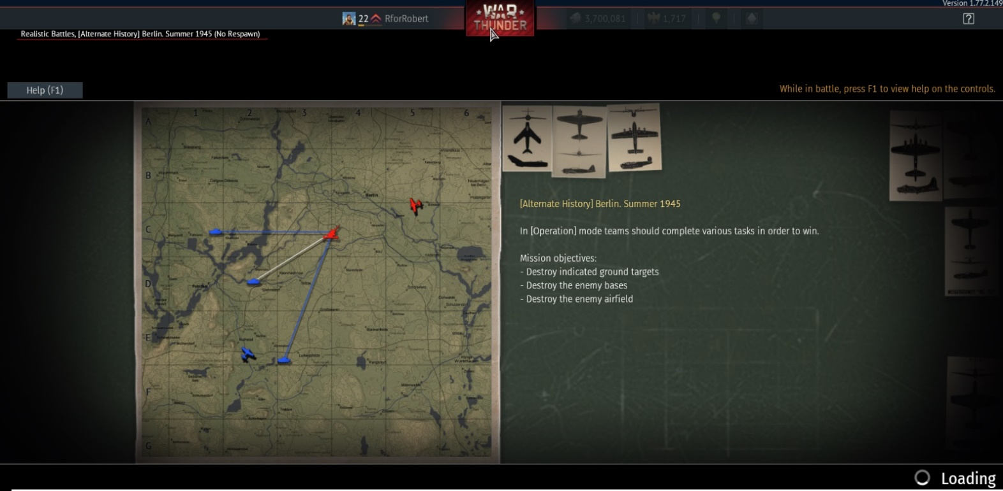
(Above: an ‘Alternate History’ game session briefing showing the typical basic “map and mission” overlay)
War Thunder also creates a pseudo-history in its team structures. In each game players are split into teams of fifteen, each grouped into a session by their “Battle Ranking” a tier system based on the abilities of the vehicles used by each player, rather than on their own abilities as a player. Similarly, within “arcade” and “simulator” battles, placing within these teams is at random, players will find themselves flying with or against others representing any of the countries included (Britain, America, France, Italy, Germany, Japan and the USSR). In this way a player flying a British line-up may find themselves with a Messerschmitt for a wingman and against an enemy armed with an identical Spitfire. Extra rewards are given for certain actions, for instance shooting down an aircraft attacking a teammate, or for attacking the most targets, but few penalties exist – a player will lose points for killing a teammate but will not be penalised for using their vehicle in a way it was not necessarily designed for – for example using a heavy bomber as a gunship to attract enemy attention. In this way critics claiming that the game does not constrain players enough into behaving as if gameplay is reality is valid but does create a flexible structure that keeps players interested. As Chapman asserts, history is taken selectively so that information that will keep the game interesting and fair for all players, as well as a basic historical framework is used, whilst other elements of history that enforce rigidity in outcomes are replaced by algorithms that allow players to create their own version of history; a pseudo-history. In this way players are encouraged for interacting with their vehicles in a manner similar to their genuine use; but are not penalised for seeking to explore different purposes, indeed being compelled to work in ways unfamiliar in real life – becoming familiar with the characteristics of having a like-vehicle for an enemy and a real-life enemy for a teammate.
Other features of the game are designed with the purpose of making gameplay provide as accurate an experience possible on different levels. Tutorials are designed to mimic training and in advanced levels or in test flights, take offs and landings are required for aircraft, with the quirks of handling and loss of aircraft risks inherent in this, making the resource unusable for the next game session. Aircraft are also coded to provide a number of playable control screens – users can fly in fighters either in a third person observer method favoured for most missions, through a detailed cockpit view, or through gunsights (with only the latter two being available for the most realistic game mode) and in bombers through these views as well as gunner views for each of the gunnery positions on the aircraft and bomb aimer’s view. Positions not controlled by the player directly are taken up by the AI coding of the game so that a player does not need to switch views to defend themselves in a bomber though players will always be accountable for firing weapons in fighters and dropping bombs in heavy aircraft as well as piloting all aircraft. Tanks run on a similar basis, with a third person view being the default and a gunsight view available for certain moments. This varying view allows the developers to claim a measure of historical accuracy, with players having the option to hold themselves fully accountable for all crew options beyond the typical ‘first person shooter’ games typical of war inspired games. The behaviour of vehicles is also coded to mimic that of the realistic models; a damage indicator shows where the vehicle has been hit, and the behaviour of the vehicle changes accordingly for the duration of the session. When damage reaches a critical point the vehicle is registered as ‘killed’ and has to be replaced from the player’s lineup, which is also limited – in realistic battles, the vehicle once killed cannot be replaced adding another feature of mimicking reality. However, as in all other ways, the damage is confined to only the current game session and repairable fully either by a small outlay of in-game currency earned through positive actions, or after a period of time has passed. This tempers progress within the game on a much smaller level than the development tree, both of which force the player to act in active gameplay for many hours before significant developments are made. This more ‘real time’ approach fits in with Chapman’s assertion that gameplay can be historically significant if it encourages understanding within players; in this case understanding over the timing of war. A more practical explanation is that this slowing down of development gives more time for developers to continually update the game, so that no player ever reaches an end-game.
However, for those players that choose not to interact overly with the history, there is one advantage provided by the developers that is most decidedly not historically accurate. Whilst it is not possible to ‘win’ the game as such, there being no end-game, players can pay to avoid the long hours of gameplay required for development, and to unlock special vehicles exclusive to such ‘pay-to-players’, which often have an advantage over the vehicles that can be developed through play. Other rewards such as camouflage and modifications can also be paid for, so that a player with a lot of money, and with little patience for gameplay can bypass the historical aspects of the game purely for the development of the advanced vehicles which are used as a sort of ego-symbol within players, and high positions within the leader boards, for which the player can also get further rewards. These advantages also prove tempting even for those players trying to play the game historically accurately, as some of the historical campaign battles are hidden behind this paywall. This is one area in which Galloway’s criticisms may hold water that a player can simply opt out of the constraining historical aspects simply by being willing to pay indicates that the developer may place wealth above integrity.
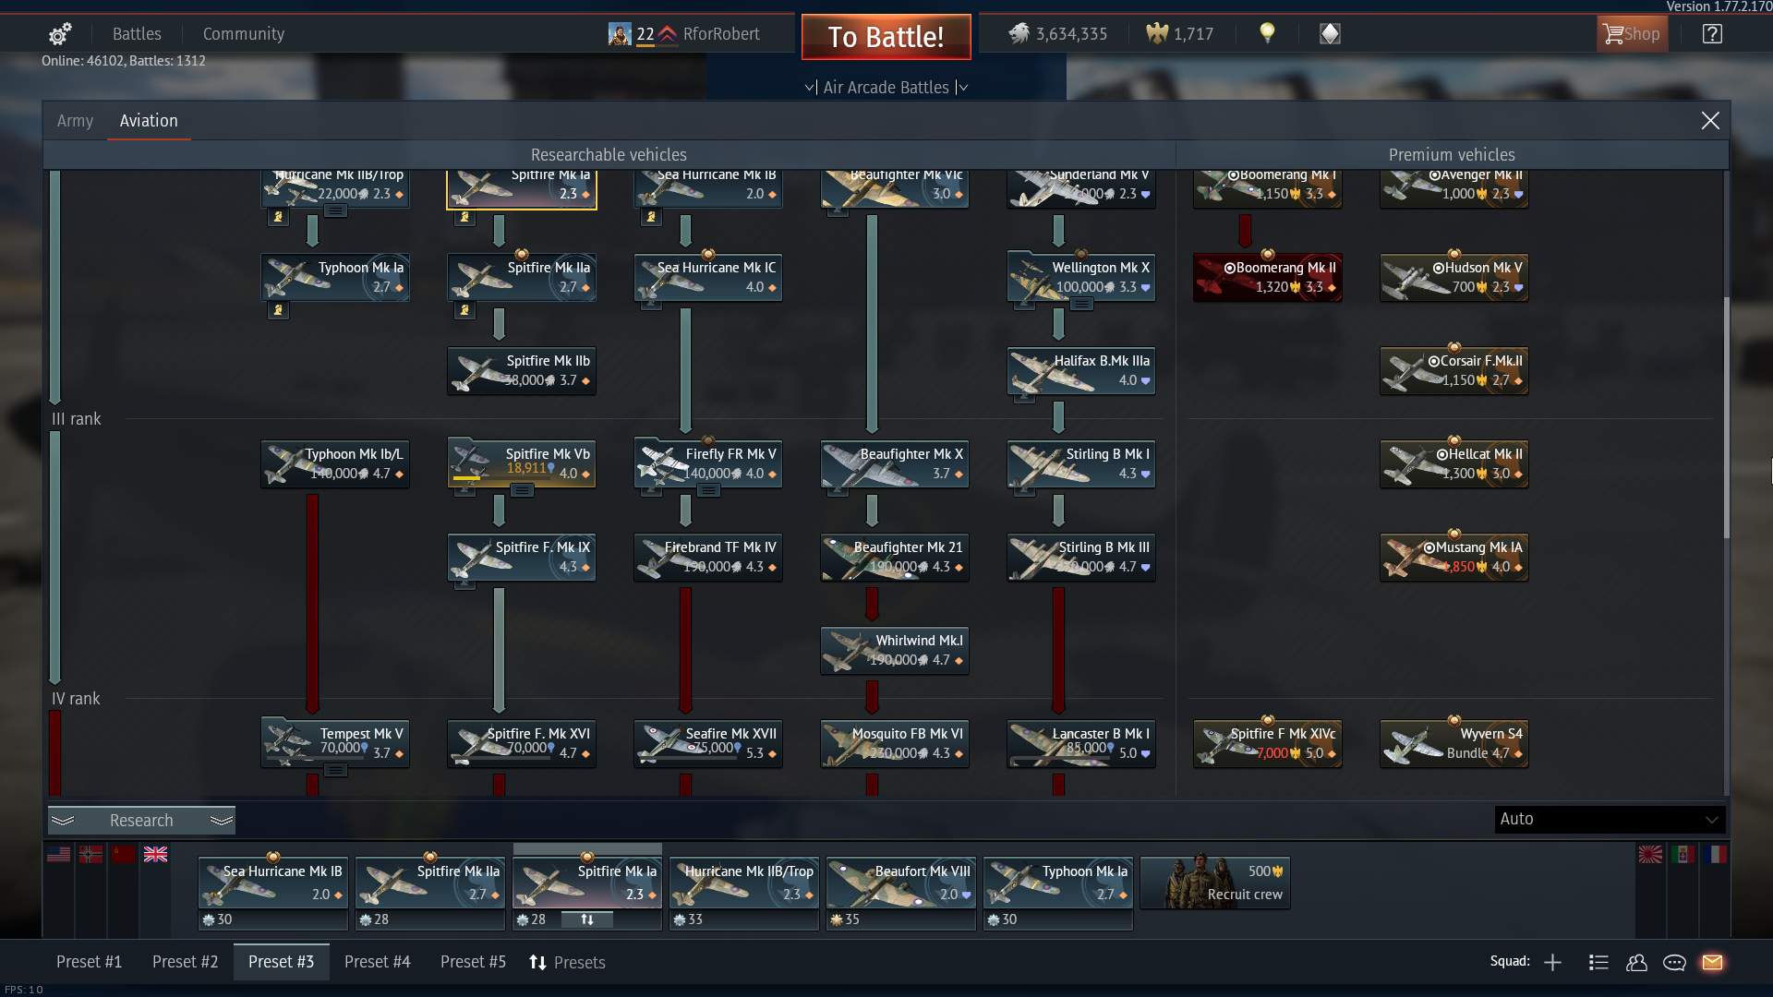
(Above: Part of the development stream for British aircraft, showing the development process and “premium vehicles” unlocked by buying them).
Another aspect which limits the historical credibility of War Thunder is its active punishment of “modders”; players who adapt or add to a game, in many cases making the games more historically accurate. Chapman cites Civilisation players as creating hundreds of mods, or DLCs, expanding the historical accuracy of the game – many of these available with the developer’s blessing. However, War Thunder is vastly different, players are banned for developing or using such mods, with only a couple of developer made DLCs each rather expensive available. This stifles the player’s additions to the game and limits the history to that which the developers choose to include, namely the main theatres of war whilst not being able to focus on other battles. Whilst this opinion of modification is by no means uncommon among developers in recent years it shows a more constrictive approach to historical accuracy than expressed in older games.
War Thunder does address many of Chapman’s views in its design, to ensure historical accuracy. Huge amounts of original sources are consulted in order to develop each vehicle and to create scenarios of varying attention to detail, with even the most fantastical of levels based on a map of war theatre. However, it does allow players to interact with history of various levels – whilst some interest in history is probably a requisite for interest in the game – players can keep their interaction with such elements to a minimum by not selecting certain options and paying to develop their vehicles. The developers at no point claim to be completely true to history, whilst Gaijin assert that they consult sources to create the resources available and provide these to players within the coding, the most the game claims to represent is an ‘alternative history’ able to be manipulated in the short term by players.

Bibliography
Books and Journals
Chapman, A., ‘Is Sid Meier’s Civilisation History?’, Rethinking History, 17.3, (2013), 312-332
Galloway, A.R., ‘Essays on Algorithmic Culture’, Electronic Mediations, 18, (2006) 1-137
Juul, J., Half-Real: Video Games Between Real Rules and Fictional Worlds (Cambridge, MIT Press, 2005),
Games
Gaijin Entertainment. 2013-., War Thunder
Websites
https://store.steampowered.com/
https://warthunder.com/en
https://wiki.warthunder.com/index.php?title=Main_Page

Adam Chapman, ‘Is Sid Meier’s Civilisation History?’, Rethinking History, 17.3, (2013), 312-332, (p.313)
Alexander R. Galloway, ‘Essays on Algorithmic Culture’, Electronic Mediations, 18, (2006) 1-137
https://store.steampowered.com/search/?term=historical%20games
Adam Chapman, ‘Is Sid Meier’s Civilisation History’ (p.318)
Jesper Juul, Half-Real: Video Games Between Real Rules and Fictional Worlds (Cambridge, MIT Press, 2005), p.57
https://wiki.warthunder.com/index.php?title=Main_Page
Adam Chapman, ‘Is Sid Meier’s Civilisation History?’ pp. 315-316
Adam Chapman, ‘Is Sid Meier’s Civilisation History?’ p.314
https://store.steampowered.com/app/236390/War_Thunder/
Alexander R. Galloway, Gaming, p.31
Adam Chapman, ‘Is Sid Meier’s Civilisation History?’ p. 317

