Contents
Introduction 2
Why WCF is preferred over web services 3
Hosting a WCF Service 4
Configuring Services 6
The ABCs of WCF 6
Principles and process of metadata exchange in WCF. 9
Administrative Approach 9
Programmatically Approach 10
The Metadata Exchange Point 11
The four major contract types 13
Service Contracts 13
Data Contracts 14
Fault contracts 14
Message Contracts 14
The various supported exchange patterns 16
Request-response 16
One-way 17
Duplex 19
Asynchronous 20
Peer to peer 21
Interoperability support 22
Bibliography 23

Introduction

With the increasing use of service-oriented applications and communications over the years, software development in turn had major developments. Windows Communication Foundation (WCF) was introduced back in 2006 as part of the .NET Framework 3.0 and became a replacement for all of Microsoft’s earlier web service technologies such as ASMX (ASP.NET Web Service) while being able to accomplish more than what a traditional “web service” would.

WCF represents a runtime environment and a set of APIs belonging to the .NET Framework to create service-oriented and connected applications. With WCF, users are able to transmit data as asynchronous messages from a service endpoint to another. WCF also received updates in .NET Framework 3.5 and 4.0 with the latest version of WCF being part of the .NET Framework 4.5 [1].

Its services are loosely coupled to one another. These services usually have a Web Service Description Language (WSDLinterface) where any WCF client can utilise to access the service no matter the service platform it is hosted on. Advanced Web Service standards which include WS-Addressing, WS-Security and WS-Reliablemessaging are implemented in WCF [2].

As WCF was designed specifically to summarise the various distributed programming infrastructures by Microsoft, users are able to enjoy more flexibility and portability in WCF compared to with the traditional ASMX. In a simple way, WCF works by logically grouping together the various ways of getting two applications to communicate while ASMX was just one of the ways to do the same and has since been grouped under WCF’s many capabilities. It is mostly ideal to implement a service-oriented architecture (SOA) [3]. Designed by service-oriented architecture principles, it provides support to distributed computing which services contain remote consumers.

Why WCF is preferred over web services

- It’s use of “DataContractSerializer” which shows what fields and properties are serialized into XML while web services which uses “XMLSerializer” does not.

- WCF supports multiple protocols such as TCP, HTTP, MSMQ and many more protocols which mean more reliability and versatility while web services only support HTTP and HTTPS protocols.

- ASP.NET web services only exchange SOAP (Simple Object Access Protocol) [4] messages through HTTP while WCF services are able to exchange messages via any format over any transport protocol.

- While web services can only be hosted on IIS, WCF can be hosted on IIS, Windows services, Windows activation services and self-hosting.

- WCF offers duplex operations support while web services do not.

- When service behaviour classes are used, WCF also supports multi-threading while web services do not [5].

Hosting a WCF Service

In order to host a service via a managed application, the code must be embedded and the endpoint must be defined for the service through a few separate ways namely, imperatively with code, declaratively in configuration or utilising default endpoints. An instance of ServiceHost is then created.

This way of hosting a service is known as self-hosting as the managed application is hosting the work itself. Hosting a service in this way provides the most flexibility as it has the smallest amount of infrastructure to deploy [6].

Step 1: Open Visual Studio and create a new console application with Visual C#.

Step 2: Open the Console App template after selecting Windows Desktop and type SelfHost in the box.

Step 3: In the Solution Explorer, right-click SelfHost to select Add Reference. Locate the .NET tab and select System.ServiceModel.

Step 4: In Solution Explorer, double-click on Program.cs in order to open the code window.
Add these two lines
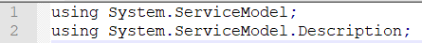

Step 5: The service contract must be implemented and defined.
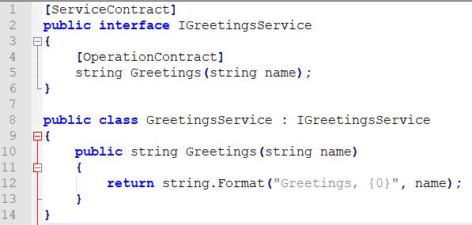
An example of the service contract

Step 6: An instance of Uri class at the start of the Main method must be created with the base address of the service.

Step 7: An instance of the ServiceHost class must be created that passes a Type representing the service type and base address URI to the ServiceHost(Type, Uri[]).

Step 8: Metadata publishing must be enabled.

Step 9: Open method is called on the ServiceHost in order to start the service and receive messages. CommunicationObject.Close is called on ServiceHost to close the service.

Configuring Services

A WCF service is configurable by using .NET Framework configuration technology. XML elements are typically added to Web.config file for an IIS site hosting a WCF service. It allows users to edit details such as an endpoint address. Also, there are some system-provided Elements that aid in selecting the simple features for a service in WCF. In .NET Framework 4.0, WCF configuration requirements are simpler as it has a new default configuration model. If no WCF configuration is provided for a service, the runtime will automatically configure the service with standard endpoints and default binding [7].

The ABCs of WCF

Communications with a WCF service happens through endpoints of the service. These endpoints offer users access to functionality of a WCF service. The creation of different end points can be made with a different port address residing in the client sided configuration file. All WCF communications happen through end points. The ABCs of WCF being the address (A), binding (B) and contract (C) are properties of endpoints and are essential to establish communication to reach an endpoint [8].

Address (A)

An address gives the endpoint a unique identifier and alerts potential users of the service with its location. The address is represented by the “EndpointAddress” class in the WCF object model. This class holds an Uri property that represents the service address and an identity property that acts as the security identity of a service and collects optional message headers. These headers provide more additional info such as detailed address information to identify the endpoint.

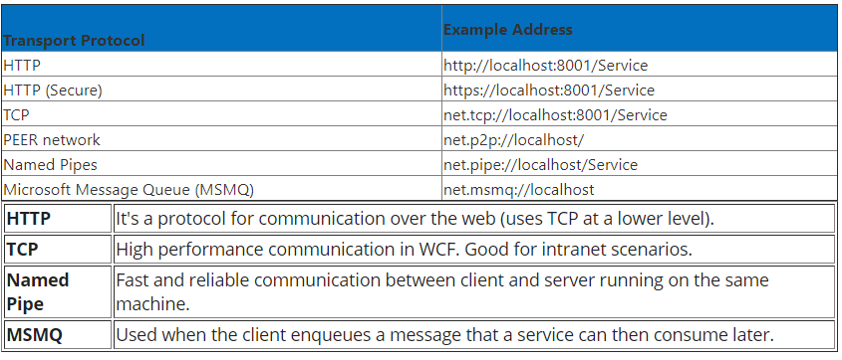

The figure above shows the protocols WCF can utilise to communicate, example addresses and characteristics of the protocols [9]

Binding (B)
Binding specifies the communication method with the endpoint which includes which transport protocol is used (HTTP for instance), the message encoding (binary or text for instance) and the security requirements necessary (SSL for instance).

Binding is defined as elements that correspond to transport and protocol channels in the channel stack. The channel stack represents the sequence of channels each passing through the runtime execution.

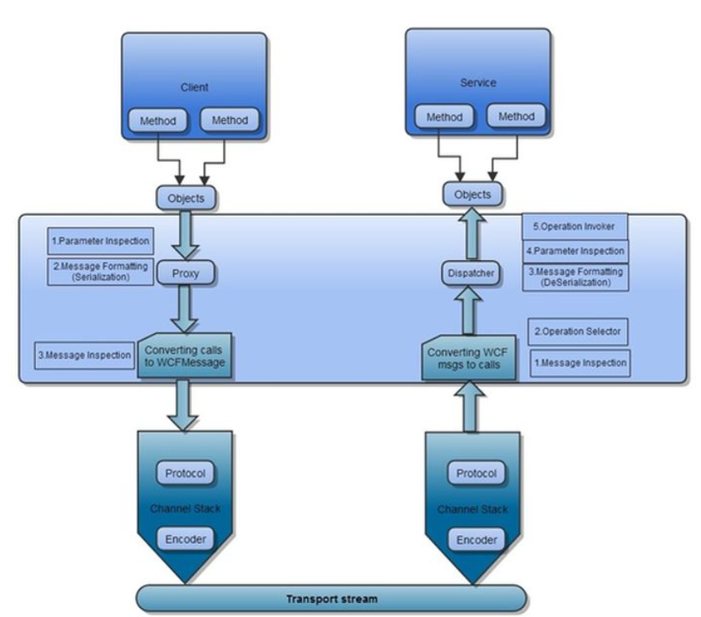
Diagram showing a WCF Runtime execution process [9]

The transport channel is responsible for transporting all messages from the client to the server utilising transport protocols such as HTTP, HTTPS, TCP and MSMQ. Its primary function is to encode and transport messages.

The protocol channel on the other hand contains protocols such as Transaction Protocol, Security Protocol and Reliable Messaging. Its primary function is to provide security features such as authentication, authorization, confidentiality and protection.

Contract (C)

A contract is the agreement between client and server describing the content and structure of exchanged messages. It is a standard and platform-neutral way to describe what the service is doing. A contract specifies the operations that are called by a client, the form of a message, types of input parameters or data used to call the operation and the type of processing or response message expected by the client [10].

Principles and process of metadata exchange in WCF.

There are two ways for a service to publish its metadata. The first way is by providing the metadata over the HTTP-GET protocol and the second way is by using a dedicated endpoint. With the first method, you need to add explicit service behaviour in order to enable WCF to provide metadata over the HTTP-GET protocol automatically for you. There are two ways to add this behaviour namely, administratively and programmatically.

Administrative Approach
With the administrative approach, the address needed by the client to use for the HTTP-GET would be the registered HTTP base address of the service.

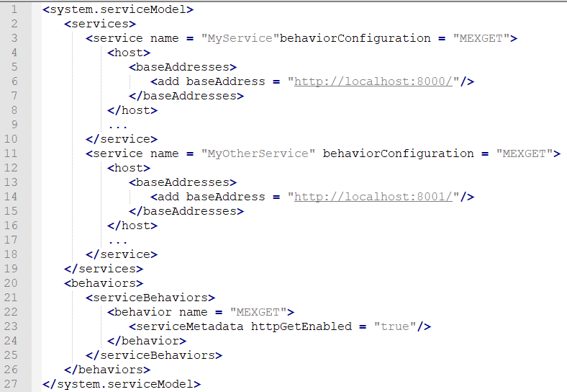

After that, navigate yourself to the HTTP base address through a browser. A confirmation page will appear if successful notifying you that a service has been successfully hosted.

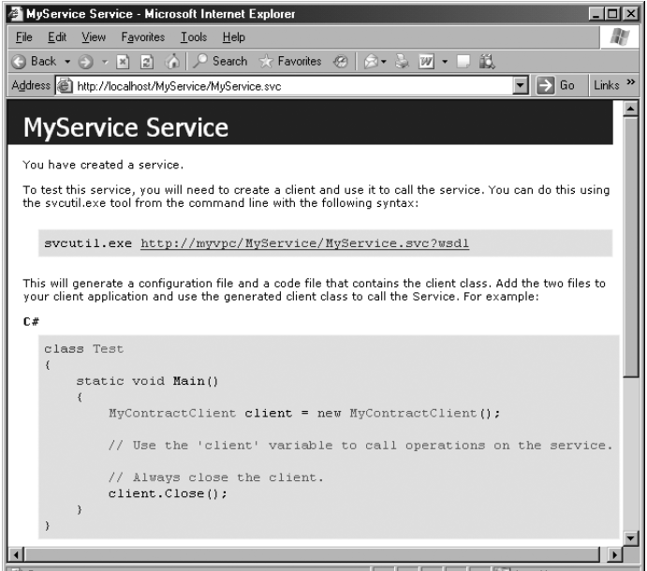
Screenshot showing an example of a service confirmation page [11]

Programmatically Approach
With this approach, the behaviour must be added to the collection of behaviours maintained by the host for the service type. Given behaviour types can only be found once in the collection.

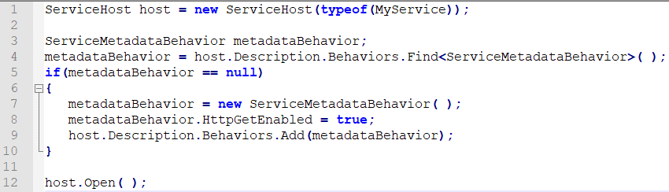

The Metadata Exchange Point

The metadata exchange point or MEX endpoint allows services to publish metadata over a selected endpoint. The IMetadataExchange is an industry standard for metadata exchange represented in WCF which must be included.

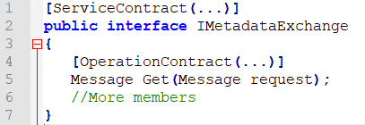

The address and bindings needs to be designated and the service metadata behaviour must be added. Regarding bindings, WCF has provided dedicated binding transport elements for protocols such as HTTP, HTTPS, TCP and ICP. Regarding the address, a full address or any registered base address can be provided. A HTTP-GET option is optional.

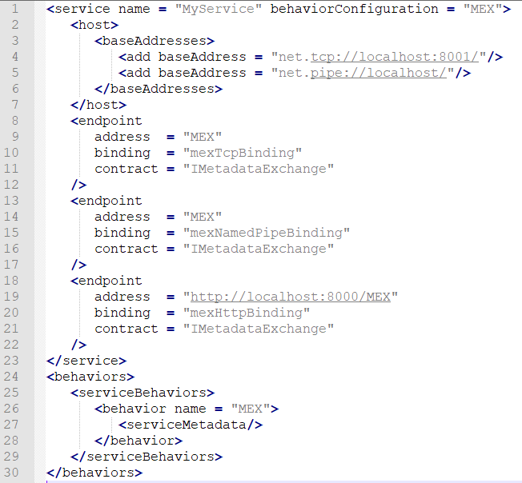
Screenshot showing an example of a service with three MEX endpoints

As there is no dedicated binding type for metadata exchange endpoints, custom bindings need to be constructed which utilise the matching transport binding element. It then must provide the binding element specified as a construction parameter to the instance of the custom binding.
To programmatically add MEX Endpoints, the method AddServiceEndpoint() must be called with the address, custom binding and IMetadataExchange contract type. It is also necessary to confirm the presence of metadata behaviour before adding the endpoint.

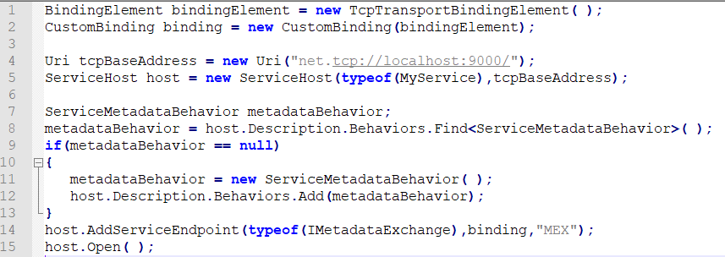

The four major contract types

There are 4 types of contracts defined by WCF which are Service contracts, Data Contracts, Fault Contracts and Message Contracts [12].

Service Contracts

Service contracts describe the operations that clients perform on the service. A service contract represents the interface of the WCF service which defines operations from the service to the outside world. It can contain service-level settings. For example, the service name.
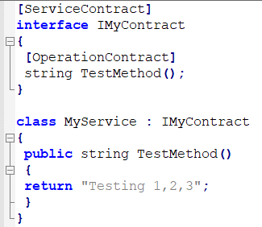

Data Contracts
Data contracts define the data types that are passed to and from the service and client. Data contracts can be utilised by operation contracts as a return type or parameter. It can also be utilised by message contracts to define an element.

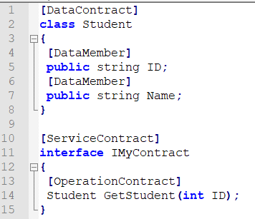

Fault contracts
Fault contracts define errors raised by the service and also how the service deals and propagates any errors to the clients. If exceptions are thrown, it will not reach a client in that way. Thus, WCF conveys error messages to clients using the SOAP Fault Contract.

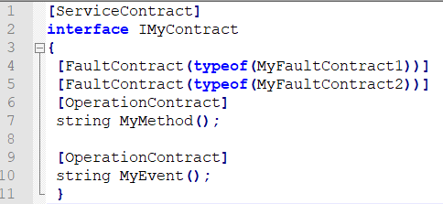

Message Contracts
Message contracts define the ability to allow direct interaction between the service and messages. If an operation contract requires a message to pass as a parameter or return value as a message, it will be defined as a message contract. Message contracts define elements of the message such as Message Headers and also message related options including message security. These contracts are either typed or untyped.

A message contract has complete control of the content of the SOAP header and structure of the SOAP body [13].

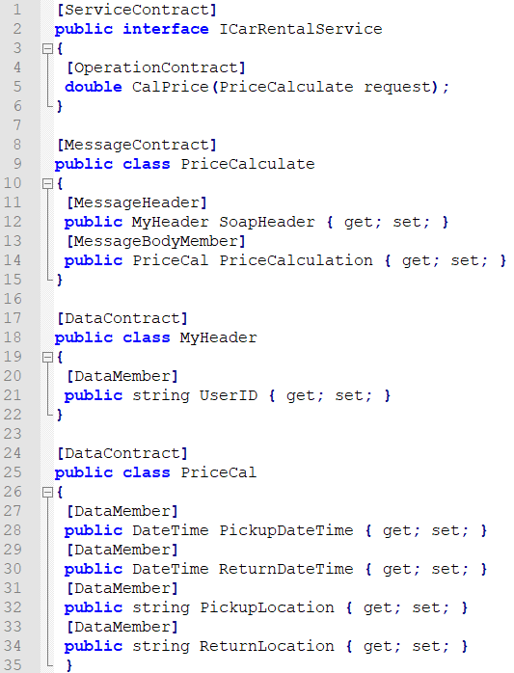

The various supported exchange patterns

Request-response

WCF uses Request-response as the default Message Exchange Pattern. With this pattern, whenever a service operation is called upon, a response message to the client will be generated. The client even receives a response if the service operation contains a void return type.

Clients must wait for a certain time from the service (ReceiveTimeout for example) before it executes the following code. The default value for ReceiveTimeout is set at one minute and after the time passes, it throws a TimeoutException type.

Benefits of this pattern are the support of all bindings except for MSMQ-based bindings and the immediate notice for the client and developer if any exception occurs in the service so they can quickly get the faults in the service. A disadvantage however is that clients must wait longer since a lot of processing occurs before the service can send out the TimeoutException to clients.

Examples of this pattern include remote procedure calls (RPC) and also browser GET requests. The pattern is also called half-duplex.

As Request-response is the default pattern in WCF, nothing needs to be done to enable it. However, for clarity, users can enable it as follows

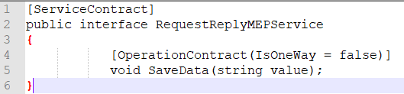

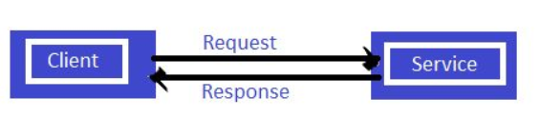
Diagram showing the request-response pattern [14]

One-way

In this pattern, the client does not need to wait for a response after sending a message to the WCF service. If any errors occur during communication, the WCF service does not send a response back. Thus, this pattern does not provide support for service operations such as output parameters, return value and reference parameters.

This pattern is utilised when users do not want to display any error to the client as with the use of Message Exchange Pattern, it does not send any messages to the client. By using “IsOneWay = true” in the service, an exception is thrown if “IsOneWay = true” is declared for the return value, reference parameter or output parameter. While using these modes, if the service becomes busy with other services and a client sends a request, the request can be kept in the Queue and the client can carry on with his other work, the client then is unblocked and the Queue limit of request can be set.

The advantages of the One-Way pattern include lesser time for process, asynchronous-like work; clients are not blocked after a request so they can do other work and clients uninformed of exceptions of the service. Disadvantages include the potential block of requests by the client if a request exceeds the limit of the queue and the clients becoming unaware if the request has successfully reached.

Users can enable One-Way MEP in WCF by doing the following:

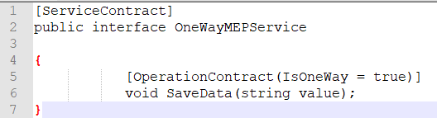

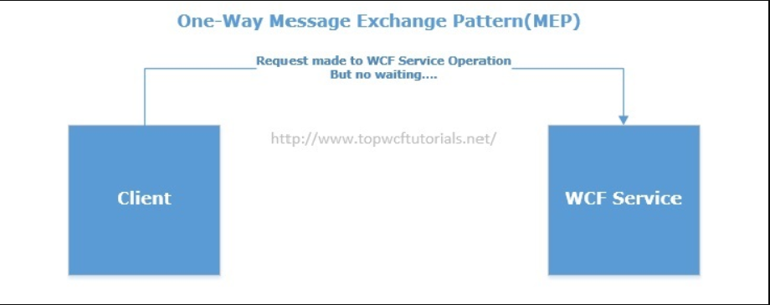
Diagram showing the One-way Message Exchange Pattern [15]

Duplex

In this pattern, it is a two-way message channel as both the Request-Response and One-Way message patterns are implemented. Both the client and the service start the pattern. It is a more complicated pattern as more communication is involved. It is utilised when users want to send notifications to clients regarding whether requests have successfully reached or not. This pattern does not support all bindings.

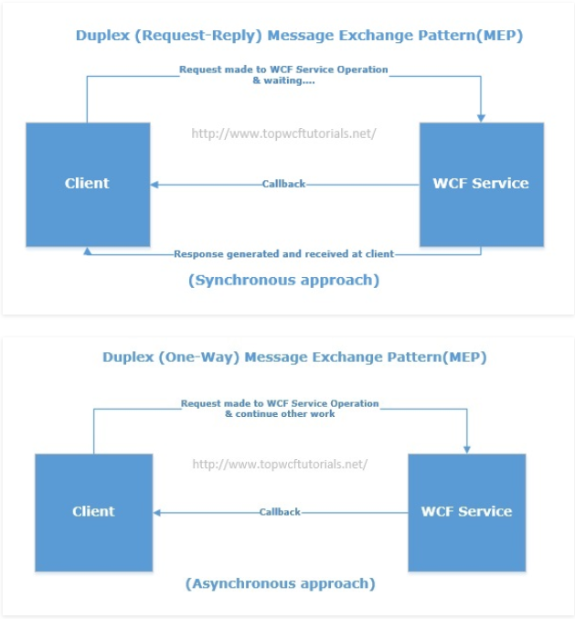
Diagram showing the concept of the Duplex Pattern [15]

To implement the Duplex pattern, CallbackContract is required with ServiceContract as well. CallbackContract must be associated with ServiceContract through the CallbackContract property of the ServiceContract.

An example with a CallbackContract named “DuplexPatternServiceCallback”
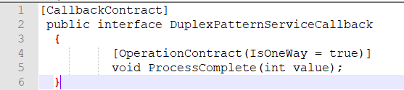

It will then be associated to a ServiceContract named “DuplexPatternService” through the CallbackContract property

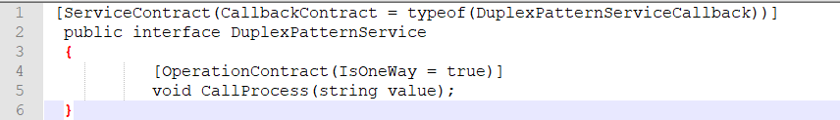

The Duplex MEP works with bindings that are bi-directional such as wsDualHttpBinding.
The endpoint would be defined like this

Things to note when using a Duplex MEP include the need for a connection back to the client which is not possible all the time and scalability issue arise after having a long-running session between parties.

Asynchronous
When it is not possible to have a one way operation or duplex service for a long running process, the only way is to call the method asynchronously for clients. Calling it asynchronously allows for the possibility of a responsive caller code with clients able to also capture proper response messages [16].

To implement this, the proxy must be configured in order to generate support for asynchronous functions. After calling a function asynchronously, the event handler is called and displays a message notifying that the function call is complete.

Peer to peer
Peer-to-peer (PWP) networking represents a distributed application architecture which divide tasks between the peers [17]. Each peer is equal in terms of privileges and strength in the application. They are also known as a network of nodes. Every node represents a computer on the network that works with other peers in order to provide a part of its resources directly available to its other peers without hosts or central coordination. Peers both consume and supply resources compared to the client-server model which divides the consumption and supply of resources.

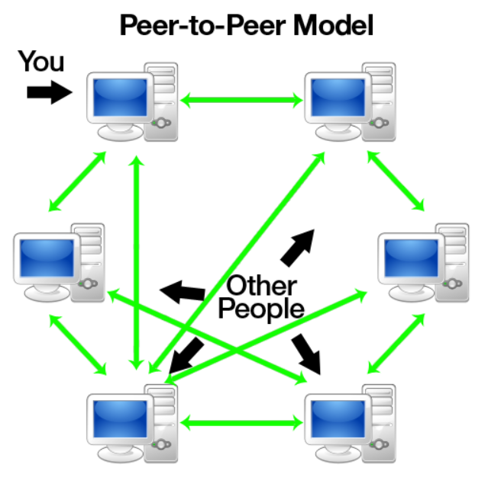
Figure showing the Peer-to-peer model interaction [17]

The two kinds of Peer-to-peer network are Pure P2P network and the Hybrid P2P network. The Pure P2P network represents a network of peers where each node is connected and plays a part in being the client and server when needed. It only works through peers without separating client or server. The Hybrid P2P network represents a network based on client and server concepts. In this network, the server is only responsible for answering requests sent by peers to gain information. It does not store data except for some totalities.

Mesh is the term coined for the network in peer to peer applications. The two mesh channel types are peer channels that represent a message based service accessible in WCF and groupings which are peer networks where messages exchange by the replication of records with the Data.Grouping obtainable in Windows XP SP2

In order to register a peer, it needs to be registered in a cloud. This can be done programmatically or by using the netsh command.

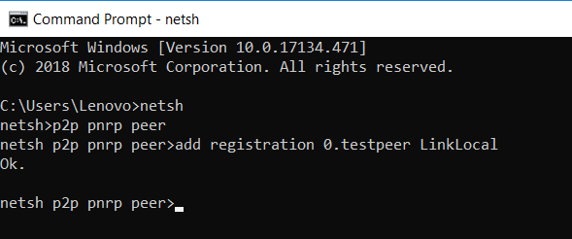

Interoperability support

Interoperability is defined as the ability to exchange and utilise information between multiple machines. It grants unrestricted resources between the systems. By ensuring services implemented in both technologies confirm to the WS-1 Basic Profile 1.1 specification, interoperability between WCF services and ASP.NET Web services can exist.
Once conformed, ASP.NET Web services are interoperable with WCF clients via BasicHTTPBinding [18].

Bibliography

[1] | N. Hadjarbegovic, “Windows Communication Foundation (WCF) Primer,” 2018. [Online]. Available: https://www.whoishostingthis.com/resources/wcf/.
[2] | M. Daadoo, “Developing and Implementation of Distributed Chat Applications using WPF and WCF,” 2017.
[3] | Z. W and L. J, “International Conference on Web Information Systems and Mining,” 2010.
[4] | Y. V. Patil, “What's the Difference between WCF and Web Services?,” CodeProject, 2010. [Online]. Available: https://www.codeproject.com/Articles/139787/What-s-the-Difference-between-WCF-and-Web-Services.
[5] | Dot Net Development, “Top 10 Differences Between WCF and Web Services,” Brainvire, 2016. [Online]. Available: https://www.brainvire.com/top-10-differences-between-wcf-and-web-services/.
[6] | M. Erlend, G. Warren, M. J. M. Hoffman, L. Latham, T. Pratt, M. Wenzel and Y. S. Jjin, “How to: Host a WCF service in a managed app,” 2018. [Online]. Available: https://docs.microsoft.com/en-us/dotnet/framework/wcf/how-to-host-a-wcf-service-in-a-managed-application.
[7] | P. Onderka, M. Jones, M. Hoffman, N. Schonning, T. Pratt, B. Wagner, Y. S. Jjin, L. Latham, M. Wenzel and E. Mackiovello, “Configuring Services Using Configuration Files,” 2017. [Online]. Available: https://docs.microsoft.com/en-us/dotnet/framework/wcf/configuring-services-using-configuration-files.
[8] | K. S. Tharun, M. Prudhvi and S. S. Reddy, “ADVANTAGES OF WCF OVER WEB SERVICES,” 2013.
[9] | R. Kartik, “ABCs of WCF,” C# Corner, 2014. [Online]. Available: https://www.c-sharpcorner.com/UploadFile/rkartikcsharp/abc-of-wcf/.
[10] | A. Li, M. Wenzel, E. M. J. N. L. Latham and Y. S. Jin, “Endpoints: Addresses, Bindings, and Contracts,” Microsoft, 2017. [Online]. Available: https://docs.microsoft.com/en-us/dotnet/framework/wcf/feature-details/endpoints-addresses-bindings-and-contracts.
[11] | J. Lowy, “Programming WCF Services,” O'Reilly, [Online]. Available: https://www.oreilly.com/library/view/programming-wcf-services/0596526997/ch01s08.html.
[12] | P. Pandey, “ABC of Windows Communication Foundation,” C# Corner, 2011. [Online]. Available: https://www.c-sharpcorner.com/uploadfile/pandeypradip/abc-of-windows-communication-foundation/.
[13] | S. Chauhan, “Understanding different types of WCF Contracts,” DotNetTricks, 2013. [Online]. Available: https://www.dotnettricks.com/learn/wcf/understanding-different-types-of-wcf-contracts.
[14] | D. Sharma, “Message Exchange Pattern in WCF,” C#Corner, 2014. [Online]. Available: https://www.c-sharpcorner.com/UploadFile/225740/message-exchange-pattern-in-wcf/.
[15] | I. A. Ghani, “Message Exchange Patterns in WCF,” WCF Tutorial, 2014. [Online]. Available: http://www.topwcftutorials.net/2014/09/message-exchange-patterns-wcf.html.
[16] | R. R. Singh, “Tutorial on Message Exchange Patterns and Asynchronous Operations in WCF,” CodeProject, 2013. [Online]. Available: https://www.codeproject.com/Articles/569866/TutorialplusonplusMessageplusExchangeplusPatternsp.
[17] | A. Jalilifard, “Peer to Peer File Sharing Through WCF,” CodeProject, 2018. [Online]. Available: https://www.codeproject.com/Articles/614028/Peer-to-Peer-File-Sharing-Through-WCF.
[18] | P. Onderka, M. Jones, Y. S. Jjin, L. Latham and M. Wenzel, “Interoperability with ASP.NET Web Services,” Microsoft, 2017. [Online]. Available: https://docs.microsoft.com/en-us/dotnet/framework/wcf/feature-details/interop-with-aspnet-web-services.

