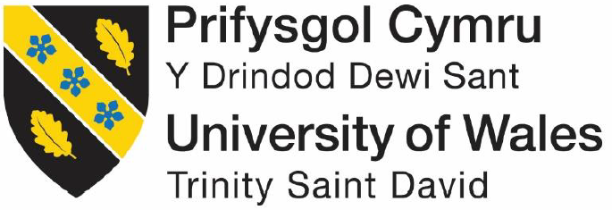

Level: 5

BMSK5005: WORKPLACE CULTURE AND ITS IMPACT ON ORGANIZATIONAL ASPECTS

Student Name: Mohammad Zakir Hossain
Student ID: 1713069

Table of Contents
1.0 Introduction 3
2.0 Critically assess the workplace culture of the organization 3
2.1 Concept of organizational culture 3
2.2 Types of organizational culture 4
2.3 Organizational culture practices by Tesco 7
2.4 Organizational ethos and values 7
2.5 Ethos and values practiced by Tesco 8
3.0 Evaluate an organization within its broader environment using appropriate environmental and organizational analysis techniques 9
3.1 External environment analysis 9
3.2 Competitive situation analysis of Sainsbury’s 11
3.3 Internal environment analysis 12
4.0 Critically appraise the cultural and ethical behavior present in Tesco 14
4.1 Cultural and ethical behavior 14
4.2 Personal ethical standards, values and beliefs 14
4.3 How Corporate Social Responsibility (CSR) support business ethics 15
4.4 Tesco’s ethics and CSR practices 16
Tesco’s CSR practices 16
4.5 How cultural and ethical behavior affect Tesco’s business 21
4.6 How organizational culture influence its ethics 22
References 23

Introduction

According to Mullins (2015), Organizational culture is considered as a system. This system includes the sharing process of ideas and values among the people within a firm’s environment. Every individual is different from one another but the culture of the organization influence the diverse behavior of them and create a good and well relationship among them (Newman, 2012). Finally; the individual as well as workplace efficiency is increased through better establishment of culture. This report is reported about the organizational culture system of Tesco plc. Tesco plc is continuing its activities as Tesco. It is a British multinational groceries and general merchandise retailer (Tesco Plc, 2018). The head-quarter of Tesco is situated in Welwyn Garden City, Hertfordshire, England. At present; Tesco has got its position in the third level in the world retailers. Tesco has run its regular business functions in several countries including Asia and Europe, UK, Ireland, Hungary and Thailand. Tesco has 6,800 shops with revenue £63,911 million, net operating revenue £2,206 million, and net income £1,320 millions (Tesco Annual Report, 2018). The employees amount of Tesco are numerous approximately 450,000. After all; this assignment mentions the workplace culture of the organization and the workplace culture of Tesco. This part also explains various kinds of organizational culture and ethos and values. It also mentions the process of using ethos and values within the firm. After the discussion of culture; this paper describes the external & internal environment with models and theories of evaluating the environment of Tesco.

2.0 Critically assess the workplace culture of the organization

2.1 Concept of organizational culture

According to Newman (2012), organizational culture is a complete set of values, beliefs, and attitudes of the employees within the firm that have impact on the feelings, performance and attitude of the employees. Each and every company has a set of cultures within the firm to create the ultimate relationship among the workers (Schein, 2012). Organizational culture has several meaning and definitions. The organizational culture affects the goals and objectives of the firm. The culture of the organization depends on the nature of the people, goals and objectives of the firm and thinking and beliefs of people. Another analyst suggests that organizational culture is a process of gaining internal control over the employees to hold the business opportunities and remove the threats of the firm (Huat 2012). According to Guest (2012), Organizational culture is a combination process of creating relationship, process of doing activities and process of maintaining the good working environment of the firm. The culture has established various stages of human being life including nation culture, national culture, organisational culture, corporate culture, professional culture, management level culture.

2.2 Types of organizational culture

According to Tyler (2018), organisational culture can be divided by several categories but four methods are important that are:

Bureaucratic culture

According to Tyler (2018), the organisational culture is set up by following formal rules of functions. This system of culture is a strict process of maintaining the functions of the workers. This culture is also helped to maintain good quality of the products and services according to standard level. The government sectors and fast food retailers are set up this culture to examine and maintain the employees.

Clan culture

According to Tyler (2018), the culture that produced in a traditional way is called clan culture. The main factors of this culture include several issues including traditional factors faithfulness of the employees, personal assurance, and self-management system of the employees. Socialization is the main consideration for this culture. Here; long-term employees are performed a role of counsellors.

Market culture

According to Tyler (2018), market culture depends on the position of the market. The goals and objectives and marketing strategies are key consideration issues to form market culture. This culture helps to increase sales, revenue and the growth of market share.

Entrepreneurial culture

According to Tyler (2018), the entrepreneurial culture has several key considerations issues normally the risks and creativity power is the main considerations. Mullins (2015) stated that organization culture is additionally classified by the following categories:

Power Culture
According to Mullins (2015), power culture is one of the vital terms of culture within the firm because this culture is formed on the basis of personal attitudes of the workers. The additional factors of power culture are personal beliefs and recognition as well as communication with the workers. This culture has few rules, regulations, policies including little administration.

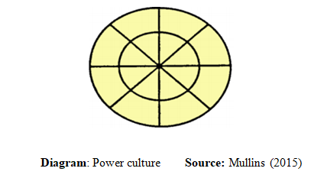

Role Culture

According to Mullins (2015), the main factor of role culture is the organizational pillars including financial capability, purchasing power and production capacity. Bureaucracy theory is applied in this culture to increase the financial capability, purchasing power and production capacity of the firm. The positive outcome of the firm depends on the effective use of role culture.

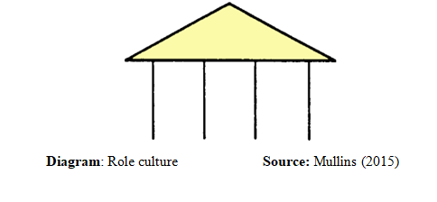

Task Culture

According to Mullins (2015), the task culture is concerned with tasks of the job or project. In case of metrics firm; this culture helps to gain the objectives of culture. This culture is organized the right people in right time to complete the overall tasks of the firm.

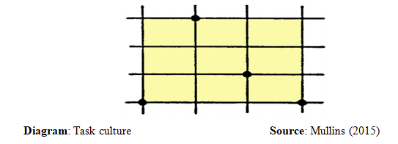

Person Culture

According to Mullins (2015), it is required for many organisations to take help of barristers, engineer, architect, and consultants. In this situation; person culture is used to run the business activities. The experts are fully worked with freedom to continue the expertise sectors of the firms.
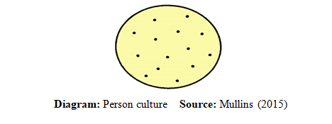

2.3 Organizational culture practices by Tesco

As Tesco is a large company it has several divisions. In the business of Tesco the heretical structure is followed. Tesco is a successful organization it will retain its success as it has economy of scale, specific rules and methods to follow to accomplish different task, structured decision making etc (Tesco, 2018). The organization has several sub headings which help the organization to make more realistic decision for the organization and make the business transparent. Employees feel motivated and independent by the empowerment of the groups, units and the self-governance. Tesco follows the task and role culture in the organization. the task and role culture help the organization to define the task and role of different individual of the organization. The performance, behavior, knowledge of the employees is governed by the culture of the organization (Mullins, 2015). Tesco has many stores in different countries. It serves in Asia in the marketplace of Taiwan and Japan and some other countries in Asia. It is the leading retail shop in Britain and successfully operate its stores in the countries where it serves its business. As Tesco operates business in many countries it faces cross culture difficulties in the nations of different culture (Tyler, 2018). Tesco opened its first store in china in 2005 where it’s faces cross-culture problem and struggled to earn revenues in the organization. Globalization of the world economy has made wonderful possibilities for worldwide association between nations; rather, it has made an exceptional arrangement of issues identified with proficient administration of organizations with various cultures.

2.4 Organizational ethos and values

According to Guest (2012), the organizational ethos is the belief or idea that structure the community, and culture of the organization. Values are the beliefs by which the choices are made about the right and wrong of a situation. The behavior of people is governed by the norms within the community which are the basic rules of that community(Mullins, 2015). Language is the core mode of communication through verbal words, written signatures. Signs are also used as the method of communication which are used among the members of a specific culture. The method by which the individuals share their values, rules, behaviors and skills is Socialism.

2.5 Ethos and values practiced by Tesco

Ethos of Tesco

In case of Tesco; the main functions are connected with functions of production and selling functions (Tesco Plc, 2018). In case of these functions; there are several additional functions including firstly production, then advertisement of the products, HRM functions and finally distributes the products in the market for final sell.
Ethos in Production: maintained smooth production and quality products and ensured cost-effective production to set up reasonable price.
Ethos in Sales: quality goods and services of Tesco, not high price and distributed the products in the market timely.

Values of Tesco

No one tries harder for customers

Firstly; a survey is needed to know about the demand of consumers, colleagues, and communities (Torrington, 2015). After that considers some important issues to make effective procedures for the customers and other bodies. Then, used the Clubcard in social media and finally used various strategic plans and procedures of producing innovative products and services to fulfill the needs of the customers.

We treat people how they want to be treated

Tesco has more concreted on the consumers, colleagues, and communities to treat them fairly because we believed that the proper respect and treat is one of the important methods of gaining success (Torrington, 2015). After getting the fair respect and treat; our colleagues are very much effective and hard workers to meet up the customers’ demand.

Every little help makes a big difference

Every little help ensure the better outcome than others- we set up standard that makes differences a little but significant impact on the customers satisfaction (Torrington, 2015). Tesco also gives concentration on making differences in the demand of the consumers, colleagues, and communities (Tesco Plc, 2018).

3.0 Evaluate an organization within its broader environment using appropriate environmental and organizational analysis techniques

3.1 External environment analysis
A type of methodology examiners and large scale ecological components that are utilized by advertisers to take care of the significant effect on the business organization is called PESTLE investigation.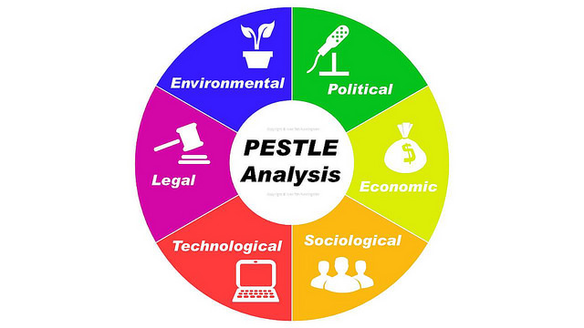
Figure: PESTLE Analysis Source: (Ovidijus Jurevicius, 2013)

PESTLE analysis is the analysis of the factors including: Political, Economic, Social, Technological, Legal, and Environmental factors (Ovidijus Jurevicius, 2013). The analysis is used to implement the several strategies for business organization.

PESTLE Analysis of Tesco

Factors | Analysis on Tesco
Political | - The performance of Tesco is basically influenced by several political factors. The basic political factors are Brexit / EU plebiscite and immigration, tax problems etc (Ovidijus Jurevicius, 2013).
Economic | - The fluctuation in the exchange rate is the basic economic factor that interrupts the profitability of the business.  - The economic condition of Tesco is also impacted by the Brexit / EU plebiscite.
Social | - The Social changes and trends also affect the business of Tesco. The behavior of people in the society also affects the business of Tesco.
Technological | - The technological changes affect the business. The improved technology reduces the cost of the organization also increases the performance as well as the profitability (Ovidijus Jurevicius, 2013)
Legal | - The legal factors of the country impose restrictions in the operation of business of Tesco.  - Nevertheless, so as to ensure the nature of Tesco business and its partners (for the most part laborers and vendors) guideline and lawful setting keep them on the correct way (Ovidijus Jurevicius, 2013).
Environmental | - Environmental factors impact on the business organization. The social awareness among consumers creates pressure on Tesco.
Table: PESTLE Analysis

Competitive situation analysis of Tesco
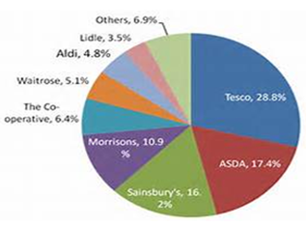
The Porter’s Five Forces exerts that as Tesco has a positive brand value it faces a little treat of new substitutes. According to Nunnally, (2015), In the term of product design ten development Tesco only accepts the efficient one. The company can arrange supplies at a fair condition as the relationship between the suppliers and the company is good and the suppliers have less bargain ability. On the other hand the consumers of the company possess moderate bargaining power (Tyler, 2018). As a result the company has to change its strategy frequently. Besides this there is a moderate entrance of new competitor for Tesco. There are several competitors of Tesco in the marketplace such as ASDA, Morrison, Waitrose, Aldi, and Lidle.

3.2 Competitive situation analysis of Sainsbury’s

The Porter’s five forces model is the model which describes five important levels to classify the strengths or weaknesses of the organization. The model was developed by Michael Porter. The profitability of a business is discussed by the model (Nunnally, 2015). The model also shows the how the consumers and suppliers mention the quality of the products and services. The model basically describes about the influential things of the business. The main loophole of the model is that it is defective at the time of qualitative assessment.
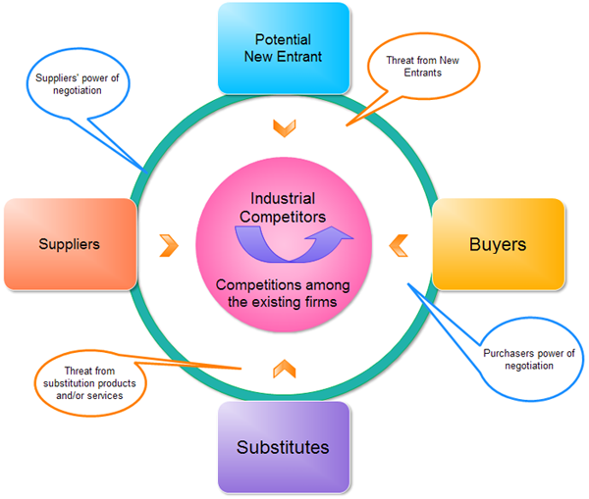

Figure: Porter's Five Forces Model Source: Nunnally (2015)

3.3 Internal environment analysis

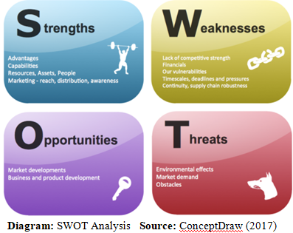
Ovidijus Jurevicius (2013) stated that SWOT analysis is considered as the vital issues that are connected with firm’s internal and external environment. The production, distribution and other regular functions of a business firm are affected by the factors of SWOT.
SWOT stands for strengths, weaknesses, opportunity and threat analysis (Ovidijus Jurevicius, 2013). There are several benefits of the analysis of SWOT. This analysis method is less cost method, easily under stable, and effective in decision making on the future functions of the firm. This method is suitable to find the real strengths and opportunities of a firm in the market. After that; this method is suitable to find the weaknesses and threats of a firm in the market (Datta and Wright, 2013). On the contrary, SWOT analysis has demerits also including increasing price mechanism, unavailability of expert labor, poor relations, and poor management of overall activities of an organization (Angela, 2018). After all; SWOT analysis has greater acceptability by the modern business world to identify their strengths, opportunities, weaknesses, and threats.

SWOT Analysis of Tesco

Strengths | Weaknesses
- Tesco has managed well established brand image in the market  - High financial capability  - Effective strategic planning  - Strong HRM and production capability  - Well established in both online-offline business (Tesco Plc, 2018).  - According to Datta and Wright (2013), Tesco has greater customer acceptance  - According to Nunnally (2015), Tesco has run its business activities not only England but also other 7 countries in the world (Tesco Plc, 2018)  - Better communication channel  - Better distribution method  - Better advertising system and Marketing campaigns  - Effective Human resource | - Sometimes weak performance of Human resource  - Only well established in UK not other countries  - Lack of storage facility  - Lack of human resource that creates problem in customers’ services in right time.  - Shortage of enough fund  - According to Torrington (2015), poor management capacity  - Poor management in online business
Opportunities | Threats
- Opportunities to spread the business activities all over the world in different countries  - Increasing trend in the sales, revenue and net income in the last few years  - According to Torrington (2015), Tesco has an expertise team to develop the new and innovative feature for the future development  - According to Tyler (2018), Better opportunities in the online market  - Global acceptance | - High competition  - Substitutions in the market  - New entry  - Political instability  - Economic downturns  - Social barriers  - Sudden technological advancement  - Challenges from Legal issues.
Table: SWOT Analysis of Tesco

4.0 Critically appraise the cultural and ethical behavior present in Tesco

4.1 Cultural and ethical behavior

Tyler (2018) said that there is not any kind of objective to change the workplace culture because the company decisions are by based of the strategies of a business. The business organization which is mainly influenced by the flat organizational structure is focused on the self-governing culture whereas the employees can easily make or share their own thoughts, ideas and decisions by working in an innovative way. On the other hand, the business organization that concentrates on the psychological demand has the main goal to maintain the good culture where solutions of different problems are easily solved. A behavior that is mainly made by local or national level is known as cultural behavior. A business organization’s cultural behavior means the importance of the strategies of a company.

4.2 Personal ethical standards, values and beliefs
Brian (2018) stated that the ethical behavior or the ethical standards or beliefs are mainly created for the person’s welfare. On the other hand, a person needs to create effective decisions by focusing on their ethical standards or values that may go above his/her self-interest. Every person has key right not to focus on the expectations of other people. Culture, lifestyle, religion, dressing styles, beliefs, income, living area and others are involved by recognition. Each of the people has their own right to live their life independently by their own way. In addition, people in the society have their rights related to their privacy by keeping their some key information secret or private. On the other hand, each of the persons has right to be valued in their life to live with respect. However, respect must be given to the people who are able to get that and not the people who are not able to get that. That means the need of the respectable behavior including make the young people of the society to respect the older or senior people. Different types of persons of a society have rights to show their viewpoints through their dressing sense, sexual preferences, beliefs, religious and cultures until the viewpoints are not harmful for anyone. In this case, organizational environment must be harmless and secure whereas the employees feel secured or safe to work properly with others.

4.3 How Corporate Social Responsibility (CSR) support business ethics

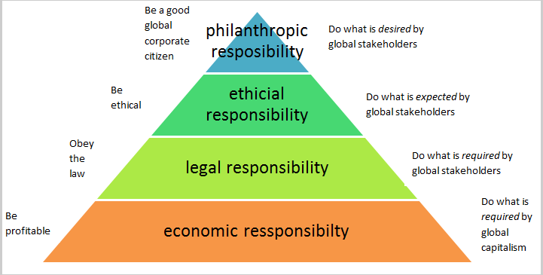
Diagram: Pyramid of corporate social responsibility Source: McWilliams (2015)
Economic responsibilities of CSR
McWilliams (2015) said that the economic responsibilities of CSR are a) making the business strategies in accordance with an improved earnings per share of a business, b) dedicating more to earn more profits for the success of the business, c) accomplishing the competitive advantage in the market by managing the business position, d) helping a business to exploit different business functions properly, and e) being the business profitable for the continuous way.
Legal responsibilities of CSR
As McWilliams (2015) notes, CSR’s different legal responsibilities are a) doing business in the legal way by fulfilling or following the demands of the government, b) focusing on different kinds of governmental rules or regulation, c) being the law remaining organization, d) presenting the successful collation of the legal responsibilities, and d) providing different products as well as services to manage the minimum legal requirements.
Ethical responsibilities of CSR
The key ethical responsibilities of CSR including a) doing business in the legal way by following the governmental rules or regulations, and b) focusing on different new ethical responsibilities which are mainly acknowledged by a society (McWilliams, 2015).
Philanthropic responsibilities of CSR
McWilliams (2015) said that CSR’s key philanthropic responsibilities mainly including a) doing business in the reliable way with different philanthropic prospects that are beneficial for a society and its people, b) helping a business top operate different functions in the philanthropic way, c) ensuring the organizational workplace in different voluntary activities between the local organizations as well as the communities.

4.4 Tesco’s ethics and CSR practices

Ethics practices

Different types of ethics as well as the environmental issues of a business organization are very much significant to their customers. Thus, it is essential to make the social as well as environmental objectives of a business organization like a way where the employees can work in a proper way (Dahlsrud, 2017). The retail method of Tesco is based on a number of key beliefs such as,
- Develop life through the organizational trade
- Help the people by focusing on their needs, expectations and demands
- Create the partnership by based on the shared standards with the dealers
- Successively evaluate different organizational environment related effects
The term belief is the response where something truly exists without any kind of proof. The problems that are faced by the retail industry cannot be easily sorted out by a particular organization only.

Tesco’s CSR practices

Tesco is represented as the leading retailer that is recorded its reputation in retail market. According to the CSR practices of Tesco, this retailer effectively focuses on the business strategies, practices or policies in the effective way by maintaining the core value of its business. The core value of Tesco is to treat the customers like a way that the customers like to be treated through the effective CSR of its business. In addition, Tesco has the capability to achieve the high profit if this retail organization and its employees work together and successfully.

Environment
To make the proper awareness on different environmental difficulties can help to permit the business organization and its people to work in the effective way. In terms of Tesco, this retail organization gives effective training to the employees about different environmental problems.

Community
Tesco focuses on different educational programs to make its business environment peaceful to work for the society and its people.

Suppliers ethical trading
To maintain different ethical standards in the business, business organizations must be accountable to promote the quality products as well as services for the customers at the competitive price that helps to encourage the good trade relationships with the suppliers.

Customer's choice and health
Customers’ health refers to the enhancement of proper health of customers in management of the preferences of the customers. Tesco must be innovative to lead the customer development by maintaining the development of the new products in the retail sector.

Workers
Employees can be offered different career development programs by business organizations through effective training and make effective communication with the employees by focusing on their requirements or feedback. Business organizations have the ability to achieve different benefits to motivate the employees by evaluating their performance and work activities effectively.
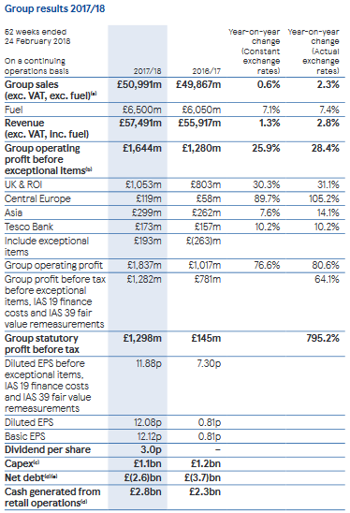
Diagram: Tesco Group results 2017/18 Source: Tesco Annual Report (2018)
From the above diagram the group sales of Tesco (excluding VAT and fuel) increased £50,991m from £49,867m in 2017/2018. On the other hand, the revenue (excluding VAT and fuel) increased by £57,491m from £55,917min 2017/2018. In addition, group operating profit (before the exceptional items) also increased from dramatically. Furthermore, the group statutory profit (before tax) increased from £145m in 2016/17 to £1298m in 2017/2018. Finally, the debt of these group results of Tesco was £3.7bn in 2016/17 and £2.6bn in 2017/2018.
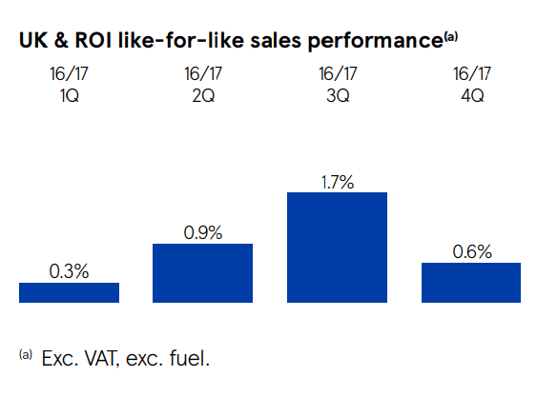
Diagram: UK & ROI like-for-like sales performances Source: Tesco Annual Report (2018)
In UK, the sales volumes increased about 1.6% where the business transactions increased by 1.7% as different business offers are enhanced by the management of Tesco.
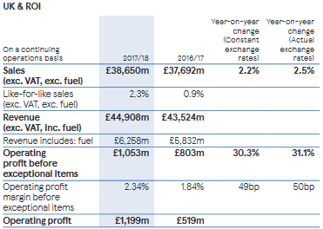
Diagram: International profit of Tesco Source: Tesco Annual Report (2018)
From the diagram of international profit of Tesco, the international sales increased by 2.5% at the actual rate. In addition, operating profit (before the exceptional items) increased 31.1% at actual exchange rate. Finally, the operating profit increased from £519m to £1199m in 2017/2018.
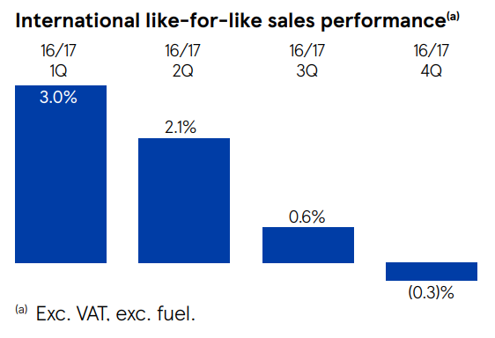
Diagram: International like-for-like sales performances Source: Tesco Annual Report (2018)
International like-for-like sales performance has increased in on the top of Poland market that is very much competitive. Tesco provides better quality products by motivating the customers of its different markets.
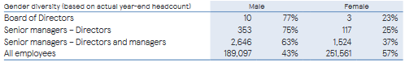
Diagram: Gender diversity of Tesco 2017/2018 Source: Tesco Annual Report (2018)
In the above diagram of gender diversity of Tesco 2017/2018, there is 77% board of directors of Tesco where the percentage of the female board of directors is 23%. In addition, there are 75% senior managers of Tesco where the percentage of the female senior managers is 25%. Furthermore, in terms of employees, there are 43% employees of Tesco where the percentage of the female employees is 57%.
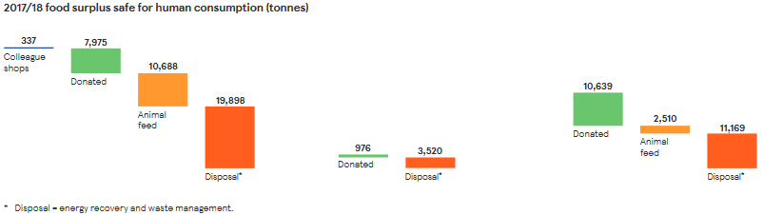
Diagram: Food surplus of Tesco 2017/2018 Source: Tesco Annual Report (2018)
From the above diagram of the food surplus of Tesco for the financial year of 2017/2018, donated, animal feed and disposal are the food surplus which is safe for the human consumption.
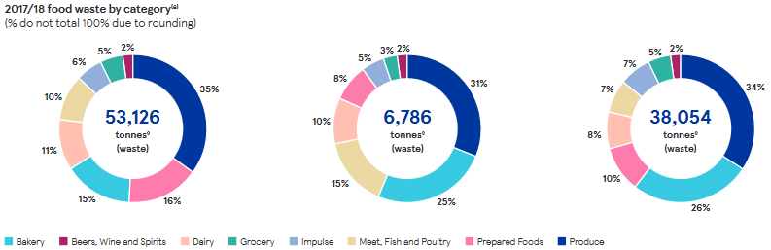
Diagram: Food waste by category Source: Tesco Annual Report (2018)
From the above chart of food waste of Tesco in different categories of 2017/2018, 35% of the foods wasted just because of poor production. In addition, 16% prepared foods wasted, 15% wasted foods are the grocery products, 11% wasted foods are the dairy products, 10% wasted foods are just because of fish, meat and poultry and the 6% wasted foods are bakery products.

4.5 How cultural and ethical behavior affect Tesco’s business

Brian (2018) said that the people who have the ability to recognize difference between good and bad is known as the ethical people. Business organizations are become ethical and fair if they maintain good relation with both customers and employees in the business organization.

Build Customer Loyalty
Hill (2018) said that the customers who provide the chance to the business organization to get the advantage of them that can make the business organization to treat like an unethical way. To become the loyal customers for a business organization can help to get success.

Retain Good Employees
Hill (2018) stated that the employees of a business organization always want fair reward system for their better work. On the other hand, the ethical business organizations are always open to deal with the talented employees by focusing on their requirements or needs. Furthermore, the non-believer workers are not capable to give their probable effort in the work performance.

Positive Work Environment
The employees of a business organization must be ethical from the time of job interview to the time of fire any employees. Business organizations must be ethical to provide the good working environment for its employees (Hill, 2018).

4.6 How organizational culture influence its ethics

Deshpande (2015) said that the ethical behavior has two different types of ideas. Leadership is a great link between the behavior and the culture of the ethical business. In addition, this is very significant for the culture of a business organization to be ethical where the leaders have to struggle more to create the proper situation for both employees and customers.
The leaders of business organizations have to be ethical in terms of both the business organization and its employees to make a good solution for a problem. In this case, the characteristics of the leader play as the significant role. On the other hand, leaders have to be visible where the ethical hopes of a business organization must be sustainable. The leaders must be ensured that the ethical behavior as well as the business culture must be linked properly.

References

Angela J. (2018) External Environment in Business, definition, types Available: https://study.com/academy/lesson/what-is-an-external-environment-in-business-definition-types-factors.html. [Accessed on: September 4, 2019]
Brian, H. (2018) Personal values, principles and beliefs. Available: https://etraining.communitydoor.org.au/mod/page/view.php?id=54. [Retrieved on: September 4, 2019]
Datta and Wright P (2013) HRM and Firm productivity. Journal of Financial Research, 27(1), 31-54.
Guest (2012). Human Resource Management: Building the worker into HRM. The Journal of Industrial Relations, 44(3), 335-358.
Huat C. (2012) Strategic human resource management and organizational performance. J. of employee management, 34(4), 10-33
Mullins, J. (2015) Management and organizational behavior.7th Edi. London: Prentice Hall.
Newman, J. (2012) HRM. 4th Edi. New York: McGraw-Hill.
Nunnally, J. (2015) Business Environment.3RD Edi. New York: McGraw-Hill
Ovidijus Jurevicius (2013) PASTLE Analysis. Available at: https://www.strategicmanagementinsight.com/tools/pest-pestel-analysis.html. [Retrieved on: September 4, 2019]
Schein, E. H., (2012) Organizational Psychology. 3r Ed. Harlow: Prentice Hall
Tesco Annual Report (2018) Tesco Annual Report-2018. Available at: www.tesco.co.uk. [Accessed on: September 4, 2019]
Tesco Plc (2018) Core Purpose and Values. Available at: https://www.tescoplc.com/about-us/core-purpose-and-values/. [Retrieved on: September 4, 2019]
Torrington, E. (2015) HRM. 7th Ed. UK: Pearson Education Ltd
Tyler (2018) Cultural Behavior in the Workplace. Available at: http://smallbusiness.chron.com/cultural-behavior-workplace-10277.html. [Retrieved on: September 4, 2019]

Dahlsrud, A. (2017) How corporate social responsibility is defined: an analysis of 37 definitions, Corporate social responsibility and environmental management, Vol.15 (1), P.1–13.

Brian, H. (2018) Personal values, principles and beliefs. Available at: https://etraining.communitydoor.org.au/mod/page/view.php?id=54. [Accessed on: 3 September 2019]

Brian, H. (2018) The Advantages of Ethical Behavior in Business. Available at: http://smallbusiness.chron.com/advantages-ethical-behavior-business-21067.html. [Accessed on: 3 September 2019]

Tyler, L. (2018) Cultural Behavior in the Workplace. Available at: http://smallbusiness.chron.com/cultural-behavior-workplace-10277.html. [Accessed on: 3 September 2019]
McWilliams, A. (2015) Corporate social responsibility and financial performance: correlation or misspecification? Strategic management journal. 21(5),pp.603–609.

Mullins, L. J., (2015) Hospitality Management and Organizational Behavior. 10th Ed. UK: Pearson Education Limited

Tesco Annual Report (2018) Annual Report and Financial Statements 2018. Available at: https://www.tescoplc.com/media/474793/tesco_ar_2018.pdf. [Accessed on: 7 September 2019]

